12/14/2025
Assessment 2
Practical and Professional Development of the Proposed Project

Module NaMe: Changemakers, Creativity and Value creation
Module Code: ACCA 5033
Student NAME: Glib Lomakin
Student ID: 2327205
Lecturer: Koushik Modak
Trinity saint david University of Wales (London Campus)

Name: Glib Lomakin
Student ID: 2327205
Table of Contents
Introduction: 2
Main Body 3
Task 1: Project Management & Practical Prototype Development 3
Q1. Project Management & Planning 3
Q2. Project Design 5
Task 2: Enterprise 6
Q1. PEST & SWOT Analysis for a Hypothetical Tech Company 6
Q2. Tech Start-up Proposal Based on Project Idea 9
Task 3: Project Reflection 10
Conclusion 12
References 13

Introduction:
This portfolio charts the journey of an innovative project: developing an AI-driven dynamic narrative framework for video games. It progresses across three integrated stages.

Task 1: Project Management & Prototype Development forms the practical foundation. It covers the detailed planning, system design, and hands-on construction of a functional "Human-in-the-Loop" prototype. This task demonstrates the integration of Generative AI with a game engine to create adaptive storytelling.

Task 2: Enterprise & Innovation shifts to a strategic view. It analyzes the commercial, legal, and ethical landscape for launching a UK-based startup, "StoryForge AI Ltd.," derived from the prototype, using PEST and SWOT analysis to frame a viable business proposition.

Task 3: Project Reflection provides the including evaluation. It assesses the skills developed, considers the project's potential societal impact, and identifies key risks and mitigations. This reflection connects the technical work to broader professional growth and responsible innovation.

Together, these tasks form a complete cycle: from building a solution and analyzing its market potential, to reflecting on the learning and impact, showing a holistic approach to technology development.

Main Body

Task 1: Project Management & Practical Prototype Development

Q1. Project Management & Planning

Project Title: AI-Driven Dynamic Narrative Framework for Role-Playing Games (RPGs)

Project Scope & Proposed Solution
This project addresses a core creative challenge in modern video game development: the escalating cost and complexity of authoring branching, player-responsive narratives. The aim is to research, design, and develop a functional prototype of a "Human-in-the-Loop" (HITL) narrative framework that leverages Generative AI to augment, not replace, human creativity [1].
The project scope is deliberately bounded to a proof-of-concept. It will not produce a commercial game but a modular software system demonstrating a viable workflow. The core proposed solution is a tripartite architecture:
- A backend AI service (using an LLM API) that generates narrative content.
- A simple game client (built in Unity) to serve as a test environment.
- A web-based designer dashboard for real-time oversight and curation of AI output.
This approach directly tackles the industry problem of scalability in narrative design by introducing AI as a collaborative tool for rapid iteration and content generation, while ensuring human authors retain final creative control and narrative coherence [2].

Required Technologies & Resources
- Core Development Stack: Python with FastAPI (backend service), OpenAI GPT-4 API (AI engine), Unity with C# (game client), React/JavaScript (dashboard frontend).
- Supporting Tools: Git for version control, draw.io for system diagrams, a project management tool like Trello for task tracking.

- Key Resources: Access to academic databases (IEEE Xplore, ACM DL) for research, and a structured Weekly Project Progress Sheet to be maintained independently for monitoring implementation against milestones.

Project Timeline, Schedule & Constraints
- Timeline: A focused 12-week development cycle.
- Schedule: See the Gantt chart below for a phased breakdown.
- Key Constraints:
- Technical: Dependency on third-party AI API performance, cost-per-call, and ethical usage policies.
- Scope: The prototype will demonstrate core functionality within a single, constrained game scenario, not a full-length title.
- Resource: Development is a solo endeavour, limiting parallel task execution and requiring careful prioritization.

Gantt Chart
The project follows a sequential, phase-gated approach. The Critical Path runs through the backend development, game integration, and final user testing stages, as any delay here directly impacts the final deliverable.
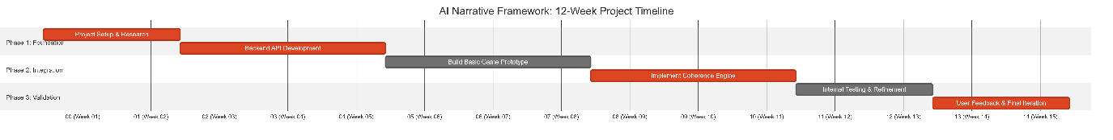

Development Method: Iterative Prototyping
Given the R&D nature of integrating emerging AI tools, a formal Agile/Scrum process is adapted into a solo iterative prototyping method. Work is organized in 2-week development cycles, each aiming to produce a testable, minimal component (e.g., a working API endpoint, a connected UI element). This approach aligns with modern, flexible project management trends [3].x

Justification: This method is optimal for projects with inherent technical uncertainty, such as working with Generative AI. It allows for rapid validation of core assumptions (e.g., "Is the AI's output suitable for game dialogue?") and enables continuous course correction based on weekly progress reviews. It provides the flexibility needed for research while maintaining the discipline of short, goal-oriented cycles, aligning with modern innovation management principles that emphasize experimentation and adaptation [4].

Q2. Project Design

Design 1: System Architecture Flowchart
This flowchart defines the core logic and data flow of the HITL system, illustrating how player agency and designer oversight interact.
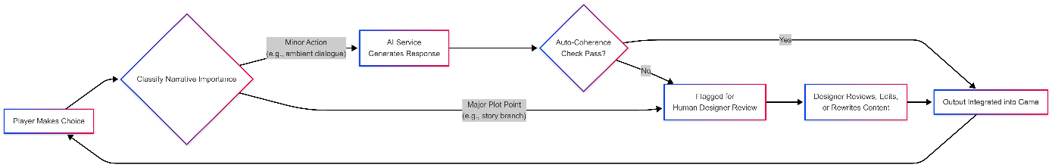

Description: This visualisation is central to the project's design philosophy. It shows the decision logic that routes content based on its narrative weight. By automating routine content and safeguarding critical story beats with human judgment, the system aims to achieve both scale and quality. The feedback loop from the game back to the player closes the interactive cycle, making the narrative dynamic and responsive.

Design 2: Wireframe for Designer Dashboard
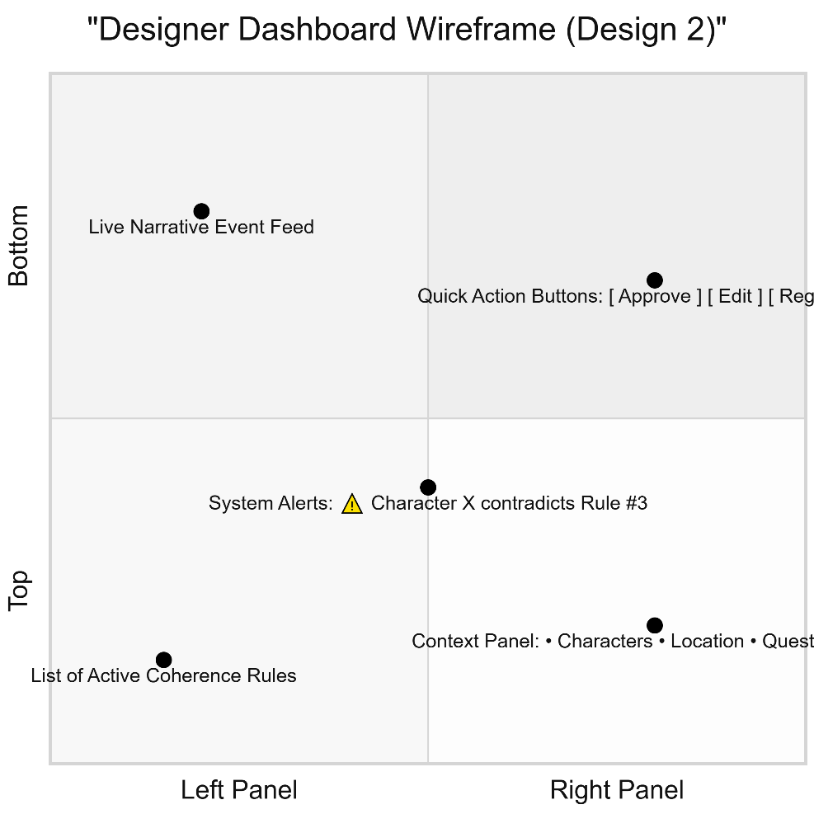
Description: This wireframe represents the interface where a designer manages AI-driven narrative generation in real time. Key elements include:

- Central Live Narrative Feed: Displays AI-generated text as it is produced.
- Context Panel (right): Shows the current game state (location, characters, quest progress) needed for decision-making.
- System Alerts (center): Highlights content that has violated predefined narrative or character coherence rules [5].
- Quick Action Buttons (bottom right): Allow the designer to instantly Approve, Edit, or Regenerate AI content.
- Active Rules List (left): Displays which specific narrative constraints (e.g., "Character Y cannot know about event Z") are currently active.

This design transforms the designer from the author of every word into a narrative curator and director, enabling efficient management of the AI system, scalable content production, and guaranteed creative control. It is a tangible implementation of the "Human-in-the-Loop" principle for the game industry.

Task 2: Enterprise

Q1. PEST & SWOT Analysis for a Hypothetical Tech Company

Company Context: "StoryForge AI" – A London-based startup developing an AI-powered dynamic narrative engine for the video game and interactive media industries, based directly on the academic project.

PEST Analysis: Key External Considerations
Political & Legal:
UK Data Protection Regime: Must comply with the UK GDPR and the Data Protection Act 2018. The Information Commissioner's Office (ICO) can impose fines of up to £17.5 million or 4% of global turnover for serious breaches. A key consideration is the transfer of game data to/from the EU, requiring adherence to EU adequacy decisions [6].
Intellectual Property under UK Law: A primary legal task is to define ownership of AI-generated narratives under the Copyright, Designs and Patents Act 1988. UK law currently requires a human author for copyright protection. Therefore, contracts must clearly state that the human game developer, using StoryForge as a tool, is the author of the final work, mitigating legal uncertainty [7].
UK AI Regulation & Pro-Innovation Approach: The startup must navigate the UK's pro-innovation AI regulatory framework, which avoids strict new laws in favour of a principles-based approach distributed among existing regulators (like the ICO). This offers flexibility but requires proactive engagement with regulatory guidance from bodies like the Centre for Data Ethics and Innovation (CDEI) [8].

Economic:
Access to Finance & R&D Incentives: A significant opportunity is leveraging the UK's R&D Tax Relief scheme and Creative Industry Tax Reliefs to offset development costs. Access to venture capital is strong in London, but competition is high.
Regional Growth Support: Potential to benefit from regional initiatives like the Creative Industries Cluster Programme, which supports tech-creation fusion in specific regions, offering grants and network access.

Socio-Cultural & Ethical:
"Creative Industries" National Identity: The UK has a strong cultural and economic identity tied to its Creative Industries. Positioning the tool as enhancing, not replacing, British creative talent aligns with national values and mitigates cultural resistance.
Diversity & Inclusion Standards: The UK industry and audiences have high expectations for diversity and representation. The AI's training data and output filters must be rigorously audited to avoid perpetuating biases and ensure inclusive storytelling, aligning with standards from bodies like the British Film Institute (BFI) [9].
Ethical AI Governance: Adopting the principles of the UK's AI Ethics and Safety Guidelines (transparency, fairness, accountability) is not just ethical but a reputational necessity to attract partnership with major UK studios and broadcasters.

Technological:
Strength in AI Research: The UK is a global leader in AI research (e.g., DeepMind). This provides a deep talent pool for hiring but also means competing for that talent with well-funded giants.
Digital Infrastructure: While major cities have excellent connectivity, serving clients or processing data from regions with less reliable broadband could pose a challenge, influencing server location decisions.

SWOT Analysis for StoryForge AI
Strengths (Internal) | Weaknesses (Internal)
UK "Creative-Tech" Hybrid Expertise aligns with a national strength. | High operational costs in London (salaries, office space).
Potential for UK government R&D grants and tax reliefs. | Brain drain risk – competition for top AI talent from US tech firms with London offices.
Early alignment with the UK's flexible, principles-based AI regulation. | Limited scale of domestic game development market compared to North America/Asia, necessitating early internationalisation.
Opportunities (External) | Threats (External)
Partnerships with prestigious UK creative institutions (BBC, BFI, major game studios). | Post-Brexit trade complexities can increase friction when selling services to the EU, a key market.
Leveraging the global reputation of UK creativity as a unique selling point. | Future divergence between UK and EU AI regulations, creating a dual compliance burden.
Growing demand for immersive and personalised content across UK gaming, TV, and edtech sectors. | Economic uncertainty and inflation potentially reducing discretionary spending by client studios.

Q2. Tech Start-up Proposal Based on Project Idea

Start-up Name: StoryForge AI Ltd.
Business Type: Private Company Limited by Shares (Ltd.). This is the most common and suitable structure for a UK tech startup. It limits shareholders' liability to their investment, provides credibility, and is straightforward for future investment or sale. It requires registration with Companies House.
Mission: To build intelligent narrative tools that augment British creativity, empowering storytellers across games and media to produce more dynamic and engaging experiences for global audiences.

Logo Concept & Brand Identity: The brand identity would merge classic British creative heritage with cutting-edge technology.
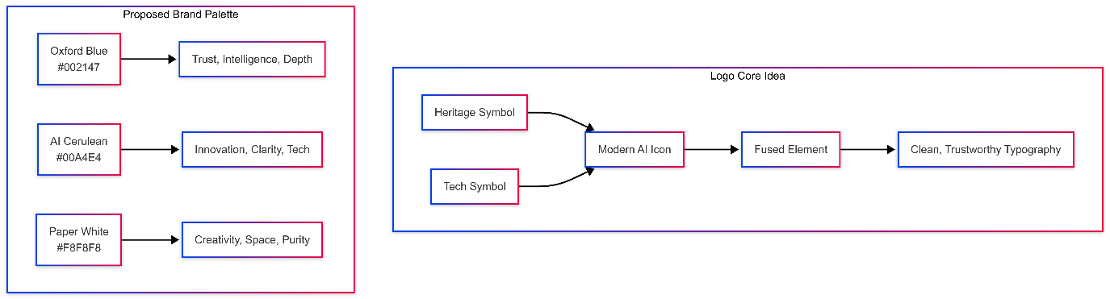
Logo Description: The logo could be a combined mark of a quill pen (symbolising literary heritage) whose nib subtly transforms into or cradles a circuit or data spark (symbolising AI). The typography would be clean, modern, and confident (e.g., a font like National or Marr Sans). The proposed colour palette uses Oxford Blue for trustworthiness, a bright AI Cerulean for technological innovation, and Paper White for a clean, creative backdrop.
Core Product: The StoryForge Engine, a cloud-based SaaS platform offering APIs and plugins for major game engines. Key features include context-aware narrative generation, real-time coherence checking, and the collaborative "Forge Dashboard" for creative teams.
Target Market (UK-First): UK-based indie and mid-size game developers, broadcasters creating interactive content, and edtech companies. Initial traction in the UK market provides a case study for global expansion.
Initial Revenue Model: Tiered monthly subscription (£X-£Y per month) based on API volume, with dedicated enterprise contracts for larger studios. The business plan would explicitly factor in UK R&D Tax Credits to reinvest a portion of revenue into development.

Task 3: Project Reflection

Developing New Skills Through the Project
Embarking on the AI-Driven Dynamic Narrative Framework project represents a significant opportunity for targeted skill development at the intersection of cutting-edge technology and creative practice. Primarily, I intend to develop deep technical proficiency in integrating Large Language Model (LLM) APIs into real-time applications, moving beyond theoretical understanding to practical implementation involving prompt engineering, context management, and latency optimisation. Concurrently, this project will force the cultivation of interdisciplinary design thinking. The core challenge is not purely technical but creative-systemic: designing a "Human-in-the-Loop" (HITL) architecture requires translating principles of narrative theory, user experience (UX), and ethical oversight into a functional software system. This mirrors the growing industry demand for professionals who can bridge the gap between computational power and human-centric design [2][5]. Finally, managing a solo R&D project from ideation to a working prototype will rigorously enhance my project management and agile execution skills, particularly in scoping iterative cycles, managing technical debt, and incorporating user feedback to pivot development priorities effectively.

Potential Societal Contribution
The skills and project outcomes have the potential to contribute positively to society in several key areas. Most directly, the project aims to democratise high-quality narrative creation. By providing smaller studios and independent creators with AI-assisted tools, the framework could lower the resource barrier to creating rich, interactive stories, fostering greater diversity of voices and innovative game formats beyond the blockbuster model. This aligns with the broader economic and cultural goals of the UK's Creative Industries sector. On a user level, the research into personalised, adaptive narratives could pioneer more engaging and accessible forms of interactive media. For example, the underlying principles could be adapted for educational software, creating dynamic story-based learning that responds to a student's choices, or for therapeutic applications in controlled narrative exposure scenarios. Furthermore, by prioritising a HITL model and embedding ethical checks for bias and coherence, the project promotes a framework for responsible AI development in creative fields. It serves as a practical case study in how to harness generative AI's potential while maintaining human authorship, creative integrity, and ethical accountability, contributing to crucial industry and societal dialogues on the future of human-AI collaboration [10].

Anticipated Risks, Challenges, and Mitigation Strategies
- Technical Risk: AI Output Quality & Coherence.

- Challenge: The LLM may generate narratively inconsistent, generic, or ethically problematic content, breaking player immersion or causing harm.
- Mitigation: Implement a multi-layered validation system. This includes a rule-based coherence engine to check for contradictions, a robust prompt-engineering framework to maintain character and plot integrity, and crucially, the HITL dashboard for human curation. Starting with a narrow, well-defined narrative genre for the prototype will help establish a viable baseline.

- Project Risk: Scope Creep and "AI Solutionism".
- Challenge: The allure of AI can lead to overcomplication, expanding the project scope to solve tangential problems rather than delivering a core, validated proof-of-concept.
- Mitigation: Adhere strictly to a Minimal Viable Product (MVP) definition focused on proving the core HITL workflow. Using an Agile-inspired methodology with bi-weekly reviews will help maintain focus. I will continually ask: "Does this feature directly address the core problem of scalable, coherent narrative generation?"

- Ethical & Professional Risk: Perceived Threat to Creative Jobs.

- Challenge: The project could be met with scepticism or resistance from within the creative community, seen as a tool for displacement rather than augmentation.
- Mitigation: Proactive communication is key. The project's discourse, documentation, and design will consistently emphasise augmentation over automation. The designer dashboard is not an afterthought but the central control panel, highlighting that the tool is designed to extend a creator's capabilities, handling volume while the human directs creative vision. Engaging with narrative designers for feedback will also ground the work in real creative needs.

Conclusion

This portfolio demonstrates a complete innovation cycle, moving from a technical proof-of-concept to a strategic business case and concluding with reflective learning.

Task 1 successfully validated the core idea, producing a functional "Human-in-the-Loop" prototype. It proved that Generative AI can be integrated into creative workflows to generate dynamic narratives, with disciplined project management ensuring its realisation.
Task 2 strategically positioned this technology, analysing the commercial, legal, and ethical landscape for a UK-based startup, "StoryForge AI Ltd." This transition from prototype to proposal highlighted that market success depends as much on strategic positioning as on technical capability.
Finally, Task 3 provided the crucial reflective layer, evaluating the skills developed and the project's societal potential. It reinforced that responsible innovation requires addressing risks like bias and workforce impact through deliberate design.

Together, these tasks showcase a holistic approach: an idea must be competently built, strategically framed, and critically examined to translate technological potential into meaningful, real-world impact.

References

[1] | L. Brown, Generative AI Applications: From Art to Code, Cambridge, MA: MIT Press, 2021.
[2] | M. Johnson, Interactive Storytelling: Techniques for 21st Century Fiction, Oxford: Oxford University Press, 2019.
[3] | S. Balaji, “Agile in 2025: Expert Predictions and Industry Trends,” Future Tech Press, 2025.
[4] | J. &. B. J. R. Tidd, Managing Innovation: Integrating Technological, Market and Organizational Change, Hoboken, NJ: Wiley, 2018.
[5] | A. Smith, AI in Game Development: Modern Approaches and Case Studies, Berlin: Springer, 2020.
[6] | I. C. O. (ICO), “Guide to the UK General Data Protection Regulation (UK GDPR),” Information Commissioner's Office, UK.
[7] | U. I. P. Office, “Artificial Intelligence and Intellectual Property: copyright and patents,” UK Intellectual Property Office, UK, 2022.
[8] | I. &. T. (. Department for Science, “A pro-innovation approach to AI regulation,” UK Government, UK, 2023.
[9] | B. F. I. (BFI), “Diversity Standards,” British Film Institute, UK.
[10] | E. M. Bender, “"On the Dangers of Stochastic Parrots: Can Language Models Be Too Big?",” Proceedings of the ACM Conference on Fairness, Accountability, and Transparency (FAccT '21), 2021.

