

Assignment Title: Cloud Engineering Principles and Practice
Student Number: 2511047
Name: Mitesh Harshadkumar Dhankecha
Module: MSc Cybersecurity and Digital Forensics
Module Code: ACCA7027
Lecturer: Renuga Jayakumar
Internal Verifier: Nathan Morgan

Table of Contents
1. Introduction 4
2. Virtualisation and Containerisation 4
2.1 Principles of Virtualisation 4
2.2 Principles and Benefits of Containerisation 5
2.2.1 Example: Creating a Dockerfile 5
2.3 Docker Images and Publishing 6
2.3.1 Example: Pushing Image to DockerHub 7
2.4 Docker Volumes 7
2.4.1 Example: Creating a Docker Volume 7
2.5 Container Networking 9
2.5.1 Example: Creating a Docker Network 9
3. Complete End-to-End Example 11
3.1 Overview of the Project 11
3.2 Step 1: Create HTML Page 11
3.3 Step 2: Build Docker Image 12
3.4 Step 3: Run Container & Test Web Server 12
3.5 Step 4: Publish Image to DockerHub 13
3.6 Summary of the Workflow 14
4. Cloud Computing Concepts 14
4.1 Load Balancing in Cloud Providers 14
4.2 Scalability in Cloud Providers 15
4.3 Application Gateways 15
4.4 Why Load Balancing and Scaling Work Together 16
4.5 Benefits of Using All Three Together 16
5. Driving Forces behind Cloud Adoption 17
5.1 Cost Efficiency 17
5.2 Flexibility & Scalability 18
5.3 Server-less Functions 18
5.4 Comparing Serverless vs Containers 19
6. Conclusion 20
7. References 22

1. Introduction
The cloud computing has transformed the IT industry at a very high rate with scalable, flexible, and affordable solutions to the business of the present day. Containerization is one of the main technologies that facilitated this alteration, where applications are stored with dependencies and thus they can be portable across environments. In contrast to conventional virtualization where a single physical host is used to create several virtual machines, with each virtual machine having its own operating system kernel, containerization uses a shared operating system kernel between containers which minimizes overhead and makes resources more efficient. This low-weight method of deploying applications has been popular especially with the emergence of platforms such as Docker that simplify the process of developing and deploying applications. Containerization and its combination with cloud computing platforms are the principles, which make micro-services architecture, continuous integration, and cloud-native application successful. Containers are especially useful to those businesses that want to enhance their efficiency and performance in the cloud by scaling and deploying services as fast as possible. We discuss the main principles of virtualization, containerization, and cloud computing in this report, and we get to understand how these technologies make operations of the modern enterprises more flexible, cost-effective, and scalable.

2. Virtualisation and Containerisation

2.1 Principles of Virtualisation
Virtualisation is the method of providing virtual versions of computing resources (servers, storage, networks or operating systems for instance) through the abstraction of the underlying physical hardware. Instead of running applications directly on these physical machines, virtualisation is a method of enabling several isolated virtual machines (VMs) to use the same physical server and yet behave as independent systems (Ukene, 2024). This is done with the help of hypervisors, special pieces of software which are responsible for the management and allocation of hardware resources to each VM.
Type 1 hypervisors, such as, VMware ESXi and Microsoft Hyper-V, are the hypervisors that run on the hardware of the host directly, and include high performance, high isolation, and enterprise grade reliability (Gudelli, 2023). Type 2 Hypervisors are those such as virtualbox and vmware which run on top of a host OS and are generally used for development and testing.

Figure 1: Docker Desktop Resource Usage Panel
An example of virtualisation of shared hardware is the situation in which one physical server is used to host a number of VMs, each of which runs its own OS and applications program. This maximises the utilisation of the hardware, minimizes costs and adds flexibility to the operation.

2.2 Principles and Benefits of Containerisation
Containerisation is a lightweight virtualisation process in which an application and everything dependent on it, such as libraries and other configuration, are compiled into a single unit called a container which is then isolated. Unlike virtual machines (VM) containers do not require the use of a full guest operating system. Instead, various containers share the host OS kernel, making them much faster, more compact and more resource-efficient than VMs (Cherukuri, 2024).
The main distinctions are that VMs virtualize with a hypervisor and when the containers virtualize with a container runtime such as docker, they are based on OS-level isolation (Kim et al. 2022). This makes containers lightweight and fast to start as well as very portable across environments.
In the sense of cloud computing, containerisation brings microservices architecture, automated scaling, CI/CD pipeline, and faster deployment in the various cloud platforms, such as Kubernetes, AWS ECS, Azure Container Instances, Google Cloud Run, etc. This is perfect for modern / cloud native applications development which uses containers.

2.2.1 Example: Creating a Dockerfile
Figure 2: Creating Project Files in PowerShell
In this image index.html and Dockerfile are opened in Notepad inside the cloud-web-example project folder.
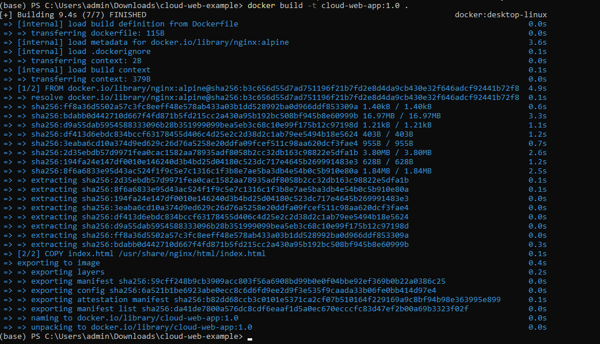
Figure 3: Successful Docker Image Build Process
Docker successfully builds the custom Nginx-based image using the Dockerfile and index.html.

2.3 Docker Images and Publishing
A Docker image is a lightweight standalone package, which contains everything required to run an application (the code, environment (on which it runs), libraries and their dependencies, and configuration files). Images are constructed from a set of instructions (defined in a Dockerfile), which enables information about how the environment of the container should be created (Lakka, 2025). These layers are cached and are shared across images, allowing them to have interesting properties like efficient storage, builds are faster and versioning is easier.
Publishing Docker images on DockerHub allows for a centralised and cloud-based repository to store images in order to share and access them from any machine (Kaiser et al. 2022). This makes the application deployment very portable and identical in each environment. By hosting images on DockerHub, developers and teams can pull the same image for development, testing, or production, ensuring reproducibility and enabling continuous integration and continuous deployment (CI/CD) workflows.

2.3.1 Example: Pushing Image to DockerHub
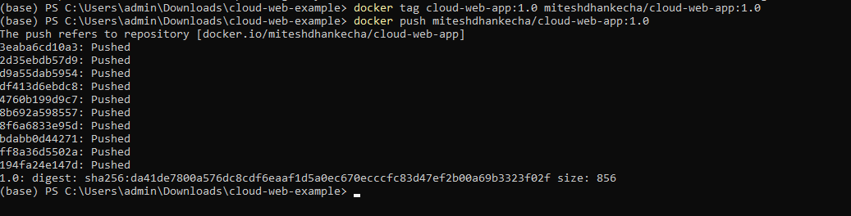
Figure 4: Docker Image Successfully Pushed to DockerHub
The image is tagged and uploaded to the user’s DockerHub repository with all layers pushed.

2.4 Docker Volumes
Docker volumes are part of Docker-managed specialised storage that can be used for data to persist outside the lifecycle of the container using it. Unlike the internal filesystem of a container which is temporary and deleted when a container is removed, volumes house their data on a host system at a location in the system that is controlled by Docker (Acharya and Suthar, 2021).
Persistent storage is essential because containers are designed to be ephemeral, which means that they can be stopped, replaced or re-created anytime during the update or scaling operations. Without persistent storage important application storage is lost whenever the container is removed. By using volumes data is kept intact if the container fails or the container is redeployed. This ensures continuity, reliability, and data integrity, as containers on the cloud more often than not will be scaling dynamically or used in distributed architectures (Verma et al. 2022).

2.4.1 Example: Creating a Docker Volume
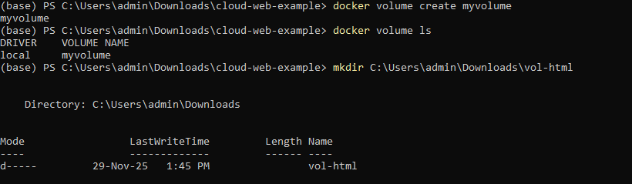
Figure 5: Creating Named Docker Volume “myvolume”
A persistent Docker volume is created and verified using docker volume ls.
Figure 6: Creating Host Directory for Volume Mapping
A new folder (vol-html) is created to store HTML files used in the volume test.
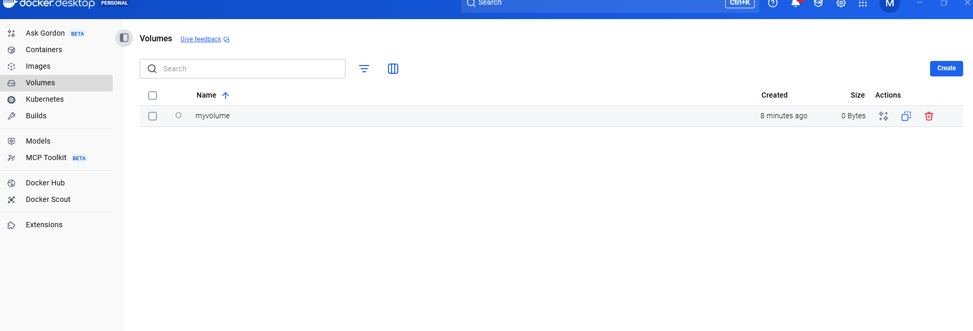
Figure 7: Running Nginx Container with Mounted Volume
The Nginx container is started using a bind-mounted Windows folder to serve custom HTML content.
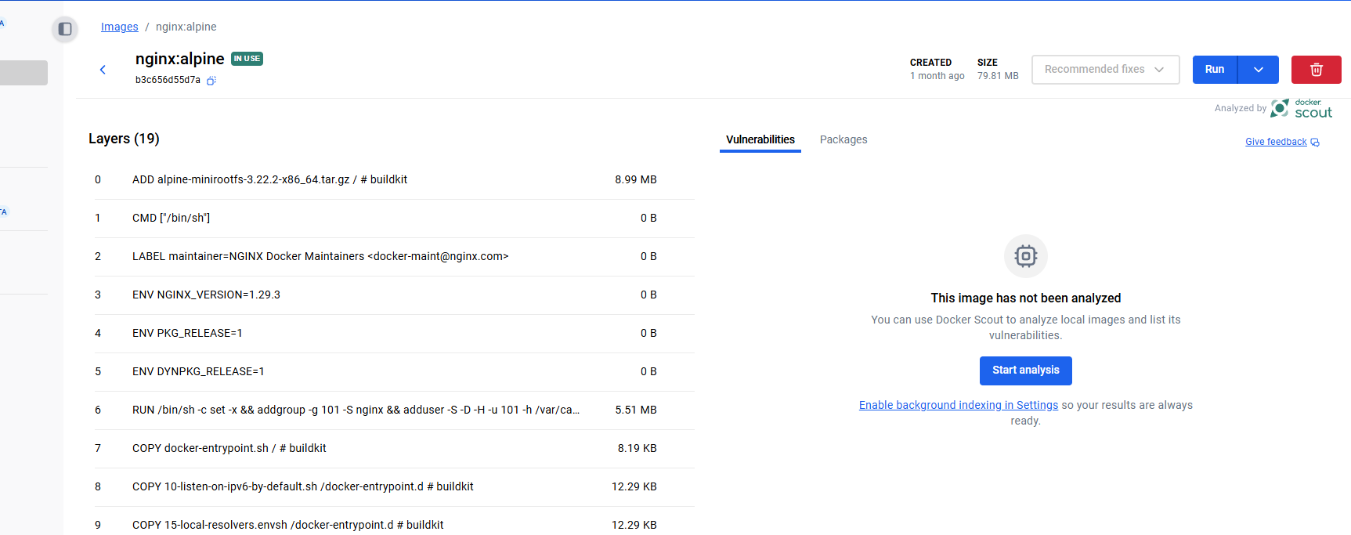
Figure 8: Viewing Created Volume in Docker Desktop UI
Docker Desktop displays the named volume "myvolume" created earlier for persistent storage.

Figure 9: Browser Output Showing Volume-Served HTML Page
Confirms the Nginx container is successfully serving the HTML file stored in the mounted Docker volume.

2.5 Container Networking
Docker networking is a way to allow containers to communicate with other containers, the host machine, and other external networks through having virtualized network interfaces and networking routing mechanisms. Each container is provided with its own isolated network namespace, including shared IP address that enables predictable and manageable communication between them (Ganne, 2022).
Docker supports several types of network and the most common is the bridge network, which is the default mode for standalone containers. In a bridge network, containers interact with each other through a private subnetwork which is managed by Docker. The host network exposes a container with the ability to directly use the network stack of the host machine, which eliminates port mapping, but lowers isolation - it is mostly used on Linux systems. The overlay network provides a way of secure communication between containers running on different hosts, which are usually within the Docker Swarm or multi-node cloud environments (Singh et al. 2023).
These network models provide flexibility, scalability, and security of communication paths that are needed for distributed and cloud-native applications.

2.5.1 Example: Creating a Docker Network
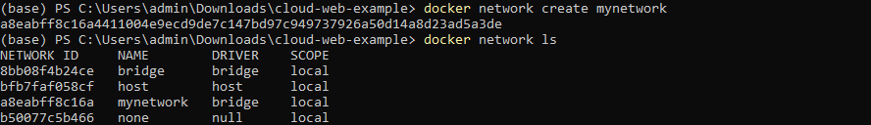
Figure 11: Creating and Listing Docker Network “mynetwork”
Shows successful creation of a custom Docker bridge network and verification using docker network ls.
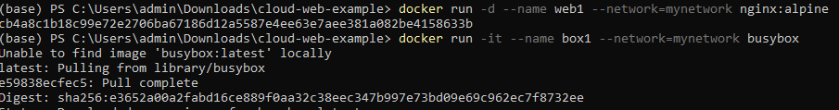
Figure 12: Running Containers Attached to the Custom Network
The nginx and busybox containers are launched on the same user-defined network to enable inter-container communication.
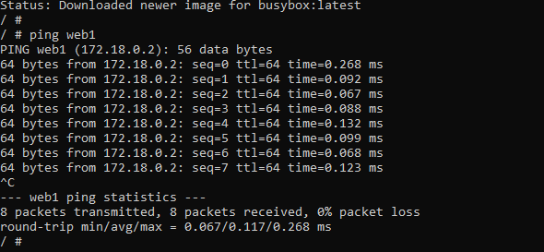
Figure 13: Successful Ping Between Containers on the Same Network
The busybox container successfully pings the nginx container, proving both containers can communicate through the Docker network.
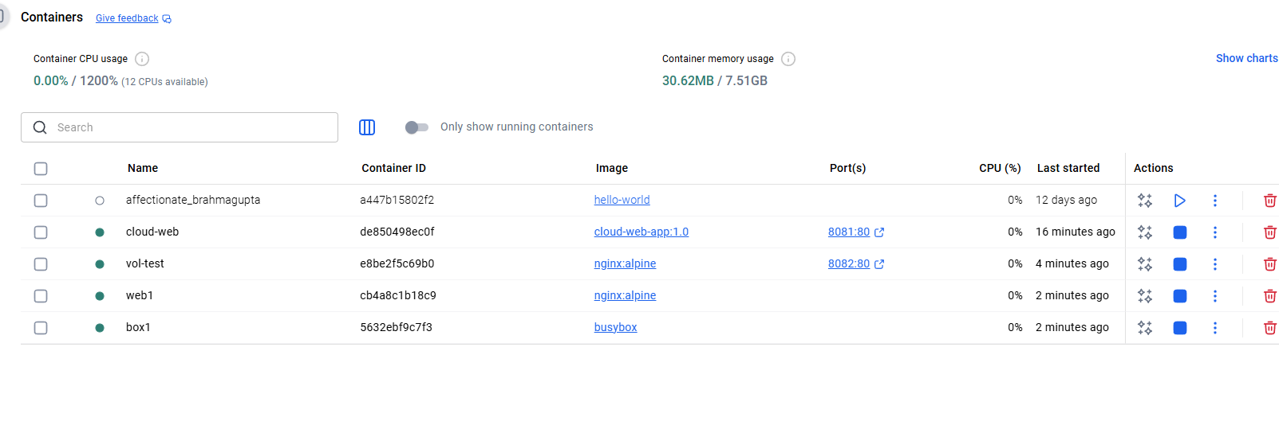
Figure 14: Docker Desktop Showing All Active Containers
Docker Desktop displays all running containers, including those connected to the custom network and volume examples.

3. Complete End-to-End Example

3.1 Overview of the Project
The given project is aimed at research and application of the containerization and cloud computing technologies, mostly with the help of Docker. Docker is a technology that enables the developers to package an application along with all its dependencies into a container. Containers are capable of being consistent across environments and therefore it is simpler to deploy applications in the cloud or locally. The project illustrates the whole procedure of developing a Docker image, initiating a container, and handling such containers to achieve the effective deployment on the cloud (Chołody and Przyłucki, 2023). The initial phase of the project would be the establishment of a virtual environment in which containers may be created and managed. The software under demonstration is a plain web server that serves an HTML page. This gives us the opportunity to demonstrate how the web server and its dependencies can be packaged in a container using Docker.
The project then explores more sophisticated capabilities of Docker such as volumes and networking. Volumes are utilized to store data beyond the lifecycle of a container that data is not lost when containers are stopped or removed. Docker networking allows the containers to interact with one another and with the outside networks, which is essential in the distributed applications. The project also incorporates the publication of the Docker image to DockerHub to be available to others to use it and this way the application can be deployed to different systems in a consistent manner (Belgaum et al. 2021). At the project completion, it is expected to have a fully operational containerized application, which can be deployed in any cloud platform or environment.

3.2 Step 1: Create HTML Page
Figure 15: Opening index.html and Dockerfile in PowerShell
The image demonstrates how to navigate to the project directory and open the index.html and Dockerfile with PowerShell. It belongs to the initial step to create the required files in order to construct the Docker image.

3.3 Step 2: Build Docker Image
Figure 16: Successful Build of the Docker Image (cloud-web-app:1.0)
An image can be taken upon the successful construction of a Docker image. The build command indicates that the image was generated using the Dockerfile and the other stages that were undertaken during the build process with the final stage being a completed Docker image which is tagged as cloud-web-app:1.0.

3.4 Step 3: Run Container & Test Web Server
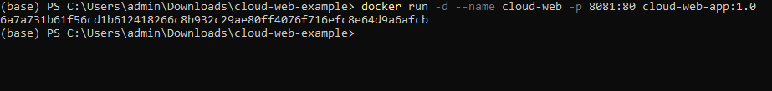
Figure 17: Running the Container With Port Mapping (8081:80)
This picture illustrates the command to execute the Docker container with port mapping. The port 8081 of the host machine is mapped to port 80 in the container enabling access to the web server.
Figure 18: Listing Running Containers Using docker ps
This picture depicts the result of the docker ps command, where all the containers are listed. It ascertains that the container is operational and available on port 8081, and in healthy condition.
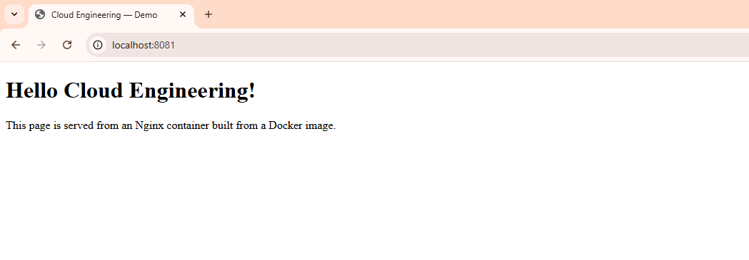
Figure 19: Web Page Served From the Docker Container
The above figure described, the position of the web page is shown within the Docker container. The browser displays the Hello Cloud Engineering! Healthy, which means that the web server in the container is functional and it is serving the content.

3.5 Step 4: Publish Image to DockerHub
Figure 20: Tagging and Pushing Image to DockerHub
In this image, the tagging of the Docker image and its pushing to DockerHub is seen. The picture is labeled with a particular version and is subsequently released to a remote repository to be shared and deployed.
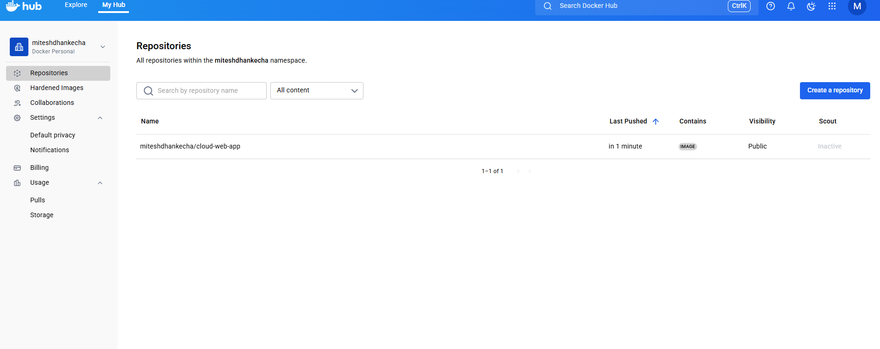
Figure 21: DockerHub Repository Displaying Uploaded Image
This image depicts the DockerHub interface that gives the uploaded Docker image. It validates that the image has been pushed to the DockerHub repository in the user account of the user and can now be used publicly.

3.6 Summary of the Workflow
This project takes place in a straightforward, systematic procedure to show how Docker could be applied to containerize an application and make it ready to be deployed. The initial one is to prepare an HTML page that will be our simple web application that we will deploy in Docker (Akerele et al. 2024). The landing page on this site is the most important part of the demonstration as it presents how Docker can be used to serve a web application. Then we create a Docker image based on the Dockerfile, which includes the commands on the establishment of the container. The Dockerfile is used to list the base image, add the required software, and transfer the HTML page to the container. When the image has been created, it can be run as a container.
Once we have run the container then we test the web server to verify that it is able to serve the HTML page correctly. This demonstrates the way in which Docker aids in the execution of applications within a uniform environment, regardless of the location of deployment. The second stage of the working process is the release of the Docker image to DockerHub. This web based repository enables us to save the image where image can be shared and deployed without much difficulty on other systems (Zhu et al. 2023). DockerHub also makes certain that all those who pull the image will have the same version of the application, which makes deployments the same. Overall, the workflow illustrates the whole process of developing, executing, and publishing a containerized application and how Docker allows making it easy to develop, deploy, and share applications across various environments.

4. Cloud Computing Concepts

4.1 Load Balancing in Cloud Providers
Load balancing is a method of allocating the incoming traffic in the network to various servers. Load balancing prevents a single server to be overloaded with requests with cloud computing to ensure that the server operating operates at high performance levels and does not crash. Cloud providers make use of load balancers to automatically redirect traffic into the most performing or least utilized server (Hammad and Abu-Zaid, 2024). Considering an example, when you have a web site on more than one server, the load balancer will examine which server is least traffic-free and direct the traffic that is received to the server. This would also prevent an overloading process of a single server so that the user experience is enhanced in terms of faster response and greater availability. Cloud technologies that support load balancing such as, AWS, Azure, and Google Cloud already have in-service load balancing that is easily configured and managed. Such services can also be scaled i.e. they can automatically expand to support greater or lesser traffic depending on the demand (Oyeniran et al. 2024). The load balancing may be performed at various levels depending on the application requirements, i.e., Application layer or network level. Overall, load balancing is an important aspect in the operation of cloud applications so that they could operate effectively and manage different traffic volumes without failures.

4.2 Scalability in Cloud Providers
Scalability is the capability of a system to support more and more work or be easily scaled up to support the growth. Scalability is a major benefit that can be given by cloud providers in the case of cloud computing. Cloud services, including AWS, Azure, and Google Cloud, enable companies to expand and shrink their resources according to their demands. Scalability takes two major forms, which include vertical and horizontal (Wei et al. 2023). Vertical scalability is the process of adding additional power (CPU, RAM) to an existing server whereas horizontal scales are adding additional servers in order to divide the load. The cloud providers simplify the task of scaling resources and do not need any physical changes to the infrastructure.

As an example, when a site suddenly starts to have a high traffic, cloud services can easily add extra virtual machines (VMs) to meet the demand without affecting the quality of the application. This is one of the factors that make cloud computing so powerful due to this dynamic scalability. It enables businesses to pay only what they use and they are able to satisfy the demand without overproviding resources (Mahmoudi and Khazaei, 2022). Scalability in the cloud world is frequently automated, and the business can concentrate on growth without caring about its infrastructure.

4.3 Application Gateways
An API or application gateway is a server that forms an interface point that enables access of web traffic to an application. It is commonly applied in the architectures of micro-services to handle and direct the incoming request to the right services. Application gateway performs various functions that involve load balancing, security, and monitoring. Application gateways are useful in cloud computing to simplify the process of communication between the user and the services (Li et al. 2021). To illustrate, an e-commerce site can contain multiple services one that takes the payments, another one that manages product listing and another one that manages user accounts. Application gateway will take care of making sure that when a user requires a service, the request is sent to the appropriate backend service.
Application gateway services, such as those provided by AWS, Arizona, and Google Cloud, are services that have additional functionality, such as termination of the use of the SSL, web application firewalls, and scaling (Syed and Ali, 2024). These properties are useful in making sure that communication between the user and the back end systems are safe and efficient. Application gateways are also used to enhance the general performance and security of cloud applications because it serves as a gatekeeper and this ensures that only authorised traffic gets through and traffic is redirected efficiently.

4.4 Why Load Balancing and Scaling Work Together
Load balancing and scaling are two inseparable methods that collaborate to enhance the performance and the availability of cloud-based applications. Load balancing assists in sharing the incoming traffic among various servers whereas scalability is a type of ensuring that the system can be expanded in line with the growing demands. These two techniques, when put together will see cloud applications manage the different volumes of traffic without compromising on the performance (Li et al. 2022). In a case of a bursting traffic, the load balancing will send the extra load to underutilized servers. Scalability on the other hand will enable the system to automatically increase the number of servers to meet the additional load. The dynamic combination means that the cloud applications will still be able to operate effectively even in case of a heavy traffic.
In the absence of load balancing, scaling (adding more servers) would not be efficient because the traffic may still be directed to a limited number of servers resulting in the slow performance or even downtime. On the same note, the system might fail to cope with high traffic seasons due to the unscaled system leading to service failures. Load balancing and scalability combined with each other to form a flexible resilient cloud infrastructure able to automatically adapt to traffic fluctuations and deliver a seamless user experience (Kambala, 2023).

4.5 Benefits of Using All Three Together
A combination of load balancing, scalability, and application gateway is a potent application in the high availability, high performance, and high security of cloud-related applications. These technologies are complementary such that they offer a smooth user experience to both the users and the businesses. Load balancing guarantees the uniformity in the distribution of traffic among several servers to avoid overload in one server. Scalability enables the system to automatically scale itself by adding or eliminating resources to match demand. Meanwhile, application gateways is an effective and safe means of traffic diversion to appropriate services. Collectively these three technologies enable cloud applications to support high volumes of traffic, swiftly accommodate change, and performance even when the demand is high.
The synergistic application of these technologies also has an effect in increasing security by safeguarding the services in the back end as well as by making sure that only the legitimate traffic is passed through the application gateway (Golec et al. 2024). Secondly, they also assist in the minimization of operational expenses because the businesses can only pay as they utilize the resources and not over a surplus. Generally, the combination of load balancing, scalability, and application gateways offers a scalable, powerful, and secure way of constructing and sustaining cloud applications that may expand with increased demand.

5. Driving Forces behind Cloud Adoption

5.1 Cost Efficiency
Cloud computing is also highly cost effective to the business as it gives the business an opportunity to pay as they utilize the resources as opposed to investing money in purchasing costly physical infrastructure. This is because the model is called “pay-as-you-go”, which allows companies to increase or decrease their services according to the demand, which avoids unutilized resources and ensures minimal costs. Cloud providers such as AWS, Azure, and Google Cloud have pricing models that enable users to customize various services depending on their requirements and thus will only pay to consume a specific quantity of compute power, storage or network bandwidth (Vahidinia et al. 2022).
To illustrate, companies do not have to invest heavily in business facilities since they can begin small and add capacity as they grow, without having to invest millions on facility construction. However, cloud services are usually provided with implicit functionalities that decrease the expenses of managing costly business infrastructure, including automated backup, security functions, and updates of software programs. This lowers the operation and capital cost.
Resource | Traditional Infrastructure | Cloud Infrastructure
Upfront Cost | High (purchase servers, storage, etc.) | Low (pay as you go)
Maintenance | Ongoing (staff, repairs, etc.) | Low (automated services)
Scalability Cost | Expensive (requires new hardware) | Flexible (scale up or down)
Energy Consumption | High (physical hardware) | Low (data centers optimized)
Backup/Disaster Recovery | High (manual setup) | Low (automated and managed)
Table 1: Cost Efficiency

5.2 Flexibility & Scalability
Cloud computing offers scalability and flexibility that ensures that business can easily adapt to changes in need. Flexibility means the possibility to select among a great variety of cloud services, tools, and technologies to satisfy the particular business needs. As an example, enterprises can choose storage, compute and database services that suit them optimally without depending on a particular hardware configuration. It could be able to combine and interchange resources maximizing performance and cost. Scalability, conversely, guarantees that the cloud systems can be expanded and contracted in regard to the demands (Wen et al. 2023). This implies that the businesses do not have to be concerned of expanding their infrastructure. In the case of a sales event, cloud services can automatically add resources such as virtual machines or storage capacity to process the additional traffic should traffic to a site grow. At the end of the event, one can reduce the resources, and the business will only pay on what is utilized.
Cloud systems such as AWS, Microsoft Azure and Google Cloud have the capability of auto-scaling resources, which automatically scales resources according to a defined set of requirements. Such systems can be scaled vertically (adding resources to already existing machines) or horizontally (adding more machines to even out the load). This makes sure that the applications can work best regardless of their size in terms of the number of users served whether there are just a few users or millions of users.
In the case of business, it means less risk, greater agility and savings in costs due to this flexibility and scalability. As an example, a company will be able to implement changes in the market in a short period without spending much money (Segarra et al. 2024). Cloud services provide the flexibility you require.

5.3 Server-less Functions
Serverless computing is a type of cloud computing in which the developers can create and execute the applications without taking care of the infrastructure. In a conventional cloud system, servers, networks, and storage have to be controlled by the developers. Contrary to this, in serverless computing, the cloud provider manages these tasks and developers are only needed to write code. Serverless functions, like AWS Lambda or Azure Functions, are triggered by events and are run to execute code in reaction to certain events, such as an HTTP request or file upload. They are only run when required and automatically scaled depending on the demand hence; these are commonly called on-demand services.
Cost efficiency is one of the benefits of serverless functions. You are only charged the real execution time of the code (in milliseconds), therefore businesses are not charged with dead time on the servers. The serverless functions are particularly suitable to applications where the usage patterns are unpredictable or not frequent. As an example, a web-based store may have an e-commerce system that utilizes serverless functions to handle orders or payments when the load is high, but only charges when the functions are active (Kounev et al. 2023). The other significant advantage is ease. Under serverless, companies do not need to concern themselves with server and infrastructure scaling. The cloud provider manages all the technical and therefore the developers develop and maintain the applications fast. Serverless computing is better suited to the micro-services architecture whereby every functions can run in isolation, so it is simpler to construct, test, and deploy smaller and modular constituents of a system.
Serverless computing is a very effective and economical option to developers and companies that want to create scalable applications in a very short time without the hassles of managing servers.

5.4 Comparing Serverless vs Containers
Both Serverless functions and containers are models of cloud computing, and they assist businesses to run applications in a low-cost and flexible manner. Although these two have certain similarities, e.g. scalability and cost efficiency, there are significant differences between the two. Serverless Computing: In serverless computing, the cloud developer handles the resources and the cloud provider automatically adds and removes resources as required. Serverless functions execute when a certain event or trigger occurs, e.g. an HTTP request or an upload. The developers need only to write code and they are charged on an execution time, which makes this a very cost-effective solution to applications that are used occasionally. Serverless computing is more suitable with smaller and event-driven tasks, in which the infrastructure does not have to be running at all times.
Containers: Containers are however, the same but they bundle an application and the dependencies together in a single unit that can be deployed across any environment. Such tools as Docker enable applications to run on isolated environments and therefore, they are portable and scable. Containers are not serverless, but they provide greater control and capabilities, which enables businesses to control the infrastructure and scale it to highs, as well as guarantee application consistency across multiple platforms. Containers can be used in applications that have long processes or ones that have to be closely interconnected with other services.
Key Differences
Management: Serverless removes all infrastructure management, whereas containers need some amount of infrastructure management.
Use Cases: Serverless is more geared towards event-driven stateless applications, whereas containers are geared towards long running, complex applications that have dependencies.
Scalability: Serverless is automatically scaled, instantly, and containers need to be scaled manually or orchestrated by scaling platforms, such as Kubernetes.
Cost Efficiency: Serverless functions have an execution price, which is based on the execution time, thus, cheaper when the workload is low. Containers can, however, be an expensive source of waiting time when provisioned beforehand.
To conclude, serverless or containers are dependent on the requirements of the application. Serverless works well with small, event-driven applications, whereas containers can be used with complex, multi-service applications that have particular dependencies. The two technologies are utilized in several businesses and this is based on the needs of various components of the business.

6. Conclusion
To sum up, the emergence of cloud computing has transformed the way in which businesses do their infrastructure and thus they are able to scale, optimize costs, and enhance performance. Containerization, load balancing, and serverless computing are also some of the essential technologies that define the current cloud architecture. Using this project, we have shown how one can take advantage of the Dockers to containerize an application, administer it efficiently by using cloud services, and facilitate efficient deployment and scaling. Application deployment is made easier with the use of tools such as Docker, because the application and all of its dependencies are packaged into containers that are isolated. This increases compatibility as the application is easily run in various environments. Containers with load balancing and auto-scaling functionalities offered by cloud providers can scale to different levels of traffic, which allows companies to have high availability and achieve the best performance.
Moreover, serverless computing has the benefit of providing a cheaper approach in the management of cloud applications. Serverless functions allow the business to concentrate on building the applications without issue of how to manage the server or scale the infrastructure. Serverless models save costs, especially when an application has unpredictable workloads; since the cost is only paid on the real execution time. On balance, using these features, containerization, load balancing, scalability, and serverless functions, companies are able to develop strong, adaptable, and scalable applications on the cloud. These technologies help businesses to innovate faster to meet the demands, streamline their business, and concentrate more on innovation without being plagued with infrastructure issues. With the evolving nature of cloud computing, it is bound to be a major implementer of growth and effectiveness to businesses in the world.

Docker Web Server Deployment: Creating Images, Using Containers, and Uploading to Docker Hub: An Example Video

Link: https://youtu.be/dhGOSgMX0-4

7. References
- Acharya, J.N. and Suthar, A.C., 2021, October. Docker container orchestration management: A review. In International Conference on Intelligent Vision and Computing (pp. 140-153). Cham: Springer International Publishing.
- Akerele, J.I., Uzoka, A., Ojukwu, P.U. and Olamijuwon, O.J., 2024. Improving healthcare application scalability through microservices architecture in the cloud. International Journal of Scientific Research Updates, 8(02), pp.100-109.
- Belgaum, M.R., Alansari, Z., Musa, S., Alam, M.M. and Mazliham, M.S., 2021. Role of artificial intelligence in cloud computing, IoT and SDN: Reliability and scalability issues. International Journal of Electrical and Computer Engineering, 11(5), p.4458.
- Cherukuri, B.R., 2024. Containerization in cloud computing: Comparing Docker and Kubernetes for scalable web applications. International Journal of Scientific Research and Application, 13(01), pp.3302-3315.
- Chołody, K. and Przyłucki, S., 2023. Analysis of the impact of using containerization techniques on application performance in Python. Journal of Computer Sciences Institute, 29, pp.413-420.
- Ganne, A., 2022. Cloud data security methods: Kubernetes vs Docker swarm. International Research Journal of Modernization in Engineering Technology, 4(11), pp.1-6.
- Golec, M., Walia, G.K., Kumar, M., Cuadrado, F., Gill, S.S. and Uhlig, S., 2024. Cold start latency in serverless computing: A systematic review, taxonomy, and future directions. ACM Computing Surveys, 57(3), pp.1-36.
- Gudelli, V.R., 2023. Containerization technologies: ECR and Docker for microservices architecture. International Journal of Innovative Research in Management, Pharmacy and Sciences (IJIRMPS), 11(3).
- Hammad, A. and Abu-Zaid, R., 2024. Applications of AI in decentralized computing systems: harnessing artificial intelligence for enhanced scalability, efficiency, and autonomous decision-making in distributed architectures. Applied Research in Artificial Intelligence and Cloud Computing, 7(6), pp.161-187.
- Kaiser, S., Haq, M.S., Tosun, A.Ş. and Korkmaz, T., 2022. Container technologies for arm architecture: A comprehensive survey of the state-of-the-art. IEEE Access, 10, pp.84853-84881.
- Kambala, G., 2023. Cloud-Native Architectures: A Comparative Analysis of Kubernetes and Serverless Computing. Journal of Emerging Technologies and Innovative Research, 10, pp.n208-n233.
- Kim, B.S., Lee, S.H., Lee, Y.R., Park, Y.H. and Jeong, J., 2022. Design and implementation of cloud docker application architecture based on machine learning in container management for smart manufacturing. Applied Sciences, 12(13), p.6737.
- Kounev, S., Herbst, N., Abad, C.L., Iosup, A., Foster, I., Shenoy, P., Rana, O. and Chien, A.A., 2023. Serverless computing: What it is, and what it is not?. Communications of the ACM, 66(9), pp.80-92.
- Lakka, M., 2025. Understanding Containers and Docker: Virtualization Made Simple. Journal Of Engineering And Computer Sciences, 4(7), pp.575-580.
- Li, Z., Chen, Q. and Guo, M., 2021. Pagurus: Eliminating cold startup in serverless computing with inter-action container sharing. arXiv preprint arXiv:2108.11240.
- Li, Z., Guo, L., Cheng, J., Chen, Q., He, B. and Guo, M., 2022. The serverless computing survey: A technical primer for design architecture. ACM Computing Surveys (CSUR), 54(10s), pp.1-34.
- Mahmoudi, N. and Khazaei, H., 2022. Performance modeling of metric-based serverless computing platforms. IEEE Transactions on Cloud Computing, 11(2), pp.1899-1910.
- Oyeniran, O.C., Modupe, O.T., Otitoola, A.A., Abiona, O.O., Adewusi, A.O. and Oladapo, O.J., 2024. A comprehensive review of leveraging cloud-native technologies for scalability and resilience in software development. International Journal of Science and Research Archive, 11(2), pp.330-337.
- Segarra, C., Feldman-Fitzthum, T., Buono, D. and Pietzuch, P., 2024, April. Serverless confidential containers: Challenges and opportunities. In Proceedings of the 2nd Workshop on SErverless Systems, Applications and MEthodologies (pp. 32-40).
- Singh, N., Hamid, Y., Juneja, S., Srivastava, G., Dhiman, G., Gadekallu, T.R. and Shah, M.A., 2023. Load balancing and service discovery using Docker Swarm for microservice based big data applications. Journal of Cloud Computing, 12(1), p.4.
- Syed, A.A.M. and Ali, S., 2024. Kubernetes and AWS Lambda for Serverless Computing: Optimizing Cost and Performance Using Kubernetes in a Hybrid Serverless Model. International Journal of Emerging Trends in Computer Science and Information Technology, 5(4), pp.50-60.
- Ukene, D.E., 2024. Assessing Performance Optimization Strategies In Cloud-Native Environments Through Containerization And Orchestration Analysis.
- Vahidinia, P., Farahani, B. and Aliee, F.S., 2022. Mitigating cold start problem in serverless computing: A reinforcement learning approach. IEEE Internet of Things Journal, 10(5), pp.3917-3927.
- Verma, S.B., Pandey, B. and Gupta, B.K., 2022. Containerization and its architectures: a study. ADCAIJ: Advances in Distributed Computing and Artificial Intelligence Journal, 11(4), pp.395-409.
- Wei, X., Lu, F., Wang, T., Gu, J., Yang, Y., Chen, R. and Chen, H., 2023. No provisioned concurrency: Fast {RDMA-codesigned} remote fork for serverless computing. In 17th USENIX Symposium on Operating Systems Design and Implementation (OSDI 23) (pp. 497-517).
- Wen, J., Chen, Z., Jin, X. and Liu, X., 2023. Rise of the planet of serverless computing: A systematic review. ACM Transactions on Software Engineering and Methodology, 32(5), pp.1-61.
- Zhu, W., Hou, A.B., Yang, R., Datta, A., Mousavi, S.M., Ellsworth, W.L. and Beroza, G.C., 2023. QuakeFlow: a scalable machine-learning-based earthquake monitoring workflow with cloud computing. Geophysical Journal International, 232(1), pp.684-693.

