L4-Micros Peripherals and Interfaces
ACDA4004
Benjamin Clark
Using and programming the 7-segment display prototype circuit

Contents
- Overview
- Section 1
- Section 2
- Section 3
  - Task 1
  - Task 2
  - Task 3
  - Task 4

Overview
The subject of this assignment is the count project, a circuit built in Proteus, with the intention of utilizing it to complete a series of tasks. This is a circuit for a 7-segment display, designed and coded to produce the hexadecimal characters 0-F, utilising a prototype assembled in Proteus, centred around the use and programming of a PIC16F84A as seen below in a Proteus simulation. This circuit will then be subject to an evolving code, starting off by counting from 0 through to F with 1 second delays, before altering the delays and then moving onto including inputs from the buttons to inform the PIC to display a different value, or changing the direction in which the PIC is counting.

Section 1
This section is showing the circuit itself, and will breakdown all of the components and what role they serve in the circuit, providing the desired output.

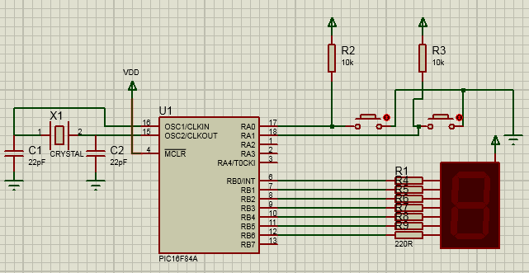
Figure 1. 7-segment display circuit assembled in Proteus

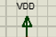
Power: Three power nodes provide power to the PIC, and the circuit as a whole, self-explanatory.

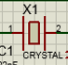
Crystal Oscillator: Provides a clock signal for the circuit, allowing the circuit to synchronise itself, which is key in relation to a display like this with delays between the numbers displayed, in the case a delay of 1 second. By regulating this, it ensures the correct timings due to the precision of the oscillator.
Ground: Grounds for the circuit, point at which voltage is 0V, self-explanatory.

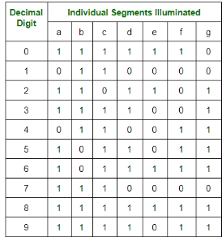
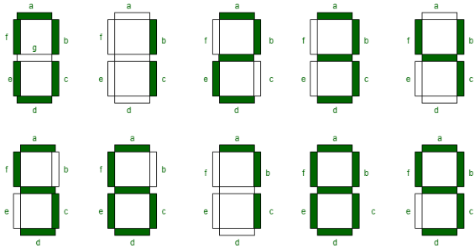
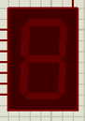
7-Segment display: The display for the data that the circuit is wanting to output, in this case hexadecimal characters 0 through to F. This is done through conversion of binary data into, with a 1 activating a segment, and 0 remaining inactive. 7 input ports are connected directly to a set segment within the display, with the code in this case providing definitions for the binary code, activating the required segments.

Figure 2. left, shows segment identification, figure 3. Right, show the binary for each number (1)
As seen in the figures above, each segment is assigned an input port, with the PIC providing the necessary binary data. For example, for the display to show the number 7, the PIC would be providing the data in the form of 1110000, activating the necessary segments.
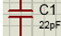
Capacitor: Stores electrical charge across the component.

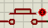
Button: Controls whether or not a connection is made between two points, in this case it will serve to interrupt the counting of the PIC instructing it to output a different function from the core code as seen in task 2, 3 and 4.
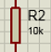
Resistor: Reduces the flow of current, in this case reducing the current to the display, due to a high current potentially burning out the segments in the display.
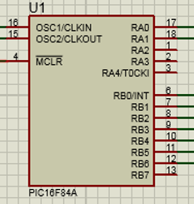
PIC16F84A Microcontroller: The core of the circuit, processes the code that will be controlling the functions of the display, as well as the inputs from the buttons. A microcontroller such as this controls a single function, in this case the operation of the 7-segment display. The data is processed by a central processor to, the data being the code that is being simulated. As mentioned it process the binary data received and outputs it to meet the required function, these being the output ports 6 through 13 which are connected to the 7-segment display (2).

Section 2
In this section, the PIC will be fed code that will allow it to control the functions of the display

