Data Handling and Business Intelligence
LCBBB5000

Ludmila Rosu
Student ID: 2114963

Amitave Banik
University of Wales Trinity St David

Table of Contents
Introduction 2
Part 1: Analysis of Superstore data using Microsoft Excel 3
Pivot Tables 3
SUMIFS 6
Data visualisation 8
Part 2: Ice-cream data analysis using SPSS 11
Quick Cluster 17
Common text mining and data mining methods 20
Advantages and disadvantage of using SPSS and Excel 21
Conclusion 23
References 24

Introduction
Data analysis can be described as the process of structuring and organising collected data. The aim of data analysis is transforming raw data into meaningful knowledge or form that can be used to make decision by teams (Heeringa, West and Berglund, 2017). Approaches used in data analysis to get the clusters, patterns or other connections among various data types must be systematic. Data visualisation also helps support data analysis and its understanding. It is the practice of using a visual format for example, use of charts, and graphs. By using data visualisation, data being examined is very engaging and accessible to the targeted stakeholders. Data visualisations are mostly used to show the actual outcomes when addressing the demands of important stakeholders. Several visualisations are required for data utilisation and comprehension of the bigger change process. In this report, PivotTables and SUMIF functions in the Excel software have been used to do the required data analysis and also provide data visualisation using charts and graphs. There is also a demonstration of SPSS data mining software usage to analyse data and find correlations between different variables.

Part 1: Analysis of Superstore data using Microsoft Excel
In this section, pivot Tables and SUMIF have been used to illustrate how excel functions can be used for data analysis with respect to Superstore dataset provided.

Pivot Tables
Data analysis is very significant and essential when handling a huge quantity of data. The data collected should be summarised so as to obtain the necessary values, and the finding presented. The features available in the Excel’s PivotTable enable data analysts to easily get the desired data as they can simply summarize hundreds of data variables. In this section, the pivot table function has been used to determine the decline of sales over the years using the data set from the superstore sales. Using the data provided, a summary of the total sales for each year has been done by creating a pivot table to summarise the result as it modifies itself dynamically.
Creating the PivotTable
During the creation of pivot tables, it was crucial to have headers on the first row. The INSERT tab on the tab was selected as soon as the Excel sheet is opened. Display of a group of tables was seen and PivotTable selected. The PivotTable dialog box appeared in which one would enter the source name of the current workbook. Lastly, choosing of a new worksheet where the PivotTable report would be placed was done.
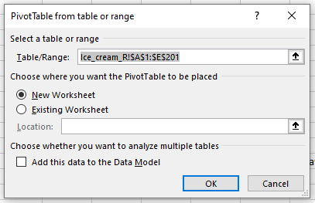
Once the “ok” button is clicked, a blank PivotTable and a PivotTable fields list appeared.
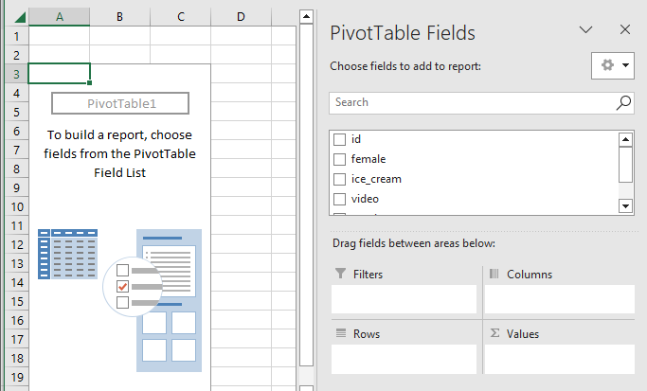
Recommended PivotTables
Recommended PivotTables give the data analyst various options to choose the most preferred format hence can be used for presenting the data in different formats. Recommended PivotTables was accessed by highlighting the data tables, then selecting the INSERT tab where a group of tables were displayed.
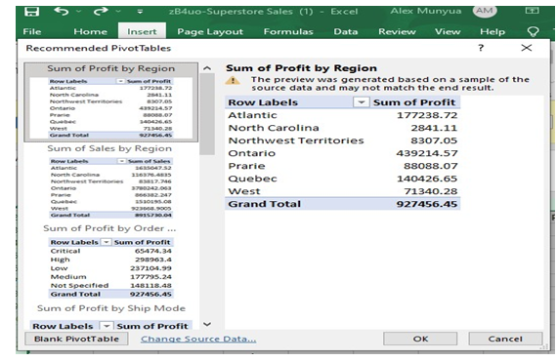
To answer the question of the required comparison of either the sales across the years or the profits asked, selection of the PivotTable that displayed relevant data was done. However, there was display of unrequired elements after the customised PivotTable was selected, therefore need to customise it further so as to display only total profits, sum sales and in the years provided was done in the PivotTables.
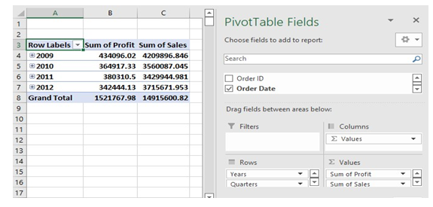
The fields to be displayed as rows and also columns were selected from the PivotTable fields and the updating of the PivotTable done as illustrated in the figure above. To investigate the extent to which the sum sales and profits plunged, the sales and profits recorded in each year was deducted from following years across the provided period.
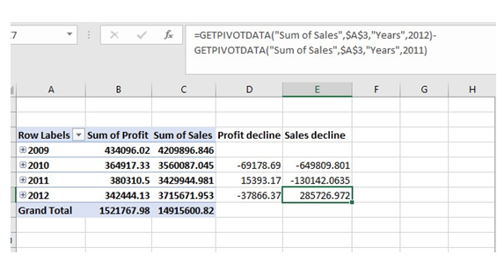
Fig 3
With reference to fig 3 above, a decline of 649809.80 for the table sales between the year 2009 and 2019 was recorded. A decrease in sales was also recorded in the following year, 2011, by 130142.0635. However, there was a sales increase of 285726.972 in the 2012 as compared to the preceding year 2011 total sales. The procedure used to compare the total sales was applied to analyse the total profits. There was decrease in the profit margin between the year 2009 and 2010 by 67178.69 while an increase of 15393.17 was noted between the year 2010 and 2011. The profit declined by a margin of 37866.37 between year 2011 and 2012.

SUMIFS
SUMIFS is a function in Microsoft Excel used to sum cells that meet multiple criteria. It works by taking a range of cells and summing the cells that meet all the criteria. The criteria can be based on logical expressions, numbers, or a combination of both (Pratiwi and Perdana, 2020). SUMIFS is a powerful tool for data analysis, allowing users to quickly and accurately sum values that meet multiple conditions. It has been used herein to compute the change in sales and profits according to the Superstore data provided.
Procedure
Upon opening the excel program, one can create a new spreadsheet for the intended data analysis. The data is entered into the spreadsheet while making sure that it is organised in a logical manner so that it is accessed and analysed conveniently. Next, the data to be analysed using the SUMIFS function is selected. This can be done by selecting the entire range of cells that you would like to analyse. Once the range is selected, one would need go to the Formulas tab and select the “SUMIFS” function.
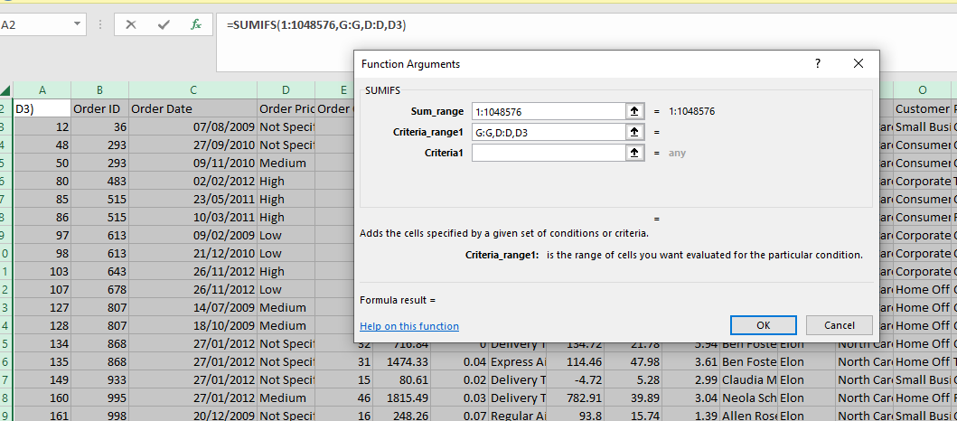

In the Sumifs function dialog box, enter the criteria you would like to use to analyze your data. This can include a range of cells, a specific cell, or a specific value. Once your criteria is entered, select the range of cells that you would like to analyze, and then click “OK”. 7. Your data will now be analysed and the results will be displayed in the spreadsheet. 8. You can now review the results of your analysis and make any necessary adjustments to your criteria or data.
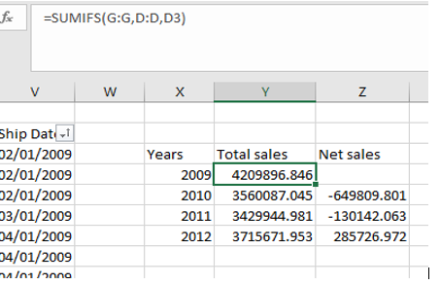
The function shown in the screenshot, =SUMIFS (G: G, D: D, D3), displays the first criterion as the sales column, the second criterion as the year column, and the third criterion as the specific year for which the sales are being totaled. To obtain the total sales made in each year individually, the same process is done for all four years. Net sales are calculated by deducting the amount of the prior year's sales from the subsequent year's total sales. The net sales values' negative sign denotes a fall in sales, indicating that there was a decline in sales between the years 2009 and 2010 and 2010 and 2011, but an increase in sales between the years 2011 and 2012.

Data visualisation
Data visualisation involves presenting data being analysed using graphical images such as charts, graphs, tables et cetera. Visualised data gives a clear depiction of relationships existing between variables as well as patterns and trends that can be used to predict future events or estimate past unrepresented situations (Sander et al., 2015). In order to make it easier for users to understand the data, extra information or observations made during data analysis might be presented in visual formats such graphs, bar charts, or pie frequency tables.
Bar chart
Excel allows a range of display options for data analysis reports. However, if the results of the data analysis can be presented as charts that accentuate the crucial portions of the data, the audience may easily interpret what one intends to project in the data. Furthermore, it has a significantly positive effect on how facts are portrayed. Excel allows users to use charts to visually display any set of data. Using the data from the given superstore, a clustered column chart has been produced to illustrate the reduction in sales as well as profitability.
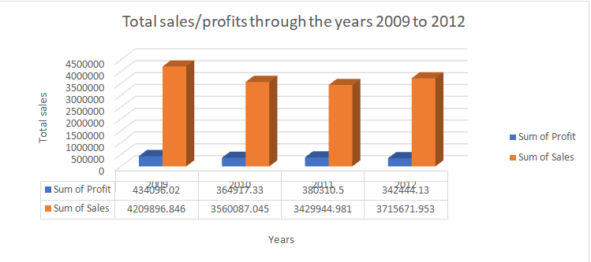
Line graphs
Line graphs are used to predict the outcomes of future data as they provide clearly displayed data patterns and factors (Rustam et al., 2020). Using a line graph, the decrease in both the profit and sales between the years 2009 and 2012 have been visualised in this section.

The screenshot of a line graph shown above clearly indicates the sharp decrease of sales between 2009 and 2010. The rate of decrease is depicted by the steepness of the gradient. The line graph also shows that the rate of decline in total sales was reduced between the year 2010 and 2011. There is an increase of sales between 2011 and 2012 according to the change of gradient direction.
Pie Chart
The relationships between a variable's component parts and its overarching patterns may be visualized by viewers using a pie chart, which is a visual representation of data. 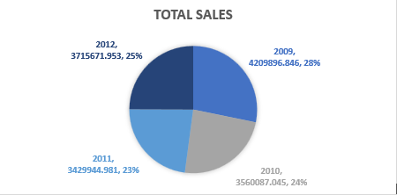
The pie chart above shows the sales of each year to the total sales made between the year 2009 and 2012. The percentages displayed in each segment of the pie charts represent; 28% represents sales made in 2009 out of the total sales made in the four consecutive years. 24% represents the sales decline in 2010 and a further decline to 23%. The sales increased by 25% in 2012.

Part 2: Ice-cream data analysis using SPSS
In this section, the data being analysed is from a survey done on 200 students in high school. The aim of this analysis is to test their scores in different test including puzzle and game. The students’ preference of ice cream flavours; chocolate, vanilla or strawberry should also be analysed and outcome noted down in the research. Using SPSS, the relationship between the gender, puzzle scores and video games, and the preference of the ice cream flavour will be analysed.
Frequencies
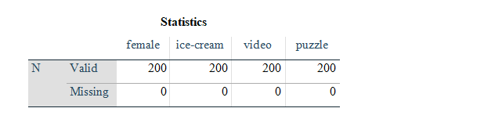
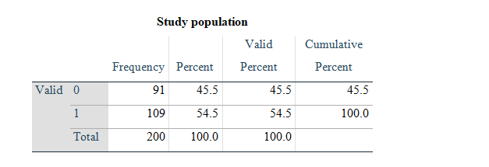
- 0 in the above table represents male while 1 represents. In this regard, there were 109 females and 91 males.
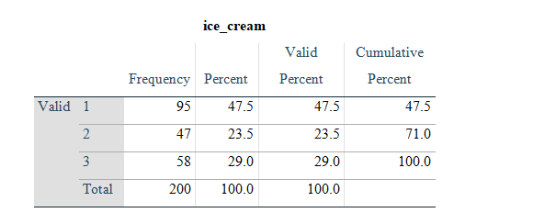
- The data above shows the frequency of ice cream consumption among a group of 200 people. From the above table, 1 represents vanilla ice-cream, 2 represents Chocolate and 3 Strawberry. In this regard, 95 people like vanilla ice-cream flavour.
- Calculated from grouped data.
This table below shows the mean and median of participants who like strawberry and chocolate ice cream flavour
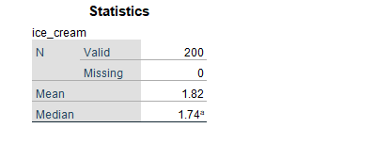
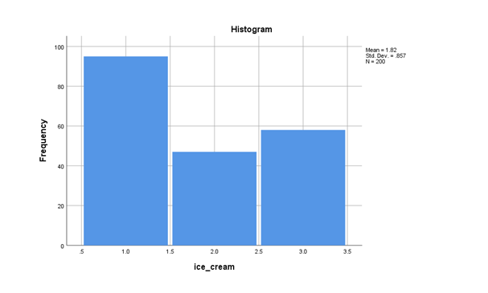
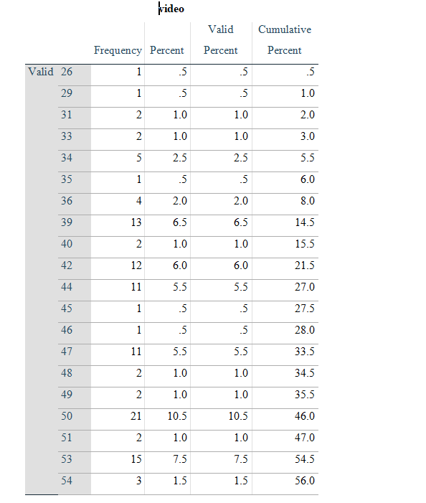
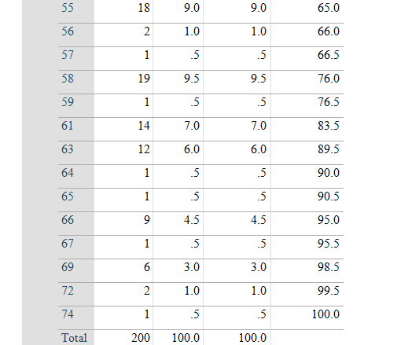
This data shows the frequency and percentage of video frames in a video sequence which had a certain number of pixels. The highest frequency was for frames with 50 pixels, at 10.5%, followed by frames with 59 pixels at 9.5%. The total amount of frames was 195, and the total percentage of all frames was 76.5%.
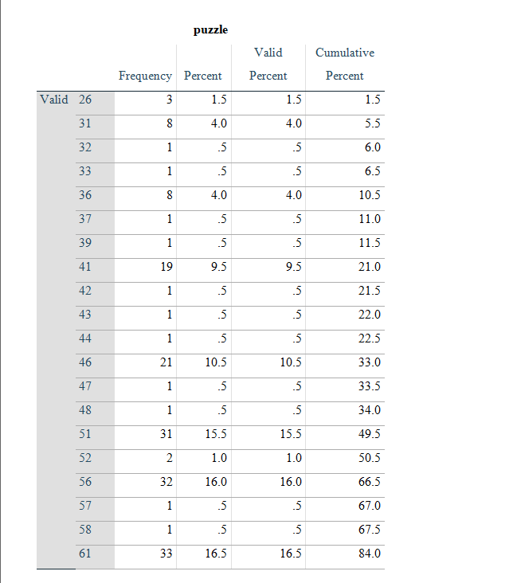

This data shows the frequency and percentage of values that were given in a puzzle. A total of 200 values were given. The most common value was 51, appearing 31 times (15.5%). The least common value was 32 and 33, each appearing only once (.5%). The cumulative percentage shows that the values up to 51 make up 49.5% of the total, and the values up to 66 make up 96% of the total.

Quick Cluster
Initial Cluster Centres

Iteration History
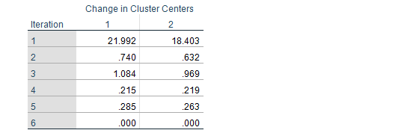
This data shows the change in cluster centers over time. The change in cluster centers between each iteration is decreasing, indicating that the clusters are converging. After 6 iterations, the maximum absolute coordinate change for any centre is .000, indicating that the clusters have converged and the clustering process is complete. This suggests that the initial clusters are stable and that the minimum distance between initial centres is 60.225.
Final Cluster Centres
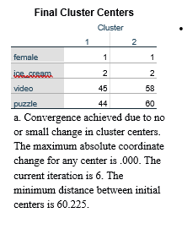

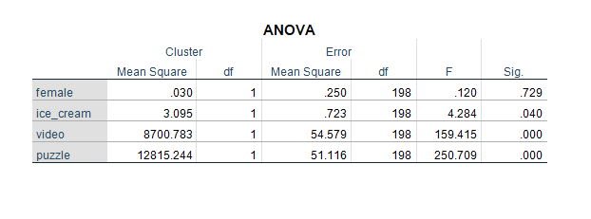
This ANOVA analysis shows that there is a statistically significant difference in the mean scores between the four different clusters. Specifically, the mean scores for the female, ice cream, video, and puzzle clusters were significantly different from each other (p < .05). Additionally, the mean square error for the female cluster was .030, and the F-values for the ice cream, video, and puzzle clusters were 4.284, 159.415, and 250.709, respectively. These results suggest that the variation in the mean scores between the four clusters is statistically significant.
Correlation between the three flavours with video game scores, puzzle scores and gender.
Pearson Correlation has been used to analyze the relationship between the variables. The results are shown in the correlation metrics below.
Correlations
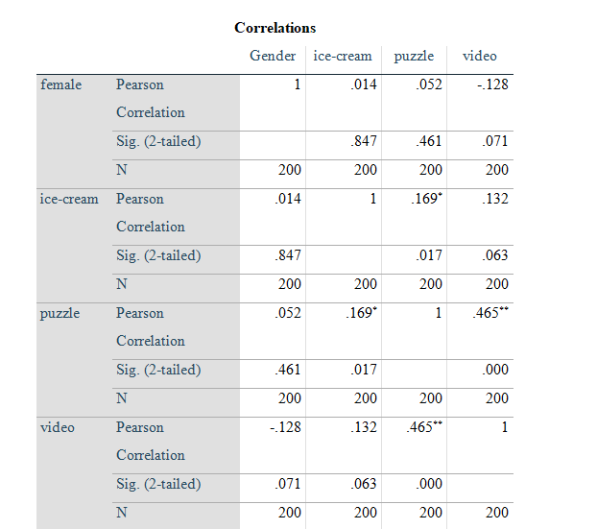
*. Correlation is significant at the 0.05 level (2-tailed).
**. Correlation is significant at the 0.01 level (2-tailed).
The data shows the correlation between gender, ice-cream, puzzle and video. Specifically, the Pearson correlation coefficients and the corresponding significance levels are provided. The results show that there is a very weak correlation between gender and ice-cream (r=0.014, p=0.847). This suggests that there is no strong relationship between the two variables. The correlation between gender and puzzle is slightly stronger (r=0.052, p=0.461), however, this is still not a statistically significant relationship. The correlation between gender and video is -0.128, which is significant at the 0.05 level (2-tailed). This suggests that there is a negative relationship between gender and video, meaning that females are less likely to play video games than males. The correlation between ice-cream and puzzle is also weak (r=0.169, p=0.017), indicating that there is a small but statistically significant relationship between the two variables. The correlation between ice-cream and video is 0.132, which is not statistically significant (p=0.063). Finally, the correlation between puzzle and video is significant at the 0.05 level (2-tailed) (r=0.539, p<0.001), suggesting that there is a moderate to strong relationship between the two variables.

Common text mining and data mining methods
Data mining is the process of discovering patterns and correlations in large data sets in order to make predictions or decisions. It is an essential tool for businesses to gain insights into customer behaviour and market trends (D’Oca and Hong, 2015). Common data mining techniques include cluster analysis, association rule learning, anomaly detection, and decision trees. Text mining is the process of extracting useful information from text documents. Common text mining techniques include sentiment analysis, topic modelling, text summarization, and text classification. Real-world examples of data mining and text mining in business include:
Cluster Analysis: Cluster analysis is used to group similar items into clusters. For example, this method can be used to segment customers into different clusters based on specific criteria such as age, gender, location, etc. This can help marketers target their campaigns more effectively and create personalized customer experiences.
Association Rule Learning: Association rule learning is used to identify relationships between different items. For example, an online retailer might use association rule learning to identify customers who are likely to purchase a certain product based on their past purchases.
Anomaly Detection: Anomaly detection is used to identify outliers in a dataset (Hendrycks, Mazeika and Dieterich, 2018). For example, a financial institution might use anomaly detection to detect suspicious transactions that are indicative of fraud.
Decision Trees: Decision trees are used to predict outcomes based on a set of conditions. For example, a bank might use a decision tree to predict whether a customer will default
Sentiment analysis: Sentiment analysis is a text mining method used to measure the sentiment of a text (Younis, 2015). In business, it can be used to analyse customer reviews and feedback to gain insights into customer sentiment towards the company’s products and services.

Advantages and disadvantage of using SPSS and Excel
 | Advantages | Disadvantages
Excel | - Excel is compatible with other Microsoft products, making it easy to use and transfer data between different applications.  - Excel has a wide range of features and functions that can be used for different types of analysis. This makes it highly flexible for different users.  - Excel can be used to automate tasks such as data entry, data analysis and other repetitive tasks. This saves time and increases productivity. | - It can be difficult to troubleshoot errors in Excel due to its lack of debugging features.  - Excel is not designed to handle large amounts of data or complex calculations.  - It is difficult to keep data secure in Excel due to its lack of user permissions and security features.
SPSS | SPSS is designed to simplify complex data analysis tasks, allowing users to quickly and easily generate accurate results.  The software can easily be integrated with other programs and applications, such as Microsoft Excel and Access.  SPSS provides comprehensive output that covers descriptive and inferential statistics, as well as charts and tables.  The software is highly flexible and can accommodate data from a variety of sources, including surveys and databases. | - The user interface of SPSS is complex and not very user friendly. It can be difficult for new users to learn.  - SPSS does not offer as many features as other statistical software packages, such as predictive analytics, text mining, and data mining.  - SPSS is limited in terms of data access, as it can only work with certain types of data files. It does not support more advanced data formats such as XML.

Conclusion
Excel and SPSS are both powerful tools for data analysis and presentation. Excel is a great choice for basic data analysis and presentation, while SPSS provides more advanced data analysis and visualization capabilities. Both tools are useful for organizing, analysing, and presenting data. Excel is more user-friendly and intuitive, while SPSS offers more statistical analysis options. Both tools are essential for data analysis, so it is important to understand the strengths and weaknesses of each to determine which is most suitable for a given task. Ultimately, the choice of which tool to use depends on the user's needs and preferences.

References
D’Oca, S. and Hong, T. (2015). Occupancy schedules learning process through a data mining framework. Energy and Buildings, 88, pp.395-408.
Heeringa, S.G., West, B.T. and Berglund, P.A. (2017). Applied survey data analysis. chapman and hall/CRC.
Hendrycks, D., Mazeika, M. and Dieterich, T. (2018). Deep anomaly detection with outlier exposure. arXiv preprint arXiv:1812.04606.
Pratiwi, Y.E. and Perdana, B.C. (2020). Analysis of Accounting Information System Design of Accounting Bookings Based On Microsoft Excel In Cv. Surya Anugerah Investindo. JEAMS (Journal of Economic, Accounting and Management Science), 2(1), pp.24-39.
Rustam, F., Reshi, A.A., Mehmood, A., Ullah, S., On, B.W., Aslam, W. and Choi, G.S. (2020). COVID-19 future forecasting using supervised machine learning models. IEEE access, 8, pp.101489-101499.
Sander, T., Freyss, J., von Korff, M. and Rufener, C. (2015). Data Warrior: an open-source program for chemistry aware data visualization and analysis. Journal of chemical information and modeling, 55(2), pp.460-473.
Younis, E.M. (2015). Sentiment analysis and text mining for social media microblogs using open-source tools: an empirical study. International Journal of Computer Applications, 112(5).

