Marketing Fundamentals Analysis and Evaluation
LCBB4004 - Tushara Balendran
Radu Claudiu Pintea - 1921951

Table of Contents
Introduction 3
Concept of market Marketing: 4
Ways marketing add values for consumers: 5
Advantages of branding for consumers: 7
Stakeholder engagement and their impact on the marketing activities of an organisation: 9
Types of stakeholders impact on marketing: 10
Internal stakeholders impact on the marketing activities: 10
External stakeholders impact on marketing activities: 11
Conclusion 13
Reference 14

Introduction
Marketing is the process of improving the brand image of the organisation by sales promotion, direct marketing and customer relationship to encourage the consumers for making sales. According to American marketing association (2018), marketing is the process, set of institutions, and process for creating, communicating and exchanging values for the consumers, and clients in which the society can be developed and improve the ability to social recognition. The impact on the marketing for adding the values of the consumers helps to develop the ability of the consumers for the developing strategy of marketing and ensuring the capabilities of the company. Volkswagen an automobile manufacturing organisation to improve the brand image by adding the values of the consumers.

Concept of market Marketing:
Marketing is the process of involving the consumers to the product and retain themselves for continuously buying the product and service. The keywords of marketing “process” mean researching, promoting, selling and distributing the product and service. Marketing helps the organisation to connect the consumers by making public relation and helping the consumer for providing the right information to the consumers. Marketing promotes the name of the business that called branding and enhanced the brand recognition of the company and improve the ability of the company to maximize the profits and wealth acquisition. There are various types of marketing and advertisement process that are the sales promotion, direct marketing, online marketing, social media marketing and mail marketing which increase the engagement of the consumers regarding the development of the product or the service (Armstrong, 2019).
According to Philip Kotler (2017), marketing is the social process in which the individuals or the groups communicated with each other for exchanging and creating products and values among themselves. Philip Kotler describes marketing as the social process which increases the ability of the company to sustain in the market and develop for quality of product and service.
Concepts of digital marketing
Digital marketing is the use of information technology, internet, social media and website to perform the marketing activities of the organisation. The digital marketing helps the organisation to reach the consumers and develop the marketing strategy for increasing market values of the brand.
According to Fauzia Burke (2019), digital marketing is the set of activities performed by the online and social media to learn the consumers about the digital marketing and help to develop the brand values of the organisation.

Ways marketing add values for consumers:
Marketing adds values for the consumer by providing information about the product and service of the company and improves the awareness of the consumer towards the brand and items of the product or service (Chaffey and Smith, 2017). Marketing helps the consumers by communicating with them and improve the business idea of the consumers and helps to develop the business organisation as well. Volkswagen is the German-based automobile company which focus on customer demand and a choice requirement for the development of the competition n and improve the strategy of the business. The company follow the marketing mix to increase the engagement of the employees for creating the employees' values and utilities for the organisation. The company operate 12 independent brands and use the marketing mix of 7Ps and demographic and geographic segmentation and the need for existing the consumer for the development of the organisation and targeting the rights consumers by adding the values of the segmented prospective consumers. Marketing adding the values of the consumer of Volkswagen to develop consumer relationships and development (Chaffey, 2019).
Managing customer expectation:
The marketing department of Volkswagen collects the requirement of the consumer and develops the product and service based on the consumer provided information. There is various type of model for the Volkswagen and continue developing the model to compete in the competitors (big player like Toyota, Nissan, BMW and Suzuki) to stay in the market long time. By the marketing functions of the organisation, the consumer gets the update information about the product and service and become aware to improve the business condition for the development of the organisation.
Provide information to the customer for awareness:
The marketing department of the organisation provides information about the markets and helps to identify the activities of the company. Volkswagen provides the information to the consumers buy online and their website for the development of the organisation and improve the ability of the company to minimize the cost of the organisation. Volkswagen provides the information to the new arrival for increasing the sales and improving the business organisation (Chaffey and Smith, 2017).

Getting engaged in the organisation:
Customer is being engaged in the organisation and helps to develop the product and service for distributing product or service. The organisation helps to develop the quality of product or service for improving ability by engaged in the activities of the company. The Volkswagen sponsored various types of sports which directly connect the consumers and know about the Volkswagen and its consumers. The behaviours of the consumers largely influenced by the organisation and its ability to develop the quality of product or service and helps to improve business. Marketing adds the values of consumers of developing relationships among themselves and increase engagement by providing information about consumers (Chaffey and Smith, 2017).
Economic benefits of marketing:
Marketing creates economic values for both consumers and organisation as the consumer learns about the product and its feature and organisation increase the power of branding (Charter, 2019). The economic benefits for marketing are to ensure the financial capabilities of the organisation to improve the business and its ability for development. Marketing creates demand for the product as the organisation learn the consumer about the product which increase the demand for product or service that influence the financial improvement of the organisation.
Definition of branding:
Branding is a marketing practice of the company in which the organisation create an image, name or symbol that identify the belonging of the organisation. Volkswagen develops a brand which increases the positive thinking of the consumers to make better performance of the company. This helps the organisation to produce the product of the company and ensure the symbols of the brand and helps to identify product and service. Branding of the organisation distinguishes the product from the competitors' product or service to establish the company very powerful to the competitors.
According to American marketing association (2018), ‘ branding is the term a name, term, design, symbol and other feature that create the sales of the product and service distinct from those of the organisation to create the symbol of the product or service.
According to Donna Antonucci (2019), a brand is the identity of the organisation which helps the consumers to find the right product and can memorise the identity of product or service for the organisation.
The brand is the marketing tools that add the vales of the consumers and assist to enter the markets for the development creative values of consumers. The marketing management of the organisation especially the branding helps to create the values by recognising the product instantly. For example, the prospect consumers of Volkswagen get recognition from the established brand and improve the ability of the company to maintain development (Charter, 2019).

Advantages of branding for consumers:
Strong and loyal branding create values for the consumers and helps to develop the quality of the product or service. The brand values of Volkswagen is about 31 billion dollars based on the customer loyalty and motivation of the employees. The advantages of branding are very important for consumer and organisation because the organisation get positive feedback and motivation from the consumers where consumer buy the product without any hesitation.
Brand save decision-making time: The purchase decision making of the consumers largely based on the brand of the company. If the brand values of the company are very high the consumers can buy the product in a very short time and without hesitation. The brand values of Volkswagen helps the automobile consumers to the purchase without any tension because it is the established company and its product quality is very high that save the decision-making time of the consumers (Kirova, 2017).
The brand provide safety: Brand helps the consumer to provide the safety measure as it developed to create the safeness of the company. To establish a brand the company need to invest billions of dollar and engage the customer relationship management and response the consumer directly. For these reasons the consumers try to purchase the product from the established brand and improve the business of the organisation as well as creating the values for the consumers (Heinze, 2020).
Enhance credibility: the credibility of the organisation at the consumer edge helps to improve the business for the development of the company. The consumer can purchase the product based on the reviews of the consumers and increase the credibility about the product or service that create the values for the consumers and become loyal consumers.
Ansoff matrix:
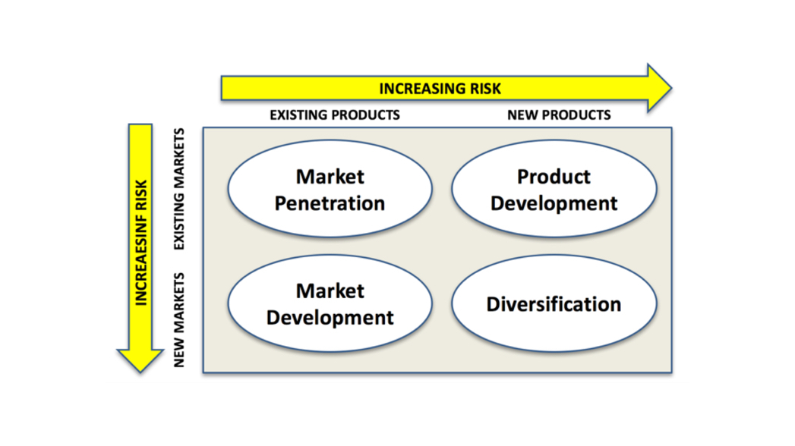
Figure: Ansoff matrix (Kirova, 2017)
The product or service matrix or market expansion grid which analysed for making the strategy of growth form the organisation and find the four matters of the market growth development that are the market penetration, product development, market development and diversification. Volkswagen uses the strategy of Ansoff matrix which is defined to the market and product development of the organisation and helps to make the market penetration of the company.
Market penetration: when the company has an established product in an existing market the company need to follow the growth strategy of market penetration. Volkswagen has a model in the UK which develop the activities of market penetration and increase the ability of the company to make development. The company focus on the increase in sales in the existing market and try to sustain in the competition.
Product development: product development occurs in the existing market and to produce a new product or service. The organisation try to increasing new product and stay in the existing market and sometimes try to enter the new markets with the existing product or service. The product development creates the consumers' values and increases the life standard by consuming the proper product or service.
Market development: when the company try to enter the new market with the existing product the company should focus on market development. The market development of Volkswagen process of entering the new markets in another country (South Africa) and another African country (Cheng, 2016).
Diversification: the diversification means to produce the product based on the diverse thinking and multiple systems of production and helps to develop the product or service. The diversification of the company helps to enter the new market with the diversified model of the product. Volkswagen follows the diversification of product development to capture the changing group of people for making development.

Stakeholder engagement and their impact on the marketing activities of an organisation:
A stakeholder is a person, group of people or the organisation in which the company has an interest or concern to development. The stakeholders offer the organisation for creating values and service to the development of the company. Some example of stakeholders are creditors, employees, government, owners, community, unions which impact the business organisation to running the business and fulfil the objectives of the company. Not all stakeholder impact on the business in the same intensity and they help to run the business smoothly and provide the information of the organisation properly and improve the activities of the business (Cheng, 2016).
According to American marketing association (2018), stakeholders are the influencing organisation or the people for the company which sometimes challenged or accelerate the sustainability of the organisation.
Stakeholders impact on the marketing activities of the organisation which helps to intensity of the business and helps to improve the activities of the company. The profit and loss as well as branding of the company influenced by the stakeholders of the company and increase the ability of the company to sustain in the markets. The internal stakeholders like employees, owners, the board of directors, manager of the organisation which impact on the business activities especially on the marketing strategy of the company.

Types of stakeholders impact on marketing:
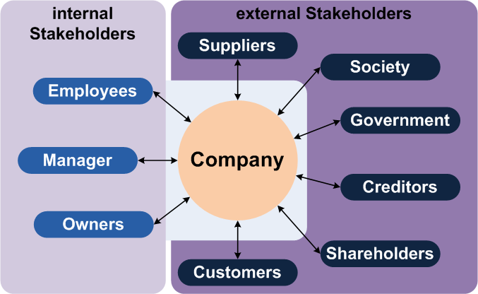
Figure; internal and external stakeholders (Heinze, 2020)
There are two types of stakeholders engaging in the development of the marketing strategy of the company that are the internal stakeholders and external stakeholders. The internal stakeholders are the person, group of people, an organisation which directly influenced and impact on the business activities of the organisation and external stakeholders are the persons or organisations indirectly impact on the business decision and business organisation.

Internal stakeholders impact on the marketing activities:
Internal stakeholders are the important components of the organisation to make the decision and improve the strategy of the company. The large organisation like Volkswagen critically evaluate the internal stakeholders of the organisation to set the marketing strategy of the company because it directly impacts on the development and strategic implication of the company (Heinze, 2020).
Employees: employees are the group of people who are working for the organisational requirement and increase the development of the organisation and helps to fulfil the mission, vision and objective. The employees are the persons who impact on the marketing strategy by producing the quality of the product and create sustainable relationships among the consumers.
Owner: the owner of the organisation helps the marketing of the organisation as they decide for the implication of various kinds of marketing strategy and influence on the development of the organisation. The owner of the Volkswagen set the branding and promoting strategy for building a good strategy of marketing (Gersen, and Hemphi, 2019).
Board of directors; the internal stakeholder make the decision for the marketing and other functional decision for improving the business activities of the organisation. The board of directors of the Volkswagen set the strategy for increasing the brand values of the company promoting the sales at a regional basis.
Manager: managers are the person who manages and controls the functional activities of the organisation and coordination and cooperation of the employees. There are various types of manger like sales manager, general managers, marketing managers who control the function of the business especially the marketing edge.

External stakeholders impact on marketing activities:
External stakeholders are the person, group of people indirectly impact on the business of the organisation and help to decide on the organisation. There are various types of external stakeholders that are the suppliers, customers, creditors, intermediaries, competitors, society and government who indirectly impact on the sustainability of the business (Heinze, 2020).
Marketing is the important function of the organisation which helps to identify the strength and weakness in the branding of the company. The marketing activities are influenced by the external stakeholders of the organisation. The external stakeholders like supplier’s impact on the marketing decision and strategy by providing quality product and supplies. The customers are the main components of marketing as the company try to develop the relationships among the consumers and develop the sustainability power of the company.
The government make various types of legislation regarding the business organisation of the country. For the external stakeholders of the Volkswagen, government impact on making the legislation like BREXIT which develop for safeguarding the local business of UK that create threats for EU based business organisation (Gersen, and Hemphi, 2019).
The external stakeholder creditors provide the funds for the marketing activities and ensure the development of the marketing strategy and improve the business.

Conclusion
After analysing the marketing based on organisation sales promotion, branding and promotion of the organisational name to improve the business of the company (Chaffey and Smith, 2017). Volkswagen takes various types of strategy to improve the business activities of the company. There are two types of stakeholders impact on the marketing of the company and ensure benefits to the development and improve the company to manage and controls the marketing of the company. To develop the strategic benefits for the company the stakeholder’s analysis must be completed.

Reference
Armstrong, G.M., Kotler, P., Harker, M. and Brennan, R., 2018. Marketing: an introduction. Pearson UK.
Chaffey, D. and Ellis-Chadwick, F., 2019. Digital marketing. Pearson UK.
Chaffey, D. and Smith, P.R., 2017. Digital marketing excellence: planning, optimizing and integrating online marketing. Taylor & Francis.
Charter, M. and Polonsky, M.J. eds., 2017. Greener marketing: A global perspective on greening marketing practice. Routledge.
Cheng, R., Lourenço, F. and Resnick, S., 2016. Educating graduates for marketing in SMEs. Journal of small business and enterprise development.
Gersen, J. and Hemphi, C.S., 2019. 33 Coca-Cola Bottle. A History of Intellectual Property in 50 Objects, p.273.
Heinze, A., Fletcher, G., Rashid, T. and Cruz, A. eds., 2020. Digital and social media marketing: a results-driven approach. Routledge.
Kirova, V., 2017. Exploring the role of strategic marketing department. Journal of Marketing Development and Competitiveness, 11(2).

