How a Geographical Information System (GIS) is Used to Find Patterns in the Spread of Phytophthora Ramorum

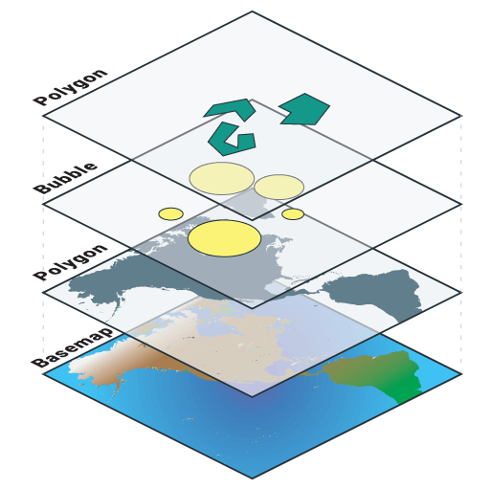

(Credit to Mango)

By Marie West (1702919)

Table of Contents
1.0 Introduction 3
1.1 Phytophthora Ramorum 3
1.2 How Phytophthora Ramorum Infect Plants 3
1.3 How to Handle Phytophthora Ramorum ………………………………………………………………………………….4 1.4 Geographic Information System……………………………………………………………………………………………….4
1.5 History of Geographic Information System………………………………………………………………………………4
2.0 Literature Review 5
3.0 Methodology 5
4.0 Data and Analysis………………………………………………………………………………………………………………………. 6
4.1 Infected Sites……………………………………………………………………………………………………………………………6
4.2 Over the Years of Infection……………………………………………………………………………………………………….9
4.3 A Roads…………………………………………………………………………………………………………………………………10
4.4 River Lines…………………………………………………………………………………………………………………………….11
4.5 National Parks………………………………………………………………………………………………………………………12
5.0 Conclusion……………………………………………………………………………………………………………………………….13
6.0 Referencing………………………………………………………………………………………………………………………………14

1.0 Introduction
1.1 Phytophthora Ramorum
There any many different types of diseases that affect trees all around the world but Phytophthora ramorum (P. ramorum) is a fungus disease which is currently affecting Oak and Larch trees around the United Kingdom. This fungal disease is a problem throughout the world, causing millions of native oak trees to die. In Europe there have been other plants that have been affected by P. ramorum, some of these are Rhododendron, Viburnum, Pieris and Camellia. The disease has infected plants which can be found in different locations, for example, private gardens, public parks, historic gardens and unmanaged woodland sites. (Department for Environment, Food and Rural Affairs, 2008)
There are reasons to be concerned of the P. ramorum disease. It is killing native British tree species, is a threat to the environment and many commercial areas. With the native species dying it will also lead to problems within the horticultural industry, the wider landscape and the United Kingdom’s biodiversity. If historical areas are losing their native collections, this could also have an economical impact, as tourists will no longer visit the various affected sites. (Department for Environment, Food and Rural Affairs, 2008)
1.2 How Phytophthora Ramorum Infects Plants and Symptoms
P. ramorum can infect health plant tissues directly or can enter through a wound. Plant cells are killed once the infection has entered and spread. The plant tissue is then affected and the symptoms of the disease will be seen. Symptoms could be delayed if the abiotic factors are not the optimal conditions. Symptoms can be delayed by temperature and humidity, in winter months the infection will be much slower. (Department for Environment, Food and Rural Affairs, 2008)
The best conditions for this infection to grow in are temperatures of 20 degrees Celsius. However, it will still grow in temperatures of 2 degrees Celsius to 30 degree Celsius. The pathogen will survive long periods of freezing temperatures, even if the symptoms are delayed. Due to being a fungus, the infection will thrive in environments that are moist. As long as the environment is damp then the infection will be able to complete its life cycle; spore production, dispersal, germination and then the infection begins. If the area is humid, it will allow the moisture to stick to the plant leaves and stems which will cause the disease to enter the plants system. This could be one of the reasons that P. ramorum prefers the South-West, as the topography is a perfect breeding ground. The South-West has dense woodland with bodies of water, valleys that are sheltered, enclosed garden sites, highly populated with plants that can be hosts- all of this makes the conditions perfect for the disease to grow. (Department for Environment, Food and Rural Affairs, 2008)
The symptoms of the disease will depend on what type of plant it is infecting and what type of environment the plant is in. The main symptoms in nursery stock and established planting is die back of shoots and blight of leaves. Any shoots that are diseased will have brown to black lesions that start from the tip and move back towards the base, the blackening of leaves will also be seen. On trees the symptoms will be similar but slightly different. Just like plants the trees will show different symptoms depending on species, for example if a beech tree gets the disease then only the bark is infected but other tree only their leaves will be affected. (Department for Environment, Food and Rural Affairs, 2008)

1.3 How to Handle Phytophthora Ramorum
This disease needs to be handled with care. The Department for Environment, Food and Rural affairs outlined a few things that could be done, such as, surveillance, quarantine, hygiene, how you water the plants, and good husbandry. They give guidance on plant passports, disease management and control, biosecurity protocol, control measures, how to deal with an outbreak in sites and much more. This disease is currently devastating the United Kingdom native tree population. The areas that are infected need to be handled correctly to prevent spreading and there is a process that can help with this, called Geographic Information System.

1.4 Geographic Information System
Geographic information system (GIS) is a process that gathers, manages and analysis’s data. The science of geography and combining of GIS means that different types of data can be shown. There are many parts to GIS which when used in the correct order can provide an image with the relevant data points on. GIS helps to show data as patterns, relationships and situations which will help the users to make decisions. (Esri, N/D)
Geographical Information System (GIS) is a system that is used by many organisations in different fields. This system helps to make maps that can aid in performing analysis, share information and find solutions to problems that are affecting places all around the world. (Esri, N/D)
“GIS technology applies geographic science with tools for understanding and collaboration. It helps people reach a common goal: to gain actionable intelligence from all types of data.” (Esri, page 1, N/D)

1.5 History of Geographic Information System
The history of GIS is a long one, in 1854 it was first used by Doctor John Sow, London England. Doctor Sow used it to map an outbreak of Cholera; he did this by adding outbreak location, roads, property boundaries and water lines. Once this information was on the map he was able to see that the outbreak was commonly found near the water line. This was the beginning of spatial analysis. (GISGeography, 2019)
The use of spatial analysis could be used in the future for climate change and global warming events to maybe see a pattern which would help us to come up with ideas that could help.
2.0 Literature review
The GIS can be used for any type of data collection. The data can just be put into the system and then a map can be crated. Such organisations that use this software are real estate, manufacturing, health, education and many more. There have been many papers written on different subjects by using this spatial Support System.
An article in Social Science and Medicine looked at the Accessibility patterns and community integration among previously homeless adults: A Geographic Information System (GIS) approach. This was carried out by using GIS, the study looked at the access and closeness to the community the ex-homeless adults were and the persons own individual space or in other words the presences in the community. (Chan et al., 2014)
An article in Water Science and Technology made use of the GIS software on their paper to be used as a tool that would allow them to look at sustainable drainage systems in large catchment and to also see what SuDs techniques would be more feasibly and effective. (Moore et al., 2012)
In the American Journal of Epidemiology GIS was used to look at residential levels of traffic related air pollution. They used it to look at the different demographic, anthropomorphic and socioeconomic factors to see what the impact of air pollution was on these areas. By using this software, they found that children that went to schools in areas with high levels of air pollution suffered with more asthma cases then one in areas with less air pollution. (Svendsen et al., 2012)

3.0 Methodology
To be able to use the GIS process you will first need to set objectives. The aim of the authors project was to examine and understand the distribution of P. ramorum throughout Wales. To be able to carry out this aim, a dataset was required. Once the datasets are obtained the layers on the map can be built. The layers can be datasets of roads, rivers, woodland areas and other environmental features.
To use the GIS process other databases and websites will be needed. The main spatial websites accessed in the United Kingdom is Digimaps and UK Data Services. Both websites provide a large coverage on different data sets; for example, datasets of climate change, lakes, vaccinations in areas given to children and social economics can be retrieved.
To enable the author to use this process effectively the gathering of the datasets of P. Ramorum infected trees in Wales was required. This dataset was obtained from the Forestry Commission of Wales. Once this data was in place, a licensing key was required to enable access to maps and roads that were built into the Mapinfo software.
After the licensing key was put into the system the author was ready to start building layers onto the maps.
If we take one of the authors maps for example,
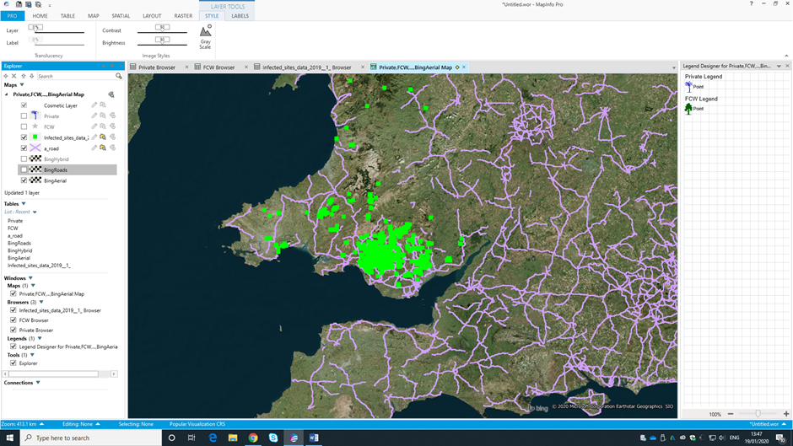
MapInfo was used to convert data e.g. Excel, from a database into an image. The Bing licensing key allowed the author to lay down the land mass (base map), more layers were then applied. When the base map was laid down the infected tree data table from Excel was imported into MapInfo. The infected sites are marked in green squares on the above photo. Digimaps was then used to download datasets for the United Kingdom roads. The A roads were placed onto the base map and these can be seen as the purple lines on the above photo.
4.0 Data and Analysis
The data was collected by making maps on the software MapInfo. In this section the data will be presented and an analysis done.
4.1 Infected sites
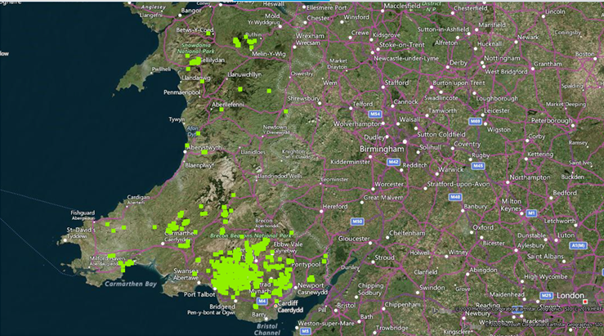

Figure 1: Infected sites in Wales. 2011-2014
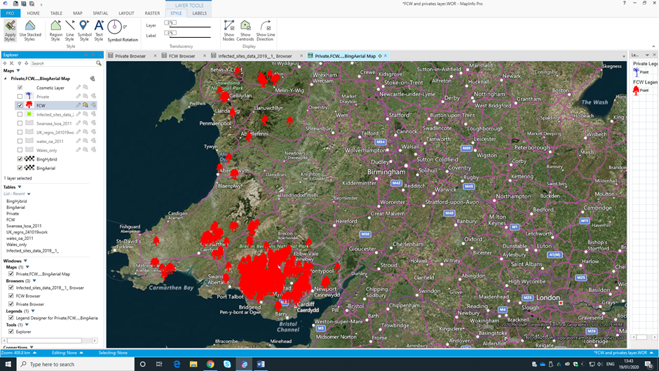
Figure 1: All of the trees that are infected with Phytophthora ramorum.
Figure 2: Forestry Commission Wales Trees that are infected. 2011-2014
Figure 2: Forestry Commission Wales trees that are infected.

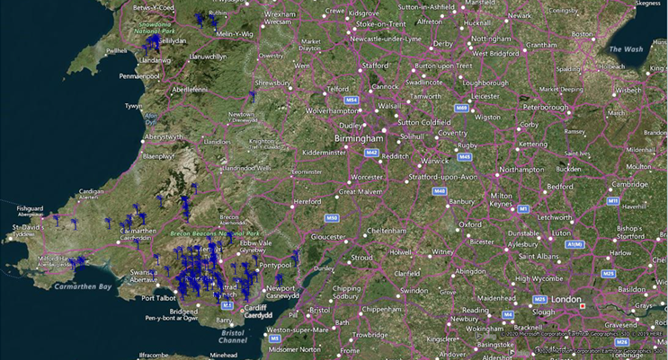
Figure 3: The privately-owned trees that are infected.
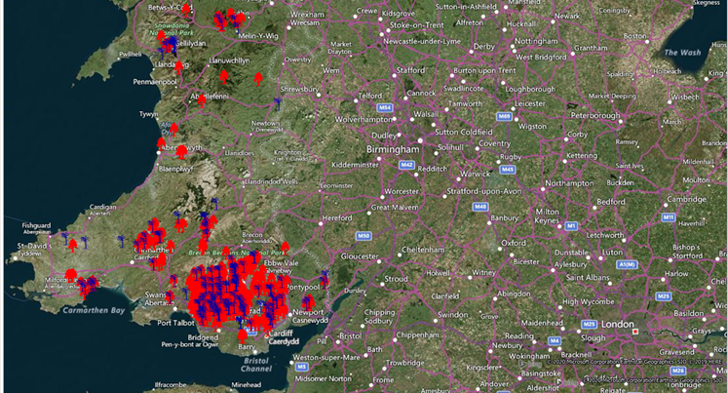
Figure 4: Infected sites, privately-owned (Blue markers), Forestry Commission Wales (Red markers). This clearly shows that the Forestry Commission Wales infected trees numbers are much higher than the privately-owned.
Figure 3: Privately owned trees that are infected. 2011-2014
Figure 4: Privately owned trees and Forestry Commission Wales infected trees. 2011-2014

4.2 Over the Years of Infection

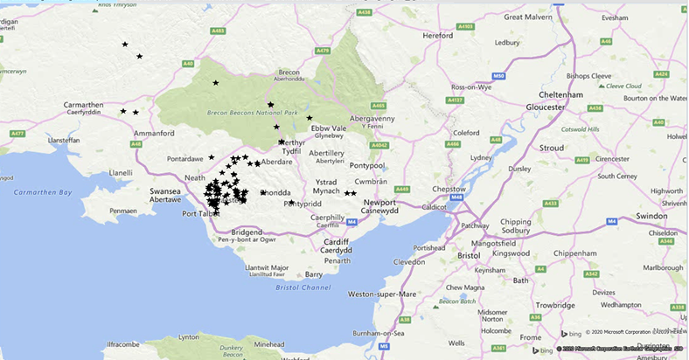
Figure 5: Infected trees in 2011 to 2012.

Figure 5: Number of all infected trees (Black markings) in 2011 to 2012.

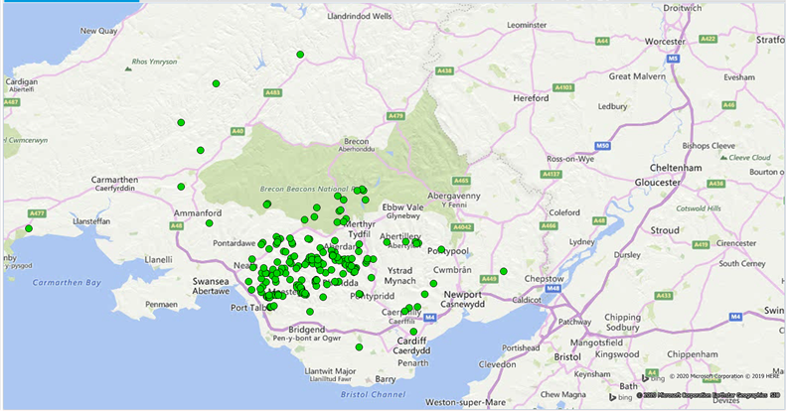
Figure 6: Number of all infected trees (Green markers) in 2012 to 2013. Comparing figure 5 to figure 6 there is a clear increase of cases, the number appears to have significantly increased.
Figure 6: Infected trees in 2012 to 2013.

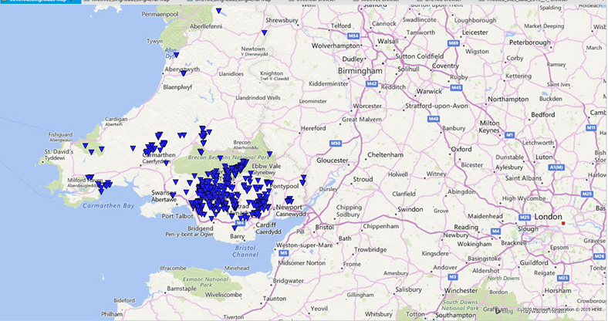
Figure 7: Number of all infected trees (Blue markers) in 2013 to 2014. The number appeared to increase between 2012 to 2013, however, from 2013 to 2014 the increase appears to have slowed down.
4.3 A Roads
Figure 7: Infected trees in 2013 to 2014.

Figure 8: Infected sites with A roads. 2011-2014

Figure 8: Infected sites (Green markers) with A roads layer (Purple lines) on top to see if there is a pattern with the infected sites and the closeness to A roads.
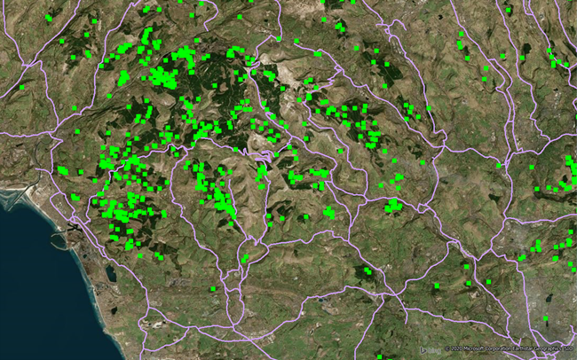
Figure 9: Close-up aerial view of South Wales. Infected sites (Green markers) with A roads layer (Purple lines) on top to allow closer examination of correlation between infected sites and A roads.
Figure 9: A Closure look at the infected sites and the A roads. 2011-2014

4.4 River Lines

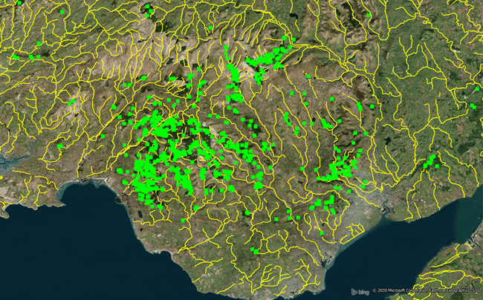
Figure 10: Close-up aerial view of the infected South Wales site (green markers) in correlation to river lines (yellow lines). River lines are where small bodies of water meet with a river.
Figure 10: Close up of River Lines. 2011-2014

4.5 National Parks
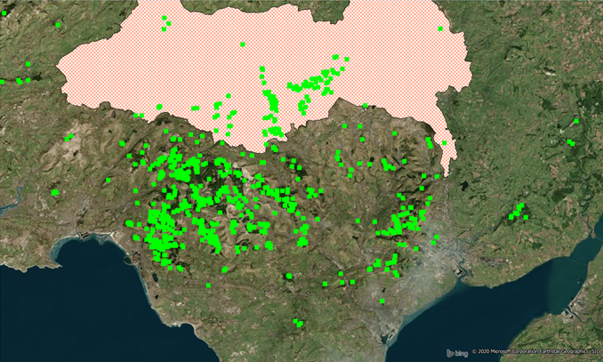
Figure 11: Infected site with Brecon Beacons National Park. 2011-2014
Figure 11: Infected sites (green markers) in relation to the Brecon Beacons National Park (red checker area).

5.0 Conclusion
Using the GIS process enable the author to make maps of the infected trees sites and additional data to be added, this process has proven to be useful. Reviewing the maps showed that the Forestry Commission Wales trees numbers were more impacted then the privately-owned tree. However, the Forestry Commission owns more tree then the local population; therefore, their trees were more likely to have a higher number, this is a rational assumption to make. The GIS to further proves this point.
In figure 1 there appears to be a large cluster of infected trees between Swansea and Cardiff with a very small cluster near Snowdonia National Park. This could be due to the Port at Port Talbot.
A significant increase in Phytophthora Ramorum infections between 2012 and 2014 can be seen, this would need to be further investigated to find out what caused the increase; it could be weather patterns, more tourism, a number of things, however without more examination this will not be determined from figure 5 to 7.
There appears to be a coalition between the spread of disease and A roads. Figure 8 and 9 show how close the trees are to the A roads, which could suggest that cars are assisting with the spread. One of these ways could be that the fungus is becoming attached to the cars and as the car is in motion the spores become dislodge and land in an area where it might or might not thrive and then it begins to infect the trees. However, without further investigation the only know information is that there does appear to be a connection between A roads and the spread.
The Department for Environment, Food and Rural Affairs stated that the disease was spread via water, there can be evidence see to further enforce their statement by looking at figure 10. The infected sites appear to be next to the river lines, the river lines also provide the best conditions for the P. ramorum to grow in; the rivers will make the area damp, moist and humid.
The author thought that the infection would affect the national parks most, however examining figure 11 does not support this theory. The reason that the Park is less affected could be due to lack of correct tree species, the trees are on higher land or not the correct conditions.
The Geographic Information System has proven to be a valuable tool in this project. The process used meant a visual aid could be used to see where the infection is and what could be helping the spread of Phytophthora Ramorum; which will allow management plans to be put in place to tackle the issue.

6.0 Referencing
Chan, D.V., Gopal, S. & Helfrich, C.A., 2014. Accessibility patterns and community integration among previously homeless adults: A Geographic Information Systems (GIS) approach. Social Science & Medicine, 120, pp.142–152.
Esri. (2020). What is GIS?. [online] Available at: https://www.esri.com/en-us/what-is-gis/overview [Accessed 23 Jan. 2020].
GISGeography. (2019). The Remarkable History of GIS. [online] Available at: https://gisgeography.com/history-of-gis/ [Accessed 23 Jan. 2020].
Mango Map (2020). Stacking Layers. [image] Available at: https://mangomap.com/gis-mapping (Mango ) [Accessed 24 Jan. 2020].
Moore, S. et al., 2012. A GIS-based methodology for selecting stormwater disconnection opportunities. Water Science and Technology, 66(2), pp.275–283.
Phytophthora ramorum: A practical guide for established parks & gardens, amenity landscape and woodland areas. (2020). [ebook] London: Department for Environment, Food and Rural Affairs, pp.3-7. Available at: https://planthealthportal.defra.gov.uk/assets/factsheets/pramparks.pdf [Accessed 23 Jan. 2020].
Svendsen, E.R. et al., 2012. GIS-Modeled Indicators of Traffic-Related Air Pollutants and Adverse Pulmonary Health Among Children in El Paso, Texas. American Journal of Epidemiology, 176(suppl7), pp.S131–S141.

