Module Code: LCBB4002
Module Title: Community Engagement
Assessment 1

Name : Ivan Todorov

Student ID : 2023561

Table of Contents
Introduction 3
Why Renewable Energy is Important for the UK 4
Description of the Programme 5
Best Practices of Community Engagement Principles 5
Socio-cultural Integration 6
Multi-culturalism 6
Relationship of Renewable Energy Programme and Its Stakeholder 7
Benefits of the Participants 8
Strategies for Community Engagement 10
Need for a Forward-looking Approach 11
Conclusion 12
Recommendations 12
References 13

Introduction
Community engagement programmes are those activities that are performed collaboratively with a particular community of people to address and solve a certain problem that is affecting them badly (Christens and Zeldin, 2011). According to the given scenario, the author of this report acts as a community engagement practitioner and is blessed with the responsibility of researching to find out a problem and initiate a project or program to help the community solving that problem. To address that responsibility, I have chosen the problem of energy depletion and work with a renewable energy programme. This has an immense benefit to the community of all kinds. This type of renewable energy programme can have several benefits to the community and can be used for societal betterment (Raybould, Cheung, Connor and Butcher, 2019). This report has been prepared to address such benefits with a renewable energy certificate programme featured by MCS Charitable Foundation. The mission of this organisation is to ensure access to renewable energy for all (About — MCS Charitable Foundation, 2021). For being a project planner to conduct a renewable energy programme, the author of this report describes and analyses the best practices of such a community engagement programme. Here, the author has identified the relationship and various benefits of stakeholders. Proper social media strategies for engaging such stakeholders have been put in place in this report. Finally, the author addresses some recommendations that can make this program a useful one to the community.

Why Renewable Energy is Important for the UK
Renewable energy is a special kind alternative source of energy that comes from different natural resources like wind, solar, water, etc. that will be never finished by continuous usage. Renewable energy has many advantages like:
- Alternative Source of Energy
- Never Ran Out
- Cost-Effective
- No Greenhouse Gas Emission
- Pollution Free Source of Energy etc.
Currently, the UK has a target to become a net-zero carbon producer targeted at 2050 from 1990 (Evans, 2021). They are still halfway to achieve that landmark.
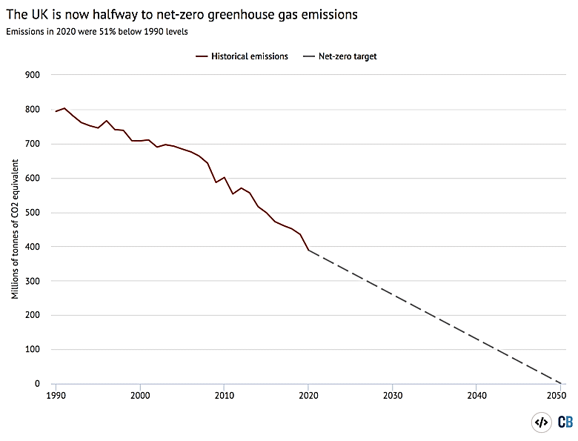
Source: (Evans, 2021)
Figure 1: Carbon Emission of UK
The UK currently produces 37% of its electricity from renewable sources. But its neighbour Scotland produces 90% of its electricity from natural resources (Renewable energy in the UK | Friends of the Earth, 2021). To improve its position and achieve the targeted level, UK must put its attention on renewable energy. For this, a renewable energy certificate programme will be a great help.

Description of the Programme
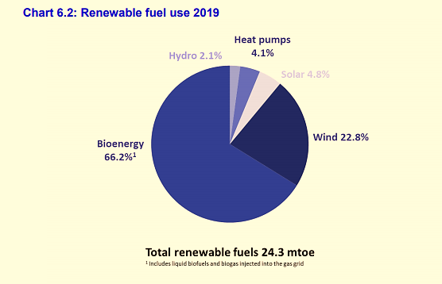
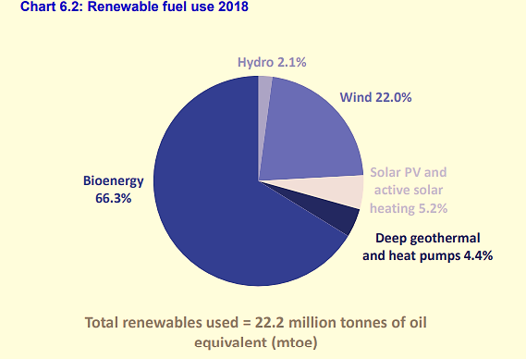
The interesting fact about the UK is that it ranks 17th in terms of carbon emission and is responsible for the emission of 1.1% of the global carbon emission (Bolton, 2021). The UK has improved in renewable energy.
Figure 2: Renewable Energy Usage in 2019 and 2018
Source: (National Statistics, 2021)
The figure above shows that the use of renewable energy has increased in 2019 than the previous year. Still, it depends mostly on fossil fuels (Evans, 2021). To reduce the dependence on non-renewable fuel and energy and carbon footprint, it is a must for the UK to be aware its people about the significance of renewable energy.
Keeping in mind that factor, the programme under the MCS Foundation, will be aware of the industries that emit the highest amount of carbon to shift their business into renewable energy. Under the programme, online seminars and webinars would be arranged and proper advice would be provided to encourage industry personnel. Collaboration with different NGOs, environment concerned organisations and local authorities, the programme will spread awareness and support to the community about the problems of non-renewable energy and how a business can shift to renewable energy at a low cost and get maximum result from such move (Spears et al., 2014). The programme will certify the participants and they will act like a change-maker for the community. Moreover, funding would be provided on time-bound projects that would promote renewable energy sources.

Best Practices of Community Engagement Principles
The best practices of such renewable energy programme on the community would be investing in the activities of the programme that create awareness and enough support about the potential of renewable energy on the community. Focusing on sustainability and identifying the problems in using fossil fuels would be the main theme of the programme. “Save the Environment” is a buzzing word nowadays. Companies are implementing green businesses and trying to reduce their carbon footprint. In such a case, raising awareness among the mass people of the community and encourage companies to adopt renewable energy can be instrumental in obtaining the community goal of a safer environment (Boait et al., 2019). Here, under the programme there would be initiatives that would:
- Identify the vulnerable group of carbon emissions due to the widespread use of non-renewable energy. Alongside this, the programme would identify the industries that are responsible for a higher amount of emissions. Then there would be a face to face conversation between the vulnerable group and the industry experts regarding the issue.
- Educate people about the negative side of non-renewable energy and encourage them to promote the use of renewable energy sources.
- Support the businesses within the community to implement such sources of energy in place of fossil fuels.

Socio-cultural Integration
Promoting renewable energy can enable socio-cultural integration. It would strengthen the community bonding. It would increase employability and reduce the health problem thus promote equal opportunity for all (Kumar, 2020). The programme would enable social interaction which ensures community participation, an important socio-cultural factor. Sharing knowledge would create a generation that will be more concerned about the environment. Thus, the programme would promote equal opportunities, community participation, social bonding and thus make it possible for socio-cultural integration.

Multi-culturalism
Multi-culturalism is the existence of different cultural communities in a nation and how the nation handles such cultural plurality (Watson, 2014). A country has different communities from many different cultural backgrounds. For example, there are many people, who are averse to environmental wellbeing and thus are not careful about renewable energy. The programme would address such multicultural issues and make all from a different culture in the same point of view by raising awareness among them about eco-friendly energy.

Relationship of Renewable Energy Programme and Its Stakeholder
A renewable energy programme is a practical knowledge-based programme that is designed to provide technical knowledge about renewable energy, project development to its participants (Kumar, 2020). Many stakeholders have some sort of interest in the programme and understanding the different types of relationships between them is important for the smooth conduction of the programme. The different types of relations are discussed below:
1. Programme Planner: The project planner plans and designs the different aspects of the project. The role of the project planner in the renewable energy programme is critical because this person plans the activities under the programme, knowledge offerings and tries to achieve sustainability with the programme (Kitisittichai and Aruninta, 2015).
2. Local community: Local community refers to the programme participants, businesses, landowners, industry experts for whom the programme is developed. They are the main stakeholder of such a programme.
3. Sponsors: Sponsors are that personnel with the project who provides monetary support to the programme. As running the programme requires much monetary support, those sponsors help in implementing such a programme by providing the required investment (Marchenko, 2018).
4. Supply chain and support network: For programme materials, it is required to have the latest technological element, education materials, enough setups etc. Those will be arranged by the supply chain and support network.

Benefits of the Participants
The programme will mainly target the youth and industry experts who can act like a change-maker in their community. The programme will benefit them in multiple ways. They are discussed below:
Educate them about the consequences of using non-renewable energy
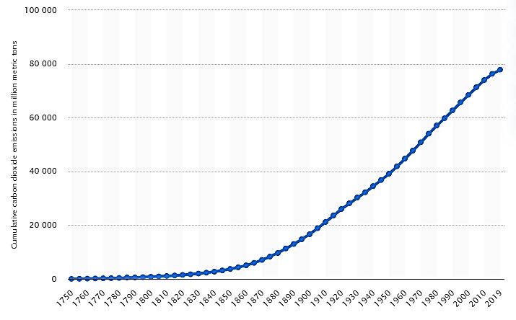
Non-renewable energy causes emissions of harmful carbon (CO2) which causes different respiratory diseases. According to a survey, due to the increase of greenhouse gas in the atmosphere, additional 22,000 people will die every year (Loria, 2018).
Figure 3: Cumulative Carbon Emission by UK (in million metric ton)
Source: (Statista.com, 2021)
The figure above represents such an increase of carbon in the atmosphere cumulatively from 1750 to 2019. We can observe a continuous increase in carbon emission throughout the period. So, with such a programme, stakeholders are let to know about the current status and realize the importance of renewable energy.

Technological Support to the Industry Emitting Higher Amount of Carbon
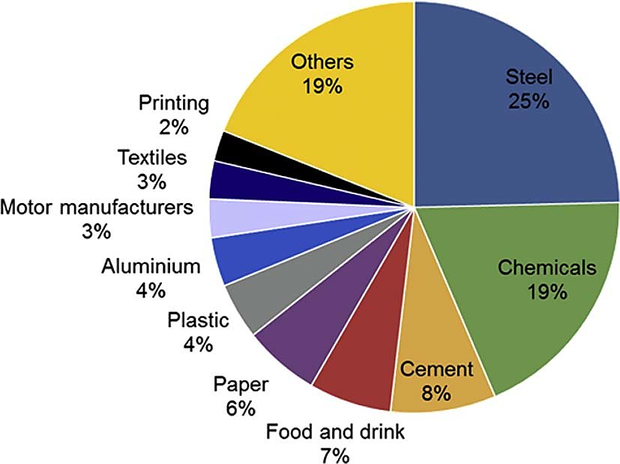
Few industries emit a higher amount of greenhouse gas. Technical support would be provided to those industries about how they utilise their resources to adopt clean energy based on renewable sources. The figure below shows the industry that emits greenhouse gas most.
Figure 4: Industry wise Carbon Emission
Source: (Griffin, Hammond and Norman, 2018)
The industry that emits the highest portion of greenhouse gas immediately needs to adopt sustainable renewable energy sources (Griffin, Hammond and Norman, 2018). So, with this programme, the industry expert of such responsible industries will get encouragement and technical support that will help them to check their carbon emission through alternative energy sources like solar, wind etc.
Promote a Safer Environment
This programme will introduce a view to all people of the nation that environmental safety should come first. This will create a generation who are more concerned about the safety of the environment, who will promote renewable energy to their community, society, businesses. The programme can also take creative ideas from its participants about the availability of technology of such energy. The programme will create a culture of environmental cleanliness and thus promote community bonding towards all (Kumar, 2020).

Strategies for Community Engagement
To engage a huge number of people from different communities, social media can be a primary and easily affordable medium. There are around 3.5 billion active users around the world connecting, interacting and sharing their views on different social media platforms and the number is also increasing day by day (Environmentalleader.com, 2021). Using such social media platform, the programme can get many views and reach a wider community. Followings are some of the ways how social media can be used as an important medium for engagement in the programme:
- Social media platforms can also create a connection between the programme co-operators and the participant community. It can reach a large number of audiences (Dostilio and Welch, 2019). The hashtag functionality of Facebook and Twitter can bring an online movement of a safer environment and ideal renewable energy.
- Those platforms can be used as a medium of two-way communication. It can be used to create and raise awareness about the usage of renewable energy and at the same time can be used to gather constructive feedback and criticization from a wider number of people.
- Social media platforms have an interesting feature of multiple modes of communication. So, using such a combination of those modes, renewable energy programmes can communicate their message to their prospective client properly.
- Using Google AdSense and promoting through social media influencers can make such a programme more valuable and acceptable to the audiences.
This is how social media facilities can be used to promote and engage the community for whom the programme is intended to. Those are very low cost and easy tools to promote the programme activities (Dostilio and Welch, 2019). Besides those, the programme website can carry information and publications about renewable energy and help the process of widespread engagements.

Need for a Forward-looking Approach
Forward-looking approach means the capability to predict future trends and situations. This is simply the visionary power of the people. As a programme planner, the author needs to take a forward-looking approach to the programme. As the world is changing rapidly with technological prosperity, without a fast forward approach the programme cannot reap the benefits. The programme organiser should adopt and inform any technological change immediately and provide valuable insights about future happenings (Peters, Fudge and Sinclair, 2010). They need to be supported by future insights based on proper data and extensive research. Without that, the programme cannot be sustainable in long run.

Conclusion
The programme can be a successful one if it is conducted with the engagement of different communities and with the best practices (Christens and Zeldin, 2011). Multiple communities will share different cultures. Thus, a cross-cultural relationship will be created between them. All walks of people from all cultures will stand by a common objective of saving the planet through the introduction of renewable energy. And this would be the satisfaction of conduction such a programme. Through this report, the author has tried to establish this common objective. This programme according to the report lacks a statistical and psychological approach to identify the participants' mentality. For a future version of such a programme, those approaches will be introduced for getting more benefits.

Recommendations
As the earth becoming old, it becomes more important to focus on the health of the environment. Technology-based renewable energy can improve the health of that environment. A programme like a renewable energy certificate programme would help in this regard. But to do better on such a programme, it is important to make renewable energy technology available to all. Assisting the government to make policies to support such technology would be crucial (Raybould, Cheung, Connor and Butcher, 2019). Moreover, the programme needed to continue on a regular basis to get the maximum result. Regular discussion with the policymakers, industry experts, technicians can help the organiser get enough resources for the programme. Taking feedback and following the work of previous programme participants is crucial for programme success (Peters, Fudge and Sinclair, 2010). Finally, success would be more affordable if the organiser maintains a good connection and promote its activities widely.

References
Assets.publishing.service.gov.uk. 2021. National Statistics. [online] Available at: <https://assets.publishing.service.gov.uk/government/uploads/system/uploads/attachment_data/file/957887/2019_Final_greenhouse_gas_emissions_statistical_release.pdf> [Accessed 29 August 2021].
Boait, P., Snape, J., Morris, R., Hamilton, J. and Darby, S., 2019. The Practice and Potential of Renewable Energy Localisation: Results from a UK Field Trial.
Bolton, P., 2021. UK and global emissions and temperature trends. [online] House of Commons Library. Available at: <https://commonslibrary.parliament.uk/uk-and-global-emissions-and-temperature-trends/> [Accessed 29 August 2021].
Christens, B. and Zeldin, S., 2011. Community Engagement.
Dostilio, L. and Welch, M., 2019. The Community Engagement Professional's Guidebook. Bloomfield: Campus Compact.
Environment + Energy Leader. 2021. Environmentalleader.com. [online] Available at: <https://www.environmentalleader.com/2011/05/social-media-in-the-renewable-energy-world/> [Accessed 28 August 2021].
Evans, S., 2021. Analysis: UK is now halfway to meeting its ‘net-zero emissions’ target | Carbon Brief. [online] Carbon Brief. Available at: <https://www.carbonbrief.org/analysis-uk-is-now-halfway-to-meeting-its-net-zero-emissions-target> [Accessed 28 August 2021].
Friends of the Earth. 2021. Renewable energy in the UK How wind, wave and sun will power the UK | Friends of the Earth. [online] Available at: <https://friendsoftheearth.uk/climate/renewable-energy-uk-how-wind-wave-and-sun-will-power-uk> [Accessed 28 August 2021].
Griffin, P., Hammond, G. and Norman, J., 2018. Industrial decarbonisation of the pulp and paper sector: A UK perspective.
Kitisittichai, P. and Aruninta, A., 2015. Best Management Practices for Sustainability in a Small-scale Community Renewable Energy: Sathya Sai School, Thailand. Applied Environmental Research, pp.93-105.
Kumar, M., 2020. Social, Economic, and Environmental Impacts of Renewable Energy Resources. Wind Solar Hybrid Renewable Energy System.
Loria, K., 2018. Earth has crossed a scary threshold for the first time in more than 800,000 years, and it could lead to tens of thousands of deaths. [online] Business Insider. Available at: <https://www.businessinsider.com/how-atmospheric-carbon-dioxide-affects-health-2018-5> [Accessed 28 August 2021].
MCS Charitable Foundation. 2021. About — MCS Charitable Foundation. [online] Available at: <https://www.mcscharitablefoundation.org/about> [Accessed 29 August 2021].
Marchenko, O., 2018. Modeling of a green certificate market. Renewable Energy, 33(8), pp.1953-1958.
Peters, M., Fudge, S. and Sinclair, P., 2010. Mobilising community action towards a low-carbon future: Opportunities and challenges for local government in the UK. Energy Policy, 38(12), pp.7596-7603.
Raybould, B., Cheung, W., Connor, C. and Butcher, R., 2019. An investigation into UK government policy and legislation to renewable energy and greenhouse gas reduction commitments. Clean Technologies and Environmental Policy, 22(2), pp.371-387.
Spears, W., Tsoh, J., Potter, M., Weller, N., Brown, A., Campbell-Voytal, K., Getrich, C., Sussman, A., Pascoe, J. and Neale, A., 2014. Use of Community Engagement Strategies to Increase Research Participation in Practice-based Research Networks (PBRNs).
Watson, D., 2014. Managing civic and community engagement. Maidenhead: Open University Press.

