 |  | Shereen Garragahan  2242394
 |  | BMHI4006
 |  | Natale Brailsford
 |  | Operating Hotel facilities
Gibbs Reflective Cycle
One of the most famous cyclical models of reflection that leads through six stages exploring an experience: the Description, the feelings, the evaluation, the analysis, the conclusion and the plan of actions (Adeani et al. 2020). The Gibbs Reflective Cycle is traced to see the reasoning behind the reflections. It was so amazing that I spent my training period in the housekeeping department where I was distinctly able to learn all the details concerning keeping the hospital setting clean and organized. In my reflective journal then, I will employ the Gibbs Reflective Cycle as a tool to explore my experiences, feelings, and lessons from this time during my job with the housekeeping department.
Description:
As a member of the housekeeping crew I was involved in keeping the rooms, corridors and other areas tidy and presentable. My tasks included anything from making beds and vacuuming to freshening up amenities and attending to guests' requests as soon as possible. Every little thing contributed to making our guests feel more important and appreciated. Detail-orientedness in this position had to be absolute (Oviawe, 2020). Every fold on a bed sheet or a spot unclean in a corner will impact the satisfaction of a guest. From thorough checks to careful cleaning approaches, I have learned that having the smallest details on point is an integral part of ensuring the guests have a homely and relaxing stay.
Feelings:
My feelings regarding my experience at the staff apartment were complex and changing. At first, I had an experience of both enthusiasm and nervousness as I got used to quickly-moving culture. The urge to beat the deadlines and to maintain a high level of standards felt like a burden at some points in time and I felt frustrated at some stage. Yet, little by little, as I started adjusting to the rhythm and got comfortable with what I was capable of, I felt pleasure of overcoming obstacles and contributing to the group’s achievements. Working side by side with my co-workers also highlighted the utter importance of well-communication and effective teamwork (Sundgren et al. 2022). Though there were occasional disputes or misinterpretations, conflicts were resolved or involved common goals and unity among team members was strengthened as a result.
Evaluation:
I summarize my achievements and pinpoint the viable areas to be improved as I evaluate my performance. By being observant, I was able to do the tasks well, and my supervisors as well as the guests found that the feedback they were getting from me was positive. On the other hand, I have learned I have areas where I could do better, mainly, in time management. Task number was so high at some times that I was getting overloaded and couldn’t manage to assign weight accordingly. Alongside this, although my interpersonal skills worked for me in many situations, I learned the hard way that it would have been better to be more assertive in expressing my queries or concerns.
Analysis:
My on-the-job training made me realize how important a part of pleasing a hotel guest the housekeeping department is. Other than cleanliness, I also got to appreciate how things of daily operation such as inventory management and quality control are crucial in the smooth running of a hotel. The conversations with the clients and the evolution of their perception of housekeeping work as a prerequisite for the quality of their experience make me appreciate the role of the housekeeping department in the formation of the guest experience (Hartutik et al. 2021). Furthermore, I appreciated the importance of having effective communication skills and working in teams for the realization of joint objectives and top-notch services.
Conclusion:
Finally, my work at the housekeeping administration was exceptional and it has been a meaningful experience that has changed my personal view about the hospitality industry (Thiagraj et al. 2021). I have learned what I believe to be the most vital competencies, perfected them, realized the extent to which persistence and discipline are cornerstones for attaining customer satisfaction.
Action Plan:
With these takeaways, I now plan to turn them into a roadmap of persisting progress. It will involve searching for best training and learning resources, practicing effective time management, and getting feedback to improve. Through adopting the permanent attitude of improvement and development, I believe that I will be fit for the highly dynamic and competitive working nature of the hospitality industry.

Component Two: Health and Safety Guide
Contribution to Overall Module Assessment: 25%
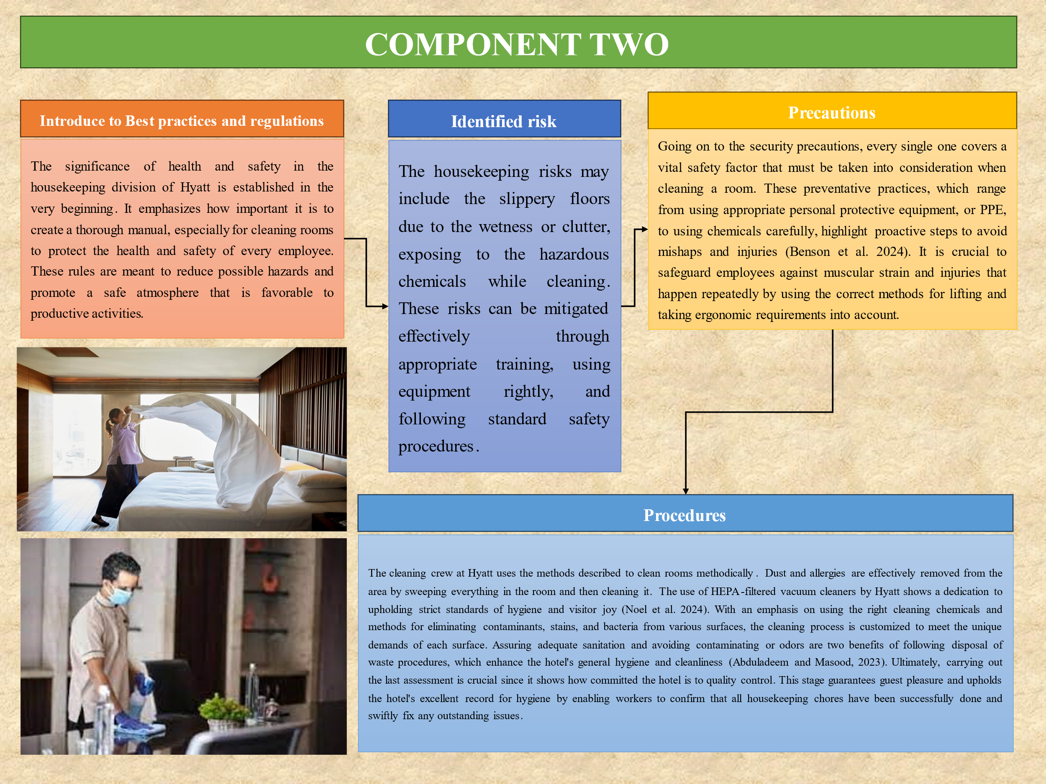
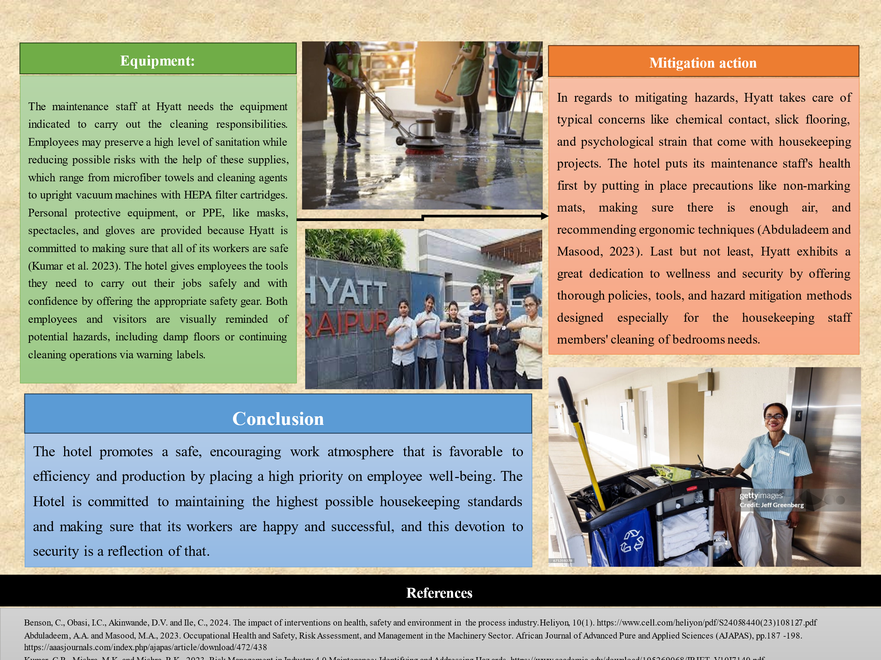

Reference List

Component 1
Adeani, I.S., Febriani, R.B. and Syafryadin, S., 2020. Using GIBBS’reflective cycle in making reflections of literary analysis. Indonesian EFL Journal, 6(2), pp.139-148.
Oviawe, J., 2020. Application of Graham Gibbs Model of Reflection to Improve Teaching Understanding among Technical Education Students in Ambrose Alli University Ekpoma Edo State. Sumerianz Journal of Education, Linguistics and Literature, 3(2), pp.1201-2617.
Sundgren, M.K., Millear, P.M., Dawber, C. and Medoro, L., 2021. Reflective practice groups and nurse professional quality of life. TheAustralian Journal of Advanced Nursing, 38(4), pp.49-67.
Thiagraj, M., Karim, A.M.A. and Veloo, A., 2021. Using reflective practices to explore postgraduate students self-directed learning readiness in mobile learning platform and task-centered activity. Turkish Online Journal of Distance Education, 22(2), pp.192-205.
Hartutik, H., Setiyaningtiyas, N., Pradnya, M.S. and Pradnya, I.N., 2023. Design of management model for facilitating practice of schooling field introduction. Scaffolding: Jurnal Pendidikan Islam Dan Multikulturalisme, 5(3), pp.632-649.

Component 2
Benson, C., Obasi, I.C., Akinwande, D.V. and Ile, C., 2024. The impact of interventions on health, safety and environment in the process industry. Heliyon, 10(1). https://www.cell.com/heliyon/pdf/S2405-8440(23)10812-7.pdf
Abduladeem, A.A. and Masood, M.A., 2023. Occupational Health and Safety, Risk Assessment, and Management in the Machinery Sector. African Journal of Advanced Pure and Applied Sciences (AJAPAS), pp.187-198. https://aaasjournals.com/index.php/ajapas/article/download/472/438
Kumar, C.R., Mishra, M.K. and Mishra, R.K., 2023. Risk Management in Industry 4.0 Maintenance: Identifying and Addressing Hazards. https://www.academia.edu/download/105269068/IRJET_V10I7140.pdf
Noel, C.K., Bruce, E.D. and Ryan, B.J., 2024. Suit Up: A Systematic Review of the Personal Protective Equipment (PPE) Recommended and Utilized by Various Classes of Responders to Nuclear Radiological Disasters at Nuclear Power Plants. Prehospital and Disaster Medicine, pp.1-9. https://www.cambridge.org/core/services/aop-cambridge-core/content/view/EF581384BB9DB01355DC0906DC4DAE99/S1049023X23006672a.pdf/suit-up-a-systematic-review-of-the-personal-protective-equipment-ppe-recommended-and-utilized-by-various-classes-of-responders-to-nuclear-radiological-disasters-at-nuclear-power-plants.pdf

