Student Name: Jeneba Rosa Marah
Student Number: 1816724
Module: Academic and Employability Skills
Module Number: BMSW4001
Module Lecturer: Navami Leena

Table of Contents
Introduction 3
Academic & Employability skills 3
Effective communication 3
Team Working 4
Time management 5
Recommendation 5
Conclusion 6
Appendix 1 7
Appendix 2 9
Reference: 11

Introduction
This report will discuss on the importance of employability skills, and how they can be an essential asset considering the perspective of employers and when being a part of a workforce. It will focus on the importance of employability skills and how they are very useful in an organisation.
Employability skills are important individual requirements to fit in every workplace. These are the overall skills job seekers need as an evidence for employers to consider in the process of recruitment [Doyle, 2019].
Studying and writing at an academic standard will together increase your focus detailed and overall language and improve your skills in demonstrate a logical communication and debating matters in an understanding way. The skill of gaining and using right vocabulary can be very important in the workplace. Communicating in an effective way usually assist in getting the outcome you wanted [Skills for Learning,2018].
It has been discovered that companies spend a lot of money on training staff in basic and general skills rather than job specific areas. Employability skills is what will set you apart from those who you are competing with to get a job. Mastering these skills can be a long process that can always be improved, this includes; communication skills, verbal communication, non-verbal communication, time management, team work, listening and emotional intelligence to name a few. [skills you need,2019]

Academic & Employability skills

Effective communication
Effective communication involves a sender that has an idea or thought and can articulate a message through the form of words, images or signs. The receiver should be able to understand the message successfully. This is an important trait to have to maintain to a healthy working environment with you and your colleagues. Employers who puts time and energy into conveying clear lines of communication will quickly help them gain trust from their employees, this will result in an increase in productivity and morale in general. Also, employees who communicate successfully with colleagues, managers and customers are a very important piece to the company and it is a skill that sets people apart from their competition when applying for jobs.
I’ve personally had to use effective communication when working in my care home. An example of when I’ve put this skill to use is if a resident has fallen over or has had an accident. I had to be able to articulate the situation properly to the resident’s family but also report it to my manager. I had to consider that the message I was conveying was clear and understandable. In the end we manage to take safety precautions to ensure that the it never happened again.
This example illustrates that I can successfully communicate and deliver a message to the receiver allowing them to comprehend what I’ve been telling them. Effective communication is a crucial skill to have in the working environment as it makes you a vital part of the organisation. Also, it sets you apart from those who you are competing with to secure the job.
In an academic circumstance you will need effective communication to be able to demonstrate understanding to what you have been taught. This being an advantage as you can communicate your difficulties or misunderstandings you had during a lesson, as a result you will be able to get the help you need. Known verbal communication is crucial when in a learning environment as your body language says a lot. Having the right body posture ensures the teacher that you are eager to learn and that you are fully comprehending everything they are saying.
Academically I now understand what the definition of paraphrasing and summarising is. I did some in-class exercise, the first one was Paraphrasing this is when you read and reconstruct the sentence keeping the meaning the same. This is usually done when doing written tasks. (see appendix 1) Summarising was also part of the in-class exercise. This is when you give a brief statement of the main points of something. This allows you to spend less time trying to remember what was said and having to repeat it word for word. (see appendix 2)
These techniques have helped me during my studies as I am able to read and dissect information allowing myself to write my assignments. In my place of work, if an incident happened and an ambulance was to be called, I would have to summarise when talking to the paramedics; as they will need to be on the premises in time.

Team Working
The ability to work as within a group of people both formal or informal. A team is consistent of a group of people linked with a common purpose. This is an important skill to have as it allows you to merge ideas together with your work colleagues, which will enable you to achieve the aims and objectives of the organisation. This is a skill that employers take in consideration when hiring, as this skill illustrates whether you can work within a group to complete a task at hand.
One of the advantages of working in a team is that everyone has unique qualities making it great to fuse all the different perspectives together. Every individual can offer their unique knowledge and ability to improve other team members. sharing these qualities will allow every team member to be more productive in the future. (The open university (2019)
Another advantage is that it helps you accomplish tasks faster. If only one person was to take on multiple tasks it will result in them becoming exhausted and very stress furthermore, you will not be able to perform to the same ability you would’ve if you worked as a team. Team work decreases the time taken to complete job. Team work also builds stronger relationships with your work colleagues and you will begin to gain trust with on another resulting in more productive work. (The open university (2019)
I have successfully used effective team working during my working experience. This involves me imputing suggestions when in meetings on how to improve the care home. Team work is also used when I’m working in my department. We will need to work as a team to take care of the residents and ensure their safety. Effective team work increases the productivity of the organisation.

Time management
Time management is very important skill for graduate and employees at the workplace. It helps to organise and prioritise you work and personal things in general. Time is dividable and consumable product or services in this present day. Time can improve organisations physical and human resources competence and capability and assist to put together the perception of time through the organisation. Consequently, it is the only quality that cannot be modify, bought or accumulation is time itself. (Nasrullah 2015)
Time is on no one’s side, so it is important that you make the most of every opening that comes your way. Time management is the use of one’s time effectively whether it be in the work place or in school. An example of when time management being used in the work or even in academic studies is when a deadline has been set for an assignment or paper work that must give in by a certain date. Having excellent time management will ensure that you get the work done before the deadline allowing you to proof read it ensuring that you made no mistakes or errors. To be good at time management you must be very responsible and professional.
I have had to use the skill of time management in my work place when taking care of the residents. Time management comes to play when I must bath and feed them ensuring that they have eaten on time and haven’t skipped a meal. Be able to manage when to do multiple activities makes me a vital component to my work force as I am able to get the job done. In my academic life I also need to be able to manage when to do my assignments and ensure I am not behind.

Recommendation
Academic and employability skills are great tools for working in an organisation. It is important that you asses the skills that you have and which ones you can build upon to make you a central asset to an organisation. Academic skills can ensure one’s future as they will undoubtedly pass if they use the skills they have. Schools, colleges, apprenticeship’s and universities can offer their student extra-curricular activities in order to boost their CV’s allowing them to get good employment.
Employers should be able to offer their staff online E-learning to boost their employability skills which will benefit the workplace, as this will show that the organisation is thinking of their staff and wanting them to progress. Allowing for their staff to go through this procedure will ensure that the rate of which will improve substantially resulting in the company to progress.
Time management is a vital part in both Academic and Employability, this will consist of:
- Effective planning
- Setting goals and objectives
- Delegation of responsibilities
- Setting deadlines
- Prioritising activities as per their importance
- Spending the right time on the right way
Sometimes we fail to see what activities take time especially when they are not priority. Here is a list of activities that take time;
- Lectures and classes
- Study (1-3 hours for every hour spent in class)
- Work
- Family
- Sleep (50-60 hours per week)
- Eating
- Travel

Conclusion
This report explained what employability and academic skills consist of and how they serve significance to career but also personal life. Maintaining these skills will ensure that you will be productive in whatever field it is that you work in. They enable colleagues and classmates to maintain a healthy and strong relationship, whether it is to work together or even to solve differences; these skills confirm for that to happen. Having academic skills can ensure that they will succeed in their school career, this leading to more qualifications resulting in more job opportunities. It can also mean less stress will be put on the student as they wouldn’t need to worry about failing or retaking a subject. Having academic skills will also improve your chances in the working world, this is because it shows that you are a hardworking and determined character, who is able to complete tasks and get the job done.
Having employability skills can be the difference between you and others who are also competing to get the job. Employers may see these skills and be more interested because they may not have to do much teaching to the member of staff as the would have already had an idea on what. Employers seeing that you have these skills will let them know that you can be a piece the puzzle that can make the organisation grow. You will see a person seeking for a job but lacking these skills will have difficult time, as they are not presented as the dream employee that most bosses want. Overall these skills can better one’s life and ensure they will be on the path to success.

Appendix 1
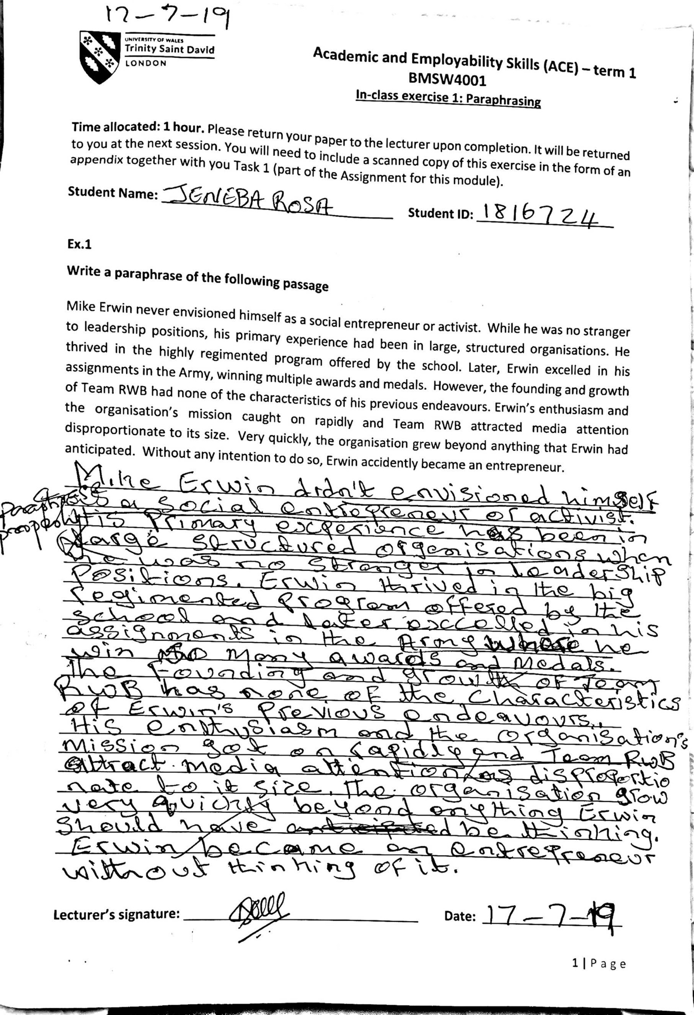
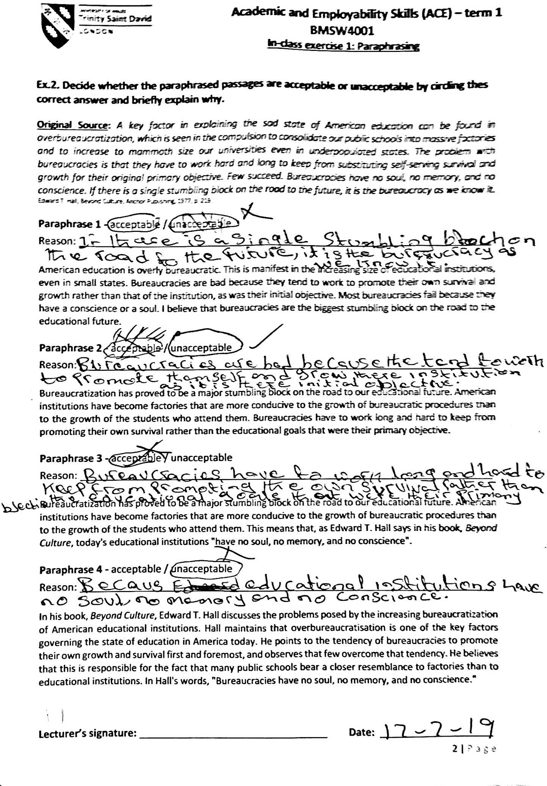

Appendix 2
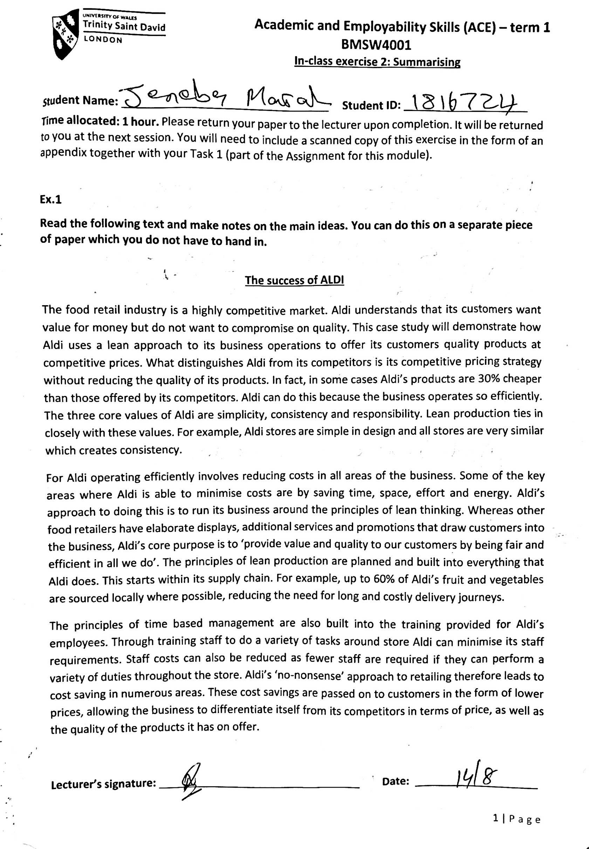

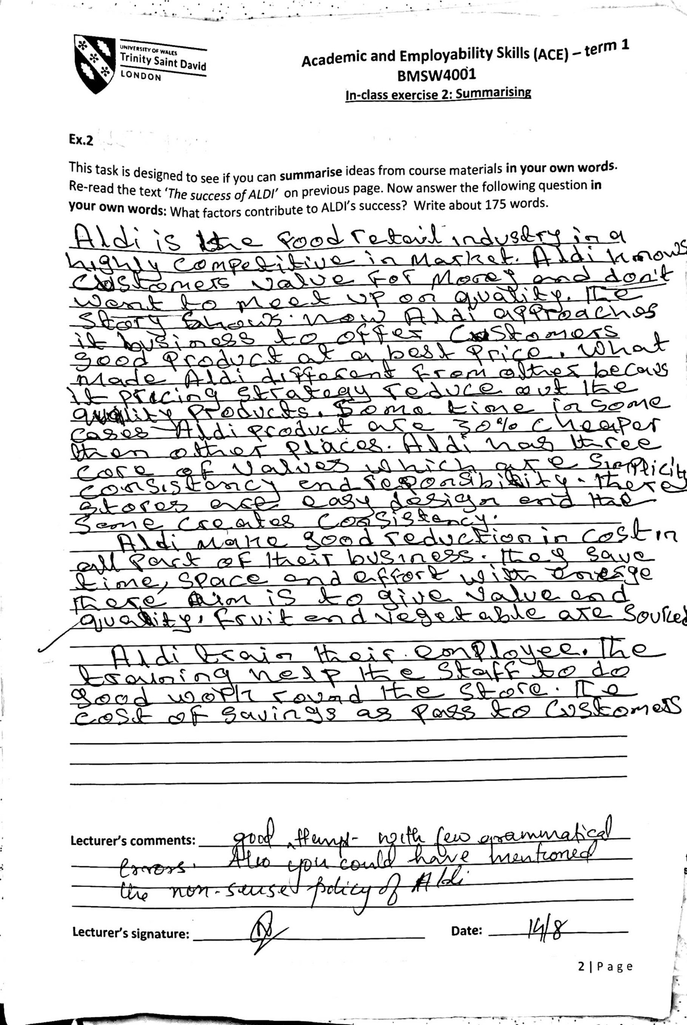

Reference:
Doyle, A. (2019). ‘Important Employability Skills for Workplace Success’ the balance career. Available at: https://www.thebalancecareers.com/employability-skills-list-and-examples-4143571 (Accessed: 20th August 2019).
Skills for Learning (2018) ‘Employability skills from academic writing’ essays and reports. University of Wolverhampton. Available at: https://www.wlv.ac.uk/lib/media/departments/lis/skills/study-guides/LS031-Guide-to-Employability-Skills-from-Academic-Writing,-Essays-and-Reports.pdf (Accessed: 20th August 2019).
Skills you need (2019). ‘Employability Skills: The Skills You Need to Get a Job’
available at:https://www.skillsyouneed.com/general/employability-skills.html (Accessed 20th August 2019)
Team work (2019). ‘What is team working?’ The open university available at: http://www.open.ac.uk/choose/unison/develop/my-skills/team-working (Accessed 24th August 2019)
Nasrullah, S. (2015). ‘The impact of time management on the students’ academic achievements’ journals of literature. Available at; https://iiste.org/Journals/index.php/JLLL/article/viewFile/23538/23819

