

Evaluation of Potential for Mobike to Entry the UK Market

Student Name: XIANG HE
Student ID: P147208
Supervisor Name: GARETH HUGHES
Submitted: 04/05/2018

Declaration

This work has not previously been accepted in substance for any degree and is not being concurrently submitted in candidature for any degree.

Signed (candidate)

Date

STATEMENT 1

This work is the result of my own investigations, except where otherwise stated. Other sources are acknowledged by footnotes giving explicit references. A bibliography is appended.

Signed (candidate)

Date

STATEMENT 2

I hereby give consent for my work, if accepted, to be available for photocopying and for inter-library loan, and for the title and summary to be made available to outside organizations.

Signed (candidate)

Date

Acknowledgments
I would like to particularly sincere appreciation to my supervisor of Gareth Hughes. Gareth gave me a lot of help in my process of writing report. In topic selection, theory choice, research method and analysis, I have received the help of Gareth. In the process of writing report, I also received some suggestions from my friends. In this sincere thanks and deep appreciation.

ABSTRACT
Research Purpose - This research is evaluation potential for Mobike to entry the UK market. Mobike in China is very successful, but Mobike successful experience in China will not necessarily suitable for UK market.

Theory - This literature has been collected by the second-hand data survey method, which provides paper with a large amount of theoretical support and data. Bike-sharing as one of the typical examples of sharing economy. First, Mobike needs to understand the sharing economy in the UK. Then, compare the sharing economy in the China. Comparing China’s bike-sharing market and UK bike-sharing market can help Mobike to have a better understand about whether Mobike's advantages in China can help Mobike how overcome barriers to entry in the UK market. Finally, summarize the characteristics of Mobike under existing environment, and investigate about how Mobike can enter into UK market.

Methodology - Through the Research Onion it finds the most suitable research method for this thesis is the online questionnaire method. The survey designed 13 questions in total. The survey was distributed 100 online questionnaires and post them through various social media, such as, Facebook, Instagram and Mysurvey website.

Findings - Mobike has potential for development in the UK. But, Mobike needs to overcome many difficulties.
Table of Contents

Acknowledgments 3
ABSTRACT 4
1.0 Introduction 9
2.0 Literature Review 16
2.1 Chapter Introduction 16
2.2 Sharing Economy 17
2.2.1 Overview of Sharing Economy 17
2.2.2 Sharing Economy China 22
2.2.2 Sharing Economy UK 25
2.3 Bike Sharing Economy 28
2.3.1 Background on Bike Sharing 28
2.3.2 Bike Sharing China 31
2.3.3 Bike Sharing UK 36
2.3.4 Environment Characteristics of Successful Mobike 38
2.4 The Research Goal is based on the Literature 41
3.0 Research Methodology 42
3.1 Chapter Overview 42
3.2 Purpose of the Research 42
3.3 The Research Onion 42
3.3.1 Philosophy - Positivism 43
3.3.2 Research Approaches –Inductive Approach 47
3.3.3 Research Strategies - Questionnaire Survey 49
3.3.4 Mono Method 49
3.3.5 Timeframe 50
3.3.6 Data Collection and Analysis 51
3.3.6.1 Questionnaire Design 51
3.3.6.2 Sample Populations 53
3.3.6.3 Distribution Method for Questionnaire 55
3.3.6.4 Techniques of Data Analysis 55
3.4 Limitations 56
3.5 Ethical Considerations 56
4.0 Results 58
4.1 Basic Demographic Information 58
4.2 The Main Obstacles Mobike Face 60
4.2.1 Brand User Distribution 61
4.2.2 Bike Sharing with British Travel Method 64
4.2.3 Illegal Behaviors 65
4.2.4 Mobike's Marketing Channels 67
4.3 People Opinion Towards Mobike 69
4.4 People's Views on the Future of Mobike 71
5.0 Analysis 75
5.1 The Main Consumers of Bike Sharing 75
5.2 The Main Competitors of Mobike 75
5.3 The Difficulties Faced by Mobike 77
5.4 British Impression of Mobike 78
5.5 The Future Development of Mobike 80
6.0 Conclusion 82
7.0 Recommendations 83
7.1 Developing the Supply Chain of Bikes 83
7.2 Improve Bike’s Alarm Technology 83
7.3 Strengthening Cooperation with the British Government 83
7.4 Enhancing the Advertising 84
7.5 Strengthen Communication with Customers 85
7.6 Limitations of the Research 85
7.7 Potential Future Studies 86
8.0 References 87
9.0 Appendices 110
9.1 Appendix 1 – Questionnaire 110
9.1 Appendix 2 – Questionnaire Data 112

LIST OF FIGURES

Figure 3. 1 Research Onion diagram (SOURCE: Saunders, Lewis & Thornhill, 2012) 43
Figure 3. 2 Bottom-up approach (Source: Lodico et al, 2010) 48

Figure 4. 1 Bike sharing users' gender distribution 58
Figure 4. 2 Bike sharing users' age distribution 59
Figure 4. 3 Bike sharing users' profession distribution 60
Figure 4. 4 British bike sharing brand user population distribution 61
Figure 4. 5 Gender distribution of different brands bike sharing users 62
Figure 4. 6 Age distribution of different brands bike sharing users 63
Figure 4. 7 Awareness of illegal behavior 66
Figure 4. 8 Informed of the situation Mobike's marketing channels 67
Figure 4. 9 Mobike's promotional approach 68
Figure 4. 10 The proportion of people's views on Mobike 69
Figure 4. 11 Customer satisfaction with Mobike prices 70
Figure 4. 12 What are the reasons for not using Mobike? 71
Figure 4. 13 People's opinion on Mobike's alleviation of traffic congestion 72
Figure 4. 14 People's views on MOBIKE entering their city 73
Figure 4. 15 People recommend Mobike to other people 73

LIST OF TABLES

Table 2. 1 In 2016, the market size of China’s sharing economy key areas 23
Table 2. 2 In 2016, the number of participants in China’s sharing economy key areas 24
Table 2. 3 Ofo and Mobike financing event table 33

Table 4. 1 The mean value table of travel method 64
Table 4. 2 The Public Bike sharing of ANOVA 65

1.0 Introduction
In 2016, bike sharing begun to be popular in China, and swept across the whole China. This environmentally friendly trip mode has become a new vogue and quickly wins the Chinese's affection. Among the competition between bike sharing companies, an orange bike is always in the forefront. This orange bike is Mobike (Mobike, 2017).

Mobike was founded in January 2015, the intelligent sharing bike service was officially launched in Shanghai on April 22, 2016. Mobike successively went into more than 150 Chinese cities and overseas cities, becoming the world's largest intelligence bike sharing operation platform. Mobike is completely ‘made in China’ with international standard. Mobike has already won several patents, including appearance design and motor control system. Mobike is driving the bicycle boom, bringing convenience to more people and a smart solution to the sustainable development of green travel in cities (Mobike, 2017).

Mobike is the world's first intelligent bike-sharing company. Unlike the traditional public bicycle, Mobike using Dockless system. Mobike comprehensively supports ‘Global Positioning System(GPS) + BeiDou Navigation Satellite System(BDS) + Global Navigation Satellite System(GLONASS)’ three navigation system, which adopts a new generation of Internet of Things technology, through a smart phone APP, it allows users to locate and use the nearest Mobike anytime and anywhere, when people arrive at the destination, they can stop by the side of the road in the nearest suitable area, turn it off and realize electronic payment and settlement(Mobike,2017).

In March 2017, Mobike landed in Singapore and started the internationalization process. In November 21, 2017, Mobike has entered 200 cities, including 11 overseas cities including Singapore, Manchester, London, Berlin and Florence (Mobike, 2017). Entering each city, Mobike need to conduct detailed research and understanding of the urban environment, communicate and have close interaction with local government and traffic management departments (Wu & Xue, 2017).

In June 2017, Mobike landed in the 100th city of the world - the second largest city in the UK, Manchester, the birthplace of the industrial revolution in Europe, and simultaneously entered Salford, which is adjacent to Manchester (Mobike, 2017). On August 1, 2017, Mobike entered London. (Mobike, 2017).

This research is evaluation potential for Mobike to entry the UK market. Mobike in China is very successful, but Mobike successful experience in China will not necessarily suitable for UK market. In order to research and evaluation potential for Mobike to entry the UK market, has set the following objectives.

Review the current literature concerning bike sharing to provide context for the research.
The Bike-sharing system has experienced four generations, the former bike-sharing system is called the public bike system (Shaheen & Guzman, 2011). The first generation of public bike system began in Amsterdam in 1965. The public bike was called Witte Fietsen. Many bikes were painted white and placed throughout the city for free use.

In 1995, according to the experience of the first-generation public bike system, Copenhagen launched the ‘improved edition’ of second generation public bike system (Shaheen, et al., 2010). In order to ensure the regulation, fixed parking spot was set, and concept of deposit was introduced. The second-generation public bike system ensures the safety of public bike by setting up specific bike stations and adding coin-deposit systems.

In 1997, based on past experience, the French Rennes public bike rental industry began to adopt computer, wireless communication and Internet technology, which realized the digital management and operation of public bike, thus the third generation of public bike system was born (Shaheen, et al., and 2010). The third-generation public bike system used the advanced IT to make the reservations, pick-up, drop-off and track information of bike.

In 2005, Lyon, France, launched the ‘Vélo’V system’, the bike equipped with electronic components (DeMaio, 2009). The Bike sharing companies can identify the distance the bike travels and track the state of the bike, such as lighting, generators, brakes, and so on. And Bike Sharing Companies collects detailed statistics on bike usage. The implementation of this bike system means that the public bike system has been transformed into a bike sharing system (Shaheen, Guzman & Zhang, 2010).

In 2007, the public bicycle system entered China, and successively carried out pilot projects in Beijing, Hangzhou, Wuhan and Guangzhou, and was gradually promoted to other cities (Shaheen, Zhang, Martin & Guzman, 2011). In 2012, more than 50 large and medium-sized cities in China provided public bicycle services (Zhang, Zhang, Duan & Bryde, 2015). Until March 2015, there are 215 cities and counties adopting public bicycle system in China (Li, Wang, Yang & Ding, 2017). However, due to the problems of operation cost, road planning and integrated management, the public bicycle system in many cities has been forced to stop. The public bicycle system in China is two investment modes: government investment + enterprise operations or enterprise investment + government subsidy. Public bicycle system relies too much on government funds with difficult profitability on its own, making it difficult for public bicycle enterprises to achieve large-scale development (Zhang el al., 2015).

In 2016, the bike-sharing system began to develop rapidly due to the Chinese government's advocacy (Jiang el al., 2017). The bike-sharing system effectively solves the problems of traditional public bicycle system. Based on mobile Internet technology, bike - sharing system builds a platform, and gather user, let the user become a node of the platform, the more nodes mean the higher value, so as to get rid of the circumstance that traditional public bicycle system has difficult profitability on its own (Chen, Ma, Pan & Jakubowicz,2017).

Assess the current market position of Mobike in order to inform and provide context for the primary research
First, Mobike needs to understand the sharing economy in the UK. Then, compare the sharing economy in the China. Mobike would be able to know whether Mobike is adapted to UK's market environment. Mobike is one of China’s largest bike-sharing giants (Christensen, 2017). The research on bike- sharing market in China can deepen the understanding of Mobike. In comparison with other bicycle- sharing companies, Mobike has its unique advantage in the competition of Chinese bicycle-sharing market. Studying UK's bike-sharing market helps Mobike know more about the competitors in UK. Comparing China’s bike-sharing market and UK bike-sharing market can help Mobike to have a better understand about whether Mobike's advantages in China can help Mobike how overcome barriers to entry in the UK market. Thus, occupied a part of UK's bike-sharing market. Finally, summarize the characteristics of Mobike under existing environment, and investigate about how Mobike can enter into UK market.

Carry out primary research, in the form of questionnaires to determine the market opportunity for bike sharing schemes in the UK
Mobike in China is very successful, but Mobike successful experience in China will not necessarily suitable for UK market. In order to research and evaluation potential for Mobike to entry the UK market, will use research onion diagram. First of all, outline clearly the purpose of the research. Then, through Research Onion, find the most suitable research method for this thesis is the online questionnaire method. Finally, the ethical issues and limitations which should be paid attention to in the investigation and research are given.

Make recommendations for market entry premised on the findings of the primary research
This research adopts online questionnaires and carries on analysis according to the results collected by online questionnaires. In addition to simple and descriptive statistical analysis (such as mean, median mode etc.) this thesis will also employ ANOVA.

The result of the research is that Mobike is very popular in the UK. The Guardian editor Pidd (2017) has sent tweets and written articles to express his love and concern for Mobike. From the result, Mobike into the UK market has market potential, but it also has encountered some problems. On June 29, 2017, Mobike was officially launched in Manchester. A total of 1000 bicycles have been launched in the initial project (Mobike, 2017). It had been reported that many had been sabotage, theft or took for their own (Kirby, 2017). Before entering into the UK market, when Mobike entered some Chinese cities there were phenomenon that bicycles were thrown into canals or wheels were unloaded. These problems inevitably make people worry about the future of Mobike, but Mobike can learn how to deal with similar problems as China does. These problems can be reduced by encouraging users to report the damaged vehicles and free parking (Kirby, 2017).

In addition to the sabotage to Mobike, it’s necessary for Mobike to improve the deficiencies of products to be more fitting of British culture. For example, in Chinese impression, the traditional British people are tall and more likely to make vehicles larger. However, in fact, the current situation seems to have changed. Small bike basket in China maybe be designed to avoid users to put their children in the basket and cause security problems, but this may not be the same in the UK(Hazael,2015).

2.0 Literature Review

2.1 Chapter Introduction
This chapter mainly shows literatures that will be used in the theme of ‘Evaluation of Potential for Mobike to Entry the UK Market’. This literature has been collected by the second-hand data survey method, which provides paper with a large amount of theoretical support and data. Bike-sharing as one of the typical examples of sharing economy. First, Mobike needs to understand the sharing economy in the UK. Then, compare the sharing economy in the China. Mobike would be able to know whether Mobike is adapted to UK's market environment. Mobike is one of China’s largest bike-sharing giants (Christensen, 2017). The research on bike- sharing market in China can deepen the understanding of Mobike. In comparison with other bicycle- sharing companies, Mobike has its unique advantage in the competition of Chinese bicycle-sharing market. Studying UK's bike-sharing market helps Mobike know more about the competitors in UK. Comparing China’s bike-sharing market and UK bike-sharing market can help Mobike to have a better understand about whether Mobike's advantages in China can help Mobike how overcome barriers to entry in the UK market. Thus, occupied a part of UK's bike-sharing market. Finally, summarize the characteristics of Mobike under existing environment, and investigate about how Mobike can enter into UK market.

2.2 Sharing Economy

2.2.1 Overview of Sharing Economy
The concept of sharing economy was first proposed jointly by Felson and Spaeth from the USA. They describe a new mode of living consumption by means of collaborative consumption. Its main characteristics are: individuals through third-party market platform for point-to-point direct transactions of goods and services (Felson & Spaeth, 1978). In 1984, American social scientist Paul put forward the concept of Lifestyles of Health and Sustainability (LOHAS), which advocates a healthy and loving way of life on Earth. Although the concepts of environmental protection, green life and slow living have emerged all along, most of the time the healthy lifestyle which focus on environment is still based on a sense of crisis of danger and harm. What is emphasized about that is ‘what cannot be done and cannot be eaten’. By contrast, the attitude of LOHAS is optimistic and inclusive. LOHAS emphasizes healthy, happy life. LOHAS believe that to care for the environment and ecology is to care for ourselves. So, its concept of ‘greener, more convenient and harmonious’ advocated was difficult to put into practice (French & Showers, 2008).

The essence of sharing economy is the sharing of infrastructure (Gregory & Halff, 2017). Sharing Economy is based on the ‘Internet Plus’ economic environment, with the help of the network and other third-party platforms. The ‘Internet Plus’ is a new economic form to realize the combination of the Internet and traditional industries by relying on the Internet information technology, which aims to achieve the economic transformation and upgrading by optimizing production factors, updating business systems, and restructuring business models (Cui, Fan, Qin, Wang & Chen, 2017). The purpose of the ‘Internet Plus’ program is to give full play to the advantages of the Internet and integrate the Internet with traditional industries deeply in order to improve productivity and finally realize the increase of social wealth (Cui et al, 2017). Sharing economy integrates a large number of scattered idle resources in society so as to realize the temporary transfer of the right to use idle resources (assets or skills), the accurate matching and the interconnection of idle resources. Sharing economy achieves platform agglomeration, reuse and supply and demand match, which a new commercial form is promoting the optimal allocation and rational utilization of social resources. The sharing economy is characterized by unlimited openness, universal participation and boundary less organization. (Peppard & Ward, 2016). The typical representatives of the sharing economy came from the ride-hailing app industry, such as Uber. Then the sharing economy began to involve all aspects of life, such as Airbnb in the residential sector (Cusumano, 2015). With modern information technology such as cloud computing, mobile payment, Internet of things, and Location Based Service (LBS), the sharing economy has greatly reduced the transaction cost of both suppliers and demanders while meeting the diversified needs of people (Tsai, Lai & Vasilakos, 2014).

Along with the advent of the Internet, network technology integrates offline items or personal services under line and provides users with lower prices (Wu, Vassileva & Zhao, 2017). Then through distribution according to one's needs to construct an environmentally friendly, convenient and harmonious lifestyle. Finally, becomes a viable new business model (Rifkin, 2014). In 2010, American scholar Botsman (2010) proposed the concept and development mode of collaborative consumption in the Internet era and divided it into several stages.

Stage 1 is code sharing. Linux provides users with information primarily via Internet but the flow of information is one-way, users cannot participate in comments and communicates among them.

Stage 2 is life sharing or content sharing, such as Facebook, Weibo. Along with Internet web 2.0 era, various online forums, communities begin to emerge, users share information and express views with strangers via network platform. However, its sharing forms are limited to content or information sharing, also not involve physical transactions. In general, there is no money reward.

Stage 3 is sharing of offline resources. That is, online sharing collapses infiltrate and extends to offline, thereby changing people's culture, economics politics and consumption world (Belk, 2014).

Sharing economy refers to temporary transfer of right to use under the premise of unchanged ownership and raising resource utilization ratio while benefiting both sides of supply and demand (Quattrone, et al., 2016). Generally, refers to obtaining certain remuneration as the main purpose a new economic model based on strangers and temporary transfer of usufruct (Hamari, Sjöklint & Ukkonen, 2016). The interactive evolution of new generation information technology and innovation 2.0 promotes the development of sharing economy. Sharing economy is the typical innovation 2.0 mode of information economy development (Hamari, Sjöklint & Ukkonen, 2016).

Sharing economy can generally be divided into three types. One is Product Service Systems Aim at temporarily obtaining the rights to use something such as borrowing leasing etc. Second is Redistribution Markets. Mainly used for reuse of junk goods, such as secondhand markets. Third is Collaborative Lifestyles. Refers to sharing or exchanging rights of use such as carpooling, objects exchanging (Belk, 2014).

From purely free information sharing to obtaining a certain amount of compensation for the purpose, and temporarily transferring personal belongings to strangers or providing personal services. Realized the transformation from sharing to sharing economy (Zervas, Proserpio & Byers, 2014). In 2009, Internet sharing network platform emerged, such as Uber and Airbnb. The commercial operation of Uber in the car rental market and the commercial operation of Airbnb in the residential rental market, two successful models of the sharing economy means the arrival of the era of sharing economy. Uber and Airbnb have achieved the enlightening and leading role in the development of the global sharing economy and have provided the theoretical basis for the business model of the sharing economy. (Cusumano, 2015).

Sharing economist Jeremy Rifkin (2014) said

“Sharing economy has brought a resources revolution which changed the way of human life, it has brought a new organization for economic life and surpassed traditional pattern of the market” (Rifkin 2014, page 31-37).

In recent years, benefit from the rapid development of mobile internet economy, the sharing economy, as a new business model, has been involved in many areas such as transportation, housing rental and financial services. Uber, Didi Chuxing and Airbnb, as typical example of sharing travel and sharing space, they are accepted by many users. In addition to, a new form of travel way - sharing bike. Bike-sharing is very popular in the world (Puschmann & Alt, 2016). As of December 2017, the total number of registered users in the world has been nearly 400 million, the number of service cities in the world has reached 304,74 enterprises have entered the market, the total number of bikes put into the market has been up to 23 million, industry has accumulated financing of more than 23 billion yuan and the number of 2017 annual orders has reached11.5 billion orders (Mingrui,2018).

The sharing economy is a new business model emerging on the Internet. It is a social and economic ecosystem based on the sharing of human and material information (Puschmann & Alt, 2016). Bike sharing, as a new model of sharing economy, faces many problems, which requires joint effort to build a healthy and orderly environment for bike sharing market and take effective measures to promote the development of sharing economy as well as achieve the optimal allocation of social resources (Cohen & Kietzmann, 2014).

2.2.2 Sharing Economy China
As the phenomenon of sharing economy is becoming more and more widespread in the world, the growth rate of the scale of China's shared economy market has gradually become increasingly prominent. The key difference between China’s sharing economy and other countries and regions is that mobile communication technology plays a unique role in promoting sharing economy growth (Chen, et al., 2014). China Skinny's marketing manager Andrew Atkinson has told CNBC that sharing economies have become very powerful since there is no cash transaction in China. Andrew also noted that mobile phone usage flourished in China has become an enabling factor for promoting sharing economies. People can almost lease everything in short-term by using cellphones.

The ‘2017 China’s sharing economy development report’ released by State Information Center (SIC) shows that China’s sharing market assets in 2016 at about three trillion four hundred and fifty-two billion RMB. Growth of 103% compared with 2015.Among them, the scale of sharing economy transactions in key areas such as life services, productive capacity, transportation, knowledge and skills, houses and accommodations, medical sharing amounted to one trillion three hundred and sixty-six billion RMB. Increase of 96% compared with 2015. Assets reached approximately two trillion eighty-six billion RMB, up 109% from 2015(SIC, 2017).

Areas | Transaction Amount (¥100 Million Yuan)
Areas | 2015 | 2016 | Growth Rate
Knowledge and Skills | 200 | 610 | 205%
Houses and Accommodations | 105 | 243 | 131%
Transportation | 1000 | 2038 | 104%
Life Services | 3603 | 7233 | 101%
Productive Capacity | 2000 | 3380 | 69%
Medical Sharing | 70 | 155 | 121%
Current Assets | 10000 | 20863 | 109%
Total | 16978 | 34522 | 103%
Source: 2017 Chinese sharing economy development report
Table 2. 1 In 2016, the market size of China’s sharing economy key areas

In 2016, China had more than 600 million people participating in economic activities, representing an increase of about 100 million compared with 2015.Employment among the sharing economy platform was approximately 5.85 million, representing an increase of 850,000 compared with 2015.According to projections, by 2020, there could be more than 100 million service providers in the sharing economy sector, with approximately 20 million full-time participants. It will effectively alleviate structural unemployment problems under the new round of technological industrial revolution (SIC, 2017).

Areas | Number of participants (People) | Number of service providers (People) | Number of platform staff (People)
Life Services | 520 million | 20 million | 3.41 million
Productive Capacity | 9 million | 5 million | 15.1 million
Transportation | 330 million | 18.55 million | 12 thousand
Knowledge and Skills | 300 million | 25 million | 20 thousand
Houses and Accommodations | 35 million | 2 million | 20 thousand
Medical Sharing | 200 million | 2.56 million | 50 thousand
Source: 2017 China’s sharing economy development report
Table 2. 2 In 2016, the number of participants in China’s sharing economy key areas

China’s rapid economic growth in 2016 is closely related to government interventions. China’s government has issued many national policies encouraging sharing economy development which brings significant policy dividends to sharing economy development. For example, in March 2016, sharing economies were first included in the Report on the China’s Government, which clearly supported sharing economy development, enhancing resource utilization efficiency and engaging more people (SIC, 2017).In July 2016, China’s government once again emphasized that sharing economy should be developed and networked collaborative innovation system should be established, and sharing economy becomes an important component of China’s information development strategy. Meanwhile, policies concerning encouraging sharing economy development are also clearly proposed in new policy documents in related fields such as consumption, logistics, transportation, manufacturing etc. Creating a favorable environment for expanding economies towards broader areas, higher levels of development and greater participation by groups (SIC, 2017).

It is worth paying attention to the fact that China’s sharing economy grew rapidly in 2016, the capital market is the important reason in addition to the support of user government. In 2016, sharing economy financing reached about ¥171 billion RMB, increase 130% over the same period (SIC, 2017). Sharing economies will continue to grow around 40% per year over the next few years, with trading size likely to account for more than 10% of GDP by 2020, and by 2025 it will climb to about 20%(SIC,2017).

2.2.2 Sharing Economy UK
Throughout the world, governments of all countries are realizing the great benefits brought by sharing economies and are brewing development plan. The fastest-moving and most thoughtful country among is the UK (Richardson, 2015). UK's attitude towards sharing economy development filled with longing for the most active in all EU countries.

The original British favorite to share the economy stemmed from the economic crisis caused by the financial crisis (Allen, 2016). Along with the international economic environment is facing difficulties, the British economy will inevitably be affected (Allen, 2016). As the pillar industry of British economy, the financial services industry is of crucial importance. The abnormal operation of the financial industry will directly cause the British economy to fail. At present, while UK's major banks are facing dilemmas, they are also worrying about rising default risk and the lack of willingness of banks to lend, thus reducing the economic activity caused by credit crunch and becomes an important issue that puzzles UK nowadays (Hughes, 2017).

As early as early 2014, UK had announced its commitment to creating global centers for sharing economies and supported by policies, encouraging the development of sharing economy. The UK government said it will spare no effort to create a favorable environment for promoting the natural economic growth (Gov.uk, 2014). In September 2014, the British Department of Commerce launched an independent survey to assess UK's sharing economy and identify the obstacles that the UK faces as it becomes a global hub for sharing economies. Its ultimate goal is to devise a roadmap for building the United Kingdom as a global hub for sharing economies (May, Königsson & Holmstrom, 2017).

In November 2014, the British Independent Research report; ‘Unlocking the Sharing Economy’ issued more than 30 recommendations to government (Wosskow, 2014). In March 2015, the British Government Department of Business Entrepreneurship and Skills responded to the report, released a government response that covered a package of sharing economy support policies. Officially took the first step towards becoming a global center for sharing economies (May, Königsson & Holmstrom, 2017).

Britons are extremely enthusiastic about sharing economies. Airbnb was announced in March 2014 when there were over 1 million customers from the UK and France (Airbnb's total then 2 million users) (Airbnb, 2015). At the same year, Nielsen's global survey on sharing communities also showed that more than 30,000 respondents in 60 countries were willing to participate in economic activities 1/3 of whom were British(Nielsen,2014).

In 2014, Nesta Charitable Foundation commissioned TNS (Taylor Nelson Sofres) to conduct an investigation on the participation of Britons in the sharing economy. The results show that over the past year, 64% of Britons participated in the sharing of economic activities, and 25% of them used the Internet and mobile applications to participate. The results show that 35-44-year-old people, married people, people with many children, rural people, people looking for full-time or part-time jobs, managers, professionals, administrators and people caring for children, are more likely participate in the sharing economy activity than the rest of population (Stokes, Clarence, Anderson & Rinne,2014).

In 2015, British government officials may choose to accommodation and travel services in sharing economies while performing their duties (Gov.uk, 2015). Earlier in 2010, UK's Croydon Council adopted resolutions starting to cooperate with Zipcar to replace government convoys. According to the London Borough of Croydon program, Zipcar offers 23 vehicles dedicated service during Monday to Friday 8:00am to 18:00pm. Outside of this time, these vehicles can be used by 1,300 Zipcar members in the Croydon municipality, such as at night and on weekends. (Zipcar, 2013).

2.3 Bike Sharing Economy

2.3.1 Background on Bike Sharing
The Bike-sharing system has experienced four generations, the former bike-sharing system is called the public bike system (Shaheen & Guzman, 2011). The first generation of public bike system began in Amsterdam in 1965. The public bike was called Witte Fietsen. Many bikes were painted white and placed throughout the city for free use. But sadly, some citizen’s often stolen or damaged bikes, this move failed shortly after it was launched. Although the first-generation public bike system failed, the concept of public bike aroused people's interest (Shaheen, Guzman & Hua, 2010).

In 1995, according to the experience of the first-generation public bike system, Copenhagen launched the ‘improved edition’ of second generation public bike system (Shaheen, et al., 2010). In order to ensure the regulation, fixed parking spot was set, and concept of deposit was introduced. The second-generation public bike system ensures the safety of public bike by setting up specific bike stations and adding coin-deposit systems. The second-generation public bike system is more reliable than the first-generation public bike system because the user has a certain and safe space to access to the available bikes. However, due to the anonymity of customer, theft remained to be main problem of coin-deposit systems (DeMaio, 2003).

In 1997, based on past experience, the French Rennes public bike rental industry began to adopt computer, wireless communication and Internet technology, which realized the digital management and operation of public bike, thus the third generation of public bike system was born (Shaheen, et al., 2010). The third-generation public bike system used the advanced IT to make the reservations, pick-up, drop-off and track information of bike. Because the third-generation public bike system had a deposit and transaction record, the condition that bike was stolen and destroyed reduced. At the same time, the French government transferred the advertising and development rights of the bike to the developer, and the profit was used as public works. Rennes' public bike laid the foundation of operation mode of the public bike system, thus it had wider popularity (Parkes, et al., 2013).

In 2005, Lyon, France, launched the ‘Vélo’V system’, the bike equipped with electronic components (DeMaio, 2009). The Bike sharing companies can identify the distance the bike travels and track the state of the bike, such as lighting, generators, brakes, and so on. And Bike Sharing Companies collects detailed statistics on bike usage. The implementation of this bike system means that the public bike system has been transformed into a bike sharing system (Shaheen, Guzman & Zhang, 2010). Bike sharing contains all the main components of the previous three generations of public bike system, while it is unlike public bike system. Bike sharing seamlessly connects to public transport and other alternative modes such as taxi and car sharing, which means that bike sharing's parking spots are located near the public transport station, so that the bike sharing is coordinated with the public transport schedule. A payment smart card has access to all available options (Shaheen & Guzman, 2011).

Clean technology is also an important trend in bike sharing system. Canada's BIXI has solar-powered mobile stations, which may become standard configurations for the future system. These mobile stations can be moved to different sites. Other improvements by Bike sharing include clean technologies and incentives to encourage redistribution system of bicycle-sharing. When riders return the bikes at a docking spot, they would be charged at a lower price or given extra time credit to reduce bike redistribution cost. (Shaheen & Guzman, 2011).

2.3.2 Bike Sharing China
China’s sharing bike has experienced three major stages:

Stage 1: Unified management led by government. The earliest history of Bike-sharing could date back to Europe where the government introduced public bikes into China on August 2007. And successively carried out pilot projects in Beijing, Hangzhou, Wuhan and Guangzhou, and was gradually promoted to other cities (Shaheen, Zhang, Martin & Guzman, 2011). In 2012, more than 50 large and medium-sized cities in China provided public bike services (Zhang, Zhang, Duan & Bryde, 2015). Until March 2015, there are 215 cities and counties adopting public bike system in China (Li, Wang, Yang & Ding, 2017).

Stage 2: Accessed by private enterprises to operate under contractual mode. In 2010 YOUON Company was established and started operating public bike systems in Zhejiang and Shanghai which achieved good results. Public bikes entered into enterprises dominated by enterprises and contracted operations mode greatly improved the operating efficiency of public bikes. However, due to the problems of operation cost, road planning and integrated management, the public bike system in many cities has been forced to stop. Public bike system relies too much on government funds with difficult profitability on its own, making it difficult for public bike enterprises to achieve large-scale development (Zhang el al., 2015).

Stage 3: the birth of bike sharing. Between 2014 and 2015 Mobike and OFO formed relying on emerging economic models such as sharing economy, Internet plus, QR code technology and emerging technologies, bike sharing began to rise. In 2016, the bike-sharing system began to develop rapidly due to the Chinese government's advocacy (Jiang el al., 2017). Many sharing bike companies were established and multiple repeatedly in a short time, Bike-sharing opened throughout China. The bike-sharing system effectively solves the problems of traditional public bike system. Based on mobile Internet technology, bike - sharing system builds a platform, and gather user, let the user become a node of the platform, the more nodes mean the higher value, so as to get rid of the circumstance that traditional public bike system has difficult profitability on its own (Chen, Ma, Pan & Jakubowicz,2017).

In 2016, massive capital inflows into China’s bike sharing sector. Ofo completed five times financing. In March 1st 2017, more than $ 450 million dollars was completed in d-round financing (OFO, 2017). Mobike completed 5th financing in June 16th 2017 and raised more than $ 600 million dollars (Mobike, 2017).

Brand | Financing Time | Financing Rounds | Financing Amount
OFO | 2016.02.01 | A | ¥15 million
OFO | 2016.08.02 | A+ | ¥10 million
OFO | 2016.09.02 | B | $ 10 million
OFO | 2016.09.26 | C | $ 10 million
OFO | 2016.10.10 | C+ | $ 130 million
OFO | 2017.03.01 | D | $ 450 million
OFO | 2017.07.06 | E | $ 700 million
Mobike | 2015.10.30 | A | $ 1 million
Mobike | 2016.08.19 | B | $10 million
Mobike | 2016.08.30 | B+ | $10 million
Mobike | 2016.09.30 | C | $130 million
Mobike | 2016.10.12 | C+ | $55 million
Mobike | 2017.01.04 | D | $215 million
Mobike | 2017.06.16 | E | $600 million
Source: https://www.ofo.com/uk/en/about & https://mobike.com/cn/investors/
Table 2. 3 Ofo and Mobike financing event table

According to the 40th China statistical report on Internet development released by Cyberspace Administration of China(CAC), shows that China has reached 106 million bike sharing users as of June 2017, accounting for 14.1% netizens overall. Its coverage has been infiltrated by large cities into small cities and began to dabble in overseas markets (CAC, 2017). According to 2017 china bike sharing market report, China’s bike sharing market size has reached ¥1.23 billion RMB in 2016. Bike sharing users has reached to 28 million people. Expected to 2017, China’s bike sharing market will reach ¥10.28 billion RMB, with a growth rate of 735.8%. In 2017, China’s sharing-bike market is expected to reach 209 million users (Iimedia, 2017).

There are many brands of Bike-sharing appearing in China’s shared bike market, the competition among them are quite fierce. In June 2017, under intense competition in the market, Ofo, Mobike and Kuqi Bike accounted for 51.9%, 45.2%and 4.6% respectively among China’s largest sharing bike APP active users coverage rate(Analysys,2017). Ofo and Mobike has become indispensable transportation vehicles for China’s people.

As one of China’s two largest bike-sharing giants Mobike pays attention to providing customers with stable and comfortable product experiences coupled with convenience of smart lock tracking. Thereby winning a good reputation for Mobike. Besides focusing on product quality and customer experience Mobike also has its unique core competitiveness (Mobike, 2017). In April 22nd 2017, Mobike launched an artificial intelligence platform nicknamed Magic Cube. The platform relies on 3.65 million smart-Bike-sharing and massive big data for 20 million trips per day. Magic Cube is also equipped with GPS + BDS+GLONASS systems (Mobike, 2017). With the help of big data's artificial intelligence platform's Magic Cube, Mobike can predict accurately the status of bike sharing riding status at any time node or anywhere, which means predicting future. By integrating areas, time, weather, vehicles models, population and other hundreds of variables factors. Magic Cube can predict the supply of bike sharing, users’ demand, vehicle usage frequency, parking condition etc. for certain time future time, thus providing guidance for operation and improving operating efficiency (Yu, 2017).

As more and more things could be sharing, people started to realize that sharing isn't as perfect. Random parking and disorderly use of Bike-sharing brings such an inconvenience to urban traffic management. After the launch of the shared umbrella. Share umbrellas are lost every day (BONOMI, 2017). All kinds of shared things bring challenges and pressures to urban management on different levels and different forms. How to manage them becomes a new problem. The ongoing regulation and management of Bike-sharing may provide a feasible idea for the next step development of China’s sharing economy.

In May 22nd 2017, Ministry of Transport of the People’s Republic of China(MOT) issued ‘Guidelines on encouraging and regulating Internet rental bikes Development’, publishing regulations for sharing services and management of bike rental units and services(MOT,2017).For example, registration is implemented in real name system; Prohibit services for children under 12; Promote the use of electronic fence technology to standardize user parking behavior effectively; Encourage enterprises to form credit information sharing card, establish trustworthiness incentive and breach punishment mechanism for users(MOT,2017).

2.3.3 Bike Sharing UK
Bike sharing has been around for seven years in the UK (Pucher & Buehler, 2017). Unlike the two major commercial competitions of China’s OFO and Mobike, the UK's bike-sharing is essentially a government-sponsored project. The bike revolution plan was originally proposed by former mayor, Boris Johnson. This program was implemented in 2010, so the London version of Bike-sharing is called ‘Boris Bike’ (Mattlamy, 2018).

The bike sharing reform plan was very successful. In London, there are more than 14000 shared bikes. The bike sharing runs all over London, with more than 770 stations having bike sharing stops (Mattlamy, 2018). Since then bike sharing has grown into unplanned cities, including Liverpool, Glasgow and Belfast. Reading, Oxford and many other schemes. One of the key differences between the Bike sharing and other models is self-service, which provides flexible and convenient pick-up and return near the station. The price of Bike sharing excursions are very cheap and each bike can be used to the utmost extent. These characteristics have contributed to the growing popularity of bike sharing in Britain (Carplus, 2015).

Boris bike is sponsored by Barclays Bank, a local British bank with a solid blue body and Barclay’s logo on it (Norcliffe, 2016). Since 2013, Santander Bank has become the main sponsor and its body color has also turned into bright red color with the bank Logo’s color (Tfl.gov.uk, 2015).

Glasgow hosted the Commonwealth Games in 2014.In support of the Olympics, Glasgow launched the public bike system Leasing Scheme run by Nextbike in 2014. Nextbike has 500 bikes and 53 stations in Glasgow, and visitors can take a ride around Glasgow. At that time Nextbike’s bikes are all over Glasgow (Nextbike, 2017).

On 13th June 2017, Mobike announced its landing in Manchester, England, and entered Salford, adjacent to Manchester. In 1st August, Mobike entered London, England. On 26th September, Mobike landed in Newcastle, England.

Mobike chose to enter the UK's market for many conveniences and quick access to British customers. However, UK does not have a comprehensive regulatory framework. The British government does not have direct legislation that requires local governments to regulate such sharing bike services (Aliya, 2017).

Mobike's original Dockless bike sharing model is bound to overturn the traditional model of returning bicycles to required docks. By operating the app on the smartphone, the bikes can be docked everywhere locked or unlocked, which means that consumers do not need to return them to a designated location after using the bikes. However, with the rapid development of the bike sharing industry in China's, it also faces a problem, random scattered bicycles (Xiong, 2017). In a written statement, Will Norman, London's walking and cycling commissioner, states that Dockless bikes have great potential to make cycling easier, but they can't be scattered randomly in the capital (Woo, 2017).

In addition to the problem of random bike parking, vandalism is one of Mobike's recent problems in Manchester (Lyons, 2017). If Mobike wants to implement a Dockless bikes system in UK Mobike needs a lot of labour and money. These labour forces need to collect bicycles that have been abandoned in the streets by people, take them to logistics centers and then process customer service reports to find out which bicycle have been illegally dropped and destroyed (Huang, 2017).

2.3.4 Environment Characteristics of Successful Mobike
The shared economy model is characterized by rapid expansion of scale, high flexibility, high capital efficiency and low barriers to entry (Cohen & Kietzmann, 2014). In 2016, the innovative travel projects such as Mobike, OFO and so on, because of the characteristics of sharing economy, set off a wave of bike travel fever, and also improved the operational efficiency of idle bikes. Mobike's R & D focus is on reducing operating costs. Because Mobike wants to create a 4-year, maintenance-free smart bike, Mobike designed and produced the bike sharing. The 25kg body, not adjustable seat, and no driving navigation are all unique designs to avoid maintenance, which increase the flexibility and autonomy of Mobike, and raise the competition advantage (Mobike, 2017). The following environmental features can be summed up through the success of Mobike:

Users’ experience: Low cost of use, freely available and shared.
The bike sharing solves the problem of a three-kilometer trip, which is cheap, faster and cheaper than taking a taxi or bus. Moreover, the registration and use of mobile phone APP is efficient and time-saving, through which people can quickly find nearby usable bikes, to effectively mobilize the stock market, improve the efficiency of idle bikes, save more space for the city and promote green and low-carbon travel (Lan, 2017). For sure, with the expansion of the scale of shared bikes, traffic management has also brought some problems, such as the problem of bike sharing parking point setting and whether the bike road construction can meet the demand and so on. Even if these problems arise, they will not prevent the advent of the sharing economy and the popularity of bike sharing (Hira & Reilly, 2017).

Platform enterprises: Competition in the industry is fierce.
From the external environment, all countries in the world vigorously advocate the concept of green environmental protection and healthy travel, and the emergence of bike sharing is consistent with the concept of green civilization in each country .so that it is easy to gain the support of all countries. Besides, the growing demand of users can make shared bikes a better development prospects (Zhang, et al., 2015). However, the entry threshold of bike sharing industry is not high, resulting in fierce competition within the industry. Many bikes sharing rental platforms pour into the market, and the market positioning of all bike sharing platforms converge, so the competition degree is very intense. Therefore, for the brands of bike sharing, if you want to successfully operate shared bike, you must have innovative design and stable cycle production, build a shared information platform and control operating and maintenance costs to obtain a unique competitive advantage and then stand out (Scott & Brown, 2016).

On the supply side and demand side: Weak ability to negotiate on price
According to Porter's five-force analysis model, electric bike sharing as an alternative to a bike sharing, an e-bike is more expensive than the bike sharing and limited to service areas and parking docks, so the rate of usage is very low. On top of that, bike sharing can not only provide users convenience, but also is another form of physical activity. So electric bikes don’t have a big impact on bike sharing (Ji, et al., 2014). In addition, two-wheeled bike manufacturers have a weak bargaining power due to an oversupply, which also helps companies on the bike sharing platform to reduce the cost of acquiring vehicles (Dell, Moseley & Rand, 2014). The user of bike sharing is the passive receiver of price, and the bargaining power is also insufficient, which can make bike sharing gain pretty stable profit not to fluctuate with rent increasing or decreasing. However, the low entry threshold causes the big threat of new entrants that bike sharing model is easy to be imitated. But the threat of new entrants can also promote bike sharing leasing platform enterprises to provide more quality services, strengthen their own management and vigorously promote R & D innovation. On the contrary, it is beneficial to manufacturer's production design and user's high-quality experience (Hamari, Sjöklint & Ukkonen, 2016).

2.4 The Research Goal is based on the Literature
According to the literature, Mobike is a very successful bike sharing company in China. But Mobike must study the potential of the UK bike sharing market when it chooses to enter the UK market. In the literature, many advantages and disadvantages of bike sharing are given. These advantages and disadvantages can be used to evaluate the potential of Mobike to enter the UK market. The study of the potential of the UK bike sharing market can be used to measure the maximum demand of the UK bike sharing market. Studying the potential of the UK bike sharing market is conducive to the investment of Mobike or the rational allocation of existing resources, as well as to help Mobike formulate its strategy.

3.0 Research Methodology

3.1 Chapter Overview
This chapter will use Research Onions (Saunders et al., 2009). First of all, outline clearly the purpose of the research. Then, through the Research Onion it finds the most suitable research method for this thesis is the online questionnaire method. Finally, the ethical issues and limitations which should be paid attention to in the investigation and research are given.

3.2 Purpose of the Research
This study is an assessment on Mobike's potential to enter the UK market. Mobike in China is very successful, but Mobike successful experience in China will not necessarily suitable for UK market. In order to research and evaluation potential for Mobike to entry the UK market, will use Research Onion diagram.

3.3 The Research Onion
Saunders, et al (2012) created the Research Onion. The Research Onion explains the needed stages for developing the research strategy. From the perspective of visual observation, each layer of the Onion describes the research process in more detail (Saunders et al, 2012). The Research Onion provides help for designing research methods, which is almost suitable to the research methods of various types and can be used in various environments (Bryman, 2012).

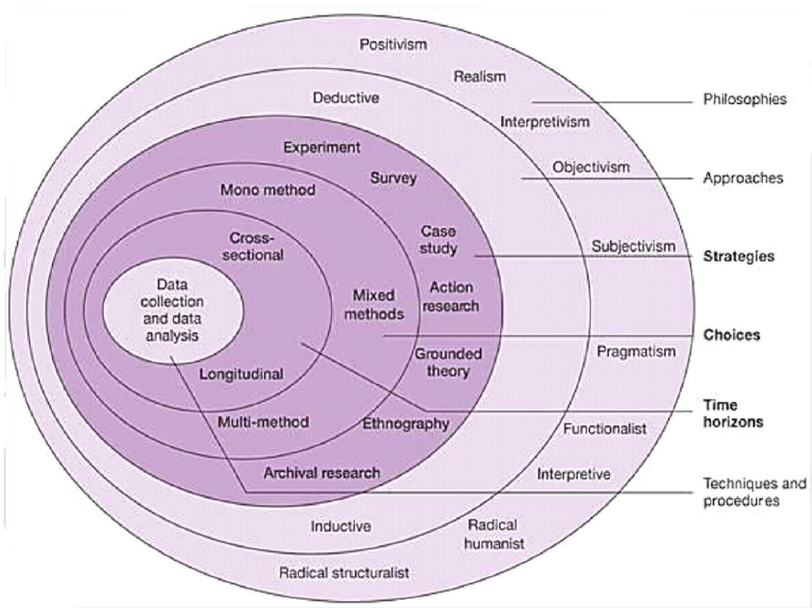
Figure 3. 1 Research Onion diagram (SOURCE: Saunders, Lewis & Thornhill, 2012)

3.3.1 Philosophy - Positivism
This research is adopting a positivistic approach. Positivism was first put forward by French philosopher and sociologist Comte (1880). Positivism lays the foundation for the development of social science. Broadly speaking, on any kind of philosophical systems, as long as the information derived from sensory experience and introspective or metaphysical knowledge rejected are positivism. In a narrow sense, positivism refers to the philosophy of the French philosopher Comte, who believes that the understanding of reality can only be achieved by specific science and observation of ordinary things (Bryant, 1985).

The purpose of positivism is to establish the objectivity of knowledge (Crotty, 1998). The fact must be from by getting to understand each person's objective circumstances and external things through observation or sensory experience (Boland, 1991). Philosophy should be based on positivism natural science, with facts and knowledge that can be observed and experimented, while abandoning the absolute, ultimate, but unproved abstract nature of theology and speculative metaphysics (Passmore, 1966). The so-called positivism refers to things with the meaning of ‘reality’, ‘usefulness’, ‘certainty’, ‘precision’, ‘affirmation’, ‘relative’ and so on(Bleicher,2014).

For a long time, positivist research based on positivism has been dominating the mainstream status of social research methodology (Alvesson & Sköldberg, 2017). The positivist research is influenced by the paradigm of natural science quantitative research (Brannen, 2017). It collects data mainly by means of experiment, investigation and quantitative literature research, and then uses the statistical analysis method to explore the general law of the object which is studied (Brannen, 2017).

Positivism can provide an appropriate philosophical standpoint for the thesis. The following three points can prove this report is suitable for positivism.

Understanding the universal of the social. The most basic advantage of positivist research is that it can break through the limitation of time and space and investigate a large number of research objects in a wide range (Brannen, 2017). For example, questionnaires can not only investigate the facts, behavior issues, but also can ask questions about ideas and feelings (Bryman, 2015). So, in the survey, the content is very extensive. In particular, it is easy to obtain the overall situation in positivism research. A sample obtained through scientific probability sampling plus a standardized questionnaire can provide statistical extrapolation of the UK bike-sharing market as a whole. Therefore, in terms of understanding the universal of the social, no any other research paradigm is better than it (Eriksson & Kovalainen, 2015).

The reliability of data collection. The reliability of positivism data sources determines the reliability of the results (Silverman, 2015). It also asserts the consistency between human society and nature according to objectivism, believing that what sociology should reveal is the general law that not only exists independently, but also separate from human consciousness and similar to the law of nature (Antwi & Hamza,2015). Positivist research can guarantee a large number of first-hand information and have data to support, so the reliability of the study greatly increased (Davies & Hughes, 2014).

The objectivity of the results. First of all, the positivist research introduces the research method and procedure used in natural science into the sociology, constructs the sociology theory according to the natural science theory pattern. And it advocates that sociological research must be tested by objective, observable empirical facts (Alvesson & Sköldberg, 2017). Then, positivist research pays more attention to the use of mathematical and statistical models to reveal social phenomena, which is more accurate and has a technical characteristic. It can also provide the knowledge that is purely instrumental in form. The findings do not imply any pursuit of given social policy or social values, and the conclusion is based on ‘positivism’ ‘empirical’ evidence and can be as value-free or value-neutral as the natural sciences (Yanow & Schwartz-Shea, 2015). Finally, positivist research has a set of standardized and normalized operating procedures which can provide scientific and precise explanations, describe and interpret social facts effectively, rather than merely expressing subjective, unsubstantiated and verifiable statements. Thus, it is helpful for people to grasp the law which is universal and objective (Symon, Cassell & Johnson, 2018).

This thesis will use quantitative methods, quantitative method come from positivism. Quantitative method is mainly to collect data or information expressed in a quantitative way, and then process, test and analyze data quantitatively, so as to obtain meaningful conclusions of the research (Sechrest & Sidani, 1995). Quantitative means measuring on the basis of numeric character (Teddlie & Tashakkori, 2009).

Quantitative methods are generally carried out for the purpose of obtaining general statistical results from a particular sample population (Kothari, 2004). Qualitative methods are exploratory, diagnostic and predictive (Alexander Di Pofi, 2002). The differences between quantitative and qualitative research lie in the following three aspects:

- Answer different questions: Quantitative methods estimate the magnitude of causal effects, while qualitative methods explain the mechanisms of effects (Yoshikawa, Weisner, Kalil & Way, 2008).
- Different types of data are used to solve the same problem: Quantitative methods mainly use numerical data, for example, data correlation analysis by using statistical analysis of numerical data sets. Qualitative methods usually use non-numeric data, for example, to describe a problem in words (Bernard & Bernard, 2012).
- Using different causality analysis and logical inference: Quantitative methods compare differences between samples, while qualitative methods track causal processes on one or more samples (Kothari, 2004).

3.3.2 Research Approaches –Inductive Approach
The second level of Research Onion should adopt inductive approach. Inductive approach, also called inductive reasoning. Starting from observation and theory, inductive reasoning is proposed as an observation result at the end of the research process (Goddard & Melville, 2004). Inductive approach includes observation and search and development of explanations – theories - via a series of assumptions (Bernard, 2011). At the beginning of the study, there was no theory or hypothesis in inductive approach, and the researchers were free to change the research direction after the research process began. Inductive reasoning is often referred to as the ‘bottom-up' approach (Lodico, Spaulding & Voegtle, 2010).

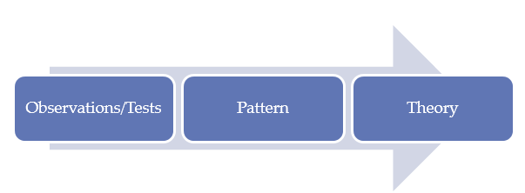
Figure 3. 2 Bottom-up approach (Source: Lodico et al, 2010)
It is important to note that Inductive approach does not mean that research questions and goals are set without regard to theory. This approach is intended to generate meaning from the collected data concentration to determine the patterns and relationships of generating theory. Inductive approach does not prevent researchers from using existing theories to develop research issues that need to be explored (Saunders, Lewis & Thornhill, 2012). Inductive reasoning is based on learning from experience. By observing patterns, resemblances and regularities in experiences (premises), can draw a conclusion or generating theory (Goddard & Melville, 2004).

This report uses an inductive approach, starting with the theme of assessing the potential for Mobike to enter the UK market. Researchers tend to develop empirical summaries and identify preliminary relationships in the research progress. No hypotheses could be found at the initial stage of the study, and the researchers were uncertain about the type and nature of the research results before the study was completed (Neuman, 2003).

3.3.3 Research Strategies - Questionnaire Survey
On the third level, the research strategy which should be adopted by Research Onion is questionnaire survey. The method of questionnaire survey refers to the method that the investigators use the unified designed questionnaire and select a certain survey sample size to understand the situation or to seek opinions (Converse & Presser,1986). This method can break through the limitation of time and space, and at the same time it can carry on the large-scale investigation. The investigation data is easy to collect and analyze, and the data is more reliable. More importantly, it can yield a better result with the less manpower and resource consumption(Wright,2005). The questionnaire survey generally adopts the anonymous method (Bryman & Bell,2015). The investigators put forward some questions and use questionnaires which are filled out voluntarily by the sample populate, then being collected and analyzed statistically. Thanks to adopting the anonymous methods, the sample populate, without any political or other pressure, can speak out their inner thoughts without misgiving, so that they can get the true perspectives and views of the sample populate and will be very helpful in improving their work (Blair, Czaja & Blair,2013).

3.3.4 Mono Method
In the 4th layer of Research Onion diagram, there are three research methods, mono method, mixed method and multi method. Mono method is also known as a single research method (Morse, 2003). This report will adopt mono method. The following three advantages show that mono method is suitable for this report. First of all, although mixed method can maximize the advantages of quantitative and qualitative research, minimize its shortcomings. However, the research of hybrid method will cost a lot of time and energy, and has difficulty in integration specifically, so mono method is more suitable than mixed method in this report (Tashakkori & Teddlie, 1998). Second, while mixed method can provide much richer knowledge and understanding, too much information may lead to too much results of analysis and cannot get the desired results. Mono method can be used to collect, analyze and effectively mine data, so as to get the desired results (Leech & Onwuegbuzie, 2009). The third mixed method can help researchers to form a more holistic understanding of things, but this understanding is not necessarily more objective, the results of different methods may result in the accumulation of wrong results, thus deviating from the purpose of the research. On the contrary, mono method will not cause the deviation of the purpose of the study (Kelle, 2006).

3.3.5 Timeframe
In Research Onion diagram, there are two types of time horizons: the cross sectional and the longitudinal (Bryman, 2012). A time horizon may look like ‘snapshot’ or like a diary when it comes to studying an important issue. Snapshot is called cross sectional, and diary is called longitudinal (Flick, 2011). This report uses cross sectional. Because there is a time limit for this report, and there is not enough time to study. Rather than having enough time like longitudinal to study the changes and developments that occur at different times (Saunders et al., 2012).

3.3.6 Data Collection and Analysis

3.3.6.1 Questionnaire Design
The data needed in this study will be obtained by means of online questionnaire survey. The design of the questionnaire generally includes the content, the way of questioning and answering, and the choosing of indicator, in which, the content of the questionnaire, the way of questioning and answering belong to the basic situation of the questionnaire (Converse & Presser, 1986).

The questionnaire is divided into three parts:

- The first part is mainly about the simple personal data of the interviewees, including sex, age and occupation, this part is answered by the way of single selection, answered by the interviewees.
- The second part is the status quo of shared cycling in the UK, including the ranking of shared bike brands in the UK, and the share of shared bikes in the entire UK traffic travel. This part of the question is also answered by the interviewees by way of single selection.
- The third part is the main part of the online questionnaire, Mobike's development potential in the UK market, a total of 8 questions. Each question has certain pertinence; this part still uses the single election way by the interviewees to answer.

There are two types of questionnaire: closed questions and open questions (Cooper et al, 2006). This report will use closed questions. The advantages of closed questions include the following:

- The answers are standardized and easy to be coded and analyzed (Converse & Presser, 1986).
- The respondents are easy to answer, which is helpful to improve the recovery rate of the questionnaire (Krosnick, 1999).
- The meaning of the question is clearer. Since the answers provided help to understand the meaning of the question, it is possible to avoid the respondents refusing to answer question because of being not understand the meaning of the question (Brace, 2008).

However, there are also some shortcomings in the issue of closed question. For example, order deviation or position deviation may have occurred, meaning that the respondents' choice of an answer may be related to the position of the answers. Respondents tend to choose the first or the last answer for a declarative answer, especially the first answer, and tend to choose the answer at intermediately position for a group of quantities or prices (Brace, 2008). To reduce order deviation, investigators prepare several forms of questions, with different orders of answer.

3.3.6.2 Sample Populations
A sampling framework is a record of the population from which a sample can be drawn. Samples represent an unbiased subset of the population (Alexander, 2006). Population is a collection of people considered for statistical purposes. If the population is relatively small, it is feasible to choose the entire population. Otherwise, a random sample will be demanded (Alexander, 2006). The UK currently has a population of 66 million (Worldometers.info, 2018). Since the public bike sharing first appeared in London in 2010, there are 26 towns in the UK that have adopted public bike sharing and many more are under development (Carplusbikeplus.org.uk, 2017). There are more than 50 thousand bike sharing vehicles and over 600 thousand bike sharing users in the UK (Carplusbikeplus.org.uk, 2017). It is not possible to conduct a survey on 600,000 people in this research. Therefore, this research can only choose random sampling.

Random sampling is a limited sample which is representative of a broader population, is often more efficient than general survey, or even more accurate (Kelley, 2003). A random sample is a sample where everyone has the equal chance to be selected. Thus, a sample is an unbiased subset of the population that allows the results of a sample to be taken from an entire population; In other words, the results of the sample can be extended to the general population (Colliss & Hussey, 2009). Despite the constrictions of a Master’s thesis it still demands a large enough sample to solve the problem, because if the sample is too small, it may carry out some important statistical tests among the subsets of the sample. The larger the sample is, the better the population it represents. Therefore, it is also necessary to determine the minimum sample size to reflect the population size (Colliss & Hussey, 2009). In the questionnaire survey, the expected response rate needs to be taken into consideration. Compared with traditional paper questionnaires, online questionnaires are more easily accepted. Due to the richness of the online questionnaire, the interface of the questionnaire is friendlier, which can increase respondents’ interest in answering questions. Consequently, the survey will distribute 100 online questionnaires and post them through various social media, such as Facebook, Instagram and Mysurvey website. Facebook and Instagram have a large user base. Researchers can quickly send online questionnaires survey to many people through Facebook and Instagram.

The samples of this study will be from people aged between 18 – 60 years. According to China Bike sharing industry development index report (Fourth quarter 2017) in terms of age distribution, 18-30-year-olds group of bike-sharing has become the main user groups, and the bike sharing cycling sport itself is the way which is more likely to accept for younger groups(CAICT,2018). Because people under the age of 18 belong to vulnerable populations, and users are mostly college students aged 18 years or over or have a job. For this part of the user, only need to pay the low deposit and low fees, can travel on a bicycle. Another is saving the cost of the use of buying their own bikes. The World Health Organization defines the aged people as people over the age of 60, so the age limit for this study is set at 60. Therefore, the sample population is designated as 18-60-year old.

3.3.6.3 Distribution Method for Questionnaire
Questionnaires will be distributed in the form of online survey, and questionnaires will be distributed through the smartsurvey. The survey will distribute 100 online questionnaires and post them through various social media, such as Facebook, Instagram and Mysurvey website. Online survey saves a lot of manpower and material resources. Merely need to design a questionnaire and then you can easily receive a certain number of answers within the specified time. Online survey can easily gather responses from web users in various areas of UK and most people can take part in answering questions. Online survey can benefit to reduce errors that may occur when researchers record human data (Wright, 2005). In the questionnaire, the respondents will be screened and the eligible subjects will be asking to fill in the questionnaire. Since the submission function button of the webpage is only allowed to complete the complete questionnaire submission, the collected data is complete and theoretically valid.

3.3.6.4 Techniques of Data Analysis
In addition to simple and descriptive statistical analysis (such as mean, median mode etc.) this thesis will also employ ANOVA. ANOVA is divided into One-Way ANOVA and Two-way ANOVA. This report will choose One-Way ANOVA. The purpose of One-Way ANOVA is to compare the average of K group, according to an independent variable. (Grimm, 1993). One-Way ANOVA assumption is that the dependent variable is usually distributed. And the two groups have approximately equal variances in the dependent variables (Grimm, 1993). First, go to the Analysis menu, select Compare Means, then select One-Way ANOVA. Move all dependent variables to the box labeled ‘Dependent List’ and move the independent variable to the box labeled ‘Factor’. Click on the button labeled ‘Options’ and check the ‘Descriptive and Homogeneity of Variance’ box. Finally, click on the box labeled "Post Hoc" and select the appropriate post hoc comparison.

3.4 Limitations
This study is limited by the deadline of the school of business administration, so this study must quickly collect and count data. In this study, the questionnaire management and data analysis are only completed by one person, so it is inevitable to take a little personal bias in the analysis.

3.5 Ethical Considerations
Many different disciplines, institutions and specialties have standards of conduct that meet their specific goals and objectives, which is useful to members of the discipline in coordination their actions or activities and build public confidence in the subject. For example, ethical dominates medical, legal, engineering, and business practices (Resnik, 2015). In several studies need to comply with ethical standards. First, standards promote the purposes of research, such as knowledge, truth and error avoidance (Resnik, 2015). Secondly, since research often involves a large number of cooperation and coordination among various personnel in different disciplines and institutions, so moral codes promote values essential to collaborative work, such as trust, accountability, mutual respect and equity(Mhute,2013) Third, moral code in the study can also help to build public support for research. If people believe that the quality and integrity of the study. People are more likely to fund a research project (Neuman, 2014). Finally, many research codes promote other significant ethical and social values, such as social responsibility, human rights, animal welfare, compliance with the law and public health and safety (Resnik, 2015). This paper observes the following ethical principles:

- No vulnerable populations (Harriss & Atkinson,2009) (i.e. no children, no people under 18 years of age, no coercion to be involved)
- Data stored securely (password protected/encrypted) access only made available to researcher and supervisor (Nosek, Banaji & Greenwald,2002)
- Subject under study is not of a controversial nature, so limited specific ethical issues likely to arise (Frankel & Siang,1999)
- The online questionnaire used in this research is filled out anonymously (Lefever, Dal & Matthiasdottir, 2007).
- All the data in this study are confidential and no personal information will be published (Resnik, 2015).

4.0 Results
This chapter will analyze the data collected by the questionnaire. This research raw data has been placed in an Excel spreadsheet, as shown in Appendix 2. The purpose of this research is to assess Mobike's potential to enter the UK market. The survey was distributed 100 online questionnaires and post them through various social media, such as, Facebook, Instagram and Mysurvey website. Finally, 100 online questionnaires were successfully recovered. With the collected 100 sample, make a statistic analysis to explore the development of Mobike in Britain.

4.1 Basic Demographic Information
Firstly, this research will see the basic sample distribution of gender data.

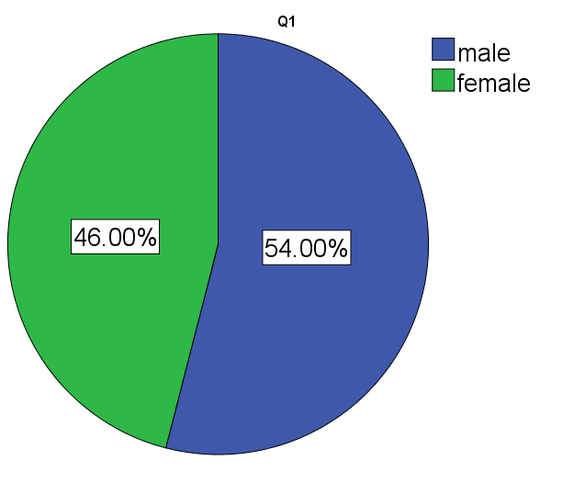
Figure 4. 1 Bike sharing users' gender distribution

According to Figure 4.1 can see that in this research data male counts for 54% and female counts for 46%. The gender ratio of bike sharing users is rather balanced.

Secondly, this research will see the basic sample distribution of age distribution.
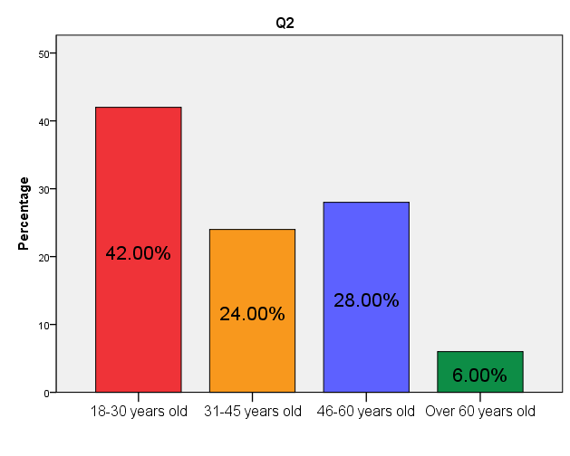
Figure 4. 2 Bike sharing users' age distribution

According to Bike sharing users' age distribution. The main users of bike sharing are young people aged 18 to 30, which occupies 42% of the total proportion. The number of users of 46-60 years old ranked second was not much different from the users of 31-45 years old, ranked third, which total 52% of the users, if added together. The number of people with the least number of users in bike sharing is those over 60 years old, accounting for only 6% of the population.

Finally, this research will see the basic sample distribution of profession distribution.

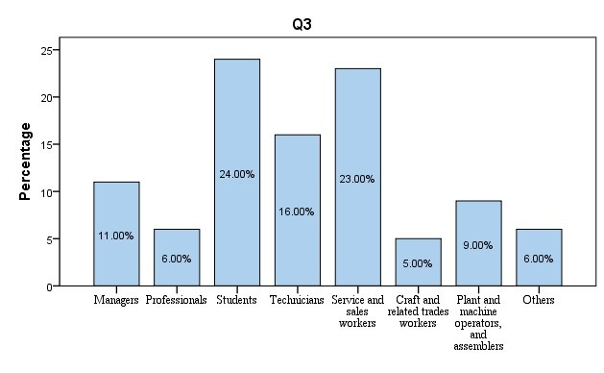
Figure 4. 3 Bike sharing users' profession distribution
Concerning bike sharing user occupation distribution, the student population accounts for 24%, Technicians for 16% and service and sales workers for 23%. These three occupations are the main consumers of bike sharing.

4.2 The Main Obstacles Mobike Face
In order to explore the obstacles Mobike now face, this research mainly compares bike sharing with others travel methods and Mobike with others bike sharing companies. Through comparison, this research will understand the current status of Mobike's bike sharing market in the UK. Besides, this research also asks the people whether they have heard the illegal behaviors, such as breaking the bike or unauthorized possession of a bike sharing behavior.

4.2.1 Brand User Distribution

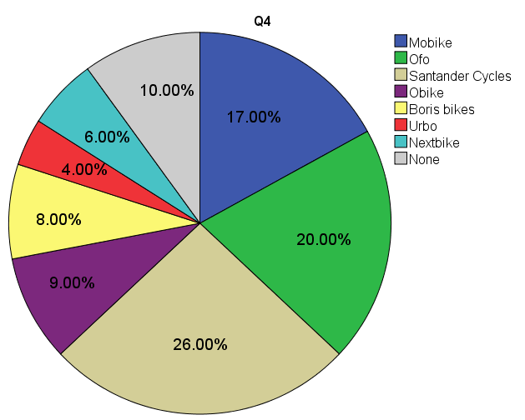
Figure 4. 4 British bike sharing brand user population distribution

According to Figure 4.4 can see the top three bike sharing are Santander Cycles, Ofo and Mobike. Santander Cycles has the largest number of users, up to 26%. Mobike's bike sharing users accounted for 17%. Ofo's bike sharing users accounted for 20%. The three bike sharing brands together accounted for 63% of the interviewees. In addition, the 10% of respondents stated that they have never used bike sharing.

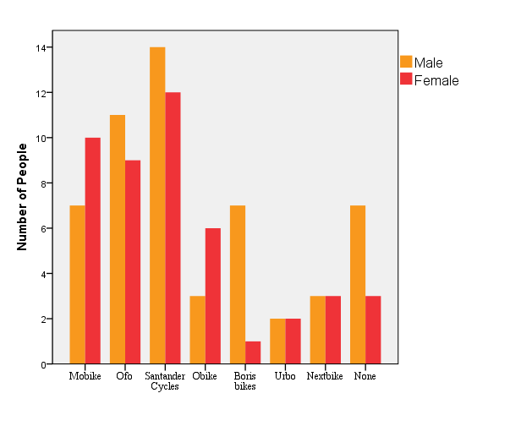
Figure 4. 5 Gender distribution of different brands bike sharing users

As shown in the bar chart of Figure 4.5, the majority of Mobike’s users are mostly female, while the users of Ofo and Santander cycle are mainly male. In the bar chart of Figure 4.5, some people have never used the bike sharing, which are mostly male.
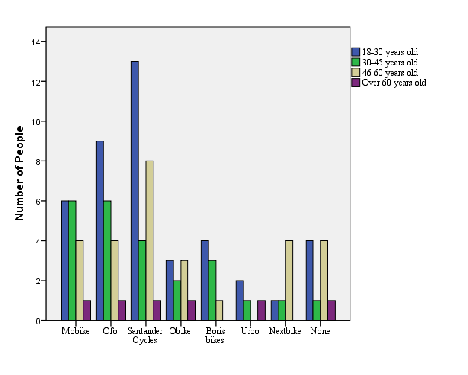
Figure 4. 6 Age distribution of different brands bike sharing users

According to the Figure 4.6, can find the young crowd ranges from 18 to 30 are the main users of all kinds of bike sharing brands, in addition to Nextbike. Although the 18-30-year-old users of Mobike are not as prominent as those of Ofo and Santander, the user crowds of Mobike are quite average.

4.2.2 Bike Sharing with British Travel Method
This study will compare bike sharing and others travel method, by comparison can understand the use of bike sharing in the daily travel of British people. This research calculates the mean score of the frequency (1 represents always and 5 represents never), the lower score represents the higher frequency. From the mean value table, besides bike sharing, people are more likely to travel by bicycle with their own, by private car or walking, travel by bus, underground, tram and light rail and so on. So, people have multi choices and the sharing public bike is not their only choice.
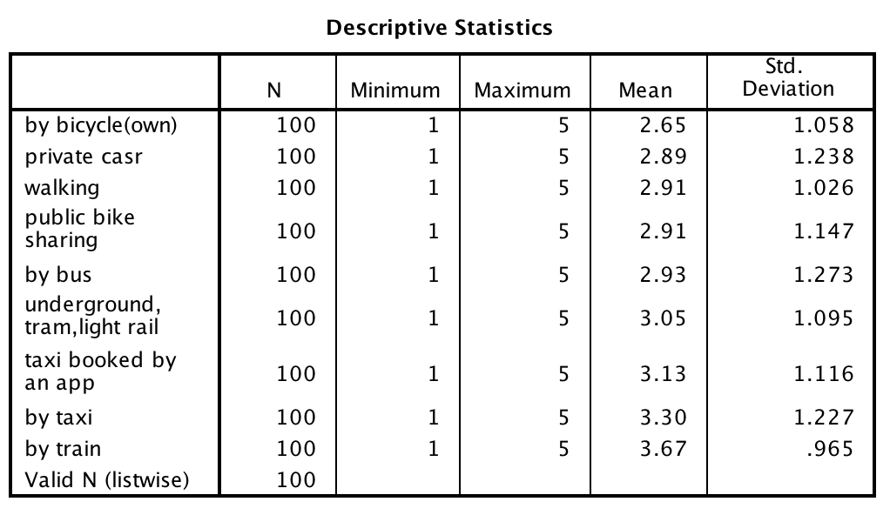
Table 4. 1 The mean value table of travel method

As for public bike sharing, this research also makes a more detailed analysis whether different age range will affect the public bike sharing willing. This research made an ANOVA (Miller Jr, 1997) analysis with the mean score of public bike sharing as dependent variable and the age range as the factor. Then establish a null hypothesis that a there is no relationship between 2 factors (Friston, et al, 1994). The null hypothesis is that year range and people willing to use public bike sharing has no relationship.

 | Sum of Squares | df | Mean Square | F | Sig.
Between Groups | 1.428 | 3 | .476 | .355 | .786
Within Groups | 128.762 | 96 | 1.341
Total | 130.190 | 99
Table 4. 2 The Public Bike sharing of ANOVA

The ANOVA result (Rice, 1989) is as follows, the F test statistic is 0.355 and the corresponding p value is 0.786. So, this research does not have enough evidence to reject the null hypothesis. So, in this research sample, the age range not seems to affect the willing of people whether they want use the public bike sharing system.

4.2.3 Illegal Behaviors
After Mobike entered the UK. There has been reports of people damaging the bikes or hacking off the wheel locks in an attempt to steal them (Kirby, 2017). Figure 4.7 illustrates the level of awareness of the UK population in regard to their awareness of this criminal damage.

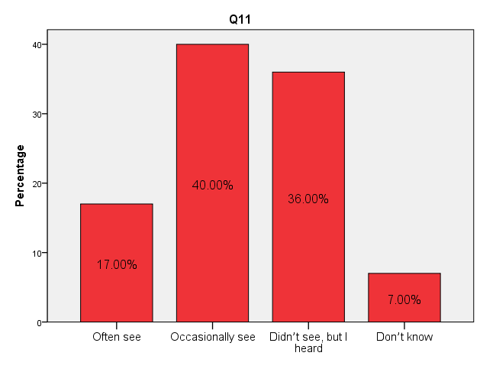
Figure 4. 7 Awareness of illegal behavior

For these bad phenomena, this research wants to know the proportion of the illegal behaviors. The bar chart shows that there is only 17% people often see the illegal behaviors and the 40% occasionally see. The 36% of people don’t see it but heard the behaviors. Only the 7% of people said they had not heard of these bad phenomena.

4.2.4 Mobike's Marketing Channels
Mobike has many advertisement methods, such as TV, newspaper or online advertising to let people know. The main advertising method is through TV, online and newspaper/magazines.

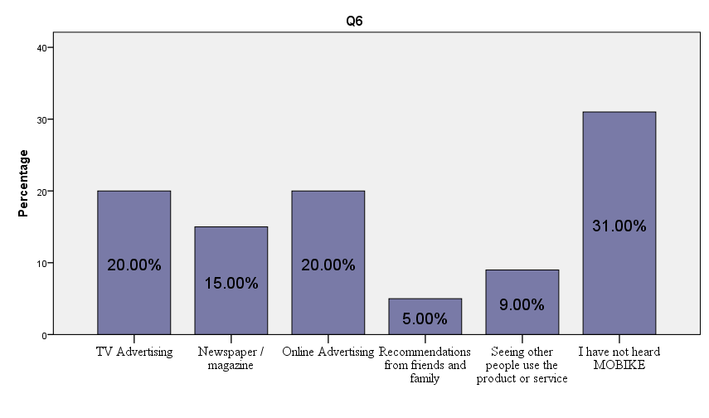
Figure 4. 8 Informed of the situation Mobike's marketing channels

According to Figure 4.8, the 20% of people know Mobike through TV advertising. Online advertising and the number of TV advertising of the same. The 15% of people know Mobike through Newspaper or magazine. From the surveyed result, there is 31% people who has not heard Mobike yet. From these percent, there is still a large part of people who still not know Mobike.

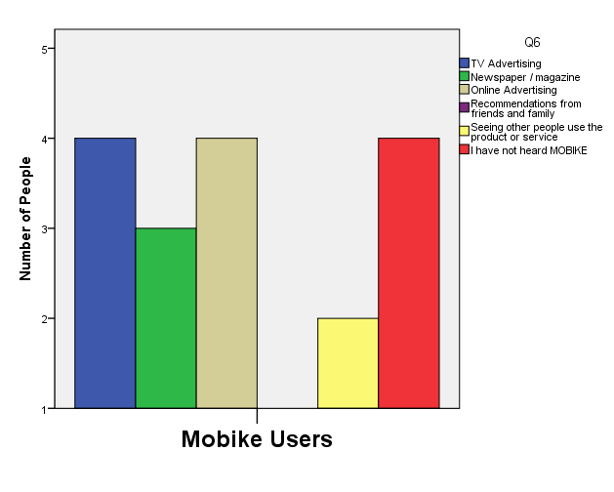
Figure 4. 9 Mobike's promotional approach
According to Figure 4.9 can know. The advertising channels of Mobike mainly are TV Advertising, Newspaper/magazine and Online Advertising. On the aspect of publicity channels, advertising is the primary approach for most Mobike users to know about Mobike, followed by seeing other people uses the product or service and recommendations from friends and family. It can be seen from it that advertising is currently the most popular ways for bike sharing users.

In conclusion, the main problems Mobike may face is that people have many different choices of travel method, such as private cars or bus, underground, tram and light rail. Mobike in the UK bike sharing market competition, there are also many competition Opponents like Ofo and Santander Cycles. Also, many illegal breaking problems also affect the use of Mobike. The advertisement also shows that there are still a lot of people not even heard Mobike.

4.3 People Opinion Towards Mobike
Besides the obstacles Mobike may face, this research also explored people’s views on Mobike, and to research whether people will accept this new way to travel.

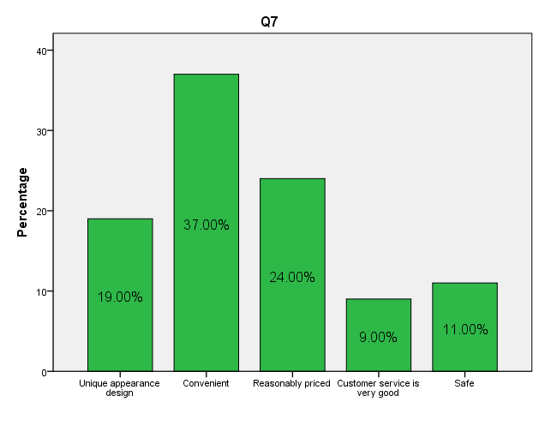
Figure 4. 10 The proportion of people's views on Mobike

According to Figure 4.10 can know, the 37% of people believe that the use of Mobike very convenient. Approximately one fifth of bike sharing users think that the design of Mobike bikes is quite unique. In addition to convenience and unique appearance design among the impression of bike sharing users, there are 24% users of bike sharing users believe that Mobike price is very reasonable.

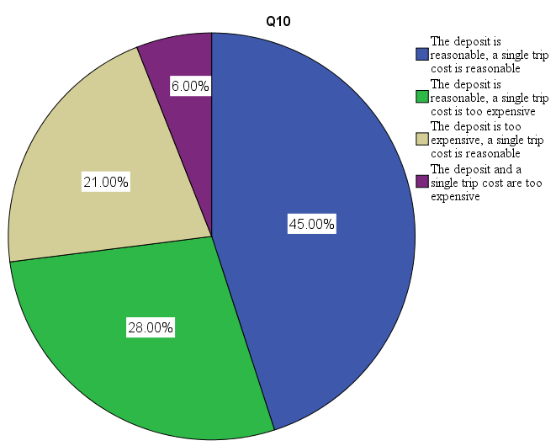
Figure 4. 11 Customer satisfaction with Mobike prices

It can be seen from Figure 4.11 nearly half of the bike sharing users believes that the mobike charges are reasonable and only 6% of bike sharing users think Mobike's charges are very expensive. The 28% of users think the deposit is reasonable, the single trip cost is too expensive. On the contrary, the 21% of users think the deposit is too expensive, the single trip cost is reasonable.

After analyzing the bike sharing user's impression of mobike, it is necessary to get to know users who have not yet used mobike. These users are Mobike's potential customers, so for those potential customers, the reasons why these potential customers are not using Mobike are investigated.

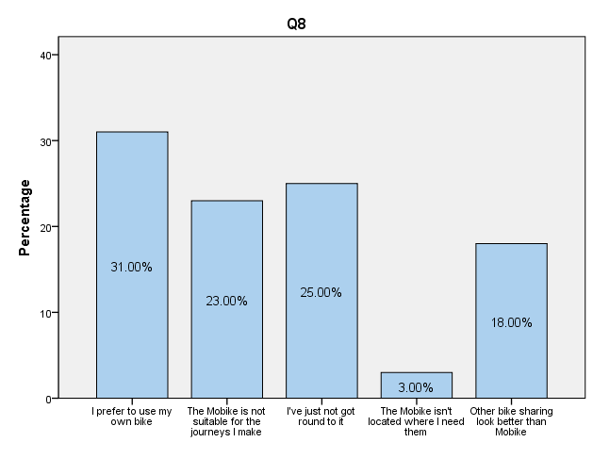
Figure 4. 12 What are the reasons for not using Mobike?

It is shown in the bar chart of Figure 4.12 that the 31% percent people prefer to use their own bike. The 23% of the people said that Mobike was not suitable for their journey. The 18% of people chose that the other bike sharing look better than mobike. The 25% of people said they didn’t have opportunity to use Mobike temporarily. The 3% of people selected the Mobike isn’t located where I need them.

4.4 People's Views on the Future of Mobike
This research analyzes customers’ views on the future of Mobike. This research can know customers’ perceptions of mobike can helps reduce traffic congestion in cities. As well as, this research can know whether people accept the Mobike into their city. Finally, through the analysis, it can know how many people are willing to recommend Mobike to others.

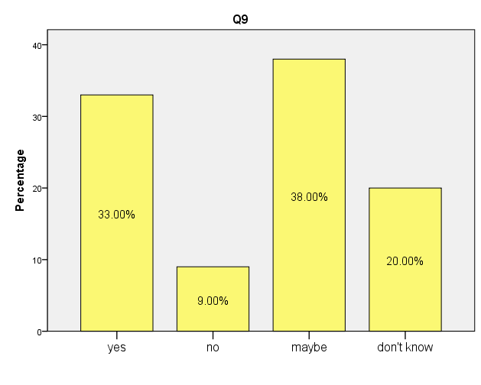
Figure 4. 13 People's opinion on Mobike's alleviation of traffic congestion

According to data from Figure 4.13, more than two-thirds of people said that Mobike could ease traffic jams. One-fifth of people said that they had no ideas and remained neutral. Only 9% of people said that Mobike could not ease traffic jams.

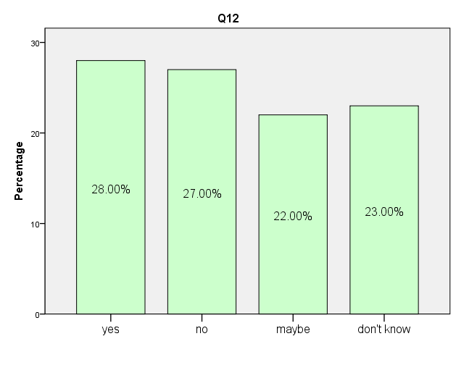
Figure 4. 14 People's views on MOBIKE entering their city

According to data from Figure 4.14, the 28% of people hope Mobike to enter their cities. There are 22% of people who said that they can accept Mobike's entry. But 27% of people hold the opposite view and do not hope to see Mobike’s entry into their city.

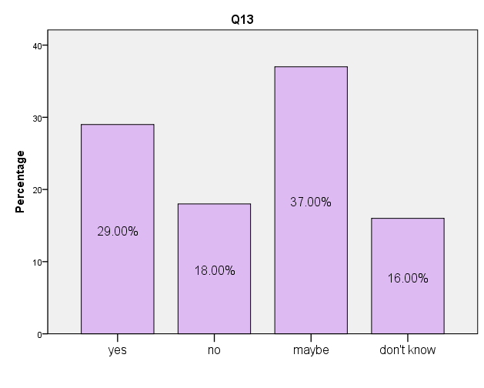
Figure 4. 15 People recommend Mobike to other people

By analyzing the data of Figure 4.15, it can be learned that 29% of people are willing to recommend Mobike to relatives and friends. The 37% said that they may recommend Mobike users, add to the 16% of users who have no ideas; there are a total of 53% users to be neutral.

In conclusion, even if there are still some problems on Mobike, people still think Mobike is promising, such as beneficial in easing traffic jams, and people expect Mobike to enter into their cities and are willing to recommend Mobike to relatives and friends.

5.0 Analysis
This research was completed the analysis of the results. Next, the results and literature review combined for analysis. According to the results of the analysis can get the following points.

5.1 The Main Consumers of Bike Sharing
The majority of bike sharing users are 18-40 years old. Bike sharing has complied with the rule that no bicycles are allowed under the age of 18. These users are mainly university students and service and sales workers. For these users, as long as they pay a low deposit and user fees, they can travel by bike, for the purpose of convenience and for saving the cost of buying their own bicycles. Young people become the main force of bike users, for whom bicycle riding is also a more acceptable way of travel and exercise. But, the bicycle sharing users not only cover young groups, the bike sharing has been accepted by people of all ages. Which furthermore indicating that Mobike are loved by all age groups. Mobike has the potential to enter the UK market.

5.2 The Main Competitors of Mobike
Mobike entered the British bike sharing market and encountered many competitors. The main competitors are Santander Cycles and Ofo.

Santander Cycles is an established British bike sharing company with public bike system. Santander Cycles’ original name was Boris bike. Boris bike is sponsored by Barclays Bank (Norcliffe, 2016). Since 2013, Santander Bank has become the main sponsor and its body color has also turned into bright red color with the bank Logo’s color (Tfl.gov.uk, 2015).

Although Santander Cycles is the localization of British bike sharing company. Compared to the Santander Cycles public bicycle system, Ofo and Mobike use the Dockless system. Dockless is more convenient than the public bicycle system, and users no longer need to go to the designated docking piles(Xiong,2017). So Ofo and Mobike can enter the UK market in a short time and have a certain market share.

Both Ofo and Mobike are come from China, entered the UK at the same time in 2017. There are many brands of Bike-sharing appearing in China’s shared bike market, the competition among them are quite fierce. In June 2017, under intense competition in the market, Ofo and Mobike accounted for 51.9% and 45.2% respectively among China’s largest sharing bike APP active users coverage rate (Analysys, 2017). Ofo and Mobike has become indispensable transportation vehicles for China’s people. So, even entered the UK bike sharing market. The number of Mobike users and Ofo users are still similar.

Men are very fond of high tech and premium products. They may choose products more sense of technology. For example, Electric car balance (Kotze, Anderson & Summerfield, 2016). In the Figure 4.5, some people have never used the bike sharing, which are mostly male. This is mainly because that compared to the female, the male has more requirements for the bicycles. Many males are riding bicycles, but the bicycles are their own entire mountain bike or all kinds of racing bikes (Reid, 2017). Although the bike sharing is quite convenient, but their cycling experience is less comparable than the bicycles elaborately selected. Instead, because of the convenience of the bike sharing, the female is especially fond of using bike sharing.

Mobike still has a unique competitive advantage with so many competitors, so has the potential to enter the UK market.

5.3 The Difficulties Faced by Mobike
According to table 4.1, besides bike sharing, British are more likely to travel by bicycle with their own, by private car or walking, travel by bus, underground, tram and light rail and so on. So, British have multi choices and the sharing public bike or Mobike is not their only choice. This may also be the problem Mobike faced.

Mobike announced its entry into Manchester on June 13, 2017. Many Mancunians praise Mobike on social media, but some Mancunians seemed to have no idea of bike sharing, and the police have received a spate of reports about Mobike, such as vandalism, throwing Mobike into the canal by someone; some people taking the place of the locks with private locks in an attempt to turn shared bikes into private bikes, or some people parking their bikes in their own homes or gardens instead of parking in public places (Kirby, 2017).

These illegal activities that with the increase of Mobike vehicle numbers, the number of artificial damage bicycles may become more, resulting in the increase in the cost of Mobike maintenance.

Mobike not high market share in the UK and encountered many illegal behaviors. It can be concluded that Mobike’s propaganda in the UK is not enough. Mobike may need more publicity to let more British people know the Mobike. Mobike needs more publicity to let the British people realize that the destruction and theft of bicycles is illegal.

5.4 British Impression of Mobike
When it comes to the impression for Mobike, most of the bike sharing users think it is quite convenient to use Mobike, which origins from the Dockless system Mobike adopts, it is more convenient for bike sharing users to rent bikes and return bikes. The bikes of Mobike are professionally designed to apply many high technologies to them, which make the bikes sturdy and durable, and thus reduce maintenance costs. Moreover, Mobike’s bicycle appearance is deliberately designed to make Mobike with higher distinctiveness on the streets.
Mobike is very convenient to use, the unique appearance design and reasonable price are the advantages of Mobike. However, it can be seen from Figure 4.10 that there are still some bike sharing users are dissatisfied with Mobike. This dissatisfaction is reflected on the safety and the customer service of Mobike, and only 11% of users think that Mobike is safe and 9% of users think that the customer service of Mobike is very good. From the two sets of data, it can be analyzed that the safety and customer service of Mobike have not reached the satisfaction of bike sharing users.

The British are very fond of cycling and many British people have their own bicycles. There are very strict rules to cycling in the United Kingdom. Cyclists generally wear special safety helmets. On rainy days or at night they are required to wear reflective vest (Gov.uk, 2015). Therefore, those who own private bicycles are unwilling to give up their bicycles and protective equipment, thereby abandoning using Mobike. It is difficult for them to become Mobike’s potential customers. In addition, there are some people hard to become potential users of Mobike, because they are loyal customers of other bike sharing brands.

Some people are reluctant to use Mobike. The reasons why these people do not use Mobike may be related to topography and regulations. Except for a few plains and basins, there are lots of hills and the terrain is very rugged across the UK (McCormack & Rowe, 2014). For example, there are lots of steep slopes in Swansea, people have to control the speed to avoid pedestrians when downhill and it’s hard to ride and only can push the bike to move when uphill, which are not suitable for the development of Mobike. In addition to terrains, strict rules in some parts of the UK may cause people to give up Mobike. For example, it is stipulated in the British Highway Code that people are not allowed to ride on sidewalks, but only allowed to ride bicycles on bike lanes and motorways (Gov.uk, 2015). Some people live in places where there are no bicycle paths and think that cycling on motorways is very dangerous, so they may give up using Mobike.
Some people have not had an opportunity to use Mobike. Those people belonged to potential users of Mobike. Potential users refer to those who have not yet used bike sharing but have the needs and purchasing power to buy bike sharing services (Fishman, Washington & Haworth, 2013). These potential users can become Mobike's loyal customers as long as Mobike make great efforts on them. In addition, some people reflect Mobike not widely available in the UK market. If Mobike put some bikes throughout the UK, it will have more Britons become Mobike users.

5.5 The Future Development of Mobike
All countries in the world vigorously advocate the concept of green environmental protection and healthy travel, and the emergence of bike sharing is consistent with the concept of green civilization in each country. The vigorous development of Mobike in the city provide a great convenience to Mobike users’ short trips, reduces Mobike users’ dependence on private cars, thus saves urban space and eases traffic jams.

Mobike will enter more British cities, and most people welcome it. However, there are still a small number of people do not want to Mobike entry. Some of these are loyal users of other bike sharing brands.

After systematically dealing with each aims and objectives of this research, conclusions can now be drawn and corresponding recommendations made. Overall, Mobike has potential for development in the UK. In the next chapter, this report will give some recommendations about Mobike strengthen strategies to enter the UK market.

6.0 Conclusion
This research conducts detailed study on British bike sharing market based on the relevant marketing theories, explores the potential of Mobike in British bike sharing market. The following conclusions can be drawn from the analysis. The first, British bike sharing market has great potential, but in the British bike sharing market, Mobike needs to compete with many rivals. These competitors have competitive advantage which Mobike doesn’t have. If Mobike wants to expand its market share in the British bike sharing market, Mobike must do better than competitors. The second, Mobike has the characteristics of fashion and beauty, which can attract people quickly, but the product itself has some defects and needs to keep improving to make the product more convenient. The third, compared to other bike sharing brands, the propaganda of Mobike is not enough. Mobike needs to enhance the publicity. Only better publicity can make more British people know Mobike and become the loyal users of Mobike. The fourth, as a new attempt of sharing economy in the area of mobile travel, Mobike can ease the traffic congestion in the UK. The concept of Mobike is sharing economy and green travelling. But willing to ease the British traffic jams, Mobike needs to have better communication with the British government. Finally, in the meanwhile, of considering how to better expand its market share, Mobike also needs to pay attention to some illegal acts. These illegal acts are not just for Mobike, but Mobike needs to think out some ways to prevent them. When these illegal acts occur, Mobike needs to think about how to solve them.

7.0 Recommendations

7.1 Developing the Supply Chain of Bikes
Facing the British huge bike sharing market, Mobike needs put a lot of bikes to form a scale effect. This means that with the same capital, Mobike should release more relatively inexpensive bikes. This helps to promote the scale effect and be of more cost and price advantages and provide users with a more convenient experience. Mobike should have in depth cooperation with the British quality bike factories to produce low-cost cycling equipment to mitigate the loss and theft of bikes by reducing the costs of sources.

7.2 Improve Bike’s Alarm Technology
Mobike can try the following ways: if Mobike's bike is unlocked and the bike's position moves 100 meters, the sound and light alarms of the bike will be automatically triggered. For the zones that are prone to bike damages, targeted operational activities can be organized, such as invite some British famous stars to ride Mobike and persuade peripheral users to love bicycles, which can make public opinions and promote social resources to carry out supervision.

7.3 Strengthening Cooperation with the British Government
In social economy, there is always a kind of PPP (Public-private Partnership) mode. Under this model, the cooperation between private enterprises, private capitals and government is encouraged to participate in the construction of public infrastructures, the former public bicycles belong to this mode. For the cooperation between Mobike and the British government, on the one hand it can play the respective advantages of British government and Mobike to make up for each other's shortcomings. The two parties can form mutually beneficial long-term goals and can provide high quality service to the public at the most effective cost. On the other hand, it can also use the power of traffic police to reduce the occurrence of bike damages and thefts. The participation of the British Government can also reduce various risks of Mobike.

7.4 Enhancing the Advertising
The ads of many companies have formed a torrent of information in marketing campaigns, and people face countless and endless ads every day. However, consumers’ information storage is limited. This requires Mobike to enhance the effectiveness of advertising. Creative advertising should originate from products and be higher than products. Creative advertising is based on product functional characteristics and is innovated under reasonable thinking mode of brand association. As one of the ways of green travelling, sharing bike can relieve the traffic pressure very well. Mobike can make advertising films in accordance with London's traffic jams. This ad can promote the role of Mobike in helping London ease traffic jams.

7.5 Strengthen Communication with Customers
Mobike should strengthen bidirectional information communication with customers. The feedback of traditional media such as television, magazines and newspapers are very poor, but the emerging media-network is of strong interaction and timely communication. Mobike can collect customers’ suggestions through creating a network forum and interacting with customers in the forum. This is beneficial for Mobike to make rapid response according to the changes of consumers’ demands, so as to make corresponding market strategy.

7.6 Limitations of the Research
Because of the constraints in terms of both time and word count, this report only studied relevant parts of Mobike's market potential in the UK. Although careful consideration was made during the writing of the dissertation. In particular, looking for theoretical knowledge, questionnaire design and analysis, repeated thinking and research. However, this report there are still some limitations. Although the theoretical derivation of the paper introduces the theory of market potential. But, the theory is not enough and the analysis is not deep. Limited to research time and personal capacity, only 100 data samples. If this research has more time and manpower, the conclusions of this research will have a higher persuasiveness and credibility. These limitations of research to be refined and improved in the future.

7.7 Potential Future Studies
At present, completed a research on Mobike into the UK market potential. Next, need to research Mobike how to profit in the UK market. Mobike can analyze bike sharing market in the UK through PEST analysis, SWOT analysis and 7P marketing theory. Through analysis and research, Mobike can find a sustainable profit model.

On July 25, 2017, Mobike officially entered Italy, entering cities including Florence and Milan. After Singapore, Britain and Japan. Italy became the fourth overseas country that Mobike entered. In addition to the UK and Italy, Mobike need to investigate and research how to enter other European countries.

Currently, Mobike into the city belong to the big cities, competition is very fierce these cities. Therefore, Mobike needs entry into smaller provincial cities outside of the major metropolises. These small cities market demand is very small, but the small city of people are very eager to use the bike sharing.

Mobike can uniquely designed bicycles, according to particular demographics. For example, for the elderly over 60 years old. Mobike can put some display panels in the parking place of the bike sharing. The display panel can give older people introducing how to use the bike sharing and the relevant knowledge of bike sharing. In addition, Mobike in some large bike rental places, can additional fixed time artificial rental service.

8.0 References
Airbnb. (2015). Airbnb Celebrates 1 Million Total Guests from the United Kingdom - Airbnb. [online] Available at: https://www.airbnb.co.uk/press/news/airbnb-celebrates-1-million-total-guests-from-the-united-kingdom [Accessed 15 Nov. 2017].

Alexander Di Pofi, J. (2002). Organizational diagnostics: integrating qualitative and quantitative methodology. Journal of organizational change management, 15(2), 156-168.

Aliya, R. (2017). China bike-sharing apps find UK market tough to crack. [online] Available at: https://www.ft.com/content/7456ed4e-e46c-11e7-97e2-916d4fbac0da [Accessed 18 Jan. 2018].

Allen, I. E., & Seaman, C. A. (2007). Likert scales and data analyses. Quality progress, 40(7), 64.

Allen, R. E. (2016). Financial crises and recession in the global economy. Edward Elgar Publishing.

Alvesson, M., & Sköldberg, K. (2017). Reflexive methodology: New vistas for qualitative research. Sage.

Analysys. (2017). June 2017 China bike sharing market. [online] Available at: https://www.analysys.cn/analysis/trade/detail/1000833/ [Accessed 18 Dec. 2017].

Antwi, S. K., & Hamza, K. (2015). Qualitative and quantitative research paradigms in business research: A philosophical reflection. European Journal of Business and Management, 7(3), 217-225.

Babones, S. (2016). Interpretive quantitative methods for the social sciences. Sociology, 50(3), 453-469.

Belk, R. (2014). Sharing versus pseudo-sharing in Web 2.0. Anthropologist, 18(1), 7-23.

Bernard, H. R., & Bernard, H. R. (2012). Social research methods: Qualitative and quantitative approaches. Sage.

Bernard, H.R. (2011) “Research Methods in Anthropology” 5th edition, AltaMira Press, p.7

Blair, J., Czaja, R. F., & Blair, E. A. (2013). Designing surveys: A guide to decisions and procedures. Sage Publications.

Bleicher, J. (2014). The Hermeneutic Imagination (RLE Social Theory): Outline of a Positive Critique of Scientism and Sociology. Routledge.

Boland, L. A. (1991). Current views on economic positivism. Companion to contemporary economic thought, 88-104.

BONOMI, D. (2017). Saan. Umbrella sharing in Shanghai.

Botsman, R. (2010). Rachel Botsman: The Case for Collaborative Consumption. TED.

Botsman, R., & Rogers, R. (2010). What’s mine is yours. The rise of collaborative consumption.

Brace, I. (2008). Questionnaire design: How to plan, structure and write survey material for effective market research. Kogan Page Publishers.

Brannen, J. (Ed.). (2017). Mixing methods: Qualitative and quantitative research. Routledge.

Bryant, C. G. (1985). Positivism in social theory and research. Macmillan.

Bryman, A. (2012). Social research methods (5th ed.). Oxford: Oxford University Press.

Bryman, A. (2015). Social research methods. Oxford university press.

Bryman, A., & Bell, E. (2015). Business research methods. Oxford University Press, USA.

Carplus (2015). Bike sharing | Carplus. [online] Available at: https://www.carplusbikeplus.org.uk/what-is-shared-mobility/bike-sharing/ [Accessed 18 Jan. 2018].

Carplusbikeplus.org.uk. (2017). Public Bike Share Users Survey Results 2017. [online] Available at: https://www.carplusbikeplus.org.uk/wp-content/uploads/2017/01/Public-Bike-Share-User-Survey-2017-A4-WEB-1.pdf [Accessed 12 Dec. 2017].

Chen, L., Ma, X., Pan, G., & Jakubowicz, J. (2017). Understanding bike trip patterns leveraging bike sharing system open data. Frontiers of computer science, 11(1), 38-48.

Chen, S., Xu, H., Liu, D., Hu, B., & Wang, H. (2014). A vision of IoT: Applications, challenges, and opportunities with china perspective. IEEE Internet of Things journal, 1(4), 349-359.

China Academy of Information and Communications Technology (2018). China Bike sharing industry development index report (Fourth quarter 2017) [ebook]. Available at: http://www.caict.ac.cn/kxyj/qwfb/ztbg/201803/P020180305560121853239.pdf [Accessed 27 Feb. 2018].

Christensen, H. R. (2017). Is the Kingdom of Bicycles Rising Again?: Cycling, Gender, and Class in Postsocialist China. Transfers, 7(2), 1-20.

Cohen, B., & Kietzmann, J. (2014). Ride on! Mobility business models for the sharing economy. Organization & Environment, 27(3), 279-296.

Collis, J. and Hussey, R. (2009). Business research: a practical guide for undergraduate and postgraduate students. 3rd ed. Basingstoke: Palgrave Macmillan, pp.209-214.

Comte, A. (1880). A general view of positivism. Reeves & Turner.

Contardo, C., Morency, C., & Rousseau, L. M. (2012). Balancing a dynamic public bike-sharing system (Vol. 4). Montreal: Cirrelt.

Converse, J. M., & Presser, S. (1986). Survey questions: Handcrafting the standardized questionnaire (Vol. 63). Sage.

Cooper, D. R., Schindler, P. S., & Sun, J. (2006). Business research methods (Vol. 9). New York: McGraw-Hill Irwin.

Crotty, M. (1998). The foundations of social research: Meaning and perspective in the research process. Sage.

Cui, G., Fan, J., Qin, Y., Wang, D., & Chen, G. (2017, May). Design and Implementation of Demand Response Information Interactive Service Platform Based on “Internet Plus” Smart Energy. In IOP Conference Series: Earth and Environmental Science (Vol. 64, No. 1, p. 012087). IOP Publishing.

Cusumano, M. A. (2015). How traditional firms must compete in the sharing economy. Communications of the ACM, 58(1), 32-34.

Cyberspace Administration of China. (2017). 40th China statistical report on Internet development. [online] Available at: http://www.cac.gov.cn/2017-08/04/c_1121427728.htm [Accessed 14 Dec. 2017].

Davies, M. B., & Hughes, N. (2014). Doing a successful research project: Using qualitative or quantitative methods. Palgrave Macmillan.

Dell, R. M., Moseley, P. T., & Rand, D. A. (2014). Towards sustainable road transport. Academic Press.

DeMaio, P. (2009). Bike-sharing: History, impacts, models of provision, and future. Journal of public transportation, 12(4), 3.

DeMaio, P. J. (2003). Smart bikes: Public transportation for the 21st century. Transportation Quarterly, 57(1), 9-11.

Dittmar, H., Beattie, J., & Friese, S. (1995). Gender identity and material symbols: Objects and decision considerations in impulse purchases. Journal of economic psychology, 16(3), 491-511.

Eriksson, P., & Kovalainen, A. (2015). Qualitative methods in business research: A practical guide to social research. Sage.

Felson, M., & Spaeth, J. L. (1978). Community structure and collaborative consumption: A routine activity approach. American Behavioral Scientist, 21(4), 614-624.

Fishman, E., Washington, S., & Haworth, N. (2013). Bike share: a synthesis of the literature. Transport reviews, 33(2), 148-165.
Flick, U. (2011). Introducing research methodology: A beginner's guide to doing a research project. London: Sage.

Frankel, M. S., & Siang, S. (1999). Ethical and legal aspects of human subjects research on the Internet. Published by AAAS online.

French, S., & Showers, L. (2008). Consumer lifestyles of health and sustainability: Insights from green consumer market segmentation. Research Review, 15(1), 31-34.

Friston, K. J., Holmes, A. P., Worsley, K. J., Poline, J. P., Frith, C. D., & Frackowiak, R. S. (1994). Statistical parametric maps in functional imaging: a general linear approach. Human brain mapping, 2(4), 189-210.

Garthwaite, J. (2011). Bike-Share Schemes Shift Into High Gear. [online] Available at: http://news.nationalgeographic.com/news/energy/2011/06/110607-global-bike-share [Accessed 26 Oct. 2017].

Goddard, W. & Melville, S. (2004) “Research Methodology: An Introduction” 2nd edition, Blackwell Publishing

Gorard, S. (2003). Quantitative methods in social science research. A&C Black.

Gov.uk. (2014). Move to make UK global centre for sharing economy - GOV.UK. [online] Available at: https://www.gov.uk/government/news/move-to-make-uk-global-centre-for-sharing-economy [Accessed 27 Nov. 2017].

Gov.uk. (2015). Independent review of the sharing economy: Government response. [online] Available at: https://www.gov.uk/government/uploads/system/uploads/attachment_data/file/414111/bis-15-172-government-response-to-the-independent-review-of-the-sharing-economy.pdf [Accessed 26 Dec. 2017].

Gov.uk. (2015). Rules for cyclists (59 to 82) - The Highway Code - Guidance - GOV.UK. [online] Available at: https://www.gov.uk/guidance/the-highway-code/rules-for-cyclists-59-to-82 [Accessed 8 Mar. 2018].

Gregory, A., & Halff, G. (2017). Understanding public relations in the ‘sharing economy’. Public Relations Review, 43(1), 4-13.

Grimm, L. G. (1993). Statistical applications for the behavioral sciences. Wiley.

Hamari, J., Sjöklint, M., & Ukkonen, A. (2016). The sharing economy: Why people participate in collaborative consumption. Journal of the Association for Information Science and Technology, 67(9), 2047-2059.
Harriss, D. J., & Atkinson, G. (2009). International Journal of Sports Medicine–ethical standards in sport and exercise science research. International Journal of Sports Medicine, 30(10), 701-702.

Hazael,V. (2015). A guide to child bike seats | Cycling UK. [online] Available at: https://www.cyclinguk.org/guide/guide-to-child-bike-seats [Accessed 3 Mar. 2018].

Hira, A., & Reilly, K. (2017). The Emergence of the Sharing Economy: Implications for Development. Journal of Developing Societies, 0169796X17710071.

Huang, E. (2017). China’s “Uber for bikes” startups are being taken for a ride by thieves, vandals, and cheapskates. [online] Quartz. Available at: https://qz.com/919739/chinese-bike-sharing-startups-like-ofo-and-mobike-are-being-taken-for-a-ride-by-thieves-vandals-and-cheapskates/ [Accessed 14 Jan. 2018].

Hughes, K. (2017). A decade after the financial crisis consumers are still worried. [online] Independent. Available at: http://www.independent.co.uk/money/spend-save/decade-after-financial-crisis-recession-debt-inflation-credit-crunch-a7883791.html [Accessed 16 Dec. 2017].

Iimedia. (2017). 2017 china bike sharing market report. [online] Available at: http://www.iimedia.cn/59210.html [Accessed 17 Dec. 2017].
Ji, S., Cherry, C. R., Han, L. D., & Jordan, D. A. (2014). Electric bike sharing: simulation of user demand and system availability. Journal of Cleaner Production, 85, 250-257.

Jiang, B., Liang, S., Peng, Z. R., Cong, H., Levy, M., Cheng, Q., ... & Remais, J. V. (2017). Transport and public health in China: the road to a healthy future. The Lancet, 390(10104), 1781-1791.

Kelle, U. (2006). Combining qualitative and quantitative methods in research practice: purposes and advantages. Qualitative research in psychology, 3(4), 293-311.

Kelley, K., Clark, B., Brown, V., & Sitzia, J. (2003). Good practice in the conduct and reporting of survey research. International Journal for quality in health care, 15(3), 261-266.

Kirby, D. (2017). Mobike: Manchester takes to bike sharing (with a few little wobbles). [online] iNews. Available at: https://inews.co.uk/sport/cycling/manchester-bike-share-scheme-mobike/ [Accessed 5 Feb. 2018].

Kothari, C. R. (2004). Research methodology: Methods and techniques. New Age International.

Kotze, T. G., Anderson, O., & Summerfield, K. (2016). Technophobia: Gender differences in the adoption of high-technology consumer products. South African Journal of Business Management, 47(1), 21-28.

Krosnick, J. A. (1999). Survey research. Annual review of psychology, 50(1), 537-567.

Lan, J., Ma, Y., Zhu, D., Mangalagiu, D., & Thornton, T. F. (2017). Enabling Value Co-Creation in the Sharing Economy: The Case of Mobike. Sustainability, 9(9), 1504.

Leech, N. L., & Onwuegbuzie, A. J. (2009). A typology of mixed methods research designs. Quality & quantity, 43(2), 265-275.

Lefever, S., Dal, M., & Matthiasdottir, A. (2007). Online data collection in academic research: advantages and limitations. British Journal of Educational Technology, 38(4), 574-582.

Lehofer, M., Heiss, M., Rogenhofer, S., Weng, C. W., Sturm, M., Rusitschka, S., & Dippl, S. (2016, April). Platforms for Smart Cities–connecting humans, infrastructure and industrial IT. In Science of Smart City Operations and Platforms Engineering (SCOPE) in partnership with Global City Teams Challenge (GCTC)(SCOPE-GCTC), 2016 1st International Workshop on (pp. 1-6). IEEE.

Li, Z., Wang, W., Yang, C., & Ding, H. (2017). Bicycle mode share in China: a city-level analysis of long term trends. Transportation, 44(4), 773-788.

Lodico, M.G., Spaulding, D.T &Voegtle, K.H. (2010) “Methods in Educational Research: From Theory to Practice” John Wiley & Sons, p.10

Lyons, I. (2017). Vandalism to Manchester's Mobikes has forced owners to write off 70 bikes in just six months. [online] Available at: https://www.manchestereveningnews.co.uk/news/greater-manchester-news/vandalism-manchesters-mobikes-forced-owners-14029395 [Accessed 15 Jan. 2018].

Malhotra, A., & Van Alstyne, M. (2014). The dark side of the sharing economy… and how to lighten it. Communications of the ACM, 57(11), 24-27.

Mattlamy (2018). A guide to hire bikes and public bike share schemes | Cycling UK. [online] Available at: https://www.cyclinguk.org/article/guide-hire-bikes-and-public-bike-share-schemes [Accessed 19 Jan. 2018].

May, S., Königsson, M., & Holmstrom, J. (2017). Unlocking the sharing economy: Investigating the barriers for the sharing economy in a city context. First Monday, 22(2).
McCormack, E., & Rowe, D. H. (2014). Bike-share planning in cities with varied terrain. Institute of Transportation Engineers. ITE Journal, 84(7), 31.

Mhute, I. (2013). ACADEMIC STANDARDS, PLAGIARISM, AND RESEARCH ETHICS. Preparing your Dissertation at a Distance: A Research, 53.

Miller Jr, R. G. (1997). Beyond ANOVA: basics of applied statistics. CRC press.

Mingrui, H. (2018). Bike-sharing boom enters smooth path. [online] Available at: http://www.ecns.cn/business/2018/01-10/287753.shtml [Accessed 16 Jan. 2018].

Mobike (2017). About Mobike. [online] Available at: https://mobike.com/cn/about [Accessed 22 Nov. 2017].

Mobike (2017). Mobike enter Berlin. Achieve the goal of 200 cities in the world. [online] Available at: https://mobike.com/cn/news/430 [Accessed 29 Nov. 2017].

Mobike (2017). Mobike enter Manchester. Completed into the 100th city in the world. [online] Available at: https://mobike.com/cn/news/271 [Accessed 24 Oct. 2017].

Mobike (2017). Mobike Technology. [online] Available at: https://mobike.com/cn/made-by-mobike/ [Accessed 22 Nov. 2017].
Mobike Global. (2017). Mobike Changes Cities with the Help of Big Data and AI. [online] Available at: https://mobike.com/global/blog/post/mobike-ai-big-data [Accessed 5 Dec. 2017].

Mobike. (2017). Financing situation. [online] Available at: https://mobike.com/cn/investors/ [Accessed 12 Nov. 2017].

Morse, J. M. (2003). Principles of mixed methods and multimethod research design. Handbook of mixed methods in social and behavioral research, 1, 189-208.

Mosteller, F., & Tukey, J. W. (1977). Data analysis and regression: a second course in statistics. Addison-Wesley Series in Behavioral Science: Quantitative Methods.

MOT. (2017). Guidelines on encouraging and regulating Internet rental bicycles Development. [online] Available at: http://www.gov.cn/xinwen/2017-08/03/content_5215640.htm [Accessed 27 Dec. 2017].

Neuman, L. W. (2014). Social research methods. Pearson Education Limited.

Neuman, W. L. (2003) “Social Research Methods: Qualitative and Quantitative Approaches” Allyn and Bacon

Nextbike.co.uk. (2017). Glasgow - nextbike Glasgow Glasgow. [online] Available at: https://www.nextbike.co.uk/en/glasgow/ [Accessed 17 Jan. 2018].

Nielsen (2014). Global Consumers Embrace the Share Economy. [online] Available at: http://www.nielsen.com/apac/en/press-room/2014/global-consumers-embrace-the-share-economy.html [Accessed 17 Dec. 2017].

Norcliffe, G. (2016). Critical geographies of cycling: History, political economy and culture. Routledge.

Nosek, B. A., Banaji, M. R., & Greenwald, A. G. (2002). E‐research: ethics, security, design, and control in psychological research on the internet. Journal of Social Issues, 58(1), 161-176.

Office for National Statistics. (2013). Graduates in the UK Labour Market. [online] Available at: https://www.ons.gov.uk/employmentandlabourmarket/peopleinwork/ employmentandemployeetypes/articles/graduatesintheuklabourmarket/2013-11-19 [Accessed 15 Dec. 2017].

Parkes, S. D., Marsden, G., Shaheen, S. A., & Cohen, A. P. (2013). Understanding the diffusion of public bikesharing systems: evidence from Europe and North America. Journal of Transport Geography, 31, 94-103.
Passmore, J., & Marić, S. (1966). A hundred years of philosophy (p. 55). London: Duckworth.

Pidd, H. (2017). Manchester’s bike-share scheme isn't working – because people don't know how to share. [online] Available at: https://www.theguardian.com/commentisfree/2017/jul/16/manchesters-bike-share-scheme-isnt-working-because-people-dont-know-how-to-share [Accessed 9 Jan. 2018].

Pucher, J., & Buehler, R. (2017). Cycling towards a more sustainable transport future.

Quattrone, G., Proserpio, D., Quercia, D., Capra, L., & Musolesi, M. (2016, April). Who benefits from the sharing economy of Airbnb?. In Proceedings of the 25th International Conference on World Wide Web (pp. 1385-1394). International World Wide Web Conferences Steering Committee.

Reid, C. (2017). Cycling in Britain—From Swarms to Sustrans (1942–1979). In Bike Boom (pp. 77-108). Island Press, Washington, DC.

Resnik, D. B. (2015). What is ethics in research & why is it important. In ideas.

Rice, W. R. (1989). Analyzing tables of statistical tests. Evolution, 43(1), 223-225.

Richardson, L. (2015). Performing the sharing economy. Geoforum, 67, 121-129.

Rifkin, J. (2014). The zero marginal cost society: The internet of things, the collaborative commons, and the eclipse of capitalism. St. Martin's Press.

Rovai, A. P., Baker, J. D., & Ponton, M. K. (2013). Social science research design and statistics: A practitioner's guide to research methods and IBM SPSS. Watertree Press LLC.

Ruan, Y., Hang, C. C., & Wang, Y. M. (2014). Government׳ s role in disruptive innovation and industry emergence: The case of the electric bike in China. Technovation, 34(12), 785-796.

Saunders, M., Lewis, P. & Thornhill, A. (2012) “Research Methods for Business Students” 6th edition, Pearson Education Limited

Saunders, M., Lewis, P., & Thornhill, A. (2009). Research Onion. Research methods for business students, 136-162.

Scott, I., & Brown, E. (2016). Redefining and Regulating the New Sharing Economy. U. Pa. J. Bus. L., 19, 553.

Sechrest, L., & Sidani, S. (1995). Quantitative and qualitative methods: Is There an Alternative? Evaluation and program planning, 18(1), 77-87.

Shaheen, S., & Guzman, S. (2011). Worldwide bikesharing. Access Magazine, 1(39).

Shaheen, S., Guzman, S., & Zhang, H. (2010). Bikesharing in Europe, the Americas, and Asia: past, present, and future. Transportation Research Record: Journal of the Transportation Research Board, (2143), 159-167.

Shaheen, S., Zhang, H., Martin, E., & Guzman, S. (2011). China's Hangzhou public bicycle: understanding early adoption and behavioral response to bikesharing. Transportation Research Record: Journal of the Transportation Research Board, (2247), 33-41.

Silverman, D. (2015). Interpreting qualitative data. Sage.

Sokal, R. R. (1963). The principles and practice of numerical taxonomy. Taxon, 190-199.

State Information Center (2017). 2017 China sharing economy development report. [online] Available at: http://www.sic.gov.cn/News/250/7737.htm [Accessed 27 Dec. 2017].
Stevens, S. S. (1946). On the theory of scales of measurement.

Stokes, K., Clarence, E., Anderson, L., & Rinne, A. (2014). Making sense of the UK collaborative economy (pp. 1-47). Nesta.

Susan Shaheen, Stacey Guzman, and Hua Zhang.（2010）. “Bikesharing in Europe, the Americas, and Asia: Past, Present, and Future,” Transportation Research Record: Journal of the Transportation Research Board, 2143: 159–167.

Symon, G., Cassell, C., & Johnson, P. (2018). Evaluative practices in qualitative management research: A critical review. International Journal of Management Reviews, 20(1), 134-154.

Tashakkori, A., & Teddlie, C. (1998). Mixed methodology: Combining qualitative and quantitative approaches (Vol. 46). Sage.

Teddlie, C., & Tashakkori, A. (2009). Foundations of mixed methods research: Integrating quantitative and qualitative approaches in the social and behavioral sciences. Sage.

Tfl.gov.uk. (2015). Mayor announces Santander as new Cycle Hire sponsor. [online] Transport for London. Available at: https://tfl.gov.uk/info-for/media/press-releases/2015/february/mayor-announces-santander-as-new-cycle-hire-sponsor [Accessed 15 Jan. 2018].

Vogel, M., Hamon, R., Lozenguez, G., Merchez, L., Abry, P., Barnier, J., ... & Robardet, C. (2014). From bicycle sharing system movements to users: a typology of Vélo’v cyclists in Lyon based on large-scale behavioural dataset. Journal of Transport Geography, 41, 280-291.

Woo, S. (2017). Bike Sharing Hits Bumps --- Asian startups in race to expand abroad, but oBike finds Uber-like obstacles in London. Wall Street Journal, p.B.2.

Worldometers.info. (2018). U.K. Population (2018) - Worldometers. [online] Available at: http://www.worldometers.info/world-population/uk-population/ [Accessed 10 Mar. 2018].

Wosskow, D. (2014). Unlocking the sharing economy. An independent review.

Wright, K. B. (2005). Researching Internet-based populations: Advantages and disadvantages of online survey research, online questionnaire authoring software packages, and web survey services. Journal of computer-mediated communication, 10(3), JCMC1034.

Wu, F., & Xue, Y. (2017). Innovations of bike sharing industry in China: A case study of Mobike’s station-less bike sharing system.

Wu, K., Vassileva, J., & Zhao, Y. (2017). Understanding users' intention to switch personal cloud storage services: Evidence from the Chinese market. Computers in Human Behavior, 68, 300-314.

Xiong, S. (2017). An Internet-based short-distance travel solution in China: case: Mobike Technology Co, Ltd.

Yanow, D., & Schwartz-Shea, P. (2015). Interpretation and method: Empirical research methods and the interpretive turn. Routledge.

Yoshikawa, H., Weisner, T. S., Kalil, A., & Way, N. (2008). Mixing qualitative and quantitative research in developmental science: uses and methodological choices. Developmental psychology, 44(2), 344.

Yu, S. (2017). Mobike announces "Magic Cube," an AI made from its mountains of user data. [online] Available at: http://technode.com/2017/04/13/mobike-magic-cube-ai/ [Accessed 14 Dec. 2017].

Zervas, G., Proserpio, D., & Byers, J. W. (2014). The rise of the sharing economy: Estimating the impact of Airbnb on the hotel industry. Journal of Marketing Research.

Zhang, L., Zhang, J., Duan, Z. Y., & Bryde, D. (2015). Sustainable bike-sharing systems: characteristics and commonalities across cases in urban China. Journal of Cleaner Production, 97, 124-133.

Zhang, L., Zhang, J., Duan, Z. Y., & Bryde, D. (2015). Sustainable bike-sharing systems: characteristics and commonalities across cases in urban China. Journal of Cleaner Production, 97, 124-133.

Zipcar. (2013). CROYDON COUNCIL CUTS EMPLOYEE CAR USAGE IN HALF WITH ZIPCAR. [online] Available at: https://www.zipcar.co.uk/press/releases/croydon-council-cuts-employee-car-usage-in-half-with-zipcar [Accessed 2 Jan. 2018].

9.0 Appendices

9.1 Appendix 1 – Questionnaire

Survey on the development potential of Mobike in the British market
Nowadays, the sharing economy is more and more widely accepted by people around the world. All kinds of shared products have covered every aspect of our life. As a representative of the sharing economy, bike-sharing is popular all over the world. On June, 2017, Mobike entered Manchester. We need a questionnaire to research on the development potential of Mobike in the British market. Please answer the following questions according to your actual situation. Thank you for your cooperation and support.

1. What’s your gender?
□Male | □Female | □Prefer not to say

2. What is your age?
□18-30 years old | □30-45 years old | □46-60 years old | □Over 60 years old

3. What is your profession?
□Managers | □Professionals | □Students | □Technicians
□Service and sales workers | □Craft and related trades workers | □Plant and machine operators, and assemblers | □Others

4. Which bike-sharing are you a user of?
□Mobike | □Ofo | □Santander Cycles | □Obike
□Boris bikes | □Urbo | □Nextbike | □None

5. How often do you travel by the following modes? Please include all trips for work, leisure and shopping etc.

Travel mode | Frequency
Travel mode | Always | Very Often | Sometimes | Rarely | Never
Bus
Train
Taxi
Bicycle (own)
Public Bike Sharing
On demand taxi booked by an App
Private car as driver or passenger
Underground, tram, light rail
Walking (more than 20mins)

6. How did you know about Mobike?
□TV Advertising | □Newspaper / magazine | □Online Advertising
□Recommendations from friends and family | □Seeing other people use the product or service | □I have not heard of MOBIKE

7. What was your impression of Mobike?
□Unique appearance design | □Convenient | □Reasonably priced
□Customer service is very good | □Safe | □No feeling

8. If you want use Mobike but have not yet used the bikes what are your reasons?
□I prefer to use my own bike | □The Mobike is not suitable for the journeys I make | □I've just not got round to it | □I don’t know
□The Mobike isn't located where I need them | □Other bike sharing look better than Mobike | □It's too expensive | □Other

9. Do you believe that Mobike would help reduce traffic jams in the city?
□Yes | □No | □Maybe | □Don’t know

10. What’s your opinion about the charging standards of Mobike (One-time refundable deposit of £49. A single trip cost is 50p for every 30mins)?
□The deposit is reasonable, a single trip cost is reasonable
□The deposit is reasonable, a single trip cost is too expensive
□The deposit is too expensive, a single trip cost is reasonable
□The deposit and a single trip cost are too expensive

11. Have you ever seen illegal behaviors (like breaking bike-sharing, locking bike-sharing with his/her own lock)?
□Often see | □Occasionally see | □Didn’t see, but I heard | □Don’t know
12. Do you want Mobike to enter your city?
□Yes | □No | □Maybe | □Don’t know

13. Would you recommend Mobike to others people?
□Yes | □No | □Maybe | □Don’t know

9.1 Appendix 2 – Questionnaire Data

This research raw data has been placed in an Excel spreadsheet.

