Programme: BA (Hons) Leadership and Management Skills in the Workplace
Module: Project Management
Module code : LCDM5003
Tutor: Xavier Martine
Student mane : Glenda Matilde Cortez Marino
Student number: 2325919
Part B (Reflection on Postal Presentation, 500 Words)

1-Introduction
The project management plant for the reconstruction of local infrastructure , in 2025 heavy rainfall and extreme weather events and this attributed to an anomalous Atlantic Sea this caused a widespread flooding across the parts of the Midlands including Worcester, Shrewsbury, and Kidderminster towns in UK. The severity of increase in water levels and this led a participation to placing regional flood management infrastructure.
The River Severn defences in multiple locations cause extensive inundation . Consequently, transport networks were disrupted, was temporally closed road, school, hospitals water systems, electricity systems failed and networks that been harmed by natural disasters, the communities and commercial properties were submerged severe difficulties when an infrastructure fail such as a restricted access to service also causing economic and social impact. (News report on extreme rainfall and flood risk,20 July 2025)
The flood event overwhelmed limitation in existing response capacities of local council, emergency service, community organisation also the Environment Agency had issued flood warnings, and this is danger risk to life, and this even necessity for improved risk communication, infrastructure resilience, and coordinate emergency response.
2-Description
The scenario described a severe flooding across the Midlands in Uk in July 2025 and this causes by prolonged rainfall from an unusual Atlantic sea weather system, the Severn River exceeded critical level of water and was breaking it’s a defences and widespread damage to home and business and local authorities , emergency services despite have prior warning issues by the Environment Agency also many residents underestimated the severity of the critical situation of impact
3-Feeling
I initially felt concerned about the extent of damage risks posed by human life, because of warning were had issued but not have action this created a sense of frustration to community member and as the consequence may had reduced with greater public awareness . I also felt empathy towards the emergency responders worked under the pressure during the crisis and affected communities.
4-Evaluation
I evaluated that in one of positive aspect of situation of flooding was that the Environment Agency provided early warnings, this demonstrated effectively monitoring system service and quick responded to the circumstances and existing flood defences was unable to cope with the extreme conditions of risk for communities.

5-Analysis
I analyse that the intense rainfall helps to saturated ground and increasing surface temperatures run off into the river and this caused by a combination of physical and human factor. The climate change also played key role by increasing the frequency of extreme weather events and this event shows that relying on solely on hard engineering solution on flood barriers is not enough and needs to be a created emphasis on sustainable approaches and reduce vulnerability to community awareness.
6-Conclusion
In conclusion reconstructing damaged local infrastructure after a natural disaster need to be planning, coordination and risk management that implantation recovery and need conducted more efficiently, safely, and sustainable supporting communities’ resilience and long-term economic recovery in affected areas.
7-Recommendation
I recommending that to reduce the impact of future similar events of flood can take a several action in investment in sustainable drainage systems, such as permeable surfaces and green space that help manage excess of water and development in high risk areas flood plain zoning could prevent, to respond quickly the communication and education need would ensure that residents take seriously and communities become more resilient to extreme weather.
8-References
Jenkins.(2025) Flood warnings in place until tonight in the black Country as thunderstorm warning covers West Midland. Available at: https://www.expressandstar.-com/news/2025/07/21/flood-warnings-in-place-until-tonight-in-the-black-country-as -thunderstorm-warning-covers-west-midlands/ ( Accessed: 26 March 2026).

ITV News (2025) Half a month’s rainfall could hit UK on Monday , says Met Office. Available: https://www.itv.com/news/2025-07-20/risk-of-flash-flooding-as-storm-coul-bring-half-a-months-rain-half-a-months-rainfall-on-monday ( Accessed: 26 Mach 2026)

The Guardian(2025) Uk weather: Half a month’s rain could hit country in next 24nhours, say Met Office. Available at: https://www.theguardian.com/uk-weather-her-a-months-rainfall-could-hit-country-in-next-24-hours-says-met-office ( Accessed 26 March 2026)

Programme: BA (Hons) Leadership and Management Skills in the Workplace
Module: Project Management
Module code : LCDM5003
Tutor: Xavier Martine
Student mane : Glenda Matilde Cortez Marino
Student number: 2325919
Part C Project Management Plan for rebuilding local infrastructure.

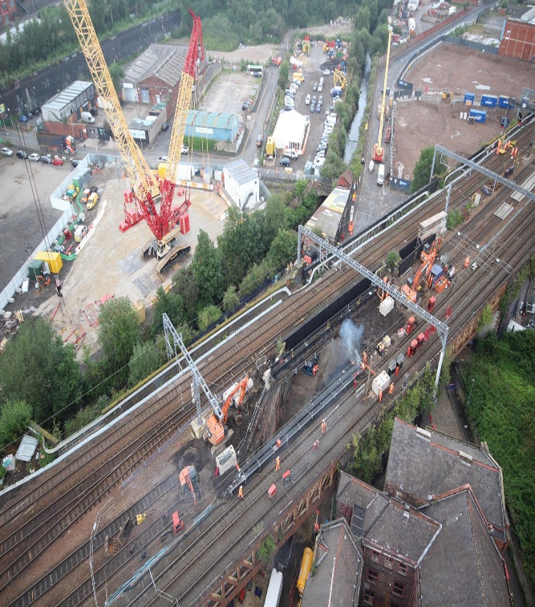

Table of Contest
1-Introduction
2-Project Description
3-Scope
4-Work Breakdown Structure (WBS)
5-Gant Chatt
6-Quad Chatt
7-Stakeholder Involvement
8-RACI MATRIX
9-Allocation of resources
10-Risk Assessment
11-Conclution
12-Recommendation
13-References

1-Introduction
The poste introduction is about a flooding event that occurred in the West Midlands ,include Worcester, Shrewsbury and Kidderminster in Uk in July 2025 and this resulted in significant socio-economic and infrastructure disruption. This prolonged and intense rainfall led to the River Severn overflow and surface water flooding and had affecting residential communities, transportation, networks, and critical infrastructure and public services, and this incident severity and frequency of extreme weather events and often have associated with climate change and growing risk to urgent need for effective flood management strategies.
The restoring regular operations, enhancing public safety are promoting economic recovery are the goal.
2-Project Description
The project management plan is about reconstruction of local infrastructure after flooded and this project focuses on restoring and improving critical local infrastructure damaged by July 2025 flood.
The scope in of the project includes rebuild roads, bridge and improve drainage systems, public facilities , and make flood resilient design resistance for future flooding and make improve sustainability and the flood disasters often damage transportation systems and affect local communities.
The scope out give recompensation for business and do reconstruction for school, hospital, private residential also agricultural land restoration.
The initial assessment identifies extended damage and prioritizes in high-risk areas , The Stakeholder engagement, included local authorities and communities these help to planning and make ensure alignment with need it.
The allocation resource will emphasize skilled labour, modern and sustainable materials and engineering solutions.
Risk management strategies this approach addresses potential delays, budge overruns, and future climate impacts.
The timeline will support progress tracking and reporting regular and ensure transparency.

3-Scope
The scope of the project management plan for reconstruction to local infrastructure after flooding in the Midland UK have boundaries many activities like include damage assessment and out-include of scope and this helping to set limits of project and focus on the efforts and guide planning, execution and understanding of the project and important to identification of goal of project.
SCOPE DIAGRAM
IN SCOPE | OUT OF SCOPE
Local council, emergency services  Utility companies,(water, electricity, gas)  Contractors, Engineers  Environment Agencies  Transport authorities | Recompensation for business  Insurance companies  Reconstruction school, hospital  Private residential,  Restoration agricultural land

4-Work Breakdown Structure (WBS)
The work Breakdown structure (WBS) show the reconstruction of project flood is divided into stage and tasks. The initiation where is scope this defined the local government had approvals and secured budged for the reconstruction project plan, Panning developing is repair strategies and scheduling are created for organise the resources and timelines , Execution is a practical work like road repair and debris removal, and inspection to environmental and safety make ensure the standards are met for the communities and the project finalize with final approval and reopening roads. Also, work breakdown structures help organise and manageable parts of project plan and making easier to plan and assign responsibilities and monitor progress into the project and make ensure all the tasks are efficiently complete in correct order, time and budget.

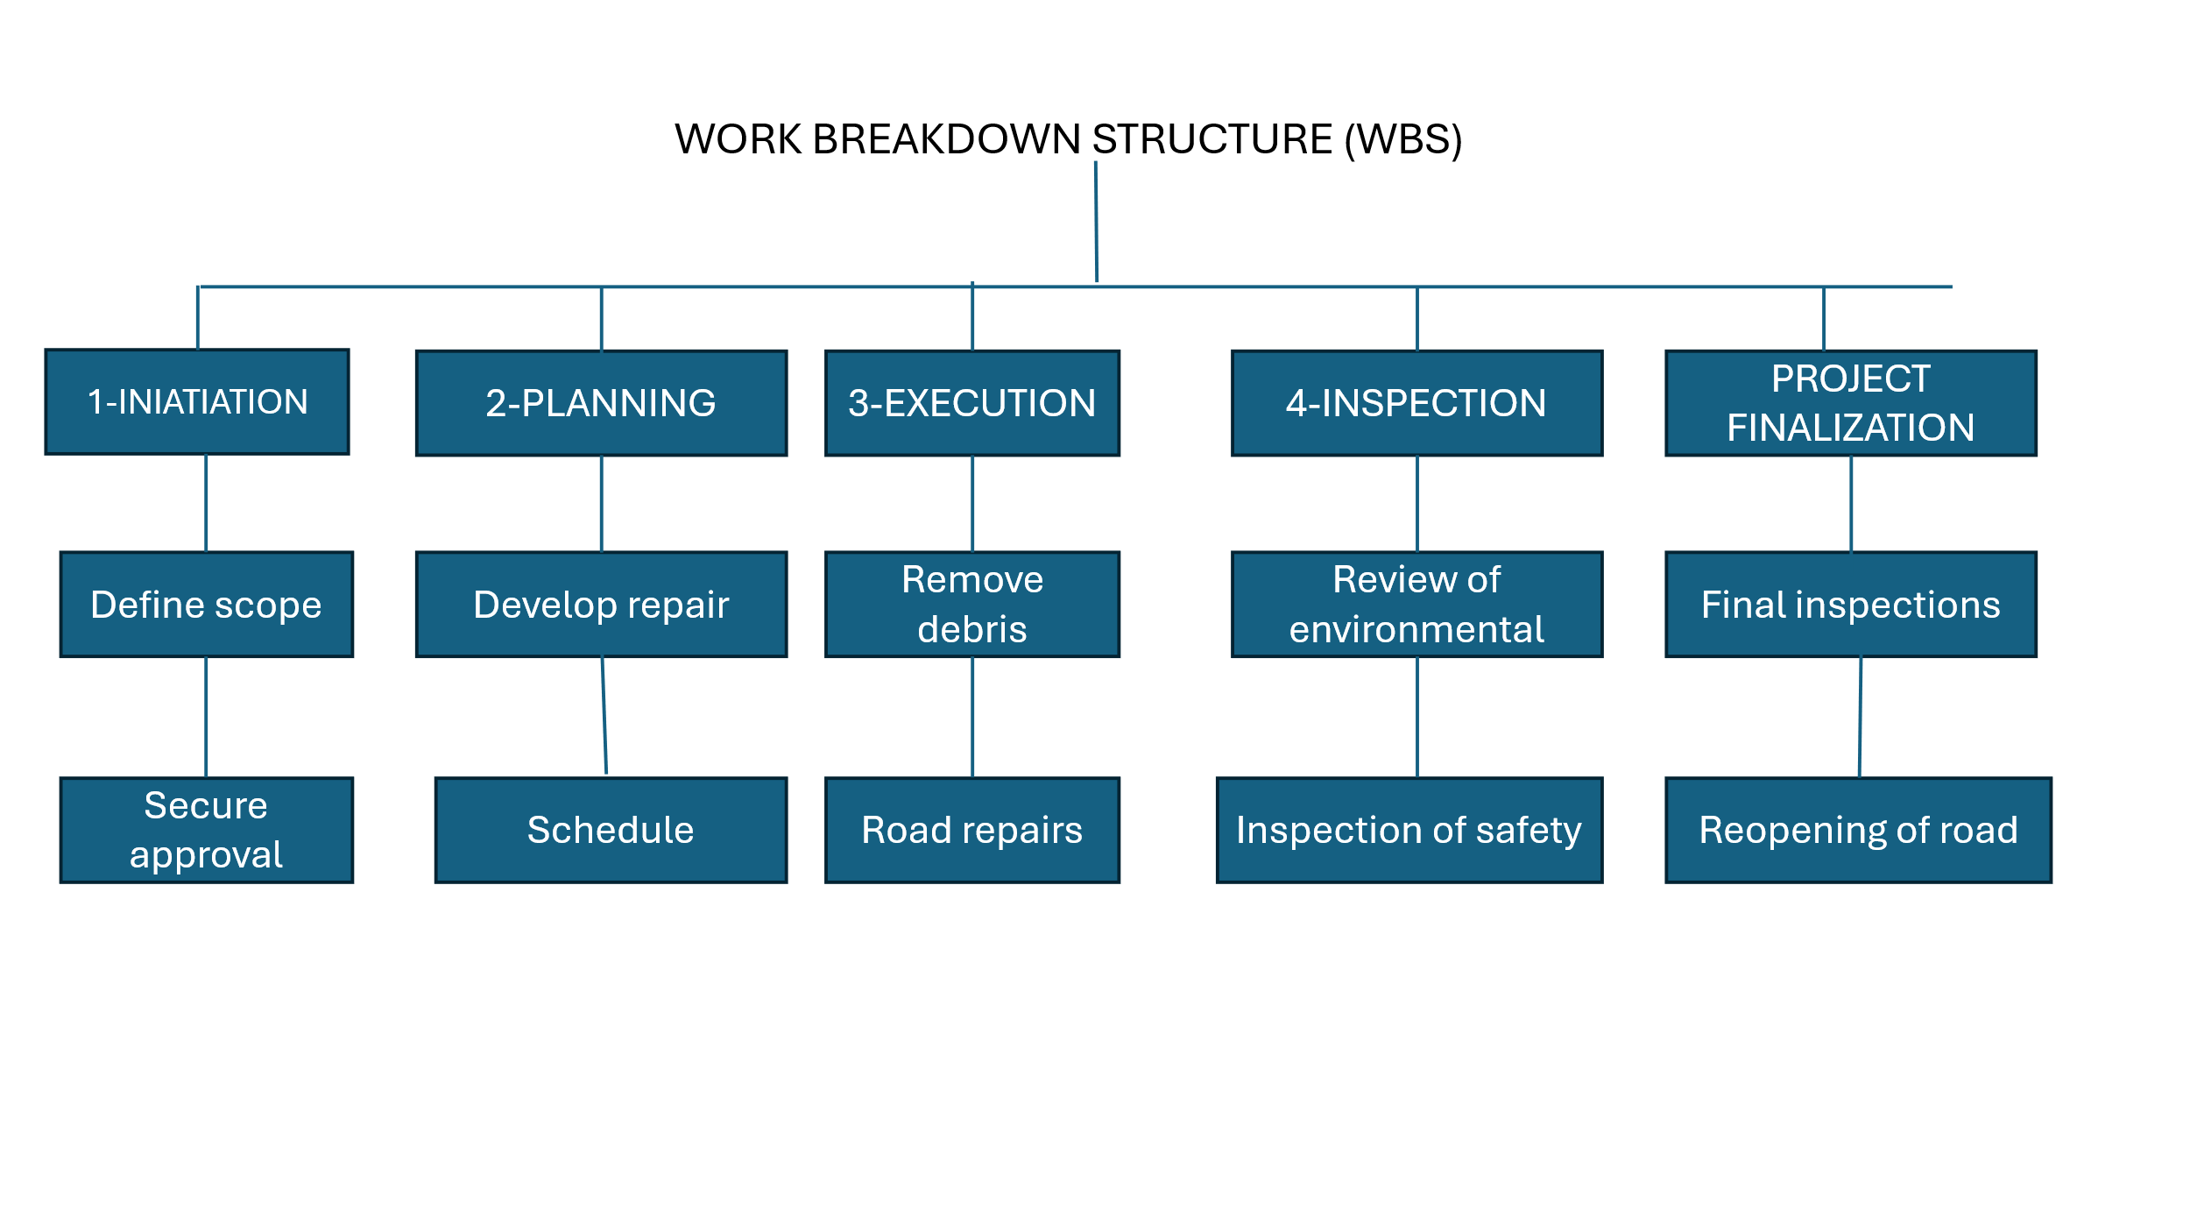

5-Gant Chatt
The Gantt Chart of the project for reconstruction to local infrastructure is visual project management tool that is using to plan and track tasks over time, and this show the project timeline from February to August. The project begins with initiation is start data of duration take February one month, and duration of Planning, Execution, Monitoring, Controlling . and closed and each bar represents the duration of a phase and the project starts with Initiation in February take one month, and Planning in March Execution of the project where construction and repair activities duration take one month in April, Monitory progress plan takes 1 month in May controlling take one month in June to July and this indicating ongoing in oversight, also closure take 1monts in August the project end with final impaction and efficient scheduling, coordination tracking progress and time management and ensure task are completed in correct order within the planned time frame and budget
A Gantt Chatt this helps to manager to organise work, monitory progress and set priorities and easier to see activities be completed before other begin.

Gantt  chard | Feb | Mach | Apr | May | Jun | Jul | Aug
Initiation
Planning
Execution
Monitory
Controlling
Closure

6-Quad Chatt
PROJECT  Focus Areas  Road & Bridge  Power & Energy  Water & Sewage Systems  Public Facilities  (Hospital, school)  Improve safety and Accessible | STAKEHOLDER  Rapid Disaster Response  Infrastructure Financing & Logistics  Technical & Engineering support  Bost local Government /Municipal  Environment, Agencies, Utility providers, Water, Electricity  Emergency services , Donors,  Farms, Resident local, Baby, Dog, Business and Traders.
DESIREEL AND RESULTS GOALS  Floods & Storms  Landslides  Winter Storms  Full repaired and operational  Safe and durable construction  Competition within budge, planned, community satisfaction. | MEASURES OF SUCCESS  Joint Funding initiatives  Engineering & training teams  Equipment and Emergency Supplies  Partnerships with Agency  Road reopened and accessible  Water and Electricity full restored  Project completed on 6-month time  Budget £1.230,1465  In fracture passes safety inspection

In the project management plan for reconstruction to local infracture shown a simple one page visual where is the communicate project goals for key information quickly and clarily and using ingineering of construction and government of project to ensure helps, clarity, supporting quick decision-making to provides to understand of project status and objectives and this summary into four section.

a-The Project plan focuses enhance safety accessible and quality of life for the community through coordinated development and stakeholder involve on improving essential local infrastructure in Midland UK community public services such as road and bridges for better transportation system services and energy and power for reliable supply , sewage systems for sanitation and water and reconstruction of local hospital and schools.
b-Stakeholder in this project for reconstruction for local infrastructure are the groups involved in planning, funding, and implementing activities. The principal stakeholder includes local government, technical expertise and engineer, environmental agencies, utilities providers for water and sanitation, electricity, donors support financing, residents, businesses, farm, animal. Also, the project key benefit outcomes through participation and feedback
c-Measure of success in this project of reconstruction for local infrastructure outlines goals for disaster of flooding in Midland UK focuses on managing risk from floods, storms, landslides, and winter storms, and ensure damaged systems are fully repaired and operational. Also, reconstruction should be safe, durable, for future event resilient and so project be completed within budge according to plan and community need and satisfaction.
d-Measure of success is a measured in a disaster recovery project and this includes securing joint funding, and trained engineering teams and security personnel and have adequate equipment and emergency supplies management and strong partnerships withing agencies are essential and reopen road, improving water quality and electricity systems and completing the project within six months and budgeting, also, passing infrastructure safety inspections.

7-Stakeholder Involvement
KEEP SATISFIED | MONITOR
Local Government responsible for planning, approvals, coordinating reconstruction activities.  Services of emergencies | General public  Environment organisation
KEEP INFORMED | MANAGE CLOSELY
Residents  Local companies and engineering | Department of transportation  Economic recovery

LOW HIGH

a-Keep satisfied In this section explain stakeholder involvement for reconstruction for local infrastructure focusing on keeping key groups satisfied and local government playing a central role such as a managing planning approvals and coordination reconstruction activities and also, emergency services is essential to support and providing and response during of crisis and is important to engaging authorities to ensure responders smooth effective disaster recovery and project delivery.
b-Monitor in this section identifies stakeholder who monitor the project of reconstruction of local infrastructure and public observes outcomes and impact and, environmental organization ensure activities comply with environmental standards of protect ecosystems during of reconstruction and recovery efforts.
c-Keep informed identifies and stakeholders who need to regular updates to resident must be informed about the project progress, impact a mentation of destruction and, engineering team and local companies regarding clear communication to coordinate work and make ensure efficiency and project support successful deliver.

d-Manage closely in this section requiring to be close stakeholder with management and the department of transportation oversees infrastructure work and while economic recovery to groups focus on restoring local economic and social and environment and ensuring coordination, efficiency, and sustainability post disaster reconstruction outcomes.
8-RACI MATRIX
Activity | Local Gov | P. Manager | Engineer | Contracts
Budge Approval | A | R | C | I
Project Planning | C | A/R | C | I
Design Engineering | I | C | A/R | I
Construct repairs | I | I | C | R
Restoration | I | I | C | R
Environment | A | I | C | I
Inspection | A | A | R | I
Final Handover | A | R | C | I

R= Responsible A= Accountable C= Consulted I= Informed

RACI Matrix of project management plan is a tool that clarifies roles and responsibilities for each activity such as a budget approval, planning, design, construction, inspection, and each column is a stakeholder, local Government ,project manager, contractor, engineer. The budge approval, project management is responsible for all activities being undertaken and local government is accountable , engineer is responsible for consulted and contractors are responsible for informed.
Design engineering and engineer is responsible for accountable other support are informed and construction & restoration contractors are responsible for clear responsibility to avoids confusion and improving coordination across all stakeholders throughout the project plan lifecycle.
9-Allocation of resources
The resources allocation will be prioritising infrastructure repair emergencies, this is including networks of transports, drainage systems and utilities, the funding and performance personnel at first will be distributed to higher impact areas such as Shrewsbury and Worcester.
The material, equipment and skilled labour will be coordinated until ensure effective recovery and while the contingencies resource will support ongoing risk management and communities’ resilience efforts.
10-Risk Assessment
Thie risk assessment for reconstruction of local infrastructure for Midland UK is a table where is identifies key project risk and their causes an impacts and management strategy and each risk is assigned a probability (P) and impact (I) score and producing a score overall to attention prioritise.
The threat like shortages of contractor, inflation may delay progress and can cost such as insurance payouts and modular construction can accelerate recover and community resistance.
The responsibilities are allocated to specific role like, Project Manager, design lead, Finance, this ensures that an accountability.
The mitigation action like partnerships early insurance engagement, contingency budget , clear communication, those are proposed to reduce risk and enhance project success and resilience.

ID | CAUSE | EFFECT | TYPE | P | I | SCOPE | OWNER | RESPONSE |  | RESPONSE
R1 | Contractor  Limited availability | Rebuilding  delays | Threat | 4 | 3 | 12 | PM | Partner with reginal firms of  project |  | Partner with reginal firms of project
R2 | Payouts  Insurance | Recovery  faster | Opportunity | 3 | 4 | 12 | Finance | Insurance early liaises |  | Insurance early liaise
R3 | Relocation to community resistance | Project delays | Threat | 2 | 5 | 10 | Manager Stakeholder | Clear communication and  conpensaion |  | Clear communication and compensation
R4 | Use construction modular | Deployment  faster | Opportunity | 4 | 4 | 16 | Design lead | Pilot modular first in unit school |  | Pilot modular first in unit school
R5 | Inflation | Overrun budge | Threat | 5 | 4 | 20 | Finance | Contingency buffer in budget  included |  | Contingency buffer in budget include

11-Conclusion
The Project plan management conclude by successfully restoring and enhancing critical infrastructure affected by 2025 flooding this ensuring improved resilience against future events. Also, the key outcomes include timely reconstruction effective risk management and efficient resource allocation and ensure effective disaster recovery through clear planning, defined roles, structured execution and continue monitoring and delivering safe, resilient infrastructure on 6 months’ time and £ 1’230,146.5 budget and communities’ satisfaction.
12-Recommendation
Recommended that for this project management plan includes continuous risk assessment and regular stakeholder communication to improve coordination. Collaboration strengthening

between teams will efficiency enhance and contingency funds allocation and scheduling flexible will unexpectedly challenges addressing and monitoring ongoing evaluation and should ensuring quality, compliance, and project delivery successful.

13-References
Environment Agency (2025) Flood and coastal erosion risk management report. Available at: https://www.gov.uk/government/publications/flood-and-coastal-erosion-risk-management-report (Accessed: 15 March 2026)
UK Department for Environment, Food & Rural Affairs (2022) National flood and coastal erosion risk management strategy for England. London: DEFRA
Hilton, D. Managing Risk in Projects. Available at: https://www.routledge.com/Managin-Risk-in- (Accessed: 15 March 2026)
UK Parliament (2024) Flood risk management and funding. Available at: https://commonlibrary–parliament.uk/research -briefings/cbp-7514 ( Accessed: 15 March 2026)
UK Government (2021) transport resilience and emergency planning guidance. Available at: https://www.gov.uk (Accessed: 5 April 2026)
Office for National Statistics ( 20220) Natural hazards and disaster risk in the UK . Available at: https:// ww.ons.gov.uk (Accessed : 5 April 2026)
Jenkins.(2025) Flood warnings in place until tonight in the black Country as thunderstorm warning covers West Midland. Available at: https://www.expressandstar.-com/news/2025/07/21/flood-warnings-in-place-until-tonight-in-the-black-country-as -thunderstorm-warning-covers-west-midlands/ ( Accessed: 26 March 2026).

ITV News (2025) Half a month’s rainfall could hit UK on Monday , says Met Office. Available: https://www.itv.com/news/2025-07-20/risk-of-flash-flooding-as-storm-coul-bring-half-a-months-rain-half-a-months-rainfall-on-monday ( Accessed: 26 Mach 2026)

The Guardian(2025) Uk weather: Half a month’s rain could hit country in next 24nhours, say Met Office. Available at: https://www.theguardian.com/uk-weather-her-a-months-rainfall-could-hit-country-in-next-24-hours-says-met-office ( Accessed 26 March 2026)

