

Module Code: LCMB7024
Module Title: Marketing Management
Marketing Management in automobile industry
Assignment Title: Assessment component 1: Individual Report
Student Name: Prit jenishbhai jariwala
Student ID: 2503896
Word count: 2694
Date of submission: 21 November 2025

Table of Contents
1. Introduction 3
2. Task 1: Critical Analysis of the Macro Marketing Environment 5
2.1 Overview of the macro marketing environment 5
2.2 Two external macro marketing actors 7
2.3 Critical analysis of each actor 11
2.3.1 The way changes impact pioneering and follower organisations differently and create opportunities and threats within the automobile industry. 11
2.3.2 Identify the key strategic implications for both pioneers and followers. 14
2.3.3 Critical analysis with data and business examples 14
3. Task 2: Strategic Responses of Pioneering and Follower 16
3.1 Pioneering Organisations’ Strategic Responses 16
3.1.1 The way pioneering firms respond to external challenges. 16
3.1.2 Responding to the external opportunities 16
3.1.3 Application of Ansoff’s Growth Matrix 17
3.1.4 Application of Porter’s Generic Strategies 19
3.2 Follower Organisations’ Strategic Responses 20
3.2.1 The way followers’ organisations have established sustainable competitive advantage strategies 20
3.2.2 Application of Ansoff’s Growth Matrix 21
3.2.3 Application of Porter’s Generic Strategies 21
4. Conclusion 23
References 25

1. Introduction
Introduce and the purpose of strategic marketing management
The marketing management with the strategic approach involves the organisational capability focusing on the external environment (Covin et al., 2024). Marketing strategy is the systematic approach of marketing management that is considered a tactical process of human resource management (Chernev, 2025).
The importance of analysing the macro marketing environment for strategic decision
For marketing management and strategic decision-making, the macro environment has been analysed with the help of an effective framework like PESTLE. Based on the environmental analysis, the organisations are able to respond and anticipate the external pressure that has shaped their marketing performance, innovation practices, along consumer behaviour. This environmental analysis has encompassed different drivers like economic, political, social, technological, legal and environmental. To conduct the strategic marketing management based on the macro environmental factors, the automobile industry has been selected.
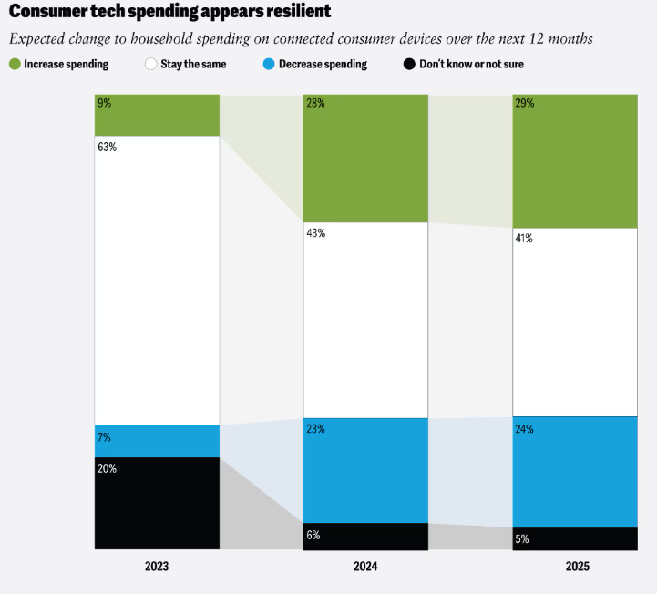
Figure 1: Consumer’s tech-spending resilience
(Source: Deloitte, 2025)
Based on the above figure, it is observed that due to technological innovation, customers’ spending has increased. In 2023, tech-based spending was 9% higher in 2025, and it became 29%.
Structure and the score of this report
The scope of this study is to focus on the macro marketing environment and its contribution to driving the strategic marketing. For evaluating the macro-marketing environment, two external macro factors have been selected and identify both threats and opportunities regarding followers and pioneer organisations. In this study, two macro environmental factors are sustainability transition and technological innovation explored and their contribution to the automotive industry. In Task 1, critically analyse how these 2 external macro marketing actors contribute to the organisational operating process. In task 2, an in-depth analysis has been conducted focusing on the automotive industry by mentioning pioneering and follower organisational examples.

2. Task 1: Critical Analysis of the Macro Marketing Environment

2.1 Overview of the macro marketing environment
Macro environment
Macro environment is considered the external context that supports the organisation to operate its business in the global market. The macro environmental factors have highly contributed to the managerial control of the organisation. As referred to by Tetteh et al. (2024) stated that macro-environmental factors contribute to three factors like regional and economic, cultural, along political and governmental factors.
Its relevance to marketing strategy
The macro environment has higher relevance in the marketing strategy that has been encompasses by the external forces that have shaped the marketing threats and opportunities. Different external forces like technological, economic, demographic, social, natural and political factors that allow the business to change their marketing strategy.
Application of the theoretical framework, like PESTLE
The six dimensions of PESTLE: political, economic, social, technological, legal and environmental factors. These have support to shape the organisational marketing strategy for driving the organisational development. PESTLE is a significant analysis tool for qualitative analysis that ensures the external environment and the organisations (Li, 2025).
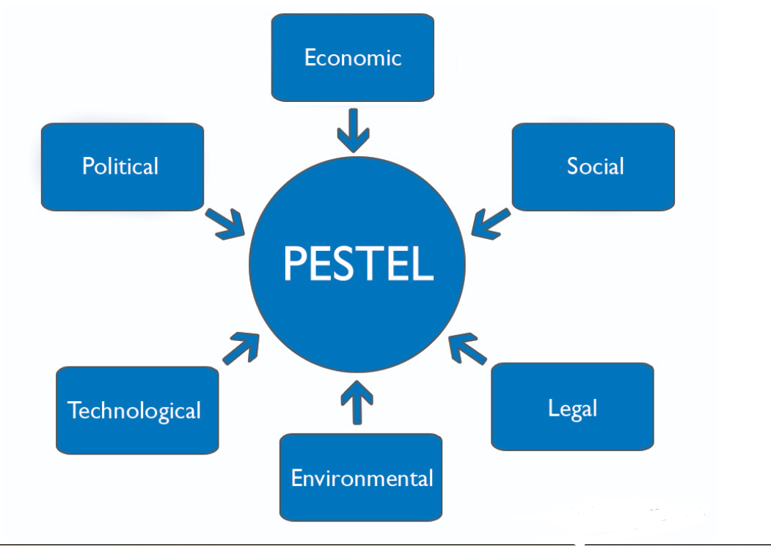
Figure 2: PESTLE framework
(Source: Li, 2025)
In response to the automobile industry, these factors have become dynamic through digital transformation, globalisation, and the transition of sustainability practices. For example, due to the sustainability demand based on technological disruption, the demand for EV vehicles in the automobile industry has been increasing. The evidence below states that EV sales have increased 25% throughout the world (Reuters, 2024).
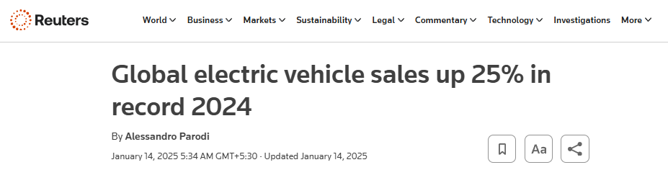
Figure 3: Rate of EV vehicles in 2024
(Source: Reuters, 2024)

2.2 Two external macro marketing actors
Two external actors
Considering the macro marketing actors, the two selected actors are technological and environmental.
Technological factors: The automobile manufacturer has implemented the advanced technology mainly to improve the reliability and safety features (Jain et al. 2024). Based on the image below, 5G has been 70% used in the automobile industry (Statista, 2025b).

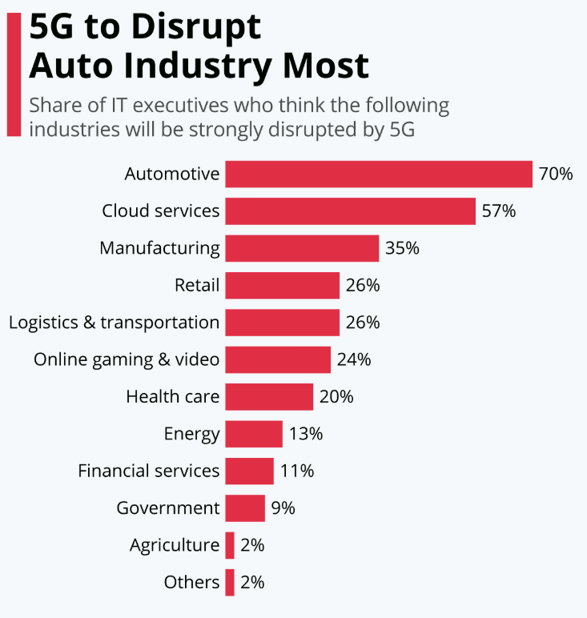
Figure 4: Application of 5G in the automobile industry
(Source: Statista, 2025b)
Justification of selecting these actor
A technological actor is considered one of the significant disruptive forces that help to shape the industry's growth. Moreover, in recent days, to increase battery efficiency, autonomous driving and connectivity are crucial for driving the consumption and reshaping production.
Environmental factors: Environmental concerns and commitment have driven the organisational performance that also influences involvement with innovation (Stocker and Erdélyi, 2024). Based on the image below, the capacity of the EV to reduce carbon emissions in 2021 was 19-66% which will be increased to 30-74% in 2030 (Statista, 2025a).
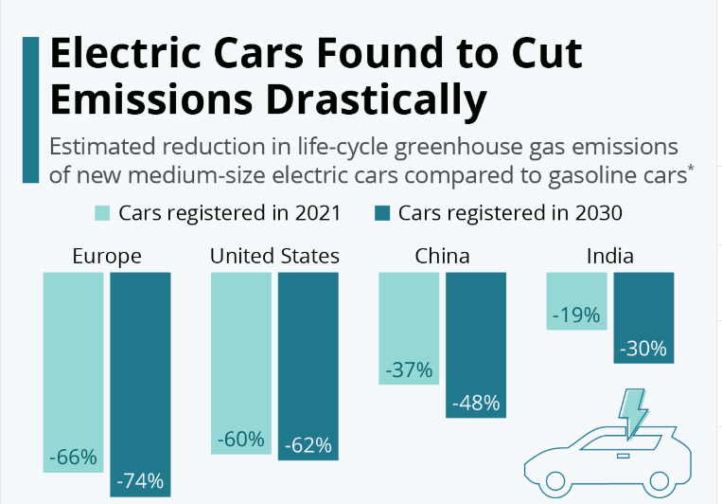
Figure 5: Declining the carbon emissions from electric cars
(Source: Statista, 2025a)
Justification of selecting these actors
The environmental factor has been selected as the demand for eco-friendly and sustainable products gas growing. Moreover, the international regulations on emission control have been stricter, along public consciousness on environmental protection has also increased.
Relevance of the technological factor on the automobile industry
Technological factors are highly relevant for establishing the innovation practices, like autonomous vehicles, electric vehicles. These have a high influence on improving the manufacturing efficiency through Industry 4.0 and automation.
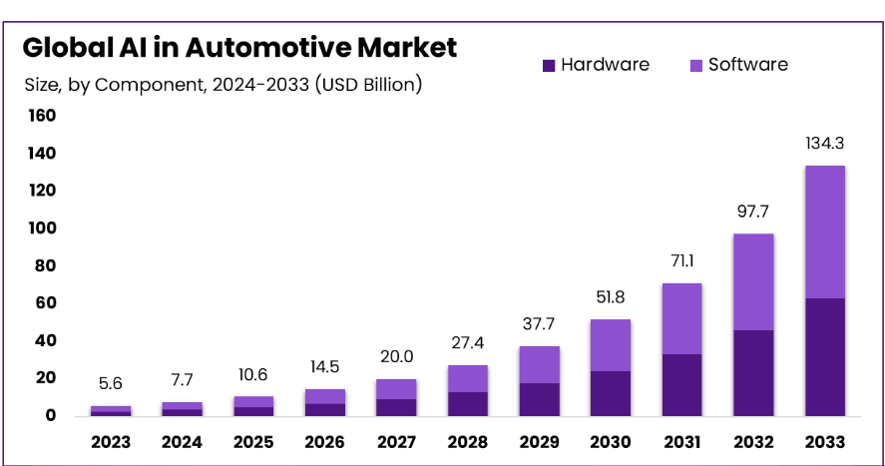
Figure 6: AI market in the global automobile industry
(Source: market, 2025)
Impact of the current influence
As per the above image, the market of AI investment in the automotive industry has support to increase organisational business operations. The development of the autonomous vehicle has driven the demand for self-driving cars. The growth of AI in the automotive market is USD 7.7 billion in 2024, which has increased by 37.4% and it is predicted that the market will be grow by USD 134.3 billion in 2033 (market, 2025).
Relevance of the environmental factor on the automobile industry
The environmental actors have also reshaped the growth of the automobile industry as it drives through green technology and sustainability. The automobile sector has a higher contribution to increasing greenhouse gas and carbon emissions. While manufacturing the vehicles, different pollutants have also been released into the air.
Impact of the current influence
The image below indicates the evolution of passenger cars in controlling CO2 emissions. Is target for the CO2 evolution is 80.8% in 2025 and 59.4% in 2030 (Europarl, 2024).
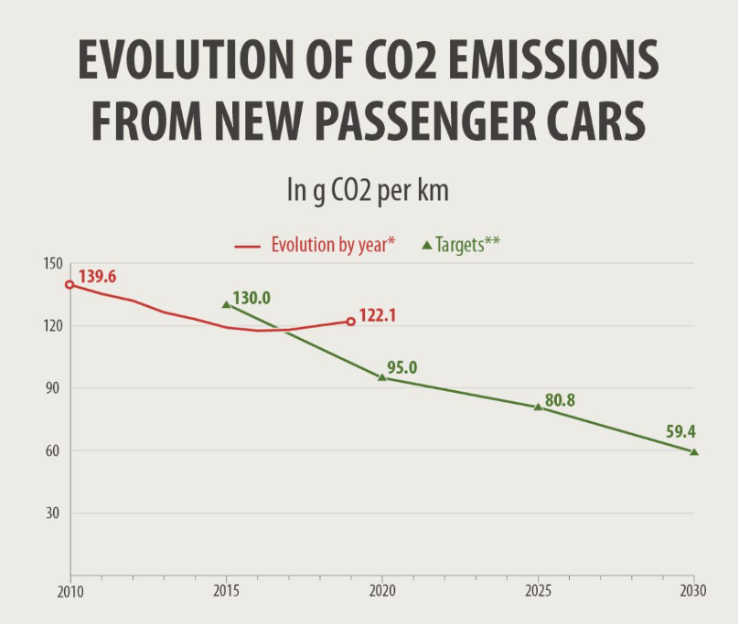
Figure 7: CO2 in new passenger car
(Source: europarl, 2024)

2.3 Critical analysis of each actor

2.3.1 The way changes impact pioneering and follower organisations differently and create opportunities and threats within the automobile industry.
- Technological actors
Impact on pioneering organisations
Technological transformation has conducted a revolutionary action for the automobile industry, focusing on the pioneering organisations like Tesla. The organisation has invested $80 billion to $100 billion in 2024 for AI (AIinvest, 2025).
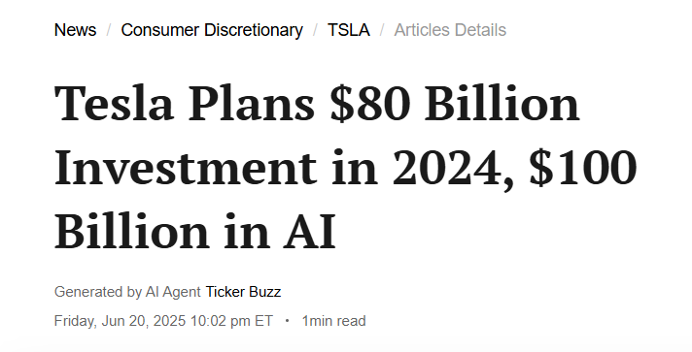
Figure 8: Evidence that Tesla has invested in technological transformation
(Source: AINVEST, 2025)
Create opportunities
- Pioneer company like Tesla has offers over-the-air updates, long-range batteries and integrated digital services.
- Technological innovation influences the ecosystem control by improving battery efficiency, which is highly essential for driving revenue growth
Threats
In the pioneering innovation, the pioneers faced risks to safety and regulatory practices.
Impact on follower organisations
Due to the technological revolution, the followers of organisations like Ford have faced the pressure of the competitive advantage.
Create opportunities
- Based on the pioneer’s risk and failure, the followers can develop their marketing and regulatory plan.
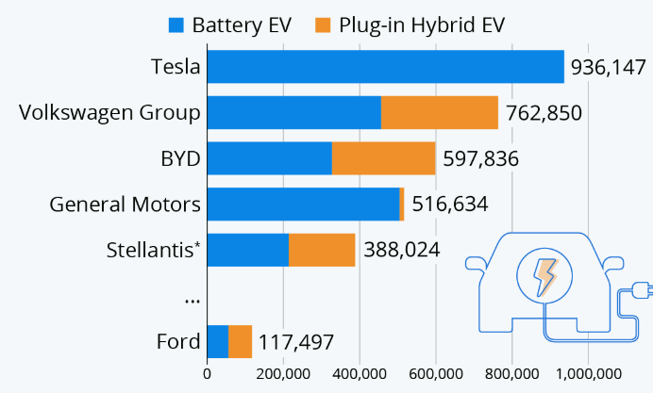
Figure 9: Restructuring plan of Ford from EV leaders
(Source: Statista, 2025c)
- The organisations can access the emerging suppliers' network at a lower unit cost.
Threats
It might face threats of a capability mismatch regarding the software-centric value and develop new market competence.
- Environmental actors
Impact on pioneering organisations
The pioneer organisation has focused on sustainability by influencing the core value proposition and brand identity.
Create opportunities
- The battery recycling process has increased by 35% (Slattery et al. 2024).
- Increase the premium product with high investment willingness of customers.
Threats
There is the risk faced by pioneers of greenwashing scrutiny.
Impact on follower organisations
The followers have faced higher pressure for low-carbon production.
Create opportunities
- The followers, like Ford, Volkswagen, have access to the mainstream market.
- Invest in manufacturing efficiency and decarbonisation
Threats
Followers face regulatory and competitive pressure while operating business in automobile industry.

2.3.2 Identify the key strategic implications for both pioneers and followers.
Technological factors
Identify the key strategic implications in pioneers
- The organisations might focus on IP protection and ensure to upgrade the architecture (Chen et al. 2024).
- They need to invest in the semiconductor sector to build data advantages.
Identify the key strategic implications in followers
- For product innovation, followers need to focus on hybrid strategies regarding product development (Bas, 2024)
- It can use a distribution and quality network that has established the value option and reliability.
Environmental factors
Identify the key strategic implications in pioneers
- Development of the financial model and design of the product line
- Develop transparency on recycling data, along with the carbon footprint.
Identify the key strategic implications in followers
- Develop a recycling partnership, agreements on renewable energy.
- Maintain customers’ trust and credibility by opening the ESG report (Rastogi et al. 2025).

2.3.3 Critical analysis with data and business examples
Technological factors
- For example, Tesla, pioneer organisation has focus on improving 80% of the battery redesign process by developing a partnership with CATL (Yahoo Finance, 2025).
- For example, followers like Ford, Volkswagen have focused on battery EV as well as Plug-in battery EV by 117,497 and 762850, respectively (Statista, 2025c).
Environmental factors
- The pioneers like Tesla have influenced the customers to incresae their willingness to invest in premium products by selling over 400,000 vehicles (Statista, 2025d).
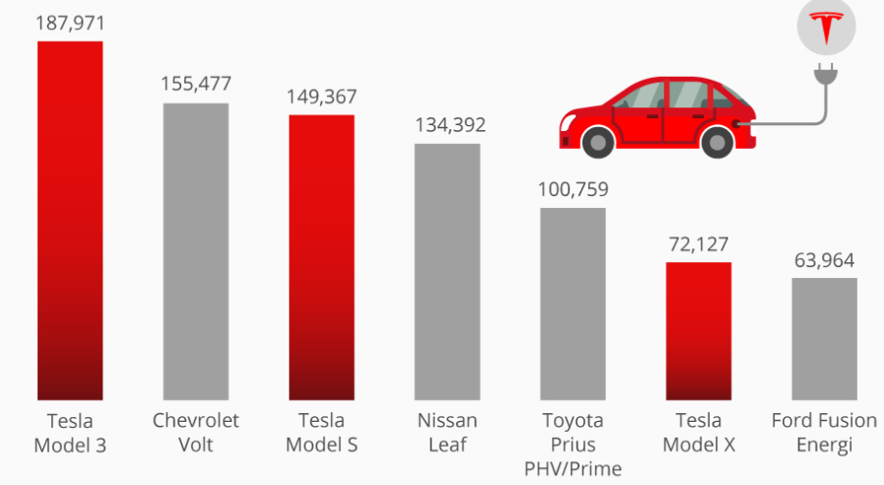
Figure 10: Tesla has a dominating EV market
(Source: Statista, 2025d)
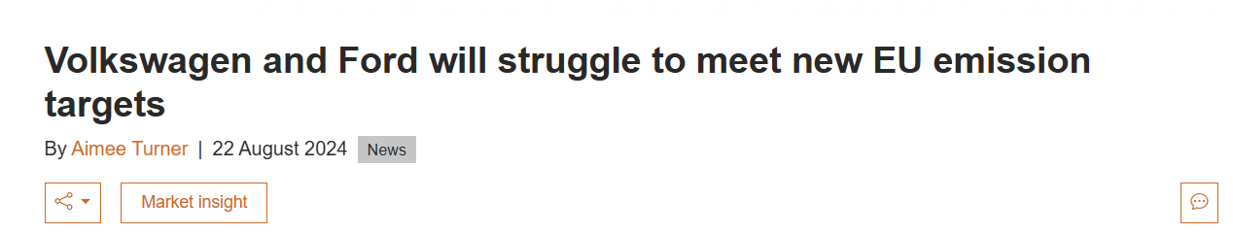
Figure 11: Evidence on the struggle in carbon emissions
(Source: am-online, 2024)
- Followers like Ford and Volkswagen face regulatory pressure on carbon reduction (am-online, 2024).

3. Task 2: Strategic Responses of Pioneering and Follower

3.1 Pioneering Organisations’ Strategic Responses

3.1.1 The way pioneering firms respond to external challenges.
The pioneering organisations have responded to the challenges regarding the environmental regulations and technological disruptions. To overcome these challenges, the organisation has implemented proactive and innovation-driven strategies. Following the market trend, the organisations have reacted to improve the customer’s expectations. By developing EV products, this automobile industry has contributed to reducing 37% emissions and is targeting net-zero gas emissions by 2050 (factcheck, 2024).
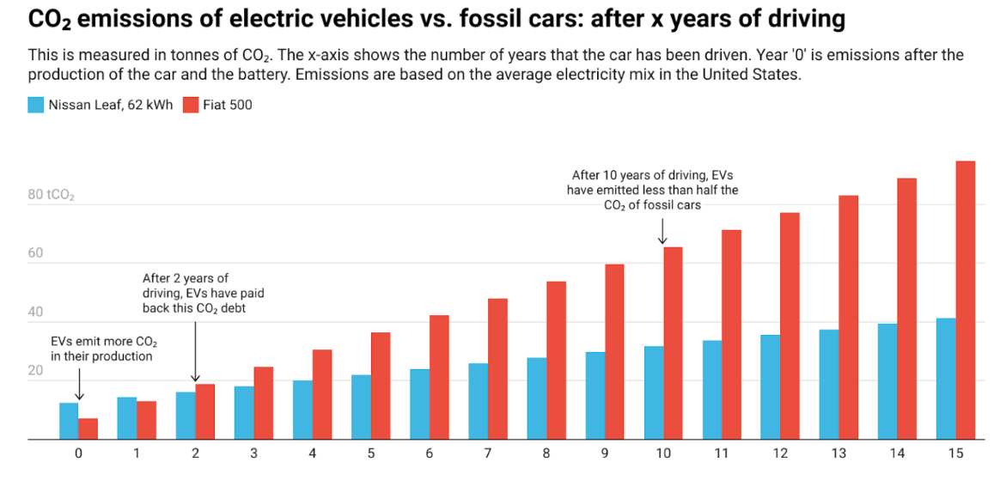
Figure 12: Impact of EV on climate change
(Source: factcheck, 2024)
To overcome the market challenges like high fuel cost, threats of climate change and governmental regulations, Tesla has made their first step towards electric vehicle production.

3.1.2 Responding to the external opportunities
The pioneer companies can access the extensive market opportunities like renewable energy initiatives, green policies, and adapt the digitalisation practices. Based on these growth opportunities, the pioneers can focus towards the sustainability trends along with improving storage and adapting solar energy. For example, BYD has developed a partnership with Skysense for 300MWh of energy storage (PVKnowHow, 2025).
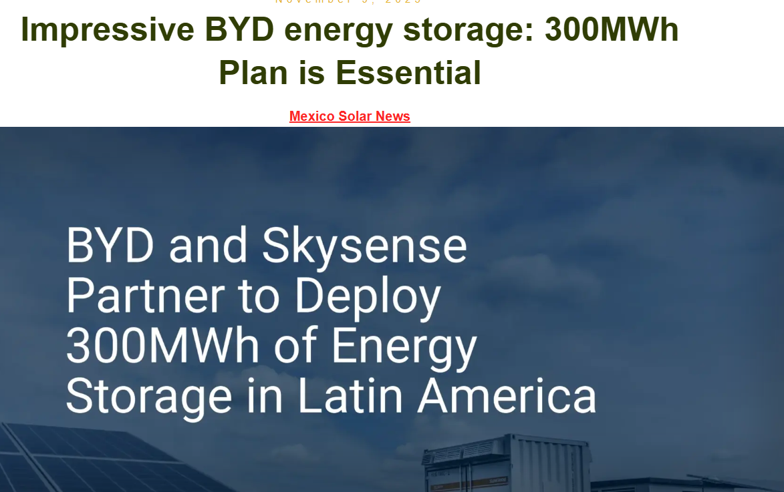
Figure 13: Evidence on BYD energy storage
(Source: pvknowhow, 2025)

3.1.3 Application of Ansoff’s Growth Matrix
Ansoff matrix is also called the product-market matrix, which supports improving the organisational growth process and influence for market changes (Pereira Ferraz Soares Ferreira and Marques, 2024).
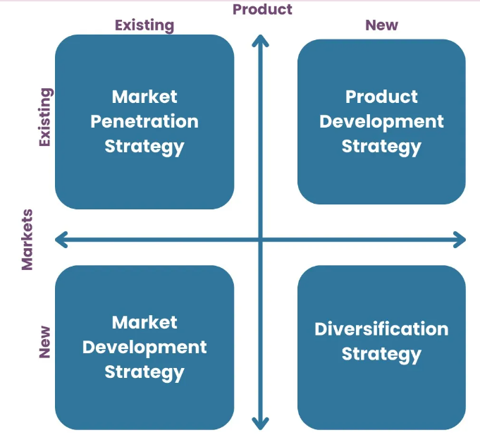
Figure 14: Ansoff matrix
(Source: Pereira Ferraz Soares Ferreira and Marques, 2024)
With respect to this growth matrix, the pioneering organisations mainly focus on market penetration and product development.
Market penetration: This strategy is mainly applicable in the automobile industry for expanding its business into developing countries. EV products have attracted customers where the environmental policies are strong and customers are highly conscious about the environment. Based on the below image, in 2024, 17.1 million EV sales have been reported, which is been increase of 25% from 2023.
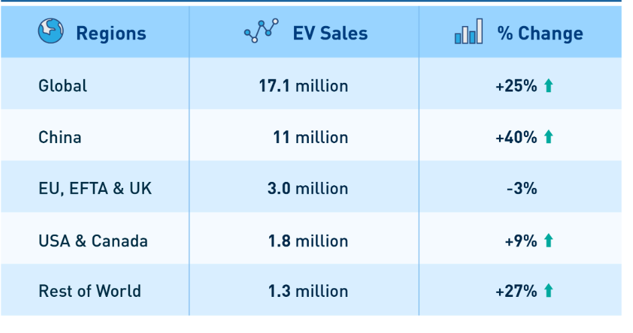
Figure 15: Rate of EV sales in different regions
(Source: leadintelligent, 2024)
Product development: Pioneers have focused on autonomous driving, improving the battery life, and investing in cutting-edge technologies.

3.1.4 Application of Porter’s Generic Strategies
Through the application of Porter’s Generic Strategy, the organisations have mainly focused on product differentiation strategy. This has influenced building a strong brand identity, enhancing technological capability mainly by adopting innovation and a sustainable approach. This carbon-neutral manufacturing with an updated software network ecosystem helps the pioneer in making product differentiation. As the market-shaper pioneers in the automobile industry, it has placed importance on customers’ expectations, regulatory standards and technological benchmarks. Due to the technological development, the automobile sales and output are 24.363 million units and 24.333 million units, respectively The Wiree, 2025).

3.2 Follower Organisations’ Strategic Responses

3.2.1 The way followers’ organisations have established sustainable competitive advantage strategies
The follower organisations in the global automobile industry have mainly adopted and strategic practices of the automobile pioneer firms. The followers have mainly focused on the market validation and developing a risk mitigation process. The followers have invested in the disruptive innovations. Based on the image below, the application of EVs as passenger cars has increased by 30.2% (EVBoosters, 2025). Integrating the practice of digitalisation and sustainability has leveraged the organisational strength that has highly contributed to the production capacity, brand equity and customers’ trust.
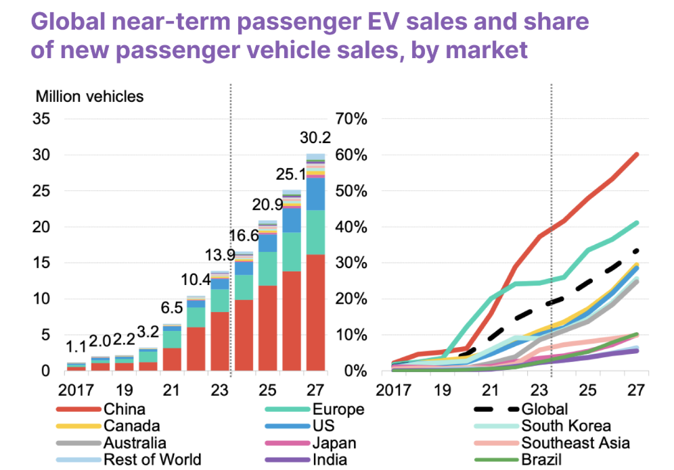
Figure 16: Growth of EV passenger cars throughout the world
(Source: evboosters, 2025)

3.2.2 Application of Ansoff’s Growth Matrix
Considering the application of the Ansoff matrix, the organisations in the automobile industry have been pursuing product development as well as market development strategies. For example, the follower organisation Volkswagen have focused on driving their EV production by 12.2% within the affordable range within the target customers to gain 28% market share (CNBC, 2025). The followers have focused on emerging market development by enhancing dominant in the automotive segment. On the other hand, Toyota has focused on the legacy of the hybrid vehicle, which has an influence on product development. The followers are highly invested in the hybrid model, with affordability mainly focusing on price sensitivity and eco-conscious customers. Due to the evaluation in the automobile industry, the follower organisations need to focus on technological trends as well as green regulatory standards, which highly contribute to reducing the risk exposure.
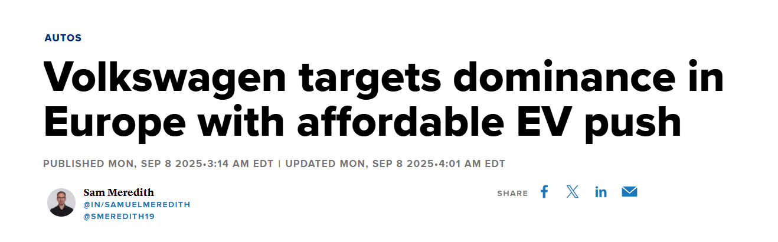
Figure 17: Evidence that VW focuses on affordable EV
(Source: CNBC, 2025)

3.2.3 Application of Porter’s Generic Strategies
Porter’s generic strategy model has significantly contributed to the strategic management, which drives higher competitive advantages (Acar, 2024). Porter’s generic strategic model consists of three elements like cost leadership, differentiation and focus.
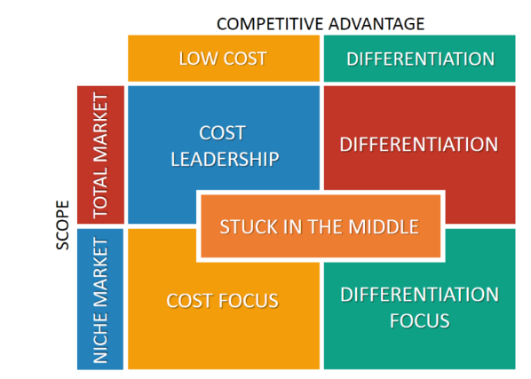
Figure 18: Porter’s generic strategic model
(Source: Acar, 2024)
In the case of the follower organisations, they mainly adopt focus differentiation and cost leadership models, which are highly influential for driving the sustainable competitive advantage. Toyota has adopted a cost leadership approach where it focuses on competitive pricing by maintaining quality. It has also invested in the optimisation of the global scale, driving the manufacturing efficiency and maintaining economic stability. On the other hand, Ford has adopted focus differentiation to build diverse models for different customer segments. Based on the above evidence, Ford has gained 6% higher record in EV sales through the retail channels (CBTNews, 2025).
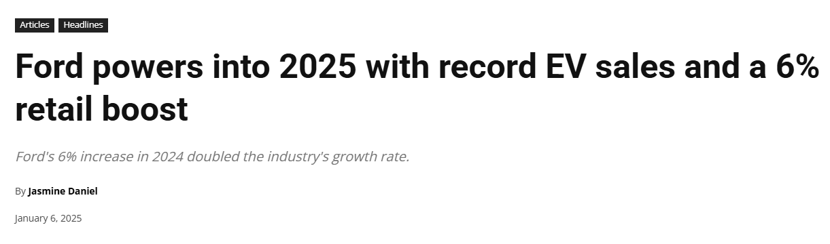
Figure 19: Evidence of Ford's increase in EV sales
(Source: Cbtnews, 2025)

4. Conclusion
Summarise the key findings
Considering the macro marketing environmental analysis, the automobile industry has gained both opportunities and challenges. With respect to the strategic response, the organisation has focused on strategic agility and environmental scanning. In the case of pioneer organisations, they can gain effective market opportunities, ecosystem control, and shape the electric vehicle market. The market opportunity can access the follower organisations by driving the high-cost advantages, along with developing strategic partnerships.
Referring to the strategic response, the pioneering organisation has adopted a market penetration and product development strategy. This highly contributes to adopting autonomous driving along with cutting-edge innovation. Pioneer organisations have adopted Porter’s generic strategy, which mainly focuses on the differentiation approach. In the case of the global followers’ organisations in the automobile industry, they have focused on market development and product development strategic approach. In the case of Porter’s generic strategy model, it mainly adapts focus differentiation and cost leadership. These are highly essential for the followers to accelerate their business growth.
Strategic significance of environmental scanning
This is an innovation-driven and globally integrated sector. This helps to monitor how sustainability practices and technological disruption drive the current pace of organisational growth.
Adaptive marketing response
The effective strategic management decision has an influential driving long-term competitive advantage. Environmental analysis has collectively boosted the industry dynamic, which supports making strategic directions.

References
Acar, S., (2024). A Review of Porter’s Generic Strategies: Strategy Examples in International Firms. International Social Sciences Studies Journal, 10(11), pp.1902-1918.https://sssjournal.com/files/sssjournal/e5935340-8b65-4cf6-a1c1-cf266026257d.pdf.
Ainvest (2025) Tesla Plans $80 Billion Investment in 2024, $100 Billion in AI, Available at: https://www.ainvest.com/news/tesla-plans-80-billion-investment-2024-100-billion-ai-2506/. [Accessed on 11.11.2025]
Am-online (2024) Volkswagen and Ford will struggle to meet new EU emission targets, Available at: https://www.am-online.com/news/volkswagen-and-ford-will-struggle-to-meet-new-eu-emission-targets. [Accessed on 11.11.2025]
Bas, S.A., (2024). A hybrid approach based on consensus decision making for green supplier selection in automotive industry. Sustainability, 16(7), p.3096.https://www.mdpi.com/2071-1050/16/7/3096.
Cbtnews (2025) Ford powers into 2025 with record EV sales and a 6% retail boost, Available at: https://www.cbtnews.com/ford-powers-into-2025-with-record-ev-sales-and-a-6-retail-boost/. [Accessed on 11.11.2025]
Chen, J., Zhang, E., Wan, Y., Huang, T., Wang, Y. and Jiang, H., (2024). A quick and innovative pipeline for producing chondrocyte-homing peptide-modified extracellular vesicles by three-dimensional dynamic culture of hADSCs spheroids to modulate the fate of remaining ear chondrocytes in the M1 macrophage-infiltrated microenvironment. Journal of Nanobiotechnology, 22(1), p.300.https://link.springer.com/content/pdf/10.1186/s12951-024-02567-5.pdf.
Chernev, A., (2025). Strategic marketing management. Cerebellum Press.https://f.letmeprint.ru/261509496-dd9247aa/fragment_9671009.pdf.
CNBC (2025) Volkswagen targets dominance in Europe with affordable EV push, Available at: https://www.cnbc.com/2025/09/08/volkswagen-targets-dominance-in-europe-with-affordable-ev-push.html. [Accessed on 11.11.2025]
Covin, J.G., Slevin, D.P. and Heeley, M.B., (2000). Pioneers and followers: Competitive tactics, environment, and firm growth. Journal of business venturing, 15(2), pp.175-210.https://www.academia.edu/download/67341664/s0883-9026_2898_2900015-920210516-3730-rx3scc.pdf.
Deloitte (2025) In the gen AI economy, consumers want innovation they can trust, Available at: https://www.deloitte.com/us/en/insights/industry/telecommunications/connectivity-mobile-trends-survey.html. [Accessed on 11.11.2025]
Europarl (2024) CO2 emissions from cars: facts and figures, Available at: https://www.europarl.europa.eu/topics/en/article/20190313STO31218/co2-emissions-from-cars-facts-and-figures-infographics. [Accessed on 11.11.2025]
Evboosters (2025) Electric Vehicle sales forecast to hit 30 million by 2027 as global adoption accelerates, Available at: https://evboosters.com/ev-charging-news/electric-vehicle-sales-forecast-to-hit-30-million-by-2027-as-global-adoption-accelerates/. [Accessed on 11.11.2025]
Factcheck (2024) Electric Vehicles Contribute Fewer Emissions Than Gasoline-Powered Cars Over Their Lifetimes, Available at: https://www.factcheck.org/2024/02/electric-vehicles-contribute-fewer-emissions-than-gasoline-powered-cars-over-their-lifetimes/. [Accessed on 11.11.2025]
Jain, M., Talwar, S., Rastogi, R., Kaur, P. and Dhir, A., (2024). Policy stimulation for the electric vehicle industry: An analysis of mainstream media discourse. Business Strategy and the Environment, 33(6), pp.5303-5324.https://onlinelibrary.wiley.com/doi/pdfdirect/10.1002/bse.3750.
Leadintelligent (2024) Global EV: Record-Breaking Sales in 2024 & Outlook for 2025, Available at: https://www.leadintelligent.com/en/global-ev-record-breaking-sales-in-2024-and-outlook-for-2025 [Accessed on 11.11.2025]
Li, Y., (2025), June. The Application and Practice of Business Analysis in Market Forecasting. In 2025 3rd International Conference on Digital Economy and Management Science (CDEMS 2025) (pp. 393-401). Atlantis Press.https://www.atlantis-press.com/article/126012784.pdf.
Market (2025) Global AI in Automotive Market by Component (Hardware, Software) by Autonomy (Semi-Autonomous Vehicles, Fully-Autonomous Vehicles) by Technology (Machine Learning & Deep Learning, Natural Language Processing, Computer Vision, Context-aware Computing, Others) Region and Companies – Industry Segment Outlook, Market Assessment, Competition Scenario, Trends and Forecast 2024-2033, Available at: https://market.us/report/ai-in-automotive-market/. [Accessed on 11.11.2025]
Pereira Ferraz Soares Ferreira, A.P. and Marques, M.B.P.D.S.M., (2024). The Importance of the Ansoff Matrix for the Study of the Information Services Market. The Canadian Journal of Information and Library Science, 47(2), pp.78-84.https://www.erudit.org/en/journals/cjils/2024-v47-n2-cjils09826/1115996ar.pdf.
Pvknowhow (2025) Impressive BYD energy storage: 300MWh Plan is Essential, Available at: https://www.pvknowhow.com/news/impressive-byd-energy-storage-300mwh-plan-is-essential/ [Accessed on 11.11.2025].
Rastogi, N., Singh, J., Tyagi, S., Ahmad, V., Kumar, R., Singh, R., Sharma, A., Priyadarshi, N. and Twala, B., (2025). Building Trust through ESG: A Study on Consumer Behaviour in Sustainable Fashion. F1000Research, 14, p.97.https://f1000research.com/articles/14-97/pdf.
Reuters (2024) Global electric vehicle sales up 25% in record 2024, Available at: https://www.reuters.com/business/autos-transportation/global-electric-vehicle-sales-up-25-record-2024-2025-01-14/. [Accessed on 11.11.2025]
Slattery, M., Dunn, J. and Kendall, A., (2024). Charting the electric vehicle battery reuse and recycling network in North America. Waste Management, 174, pp.76-87.https://www.sciencedirect.com/science/article/pii/S0956053X23006931.
Statista (2025a) Electric Cars Found to Cut Emissions Drastically, Available at: https://www.statista.com/chart/25412/life-cycle-emissions-savings-of-electric-cars/. [Accessed on 11.11.2025]
Statista (2025b) 5G to Disrupt Auto Industry Most, Available at: https://www.statista.com/chart/23424/share-of-it-executives-expecting-5g-disruptions-to-different-industries/?srsltid=AfmBOorrwyujDMLaqiuYGSqAOjv3S6sJ09jGkG63ohByrSO8dkULb8C-. [Accessed on 11.11.2025]
Statista (2025c) Ford Announces Restructuring to Catch Up With EV Leaders, Available at: https://www.statista.com/chart/26981/top-electric-vehicle-makers/?srsltid=AfmBOoougAL0Q7PPJd-pVkg5vPiqPsjoJp6buvs91WiSb43BCXkNcjYa. [Accessed on 11.11.2025]
Statista (2025d) Tesla Is Dominating U.S. Electric Vehicle Sales, Available at: https://www.statista.com/chart/18361/electric-cars-sales-by-type/?srsltid=AfmBOooBCKuAtd-CXuGIwiLZn1MWkqHipLGtlha8GNBk5qzo0RS4TBjw. [Accessed on 11.11.2025]
Stocker, M. and Erdélyi, Á., 2024. The influence of perceived macro environment on the competitiveness of internationalized medium-sized and large enterprises. Administrative Sciences, 14(6), p.116.https://www.mdpi.com/2076-3387/14/6/116.
Tetteh, C., Tasavori, M., Bhattarai, C.R., Zaefarian, R. and Rajwani, T., (2024). How do environmental factors shape entrepreneurial intention? A review and future research. International Entrepreneurship and Management Journal, 20(4), pp.2955-2977.https://link.springer.com/content/pdf/10.1007/s11365-024-01002-3.pdf.
Thewire (2025) Building on Equipment, Leading with Technology: Industry Leaders Explore New Pathways for High-Quality Automotive Development, Available at: https://thewire.in/ptiprnews/building-on-equipment-leading-with-technology-industry-leaders-explore-new-pathways-for-high-quality-automotive-development. [Accessed on 11.11.2025]
Yahho Finance (2025) 5 Ways To Invest in the Tesla Ecosystem and Maximize Your Returns, Available at: https://finance.yahoo.com/news/5-ways-invest-tesla-ecosystem-133057327.html. [Accessed on 11.11.2025]

