
Programme Name: Master of Business Administration

Module Name:
International Marketing: Principles and Practices

Module Code: LCMB7026

Assignment Title:
International Market Entry Strategy of Cadbury in the UK and Australia

Student Name: Carmen Prodan

Student ID: 2223977

Lecturer name: Dr Aso Abdullah

Number of Words: 7750 (with Abstract, References, and Appendix)
Submission Date: July 2026

Abstract
This report evaluates Cadbury’s international marketing strategy by comparing its operations in the United Kingdom and Australia. Using socio-cultural analysis, STP, the 7Ps marketing mix and performance data, the study examines how Cadbury balances global brand consistency with market-specific adaptation. Findings show that while Cadbury relies on heritage-led positioning and promotional nostalgia in the UK, its success in Australia is driven by innovation, local manufacturing and stronger digital engagement. The report also identifies ethical concerns related to responsible marketing in Australia and evaluates the limits of Cadbury’s Cocoa Life programme. Recommendations focus on health-oriented product innovation, strengthened digital marketing governance and enhanced sustainability transparency. A reflective account highlights the importance of integrating academic theory with reliable industry data to produce critical, evidence-based international marketing analysis.

Table of Contents
Abstract 2
1. Introduction 3
2. Brand and Country Overview 5
2.1 Overview of Cadbury 5
2.2 Australia - Market Entry Strategy 6
2.3 Overview of the United Kingdom 6
2.4 Overview of Australia 7
2.5 Internationalisation and Entry into Australia 7
2.6 Comparison of the Uppsala Model and the OLI Paradigm 7
3. Socio-Cultural and Macro-Environmental Context (UK vs Australia) 8
3.1 Economic Environment 8
3.2 Political and Legal Environment 9
3.3 Cultural Environment (Hofstede Analysis) 10
3.4 Implications for Cadbury’s International Marketing Strategy 11
3.5 PESTLE Analysis 11
4. Segmentation, Targeting and Positioning (STP) Analysis 12
4.1 Segmentation Strategy 12
4.2 Targeting Strategy 13
4.3 Positioning Strategy 13
4.4 Positioning Map: UK and Australian Chocolate Market 13
5. Comparison of Marketing Mix Strategies in the United Kingdom and Australia 15
5.1 Product Strategy 16
5.2 Pricing Strategy 17
5.3 Promotion Strategy 17
5.4 Place (Distribution) 18
5.5 Marketing Mix summary 19
6. Evaluation of Marketing Performance 19
6.1 Performance in the United Kingdom 19
6.2 Performance in Australia 20
6.3 Comparative Evaluation 21
7. Market entry 21
8. Evaluation of Marketing Ethics 22
9. Recommendations 23
9.1 Expand Health-Conscious Product Innovation 23
9.2 Strengthen Digital Marketing and Consumer Engagement 23
9.3 Enhance Sustainability and Ethical Transparency 24
Conclusion 24
Reflective Account Using Gibbs’ Reflective Cycle 25
References 27
Appendix 33

Introduction
International marketing has become increasingly important as firms seek growth beyond domestic markets. Globalisation, trade and communication technologies now enable companies to reach diverse consumers, but expansion requires more than entering new countries. As Beugelsdijk and Luo (2024) emphasise, organisations must navigate geographic, cultural, economic and institutional differences that shape market conditions and consumer behaviour. Thus, effective international marketing depends on understanding these cross-country differences and balancing global brand consistency with appropriate local adaptation.

Figure 1: Cadbury Factory in Bournville
Source: Cadbury (2026)
The focus of this report is Cadbury, one of the most well-known companies in the world. Cadbury’s history spans two centuries and features industrial innovation, philanthropy, global expansion, and iconic products. Founded in Birmingham in 1824 by John Cadbury, the company expanded from a small grocery shop into a global confectionery brand, establishing its manufacturing operations in Bournville and becoming renowned for products such as Dairy Milk, Roses and Crunchie (Vieira, 2025; Cadbury, 2026).
Fincham (2019) attributes Cadbury’s nineteenth-century success to the Quaker values of Richard and George Cadbury, while its continued growth reflects the company’s ability to adapt to changing market conditions. Similarly, Bailey (2019) argues that the expansion of supermarket retailing between 1953 and 1975 reshaped Cadbury’s marketing practices and distributor relationships, demonstrating its responsiveness to evolving retail environments and consumer behaviour.
Building on this adaptability, Cadbury’s emotional branding remains a key competitive strength. This report compares its international marketing strategy in the United Kingdom and Australia, two markets with shared historical and institutional foundations but differing in size, geography and consumer preferences. These differences provide a basis for evaluating the extent to which Cadbury standardises or adapts its marketing strategy. The analysis examines the socio-cultural environment, market entry, STP, the 7Ps, performance and ethical considerations to assess the effectiveness of Cadbury’s international marketing approach.

2. Brand and Country Overview

2.1 Overview of Cadbury
Cadbury has grown from a small family-owned cocoa business into one of the world’s leading confectionery brands, supported by continuous innovation, strong brand equity and international expansion. Historical accounts emphasise that competition with Fry, Nestlé, Lindt, Hershey and Mars accelerated Cadbury’s product innovation and market development, shaping the brand’s long-term strategic capabilities (Cadbury, 2010; Siegfried, 2010). This competitive pressure is not only historical, but it remains a strategic constraint today, forcing Cadbury to balance heritage-based positioning with modern consumer expectations for novelty, health-conscious options and ethical sourcing.
Operating under Mondelez International, Cadbury has strengthened its global reputation through sustainability initiatives such as Cocoa Life, launched in 2012. The programme aims to support 300,000 cocoa farmers by 2030 (Purboningtyas, 2024), signalling a shift from traditional CSR to strategic sustainability, where ethical sourcing becomes a competitive differentiator rather than a reputational add-on. This is particularly relevant in markets where consumers increasingly link brand trust to supply chain transparency, making sustainability a core part of Cadbury’s global value proposition.
Cadbury’s flagship product, Dairy Milk, illustrates the brand’s global consistency (its identity remains stable across markets), while selective adaptation, such as Australia’s Cherry Ripe Double Dipped or Marvellous Creations, responds to local preferences for novelty and flavour experimentation (Cadbury Australia, 2026). This chosen adaptation exemplifies Cadbury’s globalisation strategy, which combines a worldwide brand identity with regional execution.

2.2 Australia - Market Entry Strategy
Australia represents one of Cadbury’s most established international markets. Rather than relying solely on exports, Cadbury adopted a foreign direct investment (FDI) strategy by establishing local manufacturing operations in Tasmania in 1921. This entry mode enabled the company to produce products closer to consumers, reduce transportation costs and respond more effectively to local market demand. The location also provided access to high-quality fresh milk supplies, with Cadbury continuing to source approximately 100 million litres of milk annually from local Tasmanian farms, strengthening both supply chain efficiency and relationships with regional suppliers (Cadbury Australia, 2026). Compared with exporting or licensing, local manufacturing gave Cadbury greater control over quality, consistency and brand management while enabling faster adaptation to Australian consumer preferences. Although it required significant investment and higher operating costs, this strategy has strengthened Cadbury’s market position and long-term presence in Australia.

2.3 Overview of the United Kingdom
Cadbury’s native market, the United Kingdom, remains a key component of its global operations. While the UK confectionery industry is highly developed and characterised by strong consumer demand for chocolate products, its competitive intensity means that brand heritage alone is no longer sufficient for sustained market leadership. The marketing literature emphasises that markets and consumer preferences are continually evolving, especially with rising interest in health, ethics, and premium products; Cadbury must adapt its strategies rather than rely on tradition. Competitors like Mars, Nestlé, and Lindt are already responding to these shifts through innovation. Considering this shift, Aujla (2022) argues that Cadbury’s strong market position now depends on how effectively it monitors emerging trends and adjusts its marketing to stay relevant to UK consumers.

2.4 Overview of Australia
Australia is one of Cadbury’s most successful international markets, supported by strong purchasing power, a mature retail sector and high demand for confectionery. Despite cultural similarities with the UK, Thompson (2019) highlights that Australian consumers display distinct behavioural patterns, including a stronger preference for novelty, limited editions and flavour experimentation. This creates a strategic divergence: while UK consumers reward heritage and familiarity, Australian consumers reward innovation and variety. Cadbury’s long-standing manufacturing presence in Tasmania strengthens its competitive advantage by enabling local sourcing, fresher products and strong retailer relationships. However, this also creates operational dependency on regional milk supply and local production infrastructure.

2.5 Internationalisation and Entry into Australia
Cadbury’s entry into Australia reflects a high-commitment, market-seeking internationalisation strategy. Rather than relying on exports, Cadbury established local manufacturing operations in 1920, driven by Tasmania’s abundant supply of high-quality fresh milk. Today, Cadbury sources approximately 100 million litres of milk annually from the Burnie region (around 10% of Tasmania’s total supply), according to Mondelez International (2026). This strategy aligns with the Uppsala internationalisation model, which Vahlne (2020) suggests firms gradually increase their commitment as they gain market knowledge. However, Cadbury’s case also reveals a limitation of Uppsala as the company did not simply expand incrementally; it made an early high-commitment investment because local resource advantages (fresh milk) created a strong location-specific incentive. This demonstrates that internationalisation is not only driven by experiential learning but also by strategic resource-seeking behaviour. Local manufacturing advantages are fundamentally built in Cadbury’s success in Australia. Cadbury’s competitive position, supply chain resilience, and product differentiation in the Australian market are still shaped by this high-commitment entry approach.

2.6 Comparison of the Uppsala Model and the OLI Paradigm
Cadbury’s expansion into Australia can be partially explained by the Uppsala Model, which suggests that firms internationalise gradually by increasing their commitment as market knowledge develops. Australia represented a relatively low-risk destination because of its historical, cultural and linguistic similarities with the United Kingdom, supporting the model’s emphasis on incremental international expansion. However, the Eclectic (OLI) Paradigm provides a more comprehensive explanation of Cadbury’s market-entry strategy. Cadbury possessed strong ownership advantages, including an internationally recognised brand and manufacturing expertise; location advantages, such as Australia’s reliable dairy supply and growing consumer market; and internalisation advantages, achieved through maintaining direct control over production quality, product consistency and distribution. While the Uppsala Model explains why Australia was an attractive early international market, the OLI framework better explains Cadbury’s decision to establish local manufacturing rather than exporting or licensing products.

3. Socio-Cultural and Macro-Environmental Context (UK vs Australia)

3.1 Economic Environment
Both the UK and Australia are attractive FMCG markets due to strong consumer spending power and high GDP per capita, which support steady demand for discretionary products like chocolate. Research conducted by Ahmad et al. (2023) shows that Australia’s economic strength is reflected in its 2019 GDP of US$1.35 trillion and a per capita income of US$53,080, reinforcing its position as a high-value market for premium confectionery. These conditions enable Cadbury to operate in environments where consumers can afford higher end products, even though purchasing behaviour varies between the two countries. Rising inflation and cost-of-living pressures have increased price sensitivity among UK consumers, encouraging Cadbury to offer a wider range of smaller pack sizes and promotional discounts to maintain affordability. While this strategy helps preserve sales volumes, it may place downward pressure on profit margins. In contrast, Australia’s comparatively higher disposable income enables Cadbury to maintain premium pricing for selected products while focusing on value through quality and locally manufactured offerings.

3.2 Political and Legal Environment
Australia and the UK both enforce strict regulations on food safety, labelling and advertising, with the UK’s Food Standards Agency and Australia’s FSANZ mandating clear nutritional information and limiting misleading health claims. Growing public health concerns have led both countries to tighten restrictions on marketing high-sugar products to children. Evidence from Mytton et al (2020) in the UK shows that less-healthy food advertising contributes meaningfully to childhood overweight and obesity, reinforcing the need for stringent advertising controls (Figure 2).
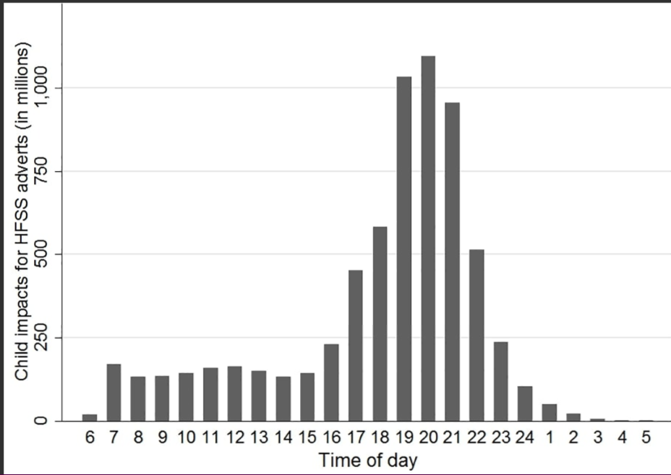
Figure 2: Children’s exposure to HFSS television advertising in the UK by time of day in 2015
Source: Mytton et al. (2020)
These regulatory pressures shape how confectionery brands like Cadbury communicate with consumers and increase the need for responsible marketing. As a result, Cadbury has had to adjust its promotional strategies, particularly in digital advertising and product placement. Australia’s political and legal environment is also increasingly influenced by public health concerns, with the World Health Organisation and national experts calling for stricter controls on online marketing of unhealthy foods.
Evidence from the Australian Ad Observatory demonstrates that major brands, including Cadbury, engage in potentially harmful marketing practices, such as youth-targeted content and sports-based promotional associations, exemplified by Cadbury’s advertisement featuring the Australian Women’s Rugby Team (Figure 3).
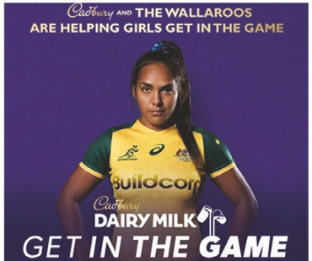
Figure 3: Example of brand marketing
Source: Northcott et al. (2025)
These findings signal a tightening regulatory environment that poses both legal and reputational risks for Cadbury, underscoring the need for heightened compliance and more responsible digital marketing strategies in the Australian market (Northcott et al., 2025).

3.3 Cultural Environment (Hofstede Analysis)
According to Hofstede’s cultural dimensions theory, Australia and the UK have comparatively similar cultural characteristics, especially when it comes to indulgence and individualism (Żemojtel-Piotrowska and Piotrowski, 2023; Hofstede, 2011). Although Hofstede’s framework provides useful insights into national cultural tendencies, it has limitations because it assumes cultural values remain relatively stable and may overlook regional diversity, demographic differences and changing consumer behaviour (Figure 4). Therefore, Cadbury should complement cultural frameworks with current market research and consumer insights when developing international marketing strategies. (Extra details in the Appendix).
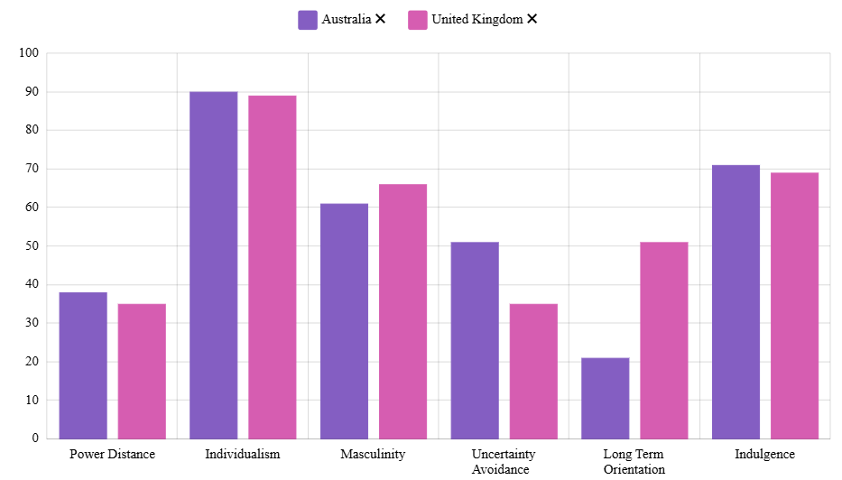Figure 4: Hofstede’s cultural dimensions comparison
Source: geerthofstede.com

3.4 Implications for Cadbury’s International Marketing Strategy
Overall, a mostly uniform marketing strategy is supported by the sociocultural similarities between the UK and Australia. Cadbury could keep its key product lines, branding, and emotive advertising themes identical in both areas. However, selective adaptation is necessary due to variations in legal frameworks and economic conditions. Pricing methods, for instance, could vary depending on the cost of living, and promotional messages need to adhere to local advertising regulations. Minor product modifications can also be required to adapt seasonal promotions and product availability around Easter, Christmas and outdoor family occasions while maintaining its globally recognised brand identity.

3.5 PESTLE Analysis
This PESTLE comparison (Table 1) highlights the key external factors shaping Cadbury’s operations in the UK and Australia. Although both markets share political stability, strong regulatory frameworks and similar cultural foundations, they differ in economic conditions, consumer expectations, technological infrastructure and environmental priorities. Understanding these contrasts enables Cadbury to balance global brand consistency with market-specific adaptations that strengthen competitiveness and long-term relevance.
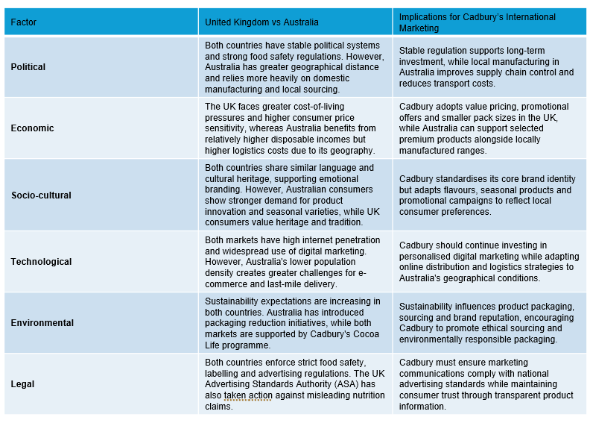Table 1: Comparative PESTLE Analysis of the United Kingdom and Australia

4. Segmentation, Targeting and Positioning (STP) Analysis

4.1 Segmentation Strategy
Cadbury applies a multi-layered segmentation strategy in both the UK and Australia, but the importance of each segment differs across the two markets. Demographically, Cadbury appeals to children, teenagers, adults and families, yet demographic categories alone do not explain purchasing behaviour. Behavioural segmentation is more influential, as chocolate consumption is shaped by snacking, gifting and seasonal occasions. In the UK, segments driven by tradition, comfort and nostalgia are particularly significant, with adults and families forming the core of Cadbury’s market. In Australia, younger consumers and novelty-seeking behavioural segments are more dominant, reflecting stronger demand for limited editions and flavour experimentation. Psychographic segmentation further differentiates consumers based on attitudes toward indulgence and emotional reward; younger consumers often treat chocolate as a self-gift, while adults associate it with comfort or nostalgia (Sondhi and Chawla, 2017). Overall, Cadbury’s segmentation is broad but strategically weighted: the UK relies more on heritage-oriented segments, whereas Australia requires greater focus on innovation-driven and lifestyle-based segments.

4.2 Targeting Strategy
Cadbury adopts a mass-marketing strategy in both the UK and Australia, but the priority target segments differ across the two markets. In the UK, Cadbury targets broad household and adult segments that value heritage, familiarity and emotional comfort, reflecting the brand’s deep cultural roots and long-standing loyalty. These consumers respond strongly to traditional flavours and nostalgic messaging, making them central to Cadbury’s UK targeting approach. In Australia, Cadbury still targets the mass market, but places greater emphasis on younger consumers, social sharers and novelty-seeking buyers who actively engage with limited editions and flavour innovation. This reflects Australia’s more experimentation-driven confectionery culture. Overall, Cadbury’s mass targeting ensures wide reach in both countries, but the brand must balance heritage-led targeting in the UK with innovation-led targeting in Australia to remain competitive.

4.3 Positioning Strategy
Cadbury positions itself as an accessible, joyful and emotionally meaningful brand in both the UK and Australia, but the emphasis differs across markets. In the UK, positioning is rooted in heritage, nostalgia and trust, reflecting Cadbury’s long cultural presence. In Australia, the brand maintains its emotional appeal but leans more toward fun, sharing and novelty to match local lifestyle patterns and demand for flavour innovation. While consistent emotional branding strengthens global identity, the UK’s heritage-led positioning risks appearing outdated to younger consumers, and Australia’s innovation-driven market requires ongoing adaptation to stay competitive.

4.4 Positioning Map: UK and Australian Chocolate Market
In highly competitive confectionery markets, as maintained by Manikandan and Sarguna (2024), sustaining a competitive edge requires Cadbury to allocate resources where they most effectively reinforce its brand position.
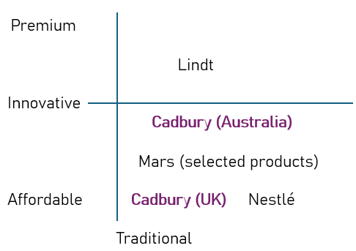
Figure 5: Positioning Map: UK and Australian Chocolate Market
Notes on the figure:
Axes:
Horizontal: Traditional <—————> Innovative
Vertical: Affordable <—————> Premium
Explanation of placement:
Cadbury UK: Affordable + traditional due to heritage positioning and classic flavours.
Cadbury Australia: Affordable + moderately innovative because of limited editions and novelty flavours.
Mars: Affordable + mid-innovation (e.g., Maltesers variants).
Nestlé: Affordable + traditional (KitKat, Aero).
Lindt: Premium + traditional/innovative depending on product line.
With only slight modifications to messaging and consumer emphasis, Cadbury’s STP strategy is mostly consistent throughout the UK and Australia. The robustness of Cadbury’s worldwide brand identity and its capacity to use emotional branding across regions with similar cultures are demonstrated by the consistency of segmentation, targeting, and positioning (STP).

5. Comparison of Marketing Mix Strategies in the United Kingdom and Australia
Cadbury’s marketing mix plays a central role in maintaining brand competitiveness across international markets. Fernandes et al. (2017) argue that long-term brand success depends on effective management of product, pricing, distribution and promotional strategies. For multinational companies, the key challenge is balancing global brand consistency with adaptation to local market conditions. The following comparative analysis examines Cadbury’s 7Ps marketing mix in the United Kingdom and Australia to assess the extent to which the company standardises or adapts its international marketing strategy. Table 2 provides a summary comparison of the seven marketing mix elements across the two markets:
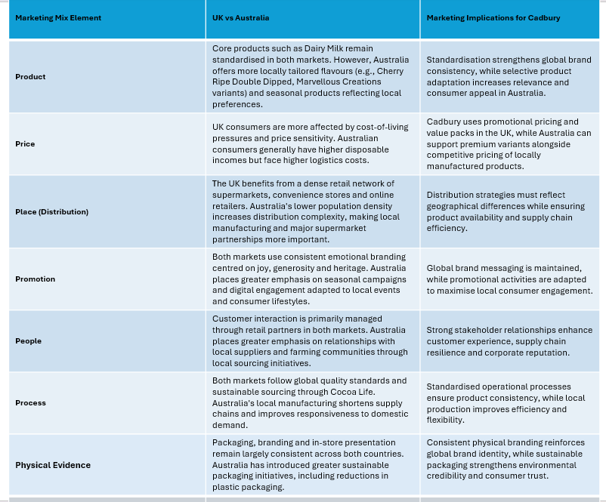
Table 2: Comparative Analysis of Cadbury’s 7Ps Marketing Mix in the United Kingdom and Australia

5.1 Product Strategy
Cadbury follows a largely standardised product strategy in the UK and Australia, using its core lines such as Dairy Milk, Crunchie, Wispa and Roses to maintain global brand equity, consistent quality and economies of scale. This approach aligns with its value-based UK identity built on ethics, heritage and trust (Burton and Turnbull, 2019). However, uniformity has limits in culturally diverse markets. Cadbury applies selective localisation to remain relevant, offering more flavour innovation and novelty in Australia while the UK focuses on classic tastes and seasonal traditions that reinforce brand history. The company has also adapted packaging in Australia, reducing plastic in its 2024 Easter range to meet rising sustainability expectations (GlobalData, 2024). These adjustments show how product and packaging decisions must balance global consistency with cultural relevance and evolving consumer values. In summary, standardisation protects global brand identity and reduces production costs, but too much uniformity risks weakening Cadbury’s ability to meet Australia’s stronger demand for novelty and seasonal experimentation.

5.2 Pricing Strategy
Cadbury adopts a competitive pricing strategy in both the United Kingdom and Australia, aiming to offer affordable products while maintaining profitability and market share. However, the strategic meaning of “competitive pricing” differs across the two markets due to variations in consumer behaviour, retail structures and economic conditions. In the UK, strong competition from Mars, Nestlé and supermarket private labels drives frequent promotions and multi-buy offers. For example, a standard Cadbury Dairy Milk 110g bar typically retails at around £1.50, but promotional pricing often reduces this to £1.00, or multi-buy deals such as 2 for £2.00 (Trolley.co.uk, 2024). These promotions are essential in a market where rising living costs have increased price sensitivity and encouraged consumers to seek value-based purchases. This means Cadbury must defend its heritage positioning while simultaneously competing in a price-driven retail environment, creating a tension between emotional branding and economic pressure. In Australia, Cadbury maintains a similar value-for-money positioning but operates in a market with higher average household incomes and stronger demand for novelty. A Cadbury Dairy Milk 180g block typically retails at around AUD $5.00, equivalent to approximately £2.60. Promotional pricing may reduce this to AUD $4.00 (£2.10) during supermarket campaigns (Woolworths, 2024; Coles, 2024). The higher baseline price reflects both larger product formats and Australia’s willingness to pay for premium or innovative variants. This allows Cadbury to rely less on aggressive discounting and more on innovation-led value creation, particularly through limited editions and region-specific flavours.

5.3 Promotion Strategy
Cadbury frequently employs emotionally charged themes: generosity, happiness, and shared enjoyment, to maintain consumer involvement across markets, making promotion one of the company’s strongest competencies. Campaigns in the UK frequently use family-centred narrative (Figure 6), nostalgia, and legacy to strengthen enduring cultural ties (Famous Campaigns, 2026).
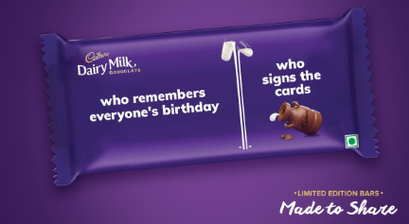
Figure 6: “Made to Share” Campaign Limited Edition Packaging
Source: designhill.com
To maintain cultural relevance, Cadbury uses a similar emotional appeal in Australia but modifies its messaging to fit local beliefs and lifestyles. Additionally, to attract younger consumers and improve brand relationships, Cadbury uses social media interaction, online advertising, and interactive content, as digital communication has become vital in both markets. While specific campaign content is modified to fit local cultural circumstances and changing consumer expectations, the promotional strategy is generally uniform in its emotive messaging. Zargar (2023) emphasises that Cadbury uses a mix of celebrities and influencers, choosing them based on campaign objectives and the context in which they want to connect with consumers. Celebrities are especially valuable for visibility and credibility during key stages of a brand’s lifecycle. Overall, consistent emotional branding strengthens global coherence, yet UK campaigns risk becoming outdated for younger consumers, and Australia’s innovation-driven market requires continuous creative refresh to stay competitive.

5.4 Place (Distribution)
Cadbury uses an extensive distribution network in both the UK and Australia, ensuring widespread availability through supermarkets, convenience stores, petrol stations, independent retailers and online platforms. While the channel structure is broadly similar, Australia presents greater logistical challenges due to its large geography and dispersed population. Research by Wu, Wang and Huo (2024) shows that sparsely populated countries face higher delivery costs, longer shipping times and more complex last-mile logistics, making e-commerce distribution more difficult for food products. These conditions require Cadbury to rely heavily on strong retail partnerships and efficient supply chain management to maintain product availability across remote regions. Although Cadbury’s distribution strategy is consistent across both markets, Australia’s logistical constraints mean that standardisation alone is insufficient; greater investment in regional supply chain resilience is necessary to sustain performance.

5.5 Marketing Mix summary
The comparison of Cadbury’s marketing mix strategies demonstrates that the company predominantly follows a standardised international marketing approach, with core product attributes, brand identity, pricing objectives and emotional promotional themes remaining largely consistent across the United Kingdom and Australia. Nevertheless, selective adaptations in areas such as product variations, promotional communication and distribution management allow the company to respond effectively to local market conditions. This balance between global consistency and local responsiveness is particularly important in cross-cultural marketing. According to Sharma et al. (2025), consumer psychology mediates the relationship between cultural values and brand perception, while market adaptation moderates the balance between standardisation and responsiveness, making an integrative approach essential for international marketing success. In addition, Tuominen et al. (2020) suggest that firms should focus not only on satisfying customer needs but also on retaining existing customers and building long-term relationships in international markets. Stronger customer relationships and ongoing competition in both areas are thus facilitated by Cadbury’s ability to integrate consumer-centric and creative communication methods with consistent brand messaging.

6. Evaluation of Marketing Performance

6.1 Performance in the United Kingdom
Cadbury continues to hold a dominant position in the UK chocolate market, supported by strong brand heritage, extensive distribution and high emotional resonance. According to Statista (2025), Cadbury maintains an estimated 26-28% share of the UK chocolate confectionery market, making it the category leader ahead of Mars and Nestlé. This leadership is reinforced by high brand recognition: YouGov BrandIndex (2025) ranks Cadbury among the top five most positively perceived FMCG brands in the UK.
However, performance pressures have increased. The UK chocolate market grew only 1.8% in 2024, while health-conscious segments grew more than 6%, indicating a shift in consumer priorities. Cadbury’s slower innovation in reduced-sugar and plant-based products limits its competitiveness in these emerging categories. The loss of its Royal Warrant in 2024 symbolically weakened its heritage positioning, signalling that historical prestige alone is no longer sufficient for market leadership (The Guardian, 2024). Cadbury’s loss of the Royal Warrant does not directly reduce sales, but it signals a decline in historical prestige and highlights the need for the brand to maintain modern relevance and consumer trust. Although Cadbury still holds strong market share and brand equity in the UK, its heavy reliance on heritage and emotional branding risks stagnation. Without faster innovation in health-focused products, Cadbury may struggle to remain appealing to younger and more health-conscious consumers.

6.2 Performance in Australia
Cadbury is one of Australia’s strongest confectionery brands, supported by local manufacturing, high product freshness and strong retailer partnerships. IBISWorld (2025) reports that Cadbury holds approximately 34-35% of the Australian chocolate market, outperforming Mars and Nestlé and maintaining leadership for more than a decade. Sales performance is also supported by Australia’s higher disposable incomes, with the chocolate confectionery market growing 4.2% in 2024, significantly faster than the UK. Brand perception data from Roy Morgan (2025) shows Cadbury as one of Australia’s most trusted confectionery brands, with particularly strong loyalty among families and younger consumers. Innovation-led products such as Marvellous Creations and limited-edition flavours have contributed to above-average category growth, demonstrating Cadbury’s ability to respond to Australia’s novelty-driven market.
Additionally, Cadbury’s ability to combine global brand consistency with targeted local adaptations has reinforced its competitive position, particularly through customised flavours and region-specific marketing initiatives. Sustainability programmes such as Cocoa Life have further strengthened consumer trust and enhanced the brand’s ethical profile. The continued sourcing of approximately 100 million litres of fresh milk annually from the Burnie region, equivalent to around 10% of Tasmania’s milk supply, highlights the strategic importance of local operations and demonstrates Cadbury’s contribution to the Australian economy (Mondelez International, 2026). However, while Cadbury’s Australian performance is strengthened by local production and innovation, it creates operational dependency on Tasmanian milk supply and higher manufacturing costs. Continued success depends on maintaining innovation momentum and managing supply chain risks.

6.3 Comparative Evaluation
Cadbury’s performance in the UK and Australia shows that its global marketing strategy remains broadly effective, supported by strong behavioural and attitudinal loyalty. As Osidele (2021) and PAI (2019) explain, repeated purchasing and positive emotional associations create composite loyalty, which strengthens long-term competitive advantage. Cultural similarities between the two markets allow Cadbury to maintain a consistent brand identity, while selective adaptations support responsiveness to local tastes and regulations. However, intensifying competition, rising health consciousness and growing sustainability expectations mean Cadbury cannot rely solely on heritage or emotional branding. Sustained innovation and proactive stakeholder engagement will be essential for maintaining relevance and protecting market share across both markets.

7. Market entry
Cadbury’s entry into Australia reflects a high commitment, market-seeking strategy that goes beyond incremental internationalisation. The company established local manufacturing in Tasmania in 1920 to leverage access to high-quality fresh milk, a resource advantage that could not be replicated through exports. This early investment created long-term operational benefits, including supply chain efficiency, fresher products and strong retailer partnerships. The continued sourcing of approximately 100 million litres of milk annually from the Burnie region demonstrates how Cadbury’s entry strategy evolved into a deeply embedded local presence. Although the Uppsala model explains Cadbury’s gradual expansion of market knowledge, the Australian case also shows that resource-based motivations can accelerate commitment when local conditions offer strategic advantage. This combination of experiential learning and resource-seeking behaviour has shaped Cadbury’s sustained competitiveness in Australia.

8. Evaluation of Marketing Ethics
Ethics has become a central component of international marketing, extending beyond regulatory compliance to encompass broader moral responsibilities in global operations. Crane et al. (2019) argue that ethical behaviour must be embedded within organisational practices, particularly for multinational companies whose stakeholders expect transparency, responsible sourcing and socially conscious marketing. For Cadbury, ethical considerations span product safety, sustainability and communication practices. One of Cadbury’s most significant ethical initiatives is Cocoa Life, a sustainability programme developed by Mondelez International to promote responsible cocoa sourcing. Working with suppliers, governments and organisations such as Fairtrade, the programme aims to improve farmer livelihoods and environmental sustainability. Its goal of engaging approximately 300,000 cocoa farmers by 2030 (Purboningtyas, 2024) demonstrates Cadbury’s long-term commitment to ethical sourcing and shared value creation.
Despite these positive developments, Cadbury has faced ethical challenges. In 2003, contamination reports involving Dairy Milk bars in India led to a decline in consumer confidence and criticism of Cadbury’s initial attempt to attribute the issue to retailer storage conditions. The company later adopted a more accountable approach through Project Vishwas, which introduced improved packaging, strengthened quality control and retailer education programmes (Naithani et al., 2024). This shift illustrates how ethical marketing is judged not only by the avoidance of harm but also by the quality of organisational response when problems occur.
Independent evidence from the Australian Ad Observatory (Northcott et al., 2025) shows that major confectionery brands, including Cadbury, have used digital content that may appeal to younger audiences, such as sports-linked advertising and youth-oriented social media formats. These practices raise ethical concerns because
Australia faces rising childhood obesity rates, and concerns persist that digital marketing of high-sugar products influences young consumers. Although Cadbury complies with national advertising regulations and Cocoa Life supports farmer welfare and environmental sustainability, these initiatives do not fully address expectations for responsible marketing. To strengthen its ethical position, Cadbury should implement stricter online marketing controls, provide clearer nutritional information, and reduce youth-targeted promotional content.

9. Recommendations

9.1 Expand Health-Conscious Product Innovation
Growing consumer awareness of nutrition and wellbeing is reshaping confectionery demand. Ersoy (2023) argues that healthier diets and sustainable food production will define future consumption patterns, making product innovation essential for long-term competitiveness. Cadbury should therefore accelerate development of reduced-sugar variants, portion-controlled formats and healthier snack options. Konar et al. (2022) further note that the functional characteristics of chocolate can be improved through enrichment and adjustments to production processes, and that chocolate is an effective carrier for functional compounds because it is widely consumed across age groups. This evidence supports the opportunity for Cadbury to explore enriched or reformulated products that meet rising health expectations without compromising enjoyment. Implementation could involve reformulating selected core products and piloting smaller pack sizes in both markets. The main risk is potential resistance from consumers who prefer traditional flavours, but the expected outcome is stronger appeal among younger and health-conscious segments and improved alignment with evolving market expectations.

9.2 Strengthen Digital Marketing and Consumer Engagement
Digital engagement increasingly shapes purchasing behaviour, particularly among younger consumers. Liu et al. (2020) highlight that firms with strong internet marketing capabilities adapt more effectively to shifting market demands, while Chuunga et al. (2025) show that digital communication enhances interaction, credibility and personalised experiences. Cadbury should build on these insights by strengthening its digital marketing capabilities through personalised content, interactive campaigns and improved social media responsiveness. Implementation may include investing in internal digital skills, expanding data-driven targeting and developing platform-specific content strategies. Although this requires ongoing investment and may increase operational complexity, the expected result is deeper consumer engagement and stronger brand relevance in both the UK and Australia.

9.3 Enhance Sustainability and Ethical Transparency
Stakeholder expectations around sustainability continue to rise. Shang (2026) notes that environmental and social responsibility increasingly shape competitive advantage, reinforcing the need for transparent ethical practices. Cadbury’s Cocoa Life programme already supports sustainable cocoa production, with Thompson (2017) emphasising its role in positioning Cadbury as a long-term partner to farmers rather than a transactional buyer. However, Cadbury should expand these initiatives by improving transparency around environmental performance, packaging reduction and sourcing practices. Clearer communication would strengthen consumer trust and differentiate the brand in competitive markets. Cadbury must also address ethical challenges in responsible advertising. The UK Advertising Standards Authority’s ban on the Cadbury Delights radio campaign for implying an unauthorised low-calorie claim (“only 91 calories”) demonstrates the importance of accurate communication (GlobalData, 2025). Although Mondelez accepted the ruling, the case highlights the need for stricter compliance and clearer nutritional messaging. Strengthening sustainability reporting and ensuring regulatory accuracy in promotional content would reinforce Cadbury’s credibility and support responsible international marketing.

Conclusion
The international marketing tactics used by Cadbury in the UK and Australia have been studied in this report. The investigation showed that Cadbury has been able to take a mostly standardised approach while implementing selective changes to fit local consumer preferences and market conditions because of the similarities between the two markets. The results demonstrated that Cadbury’s marketing success in both nations has been greatly influenced by its robust brand heritage, emotional positioning, and wide distribution network. Additionally, the company’s long-term competitive edge has been bolstered by its capacity to strike a balance between local responsiveness and worldwide consistency. Initiatives like Cocoa Life and ongoing product innovation show Cadbury’s dedication to sustainable growth, despite the company’s challenges with expanding competition, shifting consumer preferences, and rising ethical standards. Cadbury’s worldwide success highlights how important it is to combine a consistent global strategy with selective adaptation to provide value for consumers and preserve brand competitiveness.

Reflective Account Using Gibbs’ Reflective Cycle
Gibbs’ Reflective Cycle (Gibbs, 1988) offers a structured way to evaluate my learning, and it is particularly useful for reflecting on the challenges I faced while researching Cadbury’s international marketing strategy and interpreting evidence across two different markets.
Description
During this assignment, the main challenge I faced was gathering reliable and comparable market data for Cadbury’s performance in the UK and Australia. While qualitative sources were easy to access, finding consistent quantitative evidence such as market share, sales growth and consumer rankings proved more difficult. This slowed my progress and created uncertainty about the accuracy of my initial evaluation.
Feelings
At the beginning of the assignment, I felt confident about selecting Cadbury because it is a globally recognised brand with extensive information available. However, I initially found it challenging to determine how to structure the report and balance descriptive information with critical analysis. As the research progressed, I became more confident in applying international marketing theories and comparing the UK and Australian markets. Discovering relevant journal articles and practical examples, such as the Cocoa Life programme and the Project Vishwas initiative, increased my understanding of how marketing decisions are influenced by ethical and environmental considerations. By the end of the assignment, I felt more comfortable analysing international marketing strategies and linking theoretical concepts to business practice.
Evaluation
The strongest part of my approach was my ability to synthesise academic literature and apply it to Cadbury’s international marketing strategy. However, my initial research process was inefficient. I relied too heavily on general articles and did not immediately consult industry databases such as Statista, IBISWorld or YouGov. As a result, my early drafts lacked the quantitative evidence required for a critical evaluation. Once I corrected this, the quality of the performance section improved significantly.
Analysis
My research using journal articles and news reports enabled me to adopt a more balanced perspective. For example, analysing the 2003 contamination crisis in India demonstrated that ethical marketing also involves how organisations respond to failures and rebuild stakeholder trust. Similarly, the loss of Cadbury’s royal warrant in 2024 provided an example showing that even strong brands can face reputational challenges. The problem occurred because I underestimated the importance of triangulating data from multiple industry sources. Later, applying theories studied during the module, such as STP, the marketing mix and ethical frameworks, helped me understand how international marketing decisions are influenced by cultural, economic and social factors. I also recognised that successful international marketing requires firms to balance global consistency with local adaptation. This reinforced the practical relevance of concepts discussed throughout the module and demonstrated how theoretical models can be used to explain real business decisions.
Conclusion
Reflecting on the overall process, I believe that completing this assignment enhanced both my research and analytical skills. It improved my ability to evaluate information from multiple sources, apply marketing theories and construct evidence-based arguments. I learned that strong academic writing depends on both conceptual understanding and robust evidence. Although the process was challenging, it strengthened my ability to produce critical, well-supported analysis.
Action Plan
For future assignments, I will begin by identifying relevant industry databases and checking data availability before drafting any analytical sections. I will also create a structured research log to track sources, dates and reliability. If data gaps appear, I will adjust my research strategy early rather than revising large sections later. Finally, I will allocate more time to cross-checking figures to ensure accuracy and consistency. These steps will help me produce more rigorous, evidence-based work and avoid the research challenges I encountered in this project.

References

Ahmad, Shamim, and Seiya Endo. (2023). "Australia country report." Energy Outlook and Energy-Saving Potential in East Asia 2023.
Ajetunmobi, O.A., Laobangdisa, S. (2024). The Effect of Cultural and Socio-economics Factors on Consumer Perception. In: Bogueva, D. (eds) Consumer Perceptions and Food. Springer, Singapore. Available at: https://doi.org/10.1007/978-981-97-7870-6_2 (Accessed 22 July 2026).
Aujla, D.S., (2022). an Analysis of the Marketing Strategies of Cadbury. Marketing Mastery: Strategies for Captivating Audiences, p.43.
Bailey, A.R. and Alexander, A., (2019). Cadbury and the rise of the supermarket: Innovation in marketing 1953–1975. Business History, 61(4), pp.659-680.
Beugelsdijk, S. and Luo, Y., (2024). The politicized nature of international business. Journal of International Business Studies, 55(3), pp.281-284.
Bogueva, D. & Nyambayo, I., (2026). 3.6 – Food Marketing Across Cultures. In: H.L. Meiselman, ed., Food and Consumer Behavior: A Comprehensive Reference. 1st ed. Oxford: Elsevier, pp. 58–72. Available at: https://doi.org/10.1016/B978-0-443-29139-5.00083-5. (Accessed 22 July 2026).
Burton, N. and Turnbull, R., (2019). Cadbury's Ethics and the Spirit of Corporate Social Responsibility. Quakers, Business and Corporate Responsibility: Lessons and Cases for Responsible Management, p.41.
Cadbury UK (2026) Cocoa Life: 10 years focused on making cocoa more sustainable. Available at: https://www.cadbury.co.uk/about/impact/cocoa-life/ (accessed 07 June 2026).
Cadbury UK (2026) Our story. Available at: https://www.cadbury.co.uk/about/history/our-story/ (accessed 04 June 2026).
Cadbury Australia (2026) Cocoa Life. Available at: https://www.cadbury.com.au/about/who-we-are/cocoa-life/ (accessed 24 June 2026).
Cadbury Australia (2026). Products:Cadbury Cherry Ripe Double Dipped 40g.Available at: https://www.cadbury.com.au/products/cadburycherryripedoubledipped40g/ (accessed 03 July 2026).
Cadbury, D. (2010) Chocolate Wars: The 150-Year Rivalry between the World's Greatest Chocolate Makers. New York: Public Affairs.
Chuunga, K., Mpundu, M. and Qutieshat, A. (2025) “The Role of Digital Marketing in the Flourishing of International Businesses,” International Journal of Advanced Business Studies, 4(2), pp. 7–21. Available at: https://doi.org/10.59857/LHHJ1084 (Accessed 23 June 2026).
Coles (2024) Cadbury Dairy Milk Chocolate Block 180g – Product Pricing. Available at: https://www.coles.com.au/product/ (Accessed 22 July 2026).
Crane, A., Matten, D., Glozer, S. and Spence, L.J., (2019). Business ethics: Managing corporate citizenship and sustainability in the age of globalization. Oxford university press.
Ersoy, N., (2023). A cross-section from the consumer perspective on sustainable nutrition: consumer awareness and motivation status. Environmental Science and Pollution Research, 30(31), pp.76712-76717.
Famous Campaigns (2026) Cadbury brings back ‘Made to Share’ with candid moments of everyday generosity. Available at: https://www.famouscampaigns.com/2026/03/cadbury-brings-back-made-to-share-with-candid-moments-of-everyday-generosity/ (Accessed: 12 June 2026).

Fernandes, S., Chaudhuri, S. and Vidyasagar, A., (2017). Success crowns Cadbury dairy milk: Brand and culture analysis. International Journal of Applied Business and Economic Research, 15(2), pp.177-189.

Fincham, A.J., (2019). Made for Sharing: George Cadbury,‘Industrial Betterment’and Salvation1. Quaker Studies, 24(2).

Gibbs, G., (1988). Learning by doing: A guide to teaching and learning methods. Further Education Unit.

GlobalData, (2024). Cadbury Australia reduces plastic packaging for Easter series to enhance sustainability. Available at: https://explorer-globaldata-com.uwtsd.idm.oclc.org/Analysis/details/analyst-briefing-cadbury-australia-reduces-plastic-packaging-for-easter-series-to-enhance-sustainability (Accessed 13 June 2026).

GlobalData, (2025). UK watchdog bans Cadbury ad over calorie claim. Available at: https://explorer-globaldata-com.uwtsd.idm.oclc.org/News/uk-watchdog-bans-cadbury-ad-over-calorie-claim_191006 (Accessed 14 July 2026).
Ho, K.F.X., Liu, F., Tarabashkina, L. and Volery, T., (2022). Cross-cultural differences in consumers' attention to food labels. British Food Journal, 124(12), pp.4888-4904.
Hofstede, G. (2011). Dimensionalizing Cultures: The Hofstede Model in Context. Online Readings in Psychology and Culture, 2(1). Available at: https://doi.org/10.9707/2307-0919.1014 (Accessed 16 June 2026).
IBISWorld (2025) Chocolate and Confectionery Manufacturing in Australia: Market Share and Industry Statistics. Available at: https://www.ibisworld.com (Accessed 22 July 2026).
Jenneson, V., Greenwood, D.C., Clarke, G.P., Hancock, N., Cade, J.E. and Morris, M.A., (2020). Restricting promotions of ‘less healthy’foods and beverages by price and location: A big data application of UK Nutrient Profiling Models to a retail product dataset. Nutrition Bulletin, 45(4), pp.389-402.
Konar, N., Palabiyik, I., Toker, Ö.S., Saputro, A.D., Pirouzian, H.R. (2022). Improving Functionality of Chocolate. In: Galanakis, C.M. (eds) Trends in Sustainable Chocolate Production. Springer, Cham. Available at: https://doi.org/10.1007/978-3-030-90169-1_3 (Accessed 22 July 2026).
Liu, C.L., Zhang-Zhang, Y. and Ghauri, P.N., (2020). The influence of internet marketing capabilities on international market performance. International Marketing Review, 37(3), pp.447-469.
Manikandan, M. and Sarguna, G., (2024). A comparative analysis of Cadbury dairy milk and Cadbury 5 star using the BCG matrix framework. INTERNATIONAL JOURNAL OF RESEARCH IN MARKETING, 6(2), pp.238-243.
Mondelez International (2026) From milk to milk chocolate: Cadbury welcomes its Tasmanian farmers. Available at: https://www.mondelezinternational.com/assets/Country/Australia/press-releases/2026/Cadbury-Claremont-Farmer-Visit.pdf (Accessed 6 June 2026).
Mytton, O.T., Boyland, E., Adams, J., Collins, B., O’Connell, M., Russell, S.J., Smith, K., Stroud, R., Viner, R.M. and Cobiac, L.J., (2020). The potential health impact of restricting less-healthy food and beverage advertising on UK television between 05.30 and 21.00 hours: a modelling study. PLoS medicine, 17(10), p.e1003212.
Naithani, M., Binjola, H., Negi, V., Chamoli, V. and Bajaj, S., (2024), November. Crisis Communication and Corporate Reputation: Case Study of Cadbury and Meta. In Proceedings of the 3rd International Conference on Optimization Techniques in the Field of Engineering (ICOFE-2024).
Northcott, T., Sievert, K., Russell, C., Obeid, A., Angus, D. and Parker, C., (2025). Unhealthy food advertising on social media: policy lessons from the Australian Ad Observatory. Health Promotion International, 40(2), p.daae192.
Osidele, E.O., (2021). Impact of customer relationship management on customer loyalty: case study of Cadbury Nigeria Plc (Doctoral dissertation, Dublin, National College of Ireland).
PAI, C.-H., KO, K.-M. and SANTOS, T. (2019) “A Study of the Effect of Service Recovery on Customer Loyalty Based On Marketing Word Of Mouth in Tourism Industry,” Revista de cercetare şi intervenţie socialǎ, 64, pp. 74–84. Available at: https://doi.org/10.33788/rcis.64.6 (Accessed 20 June 2026).
Purboningtyas, G.N.M., (2024). Strategic Marketing Audit of Cadbury in the United Kingdom (Doctoral dissertation, UNIVERSITAS ATMA JAYA YOGYAKARTA).
Roy Morgan (2025) Most Trusted Brands: Confectionery Category – Australia. Available at: https://www.roymorgan.com (Accessed 22 July 2026).
Shang, K. (2026) “Balancing Corporate Social Responsibility, Environmental Policies, and Stakeholder Expectations for Sustainable Development: A Stakeholder‐Centric Analysis,” Sustainable development (Bradford, West Yorkshire, England), 34(S1), pp. 1491–1500. Available at: https://doi.org/10.1002/sd.70204 (Accessed 21 June 2026).
Sharma, S.K., Dongre, S., Patra, S.G., James, S., Dhote, T. and Singh, R.K., (2025). CROSS-CULTURAL MARKETING STRATEGIES IN A GLOBALIZED WORLD: A LONG RESEARCH ARTICLE ON CONSUMER PSYCHOLOGY, BRANDING, AND MARKET ADAPTATION. Lex Localis: Journal of Local Self-Government, 23.
Siegfried, D. (2010) “Chocolate Wars: The 150-Year Rivalry between the World’s Greatest Chocolate Makers,” The Booklist (Chicago, Ill. 1969). Chicago: American Library Association, p. 17.
Sondhi, N. and Chawla, D., (2017). Segmenting and profiling the chocolate consumer: an emerging market perspective. Journal of Food Products Marketing, 23(2), pp.123-143.
Statista (2025). Market share of leading chocolate confectionery brands in the United Kingdom. Available at: https://www.statista.com (Accessed 22 July 2026).
The Guardian (2024) Cadbury dropped from royal warrant list for first time in 170 years. Available at: https://www.theguardian.com/business/2024/dec/22/cadburys-dropped-from-royal-warrant-list-for-first-time-in-170-years (Accessed: 21 June 2026).
Thompson, A. (2017) “Mondelez extends cocoa sustainability program to Cadbury: Cadbury products in Ireland, UK to be sourced through Cocoa Life,” Candy industry (1982), 1 January, p. 16.
Thompson, A., (2019). Standing out from the crowd. Candy Industry, 184(6), pp. 30-31.
Trolley.co.uk (2024). Cadbury Dairy Milk 110g – Price Comparison and Promotions. Available at: https://www.trolley.co.uk/product/cadbury-dairy-milk-chocolate-bar/NGGJZ (trolley.co.uk in Bing) (Accessed 22 July 2026).
Tuominen, S., Reijonen, H., Nagy, G., Buratti, A. and Laukkanen, T., (2023). Customer-centric strategy driving innovativeness and business growth in international markets. International marketing review, 40(3), pp.479-496.
Vahlne, J. (2020). “Development of the Uppsala model of internationalization process: From internationalization to evolution,” Global strategy journal, 10(2), pp. 239–250. Available at: https://doi.org/10.1002/gsj.1375 (Accessed 15 July 2026).
Vieira, F.T., (2025). The Cadbury Takeover: Evaluating the Global Strategy of Kraft Foods (Master's thesis, Universidade NOVA de Lisboa (Portugal)).
Woolworths (2024). Cadbury Dairy Milk Chocolate Block 180g – Product Pricing. Available at: https://www.woolworths.com.au/shop/productdetails/ (Accessed 22 July 2026).

Wu, Y., Wang, B. and Huo, B. (2024) “Sustainability challenges of last-mile logistics and transition to online grocery retailing in sparsely populated areas,” Industrial management + data systems, 124(12), pp. 3197–3217. Available at: https://doi.org/10.1108/IMDS-02-2024-0131 (Accessed 20 June 2026).
YouGov (2025) BrandIndex Rankings: FMCG Brands in the UK. Available at: https://yougov.co.uk (Accessed 22 July 2026).
Zargar, U. (2023) “Decoding Cadbury’s decades worth of advertising and marketing mojo,” Available at: https://www.afaqs.com/news/mktg/decoding-cadburys-decades-worth-of-advertising-and-marketing-mojo (Accessed: 17 June 2026).
Żemojtel-Piotrowska, M. and Piotrowski, J., (2023). Hofstede’s cultural dimensions theory. In Encyclopedia of sexual psychology and behavior (pp. 1-4). Cham: Springer International Publishing.

Appendix
3.3.1 Individualism
Childhood obesity evidence from the UK shows that pervasive marketing of high-sugar, ultra-processed foods contribute to an obesogenic environment, with children particularly vulnerable to persuasive promotions (Jenneson et al., 2020). This raises important ethical questions for markets like Australia and the UK, where high individualism means consumers are especially responsive to advertising that emphasises personal choice, self-reward and identity. While Cadbury often leverages these themes, cross-cultural research highlights that consumer expectations are more complex: Australians pay close attention to assurance cues and health indicators (Ho et al., 2022), and broader studies show cultural values, traditions and socioeconomic realities strongly shape perceptions of quality, authenticity and acceptability (Ajetunmobi and Laobangdisa, 2024). Therefore, although personalised digital marketing can deepen engagement in individualistic cultures, Cadbury must ensure its strategies remain transparent, culturally sensitive and aligned with public health responsibilities, particularly in environments where unhealthy food promotion already poses significant risks.
3.3.2 Uncertainty Avoidance
Customers are generally at ease with well-known brands and well-established product categories since both cultures exhibit comparatively low uncertainty avoidance. Strong brand loyalty lessens the need for drastic product modification, which is advantageous to Cadbury.
3.3.3 Indulgence
Australia and the UK both have comparatively high indulgence scores, suggesting that consumers are more inclined to enjoy leisure and treat-based purchases. This is especially crucial for chocolate products because Cadbury's stance on "everyday treats" closely reflects customer behaviour in both areas.

