

Design and implementation of mobile scoring applications for use in recreational and competitive archery environments

by
Steffan John Benson

Supervisor: Nik Whitehead
Second Marker: Sue Maw

Project submitted as part of the requirements for the award of BSc(Hons) Computer Games Development

May 2019

Declaration FORM AND FORM OF CONSENT
DECLARATION

I, Steffan John Benson declare that I am the sole author of this Project; that all references cited have been consulted; that I have conducted all work of which this is a record, and that the finished work lies within the prescribed word limits.

This work has not previously been accepted as part of any other degree submission.

Signed: Steffan John Benson

Date: 1/5/2019

FORM OF CONSENT

I, Steffan John Benson hereby consent that my Project, submitted in candidature for the B.Sc. Computer Games Development degree, if successful, may be made available for inter-library loan or photocopying (subject to the law of copyright), and that the title and abstract may be made available to outside organisations.

Signed: Steffan John Benson

Date: 1/5/2019

ABSTRACT
This report details the research, design and implementation of scoring systems in Recreational and Competitive Archery. The initial aim of this project is to develop a series of applications, usable in scoring scenarios in archery, that will render paper scoring obsolete while also unifying scoring systems for recreational and competitive archery, which thus far have remained two separate entities. Beginning with basic market research and analysis of existing products and combined with suggestions from local archery enthusiasts, requirements are drawn that include both positive aspects of existing products as well as the elimination of their drawbacks. Initial Research found several existing products with a range of features, most of which are beneficial to the performance of archers although some are a hinderance to users whose confidence with technology is lacking. From these requirements and the analysis of existing products, features will be determined for inclusion in an implemented product, in the form of a prototype. This prototype provides a simulation of basic functionality, as well as a platform for further research and development. Following development, basic testing will determine the functionality of the prototype and whether it is a viable basis for further development.
Upon completion of the development of the prototype, it is established that further work is required to make this a viable product for use in real-world archery environments, as the developed prototype utilises PC-based software package as opposed to a mobile-based package. Although base functionality has been proven as an effective means of simplifying the scoring process, further work is required to develop an application suitable for distribution and general use. As well as this, further research is required for an effective implementation of a competitive scoring system, as large-scale data handling offers several variables which were initially unaccounted for.

Contents
Declaration FORM AND FORM OF CONSENT ii
ABSTRACT iii
Contents v
Table of figures vii
1 Introduction 8
1.1 Aim 9
1.2 Objectives 9
1.3 Structure of the Report 10
2 Research and Review of Literature 11
2.1 The problem 11
2.1.1 How archery rounds are scored 11
2.1.2 A comparison of electronic and paper scoring methods 12
2.2 Mobile Scoring Applications 14
2.2.1 Archery Companion App 15
2.2.2 MyTargets 20
2.2.3 Comparison of electronic versus pen and paper scoring platforms 25
2.3 Competitive Scoring Systems 25
2.3.1 The architecture of a scoring system 27
2.3.2 Scoresheets 27
2.3.3 Database 27
2.3.4 Electronic versus Physical scoresheets in competition 28
2.4 Technology 29
2.4.1 Software 29
2.4.2 Devices 30
2.4.3 Central Terminal Devices for Competitive Archery Environments 31
2.5 Connectivity 31
2.5.1 Wi-Fi (Wireless Interfacing) 31
2.5.2 Bluetooth 32
2.5.3 Near Field Communication 32
2.5.4 Physical connection 33
2.6 Data Handling 33
2.6.1 Spreadsheet 33
2.6.2 Recreational Data Handling 34
2.6.3 Competitive Data Handling 34
2.7 Conclusion 35
2.7.1 Recreational Scoring Applications 35
2.7.2 Competitive Scoring Applications 35
2.7.3 Mobile Devices 35
2.7.4 Connectivity 36
3 Research and Development Methodologies 37
3.1 Research 37
3.1.1 Hypothesis 37
3.2 Development Methodology 38
3.3 Selection of technical resources 39
3.3.1 Human Resources required 40
4 Design and Implementation 41
4.1 Requirements Analysis 41
4.1.1 Recreational App 41
4.1.2 Competitive Scoring Architecture 41
4.1.3 Connectivity 41
4.2 Design 42
4.2.1 Recreational Scoring Application 42
4.2.2 Competitive Scoring System 44
4.2.3 Connectivity 45
4.3 Implementation 45
5 Evaluation 48
6 Conclusions and Recommendations 50
6.1 Conclusion of work conducted 50
6.2 Suggestions for further Research and Development 53
6.2.1 App development 53
6.2.2 Competitive Infrastructure 53
7 References 54
8 Appendices 56

Table of figures
Figure 1 - Empty paper scoresheet, courtesy of Swansea University Archery Club 12
Figure 2 - Completed Portsmouth Round 15
Figure 3 - Incomplete Portsmouth Round 16
Figure 4 - List of personal records based on Round 17
Figure 5 - Completed Vegas Round with greater variation in scores 18
Figure 6 - In-App Bow Information Storage 20
Figure 7 - Score input method 21
Figure 8 - Graphical Statistics breakdown 22
Figure 9 - Graphical Statistics breakdown (cont.) 23
Figure 10 - Ianseo Score breakdown (Online Display)[4] 25
Figure 11 - Functionality simulation design with completed score (Test 2 worksheet) 43
Figure 12 - Dropdown list for bowstyle, taken from functionality simulation in Microsoft Excel 44
Figure 13 - Implemented Functionality Simulation with completed score (test 1 worksheet) 45
Figure 14 - Example of end total calculation function 45
Figure 15 - Example of function for running total 45
Figure 16 - Example of Average Arrow Score Function, passing through 2 separate sections of data 46
Figure 17 - Example of function for calculating the total number of golds scored 46
Figure 18 - Example of function for calculating the total number of hits scored 46

Introduction
For millions of years, archery has been a staple of humanity’s existence. Originally utilised for hunting and warfare, in the last century archery has become a recreational activity as opposed to a means of survival. Since then, multiple organisations have formed worldwide, hosting competitions ranging from small regional events to world-class events. As well as this, advances in technology have made bows in modern target archery profoundly more accurate, with world class compound archers rarely straying from the gold area of the target. Scoring in target archery has been predominantly handled utilising pen and paper, however with modern technologies becoming increasingly available, electronic applications have begun to take place of the old-fashioned methods. This spur in mobile applications has caused a divide in how scoring in archery is handled, with one side favouring the tried and trusted pen and paper methods, while others favour modernized applications on mobile devices. The outcome of both methods is typically the same, however the accessibility and ease of use of the two methods differ greatly.

Aim
The main aim of this project is
The design and implementation of scoring applications for use in both recreational and competitive archery environments utilising mobile and PC platforms.

Objectives
The objectives are to:
- Research and develop understanding of usability of current electronic scoring applications;
- Research and develop understanding of usability of pen and paper scoring methods;
- Compare and analyse pen and paper methods versus electronic methods;
- Assess the impact of electronic scoring methods on recreational archery scoring;
- Assess the impact of electronic scoring methods on competitive archery scoring;
- Determine key features central to effective electronic archery scoring;
- Determine issues that negatively impact electronic scoring in archery;
- Design and develop a mobile application for use in recreational archery scoring;
- Design and develop a database/spreadsheet for use in competitive archery scorekeeping;
- Develop connectivity between both applications so that data can be transferred between the two;
- Evaluate the effectiveness of the implemented system by taking user feedback;
- Compare the effectiveness of implemented system to existing systems, constructing a report detailing results of any feedback and testing undertaken.

Structure of the Report
The following report will be separated into 3 sections. Section 1 will consist of research and literature review on the topic at hand, discussing problems with current software and evaluating the necessary components for a competitive piece of software. Section 2 will cover the development of the project. In this section, development methodology as well as the methods and resources required to successfully develop the project, as well as potential hinderances to development. Section 3 will evaluate the level of success of the project. Factors, such as the content included in the software or user feedback.
The breakdown of each chapter is as follows:
Chapter 2 – Literature Review
Chapter 3 – Methodologies
Chapter 4 – Design & Implementation
Chapter 5 – Analysis
Chapter 6 – Evaluation
Chapter 7 – Conclusions & Recommendations
Chapter 8 – Reflections & Future Additions

Research and Review of Literature

The problem
Since the inception of modern competitive archery, “pen and paper” methods of scoring have been predominant and are still prominent in most competitive formats today. However, with recent advances in mobile phone and tablet technologies, opportunities to move away from paper scorecards have grown increasingly common. With these advances however, come the technological issues in the form of poor reliability and programming bugs.
The most widely used competitive scoring format, Ianseo[1], suffers from many system issues despite its worldwide popularity. Chief amongst these issues are connectivity issues which, based on the author’s personal experience, can delay competitions. The use of Wi-Fi to transmit the data from each mobile terminal is subject to the reliability of the wireless connection.
At the BUCS Indoor Championship Final in March of 2018, the unintentional disconnection of a scoring tablet caused the loss of scores for 4 competing archers. These scores were only recovered due to the use of a paper scorecard as a back-up.
Personal scoring applications are more common than competitive systems with multiple applications available for free on mobile app stores. Although useful for storing multiple scores in a single format, they can often be cumbersome to use, with many older members of the recreational archery community opting to stick with “pen and paper methods”.

How archery rounds are scored
Competitions in archery utilise various structures, known as rounds, to differentiate between different conditions. Certain rounds require more arrows to be shot than other rounds, whereas some rounds only allow certain scores to be counted. Rounds may also include varying distances and target sizes. The most commonly shot indoor round, the Portsmouth round, consists of 60 arrows shot at 18 yards onto 60cm target face (three smaller diameter faces for compound archers). The Olympic recurve qualifying round (also known as a WA 70m) is shot at 70m outdoors, onto a 122cm face and consists of 72 arrows. Head-to-Head matches in Olympic recurve are shot under the same conditions as the qualifying round, however each match only consists of 12 arrows.
Rounds are separated into groups of arrows known as ends. Ends can consist of either 3 or 6 arrows, with the rare exception of the Worcester round, which allows for 5 arrows per end. Ends are timed under competitive conditions; however, the time limit varies depending on the round being shot. After each end has been shot, the archers will walk to the target, count their scores and then retrieve their arrows.
Each target in a competitive archery environment is assigned a target captain. The target captain’s responsibility is to mark each archer’s score on the scoresheet. Each archer’s score is counted by two people, the archer and the target captain. Head-to-head matches at high-end competitions will sometimes have members of the field team counting scores and retrieving arrows on behalf of the archers to reduce the time taken per match.

A comparison of electronic and paper scoring methods
Traditional pen and paper methods are simple and effective systems of scoring. All that an archer requires is a piece of paper and a pen. Although some archers are indifferent to this, most archers prefer the paper scorecard to have a table printed so that scores are tidier and easier to understand. The archer’s running total must be calculated manually by the archer with this method. In competition environments, paper scorecards may be used as back-ups to electronic systems. Paper scorecards are filled in simultaneously to electronic scorecards and are collected periodically to be input into a centralised database system.
Electronic scoring can sometimes be more complex than pen and paper scoring; however, the basic principle remains unchanged. A predefined grid is displayed, allowing archers to input individual arrow scores. The scores accumulate automatically, removing the need for the archer to calculate running totals themselves. This automatic score calculation removes the human error involved in mental maths, making scores more accurate.

With larger scale competitions looking to modernise and simplify scorekeeping techniques, pen and paper methods have fallen into background use as back-up methods. The only error physical scorecards may encounter are human errors caused by archers using them, whereas electronic scorecards encounter programming, hardware and human errors. Despite its poor reliability compared to physical scorecards, electronic scorecards provide ease of use that makes them the first choice for many of the world’s biggest competitions.
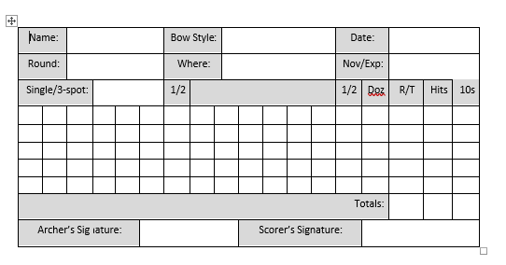
Figure 1 - Empty paper scoresheet, courtesy of Swansea University Archery Club

The purpose of this project is to take the concept of existing competitive archery scoring formats and remove the issues with connectivity. A personal scoring system may also be implemented into the mobile applications for this project, with a simple, ergonomic design.
The key components to any scoring application are: -
- User interface
- Data input
- Database
- Security

Each of these components are susceptible to different usability issues, such as lack of aesthetic appeal or complex user mechanics. Data input in scoring applications can sometimes be difficult as on-screen keyboards on mobile devices can be small and difficult to utilise without accidental incorrect inputs. Incorrect data inputs, although seemingly insignificant in isolated incidents, have the potential to delay competitions significantly in larger scale cases. Correcting incorrect inputs using pen and paper methods would require a competition judge to ratify the correct score and countersign the correction. Although the ability to adjust scores is imperative for accurate scorekeeping, this function may be abused in competitive.

Mobile Scoring Applications
Mobile scoring applications are specialised pieces of software designed to record scores from arrows shot both in competitive and recreational archery environments.
Recreational scoring applications allow archers to select from various scoring rounds pre-programmed into the application, although some applications do allow for custom rounds to be designed. Once a round has been selected, the archer will input arrow scores for the required number of arrows. The score is then calculated by the application and saved in an internal database, which can be accessed at any time. Some applications, such as Archery Companion[2], will display the highest score for each round and bow style separately, whereas the MyTargets[3] application allows an archer to input information on their bow, so that any adjustments to equipment or distance adjustments can be recorded.
Electronic competitive scoring systems typically utilise multiple mobile devices, provided by the competition organisers, connected by a large Wi-Fi network to a central terminal. Each device will run the same application, with information on who should be using each device controlled by the central terminal. Scores input after each end are then transmitted to the central terminal and stored in a database specifically created for that competition. Some systems, such as Ianseo[1], allow for competition organisers to take the scores from the central terminal and post them online, effectively providing live score tracking for spectators.
‘Pen and Paper’ scoring is the most common of all scoring methods, due mostly to its sheer simplicity. As the name states, all that are required to use these methods are a pen and a piece of paper. Although some archers prefer to use scoresheets with tables prearranged for them, most recreational archers will forego this, instead using blank paper. These methods are also used as a back-up to electronic systems implemented in larger-scale competitions.

Archery Companion App
The archery companion app is an example of a recreational scoring app for archery. The app provides pre-determined rounds which can be selected by the archer, along with their bow style and classification. Values for arrow scores are input using a dedicated numeric keyboard, with additional keys for a missed shot or X scores when appropriate. In case of errors, an undo key has been included to rectify incorrect scores. Scores are accumulated automatically, displaying the running total score, an average for score per arrow, the number of successful hits, the number arrows that have scored as 9s and the number of arrows scored as 10s. Multiple scores can be saved for each round, and the personal best for each round will be displayed in a separate tab. All stored scores can be reviewed after completion, however once a round has been completed the score cannot be edited.
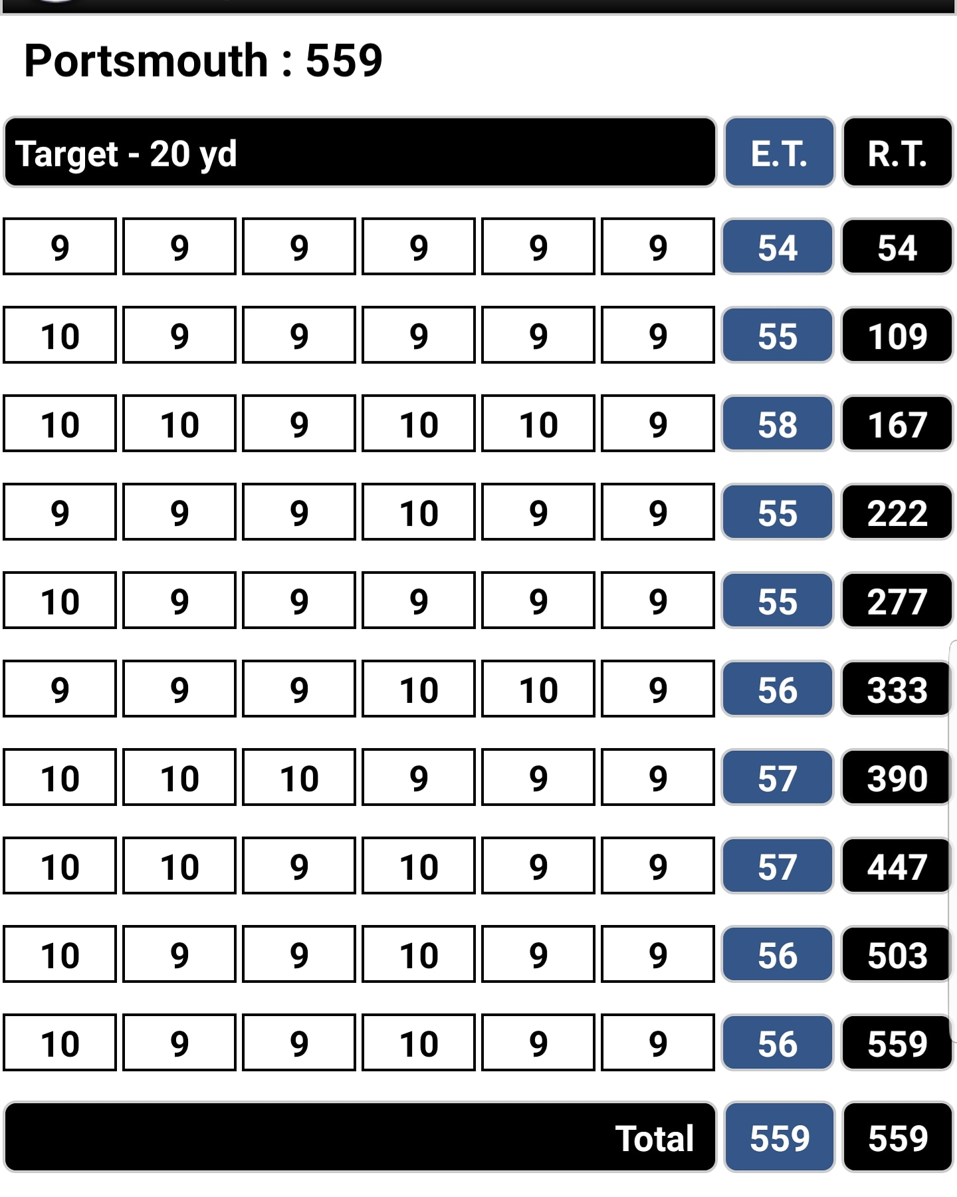
Figure 2 - Completed Portsmouth Round
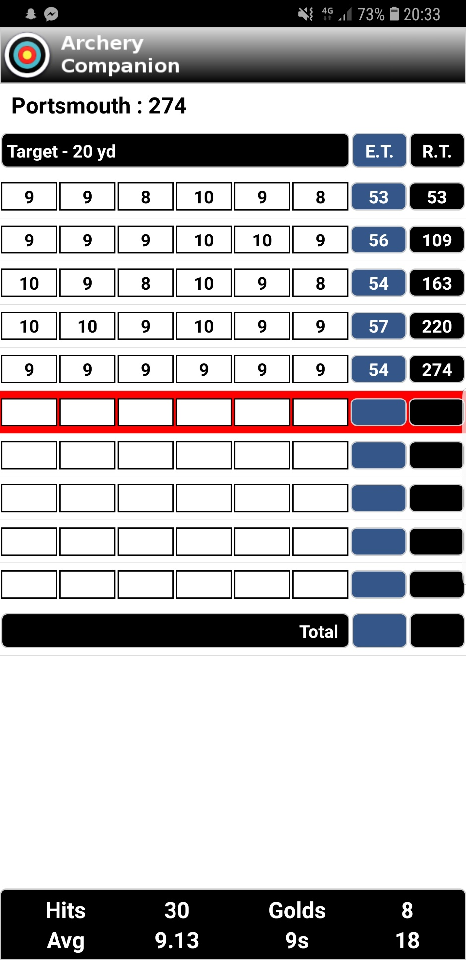
Figure 3 - Incomplete Portsmouth Round

Figure 4 - List of personal records based on Round
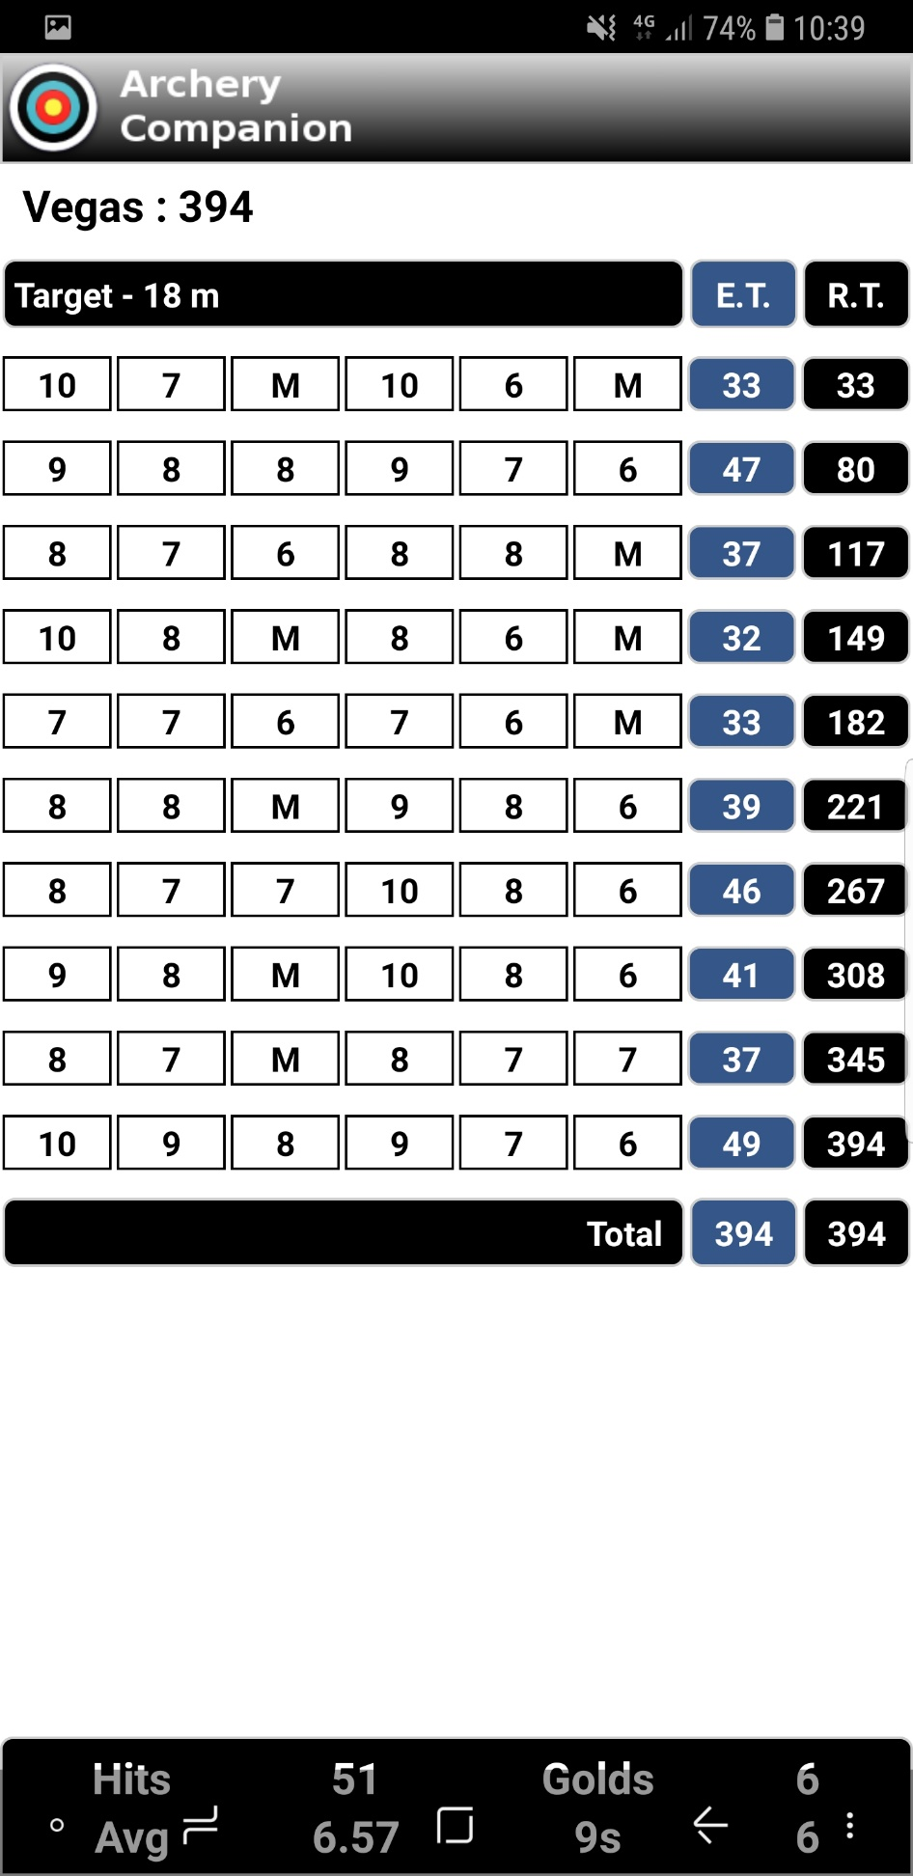
Figure 5 - Completed Vegas Round with greater variation in scores

MyTargets
MyTargets is a more comprehensive application than Archery Companion App, designed specifically for more technical archers. The application allows archers to store information on their equipment, such as bows and arrows, allowing for comparisons between separate setup configurations. While scoring, rather than simply inputting numeric values for arrow scores, the archer can indicate approximately where the arrow lies on the target face. Once the arrow location has been indicated, the app automatically allocates the correct score for the arrow. Aside from this, arrow locations on a target allow archers to see a visual depiction of their average score. This depiction affords archers an opportunity to adjust equipment, which will in turn increase average scores. Scoring using this application can be done either using pre-set rounds, or by creating custom rounds.
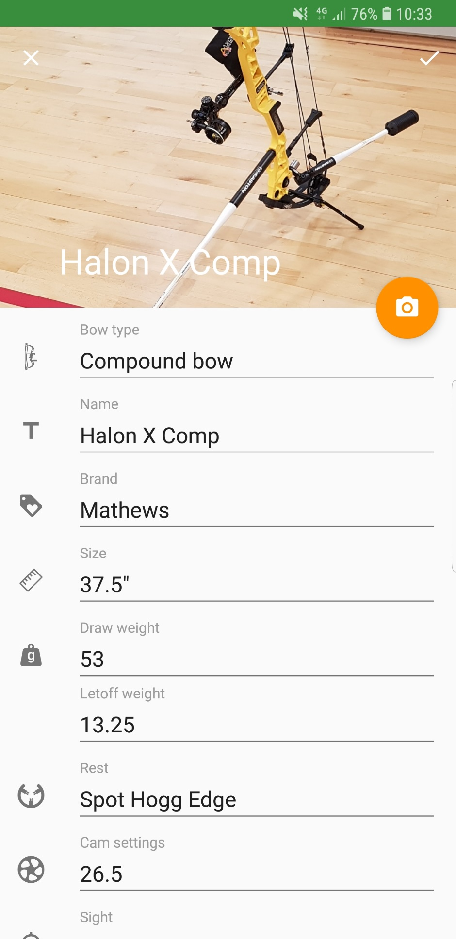
Figure 6 - In-App Bow Information Storage
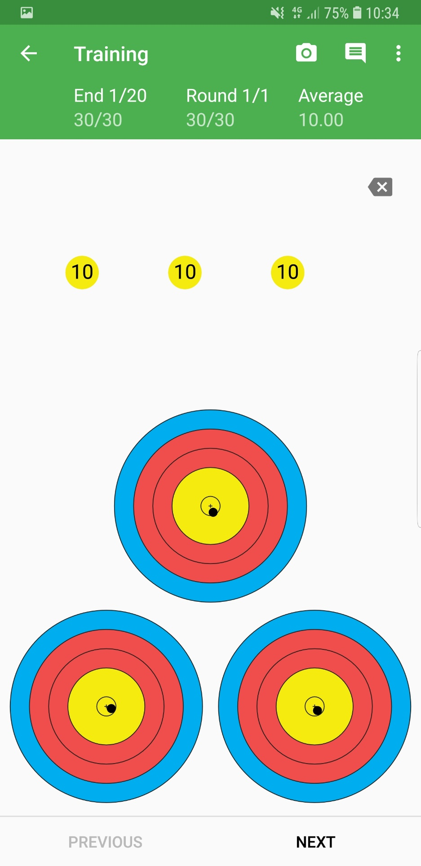
Figure 7 - Score input method
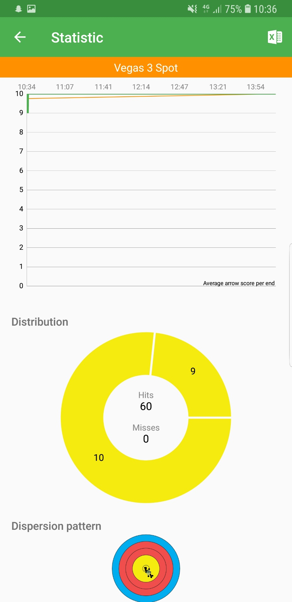
Figure 8 - Graphical Statistics breakdown
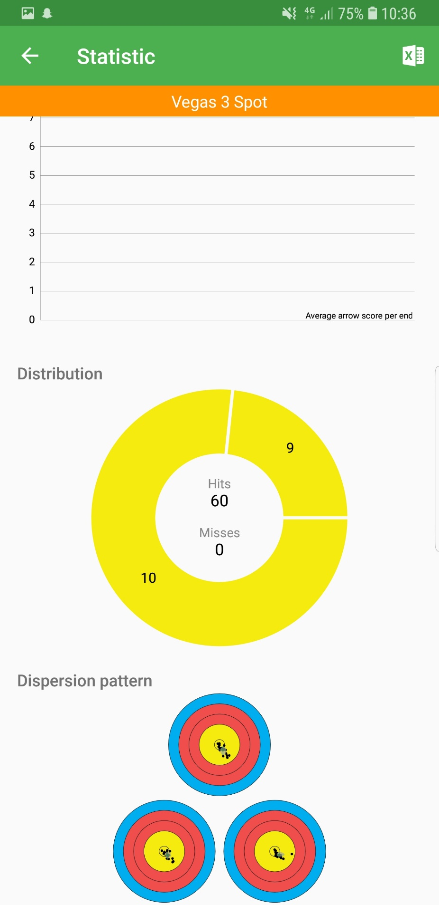
Figure 9 - Graphical Statistics breakdown (cont.)

Comparison of electronic versus pen and paper scoring platforms
Pen and paper methods are far simpler and more accessible than electronic platforms. Electronic applications require access to a smart device, smartphones or tablets for example. Although devices such as these are commonplace in modern society, many members of the older generation do not have access to smartphones or are less comfortable with such devices. In terms of functionality, electronic and paper scoresheets are the same. They utilise a table format to make scores easy to input and understand. The distinct difference between both platforms is reusability. A paper score sheet can only be used once before another must be printed out, whereas electronic applications can store and reuse multiple scoresheets without expending additional resources. For club record keepers, paper scoresheets are logistically troublesome, as each scoresheet would have to be manually inputted into a central database, whereas electronic scoring systems may contain functionality for easy data transfer. An issue unique to the electronic scoresheets is that the file can be corrupted or lost if not backed up correctly, whereas a physical scoresheet is not susceptible to data corruption.

Competitive Scoring Systems
Competitive scoring systems are commonly divided into two parts, which will be discussed individually. The first part is the scoresheet, which is assigned to each target. The second part is the central database, which is used to compare and calculate rankings in competitions. Depending on the status and size of the competition, scores may be uploaded and displayed online for spectators to see.
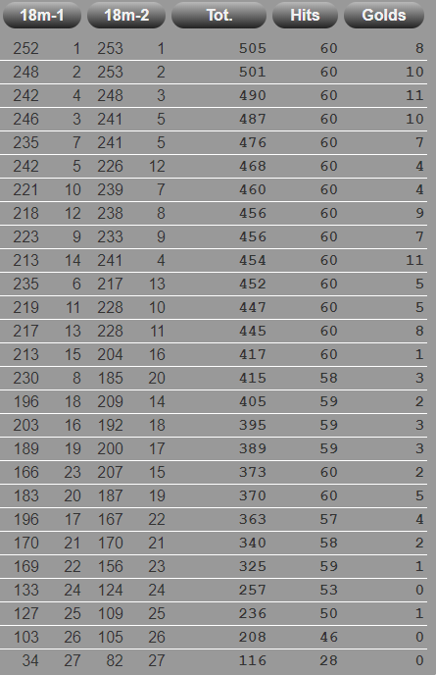
Figure 10 - Ianseo Score breakdown (Online Display)[4]

The architecture of a scoring system
Any competition scoring system has 2 fundamental components, the scoresheet and the database. The scoresheet serves as the means to collect information from each target and can be implemented in either and electronic or physical form. The database is the central store for all data gathered from targets. Data from the scoresheets is transferred to the database, where scores are tabulated, and rankings are determined. This process can either be done manually when using paper scoresheets or database, or electronically if both the scoresheet and database are electronic.

Scoresheets
The scoresheet in a competitive environment functions the same as in a recreational environment. The way scores are recorded is somewhat different in competitive archery, as each target will appoint a target captain, who will record all scores on behalf of the target.
For paper scoresheets, an additional sheet must be filled in during scoring. This additional sheet is known as the running slip. This running slip is collected at predetermined intervals, so that scores may be taken to the central database to be uploaded. If any incorrectly calculated scores are found on running slips, the running slips will be returned to the corresponding target to be adjusted.

Database
Historically, central databases for competitions would utilise paper spreadsheets. The central database is a key component in any score-based competition. All scores attained at the competition are collected and stored in the database, and functions built into the database will provide a ranking for all participants. It is also possible to detect errors on physical scoresheets, as databases may include functions to calculate running totals automatically.

Electronic versus Physical scoresheets in competition
At the 2018 BUCS National Indoor Final, both physical and electronic formats were implemented simultaneously. Due to known inconsistencies in the wireless connections between mobile devices and the central database, the paper back up was implemented so that if any mobile devices lost connection or transmitted corrupted, the scores could be retrieved from the physical copy of the scoresheet. Another issue an electronic scoring system might encounter comes from the devices given to the competitors. In order to supply devices to many people, especially where a budget may provide further constraints, the quality of such devices might suffer. Less powerful devices may not be able to cope with running a graphical user interface, a database for multiple competitors and the transmission of data simultaneously without suffering from lag. Depending on the power of the device in question, this lag may only last a moment or could result in a catastrophic failure of scoring for that target. Isolated incidents of this may not cause much delay in a competition, however repeated incidents could cause a knock-on effect, delaying competitions greatly.
Logistically, electronic scoring presents a huge advantage compared to physical scoresheets. In large scale competitions, where there might be more than 100 archers competing, inputting each score manually is incredibly time consuming. Competitions such as BUCS can take up to around 8-10 hours to complete, depending on the number of competitors and other factors, such as equipment failure or resetting the range in between sessions. Although running slips or scoresheets can be collected while shooting is underway, the number of people who can input the data may be limited, as editing the same database from multiple sources may conflict issues.

Technology
There are many different options when considering software development. From programming languages to connectivity, the technology sector is awash with many different options. Many of these options present distinct challenges during implementation, however the benefits they yield can often outweigh these challenges. Technologies implemented in scoring systems are separated into several distinctive categories. These categories are software, connectivity and data handling.

Software
Applications for mobile and PC devices can be developed in numerous different languages, ranging from basic languages like C to complex manufacturer specific languages like Xcode. The languages required to develop these apps vary depending on the operating system. Apple iOS devices typically require the use of Xcode, a proprietary language developed specifically by Apple[5]. The Android equivalent of this is the Android Development SDK. Unlike the Apple development environment, the Android SDK has access to multiple development languages, Java or C++ for example, as well as a visual development environment for ease of use[6]. Java and C++ are languages used by many other programming environments, as opposed to Xcode, which is proprietary to Apple iOS developers.
Microsoft Excel is at the forefront of digital spreadsheet handling. Not only are Excel spreadsheets widely available, they are also capable of simplifying large data sets in the form of graphs and charts, giving visual depictions of the data.

Devices
Mobile devices available in today’s market are split into several categories based on several factors, namely the operating system and device manufacturer. The two most popular of these categories are Android OS or Apple iOS. Some other OS such as Windows OS have some following, these however are negligible in comparison to Android or iOS. Both sets of devices hold distinct benefits and flaws, some of which are characteristic to both and some unique to certain devices.
Android is a widely available operating system worldwide, available on devices ranging from massively popular Samsung to lesser known manufacturers such as OnePlus or Oppo. Manufacturers who utilise Android platforms are afforded the capability to modify the OS to distinguish it from other devices, with companies like Samsung and OnePlus having previously utilised the open-source version of Android, Cyanogenmod[7]. App development tools for Android devices are widely available online free of charge and utilise a variety of programming languages in order to produce usable products. With this larger base of devices and manufacturers, Android is offered a greater level of variation between devices while maintaining the base functionality and similarity required, should users wish to transition between 2 different Android devices.
Apple’s iOS devices, which include the iPhone, the iPad and the iPod, are widely considered to be the most popular mobile device platform in recent years. Intuitive design and ergonomics provide a superior user experience to most other devices, which is evidenced by the sheer number of devices sold in comparison to some of its competitors. As well as these factors, fashion trends today dictate that iPhone are desirable, with many high-profile public figures openly using them.
Over a period of 12 months commencing in January 2018 and ending in January 2019, 74.45% of Mobile Phone devices’ market share was taken up by Android-based devices; In the same period, 22.85% of the market share was taken up by Apple and the 2% remainder is taken up by various other devices based on varying operating systems, such as KaiOS or windows[8]. These numbers accurately depict the impact of allowing multiple manufacturers to utilise an operating system. As Apple iOS is proprietary, it lacks the range of manufacturers that AndroidOS has access to.
Access to Archery Scoring applications on both Android and Apple is plentiful, with both platforms offering a reasonable range of applications to suit a user’s needs in terms of recreational scoring applications. There are some limited applications for use in small scale competitive archery, such as head-to-head competitions, however these tend to be used in recreational environments as opposed to large-scale competitive environments[9].

Central Terminal Devices for Competitive Archery Environments
In terms of accessibility and ease of use, Microsoft Windows OS has been a staple to millions of users since its first iteration. Based on market research conducted between January 2013 and January 2019, Windows OS has held a consistent dominance over PC OS, Averaging well over 75% of the overall market share[10]. Operating systems such as ChromeOS or MacOS X are proprietary operating systems designed by Google and Apple respectively, which are far less common than Windows-based devices. Operating systems such as Linux are not designed for any specific device, however systems such as Linux are typically used by more advanced users with greater understanding of programming and PC usage. The greatest advantage to using an OS like Linux is its cost, or lack thereof, as the OS is available free of charge online[11].

Connectivity
Interfacing between digital devices has become a staple of modern technology, thanks to a variety of methods in which devices can connect to one another. Ranging from physical connections to wireless connections, most modern digital devices are capable of many different forms of connectivity.

Wi-Fi (Wireless Interfacing)
Wi-Fi is a common form of wireless device interfacing via a closed network or the internet[12]. Data is transmitted at high speeds via radio waves from a mobile device or PC to a router, which then transmits the data via a transport medium to a greater network. Wi-Fi Routers can connect several devices at once, making the system ideal for large networks, both when connecting to the internet or for a closed network. Typical data transfer rates on Wi-fi networks are from around 11 Mbps to 1.3Gbps[13].

Bluetooth
Bluetooth is another form of wireless device interfacing. As opposed to large networks like with Wi-Fi, Bluetooth typically works by connecting two devices directly to one another over a small range. Typically, the maximum range of a Bluetooth connection is around 10 metres, to reduce battery usage on mobile devices[14]. Although more commonly used in modern technology to connect peripherals to devices, such as a wireless mouse to a PC or a headset to a mobile phone, Bluetooth is also capable of transmitting data. Older mobile devices and most modern devices as well frequently use it for media sharing[14][15]. Typical data transfer rates for Bluetooth connections are approximately 25Mbps for Bluetooth 3.0/4.0[16].

Near Field Communication
Near-Field Communication, or NFC, is a short-range form of wireless communication, like Bluetooth. Unlike Bluetooth or Wi-Fi, NFC does not establish a pre-existing connection between the interfacing devices, which makes NFC ideal for quick, unscheduled data transfer such as contactless payment, with examples such as Google Pay and Apple Pay already prominent in the modern technology market. Although the concept of NFC, which has been applied in contactless bank cards, has been available for a few years, the use of NFC for data transfer is still relatively unheard of. The low range of NFC makes it slightly less accessible than Wi-Fi or even Bluetooth, which allow users to transfer data from greater distances. However, the ability to quickly transfer data without initially pairing to reduces to initial setup time, providing a more efficient data transfer method. Typical data transfer rates for NFC systems are between 106kbps to 424kbps.

Physical connection
Physical connections are the simplest and oldest form of transporting data from one device to another. Physical connections utilise a physical medium to transfer data, usually a wired connection between USB ports. The connection between two devices is typically a copper wire, although large scale connections, such as internet connections to local hubs are sometimes made of optical fibres. Data transfer speeds for smaller devices rely on the USB ports available in either device, with USB 3.0 achieving data transfer rates of up to 5Gbps[17]. Wired Connections, unlike wireless connections, cannot be intercepted without a physical connection to the host devices, meaning any personal or confidential information transmitted via a physical connection is better protected from individuals who wish to steal this kind of information.

Data Handling

Spreadsheet
A common means of data handling in the modern age has been the use of spreadsheets. Spreadsheets utilise a large collection of cells, arranged into rows and columns. The most common spreadsheet tool of the digital age has been Microsoft’s Excel, which offers a wide range of tools and functions to fulfil several needs. As well as this, Excel offers a platform for using Visual Basic, a programming language written by Microsoft and used in their software from 1991 to 2008. The use of Visual Basic affords users a higher level of complexity in the functions that can be performed, for example the capability to read information and utilise said data in functions across multiple workbooks. Archery clubs typically use Excel as a means of record keeping, as it is readily available with most PCs and mobile devices. Swansea University Archery Club utilise an Excel spreadsheet with Visual Basic automation to maintain its records, meaning the records officer needs only input the data into one sheet and the overall records are updated automatically.

Recreational Data Handling
Data handling in a recreational archery environment is relatively simple in comparison to competitive scorekeeping, as only one archer’s scores are recorded. For records kept by a single archer, there are fewer variables that need to be recorded, such as details about the archer. Typically, archers will only record scores for their main bowstyle, therefore the pre-requisite variables for bowstyle can also be removed for recreational record keeping. The only pre-requisite variable that will remain are the round being shot, which will affect the way arrows are scored.
Because of the reduced amount of information stored, smaller scale spreadsheets without interlinking formulas and functions would act as a suitable base system, offering opportunities to integrate more complex functions later.

Competitive Data Handling
Competitive Archery is of a much greater scale than recreational archery, with hundreds to thousands of archers attending some competitions. Pre-requisite variables for competitive scorekeeping spreadsheets consist of names, or arbitrary identifiers for individuals whose details cannot be disclosed, archers’ bowstyles, the round(s) being recorded in the competition, as well as further information that may pertain to specific competitors, for example disabilities or equipment information.
Inputting the required data for any scale of competition is time consuming, even when the data input process can be automated. Between the time taken to input the data and the time taken to communicate with and receive the information from archers, a large team would be required to reduce the time taken. The infrastructure of competitive archery scorekeeping is complex and relies on several variables operating smoothly, with any complications disrupting the overall process greatly.

Conclusion

Recreational Scoring Applications
Regardless of the mobile device being used, there is no shortage of mobile scoring applications. With applications such as MyTargets and Archery Companion covering many important features, such as a basic UI, personal best displays or data analysis, the market for recreational scoring applications is saturated, however there is very little overlap between recreational and competitive scoring platforms, with only a few recreational scoring applications offering any semblance of competitive scoring capabilities.

Competitive Scoring Applications
For competitive score keeping, the market share for digital devices is almost completely dominated by Ianseo, with the largest competitions in the UK and World Archery utilising its digital scoring platform and online score display. For smaller scale competitions, such as regional or local competitions, traditional pen and paper methods remain the most frequently used. This is likely due to the lack of availability of systems like Ianseo, which can cost a substantial amount for use in competition.

Mobile Devices
The difference in mobile devices typically comes down to 2 factors, the software utilised and the availability of the device. The two devices types considered are Android and Apple iOS devices, the two largest competitors in the mobile device market. Smaller devices types, such as windows mobile devices, aren’t being considered due to their apparent lack of availability.
Apple Devices require knowledge of a proprietary programming language to develop applications and control the second largest market share of digital mobile devices. The availability of Apple devices makes them a viable option for an application development project; however, the use of a proprietary software language means that only users with prior knowledge or time to learn a new language will be able to develop software for these devices, reducing the viability of the project.

Android devices control the largest market share of mobile devices, due to the larger range of manufacturers who utilise android operating systems. As well as this, the programming languages utilised in the Android App SDK, Java and C, are more commonly used languages, allowing a wider range of programmers to develop applications without specialist training. Based on the two key factors, Android devices are considered more appropriate for application development. As well these factors, Android Devices are available for use in the project without the need to be purchased, whereas an Apple Device would need to be purchased in order to complete the project.

Connectivity
Numerous forms of connectivity have been explored, spanning both wired and wireless connections. The common factors explored by each type of connection are availability, reliability and data transfer rates. Wi-Fi, Bluetooth and Wired connections are all well-established technologies, with most modern mobile devices capable of utilising them in some capacity; NFC is still an emerging technology, only available on higher-end devices.
Of the technologies explored, only wired connections are the truly reliable form of connectivity, with Wi-Fi, Bluetooth and NFC all relying heavily on the strength of the connection to maintain reliability, whereas wired connections are not dependent on strength of connection.
Data transfer speeds play a crucial role in a network of devices where large quantities of data need to be transferred. The emerging technology, NFC, has a relatively low data transfer rate when compared to other means of connectivity. Wired connections offer the greatest data transfer speed, roughly 5 times greater than that of its nearest competitor, Wi-Fi.
The most viable option for connectivity is Wired connection. Thanks to the common presence of USB ports on mobile devices and PCs, it is the most readily available form of connecting devices, while also maintaining reliability and an unrivalled data transfer rate.

Research and Development Methodologies

Research
Over the course of this project, a positivistic philosophy will be employed. As with all development projects, a set of distinct criteria will need to be achieved in order to complete a final product[18]. Contrary to Positivistic research philosophies however, samples sizes during testing will be kept to a minimum, adhering more to a phenomenological philosophy as opposed to a positivistic one. The reasoning for this is due to time constraints. Larger sample sizes will require a greater amount of time to complete during testing when compared to smaller sample sizes. Following initial completion of the project, further large-scale tests could be conducted in order to return the project to its positivistic roots.
The purpose of the research will be to determine the problem/task at hand, criteria to be fulfilled and a list of viable solutions to said criteria.

Hypothesis
Existing pieces of software used for scoring in archery fulfil the requirements of both recreational and competitive archery scoring; however, they only do so for their respective category and no such application exists that fulfils the criteria set by both categories. Scoring infrastructure, especially in competitive environments, is time-consuming to organise and requires many man hours in order to successfully organise the large quantities of data being provided to the organisers by competitors.
Further to the clerical nightmare brought forth by administrative work for archery competitions, there is also the matter of records keeping in any archery environment. With a large proportion of archers still favouring pen and paper methods over the use of dedicated applications, records officers are tasked with printing scorecards, gathering completed scorecards and transferring the information into a central database. Although this process isn’t as time sensitive as it would be in a competition setting, it is still a time-consuming process. The application of digital devices in this scenario would afford records officer an easier means of transferring the data than by reinputting the data manually. The use of pen and paper methods also has a real-world impact, with the use of paper affecting ecosystems through deforestation for use in paper manufacturing. The impact of a small group of people relative to the overall global population may seem miniscule to some, however the impact will have a compound effect if ignored for an extended period.
To summarize, the problem at hand consists of two major criteria, simplifying the process of recording scores for single archers, records officers and competition organisers; and offering a more suitable alternative method of score keeping than pen and paper.

Development Methodology
Feature Driven Development, or FDD, will be implemented in this project, by separating the overall project into 3 distinct sections:
- Recreational Scoring Application
- Competitive Scoring Infrastructure
- Device Connectivity
These 3 sections will then be divided into several constituent features, which will be developed and tested individually by the developer before being assembled into a completed section[19]. This method will allow a better chance for the developer to diagnose and rectify errors during development, before external testing of the product is undertaken, by allowing the developer to test each feature independently of the larger system. Further to this, FDD allows separate features to be developed non-sequentially, although this is still a possibility. By developing features non-sequentially, there is less dependence on the completion of a pre-requisite feature before the next one can be completed, reducing the time taken during development.
FDD applies mostly to the Recreational and Competitive scoring system development, as these are the main sections that require software development from scratch. Connectivity requires less development, as it is the implementation of existing technologies.
A key disadvantage to the use of FDD is that it brings an element of risk to the project, in the form of a disorganized execution plan in comparison to more linear methods of software development, such as the waterfall method. FDD typically favours software development being undertaken by larger groups of developers, as multiple developers can simultaneously develop each feature, whereas a single developer would have to work on one feature at a time. In order to prevent this disadvantage from affecting the project, a detailed project plan with specified timelines will be prepared, providing a structure to the project while also allowing for any unforeseen discrepancies that may arise during development.

Selection of technical resources

Mobile Devices - Android
Based on several factors, such as the overall availability, availability to the developer and the means of development of an application, Android devices have been selected as the primary target for mobile devices in this project. Android devices control a greater portion of the mobile device market share, offering a greater target audience. As well as this, the Android App Studio SDK allows for app development with programming languages which are commonly used in regular programming, meaning additional training for app development isn’t essential, although it is advised as the SDK may include some variations to the standard languages.

Data Handling System – Microsoft Excel
The main candidate for the data handling system is Microsoft’s Excel software. The reasons for this selection are straightforward, the software is available to the project developer and the developer has a reasonable knowledge of Excel and its functions, although the Visual Basic programming in Excel would require further training. Excel is available on most Windows PCs, which are the most popular PC device in the world.

Connectivity – Physical/Wired Connection
A key factor in the selection of the method of connectivity is the availability of hardware for use in this project. Wi-Fi, NFC and even Bluetooth would require specialist hardware in order to connect mobile devices to a central terminal; hardware which is not readily available for use by the project developer. Wired connections are both readily available to the developer and simple to use when compared to the other options. The user need only connect the two devices via a USB cable, then manually transfer the required data.

Software Development Kit – Android App Studio
Following the selection of Android devices as the target device for the project, the development kit required to develop applications for these devices will be Android’s App Studio SDK. Developed by Android, it offers developers an environment for developers to design and implement their ideas utilising either C++ or Java programming languages, as well as a graphic design interface.

Human Resources required
Human resources required in this project are minimal, limited to the developer and the project supervisor to implement base functionality. The developer’s role will be to design and implement the project, learning any techniques or methods required to complete the project. The supervisor’s role will be to guide the developer in the design and implementation of the project, providing advice when requested by the developer, should the developer be unclear of what to do. The supervisor will also be tasked with providing any additional knowledge to enhance the probability of success of the project. During testing phases of the project, test subjects can be invited to assist in testing, however testing base functionality can be accomplished by the developer alone. External test participants would be drawn from local archery clubs, following an application process and consent of participation. Participants in any testing will be required to use any developed products in an appropriate setting, relaying any feedback on issues the product may be encountering back to the developer. The developer must then utilise this feedback to rectify any errors in the product before further testing. Participants of initial testing will be allowed to return for further testing pending proper consent.

Design and Implementation

Requirements Analysis

Recreational App
For the recreational scoring application, the base requirements are:
- General User Interface (UI)
- Page selection options
- User input
- Data storage
- Basic mathematical functions

Competitive Scoring Architecture
For the competitive scoring system, the base requirements are:
- General User Interface
- Data Encryption/Arbitrary Identifier System
- Manual data input
- Automated Functions

Connectivity
For connectivity, no development requirements are necessary as this section is the implementation of an existing technology as opposed to design and implementation of a new system; however, a plan of how to use connectivity correctly will be required in order to ensure correct implementation.

Design
This section will discuss the proposed design of a true implementation of this project and will bring forward and key design features that would be required for implementation in the product, given ideal conditions for implementation.

Recreational Scoring Application
As with all mobile device applications, ergonomics is essential when designing user-based apps. User experience is defined by the visual display of an app; and thus, simple and intuitive design will naturally provide a superior user experience. As shown in existing scoring applications such as MyTargets, bright colours and buttons make the application look attractive when initially opening the application. Contrasting colours not only make the application more appealing to the eye, but also help users identify key features in the application.
As in Archery Companion App, the initial setup for use in scoring is relatively straightforward and concise, with dropdown lists providing all the information for the user. By providing the user with the information then require, rather than requiring the user to input it themselves, it reduces the time taken during setup and allows users with lesser knowledge of scoring procedure to utilise the applications in the same way as an experienced user.
Transitioning between pages of an application will be controlled by buttons located at either the top or the bottom of the screen, as placing buttons across a screen can give a negative, disorganized impression to potential users.
During scoring, the user will see an overview of the round being recorded on the screen. In order to transition to a score input screen, a button at the bottom of the screen will be available. The button must be clear and separate from the overview screen, as not to confuse users who may not be able to intuit the location of the button should it be integrated into the page.

For the score input page, the individual end will be displayed on screen as separate boxes, with each box denoting a single arrow, along with a series of buttons underneath, each button denoting a value ranging from M for miss to 10 or X for maximum score, as well as a button to undo any incorrect inputs that may occur; additionally, a button will be available to return the user to the overview screen, which will be located at the top of the screen to avoid the user pressing the button accidentally. The buttons to input score values will be colour coordinated with the corresponding colour of the value on the target face, for example 10 and 9 will be yellow, 8 and 7 will be red, etc.; however, these boxes must be coloured translucently to avoid making the text difficult to see. The box for the arrow being scored in that end will be highlighted as to denote where the value will be allocated. Once a value has been selected for that box, the value will appear in the box and the next box will be highlighted. Once all the boxes in that end have been filled, the user will be required to press the return button at the top of the screen.
Once the user has returned to the overview screen, the updated scores will be displayed and calculations will be performed to provide a total score for that end, as well as a total score for the round so far.

Competitive Scoring System
The design for the competitive scoring system will conform with that of most generic Excel spreadsheets, as this system is designed for users with a basic knowledge on PC use as opposed to individuals with less or no experience using PCs. Each scorecard will be separated into two distinct parts, the archer details and the scorecard itself.
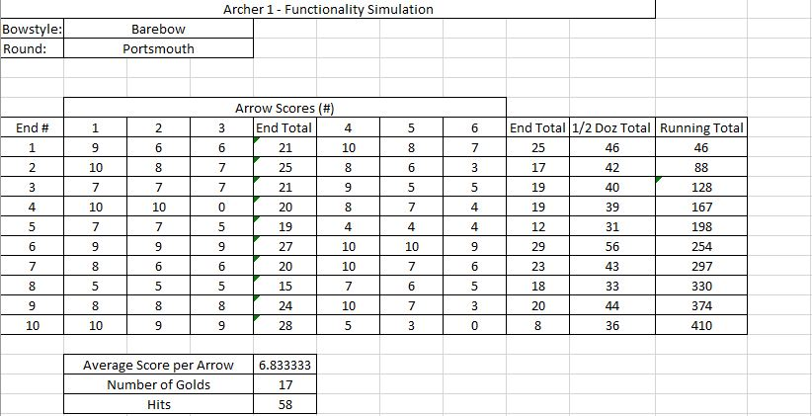
Figure 11 - Functionality simulation design with completed score (Test 2 worksheet)
The archer details section will be a series of boxes, in which the user can input relevant information about the archer in question. Boxes for bowstyle and round will have dropdown list functionality as opposed to requiring the user to input the information manually.
The score card will be laid out as a table, as seen in figure 11 above. The table will have a predefined number of rows, with each row consisting of 2 sections, both of which represent one end of scoring respectively. Each individual arrow score will feature a dropdown list with all available scores, ranging from 10/X to M for miss. Should an incorrect value be selected, the user can reopen the dropdown list and select the correct value. As values are being selected, mathematical functions will calculate total scores for each end, total scores for each half dozen arrows and a running total as the score is input. As well as these values, additional value such as number of hits, average arrow score and the number of golds (9 or 10) will be calculated.
Dropdown lists have been implemented in order to provide users with the appropriate information, as there is no guarantee that users of this database will have prior knowledge of scoring protocol. The mathematical functions have been included in order to automate the process of calculating totals, thus reducing the human error involved in mental mathematics.

Connectivity
The connectivity section of this project requires no design, as it is purely the means of transferring data from one device to another.

Implementation
Due to time constraints and the complexity of the systems at hand, the implementation of the project was simplified and simulated in the form of an Excel Application. This simulation has been implemented to demonstrate the base functionality of a scoring system in a recreational environment.
Implemented in Excel, the system takes the form of a spreadsheet that is separated into 2 sections, a section for archer details and a section for scoring. The archer details section is limited as it is simulating a recreational environment, and thus information such as names and other identifying information are unnecessary. Information required, such as bowstyle and round utilise dropdown lists to provide information to the user without requiring extended manual input.
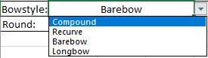
Figure 12 - Dropdown list for bowstyle, taken from functionality simulation in Microsoft Excel
Neither bowstyle nor the round being scored have any effect on the scorecard section of the system, due to the complexity of programming Excel to automatically adjust worksheets based on specific conditions. The options for the dropdown list are kept in the worksheet at a separate location, so as not to interfere with the user experience with the simulation.

The scorecard is designed as a table with several rows and separate columns, with individual cells representing value for individual arrow score, end totals, half dozen totals and running totals, as seen in figure 13 below.
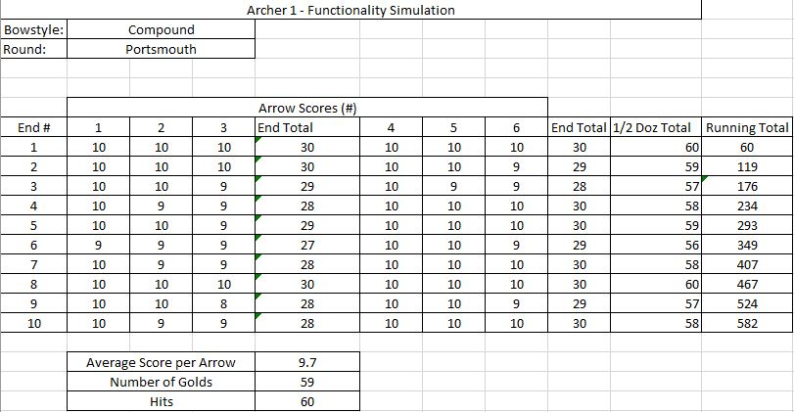
Figure 13 - Implemented Functionality Simulation with completed score (test 1 worksheet)
Each individual arrow score cell features a dropdown list, allowing users to select from a predefined set of values which are kept in the workbook at a separate section. As scores are being input into the worksheet, the total score cells automatically update to account for new inputs. This automatic calculation functionality extends to the average score, number of golds and number of hits sections as well, which all test new inputs as part of their mathematical functions.
Figure 14 - Example of end total calculation function
The running total columns operates in a different way to the end total and half dozen total columns. As opposed to taking individual arrow scores and summing them, the running total will sum the most recent half dozen total cell with the previous running total cell, or 0 in the case of the first half dozen.
Figure 15 - Example of function for running total
The average arrow score is calculated by passing in the values for arrow scores into Excel’s average function. This was made more complex by the need to pass through 2 separate sections of data while also omitting data in between the two sections, as seen above in figure 13. The solution to passing through separate sections of data is simple however, requiring the addition of a character in the function signifying that two separate data sets are being passed in, as seen below in figure 16.
Figure 16 - Example of Average Arrow Score Function, passing through 2 separate sections of data
To calculate the total number of golds scored in the round, a function to count values that fit a specific criterion is implemented in the simulation. Like the average score calculations, multiple data sets are being tested for these conditions; unlike the average score function however, the function must be implemented multiple times. By utilising the =COUNTIF function provided by excel, the data can be tested and any values matching the criterion of being equal to 9 or 10 will be counted. The function is implemented twice for each data set, with one test counting the number of values equal to 9 and the second test counting values equal to 10. Once the tests are completed, the values are summed to provide an overall total of values signifying hits in the gold region of a target face. These functions are performed live as values are being inputted into the system.
Figure 17 - Example of function for calculating the total number of golds scored
The function to count the total number of hits is similar to the function used to count the number of golds, however instead of testing for values conforming to two separate conditions, values counted need only conform to the condition that they are greater than 0, the value signifying a missed score.
Figure 18 - Example of function for calculating the total number of hits scored

Evaluation
The project at hand began with a set of seemingly simple goals, to expand on trends set by existing archery scoring applications, to provide a system that rendered pen and paper scoring methods obsolete and to amalgamate recreational and competitive scoring systems. In order to achieve these goals, the objective of the project was to develop a stylish, ergonomic mobile application that would function as a platform for score keeping in a recreational archery environment, but could also be utilised in a competitive archery setting with the data being transferred to a central terminal to be processed. As well as this mobile application, a system for the central terminal to collate the data transferred to it was to be developed to complete the competitive aspect of the project.
When the outcome of the project is compared to objectives set forth at the beginning of the project, the project has fallen short of its objectives, with no discernible product being produced to meet the objectives; however, the work completed for this project has provided an insight into the architecture and infrastructure required to develop applications of this nature, laying the groundwork for a potential future development.
Based on discussions with members of the local archery community, a mixed reaction has been noticed when concerning the concept of making pen and paper scoring methods obsolete. There is a clear divide in opinion based on age and experience with technology, with younger and more technology literate archers favouring the use of electronic applications as opposed to paper scorecards. Older, less technology literate members of the archery community typically favour paper scorecards over electronic scoring as they have been familiarized with this method over years of use, some of which occurred before the dawn of the digital age and the advent of mobile applications.

Though there is a saturation in the market of mobile scoring applications for any type of mobile device, each existing application benefits from advantages and suffers from disadvantages. Common advantages to mobile scoring applications include simplicity and ease of use, with most applications offering a wide array of pre-set rounds to choose from, or ergonomic user interfaces that are intuitive to users regardless of their technological literacy. A common flaw in scoring applications on mobile devices is that there is very little in the way of tutorials or guidance in their use. Mobile Scoring applications such as Archery Companion or MyTargets are heavily reliant on users’ ability to intuit their use, which can be a daunting task to users who are less confident with technology.
When comparing the overall reaction to the proposed development, the simulated system and the initial research, there is no clear correlation between the research and the outcome of the project. This is likely due to the lack of consensus on user feedback about the product, with an even split preventing any discernible conclusion from being drawn about its potential effectiveness.
One of the reasons for the failure of the project is the developer’s underestimation of the scale of the project during the early research stages. Provided further research had been completed with regards to the infrastructure of the individual systems before even considering a combined system, a greater appreciation for the scale of the project would have been afforded. This understanding may have allowed the developer an opportunity to either rebuild the core objectives of the project, providing a smaller set of achievable objectives, as opposed to a large set of objectives that are difficult to achieve in a reasonable timeframe.

Another reason for the overall failure of the project is the developer’s inability to conform to the initial project plan. During the early planning stages of the project, a timeline was developed in order to provide a means of time management for the developer over the course of the project. This timeline offered a concise layout of the project, with additional time set forward to account for any unforeseen issues during development. During early stages of the project, the developer conformed to the project plan; however, this began to deteriorate as the developer overestimated the time left for each section. This lack of time management caused a compound effect, which combined with the complexity of the tasks at hand during development, led to sections of the project being removed from development.

Conclusions and Recommendations

Conclusion of work conducted
Over the course of the project, several tasks have been performed in order to meet the objectives. These tasks are:
- Initial Project Research
- Project Planning
- Market Research
- Research into Resources
- Requirements Analysis
- Initial Design
- Prototype Development
- Evaluation
Initial project research provided an insight into digital scoring applications, physical scorecards and the use of both in archery. Using discussions with members of local archery clubs to develop an understanding of preferred methods of scoring in archery, a basic correlation between age, technological literacy and the use of electronic or physical scorecards was established, with older archers favouring physical scorecards and younger archers favouring electronic ones; however, this assumption also accounts for technological literacy of younger versus older people.

Once the base aims and objectives of the project were established, a project plan was proposed in order to provide a timeline for tasks required to complete specific objectives. Time was allocated for each task to be completed, with additional time set aside to account for unforeseen circumstances. As well as this project time plan, a brief overview of each task was developed in order to ensure that each task was understandable and achievable over the course of development.
Following the completion of project planning, research began with the evaluation of existing software already available to the general public, for example recreational scoring app MyTargets or competition scoring software Ianseo. Analysis of existing products provided a comprehensive list of common features, the advantages and disadvantages of these features and their influence on functionality and usability. Analysis of the applications came in 2 forms, visual inspection of user interfaces and practical implementation in archery training. By personally utilising the existing products in a real-world setting, the developer established an objective opinion and analysis of each product being examined. Experience with competitive systems, like Ianseo, came from previous encounters by the developer, namely the use of Ianseo by the developer and the competition organisers and BUCS Indoor Archery Championships of 2018, where the mobile device component of Ianseo’s scoring system failed during the early stages of the competition, affecting the developer’s scoring experience. The market research conducted revealed that the market for mobile scoring applications was saturated with several products of varying quality and that the competitive scoring system market was dominated by a single system, Ianseo.
Further to the market analysis of existing products, research into hardware and software resources was required to establish a realistic means of completing the project objectives. Possible options on mobile devices, data handling software, connectivity and Application Development Environments were explored, with several options for each section being analysed. Pros and cons for each option were discussed individually, revealing viability of each option.
Following analysis of current technologies and existing software, requirements analysis was performed to detail the requirements of the project based both on the initial research and the findings of the market and resource research. Requirements for the recreational scoring application included a general UI, a means of inputting scores, a means of storing scores, UI to transition between different pages and basic mathematical functions to automate score calculations. Requirements for the competitive scoring application include a general UI, a means of data input, both manual or through UI, data storage and data encryption to protect confidential information where required.
The initial design phase of the project and the prototype development phase for this project have been executed simultaneously, with the initial design of the application being implemented directly into a prototype. Although this prototype does not meet some of the additional requirements, specifically in terms of UI requirements; however, in terms of functionality the prototype has achieved a basic functionality and usability. Serving as a basis for which future research and development can be furthered from, the prototype functions in such a way as to simulate the basic function of the completed app, demonstrating score input using UI methods, as well as basic mathematical functions to automate calculations of score totals.

Suggestions for further Research and Development

App development
Further research and training are required for effective application development using the Android Studio SDK. Upon initial inspection and research, C++ and Java were advertised as equally usable in the SDK; however, upon utilising the SDK during the beginning of development, it was revealed that Java plays a far more pivotal role in app development for Android. The developer has prior knowledge of C++ programming language but very little understanding and experience of Java, meaning development of a true, Android application was impossible during initial development. With training in Java, a true Android application could be developed to the high standard established by existing applications.

Competitive Infrastructure
As a competitive archer, the infrastructure of a competition seems relatively self-explanatory. This is contrary to the reality of the situation, with competition of even smaller scales providing distinctive challenges of an administrative nature. Further research into the architecture and infrastructure of a competition and how that can be implemented into a scoring system would be required in order to allow for development of a unified system to be realistic in a reasonable timeframe.

References
[1] A. Scarzella, A. Gabardi, C. Deligant, M. Pisani, and M. Carpignano, “Ianseo.net User Manual - English,” 2018.
[2] Trent Rosenbaum, “Archery Companion 1.0.7,” 2013. [Online]. Available: https://archery-companion.soft112.com/. [Accessed: 13-Nov-2018].
[3] F. Dreier, “MyTargets Archery - Apps on Google Play.” [Online]. Available: https://play.google.com/store/apps/details?id=de.dreier.mytargets. [Accessed: 24-Mar-2018].
[4] “Men’s Experienced Barebow [After 60 Arrows (Session: 1, 2, 3)],” Ianseo, 2018. [Online]. Available: http://ianseo.net/TourData/2018/3656/IQMEB.php. [Accessed: 25-Apr-2019].
[5] Unknown, “Xcode - Apple Developer.” [Online]. Available: https://developer.apple.com/xcode/. [Accessed: 09-Apr-2019].
[6] Unknown, “I want to develop Android Apps – What languages should I learn?” [Online]. Available: http://www.zipcodewilmington.com/blog/i-want-to-develop-android-apps-what-languages-should-i-learn. [Accessed: 04-Mar-2018].
[7] A. Sinicki, “What happened to CyanogenMod? What is LineageOS?,” Android Authority, 2017. [Online]. Available: https://www.androidauthority.com/cyanogenmod-lineageos-654810/. [Accessed: 23-Apr-2019].
[8] M. Casserly, “iPhone vs Android Market Share Analysis - Macworld UK,” Macworld, 2019. [Online]. Available: https://www.macworld.co.uk/feature/iphone/iphone-vs-android-market-share-3691861/. [Accessed: 26-Apr-2019].
[9] World Archery, “head2head archery - Apps on Google Play.” [Online]. Available: https://play.google.com/store/apps/details?id=org.worldarchery.h2h. [Accessed: 04-May-2018].
[10] Unknown, “• Desktop OS market share 2013-2019 | Statista,” Statista, 2019. [Online]. Available: https://www.statista.com/statistics/218089/global-market-share-of-windows-7/. [Accessed: 26-Apr-2019].
[11] Unknown, “What is Linux? | Linux.com | The source for Linux information,” Linux. [Online]. Available: https://www.linux.com/what-is-linux. [Accessed: 26-Apr-2019].
[12] V. Beal, “What is Wi-Fi (Wireless)? Webopedia Definition,” Webopedia. [Online]. Available: https://www.webopedia.com/TERM/W/Wi_Fi.html. [Accessed: 26-Apr-2019].
[13] B. Mitchell, “How Fast Is a Wi-Fi Network?,” Lifewire, 2018. [Online]. Available: https://www.lifewire.com/how-fast-is-a-wifi-network-816543. [Accessed: 26-Apr-2019].
[14] J. Harris, “What is Bluetooth? - BT,” BT, 2016. [Online]. Available: http://home.bt.com/tech-gadgets/phones-tablets/tech-terms-explained-what-is-bluetooth-11363811086865. [Accessed: 26-Apr-2019].
[15] C. Woodford, “How does Bluetooth work? - Explain that Stuff,” ExplainThatStuff, 2018. [Online]. Available: https://www.explainthatstuff.com/howbluetoothworks.html. [Accessed: 26-Apr-2019].
[16] I. Paul, “Wi-Fi Direct vs. Bluetooth 4.0: A Battle for Supremacy | PCWorld,” PCWorld, 2010. [Online]. Available: https://www.pcworld.com/article/208778/Wi_Fi_Direct_vs_Bluetooth_4_0_A_Battle_for_Supremacy.html. [Accessed: 26-Apr-2019].
[17] L. Spector, “USB 3.0 speed: real and imagined | PCWorld,” PCWorld, 2014. [Online]. Available: https://www.pcworld.com/article/2360306/usb-3-0-speed-real-and-imagined.html. [Accessed: 29-Apr-2019].
[18] J. Dudovskiy, “Positivism - Research Methodology.” [Online]. Available: https://research-methodology.net/research-philosophy/positivism/. [Accessed: 30-Apr-2019].
[19] S. R. (Stephen R. Palmer and J. M. Felsing, A practical guide to feature-driven development. Prentice Hall PTR, 2002.

Appendices
Find below links to archery companion scoring apps, available on Google Play Store:
World Archery Head2Head -

MyTargets - https://play.google.com/store/apps/details?id=de.dreier.mytargets

Archery Companion - https://play.google.com/store/apps/details?id=com.archerycompanion.app.android

Find below links to competitive archery systems:
Ianseo - http://ianseo.net/

