

BMIH5006
Sustainable Hospitality & Tourism Management LEVEL 5
Assignment 2 – Report
Environmental Impact of Cruise Ship Transportation in the Hospitality Industry and Sustainable Solutions
Mohammed Ali Haider
2013121
Lecturer: Christopher Wilkins

Table of Contents
Executive Summary 3
1 Introduction 4
2 Overview of Cruise Ship Transportation in Hospitality 4
3 Environmental Damage Caused by Cruise Ships 5
3.1 Air Pollution and Greenhouse Gas Emissions 5
3.2 Water Pollution and Marine Ecosystem Disruption 6
3.3 Waste Management Issues 6
3.4 Noise Pollution and Impact on Marine Life 7
4 Plausible Solutions to Environmental Damage 8
4.1 Adoption of Cleaner Fuel Technologies 8
4.2 Waste Reduction and Advanced Waste Treatment Systems 9
4.3 Energy Efficiency Innovations 9
4.4 Sustainable Port Operations 10
5 Conclusion 11
References 12

Executive Summary
This study critically reviews the environmental effects of cruise ship transportation within the hospitality industry and explores possible ways to lessen the negative impacts. In global tourism, cruise ships are the most important, providing luxury travel and, at the same time, leading to environmental pollution. This report specifies the major environmental challenges of cruise operations, including air pollution from heavy fuel oil exhausts, pollution from untreated wastewater and ballast water discharge, waste management issues, and marine life noise pollution. The effects of these impacts constitute threats to marine ecosystems as well as coastal communities and to efforts to mitigate climate change at a global level.
In addition to this, many of the sustainable solutions offered by leading cruise companies like Royal Caribbean, Carnival Corporation, and Norwegian Cruise Line, which aim to tackle these challenges, are presented in the report. Some of such measures include the implementation of cleaner fuel technology (likened to liquefied natural gas or LNG), advanced wastewater treatment technology (such as hull design and solar energy integration), and sustainable port operation (using shore power). The report ends by saying that regulatory framework, corporate responsibility and consumer awareness are paramount for such sustainable environmental development. Implements eco-friendly practices, which have a role in reducing the footprint of the cruise industry and the sustainable development of marine tourism.

Introduction
Hospitality transport is an important part of the global tourism industry as it helps people to move from one destination to another for the purpose of leisure, business and cultural experiences (Ranasinge et al., 2021). It includes various travel modes on the air, land, and sea, which are the elements behind the accessibility and tourism market expansion on a global basis. Cruise ship transportation has become one of the major sectors in the hospitality industry, bringing a combination of travel and leisure to millions of travellers. For Baptista and Brito (2024), cruise ships are not only considered a means of transport but also act as floating resorts that accommodate, feed, entertain, and entertain millions of passengers every year.
Furthermore, Smith and Jones (2021) indicate in a study that in recent years, the cruise industry has witnessed tremendous growth thanks to growing clientele demand for luxury travel and various routes. However, this expansion has also exposed some issues related to environmental pollution of air and water, waste management problems and the impacts on marine biodiversity. This report explores alternative means of reducing the environmental impacts of cruise ship transportation and provides, more critically, an examination of the environmental damage associated with cruise ship transportation.

Overview of Cruise Ship Transportation in Hospitality
The idea of cruise ship transportation began with only simple transatlantic crossings, which has evolved into an opportunity for millions of tourists to be spoiled on what can only be described as floating resorts. After the 1970s, the growth of the industry was exponential, particularly with the emergence of leisure travel and the spread of global tourism networks (Inkson and Minnaert, 2018). Thus, cruise tourism is now an essential part of the hospitality industry and plays an important role in the global economy. This research by Sloan et al. (2017) asserts that before the COVID-19 pandemic in 2019, the global cruise industry contributed about 1.17 million jobs worldwide and more than $154 billion in total economic output.
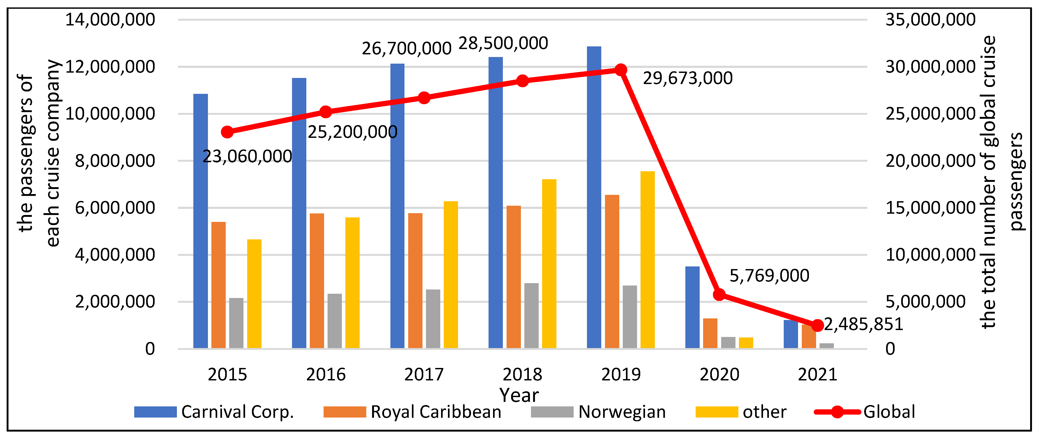
Figure 1 A Study on the Trends of the Global Cruise Tourism Industry
(Source: Sun et al., 2022)
Additionally, Lallana (2023) supports this statement by stating that these companies have a vast number of fleets, as Royal Caribbean alone has over 6 million passengers per year on their brands. Cruise lines also provide a strong dollar boost to millions of tourists, which indirectly leads to port development, tourism-related activities and the growth of local economies. The industry, despite the setbacks due to the pandemic, is expected to recover, and passenger numbers are estimated to attain 30 million by 2027 (Ranasinghe et al., 2021).

Environmental Damage Caused by Cruise Ships

Air Pollution and Greenhouse Gas Emissions
The heavy fuel oils (HFOs) used by cruise ships as fuel are major polluters of air pollution because they contribute significantly to carbon dioxide (CO₂), sulphur oxides (SOx), and nitrogen oxides (NOx). The study of Comings (2023) anticipated that a single large cruise ship can produce as much CO₂ as 12,000 cars per day and SOx emissions up to 3500 times higher than current cars, as observed by Transport and Environment. The intensity of this fuel burning contributes to global warming, and the cruise industry contributes about 10 million metric tonnes of CO₂ to the atmosphere annually. Concretely, in port cities such as Barcelona and Venice, cruise ship emissions have a drastic negative environmental impact since they cause a significant worsening of air quality that is already notorious for its deterioration (Lloret et al., 2021).
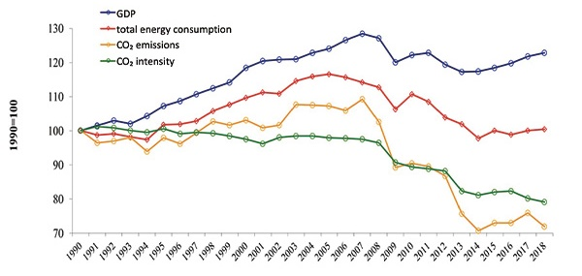
Figure 2 Air pollution: Greenhouse gas causes and trends
(Source: Seitron, 2020)

Water Pollution and Marine Ecosystem Disruption
Treated or poorly treated wastewater is routinely expelled by cruise ships directly into the oceans sewage, greywater and ballast water. Smith and Jones (2021) have found that a conventional cruise ship produces more than 1 million gallons of greywater and 210,000 gallons of sewage per week, with such an abundance of nutrient pollution that helps to create harmful algal blooms and deoxygenation in the marine ecosystems. Ballast water discharge is the cause of the introduction of invasive species that disrupt local biodiversity. On top of that, even less frequent oil spills have devastating consequences (Lloret et al., 2021). For example, in 2007, the large cruise ship MS Hebei Spirit spilt over 10,000 tonnes of crude oil off the South Korean coast, killing the surrounding marine life and local fisheries.

Waste Management Issues
Large cruise ships produce 8 tonnes of solid waste a day, made up of plastics, food waste, glass, and hazardous materials. The problem is aggravated by inadequate recycling practices and improper waste disposal at sea. The research of Donnelly and French (2021) also highlights that the International Maritime Organisation (IMO) has indicated that cruise ships account for 20% of the world's marine plastic pollution, and plastic debris poses serious threats to marine life through ingestion and entanglement. However, under MARPOL Annex V, there are already waste management regulations that are not necessarily being enforced, resulting in illegal dumping incidents (Cooper, 2021). One example is that Princess Cruises, in 2016, was fined $40 million for illicitly dumping oily waste into the sea, setting a bad example in adhering to compliance.
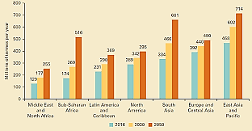
Figure 3 Trends in Solid Waste Management
(Source: World Bank, 2018)

Noise Pollution and Impact on Marine Life
Echolocation-dependent marine life, such as whales and dolphins, is adversely affected by the excessive noise pollution caused by cruise ships in the form of engine operations, propeller cavitation, and onboard activities. They are all highly susceptible to the effects of underwater noise: underwater noise disrupts their welfare as it causes stress, disorientation and even strandings (Thomsen et al., 2021). Ambient noise levels in the world’s oceans have doubled every decade since the 1950s, and commercial shipping, including cruise liners, is a leading source. In addition, Olajiga et al. (2024) have also discussed that a notable case study of this impact is on the North Atlantic right whale population, which has already been found to be suffering elevated stress levels and changed migratory patterns in busy shipping lanes along the U.S. East Coast as a result of chronic noise exposure.

Plausible Solutions to Environmental Damage

Adoption of Cleaner Fuel Technologies
It is imperative that among the most effective ways of cleaning cruise ship emissions is to transition from heavy fuel oils (HFOs) to cleaner fuels, such as liquefied natural gas (LNG). Sadiq et al. (2021) report that the use of LNG is nearly 100% reduction in harmful emissions, reducing sulphur oxides (SOx) by almost 100%, nitrogen oxides (NOx) by up to 85%, and carbon dioxide (CO₂) emissions by around 20% compared to conventional marine fuels. This is important because cruise ships typically generate maritime air pollution. However, the Royal Caribbean Group has been leading this transition, with its Icon of the Seas, which launched in 2023, being the largest LNG-powered cruise ship in the world (Thomsen et al., 2021).
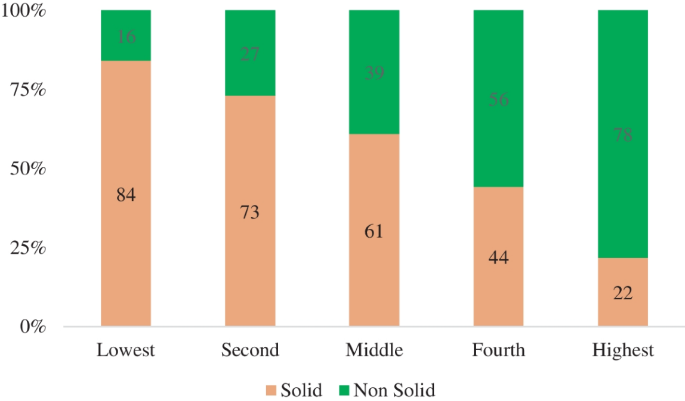
Figure 4 Drivers of clean fuel adoption and consumption intensity
(Source: Awan et al., 2024)
The vessel showcases the company's commitment to sustainability. Dual-fuel engines that run on LNG when at sea and shore power when berthed are used to minimise sea and port emissions (Haski-Leventhal, 2018). LNG, along with exhaust gas cleaning systems commonly called scrubbers for SOx reductions to as high as 98%, are also being installed on many existing ships. For example, Carnival Corporation has installed scrubbers on over 70% of its fleet in order to meet the International Maritime Organisation’s (IMO) 2020 sulfur cap regulations.

Waste Reduction and Advanced Waste Treatment Systems
Advanced technologies and sustainable waste reduction should be used to solve problems of waste management on cruise ships; as per Comings (2023), closed-loop water treatment systems are found effective, where ships can treat the wastewater onboard and avoid the release of harmful discharges into the marine environment. The systems can be used to process greywater, blackwater, and even oily bilge water to the highest international standards established by the International Maritime Organisation (IMO). Carnival Corporation has been a forerunner in the implementation of advanced wastewater purification systems (AWPS) on its fleet to ensure discharged water is generally cleaner than the seawater fed into it (Haski-Leventhal, 2018).
The environmental sustainability programme seeks to cut single-use plastic by 50% and increase waste segregation for recycling. They also aim to stop using plastic straws, install advanced waste shredders, and increase food waste digesters to reduce organic waste. Comings (2023), in his studies, shows that Norwegian Cruise Line (NCL) has also incorporated zero waste initiatives with its “Sail and Sustain” programme, which is aimed at decreasing land areas of waste through improving onboard recycling programmes.

Energy Efficiency Innovations
It is evident that easing fuel consumption and minimising environmental impact on cruise ships is essential to improving energy efficiency. Similar to Olajiga et al. (2024), one notable innovation is the integration of solar panels and energy-efficient LED lighting, which greatly reduces dependence on traditional energy. Supplementary power to light and small appliances can be generated by solar panels, reducing energy demand. Also, hull design needs to be optimised to enhance fuel efficiency. The modern cruise ship with a streamlined hull and a more advanced propeller system can reduce fuel consumption by 10~15% than the traditional hull and propellers (Wang et al., 2025).
In addition to this, Norwegian Cruise Line (NCL) has been leading the way in the conservation of energy, according to Inkson and Minnaert (2018), in placing its “Eco-Smart Cruising” into practise. The installation of energy-saving technologies such as LED lighting, advanced HVAC systems, and waste heat recovery units that recover excess heat from engine operations to power other ship systems is included in this programme. Additionally, Jauhari's (2021) research discussed hydrodynamic hull designs that NCL’s Norwegian Bliss used, which enhance propulsion efficiency and reduce fuel consumption by up to 12% compared to older ships.

Sustainable Port Operations
Environmental impacts of cruise ships are substantial in the air and water when the vessels are at sea, and at ports where the vessels are docked, they contribute disproportionately to air and water pollution. However, to minimise carbon emissions these days, many ports and cruise lines have deployed shore power technologies – cold ironing that allow ships to plug into the local electrical grid and go without their diesel engines. According to Smith and Jones (2021), this cuts emissions to as low as 95%, especially during ports, improving considerably air quality in port cities. There are Green Port Initiatives in Europe, such as Hamburg and Oslo, to promote sustainable port operations of ports by giving them shore power infrastructure.
Furthermore, a significant reduction in emissions during port stays (Wang et al., 2025) has been achieved by Royal Caribbean’s integration of shore power capabilities in the new vessels. Also, Carnival Corporation works with eco-friendly ports to implement such practices that minimise waste discharge and conserve energy, including waste reception facilities with the most advanced technology and sustainable terminal designs. Carnival Environmental Compliance Plan, such as the practice of emphasising sustainable port partnerships to reduce regulatory compliance risks and environmental risks. As Sadiq et al. (2021) have shown in their research, it also means that terminals are using renewable sources of energy there and that logistics are improved to reduce the time ships spend idle and, therefore, emit less.

Conclusion
It is concluded that although a main player in the global hospitality industry, cruise ship transportation of heavy polluting fuels creates extensive environmental impacts: severe air pollution by heavy fuel oils with high CO₂, SOx and NOx emissions leading to climate change and poor air quality in port cities, untreated sewage and greywater water pollution, improper waste disposal, presence of noise pollution that affects marine life were highlighted as critical concerns. To overcome these challenges, methods of adopting cleaner fuel technology such as LNG, enhanced wastewater treatment, energy efficiency improvement, and sustainable port operations are analysed. Initiatives of emission reduction, waste management and saving energy by Royal Caribbean, Carnival Corporation, Norwegian Cruise Line and other companies have been made on considerable degree.
Moreover, regulatory frameworks become very important to enforce environmental standards and to ensure that they are complied with by the industry. The cruise companies must invest in newer and greener technology and sustainable practises. For their bookings are also equal and it is also important to increase consumer awareness, because environmentally conscious tourists can change the industry practises with the power of bookings from eco friendly cruise options. The cruise lines and the consumers, as well as the regulatory bodies, should join hands to make the cruise sector to be environmentally sustainable in the long term.

References
Awan, A., Rahut, D. B., Sadiq, M. & Balsalobre Lorente, D. (2024) 'Title of the article', Energy Efficiency, Volume(Issue), Page numbers.
Comings, A. (2023). How the Push for Cleaner Air Dirtied the Water: The Shipping Industry and its Impact on the Environment. California Western International Law Journal, 53(2), 10.
Cooper, C. (2021). Essentials of tourism. Third edition. London: SAGE.
Donnelly, T., and French, L. (2021). Strategic Sustainability Management in the Event Sector. Event Management, 25(3), 279–296.
dos Santos, M. E. (2021). Addressing underwater noise in Europe: Current state of knowledge and future priorities.
Haski-Leventhal, D. (2018). Strategic corporate social responsibility : tools and theories for responsible management. London: SAGE.
Inkson, C. and Minnaert, L. (2018). Tourism management : an introduction. 2nd ed. London: SAGE.
Jauhari, V (2021). ‘Managing Sustainability in the Hospitality and Tourism Industry: Paradigms and Directions for the Future’ 9 th edn.Oakville: Apple Academic Press. Inc.
Lallani, S. S. (2023). The World on a Ship: Simulating Cultural Encounters in the US-Caribbean Mass-Market Cruise Industry, 1966-Present (Doctoral dissertation, Université d'Ottawa/University of Ottawa).
Lloret, J., Carreño, A., Carić, H., San, J., and Fleming, L. E. (2021). Environmental and human health impacts of cruise tourism: A review. Marine pollution bulletin, 173, 112979.
Olajiga, O. K., Ani, E. C., Sikhakane, Z. Q., and Olatunde, T. M. (2024). A comprehensive review of energy-efficient lighting technologies and trends. Engineering Science and Technology Journal, 5(3), 1097-1111.
Ranasinghe, R., Gangananda, N., Bandara, A., and Perera, P. (2021). Role of tourism in the global economy: The past, present and future. Journal of Management and Tourism Research, 4(1).
Sadiq, M., Ali, S. W., Terriche, Y., Mutarraf, M. U., Hassan, M. A., Hamid, K., ... and Guerrero, J. M. (2021). Future greener seaports: A review of new infrastructure, challenges, and energy efficiency measures. IEEE Access, 9, 75568-75587.
Seitron (2020) 'Air Pollution & Greenhouse Gas: Causes and Trends'.
Sloan, P., Legrand, W. and Chen, J.S. (2017). Sustainability in the hospitality industry : principles of sustainable operations. 3rd edn. London: Butterworth-Heinemann.
Smith, D. E., and Jones, D. L. (2021). Floating Cities. Natural Resources and Environment, 35(4), 28-34.
Sun, S., Wang, X., Law, R., & Li, G. (2022) 'A study on the trends of the global cruise tourism industry, sustainable development, and the impacts of the COVID-19 pandemic', Sustainability, 14(11), p. 6890.
Thomsen, F., Mendes, S., Bertucci, F., Breitzke, M., Ciappi, E., Cresci, A., ... and
Wang, K., Li, Z., Zhang, R., Ma, R., Huang, L., Wang, Z., and Jiang, X. (2025). Computational fluid dynamics-based ship energy-saving technologies: A comprehensive review. Renewable and Sustainable Energy Reviews, 207, 114896.
World Bank (2018) 'Trends in Solid Waste Management'.

