Lizzie’s notes

Link to the visualisation activity:

https://blogs.ed.ac.uk/oeer/the-unconscious-normatives-of-the-outdoors/

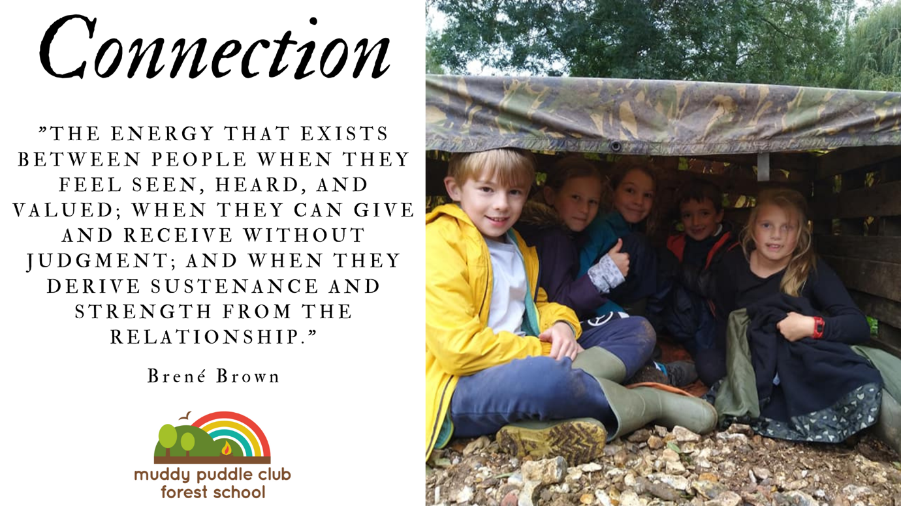

Place pedagogy and environmental justice

I have taken this from my own essay on Place pedagogy as a starting point to think about the connection between place and environmental justice. (Note, this is not published or peer reviewed, so just my own thoughts)

Pedagogy of Place and Environmental Justice

Research has shown that place connection can contribute to pro-environmental behaviours(Stedman, 2002; Halpenny, 2010; Scannell and Gifford, 2010). The premise linking place-based outdoor education with pro-environmental behaviour is that knowing a place leads to improving a place. In Williams 2018 report, he found that in order to improve natural spaces, we must consider three factors. First, “howthe current generation live in and around a particular outdoor place”, then “the different ways that previous generations have lived their lives in that same outdoor place” and, finally, “consideration of the concerns and issues that might arise for future generations in that place.” (Williams, 2018, p. 14). To improve environmental equity, we need to identify places that currently have less access to outdoor spaces, environmental concerns like pollution affecting air and water quality, and locally poor biodiversity. This is more likely to be urban settings and, as we have seen, will mostly be affecting minority groups. With this in mind, we need to think about the importance of the cultures of the people who live in these places, their backgrounds and histories; these are as important as the background and history of the place itself. Place pedagogy involves connecting local communities with their local natural green spaces and, I argue, creating a nature connection which encourages local environmental stewardship and increase involvement with local, national and even global environmental issues.

Through place we can see the effects that the local will have on global issues, it foregrounds a narrative of local and regional politics that is attuned to the
particularities of where people actually live, and that is connected to global development trends that impact local places (Gruenewald, 2003, p. 3). Where local issues can open people’s awareness to global issues, sense of place actually enables us to act locally whilst considering what is happening globally (Soja, 2000). For
example, making changes to encourage endangered species within local habitats. There is a large overlap between place pedagogy and involvements in community projects (Beames and Brown, 2016), and feeling part of a community, whether local or global, is central to making change happen. In his 2001 paper, Henderson argues that, through place pedagogy, we can create a sense of belonging “that allows us to be engaged with the place as home, as a meaningful and alluring place which not only offers comfort but also demands responsibility” (p. 15). This is the basis of this paper’s argument, that place pedagogy, when aimed at communities with poor environmental inequity, can cultivate an appetite for change. Gruenewald (2003), drawing from Giroux (1988), questioned inequalities of power and opportunity, and said that sense of place should focus on how the people that live in these places have the power to transform them. He argued that the outcome of place- based pedagogy is to enable people to have the power to change their place and, as a result, live well in them socially and ecologically.

A recent and ongoing example of how connecting with place has led to social activism,
which aims to change government policies and decisions, I the HS2 rebellion. HS2 is a large- scale government project to create a new, high-speed rail link to London. The project has been controversial from the outset due to the new train line route going through many ancient woodlands and natural green spaces. There has been an organised rebellion against the project, with many environmentalists creating camps to protect the woodlands. It is reminiscent of the Newbury Bypass protests in the 1990s and has links with the extinction rebellion protests. The HS2 rebellion is of interest due to the involvement of local people who are using stories of their childhoods in these green spaces and the heartbreak they are experiencing of losing not only wildlife habitats, but also places where they hold strong memories from regular visits. In other words, from the sense of place and connection that they feel with these spaces. For example, Jones Hill Wood in Buckinghamshire is the woodland which influenced the writing of Fantastic Mr Fox by Roald Dahl. The Woodland Trust (2020) quoted Luci Ryan, from the HS2 rebellion; Jones Hill Wood is a literary loss. It is culturally significant, the stuff of childhood memories. Millions of children and their parents have been captivated by the story of Fantastic Mr Fox and his friends the badgers, moles, rabbits and weasels with whom he shares the wood. The story of course will live on. The wood, however, will not.
Following the reporting of the loss of this woodland, many locals became involved with the local protest. Months later, the work was halted in October 2020, when locals reported wildlife crimes to the police who investigated, involved lawyers and ecologists, and eventually successfully halted the work. (hs2rebellion, 2020) This is an example of how the cultural history of a natural green space created a sense of place, leading to local people using justice systems to protect it. The power of storytelling about the history of a place is evident in this situation, and it also builds on the premise that “One of the most compelling reasons to adopt place-based education is to provide students with the knowledge and experiences needed to actively participate in the democratic process.” (Woodhouse & Knapp, 2000, p. 4)

It is important to remember, however, that social injustice means that one of the barriers is the lack of time and funding. Wealthy families, who already have better access to healthy green spaces, can afford regular sessions, such as Forest School, but poorer families, who need to create nature connections, cannot. Often the projects receive funding to get started, but they are required to self-fund once established, and the communities involved with the projects cannot afford to keep them running. This reveals the issues with systematic injustice, the distribution of environmental and monetary wealth is unequal and injustice is deeply rooted in our systems; it is difficult to change. An example of this is the Food for Families community garden project in Reading, UK, which received national lottery funding for place-based gardening for food project. Their final report stated the project made “relevant contribution to our local communities at a time of deeply serious climate change.” (Food4Families, 2018, p.3) It showed that the community urban garden engaged a diverse group of people with nature, but the funding was limited, and the project could no longer continue.

There is hope, however, as the UK government acknowledges environmental justice issues and has been creating policies and documents which aim to address these inequalities. In 2005 they produced the ‘Sustainable Development Strategy’ which pledged a commitment to creating more equal access to outdoor natural spaces. In 2018 they created the “A Green Future: Our 25 Year Plan to Improve the Environment”, which funded an educational project, Nature Friendly Schools, which focusses on bringing outdoor and environmental learning to children in areas of high deprivation. They recognised that “In the most deprived areas of England, people tend to have the poorest health and significantly less green space than wealthier areas” (p.72) and “The poorer you are, the more likely it is that your house, and your children’s school and playground are close to highly-polluted roads, and the less likely you are to enjoy ready access to green spaces”(p.16) The aim of the project is to provide opportunities for children to connect with a local natural space on a regular basis for wellbeing and to encourage environmental stewardship. It is based on the idea that if we directly link the academic curriculum with what is happening in local communities, we can break down the ‘artificial separation between the classroom and the real world.” (Blank and
Berg 2006, p.8). The project was awarded to the Wildlife Trusts who have been working
with schools in areas of highlighted deprivation (based on data for free school meal
eligibility). The project uses sense of place pedagogy, combined with environmental
experiential learning, to develop nature connection in young children. As this project is
directly aimed at deprived communities, this project can make changes in environmental justice. However, the funding for this project is limited to 3 years. Is this long enough to have a profound impact on the communities involved?

Podcast episode with me talking about queer ecology!

https://www.youtube.com/watch?v=1bUq6JMlOHk

Also on spotify

