Module: Leading and Implementing Change (LIC)
Module code: LCLM6003
Assignment Title: A Strategic Change Plan
Name : Ingrid Takacs
Student ID:2317939
Lecturer: Nadeem Mirza

Executive Summary
This report has discussed the strategic change problem that Aston Martin encountered in the premium automotive market sector. It has been recognised that the pressures on the company are high due to poor financial results, the need for investments to grow, electrification, digital disruption, sustainability expectations and the growing strength of technological competition. The internal and external pressures are emphasising the need for Aston Martin to change its operations, products and organisational capabilities to be competitive in the changing market. The report has recapped the organisation's strategic environment and assessed the key forces driving change impacting their performance and future. It has used Kotter's change management model as the primary change management model and has included Lewin's three-step model to understand and manage Aston Martin's change process. It has also offered a transformational leadership lens to consider leadership's influence on strategic renewal and employee engagement in the context of change. The report has outlined a strategic change plan for Aston Martin in 3 phases, with the first seeking to drive the pace of electrification, the second to build up the company's digital skills and the third to boost operational efficiencies to support sustainability targets without damaging the luxury brand's value. The outcomes anticipated have been increased competitiveness, better adaptability of the organisation, increased technological readiness and a more sustainable long-term strategic position.

Table of Contents
Introduction 4
a) Introduction to the Chosen Organisation 5
b) Analysis of Recent Organisational Performance and Internal–External Change Drivers 7
c) Evaluation of Change Management Models and How Change Was Managed 15
d) Change Management, People and Organisational Culture at Aston Martin 21
e) Strategic Change Management Plan for Aston Martin 24
Conclusion 28
Reference List 29

Introduction
In today's dynamic and highly competitive business world, strategic change has become a must for organisations. The automotive industry is undergoing significant change as a result of rapid technological advancement, digitalisation, artificial intelligence, sustainability demands and changing customer expectations. Concurrently, the businesses are dealing with economic instability, regulatory shifts and growing rivalry. Therefore, good change management and good leadership play an important role in the sustainability of an organisation's performance and long-term competitiveness (Llopis-Albert, et. al., 2021).
This report explores the strategic change challenges of the selected organisation in the UK automotive industry. It critically examines both internal and external forces that fuel organisational change and its analysis of suitable models of change management, approaches to change leadership and the role of organisational culture in the process of change. The report then creates a strategic change management plan, incorporating clear goals, budget, communication plans and evaluation measures to facilitate sustainable business transformation and future success.

a) Introduction to the Chosen Organisation
Aston Martin Lagonda Global Holdings plc (AMGH) is a British luxury carmaker which has its roots in 1913. The company is targeted at the top end of the performance car market and offers the best of both high-performance engineering and high-end styling and brand exclusivity. It produces sports cars, grand tourers, SUVs, limited editions, and some of the most important models include DB12, Vantage, Vanquish, DBX and the hybrid Valhalla. This portfolio embodies the essence of Aston Martin's commitment to combining heritage luxury with innovation and electric performance.
Aston Martin is based in the UK, but sells cars in a global luxury market via an international dealer network in the Americas, Europe, the Middle East and Asia-Pacific. The company's revenue for FY2025 was £1.26 billion, while the wholesale vehicle deliveries made across the globe were 5,448. But revenues dropped 21% from FY2024 as a result of macroeconomic pressure, reduced special editions deliveries, and market conditions. Meanwhile, core ASP rose 5%, reflecting the solid performance of its high-end brand. In conclusion, Aston Martin is a well-known luxury car brand around the world, but its current situation is marked by financial constraints, product evolution and a desire to evolve and embrace electrification and digitalisation (Aston Martin, 2024).
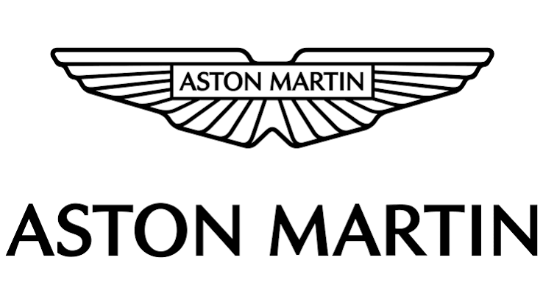
Figure: Company Logo
(Source: Aston Martin, 2024)

b) Analysis of Recent Organisational Performance and Internal–External Change Drivers
Organisation context and performance trends in recent years
The recent performance of Aston Martin shows that there is a definite need for a change in the strategy of the company. In FY2025, revenue fell to £1.26 billion; volumes of wholesales decreased to 5,448 vehicles, which was 21% lower than the previous year, and 10% lower than the previous year. It said it was due to a challenging trading environment, a reduction in special model deliveries with higher margins and discipline in production to maintain price/volume balance. While Aston Martin has launched new vehicles like its Valhalla and refreshed its core line, the profitability hasn't been great as the company has to support both product renewal, electrification and transformation. The result is strategic repositioning pressure: Aston Martin has to safeguard its luxury brand, increase its financial strength, capabilities and long-term competitiveness in a fast-changing automotive market (Aston Martin, 2024).
External environment analysis
Factor | Key external change drivers affecting Aston Martin | Impact on Aston Martin
Political / Legal | Tightening emissions regulations, stricter EV transition policies, and stronger sustainability reporting requirements, and continuing trade/supply-chain uncertainty in international markets. | Aston Martin faces pressure to accelerate electrification and reduce dependence on traditional combustion-led models. Compliance with environmental regulations also increases development and operational costs. At the same time, trade barriers, tariff exposure and supply-chain disruption can delay production, raise component costs and reduce operational flexibility.
Economic | Inflation, rising energy and raw material costs, volatile exchange conditions, weaker consumer confidence in some regions, and high investment pressure linked to electrification and technology (Shee Weng, 2025). | Aston Martin’s low-volume luxury business model is exposed to cost escalation because it operates with high fixed costs and limited scale advantages. The company must fund EV development, digital transformation and new product investment while also protecting margins and managing fluctuating global luxury demand.
Social | Growing customer interest in sustainability, lower-emission mobility, premium EVs, digital convenience and ethical brand positioning. Younger luxury consumers increasingly expect performance to be combined with innovation and environmental responsibility. | Aston Martin can no longer rely only on heritage, exclusivity and performance. It must modernise its value proposition by aligning luxury with sustainability, electrification and a stronger digital customer experience in order to remain relevant to future premium buyers.
Technological | Rapid development of EV platforms, battery technology, AI, digitalisation, smart manufacturing, connected vehicles, and data-driven customer systems (Cavus, et. al., 2025). | These technologies are reshaping product design, manufacturing efficiency, customer experience and supply-chain coordination. Aston Martin must invest in electrified models, digital systems and advanced manufacturing capability to avoid falling behind more technologically advanced competitors.
Competitive Pressure | Intense competition from established premium and performance brands such as Ferrari, Porsche, Bentley and Mercedes-AMG, as well as technology-led EV competitors such as Tesla. | Competition is no longer based only on luxury design and performance. Rivals are strengthening electrified portfolios, software capability and digital customer ecosystems. This increases pressure on Aston Martin to transform quickly, improve innovation capability and reposition itself within a more technology-driven luxury automotive market.
Internal environment analysis
Internal factor | Critical analysis of Aston Martin’s internal position | Impact on strategic change
Dependence on luxury niche positioning | Aston Martin operates in a narrow ultra-luxury performance segment, which gives the firm exclusivity and premium pricing potential. However, dependence on a niche market also increases vulnerability because demand is tied to a relatively small customer base and is sensitive to global economic uncertainty. The business, therefore, has less room to absorb market shocks than larger, more diversified automotive groups. | Strategic change is necessary because Aston Martin cannot rely solely on heritage and exclusivity for long-term growth. It must strengthen resilience through product innovation, broader technological relevance and a more future-oriented market position (Salamzadeh, et. al., 2022).
Cost structure and profitability pressure | Aston Martin faces a difficult cost structure characterised by high fixed costs, low production scale and significant development expenditure. This limits economies of scale and places profitability under pressure, particularly when wholesale volumes decline or product launches are delayed. The need to finance transformation while maintaining day-to-day performance creates a tension between long-term investment and short-term financial stability. | This internal pressure increases the urgency for change because the company must improve efficiency, cost discipline and operational productivity while still funding strategic renewal (Wang, et. al., 2023).
Innovation capability and R&D burden | The company must invest in electrification, software capability, digital systems and new model development, yet it does not possess the scale advantages of larger automotive competitors. As a result, R&D becomes a strategic burden as well as a necessity. Innovation is essential for survival, but it also raises financial risk if returns are delayed or market uptake is uncertain. | Aston Martin must manage change carefully by prioritising innovation areas that strengthen both competitiveness and financial sustainability.
Brand strength versus operational weakness | Aston Martin’s brand remains a major internal asset because it is associated with luxury, prestige and performance. However, brand strength does not automatically translate into operational efficiency, technological readiness or financial resilience. There is a risk that the symbolic value of the brand can mask deeper structural weaknesses in execution, cost control and transformation capability. | The company needs a strategic change that protects brand equity while addressing operational weaknesses that undermine long-term performance.
Readiness for electrification and digital transformation | Aston Martin has recognised the importance of electrified products and digital transformation, but readiness appears uneven. Transitioning to EVs and data-driven operations requires new skills, technology partnerships, investment capacity and internal alignment. For a heritage luxury manufacturer, this is a major organisational shift rather than a simple product update. | Change management must focus on capability building, investment prioritisation and organisational alignment to ensure the transition is practical and not only strategic in ambition (Carreño, 2024).
Internal resistance and capability gaps | Restructuring, digital transformation and electrification can generate internal resistance, particularly where employees are attached to traditional engineering practices, legacy processes or established brand identity. Capability gaps in digital systems, software and advanced manufacturing may also slow implementation if reskilling is insufficient. | Leadership must address cultural resistance, workforce capability and communication if change is to be embedded successfully across the organisation.
Impact of digital disruption, digitalisation and AI on Aston Martin
Digital disruption is driving urgency to modernise the way Aston Martin does business and what it offers its customers. The luxury automobile segment now demands more than performance and exclusivity; it is looking for superior connectivity, digital interfaces and a more personalised ownership experience. But this demands that Aston Martin build up digital customer engagement as well as product innovation. Internally, digitalisation plays a vital role in increasing efficiency, accuracy of forecasting and control of operations (King and Cnop, 2025). The use of AI and data analytics can aid in demand forecasting, customer insight creation, predictive maintenance, and supply chain decision-making, which helps the company to navigate uncertainty and enhance responsiveness. Digital manufacturing and other Industry 4.0 technologies can also enhance quality control, production planning and cost efficiency in operations. But if digital transformation is still lagging behind the expectations of the market, then Aston Martin may fall behind the more advanced competitors. Thus, digital disruption is not a side issue; it is a key strategic challenge and an urgent business imperative that demands Aston Martin to pursue the organisational transformation, capability development and technology adoption agenda to accelerate.

c) Evaluation of Change Management Models and How Change Was Managed
A brief discussion of alternative change models
Change management models offer a framework for understanding organisational change from a current state to a desired future state, but this can be very useful depending on the extent and complexity of the change (Kherrazi and Roquilly, 2025).
Lewin’s three-step model
Lewin's three-step model is useful because it breaks change down into three steps: unfreezing, changing and refreezing. In Aston Martin's environment, this model helps them to understand how they need to “shake up” their routines and thinking before they can “plant” new habits in place. But, when applied to transforming a luxury automotive company, Lewin's model has its limitations because it is not specific enough to handle the simultaneous and overlapping changes that a company may experience in electrification, digitalisation, sustainability adaptation and operational restructuring. It reflects the rationale behind transition, but not specifically the steps required to bring about significant change in functions, people and technologies.
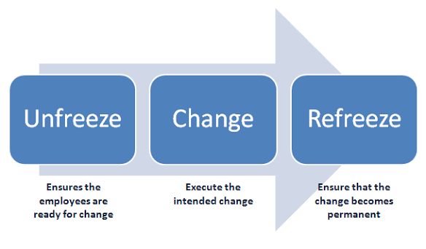
Figure: Lewin’s three-step model
(Source: Self-developed)
Kotter’s eight-step model
The Kotter 8-step model is more appropriate to strategic change at a large scale because it offers a more straightforward process for creating urgency, finding leadership alignment, visioning, action and maintaining momentum. This is especially true of Aston Martin, in which the change becomes a transformation, and not just a matter of investment in technology; of culture change; of the disciplines involved in implementation. Whereas Kotter has been enhanced by recognising the political and behavioural nature of change, particularly the importance of creating coalitions and gaining employee buy-in, Lewin has been forgotten. The model may still be linear in environments that do not involve a sequence of change but are continuous. Businesses in the automotive sector may be on a mission to adapt to a range of pressures that can't be achieved in a step-by-step fashion (Shah, et. al., 2023).
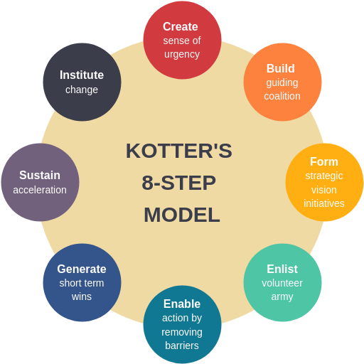
Figure: Kotter 8-step model
(Source: Shah, et. al., 2023)
ADKAR
The individual aspect of change (Awareness, Desire, Knowledge, Ability and Reinforcement) makes ADKAR useful. This builds its worth for comprehending staff reactions to electrification, digital systems and new working methods. ADKAR demonstrates to Aston Martin the critical need for workforce capability, communication and behavioural reinforcement. Its problem is that it can't fully solve strategic problems like positioning, market timing and structural change of the organisation (Leksono and Yulianti, 2022).
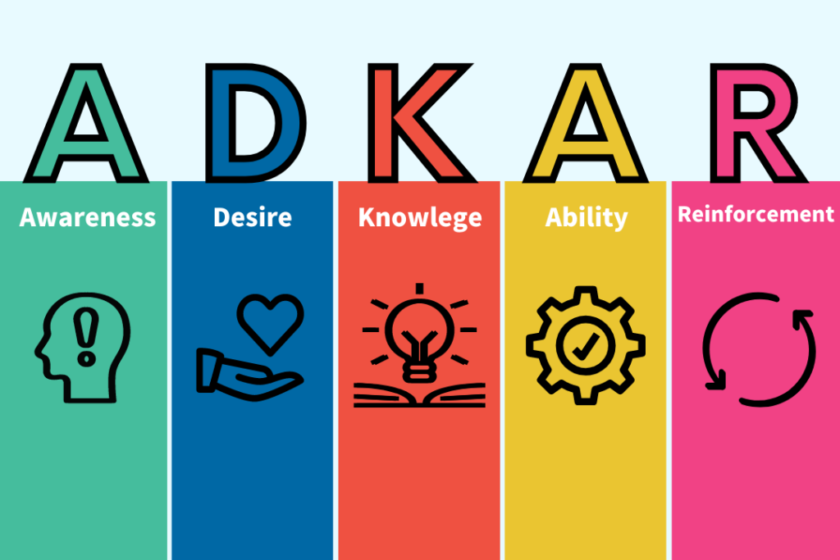
Figure: ADKAR
(Source: Leksono and Yulianti, 2022)
In conclusion, although Lewin has a comprehensive staged logic, ADKAR is useful for understanding the adoption of the product by employees, but Kotter's approach is more useful for understanding the large-scale strategic change at Aston Martin as it is more accurate and effective with regard to urgency, leadership, communication and implementation.
Application to Aston Martin’s strategic change situation
The best way to explain the strategic change pressures at Aston Martin is by using Kotter's model and the logic of the Lewin model. Electrification, digital disruption, sustainability demands and ongoing financial pressures are all challenges to the company. Kotter's first step is to create a sense of urgency. The need for change is reinforced by declining revenues, declining wholesale volumes, increasing technological competition and heavy investment demands. It is no longer about choice, but about regulation, customer expectations and competitive survival: that is the reason for electrification. Similarly, digital transformation is critical for enhanced manufacturing efficiency, supply-chain responsiveness and customer experience (Dathe, et. al., 2024).
Kotter's steps of establishing a guiding coalition and developing a vision are also very applicable. The transformation of Aston Martin needs to be coordinated with the leadership, engineering, operations, marketing, and external technology partners. If this alignment is not maintained, change could be disjointed between financial recovery, product innovation and operational improvement. Thus, a clear strategic vision must be the amalgamation of luxury brand preservation, product development for electrification, efficiency enhancement, and enhanced sustainability performance (Varga, 2021).
The model of Lewin can be used to explain the implementation phase as well. Aston Martin has to first "unfreeze" the traditional thinking that has been associated with combustion-driven performance and manufacturing heritage, and then introduce new methods of working based on digital and electrification. The “change” phase of the model encompasses product redesign, building digital skills and improving processes, and the “refreezing” phase consists of making the change a reality in daily operations. ADKAR is a good way of getting to grips with employee awareness, knowledge and ability, but Aston Martin's problems go wider than just employee behaviour. In general, Kotter provides the best model because the transformation of Aston Martin is a strategic repositioning process that needs to be accelerated, aligned, communicated and implemented over time (Vasel, 2025).
Critical evaluation of how the change was managed in Aston Martin
The recent change efforts that Aston Martin has undertaken seem to have been more of a proactive response to the changes, but obviously also a large reactive one. The company has recognised the importance of electrification, digital transformation and sustainability, and has an intention of some kind in the strategic sense. Leadership shows their focus on the future, and product renewal is an add-on to investment in future technologies (Varga, 2021). Much of the change has also taken place in a reactive way; however, due to poor performance, money pressures and the need for competitiveness to be improved. The question arises as to whether a clear long-term strategy has been provided for transformation—or whether it will be provided—or if it's more about stabilising a situation where performance has declined in the recent past.
There also seems to be a disparity in the rate of change. Aston Martin has taken steps to make strides to realign its product portfolio and get ready for electrification, but it will be interesting to see how much further it can go without its competitors, who have better financial and technological means. The beginnings of the transformation story lie in the power of communication and leadership commitment, but the most challenging part is in doing it. Bigger organisational change is likely required for capability building and digital readiness, and operational improvement, than what will be accomplished by product launches alone (Trabucchi, et. al., 2022).
Consequently, ongoing change-reaction decisions may be made that tackle some underlying drivers, like the need for innovation or strategic repositioning, but the decisions do not necessarily address the root causes of the structural pressures relating to scale, profitability, and capability to transform. This implies that Aston Martin has taken the right course of action about change management, but not enough to assure long-term strategic risk reduction.

d) Change Management, People and Organisational Culture at Aston Martin
Leadership and change management at Aston Martin.
But in Aston Martin, leadership is the key to change management, as, rather than one change, there are several strategic challenges that the company is dealing with. These are such as restructuring demands, electrification, digital transformation and adaptation to sustainability. In this context, leadership has to go beyond the management of day-to-day operations – it has to give direction, engage stakeholders inside and outside the organisation and create a sense of commitment for change. This is especially important, as it is a leadership style that stresses vision, inspiration, communication that conveys change and the capacity to motivate other people to focus on a common future. It's the strategy that's suited to Aston Martin as leadership needs to prove to its employees, investors and partners that it can maintain the luxury brand image while operating in a digital and electrified car industry (Musaigwa, 2023).
A transformational leadership approach to being a leader requires that they develop a compelling vision, articulate urgency, and promote innovation throughout the organisation. For Aston Martin, it is transforming electrification and digitalisation from a threat to a natural evolution – one that is essential to keeping the brand relevant and competitive for the long-term. Leadership needs to be able to relate and link the short-term operational improvements to the broader strategic renewal and to show how efficiency, sustainability and technology investment will help the business to perform in the future. It is important in a heritage-based organisation because there are likely to be engineers who are very attached to traditional engineering values and working practices (FN, 2025).
However, Aston Martin's leadership response is unclear. The company has identified a need for product renewal, electrification and transformation of its operations – this demonstrates a strategic awareness. However, much of this change seems to be more of a reactive, rather than visionary, approach to leadership, spurred by financial pressures and poor performance. Given this, as long-term transformation continues to be undermined by a strategy of financial survival and cultural change, the transformation process may become softer.
Organisational culture and its impact on the change programme
Schein's model of organisational culture can be used to critically analyse Aston Martin's organisational culture, which involves identifying the artefacts, espoused values and underlying assumptions. The culture of luxury craftsmanship, exclusivity, performance and design prestige is evident at the artefact level of Aston Martin. The elements are visible and contribute to building a strong company identity and to differentiation in the premium automotive market. The organisation's espoused values of engineering excellence, quality and an unwavering focus on a high level of customer experience all have the potential to support strategic change by giving it a clear sense of purpose and premium positioning (Alvesson and Sveningsson, 2024).
However, the underlying values associated with Aston Martin's 'culture' can also impede change. Craft-based culture, tradition and combustion-based performance can lead to resistance to digitalisation, AI adoption and electrification. Technology can trigger a fear of change in employees and not a call to change. This friction may decrease the agility of the organisation and slow down experimentation. Particularly, the way employees react to restructuring and capability development is influenced by culture. When cooperation, learning and openness are low, it's more difficult to get transformation to take hold. Thus, Aston Martin's change programme relies on the need to change the culture where the norms of heritage and innovation are put together. If this cultural change isn't captured, then strategic change could be met with resistance and not be accepted at an organisational level (Williams, 2022).

e) Strategic Change Management Plan for Aston Martin
Proposed strategic change
Aston Martin needs to have a multi-phase strategic transformation programme that is geared towards bringing about higher electric vehicle penetration and smartness, and greater operational efficiencies in parallel with maintaining the luxury brand image. Product innovation, the restructuring of the company's operations and the development of worker skills should be integrated into the plan and linked to the measures for the sustainability of the business to make the company more competitive without compromising its premium positioning in the global luxury automotive market (Hudson, et. āl., 2024).
Clear objectives
- To expand electrified capability by expediting the development of hybrid and EV products and by attaining clear electrification milestones in the near term (3-5 years).
- To gain operational efficiency and control, minimise waste and optimise production planning and supply chain coordination by implementing digital systems.
- To enhance and drive Digital Customer engagement and long-term competitiveness through data-driven decision making, enhance customer experience and integrate sustainability into future strategy and operations.
Financial plan
Investment area | Funding/implementation logic | Expected benefit
EV and hybrid technology development | Prioritise phased investment in electrified product platforms and battery-related capability. Use strategic partnerships and staged capital allocation to reduce financial pressure. | Supports compliance, product relevance and long-term competitiveness in the luxury performance market.
Digital systems and AI-enabled operations | Invest in forecasting tools, supply-chain visibility, customer data systems and digital manufacturing technologies. Focus first on high-return operational areas. | Improves efficiency, decision-making, customer insight and production control.
Workforce capability and training | Allocate budget for reskilling in digital systems, electrification and advanced manufacturing. Combine internal development with specialist external support where needed. | Reduces capability gaps, supports implementation and strengthens employee readiness for change (Supriharyanti and Sukoco, 2023).
Supply-chain and operational improvement | Invest selectively in supplier integration, planning systems and process improvement to reduce disruption and waste. | Improves resilience, cost control and revenue stability through more reliable operations.
Communication plan
Stakeholder group | Key communication focus | Main channels/purpose
Employees | Explain why change is necessary, what will change, the required new skills and the expected benefits. | Leadership briefings, team meetings and internal updates to reduce uncertainty and resistance (Zhu, et. al., 2023).
Investors and board | Communicate strategic rationale, investment priorities, expected returns and milestone progress. | Investor presentations, reports, and review meetings to maintain confidence and support.
Suppliers, dealers and customers | Clarify product direction, sustainability goals, implementation timelines and service expectations. | Stakeholder meetings, digital communication and market updates to maintain alignment and trust.
Evaluation plan
KPI area | Example measures | Purpose
Electrification progress | Number of electrified models launched, achievement of EV/hybrid development milestones, and share of electrified portfolio. | Tracks whether Aston Martin is progressing towards strategic product transformation.
Operational performance | Cost reduction, production efficiency, lead-time improvement and inventory accuracy (Gebeyehu, et. al., 2022). | Measures whether digital and operational changes are improving performance and cost control.
Capability development | Employee training completion, digital skills uptake and engagement with change programmes. | Assesses whether the workforce is prepared to support transformation.
Sustainability performance | Emissions reduction progress, resource efficiency and sustainability reporting targets. | Evaluates whether environmental objectives are being integrated into operations and strategy.
Market and customer outcomes | Sales growth in target segments, customer satisfaction, repeat purchase intent and brand perception (Almursyid, et. al., 2024). | Shows whether change is strengthening competitiveness and customer value in the luxury market.

Conclusion
Aston Martin is in a very strategic turnaround in response to external disruptions and internal pressures. The analysis has revealed that the premium automotive market is set to change through the strengthening of environmental regulation, the shift towards electrification, digital disruption, technological competition and customer expectations. Concurrently, Aston Martin is dealing with internal issues associated with its luxury focus, cost issues, profitability issues, capability building issues and the challenges of having a heritage organisation change. All of these aspects make strategic change not so much a choice, but a necessity. The report has also shown that successful transformation is not just about technology investment, it is also about good change management, leadership direction and cultural alignment. Leadership needs to establish a sense of urgency, articulate a vision and offer a vision of capability development, and organisational culture needs to change to ensure a balance between the ability to build capabilities and also respect heritage. The strategy plan for change, therefore, provides a viable way of developing Aston Martin's long-term competitiveness by electrification, digital development, business operational enhancement and sustainable business transformation.

Reference List
Almursyid, M.Z., Surahman, A. and Rahman, F., (2024). Analysis of consumer behavior in repeat purchases of a product. International Journal of Management and Business Economics, 2(3), pp.94-97.
Alvesson, M. and Sveningsson, S., (2024). Changing organizational culture: Cultural change work in progress. Routledge.
Aston Martin, (2024). Aston Martin Lagonda is the world’s only independent luxury car group with... [online] Aston Martin. Available at: https://media.astonmartin.com/about-us/?lang=eng [Accessed 2 Jul. 2026].
Aston Martin, (2024). Corporate. [online] Astonmartin.com. Available at: https://www.astonmartin.com/en/corporate [Accessed 2 Jul. 2026].
Carreño, A.M., (2024). Strategic alignment in program management: A framework for sustainable business transformation. Institute for Change Leadership and Business Transformation. https://doi. org/10.5281/zenodo, 13922003.
Cavus, M., Dissanayake, D. and Bell, M., (2025). Next generation of electric vehicles: AI-driven approaches for predictive maintenance and battery management. Energies, 18(5), p.1041.
Dathe, T., Helmold, M., Dathe, R. and Dathe, I., (2024). Strategy implementation. In Implementing environmental, social and governance (ESG) principles for sustainable businesses: A practical guide in sustainability management (pp. 85-97). Cham: Springer International Publishing.
FN, A.A., (2025). Transformational Leadership in Crisis: Inspiring Change and Innovation. Journal of Social Science and Management Studies, pp.32-40.
Gebeyehu, S.G., Abebe, M. and Gochel, A., (2022). Production lead time improvement through lean manufacturing. Cogent Engineering, 9(1), p.2034255.
Hudson, B., Razeghi, G. and Samuelsen, S., (2024). Mitigating impacts associated with a high-penetration of plug-in electric vehicles on local residential smart grid infrastructure. Journal of Power Sources, 593, p.233961.
Kherrazi, S. and Roquilly, C., (2025). Managing digital transformation in contemporary contexts: Are classical change management frameworks still relevant?. Journal of Change Management, 25(2), pp.85-115.
King, K.A. and Cnop, A., (2025). Transformation in the automotive sector: the management challenges of AI and the digital revolution. In Navigating the 21st Century Business World. LSE Press.
Leksono, A. and Yulianti, P., (2022). Analysis of Effectiveness of Change of Training Program with Adkar Approach (Awareness, Desire, Knowledge, Ability and Reinforcement). Jurnal Multidisiplin Madani, 2(10), pp.3807-3812.
Llopis-Albert, C., Rubio, F. and Valero, F., (2021). Impact of digital transformation on the automotive industry. Technological forecasting and social change, 162, p.120343.
Musaigwa, M., (2023). The role of leadership in managing change. International review of management and marketing, 13(6), p.1.
Salamzadeh, A., Hadizadeh, M., Rastgoo, N., Rahman, M.M. and Radfard, S., (2022). Sustainability-oriented innovation foresight in international new technology-based firms. Sustainability, 14(20), p.13501.
Shah, G.M., Memon, N.A., Tunio, G. and Joyo, A.S., (2023). Revamping higher education: Unleashing the power of John Kotter's eight-step change model for enhanced performance. Russian Law Journal, 11(5), pp.613-623.
Shee Weng, L., (2025). The Carbon-Driven Economy: Trade, Inflation, and Investment Strategies in the Net-Zero Transition (Part 1). The Carbon-Driven Economy: Trade, Inflation, and Investment Strategies in the Net-Zero Transition (Part 1)(February 03, 2025).
Supriharyanti, E. and Sukoco, B.M., (2023). Organizational change capability: a systematic review and future research directions. Management Research Review, 46(1), pp.46-81.
Trabucchi, D., Buganza, T., Bellis, P., Magnanini, S., Press, J., Verganti, R. and Zasa, F.P., (2022). Story-making to nurture change: creating a journey to make transformation happen. Journal of Knowledge Management, 26(11), pp.427-460.
Varga, J.T.D., (2021). Analysing the Kotter Management Leader Model in Organizational Change. Leadership Theories and Models in Today’s Perspectives, p.63.
Vasel, H., (2025). Factors shaping the implementation of educational organizational change: An analysis of Lewin's model in the context of teaching innovations. Social Sciences & Humanities Open, 11, p.101599.
Wang, K., Zhang, Z., Xiong, J., Li, H., Liu, H. and Ma, H., (2023). Balancing strategic renewal, cost and efficiency: a case study in digital transformation. Journal of Business Strategy, 44(5), pp.266-276.
Williams, P., (2022). Organisational culture: definitions, distinctions and functions. In Handbook of research methods for organisational culture (pp. 5-22). Edward Elgar Publishing.
Zhu, Y., Long, L., Liu, W., Shu, P. and Chen, S., (2023). How and when does authentic leadership reduce employee resistance to change? An explanation from uncertainty management theory. Leadership & Organization Development Journal, 44(8), pp.969-993.

