Problem
Analysis and Solution
Development

Module Name: Analysing and Solving Problems
Module Code: ACCA 4019
Student Name: Fernel Ramirez Espinal
Student ID: 2508572
Group: 3
Lecturer’s Name: Dr Redhwan Al-amri

Table of Contents
Table of Contents 1
1. Introduction 2
2. Deconstruct the Problem 2
2.1 MoSCoW Technique Requirement 2
2.2 Variables Identification 2
3. Proposed Solution 2
3.1 Flowchart 2
3.2 Flowchart Explanation 2
4. Reflection and Justification 2
4.1 Abstract thinking 2
4.2 Sub-dividing 2
4.3 Justification of solution 2
4.4 Limitation 2
4.5 Assumption 2
5. Conclusion 2
References 2

Introduction
Many colleges face challenges when organizing classrooms for different lessons. As student numbers increase and timetables become more complex, it can be difficult to make sure every class has a suitable room. This often leads to overcrowded classrooms, empty rooms that are not being used, timetable clashes, and students or teachers having to walk long distances between lessons. These problems can affect the quality of teaching and learning.
The aim of this report is to analyses the classroom allocation problem using abstract thinking and problem-solving techniques. It will identify the main requirements and limitations before proposing a logical solution that will help the college make better use of its classrooms, reduce unnecessary movement around campus, and create a more efficient timetable.

Deconstruct the Problem
Before designing a solution, it is important to break the problem down into smaller, more manageable parts. This makes it easier to understand what is causing the issues and what needs to be improved.
The college's classroom allocation problem can be divided into several key areas:
Overcrowded classrooms: Some classes are assigned to rooms that are too small for the number of students. This can make lessons uncomfortable, reduce student engagement, and create health and safety concerns.
Underused classrooms: While some rooms are overcrowded, others remain empty or are only used for a few hours each day. This means the college is not making the best use of its available facilities.
Timetable clashes: In some cases, two different classes may be scheduled in the same room at the same time. These clashes can cause confusion for both staff and students, resulting in delays and disruption to teaching.
Unnecessary movement: Students and lecturers often need to travel between buildings or distant classrooms for consecutive lessons. This increases the time spent moving around campus and can lead to lessons starting late.
Limited resources: The college has a fixed number of classrooms, each with different capacities and facilities. Some subjects also require specialist rooms, such as computer laboratories or science labs, which limit where those lessons can be scheduled.
By breaking the problem into these individual parts, it becomes easier to identify the main causes of the issue and develop a solution that addresses each one. This approach follows the principles of computational thinking by simplifying a complex problem into smaller components that can be analyzed and solved systematically.

Moscow Technique Requirement
To decide which features are the most important, I used the Moscow prioritization technique. This method helps separate the essential requirements from the features that would simply improve the system if there is enough time or resources. By doing this, it becomes much easier to focus on solving the biggest problems first while keeping the project realistic.
Priority | Requirement | Why it is important
Must Have | Allocate every class to a classroom with enough space for all students. | If a classroom is too small, students may not have enough space, making lessons uncomfortable and potentially unsafe. This is one of the most important requirements.
Must Have | Make sure the same classroom is not booked for two classes at the same time. | Timetable clashes would disrupt lessons and create confusion for both staff and students. Therefore, this must be avoided.
Must Have | Produce a clear and accurate timetable. | Staff and students need to know where and when their lessons take place, so the timetable must be reliable and easy to understand.
Should Have | Reduce the distance students and lecturers travel between lessons. | Shorter walking distances can save time and make it easier for students and lecturers to arrive at their next class on time.
Should Have | Make better use of all available classrooms. | Using classrooms efficiently can reduce overcrowding while also preventing rooms from being left unused.
Could Have | Create reports showing how often each classroom is used. | This information could help the college evaluate future timetables and identify classrooms that are being underused.
Could Have | Allow quick changes if class sizes or timetables change during the year. | This would make the system more flexible and easier to manage when unexpected changes occur.
Won't Have | Build new classrooms or increase the size of existing ones. | The project focuses on improving classroom allocation rather than making physical changes to the college's buildings.
Won't Have | Include features such as attendance tracking or student grades. | Although these features may be useful, they are outside the scope of the classroom allocation problem and would make the project unnecessarily complex.
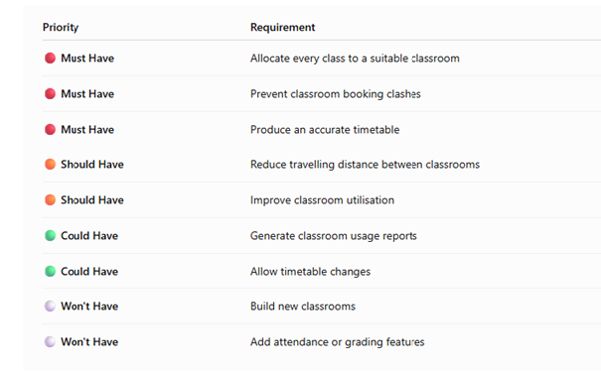
Using the Moscow technique made it easier to decide which requirements should be given the highest priority. The Must Have requirements are the features the system cannot work without because they solve the main problems identified in the scenario. The Should Have requirements improve the overall experience but are not essential for the system to function. The Could Have requirements would add extra value if there is enough time to develop them, while the Won't Have requirements clearly define what is outside the scope of this project. Setting these priorities helps keep the solution focused, practical, and achievable

Variables Identification
When solving the classroom allocation problem, it is important to identify the different variables involved. Variables are the pieces of information that can change depending on the situation and can affect the final solution. Understanding these variables helps the system make better decisions when assigning classrooms and creating timetables.
The main variables involved in this problem are:

Class Size
The number of students in each class is an important variable because it determines which classrooms are suitable. A small class may fit into a smaller room, while a larger class will require a bigger classroom with enough seating capacity.

Room Capacity
Each classroom has a different maximum capacity. This variable is used to compare the number of students in a class with the available space. The system needs to make sure that a classroom is never assigned to a class that is larger than its capacity.

Classroom Availability
The availability of each classroom changes depending on the timetable. A room may be available during one period but already booked during another. This variable helps prevent two classes from being scheduled in the same room at the same time.

Lesson Time
The time and duration of each lesson are important variables because they affect when classrooms can be used. The system must consider lesson schedules to make sure that rooms are allocated correctly without causing timetable conflicts.

Teacher Availability
Teachers may only be available at certain times, which affects when lessons can be scheduled. This variable ensures that classes are planned around the availability of teaching staff.

Classroom Location
The location of each classroom is another variable that can influence the allocation process. If possible, the system should assign rooms that reduce the amount of travelling required between consecutive lessons for students and lecturers.

Room Type
Some subjects require specific types of rooms, such as computer rooms, laboratories, or lecture halls. This variable ensures that classes are placed in rooms that have the correct facilities.
By identifying these variables, the problem becomes easier to understand and manage. The system can use this information to make more accurate classroom assignments, reduce timetable issues, and improve the overall learning experience for both students and staff.

Proposed Solution
After looking at the main problems with classroom allocation, the proposed solution is to create a classroom allocation management system that helps the college organize its rooms and timetables more effectively. The main aim of this system is to make sure that every class is placed in a suitable classroom, avoid timetable problems, and reduce the amount of time students and teachers spend moving between lessons.
Currently, classroom allocation can be difficult to manage manually because there are many factors that need to be considered at the same time. These include the number of students in each class, classroom sizes, teacher availability, lesson times, and room locations. By using a computer-based system, these factors can be analyzed more quickly and accurately, reducing human errors.
The proposed system would work through the following stages:
1. Gathering the Required Information
The first step in solving the classroom allocation problem is to collect all the information needed to make accurate decisions. Before assigning classes to rooms, the system needs to understand the requirements of both students and lecturers, as well as the available classrooms.
The information collected would include:
- Number of students: How many students are expected to attend each class.
- Classroom capacity: The maximum number of students that each room can safely accommodate.
- Classroom facilities: Whether a room has the equipment or facilities needed for a particular lesson, such as computers, projectors, or specialist equipment.
- Lesson timetable: The days and times when each class needs to take place.
- Teacher availability: When lecturers are available to teach their classes.
- Classroom location: Where each room is located within the college, which can help reduce unnecessary travel between lessons.

2. Assigning Suitable Classrooms
Once the information has been collected, the system would compare each class size with the available classrooms. It would then choose a classroom that can comfortably fit all students without wasting larger rooms unnecessarily.
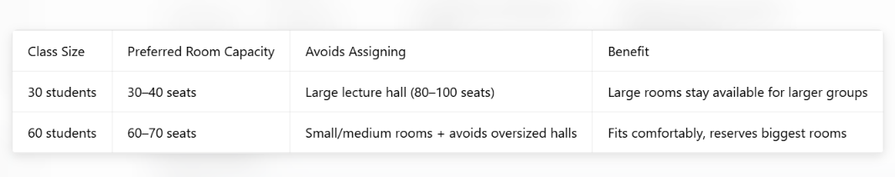
For example, if a class has 30 students, the system will try to assign a room that can hold around 30–40 students rather than using a large lecture hall. This means larger rooms remain available for bigger classes that need them.

3. Checking for Timetable Problems
Before confirming any classroom allocation, the system would check if the room was already being used at the selected time. If the classroom is unavailable, the system would search for another suitable option.
This would help prevent common problems such as two classes being assigned to the same room or lessons being delayed because a classroom is occupied.
4. Reducing Travel Time Around Campus
Another important part of the solution is considering classroom locations. If students or teachers have two lessons close together, the system would try to assign nearby classrooms where possible.
This would reduce unnecessary walking time and help lessons begin on schedule.
5. Creating the Final Timetable
After all classrooms have been assigned, the system would generate a complete timetable that shows:
- The class name.
- The assigned classroom.
- The lesson time.
- The teacher responsible.
The final timetable would provide clear information for both staff and students, making it easier for everyone to plan their day.
Advantages of the Proposed Solution
This solution would help the college in several ways:
Classrooms would be used more efficiently.
Students would have more suitable learning spaces.
Timetable conflicts would be reduced.
Staff and students would spend less time travelling between lessons.
The process of creating and updating timetables would become easier.
Overall, the proposed system provides a realistic solution to the classroom allocation problem. By using problem-solving techniques and focusing on the important variables, the college can improve the way it manages its classrooms and create a more organized learning environment.

Flowchart
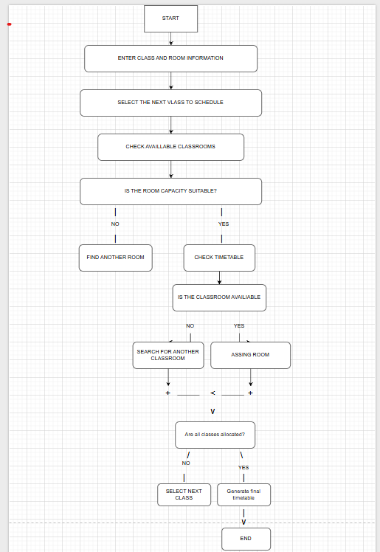
A flowchart is used to represent the steps involved in solving the classroom allocation problem in a clear and visual way. It shows the order of actions the system follows when assigning classrooms to classes. By using a flowchart, it becomes easier to understand how decisions are made and how the system handles possible problems, such as rooms being unavailable or not having enough capacity.
The flowchart below shows the process of checking class information, finding a suitable classroom, avoiding timetable conflicts, and creating the final timetable.

This flowchart demonstrates how the proposed system makes decisions step by step. It first checks the information available, then finds a classroom that meets the requirements of each class. If a problem occurs, such as insufficient space or a timetable conflict, the system searches for another option. This process continues until all classes have been successfully allocated and the final timetable is produced.

Flowchart Explanation
The flowchart shows how the classroom allocation system works from the beginning to the end of the process. It explains the different steps the system follows to make sure that each class is assigned to the most suitable classroom while avoiding problems such as overcrowding and timetable clashes.
The process starts by entering the important information needed by the system. This includes details such as the number of students in each class, the available classrooms, room capacities, lesson times, and teacher availability. Without this information, the system would not be able to make accurate classroom decisions.
After the information has been entered, the system selects a class that needs a classroom. It then checks the available rooms to find one that is large enough to accommodate all students. If the classroom is too small, the system will continue searching until it finds a room that meets the class requirements.
Once a suitable room has been found, the system checks if that classroom is free at the required time. This step is important because it prevents situations where two different classes are accidentally scheduled in the same room. If the room is already being used, the system will look for another available classroom.
When the system finds a classroom that has enough space and is available, it assigns the room to the class. It then checks if there are any other classes that still need to be scheduled. If there are more classes remaining, the same process is repeated until every class has been given a suitable classroom.
Finally, when all classes have been successfully allocated, the system creates the final timetable. The completed timetable provides clear information about where and when each lesson will take place, helping students and teachers avoid confusion.
Overall, the flowchart provides a simple way to understand how the proposed solution solves the classroom allocation problem. By following these steps, the system can improve the use of available classrooms, reduce scheduling errors, and create a more organized timetable for the college.

Reflection and Justification
While working on this problem, I learned that classroom allocation is more complicated than when it first appears. At first, it may seem like the solution is simply to find an empty classroom and assign it to a class. However, after analyzing the problem in more detail, I realized that many different factors need to be considered to create an effective solution.
Using abstract thinking helped me separate the important information from the details that were not necessary. Instead of focusing on things that do not affect the outcome, I concentrated on the main factors that influence classroom allocation, such as the number of students, classroom capacity, lesson times, teacher availability, and room locations. This made it easier to understand the problem and develop a solution that could work in a real college environment.
The solution I proposed focuses on solving the main issues identified during the problem analysis. The most important aim was to make sure that every class has a classroom that is suitable for its size while preventing timetable conflicts. I also considered the importance of reducing travel time between lessons because students and teachers losing time moving around campus can affect the learning experience.
The MoSCoW technique helped me decide which features were most important for the system. The "Must Have" requirements were prioritized because they are essential for the system to function properly. For example, avoiding classroom clashes and ensuring rooms have enough capacity are necessary to solve the main problems. Other features, such as generating room usage reports, were considered useful improvements but were not as important as the basic functions.
Creating the flowchart and algorithm also helped me understand how the solution would work in practice. By breaking the process into smaller steps, it became easier to see how the system would collect information, check available options, make decisions, and produce a final timetable. This approach helped turn a complex problem into a series of simpler tasks.
Overall, I believe the proposed solution is a realistic way to improve classroom management within the college. Although the system cannot remove all limitations, such as having a fixed number of classrooms, it can help the college use its existing resources more effectively. This task showed me the importance of analyzing a problem carefully before creating a solution and how abstract thinking can be used to solve real-world problems in a structured way.

Abstract thinking
Abstract thinking is the ability to look at a problem by focusing on the most important information while ignoring details that are not needed. It helps to simplify complex situations by identifying the main ideas, patterns, and relationships that can be used to create a solution.
For the classroom allocation problem, abstract thinking helps to focus on the factors that directly affect how classrooms should be organized. Instead of looking at every small detail about the college, the solution only considers information that has an impact on classroom planning.
The main information that needs to be considered includes:
- Number of students in each class: This helps determine which classrooms are suitable and prevents classes from being placed in rooms that are too small.
- Classroom capacity: Each room is a different size, so the system needs to know how many students each room can accommodate.
- Lesson schedules: The system needs to know when classes take place to avoid booking the same classroom for multiple lessons at the same time.
- Teacher availability: Teachers can only teach during certain periods, so this needs to be considered when creating the timetable.
- Classroom location: The location of rooms is important because placing lessons closer together can reduce unnecessary travel time.
At the same time, abstract thinking allows unnecessary details to be removed from the problem. Information such as classroom decoration, wall colors, or individual student names does not affect how classrooms should be allocated, so it does not need to be included in the solution.
By applying abstract thinking, the classroom allocation problem becomes easier to understand and manage. Instead of trying to solve every possible issue at once, the problem can be broken down into the key areas that need attention. This creates a clearer path towards developing a practical solution that improves classroom usage and creates better experience for students and staff.

Sub-dividing
Sub-dividing means breaking a big problem into smaller sections that are easier to understand and solve. When looking at the classroom allocation issue, it would be difficult to solve everything at once because there are many different things that need to be considered. By dividing the problem into smaller parts, each area can be looked at separately before creating the final solution.
For this problem, the main areas were divided into:
- Classroom capacity: Checking the number of students in each class and finding a room that has enough space.
- Room availability: Making sure that classrooms are not already being used when another lesson is scheduled.
- Timetable organization: Creating a timetable where lessons can run smoothly without conflicts.
- Teacher availability: Considering when teachers are available before assigning lesson times.
- Classroom locations: Trying to reduce the amount of time students and teachers spend walking between lessons.
Breaking the problem into these smaller sections made it easier to understand the causes of the problem and decide what the system needs to do. Instead of dealing with one large, complicated issue, each part can be analyzed individually and then combined to create a complete solution.

Justification of solution
The proposed classroom allocation system was selected because it provides a realistic way of solving the main problems experienced by the college. Managing classrooms manually can become difficult, especially when there are many classes, teachers, and rooms to organise. This increases the possibility of mistakes, such as putting a large class into a small room or accidentally scheduling two lessons in the same classroom.
The solution improves this process by using important information, such as class sizes, classroom capacities, lesson times, and room availability, to make better decisions. The system can quickly identify the most suitable classroom for each lesson while reducing wasted space.
Another reason this solution is suitable is that it considers the movement of students and staff around the college. By taking classroom locations into account, the system can help reduce unnecessary travel time and make the daily timetable more convenient.
Overall, this solution was chosen because it focuses on improving the use of existing resources rather than requiring expensive changes. It provides a practical and organized way for the college to manage classrooms more effectively.

Limitation
Although the proposed solution can improve classroom management, there are some limitations that should be considered.
One limitation is that the system relies on the information provided being correct. If the details about class numbers, classroom sizes, or teacher schedules are outdated, the timetable created by the system may not be accurate.
Another limitation is that the system cannot solve problems caused by a lack of physical space. For example, if there are more classes than available classrooms, the system can only organize the available rooms more efficiently; it cannot create additional classrooms.
Some subjects may also require specific rooms, such as computer laboratories or science rooms. This can reduce the number of options available because not every classroom will be suitable for every type of lesson.
Unexpected situations, such as a teacher being absent or a class size change, may also require adjustments to the timetable. This means the system may still need occasional human input to handle unusual situations.

Assumption
When designing this solution, some assumptions were made to help simplify the problem.
The first assumption is that the information entered into the system will be accurate and updated regularly. This includes details about classroom capacities, class sizes, lesson times, and teacher availability.
It is also assumed that the college already has a fixed number of classrooms and that the main goal is to improve how these rooms are used rather than create new ones.
Another assumption is that the college will provide correct information about specialist rooms and their availability. For example, a computer science class should only be assigned to a room that has the required computers and equipment.
These assumptions allow the solution to focus on improving classroom allocation while keeping the problem realistic and manageable.

Conclusion
To conclude, the classroom allocation problem is more complex than simply finding an empty room for each lesson. Many different factors need to be considered, including class sizes, classroom capacity, teacher schedules, and room availability.
By using abstract thinking and problem-solving techniques, the problem broke down into smaller parts, making it easier to analyses and develop a suitable solution. The proposed classroom allocation system provides a structured way to assign rooms, avoid timetable clashes, and reduce unnecessary movement around the college.
Although the solution has some limitations, it can still help the college make better use of its existing classrooms and improve the organization of lessons. This project has shown how computational thinking can be applied to real-world problems by analyzing the situation carefully, identifying requirements, and creating a logical solution.
Overall, the proposed system would create a more efficient classroom management process and provide better experience for both students and staff.

References

[1] J. Wing, “Computational Thinking,” Communications of the ACM, vol. 49, no. 3, pp. 33–35, Mar. 2006.
[2] B. Bruegge and A. H. Dutoit, Object-Oriented Software Engineering: Using UML, Patterns, and Java, 3rd ed. London, UK: Pearson Education, 2010.
[3] K. Schwaber and J. Sutherland, “The Scrum Guide,” 2020. [Online]. Available: https://scrumguides.org
[4] I. Sommerville, Software Engineering, 10th ed. Boston, MA, USA: Pearson Education, 2015.
[5] A. Cockburn, Writing Effective Use Cases. Boston, MA, USA: Addison-Wesley, 2001.
[6] R. Pressman and B. Maxim, Software Engineering: A Practitioner’s Approach, 9th ed. New York, NY, USA: McGraw-Hill Education, 2019.
[7] J. P. Womack and D. T. Jones, Lean Thinking: Banish Waste and Create Wealth in Your Corporation. New York, NY, USA: Free Press, 2003.
[8] M. Cohn, Agile Estimating and Planning. Upper Saddle River, NJ, USA: Prentice Hall, 2005

