
Module name: Enterprise Development and Commercial Innovation
Module code: BMBS5000
Lecturer: Chris Wilkin
Assignment name: Academic Interview
_______________________________
Student name: Ionut Humulescu
Student number: 2332006
_______________________________
Deadline: 12/10/2026, 23:59

AI Acknowledgement
I confirm that I have not presented any AI generated materials as my own.
I acknowledge I have used AI to create the basis of my Buyer Personas (with HubSpot).
I have also used MindMeister to help build my mind map, however all the links, connections, ideas and content is my own work and creation.
I acknowledge I have also used Google Scholar and Google search engine to find accurate and relevant data and references for my research.

Business Opportunity Mind Map: Dental AI
https://mm.tt/map/4099209918?t=gPKUI5jcTY
Value Proposition Canvas
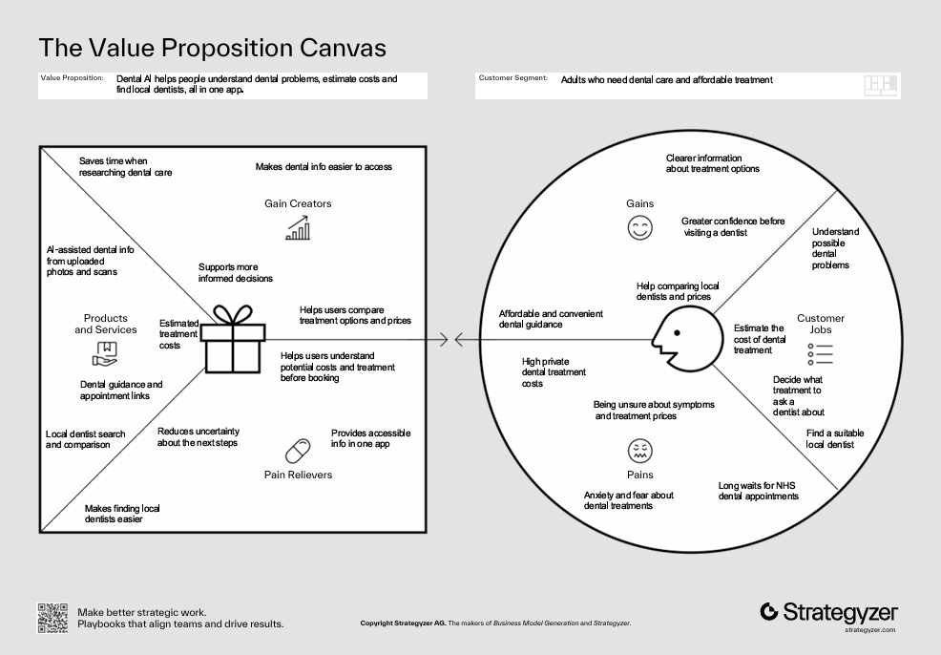

Buyer Persona: Laura Lark
https://www.hubspot.com/make-my-persona?share=true#/share/-P3le7iBiQJQPCu79EM9
Buyer Persona: Daniel Denton
https://www.hubspot.com/make-my-persona?share=true#/share/-P3eD_iX3tuXqSqznw5U

References
- Alharbi, S. S. and Alhasson, H. F. (2024) ’Exploring the applications of artificial intelligence in dental image detection: a systematic review’, Diagnostics, 14(21), article 2442. Available at: https://doi.org/10.3390/diagnostics14212442 .
- Antonio, J.L., Schmidt, A.L., Kanbach, D.K. and Meyer, N. (2024). ‘Enacting disruption: how entrepreneurial ventures innovate value propositions to increase the attractiveness of their technologies’, International Journal of Entrepreneurial Behavior & Research, 30(4), pp.885-915. Available at: https://doi.org/10.1108/IJEBR-07-2023-0688 .
- Barringer, B.R. and Ireland, R.D. (2021). Entrepreneurship: Successfully launching new ventures. 6th edn. Pearson.
- Competition and Markets Authority (2026). Choosing and paying for dental care. Available at: https://www.gov.uk/guidance/choosing-and-paying-for-dental-care (Accessed 12 October 2026)
- Dale, V., Gutacker, N. and Bloor, K. (2021). NHS dental charges and the effect of increases on access: an exploration. Available at: https://www.york.ac.uk/media/healthsciences/images/research/prepare/NHS%20dental%20charges%20and%20the%20effect%20of%20increases%20on%20access%20-%20an%20exploration.pdf .
- Edwards, J.W., Bogale, B and Gallagher, J.E. (2025). ‘Tackling geographic barriers to primary dental care (dental deserts): a systematic review’, British Dental Journal. Available at: https://doi.org/10.1038/s41415-025-8487-8 .
- Kaviandost, P., Barkhordar, S. and Asghari, M. (2025) ’Revolutionizing dentistry: the role of artificial intelligence in diagnosis, treatment planning, and patient care’, Saudi Journal of Oral and Dental Research, 10(6), pp. 260-266. Available at: https://doi.org/10.36348/sjodr.2025.v10i06.002 .
- Kim, W.C. and Mauborgne, R. (2015). Blue Ocen Strategy: How to Create Uncontested Market Space and Make the Competition Irrelevant. Expanded edn. Boston, Ma: Harvard Business Review Press.
- National Health Service (NHS) (n.d.). How to find an NHS dentist. Available at: https://www.nhs.uk/nhs-services/dentists/how-to-find-an-nhs-dentist/. (Accessed 10 October 2026)
- Osterwalder, A. and Pigneur, Y. (2010). Business model generation: a handbook for visionaries, game changers, and challengers. Hoboken, NJ: John Wiley & Sons.
- Sürücü, H.A., Durgu, N. and Ozan, E. (2026). ‘A multilayered barrier to oral health: a mixed methods exploration of dental anxiety’, BMC Oral Health, 26, article 904. Available at: https://doi.org/10.1186/s12903-026-08393-5 .
- World Health Organization (2021), ‘WHO issues first global report on Artificial Intelligence available at: (AI) in health and six guiding principles for its design and use’. 28 June. Available at: https://www.who.int/news/item/28-06-2021-who-issues-first-global-report-on-ai-in-health-and-six-guiding-principles-for-its-design-and-use .

