Name: Faima Siddiquie
Student ID: 1913563
Lecturer: Charles Nimoh
Module Code: BMSW 4005

FAIMA SIDDIQUIE

PROFESSIONAL SUMMARY CONTACT

Committed Health Care Assistant focused on enhancing ADDRESS 29 Kingscliff Road
daily life of challenging through compassionate care. Birmingham, B109JU
Providing physical assistance PHONE 07715403381
To encourage customer care. Diligent in monitoring EMAIL Faima121@yahoo.com
health changes for optional safety and wellbeing. I
am a professional Healthcare Assistant proving
compassionate patient care, Eager SKILLS
healthcare professional with 4 years of experience
providing support and care. Committed to increasing -Exceptional communicator
knowledge of treatments through hands-on learning and -Compassionate care giver
detail Oriented record-keeping. Proven ability to solve -Team player
complex problems and remain calm in emergency -strong verbal
situations. Skilled at maintaining relationships with patients communication
to provide top-of-the-line care. -Team leadership
-Self motivated
-Motivational team player
WORK HISTORY -Extremely organised
-Excellent customer service
Health Care Assistant, 03/2016 to current -Communication skills
Lloyds Pharmacy- Birmingham West Midlands
- Assisted chemist with filling prescriptions for all
customers daily.
- Communicated instructions to patients or care givers.
- Merchandised pharmacy goods according to company
standards and with an eye for grabbing customer attention.
- Organised deliveries, enabling sufficient supplies.
- Verified order information against computer database.
- Maintained through patient medication records, ensuring
confidentiality and safety of information in line with data
protection laws.
- Provided safe and correct transfer of dispensed items to
appropriate patients.
- Selected, labelled and dispensed prescriptions accurately,
in line with operating procedures.
- Assisted in medicine product recommendations and
selections according to patient-specific needs.
- Greeted customers and provided friendly, knowledgeable
service.
- Processed incoming drug orders.
- Counted and labelled prescriptions with correct item and quantity.
kept pharmacy counter and related areas clean, neat and organised.
- Assisted pharmacy staff in preparing medications and filling orders.

Receptionist Administrator 01/2013 to 2016
Nationwide Power Service- Birmingham, West Midlands

- Completed bi-weekly payroll for all employees.
- Received, screened and routed incoming calls.
- Maintained computer and physical filling systems.
- Handled all incoming business and client requests
for information.
- Increased team productively by reorganising office
supplies and protocols.
- Solved problems timely and effectively, ensuring
customer satisfaction.
- Oversaw appointment scheduling and itinerary
coordination for both clients and personnel.
- Kept physical files and digitised records organised for
easy updating and retrieval by any team member with access.

EDUCATION

GCSE 04/2006
Saltley School – Birmingham

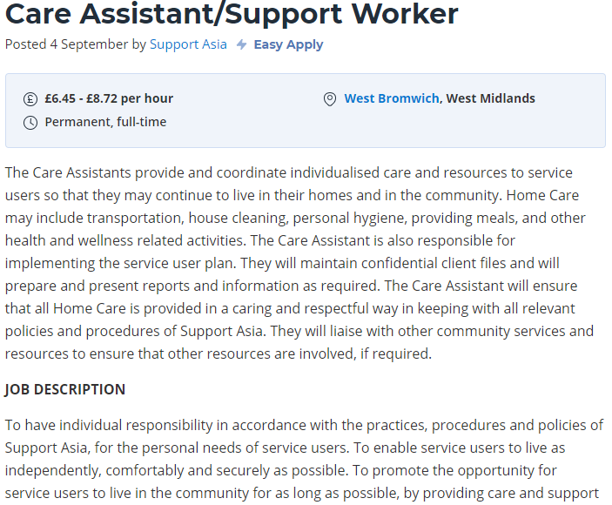

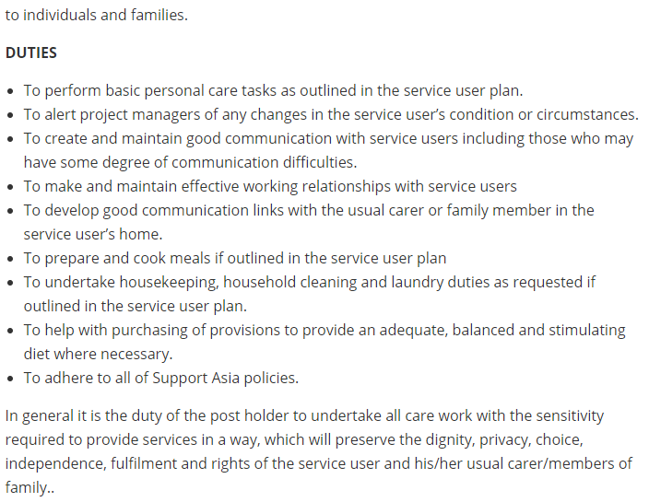

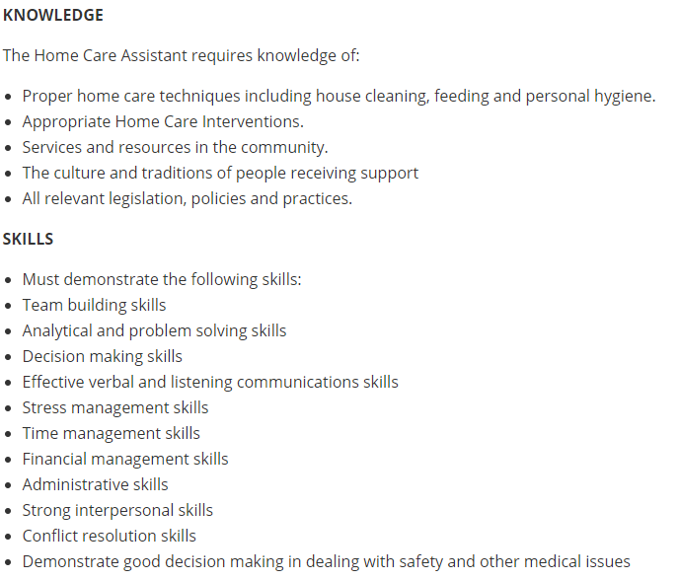

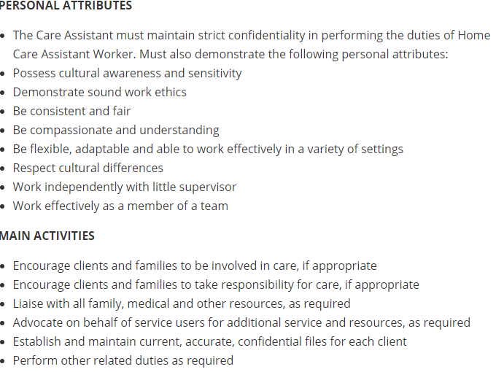

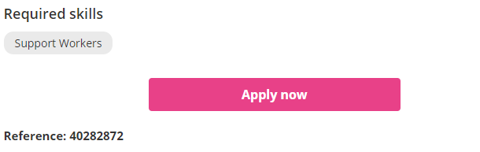

To Whom, it may concern,

Application for the vacancy of Healthcare assistant

I am presenting my CV for the position advertised, I am greatly interested in this position, I believe that my skills, personal care experience make me the best candidate for the job. I am physically fit and have dealt with some challenging circumstances.
I communicate well with others and spend a lot of time interacting, I am also well organised and work well doing a number of different tasks at once. I am confident communicator at all level, I am able to put people at ease and gain their trust even in difficult circumstances, I am friendly and supportive, being sensitive to peoples needs and am able to explain information clearly and patiently.
I am patient and polite and work well with a wide range of people from all walks of life. I always pride myself in my ability to deliver the very best service possible at all times and feel I would make a valuable addition to your team.
I look forward to hearing from you.
Yours sincerely
Faima Siddiquie

