CertHE Skills for the Workplace (Health and Social Care)

Module: Professional Career Development

Module code: BMSW4005
Lecturer: Sylvia Hoffmann
Internal Verifier: Husam Alharahsheh
Assignment Title: Professional career development report and role play (interviewee and interviewer)
Contribution to Overall Module
Assessment (%): 100%
Name: Joao Pereira
Student Number: 2012063

Contents
Introduction 3
Recruitment and selection Reflective cycle – Gibbs 4
Self evaluation review 5
Personal Development Planning 6
Review of your understanding and expectations of the world of employment 9
Reference 10
Appendix 10

Introduction

This report is about my professional and personal growth, and my name is Joao Pereira. This section will provide a detailed description and explanation of my step-by-step approach.
With the COVID-19 pandemic, universities around the world have had to adjust their teaching methods to include online classes. In my case, I have been experiencing this situation. My personal opinion is that this mode of study is much better structured than I expected but interaction within a class in my opinion is still the best way of learning.
Everyone seems to be making the most of what they have to survive the pandemic crisis. There are many young people who decide to pursue educational courses in the hope of having a better life like myself.
A big dream of mine was to pursue studies. I have travelled a long path in order to get to where I am now. Physiotherapy has always been a dream of mine. A year ago, I started the process of becoming a physiotherapist. This is an entirely new experience for me, as I have never studied in the UK before.
Due to the online nature of all the classes, maintaining workloads and meeting the expectations of the tutors for each module took a lot of motivation and organization. As all communication was done via email or video calls on Teams, it was challenging. In the absence of person-to-person interaction, I have missed expressing myself fully, as well as being able to describe how I can improve my work, study, self-motivation, as well as be aware of my work progress.
With the help of a team of professionals, I was able to stay in touch with the university and was provided full access to all online resources and all materials uploaded by tutors to complete my assessments.
The next step in my reflection will be to review and plan my self-evaluation and personal development. I'm reflecting on how my role play assessment helped me gain insight into the world of employment as a physiotherapist using Gibbs reflection cycle model.

Recruitment and selection Reflective cycle – Gibbs

As I reflect on role play, I would describe my experience in terms of Gibbs cycle model.

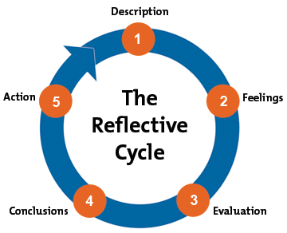
Description; My application was based on a future career as a health care assistant after finishing these courses.
Feelings: As I exchanged information and understood how critical my role could be in these roles, I felt confident and positive.
Through the evaluation process, I was able to comprehend what was required of me in these roles, specifically the benefits of continuing to learn and grow within these companies.
Evaluation: I have gained an experience of what will be expected from me at the real interview. I have managed to critically analyse my strengths and weaknesses as a potential health and care professional. I believe it is a good method of practice before the real interview take place. In my opinion the only bad side of this method is that we will always assume we will get the job but not always we receive the same outsome in reality.
Conclusions; I have had a better understanding of the reality that awaits me out there, as well as identifying opportunities, such as avoiding agencies for example. Directly approaching a company has many benefits.
Action: Additionally, I'll use my time as much as possible to ask any questions related to anything I find valuable.
After the job interview is over, the first thing to do is to keep looking for other opportunities and not take any job interview as a guarantee of employment. So keeping myself busy to approach any other opportunities that may come.
I belive the correrct way to conduct or be prepared for an itervew is wide research of the job description, company it self and location. These are they key aspects as it will allow me to evaluate my skills and plan how to improve my weakneses or gain experience by contacting the organisations to see if I can join for a training or volountary job.
I found role-playing to be much easier than I expected. When I played in character and had my tutor as a partner, it was especially easy. But not for that it went fully well as I wished to be. Looking back I think that I have missed the opportunity to ask my tutor to expand of how the role play is expected to be presented. After the role-play took place I have gain better understanding of what was expected and for the future I am sure I would expand my research further and re-evaluate my skills.
Role-play tought me a lot about the interviewer role as well. It gave me understanding of what companies are looking for and that I will not be fully prepare for the interview the interviewer will not spend his to on explaining the basic information about the position to me as they have a lot of other option in my place. Interviewer makes the interview and they need to be confident in there role as their final decision will effect the company performance and customer satisfaction. In the result interviewer if they see that person is not fit for the job, they should advised at start and do not lead to false expectations of interviewee.

Self evaluation review

I have started this course with a little knowledge of self evaluation skills, motivational techniques and learning styles. I was not aware that applying techniques to learinging or working can increase overall performance in quality of work as well bring a healthy balance in my life style.
As we are in pandemic crises face to face classes were not taking place and all study was taking place online. I felt scared and worried that I will have to manage all study and write assigments all by myself.
At first I have been introduced to academic skills module which has opened my eyes about being able to discover my strengths and weaknesses when it comes to organizational skills and prioritizing my workload according to set deadlines.
To help me study and keep on track with my week by week studies I have opened a personal organizer where I have put down all my important dates as a priority. Followed with all the required reading for up coming classes and review the porwepoint slides before online classes started.
Another useful for my learning progress was to list down any questions I had, so I could ask in class for an answer or even open a discussion. Questions were mostly in regards to assignment or to get better understanding about the topic that was covered at that time.
As I have dyslexia, which sometimes it plays a huge difficulty in my learning I have use audio books or audio speakers when I have been writing my assigments. This way I have made myself be focused about the subject and tried to answer the question to the best abilities I possibly can.

Personal Development Planning
SWOT Analysis
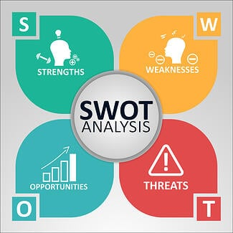
Source: SWOT Analysis www.rhythmsystems.com/ (2022)
SWOT Analysis of me
Strenghts  - Multi lingual  - Helpful  - Solving problems under pressure  - Fast learner and openminded | Weaknesses  - Dyslexia  - Easily distracted  - Missunderstood the tasks or not meeting the expectation as having a different approach to the task
Opportunites  - New job opportunities – Health and Social Care professional | Threats  - Personal circumstances and health condition
As presented above these are key points of my SWOT analysis that I keep evaluating and working to develop my skills and weaknesses and push myself to take opportunities in my career path and progress.

Johari Window
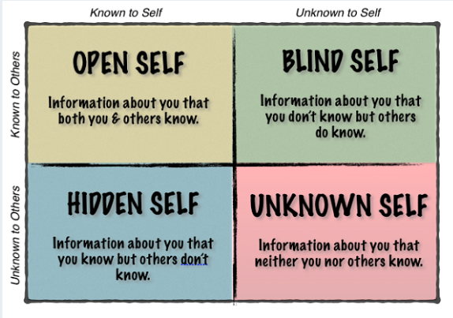
Source: Johari Window Model www.successfulculture.com (2022)
Johari Window Model of me
Open Self  - Personal details  - I am a father  - I work and study at the same time  - I would like to become a physiotherapist | Blind Self  - Inteligent more than I think  - Capable of taking tasks that are difficult  - Able to speak to people more openly
Hidden self  - Fear of not being able to get to the University of my first choice  - Retake some assessment | Unknown Self  - n/a

Smart Objective

Source:SMART Objectives https://www.eln.co.uk/ (2022)
My Smart Objective
S – Becoming a physiotherapist
M – Complete my foundation year February 2022 and start my first year in September 2022 for Phsyiotherapy course at the University. Already completed and submitted UCAS application
A – 4 Years in total of the full jeourny to become physiotherapist but foundation year will be completed by February 2022
R – Allowing 4 Years for study and development gives me a realistic vision of my career path progress
T – 4 Years

Review of your understanding and expectations of the world of employment

Last but not least my understanding and expectations of the world of employment is much wider and clearer. I have saved several website which helps you to prepare for real job interviewes. I found them helpful and most of the presentations / videos are created by work coached or employeers. I was able to find information such as what are the company expectation directly and based on this and job description I was able to match and compare my SWOT analysis and Johari Window will I potentially be good for this open vacancy.
Based on my research to which university I would like to continue my study I have managed to garher information in regards to the support that they offer when it comes to looking for an employment part time at some local NHS practice.
As everyone one is using social platforms I have also joined physiotherapist groups on Facebook and opened my LinkedIn account where I have provided all relevant information about myself and my career goals as well my current progress.
I feel like I am ready for the world of employment in Health and Social Care field and I am feeling excited to push myself for new opportunities. I also know and feel much more confident that if I am not sure about something I know where to look for support or ask for more advanced training before I start my future employment.

Reference
GIBBS' REFLECTIVE CYCLE: HELPING PEOPLE LEARN FROM EXPERIENCE
In-text: (Gibbs' Reflective Cycle: Helping People Learn From Experience, 2022)
Bibliography: Mindtools.com. 2022. Gibbs' Reflective Cycle: Helping People Learn From Experience. [online] Available at: <https://www.mindtools.com/pages/article/reflective-cycle.htm> [Accessed 5 January 2022].

HOW TO BUILD MORE SELF-AWARENESS & A STRONGER CULTURE USING THE JOHARI WINDOW - SUCCESSFUL CULTURE
In-text: (How to Build More Self-Awareness & a Stronger Culture Using the Johari Window - Successful Culture, 2022)
Your Bibliography: Successful Culture. 2022. How to Build More Self-Awareness & a Stronger Culture Using the Johari Window - Successful Culture. [online] Available at: <https://www.successfulculture.com/stronger-culture-using-johari-window/> [Accessed 5 January 2022].

5 USEFUL TIPS FOR FOLLOWING THE SMART CRITERIA | ELN BLOG
In-text: (5 Useful tips for following the SMART criteria | ELN Blog, 2022)
Your Bibliography: Eln.co.uk. 2022. 5 Useful tips for following the SMART criteria | ELN Blog. [online] Available at: <https://www.eln.co.uk/blog/5-useful-tips-following-smart-criteria> [Accessed 1 January 2022].

COVID 19 SWOT ANALYSIS: SWOT ANALYSIS IN A PANDEMIC
In-text: (COVID 19 SWOT Analysis: SWOT Analysis in a Pandemic, 2022)
Your Bibliography: Rhythmsystems.com. 2022. COVID 19 SWOT Analysis: SWOT Analysis in a Pandemic. [online] Available at: <https://www.rhythmsystems.com/blog/4-steps-to-swot-a-pandemic> [Accessed 10 January 2022].

Appendix

Position Applied For

Care Assistant

How did you learn about this vacancy?
Online

1. Personal Details
Title Mr

Surname
Pereira
Previous Name
Joao
Forenames
Pereira

Address

21 walk strit

Post Code
Ow449gh
Telephone number 08574645534
Mobile No
E-mail address Joaopereira@gmail.com

National Insurance
Number St24345a

Title: Carre assistant
Location: Cambridge
Salary: Competitive hourly rate, £11.14 per hour Monday to Friday & £11.59 per hour bank holidays and weekends

Main Duties

• Personal care includes washing, dressing, bathing, toileting and medication monitoring and/or assistance
• Social and shopping calls
• Meal preparation
• To provide the highest quality care to service users in their own homes in accordance with their support plan, in person-centred approach
• To be aware of the personal needs and requirements of your service users, communicating successfully, not only with your service user, their family, friends and other healthcare professionals
• Maintain appropriate records to meet the needs of the service, observing and promptly reporting back any changes or concerns in your service user’s circumstances or condition

Application Form

Please return this form to:
Cambridge walk stret p46 3nw APPLICATION FOR EMPLOYMENT
POST APPLIED FOR
Care assistent
Full-Time/Part-time (delete as appropriate)
HOW DID YOU HEAR ABOUT THIS POST

Internet

PERSONAL
Please complete each section of this form legibly in your own handwriting in black ink.

Surname: Pereira Forename(s): Joao

Address: My HOUSE
Anytown

Daytime Tel No: 12345678
Mobile:07123456789

Email address: JOAO@PEREIRA.co.uk

Do you need a work permit to work in the UK? No
Have you a current driving licence? YeS

EDUCATION
Schools/colleges attended Dates Qualifications attained (including grades)
Sometown Primary School Sept 2002 - June 2006
Sometown High School Sept 2006 - June 2010 GCSE Maths B GCSE English C GCSE Science (Double Award) Cc GCSE Geography A GCSE Spanish B
Anytown College of Further and Higher Education Feb 2021 - Feb 2022 Certificate of hier education in health social care levol 4

Training - accredited courses, short courses, apprenticeships etc (include title; awarding body/organisation and dates)

Certificate Level 3 Certificate in HEALT SOCIAL CARE Effective Customer Care European Computer Driving Licence

Application Form 1

EMPLOYMENT HISTORY (current or most recent employer first) Please include
temporary posts and work experience.

From - To Name & Address of Employer Job Title & Duties Final Salary & Reason for Leaving
Sept 2015- November 2016

November 2016 -
at present Black Pull Anytown

dunelm chef

Cataring

Sales assistent £12,000 per annum Work opportunity closer to home

£12,000

INTERESTS Please note here your leisure interests, sports, hobbies and other pastimes (including positions of responsibility held).

In my spare time I enjoy reading and plying sports

REFERENCES Please give the names and addresses of two referees. These must include your present line manager or course tutor (last employer if currently unemployed) and should not be related to you. If you are invited for an interview referees will automatically
be contacted. Please tell us if you do not wish us to do this.

1. callum wolf 2. charlie
University of Wales trinity sand David Dunelmm grop

Capacity in which known
Student prep
Contact prior to interview: YES/NO
Capacity in which known
Maneger
Contact prior to interview: YES/NO

