Security Analysis Report
Vigilant Trust & Asset Management (VTAM)

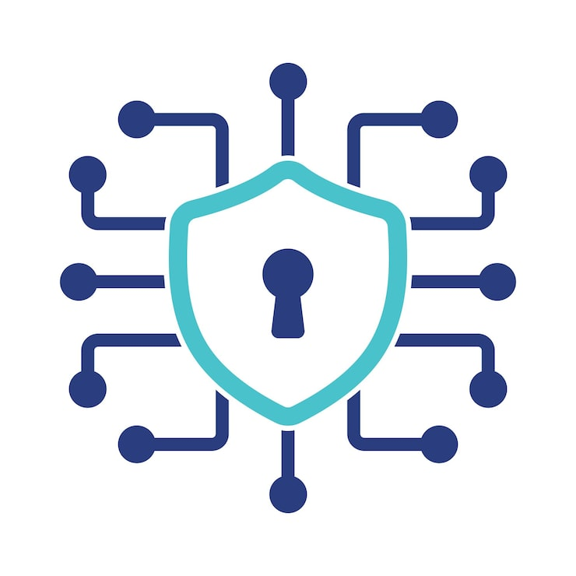
Figure 1

Prepared by:
Beniamin Markiewicz (2513687)

Lecturer:
Muhammad Azeem Abbas

Abstract

The report identifies the current cybersecurity threats the company is experiencing, e.g. vishing, insider espionage and cloud adaptation etc. and provides detailed mitigation measures that should prevent and minimize the damage done to sensitive information, it also provides many policies that establish rules and regulations within the company that all employees must abide by and are in line with the NIST and ISO/IEC 27001 recommendations. The report goes to provide which type of training the employees should receive based on the current trends in cybersecurity, e.g. simulated phishing attacks to ensure they understand the threats and properly identify them without issue. The report closes with conclusion about future work and how it could be revised according to the constantly changing trends in cybersecurity.

Contents

Abstract 2
Introduction 4
Identification of Modern Threats 5
Modern Security Policies 6
Technical Mitigation Measures 7
Proactive Monitoring and Incident Response 8
Continuous Training and Awareness 9
Conclusion 10
References 11
Appendix 12
Slide 1 (Opening): 12
Slide 2: 12
Slide 3: 13
Slide 4: 14
Slide 5: 14
Slide 6: 15
Slide 7: 16
Slide 8: 17
Slide 9: 18
Slide 10: 18
Slide 11 (Ending) 19

Introduction

Cybersecurity is the practice of protecting computers, networks, software and data from different kinds of attacks. Technology has become a part of everyday life, which means that cybersecurity is an essential process for every ascpet of life. Major challenges in cybersecurity include data breaches, privacy concerns and how cybercriminals are rapidly evolving their techniques and attacks in response to cybersecurity specialists expanding their problem-solving skills.

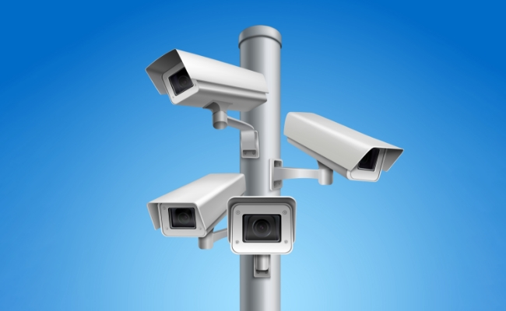

Figure 2

Cybersecurity also had an impact on important infrastructure, for example, healthcare, communication and online banking. It allows data to be protected by many complex systems that help an average person not be subjected to identity fraud, privacy violations and blackmailing. This all points to cybersecurity being an essential part for maintaning safety in the world.

Identification of Modern Threats

One of the identified threats is Ransomware-as-a-Service (RaaS). For a share of the profits, ransomware developers lease their malware to other cybercriminals to attack a valuable target such as database that contains all employees’ data or other valuable information that the individual can sold off to, for example, another company. This has made ransomware attacks much more common because cybercriminals no longer need technical skills to perform attacks, since they can rent software from a ransomware developer. RaaS attacks target government agencies and various businesses, encrypting the stolen data and demanding payment if the victim wants the data back [1].

Another threat that has been identified is ai-powered social engineering (vishing). Phishing is also a form of social engineering, its goal is to send victims various messages that contain malicious links and convincing the user to click on them, these messages, often emails, often impersonate organisations and people that the victim already knows. Vishing is phishing but with AI-generated voice, which lately has become an immensely popular method, since AI has expanded in the last years. These voices usually resemble people that the victim already knows, mainly family members, but it can include other people as well [2] [3].

Another threat is the supply chain compromise; it occurs when cybercriminals trusted software providers or service providers to gain access to organizations. This means that instead of attacking directly they utilize exploits in the suppliers’ system. This is especially dangerous since organizations trust software that comes from these suppliers [4].

There are also some threats that are associated with adapting the cloud into the company, for example, misconfigured cloud storage which can cause the storage limit to be much lower than anticipated, weak access controls, insider threats, which means that a malicious person that works for the company could leak the data outside and accidental exposure of data. This means that companies should implement strong countermeasures and mitigate those risks to ensure proper cloud usage [5].

There are risks involving the hybrid work as well, as many employees, when working from home, access their organization’s software and systems from their home devices which might now have the same security features as devices that are available inside the company, which can open them to attacks and unauthorized access. There is also risk of losing their device or the device itself being stolen.

The final threat that has been identified is the internal espionage; they involve employees or business partners who have access to the sensitive data. Most internal attacks are intentional such as data theft or sabotage, but they can be accidental such as accidental sharing of data by an employee.

Modern Security Policies

The first policy that could be implemented is the Access Control Policy, the company should adopt a Zero Trust approach, which means that no device or user will be automatically trusted, the access granted to the organizational systems should be reviewed regularly to ensure proper security. Employees should only be granted the minimum level of access that is required to perform their duties, in line with the principle of least privilege.

Another policy that could be implemented is the Data Classification Policy; this policy instructs that information is only classified according to its sensitivity and value to the company. Employees will be responsible for storing and sharing data according to the data’s classification. This reduces the risk of exposing data from ransomware attacks and insider threats and aligns with ISO/IEC 27001 information classification controls.

Another policy could be the Chain Security Policy; The company should ensure that all suppliers and service providers meet all cybersecurity requirements before being granted access to the data managed by the company. These suppliers and service providers will be bound by a contract to protect the information they have access to and report any incident and attacks that could affect the company.

Another policy could be the Cloud Security Policy; All cloud services and systems that are currently used by the company should be approved through established processes. Employees should only use authorized cloud systems for managing data or sharing it. Information should not be stored in private cloud storage or unauthorized online storage platforms. Responsibilities for protecting information stored in the cloud should be clearly defined between the company and the cloud service provider.

Another policy could be the Social Engineering Awareness Policy; All employees should participate in training to understand current cyber security threats, this would include phishing, vishing, and impersonation attacks. Employees should verify unusual requests that involve sensitive information before performing those tasks. Failure to comply might result in disciplinary action. This policy aligns with the NIST CSF Protect category.

The final policy could be the Ransomware Response Policy; The company should maintain documented procedures for responding to ransomware incidents. All employees should promptly report suspected ransomware attacks and unusual behaviour. During a ransomware attack, decisions should only be made in accordance with already established documentation and procedures. After the ransomware attack all documentation should be reviewed and updated.

Technical Mitigation Measures

The first measure to mitigate the RaaS could be to use the Multi-Factor Authentication (MFA); The company should implement MFA for all the employee accounts, especially privileged accounts that have access to sensitive information. Users should authenticate their passwords together with an additional verification, for example, a mobile authenticator or a security key.

Another measure could be to mitigate vishing; a gateway could be implemented so that every email is inspected and filtered for malicious attachments and links before they reach any inboxes. Communication systems should have identify verification procedures that involve sensitive data, employees should verify requests involving payments and confidential information. The Security Information and Event Management (SIEM) should monitor logs for suspicious login attempts and generate alerts when unusual user behaviour is detected.

Another measure could be to strengthen cloud security; cloud security management should scan cloud systems to identify security configurations and storage that is exposed to the public. The system should automatically generate alerts and reports for security team to review. Employees that use the cloud storage should have permission based on their tasks, their rights to access the storage should be reviewed regularly.

Proactive Monitoring and Incident Response

The SIEM should monitor, collect, and analyse security events from across the company. The Security Orchestration, Automation and Response (SOAR), should work along with the SIEM to automate response actions and improve incident response time. This approach would support the Zero Trust principle and continually verify account and users.

The SIEM would analyse incoming events in real time using already established detection rules and behaviours, that includes ransomware detection- large numbers of encrypted files and sudden privilege gain by suspicious users, vishing- logins from unfamiliar locations or unusual authentication behaviour and finally cloud security- cloud storage exposed to the public and excessive permission being granted to users. Once the SIEM generates an alert based on those specifications the SOAR should automatically execute already predefined counter measures to mitigate the attack. Below is the diagram that illustrates what has been said:

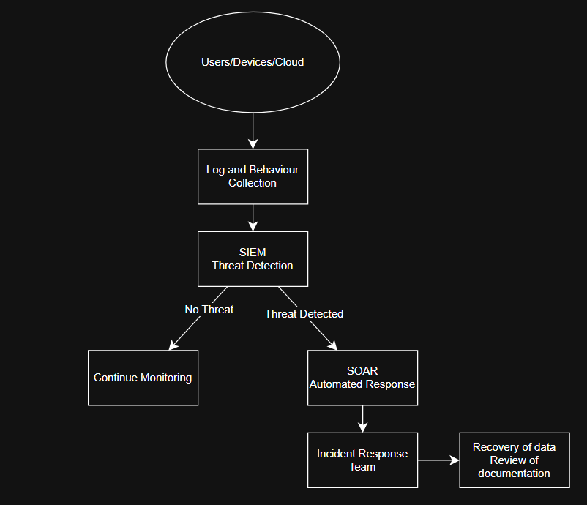

Figure 3 Response Diagram

Continuous Training and Awareness

A continuous training should be implemented to ensure that the employees are well equipped to manage and identify threats without any issue. New employees should complete mandatory cybersecurity awareness training during their induction.
To improve the engagement from employees, the company should perform simulated phishing and vishing attacks with realistic scenarios that would impersonate other employees or management [6].

The company should also promote positive security culture by making the employees report suspicious emails and phone calls without any reprimand. These should include weekly or monthly posters, newsletters, and videos on how to report and deal with suspected threats. The campaign should focus on current trends in cybersecurity, for example, increased amount of ransomware attacks or AI-powered vishing attacks [7].

Conclusion

In conclusion this report showcases the threats that the company must mitigate and provides detailed identification and mitigation measures along with policies in line with NIST and ISO/IEC 27001. In future this report might be revised with updated policies that cover a wider array of threats along with updated continuous training that the company must provide to ensure that the training stays relevant to current cybersecurity trends to avoid its employees using outdated information against incidents within the company.

References

[1] National Cyber Security Centre (NCSC), Guidance and Threat Reports. Available: https://www.ncsc.gov.uk. [Accessed: 21 Jul. 2026].

[2] OpenAI, AI and Cybersecurity Insights. Available: https://openai.com/index/cybersecurity-in-the-intelligence-age/. [Accessed: 21 Jul. 2026].

[3] IBM, Cost of a Data Breach Report 2024. Available: https://www.ibm.com/reports/data-breach. [Accessed: 21 Jul. 2026].

[4] Cybersecurity and Infrastructure Security Agency (CISA), Cybersecurity Best Practices. Available: https://www.cisa.gov/topics/cybersecurity-best-practices. [Accessed: 21-Jul-2026].

[5] National Institute of Standards and Technology (NIST), Cybersecurity Framework (CSF) 2.0. Available: https://www.nist.gov/cyberframework. [Accessed: 21 Jul. 2026].

[6] S. Dawkins and J. Jacobs, Phishing With a Net: The NIST Phish Scale and Cybersecurity Awareness, Apr. 2023, National Institute of Standards and Technology (NIST). Available: https://www.nist.gov/publications/phishing-net-nist-phish-scale-and-cybersecurity-awareness [Accessed: 21 Jul. 2025].

[7] D. Lain, K. Kostiainen and S. Čapkun, Phishing in Organizations: Findings from a Large-Scale and Long-Term Study, 2022, doi: arXiv:2112.07498. Available: https://arxiv.org/abs/2112.07498. [Accessed: 21 Jul. 2026].

Appendix

Slide 1 (Opening):

Cybersecurity Risk Assessment and Security StrategY

Objectives
- Assess business risks
- Recommend security improvements to reduce organisational risk
- Review the company’s current cybersecurity threats

Slide 2:

Why This Matters

Objectives
- Review the organisation's current cybersecurity threats
- Assess business risks
- Present a Zero Trust security strategy
- Recommend security improvements to reduce company’s risk

Slide 3:

Key Cybersecurity Threats

The assessment identified six major threats:

- Ransomware-as-a-Service (RaaS)
Criminal groups encrypt organisational data and demand payment.
- AI-Powered Social Engineering (Vishing)
AI-generated voice frauds impersonating trusted individuals
- Supply Chain Compromise
Attackers exploit trusted software vendors or suppliers
- Cloud Security Risks
Misconfigured cloud services and weak access controls.
- Hybrid Working Risks
Increased exposure from remote users and personal devices.
- Insider Threats
Malicious or accidental actions by employees or contractors.

Slide 4:

Impact on the Company

Successful cyber-attacks could result in:

- Loss of sensitive business information
- Financial losses and operational disruption
- Regulatory penalties
- Damage to customer trust and company reputation
- Business downtime
- Loss of intellectual property

Slide 5:

Security Strategy

Zero Trust Security Model
“Never Trust, Always Verify. “

Core principles of this approach:
- Verify every user and device
- Grant only minimum required access
- Continuously monitor user activity
- Assume breaches can occur

Slide 6:

Security Policies

Recommended organisational policies include:

- Access Control Policy
- Data Classification Policy
- Supply Chain Security Policy
- Cloud Security Policy
- Social Engineering Awareness Policy
- Ransomware Response Policy

These policies establish accountability and consistent security practices across the organisation.

Slide 7:

Recommended Security Controls

Multi-Factor Authentication (MFA)
Security Information and Event Management (SIEM)
Security Orchestration, Automation and Response (SOAR)
Data Loss Prevention (DLP)

Benefits
- Stronger access control
- Faster threat detection
- Automated responses
- Improved cloud security
- Protection against insider threats

Slide 8:

24/7 Monitoring and Incident Response

Flowchart of the overview of the monitoring:

Benefits
- Early threat detection
- Rapid incident response
- Reduced business disruption
- Improved resilience

Slide 9:

Security Awareness

Technology cannot stop all cyber attacks

Recommended programme
- Employee induction training
- Simulated phishing campaigns
- Simulated AI-powered vishing exercises
- Weekly/Monthly security awareness communications
- Employees become an active layer of defence rather than the weakest link

Slide 10:

Next Steps

Immediate Priorities
- Approve the Zero Trust security strategy
- Implement organisation-wide MFA
- Deploy SIEM and SOAR for monitoring
- Strengthen cloud security
- Improve supplier risk management
- Launch security awareness programme
Expected Outcomes
- Reduced cyber risk
- Faster incident detection and response
- Improved policy compliance

Slide 11 (Ending)

Thank you
Any Questions?

