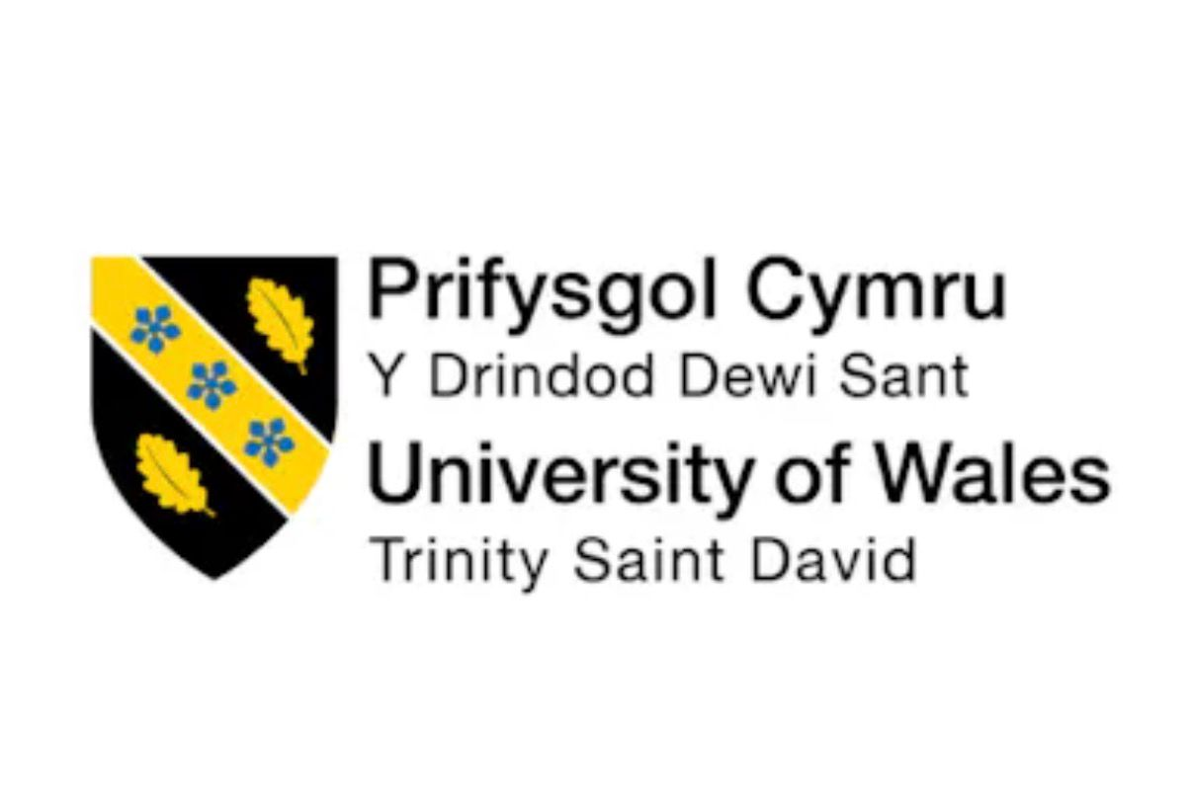

STUDENT NAME: ANA MIHAILESCU
STUDENT ID:2413169
MODULE CODE: LCLM5003
PORTFOLIO A, B, C
POSTER +REFLECTION (500 WORDS) + 2500 WORDS PROJECT MANAGEMENT PLAN

Table of Contents
PART B 4
PART C 6
Introduction 6
Project Description 7
Project Scope 7
Work Breakdown Structure (WBS) 8
Quad Chart 10
Gantt Chart 11
Stakeholders’ Involvement 12
Key Stakeholders 13
Allocation of Resources 13
Conclusion 15
References 16

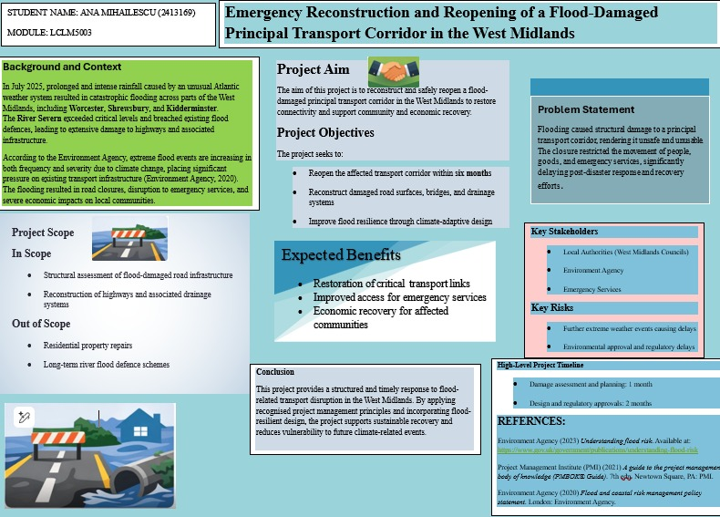

PART B
Reflection on Feedback from Tutor and Peers

The responses of my tutor and classmates to my Project Poster, Emergency Reconstruction and Reopening of a Flood-Damaged Principal Transport Corridor in the West Midlands proved very useful in terms of both highlighting the merits of my work as well as the areas in my work that require enhancement as we work towards the final project plan. Feedback can be a critical aspect of student development as it offers opportunity for learners to reflect on their work and identify ways to enhance their conceptual ability and practices (Moon, 2013). Reviewing the feedback gave me an idea of what made the poster successful and also found aspects which have room for improvement. A key positive that came up in the feedback was the clarity of the project’s aim and objectives. The tutor and a few friends all commented that the purpose of the project was clearly explained and easy to understand. We were able to envisage a flood-plagued transport corridor that would be reconstructed and reopened to reconnect the whole area for economic recovery in the West Midlands. Moreover, the goals for the poster in relation to reopening the corridor in six months, rebuilding damaged infrastructure and enhancing flood resilience with adaptive design for climate change are also logical and related to the overall objective. Specific and clear objectives are fundamental in project planning because they offer guidance and enable the project to remain focused on the problem (Saunders, Lewis and Thornhill, 2019). In response to feedback a second strength was the organisation of the poster. The material was organized into well-defined subheadings (Background and context, Problem statement, The scope of the project, Stakeholders, Risks and expected benefits). Multiple colleagues pointed out that this organisation made the poster easy to read and provided them with a clear and succinct overview of the project. The effective organisation is essential for academic communication to ensure that the audience can easily understand the reasoning behind the argument or proposal (Bell, Bryman, & Harley, 2019). Leveraging credible sources with examples like reports from the Environment Agency, was also marked as being a positive – showing evidence to back up your arguments for the topic of the project. The criticism did note aspects of the project plan which would be beneficial. The tutor proposed that the project timeline and development should be better clarified in the final project plan. While this poster shared a high-level project timeline, there was no information provided outlining how the reconstruction activities would be addressed. My strategy to overcome this difficulty is to build on this section and clearly address the reconstruction phases and application of project management methodologies. To clarify the approach chosen, it’s essential to articulate reasons as it indicates that the project is feasible and attainable (Project Management Institute, 2021). There's also room for improvement in the background section. On the poster they had said the flood risk was becoming increasingly dangerous and the power of climate change, tutor suggested including more academic reference points in order to be discussed in this way. It will further add to justification for the project and to strengthen connection between the research situation and the solution. A well-articulated background section is important, as it will articulate a clear rationale for why the problem is important and where the project has an added effect in this regard (Creswell and Creswell, 2018). The last part was feedback that highlighted room for growth in the section on risk. The poster revealed primary risks more extreme weather events, possible regulatory delays but the project's final plan will go on to outline detailed risk mitigation strategies. Management of risks is a crucial component on infrastructure projects, especially when involving emergency reconstruction in the wake of natural disasters. The overall constructive nature of the feedback I received has enabled me to know how this project can be improved as well as how that project might need further work. Though the poster did effectively communicate my main idea and structure for the project, the final project plan will provide greater detail, stronger academic support, and clearer explanations of the project approach.

References
Bell, E., Bryman, A. and Harley, B. (2019) Business Research Methods. 5th edn. Oxford: Oxford University Press.
Creswell, J.W. and Creswell, J.D. (2018) Research Design: Qualitative, Quantitative and Mixed Methods Approaches. 5th edn. London: Sage.
Moon, J. (2013) Reflection in Learning and Professional Development. London: Routledge.
Project Management Institute (2021) A Guide to the Project Management Body of Knowledge (PMBOK Guide). 7th edn. Pennsylvania: PMI.
Saunders, M., Lewis, P. and Thornhill, A. (2019) Research Methods for Business Students. 8th edn. Harlow: Pearson.

PART C

Project Management Plan
Emergency Reconstruction and Reopening of a Flood-Damaged Principal Transport Corridor in the West Midlands

Introduction
Infrastructure is central to underpinning economic activity, social mobility and emergency response systems. Especially transport corridors are important for people, goods and services to cross regions. But climate change and other frequent extreme weather events are posing an ever-greater threat to resilience of infrastructure networks across the United Kingdom. Flooding has emerged as one of the major environmental problems related to transportation infrastructure in recent years, frequently resulting in significant damage to roads, bridges or drainage systems (Environment Agency, 2020). In July 2025, flooding from a very active stormy Atlantic weather system caused widespread disruption throughout parts of the West Midlands. The flooding seriously damaged infrastructure in a main transport artery, rendering it unsafe for public usage, seriously reducing support for local communities, businesses and emergency services. The closure of this critical transport corridor disrupted regional connectivity and hindered the performance of emergency response services while stressing the need for quick infrastructure restoration following natural disasters. Project management offers methodical ways to help an organisation in the planning, execution, and control of more complicated tasks efficiently and within good practices. Based on the Project Management Institute (2021), Project management is a process in which a clear vision for project objectives, resource allocation, risk management, risk management coordination and task allocation to ensure project delivery within time and budget limits are established and defined. Some of these management principles are especially relevant to infrastructure recovery projects where restoring critical services is a priority. The following project management plan details the plan to reconstruct and reopen the flood-damaged transport corridor located in the West Midlands. This plan takes into account existing project methodologies and tools such as work breakdown structures (WBS), Gantt plots, stakeholder analysis, resource distribution and risk analysis and mitigation approaches. The aim of this document will be to offer stakeholders a clear process for delivering the project effectively.

Project Description
The initiative involves the emergency reconstruction and reopening of a flood-affected principal transport corridor in the West Midlands. The main pathway of transportation for commuting to work, freight carrying, and emergency services is through this corridor. Roads were severely inundated, destruction and damage to the drainage systems occurred, and related infrastructure weakened. The objective of the project is to ensure that the transport corridor operates optimally in a period of six months and is more resilient to future floods. Realizing this goal will require a coordinated work between engineers, towns, environmental agencies, construction companies and emergency services. It will operate in phases during the reconstruction project. The first task is to carry out an in-depth structural survey of the damaged infrastructure for damage. After such an evaluation, engineering units will work together to create plan of reconstruction that is based on better drainage and flood resilient construction. Upon completion of the designs being cleared by the appropriate policy-making bodies of the relevant authorities, reconstruction projects will begin. Beyond repairing existing damage, the project will include climate-resilient infrastructure projects. Infrastructure resilience is an increasingly central aspect of sustainable transport planning in particular in regions at risk from extreme weather events (Department for Transport, 2021). Better drainage systems and flood-resistant road materials have been integrated, which will reduce the risk of similar incidents in the future. Finally, a final successful outcome of the work will also restore transport connectivity, allow for better access to emergency aid services, and assist in economic recovery in regions affected by flooding.

Project Scope
Scope delineation ensures that project objectives are clearly defined to be met without unnecessary expansion of project activities. Scope management helps project managers maintain control over project deliverables and prevents problems caused by scope creep, which can result in delays and increased costs (Kerzner, 2022).
In Scope
The project will consist of the following activities:
Structural assessment of flood-damaged road infrastructure
Engineering design and planning for reconstruction
Reconstruction of damaged road surfaces and supporting structures
Repair and upgrade of drainage systems
Installation of improved flood mitigation measures
Safety inspections and regulatory compliance checks
Reopening of the transport corridor to the public
Out of Scope
The following actions are beyond the scope of this project:
Repair of residential properties affected by flooding
Construction of new transport corridors
Long-term regional flood defence infrastructure
Urban redevelopment projects unrelated to the damaged corridor
Setting these boundaries keeps the project focused on restoring the damaged transport corridor within the specified timeframe.

Work Breakdown Structure (WBS)

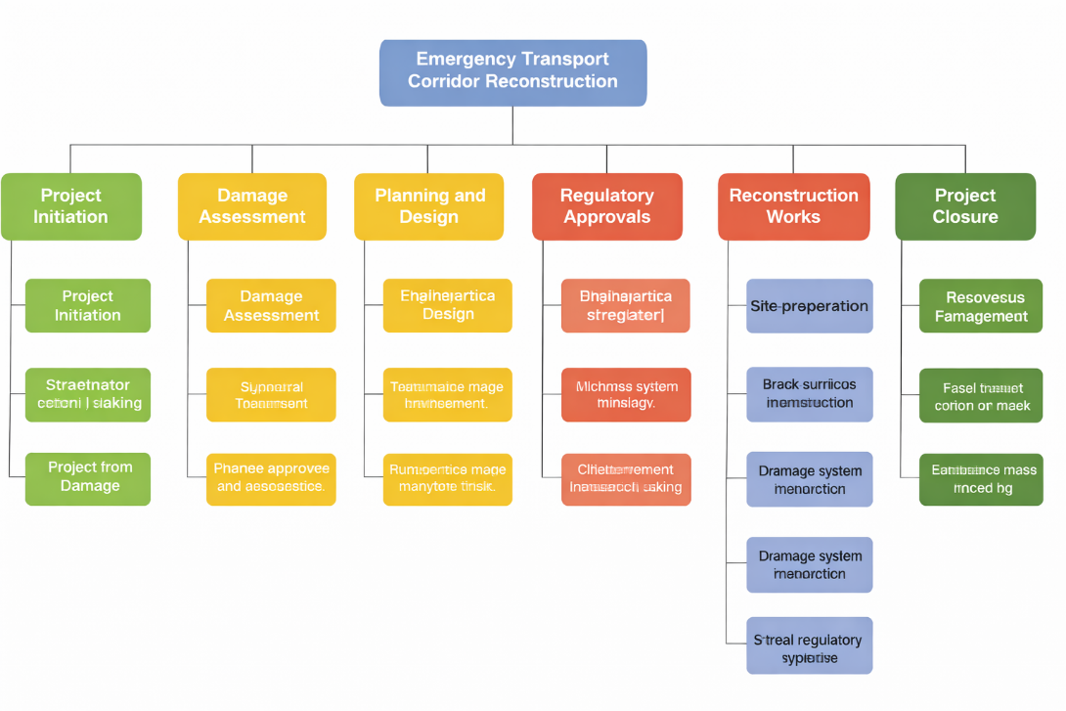
A Work Breakdown Structure (WBS) is a key project management tool used to divide a project into smaller, manageable tasks. According to the Project Management Institute (2021), the WBS provides a hierarchical framework that helps project managers organise tasks, allocate resources, and monitor progress effectively.
Level 1: Transport Corridor Reconstruction Project
An important project management tool is the Work Breakdown Structure (WBS), that is, the total project scope is broken into smaller, more manageable packages. The WBS is a hierarchical framework which allows project managers to be able to schedule activities (in structure), organise time and resources effectively, and to chart results during the entire project time (Project Management Institute, 2021). By dividing the whole job into distinct activities and sub-jobs, a WBS offers better organisational coordination in the reconstruction of complex infrastructure. In the first phase of this project Initiation, laying the foundation for all its subsequent stages, also includes securing project approval and obtaining funding from relevant authorities in terms of sources. It is not only necessary to obtain the funding to support construction activities, equipment procurement as well as labour costs. Furthermore, the project will identify the interests and organisations that are influential on the project. Other crucial parties such as local authorities, environmental agencies, and emergency services need to be established. There is also project team formation at this stage, by ensuring that qualified individuals with positions such as engineers, project managers, environmental specialists, and developers are well-matched for a specific task of work (Kerzner, 2022). The next stage is Damage Assessment which computes the extent of the infrastructure damage suffered by the flooding. The condition of the road surfaces, drainage systems, and structural components are inspected. Engineers also check the structural condition to decide if it is still part of the corridor, or to decide it has to be reconstructed. Furthermore, an environmental impact assessment is conducted of reconstruction activities for potential environmental risks and for compliance with environmental regulations (Environment Agency, 2020). The Planning and Design stages involve technical solutions to help recreate the transport corridor. Engineering design development involves developing detailed construction plans, listing the materials, techniques, and structural specifications for reconstruction. Drainage system construction: the system of drainage design is also redesigned for this reason, so that water management systems will be able in the future cope with various climate conditions. It also includes plans for climate-resilient infrastructure to improve the long-term success of the transportation corridor. After all, the work starts on Design, when the project crosses into Regulatory Approvals: once the environment is fully developed and approved, a need for environmental compliance, local authority construction works permits as well as for health and safety approvals is made to undertake work on how to properly rebuild the project. This Reconstruction Works phase includes site preparation, road surface reconstruction, drainage installation, and structural reinforcement of damaged infrastructure. Testing and Inspection will ensure that the reconstructed infrastructure meets acceptable safety and quality standards before the project enters the Project Closure phase, or in other words reopening the transport corridor, producing a final evaluation report, and a stakeholder review meeting to assess project status.

Quad Chart

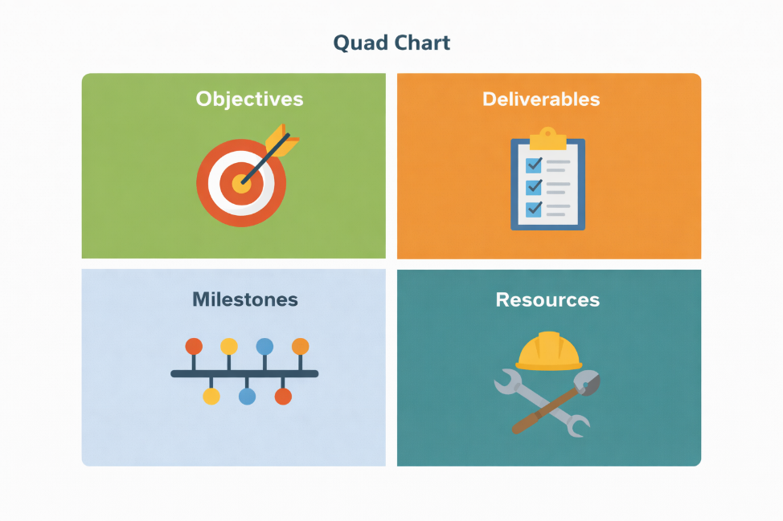

A Quad Chart is a visual project management tool that summarises key project information in four sections, providing stakeholders with a concise overview of the project (Kerzner, 2022).
Objectives
The primary task under this project is to restore and rehabilitate the flood-affected transport corridor within six months. Infrastructure resilience is expected to be increased by ensuring safe transportation for road users.
Deliverables. Project completion: Important deliverables: restored roads, upgraded drainage systems, better flood mitigation features.
Milestones. Crucial milestones include completion of damage assessment, approval of engineering designs, completion of reconstruction works, and the reopening of the transport corridor.
Resources. The project involves skilled labour, engineering expertise, construction equipment, and financial resources.

Gantt Chart
A Gantt chart is commonly used in project management to schedule tasks and track project progress over time. It provides a visual representation of project activities and their durations (Kerzner, 2022).

Project Phase | Duration
Project initiation | Week 1
Damage assessment | Weeks 1–4
Planning and engineering design | Weeks 3–8
Regulatory approvals | Weeks 6–10
Reconstruction works | Weeks 9–20
Testing and inspection | Weeks 20–23
Corridor reopening | Week 24

Using a Gantt chart helps ensure that tasks are completed in the correct sequence and allows project managers to monitor potential delays.

Stakeholders’ Involvement
Stakeholder Analysis Table

Stakeholder | Role in the Project | Level of Influence | Interest in Project
Local Authorities (West Midlands Councils) | Oversee infrastructure management, approve project activities and ensure alignment with regional transport policies | High | High
Environment Agency | Provide guidance on flood risk management and ensure environmental compliance | High | High
Emergency Services | Depend on the corridor for rapid response and emergency operations | Medium | High
Construction Contractors | Responsible for reconstruction works, infrastructure repair, and implementation of engineering designs | High | Medium
Local Communities and Businesses | Benefit from restored transport access and improved connectivity | Medium | High

The stakeholder assessment describes the different degrees of influence and interest within the critical stakeholders of the project. Knowledge of such relationships helps the project management team in designing and implementing effective processes to communicate effectively and manage stakeholder expectations throughout the project lifecycle (Project Management Institute, 2021). The approach of stakeholder relation development is relevant in this project management as the nature of various projects sometimes involves several organisations and persons with divergent preferences and roles (Freeman, 2010). Communication and coordination among all stakeholders play a key role in a successful project delivery.

Key Stakeholders

West Midlands Councils Local Authorities. In charge of infrastructure management and coordinating the reconstruction process in the region. Environment Agency. Specializes in flood risk management and ensures compliance with environmental regulations. Emergency Services. Depend on transport infrastructure to provide rapid response to emergencies. Construction Contractors. Responsible for carrying out the reconstruction work according to engineering specifications. Local Communities and Businesses. Benefit from improved transport access and economic recovery once the corridor is reopened. Regular communication between stakeholders will be maintained through progress reports, meetings, and collaborative planning sessions.

Allocation of Resources
Resource allocation is critical for ensuring that projects are delivered efficiently. According to the Project Management Institute (2021), effective resource management involves assigning appropriate personnel, equipment, and financial resources to project tasks.
Resource Allocation
Managing the allocation of resources is one of the major elements of managing how effectively to complete project work in a timely manner. A project manager, civil engineers, environmental practitioners, construction workers and safety inspectors will be part of multidisciplinary project team. Each team member will bring technical expertise, which is vital to planning, doing and monitoring the reconstruction process. Beside human and financial aspects, adequate resources are required for the project implementation and execution. Funding will be set aside to address critical needs such as material and manpower expenses, engineering advisory services and rental/maintenance of equipment. Through appropriate use of these resources a successful project can be completed, and the project can achieve its objectives (Project Management Institute, 2021).
Equipment and Materials
Excavators, road paving machines, drainage installation equipment and structural testing tools would all need to be used on the project. Well-handled resources will provide necessary conditions for the project activities to be achieved.
Risk Analysis
In infrastructure projects, risk management is therefore essential, as unexpected events can throw projects off course and raise overall costs. Risk analysis involves identifying potential risks and creating strategies to minimise their effects (Hillson, 2017).

Risk | Impact | Mitigation Strategy
Further extreme weather events | Delays in construction | Flexible scheduling and weather monitoring
Regulatory approval delays | Project timeline disruption | Early engagement with authorities
Budget overruns | Financial strain | Strict cost monitoring
Supply chain disruptions | Material shortages | Multiple supplier agreements
Workplace safety incidents | Project stoppages | Strong health and safety protocols

Continuous monitoring and proactive risk management will help ensure that the project remains on schedule.

Conclusion
The flood-damaged transport corridor in the West Midlands is being rehabilitated and reopened. It aims to restore regional connectivity and support community recovery following severe flooding. The management of this project is a comprehensive concept designed to enable effective delivery of the project. Recognition of several good project management principles and tools underpins our project management strategy. The plan describes the main aspects of the project, including project scope, work breakdown structure, stakeholder involvement, resource allocation, and risk management strategies. It helps to coordinate work with the construction teams, address issues quickly, and keep the reconstruction time within the planned limit. Additionally, design steps to ensure climate resilience will enhance the long-term sustainability of the transport corridor and decrease the vulnerability of infrastructure to future flooding events.

References
Bell, E., Bryman, A. and Harley, B. (2019) Business Research Methods. 5th edn. Oxford: Oxford University Press.
Department for Transport (2021) Transport Infrastructure Resilience Strategy. London: UK Government.
Environment Agency (2020) Flood and Coastal Risk Management Policy Statement. London: Environment Agency.
Freeman, R.E. (2010) Strategic Management: A Stakeholder Approach. Cambridge: Cambridge University Press.
Hillson, D. (2017) Practical Project Risk Management: The ATOM Methodology. Vienna: Management Concepts.
Kerzner, H. (2022) Project Management: A Systems Approach to Planning, Scheduling and Controlling. 13th edn. Hoboken: John Wiley & Sons.
Lock, D. (2020) Project Management. 11th edn. London: Routledge.
Morris, P.W.G. (2013) Reconstructing Project Management. Chichester: Wiley-Blackwell.
Project Management Institute (2021) A Guide to the Project Management Body of Knowledge (PMBOK Guide). 7th edn. Pennsylvania: PMI.
Saunders, M., Lewis, P. and Thornhill, A. (2019) Research Methods for Business Students. 8th edn. Harlow: Pearson.

