Marketing Fundamentals

Student name: Vasile Ciprian Alin Diaconu
Student number: 2030168
Table of Contents

Introduction 3
Company Overview 4
5 Stages of Marketing Process 5
Evaluating the Role of Internal Marketing Environment of Premier Foods 6
SWOT Analysis 6
Resource Capability Analysis of Premier Foods 8
Evaluating the Role of External Marketing Environment of Premier Foods 9
PESTEL Analysis of Premier Foods 10
Porter's Five Model Forces Analysis of Premier Foods 12
Market Segmentation, Targeting and Positioning in Context of Premier Foods 13
Market Segmentation 13
Market Targeting 14
Market Positioning 14
Marketing Mix in Context of Premier Foods 14
Conclusion 16
References 17

Introduction
Marketing can be described as the process of capturing value from customers and managing profitable relationship with them through communicating, delivering and exchanging offerings (Deepak, and Jeyakumar, 2019). Marketing is an important business function which helps the business to offer customer oriented goods services to its customers in order to ensure profitable relationship with customers. At present, marketing plays an important role in business world as it helps to identify the customer’s needs and wants (Deges, 2018). An effective marketing strategy can easily increase customer’s base which brings high profit for the company (Grewal, Hulland, Kopalle, and Karahanna, 2020). But, it can be seen too that COVID-19 pandemic affected the marketing function highly. Almost every elements of marketing were affected by the impacts of COVID-19 pandemic. This report has been made on to discuss the impacts of COVID-19 in marketing function and its environment in context of a British public limited company, Premier Foods plc. The marketing stages, internal and external environment analysis of Premier Foods, market segmentation, targeting, positioning, and marketing mix of Premier Foods will be discussed in this report.

Company Overview
Premier Foods plc is a renowned public limited company that deals in food manufacturing industry. It has been founded in 1975 (Premierfoods.co.uk. 2021). Headquartered in St Albans Hertfordshire, the company owns several well known brands, such as - Ambrosia, Bird's Custard, Mr Kipling, Homepride cooking sauces, Sharwood's, Angel Delight, Loyd Grossman sauces, Oxo, Plantastic and Bisto etc (Premierfoods.co.uk. 2021). Food products are the main offerings of Premier Food, and the company has around 4,200 employees who are directly concerned with its business.
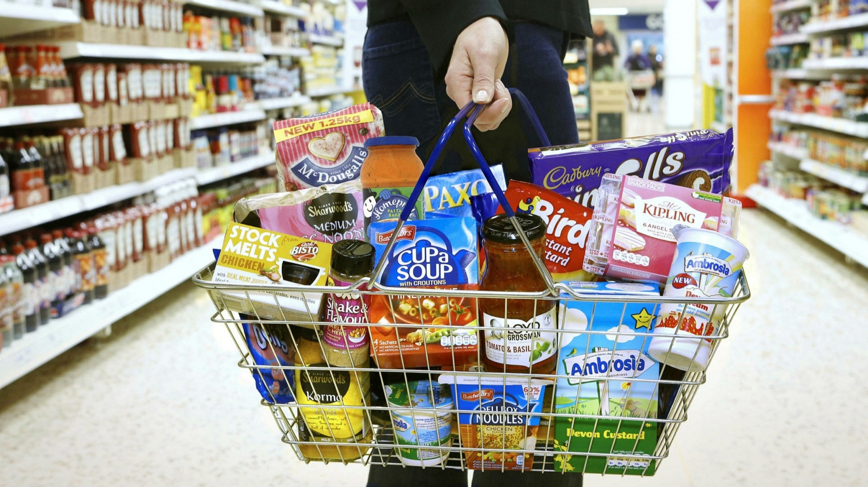
Figure 1: A Visual of Premier Foods’ Products on Different Brand Names
Premier Foods and its marketing function affected significantly during COVID-19 pandemic. Marketing operations became slow, marketing environments faced several challenges including internal and external changes, capacity changes etc, however the company managed itself to run stand-out business during this pandemic.

5 Stages of Marketing Process
Marketing process can be defined as the combinations of such work that planned and implemented upon customer's needs which intersects with company profile. The process involves five stages that are - Company Mission, Situation Analysis, Marketing Plan, Marketing Mix, and Implementation and Control (Fahy, and Jobber, 2019). Marketing process works as a guideline for a company to manage the marketing operations in different situations. The marketing process of Premier Foods during COVID-19 pandemic is described below -
- Company Mission: Company mission indicates the company goals and objectives that guide the company in its accomplishments (Kamps, and Schetter, 2018). The company mission of Premier Foods is - enrich life through food. The mission indicates the company works to offer healthy and delicious foods to its consumers that will lead them to sustainability and increase lifestyle. The company made its decision by keeping up its statement during COVID pandemic as it does always.
- Situation Analysis: Situation analysis involves in evaluating the condition surrounding. Since Premier was able to evaluate the impacts of COVID pandemic, it analyzed how best the business operations could go to ensure safe and healthier foods for its company.
- Marketing Plan: Market plan involves in developing ideas based on situation analysis which will be more beneficiary for both the customers and the company (Di Gregorio, Maggioni, Mauri, and Mazzucchelli, 2019). Premier Foods also developed marketing plan in a new ornament during COVID pandemic winch went right and ensured benefits for both sides.
- Marketing Mix: Marketing mix involves in ensuring product that developed based on plan, price that set on customer's preference, place that made available the products and promotion that branded the products to its customers (Eckhardt, Houston, Jiang, Lamberton, Rindfleisch, and Zervas, 2019). Premier Foods has rightly used marketing mix before implementing its plan during COVID-19.
- Implementation and Control: Implementation and control refers to start working on the plan that has been developed and control the actions over (Malhotra, Nunan, and Birks, 2017). Premier Foods planned to deliver foods of its several brands to its customers through door to door purchasing during COVID-19. Customers ordered their preferable foods items on online bucket list of the company and then the company delivered the food to them with a minimum charge. Customers didn’t need to go retail stores or company outlets to buy their foods. This implementation became beneficiary for both sides and the company rightly controlled the process (Premierfoods.co.uk. 2021).

Evaluating the Role of Internal Marketing Environment of Premier Foods
Internal marketing environment can be described as the combination of narrow factors of a firm that are surrounded around the business and have direct impacts in marketing operations (Quach, Thaichon, Lee, Weaven, and Palmatier, 2020), such as - customers, distributors, suppliers, managerial board, workers, capacities and many more. Premier Foods has a wide range of internal environmental factors that were affected due to COVID-19. Now, the analysis of Premier Foods' internal marketing environmental factors is shown below through several techniques by considering the impact of COVID-19 –

SWOT Analysis
SWOT analysis is a tool to evaluate internal environment based on firm's strengths, weaknesses, opportunities and threats (Vlados, 2019). The SWOT analysis of Premier Foods' internal marketing environment is shown below –
SWOT Analysis Premier Foods
Strengths | Weaknesses
- High quality products  - Strong customer base  - Efficient human resources  - Productive management  - Effective distribution channel | - Precise operations  - Expensive production cost
Opportunities | Threats
- Good relationship with suppliers  - Technology concern  - Customer oriented business | - High competition in market
Strengths
- Premier Foods company concerns with their high quality products (Premierfoods.co.uk. 2021). As a result they always try to improve the quality of foods items they offer and increase the consumption value.
- The company has strong customer's base that are very loyal to the products of the company.
- The company has efficient human resources who work hard to achieve the objectives and goals of the company (Premierfoods.co.uk. 2021). As well as, they also focus on bringing efficiency in their work carefully.
- Premier Foods has a very strong administrative body and managerial body who is effective can make appropriate decision in uncertain situations which is now a significant strength of the company.
- Premier Foods has rightly maintained its effective distribution channels which are able to deliver the products to customer's availability (Premierfoods.co.uk. 2021). Though COVID-19 made most of distribution channels of other companies dormant, the distribution channels of Premier Foods were able to run its operations properly.
Weaknesses
- Premier foods is able to flourish its business internationally but the company is less concerned with its international business expansion which might affect its operations in long run.
- Premier foods has to count high cost for its goods production which ultimately increase the product price.
Opportunities
- Premier Foods has rightly managed its relationship with its supplies. The company needs a wide range of raw materials for producing the food products. On that point, the company manages good relationship with its suppliers which help the company to get raw materials in short time and to conduct smoother production.
- Premier Foods is much concern about modern technology and tools. COVID-19 pandemic could make the company less operative but its concerns to use modern technology and tools in business made the company much operative.
- The company develops business plans and makes decision based on its customer's demand and wants. In COVID-19 pandemic, the customer oriented business decisions bring much benefit to the company.
Threats
- The company has high level competition threats in market as there are many companies available in the market who offers same products, such as - Well Food, British Food, King's Bakery and many more.

Resource Capability Analysis of Premier Foods
Resource capability analysis is a type tool to evaluate a firm's resources that are associated with its business function. Such resources are categorized intro three type - tangible resources, intangible resources and human resources (Nwachukwu, and Chladkova, 2019).
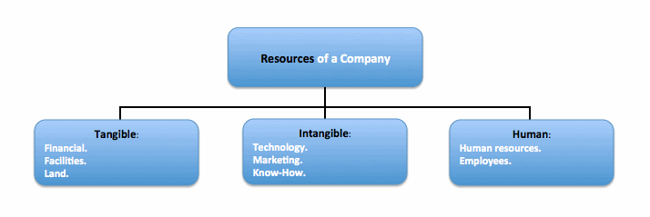
Figure 2: A Visual of Three Types of Resources of a Company
Now, an analysis of these three types of resource capabilities in context of the impacts of COVID-19 on Premier Foods is shown below -
Tangible Resources of Premier Foods
Tangible resources are the actual resources that can be seen and touched which are used in production and operate the business (Tuominen, and Anttila, 2006). The tangible resources of Premier Foods are - its office, properties, factories, machineries, technological equipment and those which have financial value (Premierfoods.co.uk. 2021). The company is much careful in uses of its tangible resources. COVID-19 made the company to acquire new tangible resources such as - some technological equipment, machineries, delivery van etc. Through the proper application of these tangible resources, the company could able to operate its business properly during COVID-19 crisis.
Intangible Resources
Intangible resources are such resources that cannot be seen or touched, but can only be utilized, such as - brand value, marketing stability, effective administration and many more (Hall, 1992). Premier Foods is a well known brand among its customers. It has a strong brand value which helps the company to operate a smoother business. As well as, its effective administration and strong marketing policies help the business to be flourished. It is the company’s intangible resources which created value among customers during COVID-19 and made them to purchase products through online orders from them.
Human Resources of Premier Foods
Human resources indicate the people who are engaged with the firm for production and management purpose (Tong, Luo, and Xu, 2020). Premier company has its efficient workers in production function, productive employees in management bodies who involve ensuring business operations for the company (Premierfoods.co.uk. 2021). In COVID-19, this type of resources played a leading role behind the smoother operation of COVID-19.

Evaluating the Role of External Marketing Environment of Premier Foods
External marketing environment can be described as the combination of wider factors that impact the business in long run either directly or indirectly (Jain, and Yadav, 2017), such as - government, government’ polices, law enforcement, market condition, economic stability, economic growth, customer's belief, their buying power, distributor's power, law and acts, environment, technology and many more. Now, the external marketing environmental factors of Premier Foods by considering the impact of COVID-19 is analyzed below through PESTEL and Porter's Five Forces Model analysis -

PESTEL Analysis of Premier Foods
PESTEL analysis is a tool of evaluating firm's wider factors in a disciplined manner (Shatskaya, Samarina, and Nekhorosheva, 2016). PESTEL is a combination of six different types of external environments, such are - political, economic, social, technological, environmental and legal environment (Pan, Chen, and Zhan, 2019). Now, the PESTEL of Premier Foods is analyzed below -
PESTEL Analysis Premier Foods
Political | Economic | Social
- Government’s business policy  - Government’s COVID vaccination policy  - Political stability | - Economic progress  - Consumer's income  - Market condition | - Consumer's belief  - Consumer's preference
Technological | Environmental | Legal
- Modern technologies  - Production machineries | - Climate change  - Waste management | - Consumer safety act  - Business law
Political
- Government’s business policy is one of the most important external factors that affect the entire business directly. In COVID-19 pandemic, the government business policy was much conservative as it involves several restricted associated with business. However, Premier Foods could able to run its business in following the policy.
- Government’s COVID vaccination policy is involved in vaccinating each employees and workers if the business wanted employees to join work in person. The company has rightly followed the policy and brought its employees under vaccination.
- Political stability refers to the sound political practice within a political territory area. Since UK has sound political practice and the situation is much stable, the company utilized the opportunity in full stack and run the business.
Economic
- Economic progress leads a business in sustainable growth which ensures more profit. Though UK faced a little touch of recession during COVID pandemic, the economic situation is much is stable now which leads the Premier Foods to run a successful business
- Consumer's income is a major factor that highly determines the business success. In UK, people have a sound income rate which is £29,147 per head. Though the Income level decreased slightly from the income level of 2019, the economic situation is now in its progress which will increase the income level.
- Market condition refers to the demands and competitors associated with the business. Though Premier Foods has several competitors in market, its products are in demand to its customers.
Social
- Consumer's belief depends on the offerings that a company provide to them (Bayazovna, 2020). Since Premier Foods is well reputed in its customer’s community and leads a renowned position in its market because of offering quality products, consumers have strong belief in their offerings which lead them to buy more and more products of the company.
- Consumer's preference is made upon the value that companies provide to them (Purcărea, 2020). A consumer will only buy that product which will give them more satisfaction. The products of Premier Foods ensure quality and satisfaction of customers which is why consumers prefer the products of the Premier Foods more.

Technological
- Modern technologies bring efficiency and help the company to keep pace with modern world. Since Premier Foods introduced many technologies in COVID pandemic, as well as used technologies on smoother business operations, it made itself able to keep pace with modern tools and technologies.
- Modern production machineries make the productions faster and increase the production level (MUTISO, 2017). The company introduced several modern production machineries in its factories which make its production function more efficient.
Environmental
- Climate change has some notable affects on business. It may make the business to change the operations which include natural resources. Premier Foods has rightly managed this type of factor.
- Waste management is important in business operations. Factories should follow standards to manage their waste. The company has proper waste disposal system which leads to better waste management.
Legal
- Consumer safety act assures good quality products that the company offers to its consumers. Premier Foods is known to offer quality and healthier foods to its consumers.
- Business law is maintained to guide businesses that are happening properly into a political territory (Black, Pretorius, and Sherwin, 2015). Premier Foods rightly follows all such business laws associated with its business which works as to increase its brand value.

Porter's Five Model Forces Analysis of Premier Foods
Porter's five model analysis is an evaluation tool to evaluate the five external factors of a firm that are closely related with the business and have significant affect in the operations. Such factors are - bargaining power of customers, bargaining power of suppliers, rivalry among existing competitors, threat to new entrants, and threat to substitutes (Camilleri, 2018). Now Porter's five model forces are analyzed below -
Bargaining power of customers: In this perspective, the bargaining power of customers is low. Since the products of Premier Foods are mostly sold in supermarkets, retail stores and online grocery stores, the prices against the products are fixes, which is why customers get low chance to bargain.
Bargaining power of suppliers: The bargaining power of suppliers is low too as most of the prices against the raw materials that the company purchase are fixed, however a slight negotiation is seen often when to purchase in a huge amount.
Rivalry among existing competitors: Here the risk level is high. There are already many companies expiated in the same market and deals with same category product line.
Threat to new entrants: Here the risk level is low as there are already many competitors in the market. Not only this but also a huge amount of capital is required for a company to entry into this market with this type of product line.
Threat to substitutes: Here, the risk level is high as there are many close substitutes available in the market as well as some competitors offer same product in lower price though their product quality is questioned.

Market Segmentation, Targeting and Positioning in Context of Premier Foods

Market Segmentation
Market segmentation refers to categorize the market based on consumer's attributes, such as - race, ethnicity, gender, age, income, preference etc (Davis, 2017). During this COVID-19 pandemic, Premier Foods brought a little change on its market segmentation planning. Since the products' price of the company is little bit higher than others, the company segmented the market based on consumer's income. Lower level, mid level, and higher level income were the three major segments of its market segmentation during the COVID pandemic (Premierfoods.co.uk. 2021).

Market Targeting
Premier Foods mainly targeted the segment of mid level income people. People who earn £1,500 to £3,000 per month were mainly targeted as they can afford the products of Premier Foods without any major hesitation (Premierfoods.co.uk. 2021). However, there were also some products that were targeted to high income level segment as those products are premium and people needs to around spend £15 for each item. This is how the company targeted its most preferable segment during COVID pandemic as the people in this segment can afford its products easily.

Market Positioning
Market positioning refers to take the product in its targeted consumers' mind so that they can buy the product which has been developed for them (Strycharzvan Noort, Helberger, and Smit, 2019). After targeting most preferable segment of market, Premier Foods started to create brand awareness of their products through commercial television advertisements and billboards (Premierfoods.co.uk. 2021). The company was much able to create brand awareness and its products identity into its consumers' mind which proved as much beneficiary and still the company receives the benefit from its positioning strategy to targeted segment.

Marketing Mix in Context of Premier Foods
Marketing mix is marketing tool that helps the company to create brand awareness bases on product and its associated attributes. Marketing mix involves considering product, price, place and promotion into marketing strategy (Pomering, 2017). Now the marketing mix of Premier Foods during COVID-19 pandemic is discussed below -
Product: Product is the offering that a company offers to the customers (Balducci, and Marinova, 2018). Though Premier Foods has a wide range of product category, the company introduced some new products and modified some existing products such as - breakfast cereal, corn flacks, sauces, bread and many more just to ensure the healthier and quality food for its loyal customers.
Price: The company mostly followed cost based pricing policy as good quality products incur a little bit higher prices behind their productions (Premierfoods.co.uk. 2021).
Place: Premium Foods has good partnership with almost every supermarket, such as - Tesco, Morrison's, Waitrose, ASDA, Sainsburry etc (Premierfoods.co.uk. 2021). The company products were available their during COVID situation and still available. As well as, the company also opened home delivery where customers could easily buy the products via online orders.
Promotion: The company uses commercial television advertisements and billboard advertisements for promoting the products and creating brand awareness about the brand which went right as a lot of new customers were attracted from the company’s promotional strategy.

Conclusion
Marketing is an important business function as it involves in planning and branding customer oriented product development which ensures profit for the company. This report covers a brief discussion on marketing fundamental in context of a British food company named Premier Foods plc based on the impacts of COVID-19 pandemic. The stages of marketing process, internal marketing environment analysis of Premier Foods through SWOT analysis and resource capability analysis, external marketing environment analysis of the company through PESTEL analysis and Porter's five model forces analysis, market segmentation, targeting and positioning of the company, and marketing mix of the company have been discussed in this report.

References
- Balducci, B. and Marinova, D., 2018. Unstructured data in marketing. Journal of the Academy of Marketing Science, 46(4), pp.557-590.
- Bayazovna, G.N., 2020. Marketing communication strategy and its essence. Вопросынауки и образования, (1 (85)).
- Black, S., Pretorius, A. and Sherwin, C., 2015. From Scotch to Sausage Rolls: Digesting Recent FMCG Control Cases in the UK. Competititon LJ, 14, p.169.
- Camilleri, M.A., 2018. The marketing environment. In Travel marketing, tourism economics and the airline product (pp. 51-68). Springer, Cham.
- Davis, J., 2017. Measuring marketing. De Gruyter.
- Deepak, R.K.A. and Jeyakumar, S., 2019. Marketing management. Educreation Publishing.
- Deges, F., 2018. Quick guide influencer marketing. Springer Fachmedien Wiesbaden.
- Di Gregorio, A., Maggioni, I., Mauri, C. and Mazzucchelli, A., 2019. Employability skills for future marketing professionals. European management journal, 37(3), pp.251-258.
- Eckhardt, G.M., Houston, M.B., Jiang, B., Lamberton, C., Rindfleisch, A. and Zervas, G., 2019. Marketing in the sharing economy. Journal of Marketing, 83(5), pp.5-27.
- Fahy, J. and Jobber, D., 2019. EBOOK: Foundations of Marketing, 6e. McGraw Hill.
- Grewal, D., Hulland, J., Kopalle, P.K. and Karahanna, E., 2020. The future of technology and marketing: A multidisciplinary perspective.
- Hall, R., 1992. The strategic analysis of intangible resources. Strategic management journal, 13(2), pp.135-144.
- Jain, E. and Yadav, A., 2017. Marketing and technology: role of technology in modern marketing. IOSR Journal of Business and Management, 19(5), pp.49-53.
- Premierfoods.co.uk. 2021. [online] Available at: <https://www.premierfoods.com/uk/> [Accessed 11 November 2021].
- Purcărea, T., 2020. Retailers under Pressure of Faster Adaptation to the New Marketing Environment.
- Quach, S., Thaichon, P., Lee, J.Y., Weaven, S. and Palmatier, R.W., 2020. Toward a theory of outside-in marketing: Past, present, and future. Industrial Marketing Management, 89, pp.107-128.
- Shatskaya, E., Samarina, M. and Nekhorosheva, K., 2016. PESTEL analysis as a tool of strategic analysis in international markets. SCOPE ACADEMIC HOUSE B&M PUBLISHING, p.47.
- Strycharz, J., van Noort, G., Helberger, N. and Smit, E., 2019. Contrasting perspectives–practitioner’s viewpoint on personalised marketing communication. European Journal of Marketing.
- Tong, S., Luo, X. and Xu, B., 2020. Personalized mobile marketing strategies. Journal of the Academy of Marketing Science, 48(1), pp.64-78.
- Tuominen, M. and Anttila, M., 2006. Strategising for innovation and inter-firm collaboration: capability analysis in assessing competitive superiority. International Journal of Technology Management, 33(2-3), pp.214-233.
- Vlados, C., 2019. On a correlative and evolutionary SWOT analysis. Journal of Strategy and Management.

