

Marketing Plan

Holiday Inn

Iulia Tanase

Student ID: 2230512

Module: Marketing Essentials BMIH4005

Lecturer: Scott James

Word Count: 1353

Introduction
The purpose of this essay is to explore ways in which Holiday Inn, my chosen hotel brand, can enhance its marketing plan to improve its publicity and attract more customers. Through a thorough evaluation of its current strategies, I will identify opportunities for development and improvement, with the goal of expanding its reach to various customer segments.
To achieve this, I will utilise various analysis strategies and theories such as SOSTAC, Bowman’s Clock, Perpetual Positioning, SWOT, and PESTLE – which will all allow me to deepen my knowledge and extend my information of the brand.

Situational Analysis
Holiday Inn is a highly respected and widely recognized hotel brand that has consistently achieved success. One of its key strengths is its strong brand reputation and quality of service, which attracts a diverse range of customers who trust the brand. Furthermore, compared to many other hotels worldwide, Holiday Inn has a significant advantage in terms of market presence and accessibility for customers of all types. However, it is important to consider the brand's weaknesses when conducting a thorough analysis.
Personalized experiences may be limited due to standardization across hotels, which is a potential area for improvement resulting from the brand's focus on providing an affordable experience. After conducting extensive research, it became clear that Holiday Inn caters to a wide range of customers, including business travellers, tourists, leisure travellers, and those seeking medium-term stays on a budget. This is a large and diverse customer base that the brand intends to continue targeting.
By using perceptual positioning, I have identified Marriott Hotels and Resorts as a direct competitor, as they also cater to upscale customers seeking luxurious experiences. Additionally, using Bowman's Strategy Clock, I have identified Motel 6 and Super 8 as potential competitors due to their focus on providing low prices for services. Like any hotel chain, Holiday Inn is impacted by various external factors which have been analysed through a pestle analysis. Government regulations and stability have a political influence on the hotel's operations, particularly in relation to taxation, employment laws, and travel restrictions.
Accommodation demand is affected by economic conditions such as GDP growth and disposable income levels. Recessions or economic downturns can reduce travel and spending. Guest preferences and expectations are influenced by social factors, including demographic trends and consumer behaviour, which require Holiday Inn to adapt its offerings accordingly. Technological advancements and data security are crucial for staying competitive and ensuring guest trust.
Environmental concerns drive the need for sustainable practices and green initiatives, while compliance with health and safety regulations is required for guest safety. Legal factors encompass aspects such as intellectual property protection and adherence to health and safety regulations.

Objectives
Holiday Inn has set its sights on enhancing brand visibility and generating increased customer engagement by implementing a comprehensive digital marketing campaign. The campaign will incorporate targeted social media ads, influencer collaborations, and online contests. This initiative aims to achieve a 20% increase in social media followers, a 15% growth in website traffic, and a 10% rise in direct bookings attributed to the campaign.
Additionally, Holiday Inn intends to boost its online reputation as a premier destination for travellers seeking exceptional experiences and value by increasing positive online reviews and expects this to be successful by the end of the season.

Strategy
As a result of the marketing plan’s views and ideas, and through the theory of the Ansoff Matrix, the strategy which Holiday Inn will make use of would-be market development, as it attempts to develop their online marketing, and ensure that they create an opportunity for the future of the brand for a high increase in profits, and improved reputation regarding social media and their websites. The progress of this strategy can be tracked through network analysis of the visits that happen each week or month and use the data to check if the strategy is effective and beneficial for Holiday Inn.
However, as a failsafe, this marketing plan has a backup strategy in case the focus on marketing development fails to succeed in the way it was created. This backup strategy entails the product development section in the Ansoff Matrix, which will cover the development of new and upgraded on-site services for all current and new guests, as research has found that by sharing new things, and supposedly better services to customers, creates more interest for them in the hotel and would want to check for themselves how the new services will impact their experience.
To stand out from its competitors, Holiday Inn may want to explore more personalized and experimental marketing strategies. This can be achieved through tailored services, highlighting distinctive experiences, and utilizing digital platforms to interact with customers. By doing so, they can improve their brand image and appeal to a broader audience.

Tactics
To enhance its publicity, Holiday Inn can implement a strong strategy that utilises the communication mix. The first step is to create an integrated marketing communications approach, which ensures a consistent brand message across all channels. This involves developing a captivating website, optimising it for search engines, and utilizing social media platforms to engage with customers and promote special offers.
Holiday Inn should also prioritize public relations efforts by fostering media relationships, issuing press releases, and participating in industry events. Content marketing plays an important role in providing valuable and relevant content to establish Holiday Inn as a reliable resource. By utilizing customer relationship management systems, they can personalise communication and cultivate customer loyalty. Lastly, by continuously measuring and analysing key metrics, they can refine their strategy based on data-driven insights, ensuring ongoing improvement and effectiveness.
Through effective use of the communication mix, Holiday Inn can enhance its publicity, strengthen brand visibility, and attract more customers. I will use these tactics, for the purpose of Holiday Inn targeting social media platforms and the guests on its websites and sharing extensive information on the capability of the hotel brand and its real intent on creating a more interesting and enjoyable environment which would also provide more unique experiences which the hotel lacked before, limiting the interest of customers and guests, and decreasing the publicity they have the potential to possess worldwide.

Action

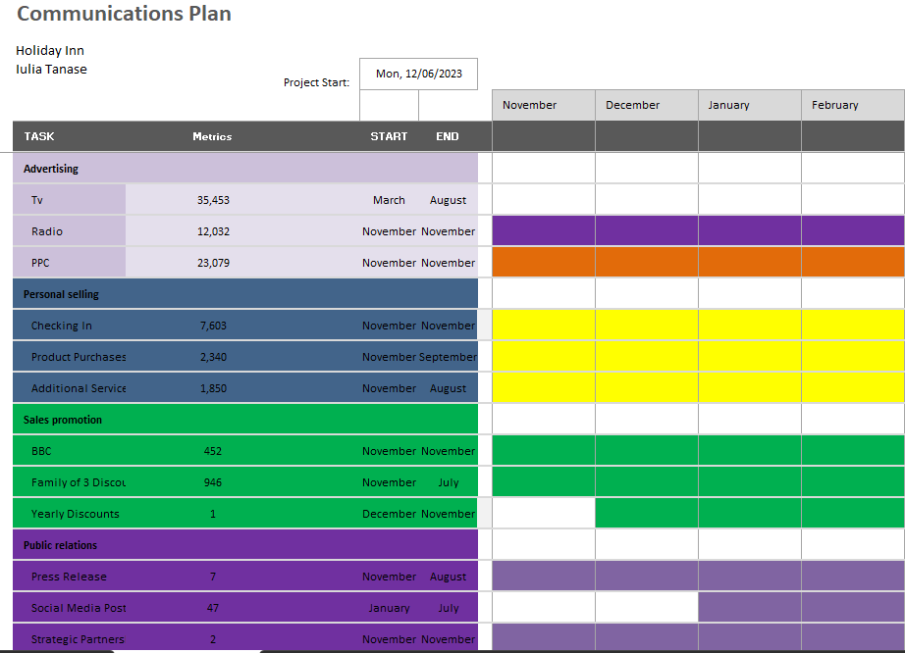

I made sure to include advertising as the introduction, so that the brand receives recognition, and everyone is aware of the brand before any next steps. Afterwards, personal selling would include lots of face-to-face interaction, making sure I am able to track any sales made in person, and compare them to online sales, and see which is preferrable to guests and customers.
Furthermore, sales promotion would include television broadcasting, and increase views and visits on new services and products. Finally, public relations and direct marketing would be close to each other as they would be at the halfway mark after many of the guests and customers of the hospitality industry are aware of Holiday Inn’s achievements and accessibility, and the brand would be able to use this for investors and further funding projects.

Control
To measure the success and the improvement in the hotel through the new strategies, I attempt to implement progress tracking and mandatory statistics release of the continuous changes in the brand, the marketing plan I created would suggest that any and all changes to the brand should be recorded, with past data, current data, and estimated or targeted data/statistics, and after a certain duration, the estimated data/statistics should be checked if it was met/achieved. By continuously doing this after each change, the brand can have a better understanding of future operations and their outcome.
Conclusion
In this marketing plan, I made sure that I changed Holiday Inn’s dull and uninteresting strategies on publicity, to a brand new, revamped strategy on their online market development and created strategies for new opportunities in the market that Holiday Inn could take advantage of, in order to achieve an improvement in the current and future profits and publicity from the overall guests.
For the future, it is essential to recommend that after the changes are made, that continuous and consistent progress tracking is made, to ensure there are no weaknesses and that any potential risks are accounted for.

References
Ansoff, H. I. (1957). Strategies for Diversification. Harvard Business Review.
Evans, C., & Wright, W. (2009). The “How to” series. Manager: British Journal of Administrative Management, 65, 10–11.
Grundy, T. (2006). Rethinking and reinventing Michael Porter’s five forces model. Strategic Change, 15(5), 213–229.
Hitt, M. A., Ireland, R. D., & Hoskinson, R. E. (2012). Strategic management: Concepts: Competitiveness and globalization (10th ed., p. 472). Mason, OH: Cengage Learning.
Keegan, W. J., & Green, M. C. (2012). Global marketing (7th ed.). Upper Saddle River, NJ: Prentice-Hall.
Kim, W. C. , & Mauborgne, R. (2015). Blue ocean strategy: How to create uncontested market space and make the competition irrelevant (Expanded ed., pp. 256). Boston, MA: Harvard Business Review Press.
Kotler, P., & Keller, K. L. (2006). Chapter 08: Identifying market segments and targets. In Marketing Management (pp. 240–271)
Kotler, P., Armstrong, G., Saunders, J. & Wong, V. (1999). Principles of marketing (2nd ed.). Englewood Cliggs, NJ: Prentice Hall.
Malhotra, N. K. (2015). Essentials of marketing research: A hands-on orientation. Upper Saddle River, NJ: Prentice Hall.
Porter, M. E. (1985). Competitive advantage: Creating and sustaining superior performance (Illustrated ed., pp. 557). Massachusetts: Free Press.
Porter, M. E. (2008). The five competitive forces that shape strategy. Harvard Business Review, 86(1), 78–93.
Rajagopal, R., & Sanchez, R. (2004). Conceptual analysis of brand architecture and relationships within product categories. Journal of Brand Management, 11(3), 233–247.
Stauffer, D. (2001). What customer-centric really means: Seven key insights (cover story). Harvard Management Update, 6(8), 1.
Thompson, A. A., & Strickland, A. J. (2003). Strategic management: Concepts and cases (13th ed., pp. 3–29). San Diago, CA: McGraw-Hill/Irwin.
Tonks, D. (2009). Validity and the design of market segments. Journal of Marketing Management, 25(3–4), 341–356.

PowerPoint Slides


