

Applied Computing
Wales Institute of Science and Art (WISA)

Advanced Networking (ACCA5024)

Home Work 1: Research IT and Networking Job
Opportunities (Regional/ International)

Submission Deadline: On or before 23/10/2020 23.59 Hrs.
Submission Via Moodle Link.


n.kaliyamurthy@uwtsd.ac.uk 1

Objectives
To understand the existing job opportunities related to Information Technology and Computer Networking.
Required Resources
• Device with Internet access

Task
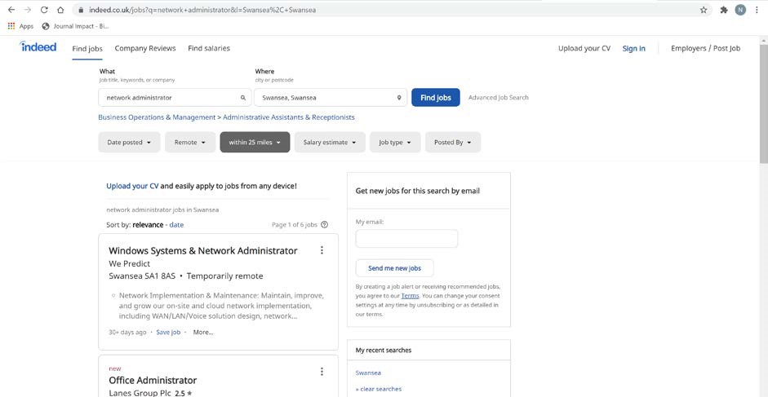
Do a Self-Study on Job Market related to networking skills in ANY Region of your choice (UK, Europe, Middle East etc). Analyze the requirements in the Industry, Skills Sets to be developed, Certifications required to apply for the Job, Salary ranges associated with the Jobs.
ACCA4024

2

n.kaliyamurthy@uwtsd.ac.uk

To complete this task,
You will use a web browser to visit the popular job listing websites, such as monster.com, indeed.co.uk, salary.com. Search on the “Networking” related jobs listed. You shall use keywords like “Network Administrator”, “System Administrator” etc.
Check out the Jobs available, its geographical location (Example: Swansea, Wales), the required technical skills, Certifications and Salary range.
Guidelines:
- Open a web browser and go to a job listing website. In the URL address bar type http://indeed.co.uk and press Enter.
- Search for networking related jobs. Type the word Network Administrator in the Keyword or Title box. Click Find Jobs to continue.

- Notice the search results. Now, focus your search by adding terms to the search for Network Administrator. Try terms like Cisco CCNA, CCNP, CCNA Security, CCNA Voice, etc.
- Try searching a different website. Add a search term like Information Technology to the Job title or Keyword field box and click Get my salary estimate.
- Note the large number of matching search results. Select a job title that interests you. Click
SHOW MY SALARY ESTIMATE RESULTS.
- Spend time searching for jobs and looking through the search results. Take note of what skills are required for different job titles and the range of starting salaries.

Write your report. (Word Limit 300 – 600)
Your report should be a summary of your search which should include (not limited to) the following:
- What job titles did you search for?
I searched for Network Administrator, Network Programmer, Network manager, Cyber Security and any title jobs that could be related to the most relevant one which is Network Administrator.
- What skills or certifications were required?
The first job which was strictly for Network Administrator only required
- Network Administration: 3 years (Preferred)
And that is it.
The second job I found was Network programmer and this job requires:
- Fluent C++ deployed within a similar role in the games industry
- Understanding of client-server and peer-to-peer networks and extensive experience in relation to games
- Deep knowledge o& experience of the network libraries from at least one of the current games console platforms.
- A 2:1-1st class degree or equivalent in a relevant subject such as games, computer science, maths or engineering.
- Experience using version control software in games
- Ability to write clear and maintainable code pertaining games networks
- Experience implementing multi-platform game client networking solutions on current console & PC platforms.
- Solid games industry track record, evidenced such as previously published products
- Desirable; C# and web server programming
And this is it.
The third job I found is Network Manager and this job requires:
- You will have proven experience in IT leadership and technical architecture, managing 20+ employees in conjunction with large outsourced teams.
- You will have in depth experience as a network engineer particularly in planning and designing robust, scalable networks
- A confident communicator with superior oral and written communication, customer service, organizational and problem solving skills
- You will possess an in depth knowledge of operating systems such as Cisco IOS, NX-OS, AireOS, and Palo Alto Network PAN-OS; network protocols such as BGP, OSPF, PFR, etc.
- You will have strong ITIL knowledge and change management experience
- A solid understanding of modern web application architecture, complex cloud network topologies, and security.
- A demonstrated ability to think strategically about business, product, and technical challenges
- Proven project management experience and understanding of network design models
The fourth job requires which is Cyber Security analyst and any person that wants to apply needs to have:
- The Cyber Security Analyst should have IT experience, ideally in an Analyst type role.
As Cyber Security Analyst, you should have an interest/education that is relevant to Cyber Security i.e CompTIA Security +, CISSP and CCNA Security.
We look for outstanding technical people, creative and analytical thinkers, decision-makers, influencers, and excellent communicators. Join us today.

- Did you find any jobs that you previously did not know existed? If so, what were they?
I have not found any jobs that I did not know existed.
- Did you find any jobs that you are interested in? If so, which ones and what skills or certifications do they require?

Yes, the job that caught my attention was “Cyber Security Analyst” and it requires to have some IT Experience and have an interest in a topic or stuff which is related to Cyber Security such as CCNA for example. They’re looking for some really good technical people, creative and also analytical thinkers, decision-makers, influencers and good talkers.

Average salaries
An average salary for workers who just joined Cyber Security industry starts between 25000-35000 GBP.
An average salary for experienced workers starts around 50000 GBP.
An average salary for Cyber Security network managers and leaders starts at a minimum of 70000 GBP.

ACCA4024

End of Document

3 n.kaliyamurthy@uwtsd.ac.uk

