Kate Davies- 2316342

MARKETING MANAGEMENT
BMMB7026- Dec 2023
Netflix change Management report

Executive Summary
This executive summary provides a critical evaluation of Netflix's marketing activities, examining their effectiveness and alignment with the dynamic needs of the streaming and entertainment industry. Building upon a comprehensive analysis, it identifies the effectiveness of Netflix's marketing strategies, resources allocated, and how they've been influenced by both the macro and micro marketing environments.
Marketing Effectiveness and Resources:
The report assesses the effectiveness of Netflix's substantial investment in marketing, particularly in data analytics and AI for personalised content delivery. However, critiquing the limitations of a solely digital approach and the challenges posed by intense competition and subscriber retention.
Influence of Marketing Environments:
delving into how geopolitical unrest, economic cycles, technological advancements, and cultural shifts have influenced Netflix's marketing strategy. Arguing that while Netflix has adeptly navigated these complexities, there's a need for more agile responses to the rapidly changing global landscape.
Change Management Strategies:
The effectiveness of Netflix's transition from an innovation-driven to a data-driven strategy is scrutinised. The report suggests that while this shift has brought sophisticated market targeting and positioning, it may have also contributed to a reactive rather than proactive stance in a fiercely competitive market.
Target Markets and Media Selection:
An analysis of Netflix's target markets reveals strengths in market segmentation and content personalisation but notes potential oversights in account sharing and content fatigue. The report evaluates the selection of media channels, praising the use of social media and SEO but questioning the overall diversity and reach of the digital-only approach.
Measuring Success:
The summary critically evaluates the metrics used by Netflix to measure campaign success, including subscriber growth, engagement metrics, and ROI. It suggests that while these metrics provide valuable insights, they might not fully capture long-term brand loyalty and market position.
Conclusions and Shortcomings:
The conclusion addresses the identified shortcomings, notably in digital market reach, subscriber retention, and the need for more diverse and proactive change management strategies. It emphasises that while Netflix's marketing has been largely successful, these areas represent critical leverage points for future growth and market leadership.
Targeted Recommendations:
Based on these conclusions, the summary proposes targeted recommendations. It suggests that Netflix should explore more diverse, non-digital advertising channels to broaden its market reach, invest in more personalisation algorithms to reduce churn, and adopt more proactive and innovative change management strategies to stay ahead of market trends. These recommendations are presented with an understanding of Netflix's budgetary and resource constraints, aiming for realistic and impactful changes.

Contents
Executive Summary 1
1.0 Introduction 4
2.0 Evaluation of Netflix’s Marketing Activity 5
2.1 Approach and resource allocation 5
2.2 Macro and Micro-Environment 6
2.2.1 Macro Environment (Pestel) 6
2.2.2 Micro Environment (Porter’s Five Forces) 8
2.2.3 Swot 9
2.3 Change Management Strategies 11
2.4 Target Market 13
2.5 Selection of Media 14
2.6 Measuring Success Factors 15
3.0 Conclusion 17
4.0 Recommendations 18
5.0 References 19

1.0 Introduction
The modern business landscape is characterised by dynamic changes and fierce competition. As organisations strive to remain relevant and competitive, the role and activities of the marketing department have become pivotal in shaping their success. This report critically evaluates the change management of the marketing department of Netflix, a global leader in the streaming and content production industry. Building upon the research conducted in Assignment 1 (Marketing MBA presentation, 2023), this report aims to provide a comprehensive analysis of Netflix's marketing activities, assess their effectiveness, and outline future developments to address identified challenges.
Netflix business model success factors- These include strategic alliances with various tech companies, a compelling value proposition, essential activities such as content curation, and a customer-centric approach to partnerships as studied in Exploring Strategy (Whittington et al., 2020). Today, Netflix (2023a, c) is recognised as a subscription-based streaming service and content production company that has transformed the entertainment industry with its vast library of TV shows, movies, documentaries, and original content. It is accessible on a wide range of internet-connected devices and operates in 190 countries, boasting a subscriber base of 231 million, generating approximately 31.6 billion U.S. dollars in annual revenue (Statista, 2023b)- a significant growth from just a decade ago when it generated 3.6 billion U.S. dollars in revenue.
Marketing strategy success factors- The company excels in its use of AI resulting in personalised content recommendations, effective use of social media for engagement and promotion, wide-reaching campaigns, and maintaining a strong presence in search engine results through search engine optimisation. Furthermore, Netflix's commitment to customer obsession and innovation, sets it apart in the industry. Its data analytics capabilities enable a deep understanding of consumer preferences, leading to the delivery of high-quality, ad-free content 24/7 on various devices, solidifying its position as a global entertainment powerhouse as studied (Jobber and Ellis-Chadwick, 2016).
Challenges
Whilst Netflix hold the largest share, they have recently experienced a loss in existing subscribers, disguised by expansion into new markets attaining new subscribers. Whilst Netflix continues to grow their rivals are growing at a faster pace (Sweney, 2023).
Report Scope
This report aims to evaluate Netflix's marketing department and activities utilising academic marketing theory, focusing on change management due to shifts in consumer buying behaviour, resource allocation, and the impact of the macro and micro marketing environment. It also assesses threats, target market strategies, media channels, and campaign measurement. The report aims to identify challenges and provide recommendations for improving Netflix's marketing strategy in an evolving industry.

2.0 Evaluation of Netflix’s Marketing Activity

2.1 Approach and resource allocation
Netflix according to Statista (2023a) allocated (approximately) $2.53 billion to its marketing efforts in 2022, whilst an extensive expenditure this is a moderate expense in relation to their $31.6 billion revenue equating to 8% of revenue. According to theorists (Turner, 2022) a budget of 10% of sales is considered optimal.
Netflix (2023c) state their marketing approach focuses on connecting people with diverse content and delivering value. They use research and machine learning to identify growth opportunities, prioritise markets, and optimise advertising for attracting new members. Collaborations with online advertisers help broaden their reach. They also employ causal modelling and automation to fine-tune budgets and maximise the impact of their marketing efforts.
From the statement provided by Netflix, we can determine and analyse several aspects of their marketing approach and the resources they allocate thought the lens of academic theory as studied by Jobber and Ellis-Chadwick, (2016) and Lynch (2018)
Data-Driven Decision-Making: using various research models, machine learning to understand member behaviours, prioritise geographical markets, and optimise their advertising spend. This demonstrates a strong commitment to leveraging data and analytics in their marketing strategies.
Personalisation: Netflix targets members who would perceive value in their content library. They use algorithms to optimise how they reach out to members, with a goal to maximise member enjoyment. This highlights their dedication to delivering personalised content recommendations and marketing messages.
Content Marketing: acknowledging the importance of deciding which titles to market. They collaborate with leading online advertisers and employ machine learning to identify content that resonates with non-members. This approach suggests that they invest resources in selecting and promoting the most appealing content to potential subscribers.
Efficient Marketing Spend: The statement reveals that Netflix is concerned about optimising its advertising spend. They seek to determine the net effect of their marketing efforts and focus bids on opportunities where they will make the biggest difference. This reflects a strategic allocation of resources to ensure efficient use of their marketing budget.
Global Strategy: Netflix operates in multiple countries, and they are concerned about how to allocate marketing resources in each country, time window, and channel. They acknowledge that automating these decisions is essential for optimising growth. This demonstrates their commitment to a global marketing strategy and the allocation of resources to support it.
Continuous Experimentation: Netflix mentions designing experiments to understand the marketing space better. This implies that they allocate resources to experimentation and testing to refine their marketing strategies continually.
Collaboration: Netflix collaborates with leading online advertisers such as Facebook, Google, and YouTube. This suggests that they allocate resources to build partnerships and collaborations that can extend the reach of their marketing messages.
It can be determined that Netflix’s marketing strategy and competitive advantage derive from.
- Customer centric approach
- Content variety and original production
- Global expansion and localisation
Summary
Netflix aim to create value for consumers from performance value methods a modern approach towards value creation and brand building as studied in the Harvard Business Review (Stengel, Lamberton and Favaro, 2023) involving the process of utilising machine learning, modelling, and experimentation to refine their strategies continuously. Their commitment to understanding member behaviour and optimising advertising spend reflects a sophisticated and dynamic marketing approach. This approach means their marketing budget is largely spent on software to generate this approach.
However, Netflix's marketing approach, while successful, has several potential drawbacks. Their approach is entirely digital posing threats of limiting potential consumer reach. Digital practices concerns, content overload causing decision fatigue, and potential variations in content quality, all posing challenges. Netflix also faces issues with subscription churn and the effectiveness of content recommendations.

2.2 Macro and Micro-Environment

2.2.1 Macro Environment (Pestel)
Understanding the macro environment with the use of Pestel as studied in The Global Business Environment (Morrison, 2023)
Political:
- Geopolitical unrest: Ongoing tensions, especially the Russia-Ukraine conflict, contribute to global supply chain vulnerabilities and inflationary pressures, affecting Netflix in operations of content creation and rising costs (Accenture, 2022).
- Regulations and Content Restrictions: Due to individual countries set of regulations regarding content censorship and licensing. Netflix (2023c) is not available due to restrictions in four countries China, Crimea, North Korea, Russia, and Syria.
- Political tax interventions: Netflix is available for streaming in more than 190 countries with different political stances on streaming services taxation, The US has different taxes for each state with increasing demand for higher taxes as reported by Deloitte, (2022)
Economic:
- Economic Cycles: Economic conditions such as high inflation rates affect consumers' willingness to spend on entertainment subscriptions. Impact evidenced resulting in reported lowest level of new subscribers to date (This Is Money, 2023).
- Operation costs: because of record high inflation rates Netflix operational costs will increase. Reporting a 3.79% increase in 2023 (Macrotrends, 2023)
Sociocultural:
- Changing Viewing Habits: Binge-watching, especially among younger age groups, has become more prevalent as home-based entertainment gains importance whilst this is beneficial for Netflix health studies are reporting Alimoradi et al. (2022) negative mental health affects which will impact Netflix subscribers’ views.
- Family-Oriented Lifestyle: Lifestyle changes towards more family-oriented and balanced entertainment may influence content preferences.
- Language and Localisation: In the United States, 55% of Netflix's library consists of English titles, while 45% are foreign-language titles (Moore, 2020). Offering local language content or accurate subtitles is essential for broader appeal. However, in primarily one language speaking regions, the extensive diversity and content volume may not align with consumer preferences.
Technological:
- Tech advancements: Netflix (2023c) utilises AI for tracking consumer behaviour to enhance content recommendations and user experience.
- Rapid Content Production: The ability to rapidly produce content enhances marketing efficiency.
- Internet provisions: Increasing global internet provisions and quality enables Netflix to reach further and provide better services with uninterrupted streaming and high-quality content delivery. The UN (2021) reports that a third of the population (2.9 billion people) have never used the internet.
- Data Security and Privacy: As a data-intensive platform, Netflix (2023b) faces challenges related to data security and privacy. Ensuring the protection of user data is crucial to maintain trust.
Environmental:
- Environmental Impact: Netflix's (2023c) data centres and streaming infrastructure have environmental implications due to their energy consumption. Following pressures to reduce the environmental footprint Netflix have committed to cut footprint by half by 2030.
Legal:
- Copyright and Intellectual Property: Legal challenges related to copyright infringement and intellectual property rights can arise, especially concerning original content production and licensing agreements.
- Antitrust and Competition Regulations: Netflix operates in a highly competitive market. Antitrust and competition regulations may affect market dynamics and require compliance.
- Union Strikes: Actors strikes affect content delivery.
Summary
Netflix faces geopolitical, regulatory, economic, and cultural challenges, but it has opportunities in AI insights, technological advancements, efficient content promotion, improved internet provisions, sustainability, and legal compliance. Leveraging these opportunities can help Netflix mitigate threats and maintain its competitive edge in the streaming industry.

2.2.2 Microenvironment (Porter’s Five Forces)
Utilising academic theory (Whittington et al., 2020) to analyse the industry and sector the competitors have been identified, industry analysed, and Porter’s (1979) five forces applied.
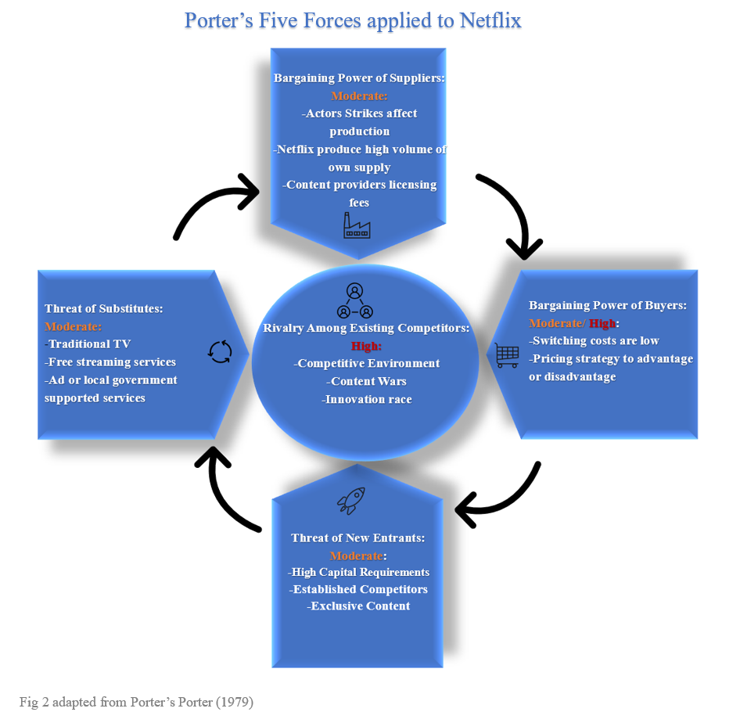
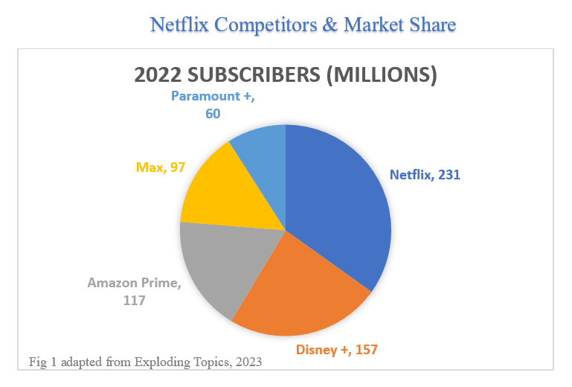
A Five Forces analysis reveals a competitive industry landscape characterised by growing rivalry. In this sector, Netflix contends with formidable rivals in the form of major corporations like Amazon, Disney, and Max (Exploding Topics, 2023), which benefit from robust additional revenue sources, enabling substantial investments in their streaming platforms. This competitive landscape amplifies the influence of the buying power incidentally Netflix's driver of change. Competitors, marked by their strong brand presence and expansive customer bases, further intensify this dynamic.
Netflix (2023b) is acutely aware of this challenging environment and adopts strategies for differentiation. The company sets itself apart by consistently delivering an extensive catalogue of original content, personalised user experiences, and region-specific approaches to markets. These strategic initiatives collectively serve to shape consumer behaviour by enhancing the perceived value of Netflix's offerings.
Summary
The streaming industry is characterised by strong competitive rivalry and the need for substantial investments in content and technology whilst strategically considering plans for price sensitive consumers. While the threat of new entrants is low. This noted, at present Netflix have the largest market share and strong brand recognition suggesting successful marketing strategy. Managing content costs and innovation are critical for Netflix's competitiveness.

2.2.3 Swot
Compiling a holistic review of the operating environments, applying a SWOT framework as studied in Strategic Management (Lynch, 2018)
Strengths:
- Strong Brand Recognition: Netflix is a well-established global leader in the streaming and content production industry with a subscriber base of 231 million.
- Content Variety and Original Production: Netflix's extensive library of original content sets it apart in the industry.
- Global Expansion and Localisation: Operating in 190 countries demonstrates global reach and adaptability to local preferences.
- Innovation and Technology: Netflix's use of AI, data analytics, and machine learning enhances user experiences and content recommendations.
Weaknesses:
- Digital-Only Presence: Netflix's digital focus may limit its reach to potential consumers who prefer traditional media.
- Subscription Churn: Challenges related to retaining existing subscribers.
- Algorithmic Personalisation Limitations: Overreliance on algorithms may result in skewed recommendations.
- Increased Competition: Rivals are growing at a faster pace, posing a threat to Netflix's market share.
Opportunities:
- AI Insights and Technology: Continued advancements in AI can further improve content recommendations and user experience.
- Efficient Content Promotion: Opportunities to enhance marketing efficiency.
- Improved Internet Provisions: Increasing global internet provisions enable better services.
Threats:
- Geopolitical and Regulatory Challenges: Geopolitical tensions and content regulations in various countries can affect operations and content availability.
- Economic Factors: Economic cycles and high inflation rates can impact consumer willingness to spend on subscriptions.
- Changing Viewing Habits: Negative mental health effects associated with binge-watching may affect subscribers' views.
- Content Production Costs: The financial burden of producing original content may pose challenges.
This SWOT analysis highlights Netflix's strengths in brand recognition, data-driven decision-making, and content variety. However, it also underscores the need to address weaknesses such as content overload, subscription churn, and algorithmic limitations. Netflix should seize opportunities in AI, technology and new markets with increasing internet provisions while navigating geopolitical and regulatory challenges and managing content production costs in the face of growing competition.

2.3 Change Management Strategies
Netflix (2023a), throughout its history, has undergone numerous instances of change management as studied (Cameron and Green, 2019), primarily driven by innovation defining the industry as they grow. Now an established streaming platform their driver of change has altered from anticipating consumer buying behaviour to managing it. The company has consistently positioned itself as a technology-driven entity (Economist Impact, 2022), characterised by a relentless pursuit of innovation. Netflix has often led the industry in pioneering advancements, as evidenced by Gartner's (2018) technology hype cycle, which illustrates how the company has effectively responded to the drivers of change experienced.
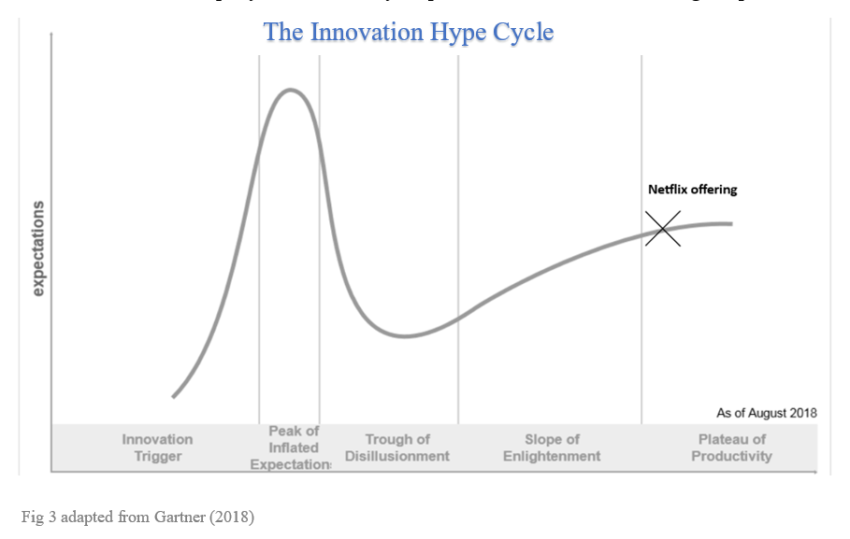
Netflix's strategy has involved the strategic deployment of new products and technologies during the second or third phases of the hype cycle, pre-empting consumer disillusionment. This proactive approach allowed them to be propelled into an industry leader, marked by sustained and consistent growth over the years. This approach is considered highly successful in gaining competitive advantage (Gartner, 2018). However, it is noteworthy that in the past decade, Netflix has refrained from making significant alterations to its offerings. Consequently, the company now finds itself in uncharted waters, grappling with intensified competition, while the subscriber base continues to expand with new sign-ups, Netflix is concurrently experiencing attrition among existing subscribers, as reported by The Guardian (Sweney, 2023).
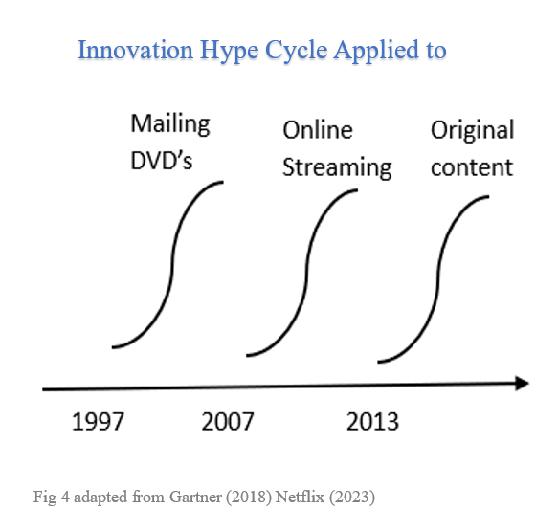

It can be argued the reason for this is that Netflix has undergone a shift in its approach to adapting to market trends. Netflix has shifted from innovation-driven to data-driven, emphasising the importance of user data for identifying trends and content preferences. It now relies on advanced analytics tools to extract valuable insights from user data.
Netflix's historical change management has been successful, reflecting its agility and market enhancement capabilities. While its marketing is digitally focused, transitioning from innovation to data-driven approaches has made it more reactive to consumer behaviour shifts as opposed to proactive.

2.4 Target Market
Netflix(2023b) employs a well-defined Segmentation, Targeting, and Positioning strategy as studied (Jobber and Ellis-Chadwick, 2016).
Segmentation
Demographics: Initially used to effectively target potential subscribers, demographics become less important once an individual subscriber.
Geographic: Netflix adapts offerings to local preferences, utilizing geographic segmentation to expand into new markets.
Psychographics: Netflix excels in understanding viewer interests and behaviours, categorizing users into segments like "comedy enthusiasts" and "action seekers" to personalize content recommendations.
Usage Patterns: Netflix employs algorithms to monitor viewing habits, enhancing personalization by recommending content aligned with user behaviour.
Content Preferences: Previous segmentation considerations inform content recommendations, enhancing the overall user experience.
Analysis: Netflix's psychographic segmentation and personalised content recommendations are clear strengths. However, it's essential to acknowledge that their overreliance on algorithms is a weakness and may sometimes result in skewed recommendations, especially if multiple users share an account or if a viewer occasionally explores different content genres.

Targeting
Broad Targeting: Netflix effectively reaches a diverse audience through data analytics and AI, catering to a wide range of consumers.
Micro Targeting: Utilising data-driven insights, Netflix customises content for specific niche markets. Popularity assessments guide content commissioning, meeting the demands of various audience segments enabling them to micro market.
Analysis: Netflix's ability to produce diverse content to balance broad targeting with micro marketing is a strategic advantage over competitors and arguably Netflix’s’ area of excellence.

Positioning
Quality and Variety: Emphasising high-quality content and diverse genres.
Convenience: Highlighting ad-free, on-demand viewing.
Personalisation: Understanding and catering to individual preferences.
Global Reach: Offering content in multiple languages and regions.
Original Content: Being a hub for exclusive and original content.
Analysis: Netflix's positioning as a premium, user-centric, and global streaming service has been instrumental in its success. However, competitor subscription number increasing evidence a need for attention in this area.
Summary
Netflix's STP strategy is a foundation of its industry leadership. The innovative use of AI and data analytics enables them to cater to a broad audience while also delving into niche markets. Nevertheless, it is important to acknowledge the limitations associated with algorithmic personalisation and account sharing, increased competition and consumer retention issues present a warning sign for their current positioning strategy.

2.5 Selection of Media
Netflix has recently adjusted its marketing approach (Hanlon, 2023) by refining its product offerings, introducing subscription tiers tied to various quality and price levels (Frost, 2023). This strategic shift is driven by internal drivers aimed at influencing consumer buyer behaviour, and external drivers of increased competition, with the goal of both retaining existing customers and attracting new ones.
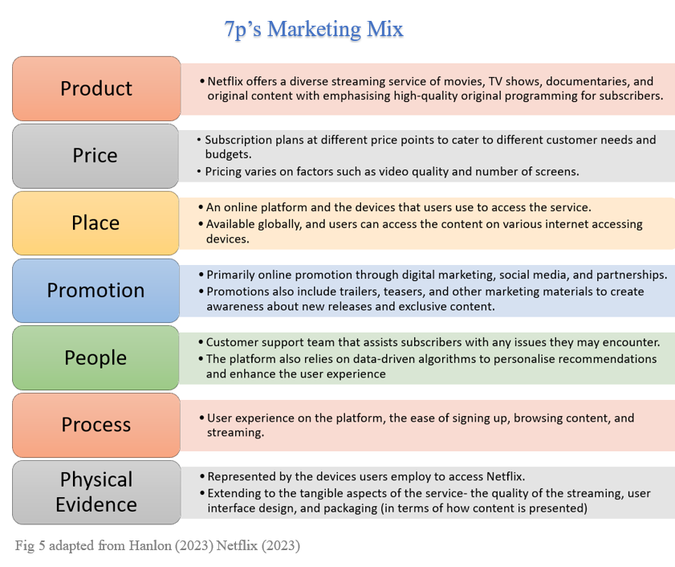
Netflix's marketing mix emphasises product quality, flexible pricing, global accessibility, effective digital promotion, and a seamless user experience. These elements position Netflix as a leader in the streaming industry, catering to a broad audience and driving growth. However, pricing increases and the financial burden of original content creation pose challenges.
In Netflix's transition from DVD rental to digital streaming, significant changes occurred in the 7Ps marketing mix:
Product:
Change: Netflix expanded from DVD rental to digital streaming with diverse content, including originals.
Innovation: Introduction of original content marked a significant shift.
Place:
Change: Delivery shifted from physical DVDs to digital streaming on various devices.
Innovation: Enabled global accessibility.
Promotion:
Change: Promotion evolved from DVD rentals to digital streaming, focusing on digital marketing and partnerships.
Innovation: Use of trailers and digital materials created anticipation for exclusive content.
Physical Evidence:
Change: Shifted from DVD mailings to digital access.
Innovation: Improved streaming quality and user interface design, enhancing the streaming experience.
These changes reflect Netflix's strategic response to the evolving preferences of consumers and the digital transformation of the entertainment industry. Netflix's innovation in content creation, streaming technology, and user experience has been pivotal in adapting its marketing mix to meet the demands of the digital age.

2.6 Measuring Success Factors
Netflix (2023b) assesses the effectiveness of its marketing campaigns through various key performance indicators (KPIs) and analytical tools as studied (Dragana Velimirovic, Milan and Stanković Rade, 2011). Whilst Netflix do not explicitly state their KPI we can theorise that the following methods would be suitable to analyse performance:
Subscriber Growth: Netflix tracks the number of new subscribers acquired during and after a campaign to measure its impact on subscriber growth.
Churn Rate: The company monitors the churn rate to see if marketing campaigns are effective in retaining existing subscribers.
Engagement Metrics: Metrics like user engagement, content consumption rates, and time spent on the platform are used to gauge how well a campaign encourages active usage.
Conversion Rates: Netflix analyses conversion rates at different stages of the customer journey, from website visits to sign-ups and upgrades.
Content Popularity: The popularity of promoted content, measured through views, ratings, and user interactions, indicates campaign success.
Audience Segmentation: By analysing campaign performance across different audience segments, Netflix can tailor future campaigns to specific demographics or viewer preferences.
Customer Feedback: Monitoring user reviews, comments, and feedback on social media and the platform itself provides insights into customer sentiment.
Return on Investment (ROI): Netflix calculates the ROI of marketing campaigns by comparing the cost of the campaign to the revenue generated from new subscriptions or retained subscribers.
A/B Testing: Conducting A/B tests allows Netflix to compare the effectiveness of different campaign elements, such as ad copy, visuals, or targeting.
Data Analytics: Netflix relies on advanced data analytics and machine learning to analyse large datasets, identify trends, and uncover insights about user behaviour and campaign impact.
Competitive Benchmarking: Netflix also compares its campaign performance to that of competitors to assess its market position and identify areas for improvement.
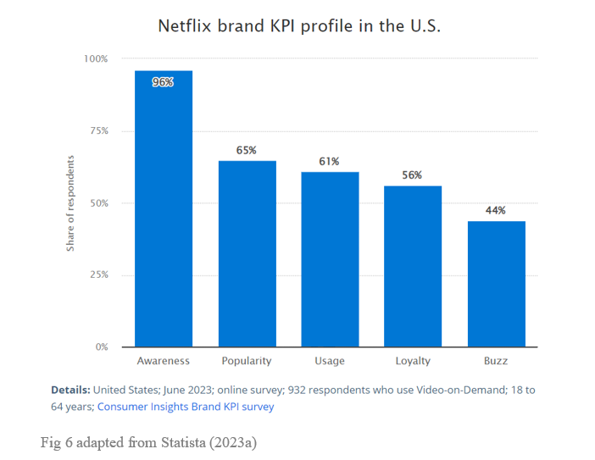
By combining these methods and leveraging data-driven insights, Netflix can continually refine its marketing strategies and campaigns to maximise their effectiveness in attracting, retaining, and engaging subscribers ultimately these insights are where Netflix can exert control on the bigger picture of their offering and brand as shown in Statista (2023a) publishing a positive brand profile KPI.

3.0 Conclusion
In conclusion, Netflix's journey from a DVD rental service to a global streaming giant with 231 million subscribers and significant annual revenue of 31.6 billion U.S. dollars showcases its remarkable success.
Netflix's marketing strategies have been successful in many aspects, particularly in the use of data-driven decision-making, personalisation, content curation, and global expansion. The company's commitment to understanding user behaviour and optimising advertising spend has solidified its position as a global entertainment powerhouse.
However, several challenges and potential drawbacks have been identified. These include digital limitations, high subscription costs, algorithmic issues, subscription churn, and the effectiveness of content recommendations. To address these challenges and continue its success, Netflix must remain innovative and adaptable in the rapidly changing digital landscape.
The report also examined the macro and micro marketing environment. Netflix faces challenges and opportunities in these areas, such as geopolitical unrest, economic cycles, changing viewing habits, and technological advancements. Leveraging opportunities and mitigating threats will be crucial for Netflix's competitiveness.
Furthermore, the report discussed Netflix's change management strategies, highlighting its shift from an innovation-driven approach to a data-driven one. While Netflix has a history of successfully adapting to market trends, it now faces intensified competition and subscriber attrition.
The report delved into Netflix's segmentation, targeting, and positioning strategy, emphasising its use of data analytics and AI to cater to a broad audience while also exploring niche markets. Maintaining a high level of personalisation while addressing algorithmic challenges and reviewing positioning strategy is essential for customer satisfaction.
Finally, the report examined Netflix's marketing mix, Netflix's emphasis on product quality, flexible pricing, global accessibility, effective digital promotion, and seamless user experience positions it as an industry leader. However, challenges such as pricing increases and content quality variations need to be addressed.
Overall, Netflix's marketing department has demonstrated significant strengths and achievements, but it must remain vigilant and adaptive in the face of evolving consumer preferences and competitive pressures in the streaming industry. Continuing to innovate, refine its strategies, and prioritise customer satisfaction will be key to its future success.

4.0 Recommendations
Based on the report, here are three marketing recommendations for Netflix that provide a plan of action for a multidimensional view that aim to turn a strength into an opportunity, tackle a weakness and mitigate a threat:

- Leverage Collaborations to Integrate Virtual Reality (VR):
Netflix should collaborate with VR technology companies, such as Meta to integrate virtual reality experiences into its platform and deploy within the next 12 months. VR can provide immersive and interactive content experiences, enhancing user engagement and satisfaction. By embracing emerging technologies like VR. This recommendation would seek to innovate their current offering attaining differentiation, proactively addressing the positioning issues whilst capitalising on their strength in brand recognition to be able to partner with high profile companies.

- Enhance Personalisation Algorithms:
Netflix should continue to tackle its weaknesses and invest in refining its personalisation algorithms. While the company excels in data-driven decision-making, addressing algorithmic issues is crucial. Netflix should focus on reducing decision fatigue for subscribers by improving content recommendations. Ensuring that content suggestions align more closely with viewers' tastes will lead to higher user satisfaction and longer subscriptions aiming to increase retention by 30% on the previous year.

- Expansion by Content Variety and Localisation Marketing:
To minimise threats of economic cycles Netflix should capitalise on its strength of expansion through localisation Netflix should utilise the opportunity of increased internet provisions and quality to expand further Netflix should prioritise content variety and localisation. While maintaining its extensive library content. By offering a diverse range of content options that reflect the cultural and linguistic diversity of its global audience, Netflix can expand its market reach and appeal with a less digital delivery system with billboards and localised adverts to target a broader demographic. An additional 2% of revenue can be allocated for this task, keeping marketing budget within advised scope.

These recommendations align with Netflix's current strengths and the challenges it faces, providing opportunities for growth, differentiation, and improved customer satisfaction in an ever-evolving streaming landscape.

Words 4021

5.0 References
Accenture (2022) How visibility can boost supply chain resilience | Accenture, Accenture.com. Available at: https://www.accenture.com/gb-en/about/company/war-in-ukraine-business-impact (Accessed: 6 December 2023).
Alimoradi, Z. et al. (2022) ‘Binge-Watching and Mental Health Problems: A Systematic Review and Meta-Analysis’, International Journal of Environmental Research and Public Health, 19(15), p. 9707. Available at: https://doi.org/10.3390/ijerph19159707.
Cameron, E. and Green, M. (2019) Making sense of change management: a complete guide to the models, tools, and techniques of ... organizational change. Kogan Page Stylus.
Deloitte (2022) Streaming services+tax: Rules Shift Rapidly across the United States, Deloitte Insights. Available at: https://www2.deloitte.com/uk/en/insights/industry/technology/tax-on-streaming-services.html (Accessed: 13 December 2023).
Dragana Velimirovic, Milan, V. and Stanković Rade (2011) Role and importance of key performance indicators measurement, ResearchGate. unknown. Available at: https://www.researchgate.net/publication/50373240_Role_and_importance_of_key_performance_indicators_measurement (Accessed: 4 January 2024).
Economist Impact (2022) How Netflix Created an Ecosystem for Open Innovation, impact.economist.com. Available at: https://impact.economist.com/projects/open-innovation/article (Accessed: 4 January 2024).
Exploding Topics (2023) Video Streaming Services Stats (2023), Exploding Topics. Available at: https://explodingtopics.com/blog/video-streaming-stats (Accessed: 2 January 2024).
Frost, G. (2023) Netflix price changes UK: how they affect subscribers, Times Money Mentor. Available at: https://www.thetimes.co.uk/money-mentor/income-budgeting/netflix-uk-price-news (Accessed: 4 January 2024).
Gartner (2018) Gartner Hype Cycle Research Methodology, Gartner. Available at: https://www.gartner.co.uk/en/methodologies/gartner-hype-cycle (Accessed: 20 November 2023).
Hanlon, A. (2023) How to Use the 7Ps Marketing Mix? - Smart Insights, Smart Insights. Available at: https://www.smartinsights.com/marketing-planning/marketing-models/how-to-use-the-7ps-marketing-mix/ (Accessed: 20 November 2023).
Jobber, D. and Ellis-Chadwick, F. (2016) Principles and Practice of marketing. 8th edn. Maidenhead: Mcgraw-Hill Higher Education.
Lynch, R. (2018) Strategic Management. 8th edn. Harlow, United Kingdom; New York: Pearson Education Limited.
Macrotrends (2023) Netflix Operating Expenses 2010-2022 | NFLX, www.macrotrends.net. Available at: https://www.macrotrends.net/stocks/charts/NFLX/netflix/operating-expenses#:~:text=Netflix%20operating%20expenses%20for%20the%20twelve%20months%20ending%20September%2030 (Accessed: 13 December 2023).
Marketing MBA presentation (2023) Netflix Group Presentation. University Of Wales Trinity StDavid.
Moore, K. (2020) Does Netflix Have Too Much Foreign Content? What’s on Netflix. Available at: https://www.whats-on-netflix.com/news/does-netflix-have-too-much-foreign-content/ (Accessed: 13 December 2023).
Morrison, J. (2023) The Global Business Environment. 6th edn. Bloomsbury Publishing.
Netflix (2023a) About Netflix, Netflix. Available at: https://about.netflix.com/en (Accessed: 20 November 2023).
Netflix (2023b) Netflix annual report 2022. Available at: https://s22.q4cdn.com/959853165/files/doc_financials/2022/ar/4e32b45c-a99e-4c7d-b988-4eef8377500c.pdf (Accessed: 2 January 2024).
Netflix (2023c) Netflix Research Marketing & Growth, Netflix.com. Available at: https://research.netflix.com/business-area/marketing-and-growth (Accessed: 13 December 2023).
Netflix (2023d) Where is Netflix available? Netflix Help Center. Available at: https://help.netflix.com/en/node/14164 (Accessed: 13 December 2023).
Porter, M.E. (1979) How Competitive Forces Shape Strategy, Harvard Business Review. Available at: https://hbr.org/1979/03/how-competitive-forces-shape-strategy (Accessed: 9 December 2023).
Statista (2023a) Consumer Insights Brand KPI survey, Statista. Available at: https://www.statista.com/insights/consumer/brand-profiles/3/5/netflix/united-states/#contentBox1 (Accessed: 4 January 2024).
Statista (2023b) Netflix: marketing expenditure 2022, Statista. Available at: https://www.statista.com/statistics/1097045/netflix-marketing-expenditure/#:~:text=In%202022%2C%20Netflix%20spent%20around (Accessed: 13 December 2023).
Statista (2023c) Netflix: revenue in 2018 | Statista, Statista. www.statista.com. Available at: https://www.statista.com/statistics/272545/annual-revenue-of-netflix/ (Accessed: 2 January 2024).
Stengel, J., Lamberton, C. and Favaro, K. (2023) ‘How Brand Building and Performance Marketing Can Work Together’, Harvard Business Review. Available at: https://hbr.org/2023/05/how-brand-building-and-performance-marketing-can-work-together (Accessed: 2 January 2024).
Sweney, M. (2023) Netflix to lose 700,000 UK customers in two years, analysts predict, the Guardian. Available at: https://www.theguardian.com/media/2023/jan/01/netflix-to-lose-700000-uk-customers-in-two-years-analysts-predict (Accessed: 13 December 2023).
This Is Money (2023) Netflix Hit by Cost-of-Living Crisis as Fewer New Subscribers Sign up, This Is Money. Available at: https://www.thisismoney.co.uk/money/markets/article-12616541/Netflix-hit-cost-living-crisis-number-new-subscribers-slumps-lowest-decade.html (Accessed: 13 December 2023).
Turner, J. (2022) What Marketing Budgets Look Like in 2022, Gartner. Available at: https://www.gartner.com/en/articles/what-marketing-budgets-look-like-in-2022 (Accessed: 2 January 2024).
United Nations (2021) Despite COVID-19 connectivity boost, world’s poorest left far behind, UN News. Available at: https://news.un.org/en/story/2021/12/1106862 (Accessed: 13 December 2023).
Whittington, R. et al. (2020) Exploring Strategy. 12th edn. Hoboken: Pearson.

