Project Management & Research Methods – Individual Report

Project: GoGoCook

Author: Ben Kiddie

Student Number: 1800242

Submitted: 31 / 01 / 2020

Contents
Risk Management 1
Potential Risks 2
Risk Evaluation Matrix 4
Sustainability Issues 5
Sustainability Analysis 6
Order of Impacts Analysis 7
First Order Impacts 7
Second Order Impacts 7
Third Order Impacts 7
Ethical and Legal Issues 8
British Computing Society (BCS) Code of Conduct 9
General Data Protection Regulation (GDPR) 11
Quality Assurance 12
SMART Quality Assurance 13
Educational Objectives 14
Gamification Objectives 17
Utility Objectives 21
Overall App Design 24
Bibliography 27
Table of Figures 28
Appendix 29

Risk Management
This section aims to discuss the different kinds of risks that face the development of our group project – the development of a phone application “GoGoCook” – and highlight these within a risk evaluation matrix, where the risks (each numbered) are plotted in a probability versus impact graph.

Potential Risks
The following is a list of potential risks to the development of the project. These are broken down into what they are, how they impact the project, in addition to a probability (very unlikely, unlikely, possible, likely, very likely) and impact rating (very small, small, moderate, high, very high):
- Illness among personnel may affect the speed at which they work, or in worst case halt work. However, it is possible to telecommute with software, and may reduce the impact that illness has. Probability – Possible; Impact – Small.
- Injury among personnel may prevent them from working on the project. However, given the environment of working with software, this is not a likely event. Probability – Unlikely; Impact – Moderate.
- Lack of resources required to complete the project may slow progression where personnel may need to temporarily work on something else, or in worst case halt progression if the task at hand is necessary for the next step to proceed. Given the nature of software development, it is possible that further need of resources is possible. Probability – Possible; Impact – Moderate.
- In the event personnel miss a group meeting or don’t appear at any events involving the rest of the group, they will miss out on important happenings and details within the group project. However, this is mitigated greatly using communication services such as social media, which can be used to relay what occurred. Probability – Very Likely; Impact – Very Small.
- A delay in acquisition of resources, e.g. an online order not arriving on time, will potentially slow or halt project development. Probability – Unlikely; Impact – Small.
- A lack of time management, or unexpected changes in time needed such as a shortened deadline or new tasks taking up already allocated time would require a change in personnel and time allocations. It is generally unlikely that deadlines will change, and the need for new task allocations are uncommon. Probability – Unlikely; Impact – High.

- A change in project scope, i.e. new requirements or resources are needed for the project to proceed, will most certainly slow down the project progression. In addition, the nature of this project is a foray into new software practices, so unexpected delays are to be expected. Probability – Possible; Impact – Moderate.
- Loss or damage to hardware will halt project development, or in worst case reset progress within the hardware role of the project. Hardware can be replaced, but at a cost of money and time to replace. General safety precautions can be taken to reduce probability of this occurring, such as storing the hardware safely. Probability – Unlikely; Impact – High.
- Loss or damage of software is generally not as much of an issue compared to hardware given the presence of the Internet enabling the redownload of software within a particularly short timeframe. Backups of software reduce this further. Additionally, high profile software is typically robust enough to reduce the probability of this happening significantly. However, this will slow project development, albeit not much. Probability – Very Unlikely; Impact – Very Small.
- Loss or corruption of data is very unlikely, however poor management and failure to adhere to general software handling practices make this a potential risk. This will end up halting project development, or potentially resetting progress, and in worst case means starting over. So long as backups of software are made regularly, the impact this has can be lessened. Probability – Very Unlikely; Impact – Very High.

Risk Evaluation Matrix
The purpose of this matrix is to provide a simple graphic showing the risks listed previously.
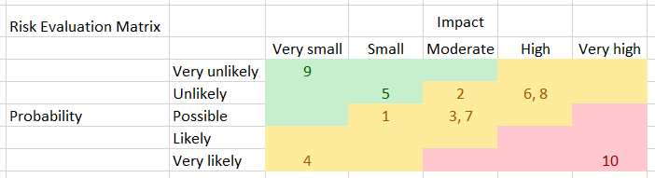
Figure 1 Risk Evaluation Matrix

Sustainability Issues
The development and maintenance of a project will impact and be impacted on by many external factors. In this section, the environmental sustainability of this project will be analysed, followed by a list of first, second and third order impacts of our project.

Sustainability Analysis
The term ‘sustainability’ is defined as “the development that meets the needs of the present without compromising the ability of future generations to meet their own needs” according to an article by Marisa [1]. In our project, there are several outstanding features that may influence environmental sustainability. These are listed below with potential mitigations to their impacts:
- The weighing scale produced by our project can be produced using many different materials, including non-environmentally friendly kinds. Our project should aim to make the scale using biodegradable materials to reduce e-waste potential.
- The scale could be manufactured using non-green sources of energy. To mitigate the carbon footprint in this process, seeking out green sources of energy (man-made, renewables, etc) is desirable.
- The devices used in development of the project may be energy intensive. Good development practice would be to minimize energy usage and reuse available devices to reduce overall waste.
- The ideal product would be making use of servers, which are quite energy intensive. Any usage of servers within our project should be running on green energy to reduce the overall carbon footprint of the project.
- The dishes promoted within “GoGoCook” should include greener alternative dishes to promote the minimisation of the carbon footprint of potential customers.
- The energy efficiency of the app may influence overall usage of mobile phone energy. Utilising software infrastructure techniques that minimise memory usage and execution times will reduce the overall carbon footprint as a result of lower battery consumption.

Order of Impacts Analysis

First Order Impacts
First order impacts are those that directly influence the environment. In the case of our app, the following fall under this category:
- Scales may be produced using non-green energy, and of non-biodegradable materials.
- The infrastructure of the app may influence the energy usage of a phone, affecting users’ carbon footprint.
- The type and amount of potential server usage affects the company’s (i.e. the project team) carbon footprint.

Second Order Impacts
Second order impacts are the effects the project has on other aspects of society which influence the environment. Some potential second orders are as follows:
- Our app promotes cooking, which encourages shopping at grocers or buying fresh ingredients from supermarkets. This may encourage purchasing food grown locally, therefore reducing carbon footprint by way of diverging from goods transported from other areas of the country.
- Due to the app encouraging the user to cook, this also means that other food companies may be influenced:
  - Takeout becomes less of an attractive option, lowering the traffic of delivery companies, thus reducing carbon emissions.
  - Ready made meals with single use packaging may become less popular, reducing waste.
  - Fast food could be influenced, as this industry is intensive on transportation (e.g. long-distance hauling) and production (e.g. clearing farmland, raising livestock) of ingredients.

Third Order Impacts
Third order impacts are the larger long-term effects our project may have on society. Some potential third order impacts are:
- Improved business for local agriculture.
- Reduction in the carbon footprint of fast food and take-out.

Ethical and Legal Issues
The ethical and legal side of project development is very important, as governing bodies must be kept happy in terms of what goes on within a company. This section will aim to cover the BCS [2] code of conduct. In addition, aspects of the GDPR [3] will be discussed in the context of our project.

British Computing Society (BCS) Code of Conduct
The BCS Code of Conduct looks to maintain professional standards of people within companies, regardless of their position or role. There are four main areas the BCS covers, which will be discussed in the context of our project:
- Public Interest
  - Our app promotes the wellbeing of users through healthy dish options. The design will be robust and secure to preserve user integrity.
  - Our company will not violate the rights of companies influenced by our project. These may include, but are not limited to, storefronts that sell our product (e.g. Google Play, iOS Store), supermarkets or fast food joints.
  - Our company will not discriminate between people involved in the project.
  - Our company will not discriminate between people who wish to access our product.
- Professional Competence and Integrity
Our company shall:
  - Not work members of our team outside of their designated roles or professions within the company.
  - Not claim to be proficient in fields or industries we are not.
  - Seek to continuously maintain and adapt skills relevant to the fields necessary for the development of our app. This may include keeping informed with legal bodies (e.g. subscribing to bulletins) and staying up to date with other companies (e.g. via newsletters, direct communication).
  - Comply with any regulations set out by legal bodies. These include, but are not limited to, the GDPR, IET Code of Conduct [4], or PEGI [5].
  - Respect the viewpoints & critiques of team members, and provide honest, constructive feedback to the work of team members.
  - Set measures for avoiding injury to others or damage to others’ property, reputation or employment. Some measures for office safety can be found in an article by Tomberlin et al [6], which potentially includes a strong need for understanding of equipment used and what constitutes misuse of such equipment, and knowledge of safety precautions in the event of potential harm (e.g. overheating or combustion of equipment, damage or leakage of volatile components within equipment). Our end product is designed to protect the safety and privacy of users through robust design of product and policies.
  - Not engage in unethical business practices.
- Duty to Relevant Authority
Our company shall:
  - Exercise due diligence when carrying out professional activities. Appropriate judgment will be carried out where necessary.
  - Not proliferate any conflicts of interest between us and relevant bodies.
  - Take full responsibility for our work and practices of members in our team.
  - Ensure confidential information pertaining to bodies relevant to our company (e.g. consumers, team members, sponsors) will not be disclosed or misused for personal, company, or third-party gains.
  - Not misrepresent or withhold information pertaining to us, our products, or services. We shall also not exploit any lack of knowledge that may enable taking advantage of relevant bodies.
- Duty to the Profession
Our company shall:
  - Uphold set standards to maintain the reputation of our professions. Such standards involve maintaining a positive application of regulations such as the GDPR or IET.
  - Seek to improve the standards of our professions.
  - Uphold the BCS Code of Conduct in order to maintain a strong standard of professionalism and positive outlook on the BCS.
  - Ensure integrity and respect when developing and maintaining relationships between the BCS or other relevant bodies in which we conduct professional activities alongside.
  - If upon being convicted, becoming bankrupt, or the company director (i.e. team leader) is disqualified, will notify the BCS and provide details of the case.
  - Support other BCS members in the development of their profession.

General Data Protection Regulation (GDPR)
The GDPR (also known as GDPL / GDPA) is a regulation that aims to protect the data pertaining to a consumer (of services, digital or otherwise) and regulate the flow and manipulation of said data. Before any data flow or manipulation can occur, the consumer must provide their consent to enable this, which can be done by providing a window for the consumer to gauge what data is used and how, with an option to opt out of all but essential data.
Our app, “GoGoCook”, utilises the integration of social media to enhance the user experience. However, this presents some concerns over what logging into social media via the app allows us, the developers, to do with such login data. The final product will provide windows to the user which allow them to observe which permissions our app will have with their account. This includes the ability to log into their account using an access token that can persist across sessions, the ability to log out at user request, and the ability to share content to their profiles on social media (text, images). The user will have the ability to not utilise social media integration, and if they wish to do so, will be able to decline permissions.
The app also can connect to a weighing scale specialised for usage within GoGoCook. This scale provides the current weight of objects set on it over a connection between it and the phone. The final product will aim to utilise a Wi-Fi connection to maintain a secure connection between the devices. Our scale will not utilise any other data besides what is necessary to connect to the network and will not maintain this data after sessions to maintain integrity.

Quality Assurance
Quality assurance are measures taken to evaluate the product designed to ensure requirements are met. One such way of gauging the quality of a product includes the application of SMART metrics. This will be discussed below in the context of our project.

SMART Quality Assurance
SMART is an acronym meaning specific, measurable, attainable, relevant, and timely. It is used primarily to identify the meaning and bounds behind a project.
- Specific, list of project requirements with examples of how to meet them.
- Measurable, how to identify if a goal is met, including quality metrics (e.g. ISO standards [7]).
- Attainable, what is necessary to accomplish a goal, listed and with justifications for the need.
- Relevant, how do the goals of a project, with justification for why they fulfil the requirements.
- Timely, can the objectives be met within a given timeframe, includes expectations (e.g. Appendix 1 Gantt Chart).
Below is an example of SMART application to our project:
(List of project requirements)
Specific | Examples of how to meet the requirements
Measurable | Implementation of different quality metrics
Attainable | A list of necessities for the listed scope requirements
Relevant | Justifications for each requirement
Timely | Example of Gantt chart time allocation (see Appendix 1 for full time allocations). Final product deadline is 15th March.

The three objectives of our product will be analysed using a SMART table for each.

Educational Objectives
The first goal of the project was to teach potential users how to prepare dishes. The requirements are:
- The user has access to a variety of recipes.
- Each recipe has a list of ingredients to inform the user of what to purchase.
- Each recipe has a method describing recipe preparation.
- Each recipe has nutritional information to inform the user.
Specific | - Recipes will be researched and implemented into the app.  - Ingredients will be researched, and cross referenced against with other recipes of its kind to determine the best choice for the user.  - Each recipe implemented will be cross referenced with other recipes of its kind to fine tune a method of preparation.  - Nutritional information will be calculated per recipe.
Measurable | - Surveys can be utilised (scales being 1 – failure, to 10 – successful):  - Rate dish prep skills on a scale before and after using the app.  - Legibility of each recipe’s ingredient list, method and nutrition info.  - Quality of ingredient list, method and nutrition info.  - A list tracking functional completeness is maintained.  - User has error protection and recoverability.
Attainable | Research skills to identify suitable recipes and cross reference, devices or books to perform research, potential network connection for Internet research purposes, the ability to calculate nutrition in a dish.
Relevant | - A variety of dishes is necessary to provide options to the user, as some users may have different dietary preferences.  - A clear guide to what ingredients are needed to prepare a dish is necessary to learn cooking.  - A method for dish preparation is necessary to teach cooking.  - Nutritional information will allow users to filter out dishes that don’t conform to their dietary standards.
Timely | - One day to pick and research a dish.  - One day to gather nutritional information and plan testing.  - One day to gather ingredients and test dish.  - One day to analyse results and make any necessary changes.  - One day to integrate into application.  Time allocation = Five days per recipe. Final product minimum is three recipes, hence 15 days needed for fulfilling education requirements.

Gamification Objectives
The app needs to make cooking fun using ‘gamification’. This will be done by:
- Implementing a scoring system.
- Awarding points for utilising an in-built timer.
- Awarding points by utilising the weighing scale.
- Awarding points by utilising social media features.
Specific | - A scoring system will be implemented which tracks the amount of points that the user has accumulated.  - An in-built timer is implemented. The user can start the timer to indicate they have begun a step for dish preparation and may stop it at any time. The closer they stop the timer to what is needed, the more points they get.  - A weighing scale is designed for the user. During dish prep, the closer the weight of the ingredients they have to what is needed, the more points they get.  - Social media features are optional. The user may select a platform (e.g. Facebook, Twitter) and login to their account. From there, they may take a photo of their finished dish, and post it. Doing so awards points.
Measurable | - Surveys can be utilised to gauge:  - Appropriateness of scoring system and points awarded for each step.  - Satisfaction with integrity of data handling.  - Functionality checklist should be maintained.  - Accessibility should maintain as many features for people with disabilities as possible.
Attainable | Research of programming techniques, weighing scale design and development, and social media integration is needed. Books, devices, a network connection, and Arduino device are necessary for further development.
Relevant | - The scoring system incentivises the user to fulfil each step towards a finished dish. This positive feedback encourages future cooking endeavours.  - An in-built timer is simple to implement, and helps the user track the cooking completion of their dish to ensure it is finished at a satisfactory quality. It is a key feature that promotes good cooking practices with positive feedback.  - The weighing scale aids the user in tracking the amount of ingredients they need. Helps develop good cooking practices and positively reinforces the user.  - Social media can be utilised to provide points to the user for sharing their dishes. Helps familiarise users with the app and can inspire their friends to pick up cooking.
Timely | - Design and development of the app’s scoring and timer system will require time, with leeway for research and testing. Approximately three weeks are allocated to research & design, with about a month for development.  - Research & design of the weighing scale allocated approximately one month, with an additional month for construction and testing. Additional time before deadline allocated to further improvements to current design.  - Social media integration research & design allocated approximately a month, with a few weeks for implementation.

Utility Objectives
Our app will have utility features that promote accessibility and quality of life. These include:
- The ability to pause the app.
- A settings menu.
- A means of backtracking their progress on a dish.
- A volume gradient.
- Colour blind options.
- A help menu.
- A link to the privacy policy and terms & conditions (T&C) policy.
Specific | - The app must be able to be paused at any given moment. A button should always be on screen that stops the app.  - A settings menu will pop up upon pausing the game. App features can be accessed here, and the game can be resumed at the push of a button.  - The settings menu will allow reverting to previous checkpoints in the dish or exit the dish process completely.  - A master volume gradient should be provided, potentially in the form of a slider or scale.  - Colour blind options should be allowed, either for accessibility or preference.  - A help menu should be available which tells the user what each feature of the app does.  - A link to the privacy policy and T&C’s should be included. Upon selecting the link, the user will be taken to the policy to read.
Measurable | - Surveys can be used to gauge:  - Effectiveness of current utility features.  - Need for additional features.  - How omnipresent these features are (scale, 1 – hardly available, 10 – always available).  - Functionality checklist is maintained.
Attainable | Research of software development techniques is needed to implement pausing, sound modifiers, and colour-blind options. Research into writing an appropriate privacy policy is needed. Devices and a network connection are needed.
Relevant | - Being able to pause the app gives the user greater freedom.  - A settings menu centralises the options available to the user, simplifying the design of the app.  - Being able to backtrack progress gives the user freedom of app navigation. If they make a mistake or wish to stop making a dish, they may do so.  - A master volume gradient allows the user to tweak the app to their desired level of comfort.  - Colour blind options provide accessibility option to users.  - A help menu is necessary as it is possible some users may have difficulty navigating the app or are unsure what some features do.  - The privacy policy and T&C should always be available to the user, should they wish to know more about the app.
Timely | Research of software development techniques will take approximately three weeks, with a month for integration of the utility features.

Overall App Design
The overall app design may have additional criteria for a robust design that maintains strong integrity:
- Menus are not cluttered.
- Audio is clear.
- Suitable aesthetic choices.
- Data is secure (e.g. social media login details, scores).
Specific | - The menu will have assets be of appropriate size for the user device. Relevant information is displayed at a suitable distance away from other information.  - Audio should be proofed and doctored to be as clear as possible for the user to playback when needed.  - The application requires art assets of suitable style for the context.  - Data manipulated by the app should retain integrity throughout.
Measurable | Implementation of different quality metrics
Attainable | Research for appropriate art design and software development methods is necessary. Specialised art software potentially needed. Devices and a network connection necessary.
Relevant | - Menus should not be cluttered as to not intimidate the user. The user should be able to perceive the information of the app as clearly as possible.  - Audio is a strong accessibility option that doubles as utility for those who like to work away from their phones.  - Suitable aesthetic choices should be made to entice users into the app and provide an overarching theme.  - Data must remain as secure as possible to preserve the integrity of the app and reassure users of the secure app design.
Timely | Art assets have been allocated six weeks for research and design. An additional two days are available for potential future options.  Approximately two weeks are allocated towards the writing and voicing of the audio.  Security of data is allocated three weeks for research, and a month for implementation.

Bibliography

[1] | M. A. Sánchez, “Integrating sustainability issues into project management,” Journal of Cleaner Production, vol. 96, pp. 319 - 330, 2015.
[2] | The Chartered Institute for IT, “BCS Code of Conduct,” British Computer Society, 3 June 2015. [Online]. Available: https://www.bcs.org/membership/become-a-member/bcs-code-of-conduct/. [Accessed 27 January 2020].
[3] | European Parliament, “General Data Protection Regulation,” Intersoft Consulting, 25 May 2015. [Online]. Available: https://eur-lex.europa.eu/legal-content/EN/TXT/PDF/?uri=CELEX:32016R0679. [Accessed 27 January 2020].
[4] | The Institution of Engineering and Technology, “Rules of Conduct,” 3 October 2019. [Online]. Available: https://www.theiet.org/media/4618/rules-of-conduct-oct-2019.pdf. [Accessed 27 January 2020].
[5] | Pan European Game Information, “The PEGI Code of Conduct,” [Online]. Available: https://pegi.info/pegi-code-of-conduct. [Accessed 27 January 2020].
[6] | Tomberlin, C. Nancy, Bluestein, Sheldon, Dubov, M. Pamela, Pence, L. James and e. al, “Standard on facilities, computers, equipment, and supplies,” Assessment Journal; Chicago, vol. 10, no. 1, pp. 53-66, 2003.
[7] | International Organisation for Standardisation, “`Systems and software engineering — Systems and software Quality Requirements and Evaluation (SQuaRE) — System and software quality models,” March 2011. [Online]. Available: https://www.iso.org/obp/ui/#iso:std:iso-iec:25010:ed-1:v1:en. [Accessed 29 January 2020].

Table of Figures
Figure 1 Risk Evaluation Matrix 4

Appendix
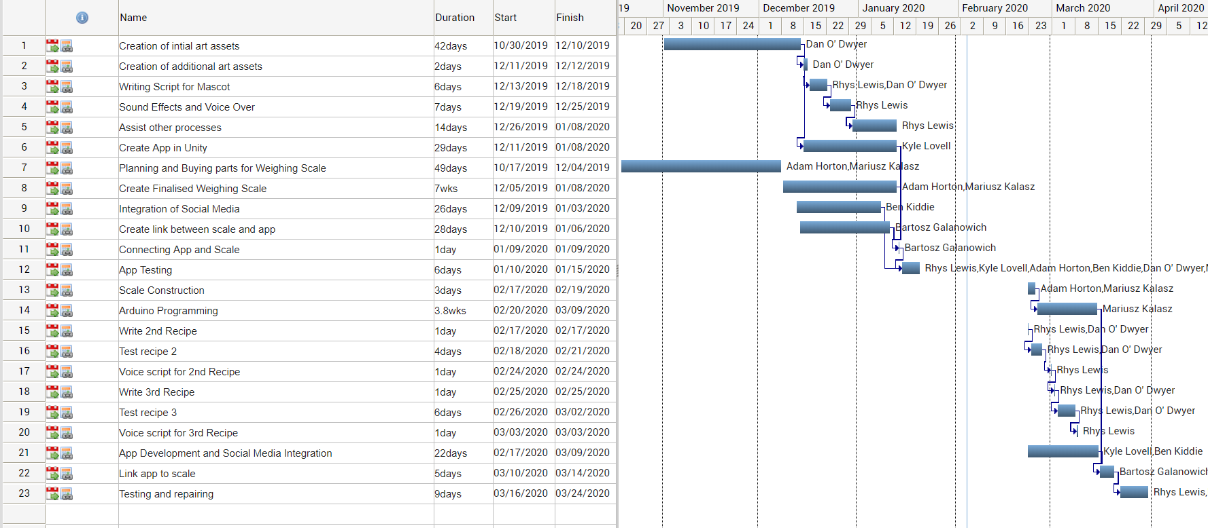
Appendix 1 Gantt Chart showing development of the project
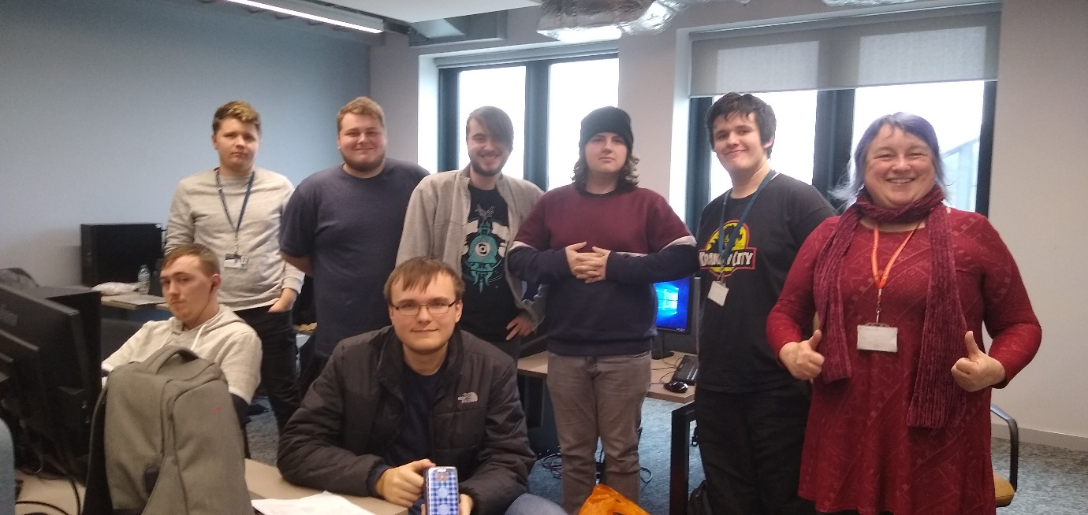
Appendix 2 Photo portraying the team after task 2 - project demo
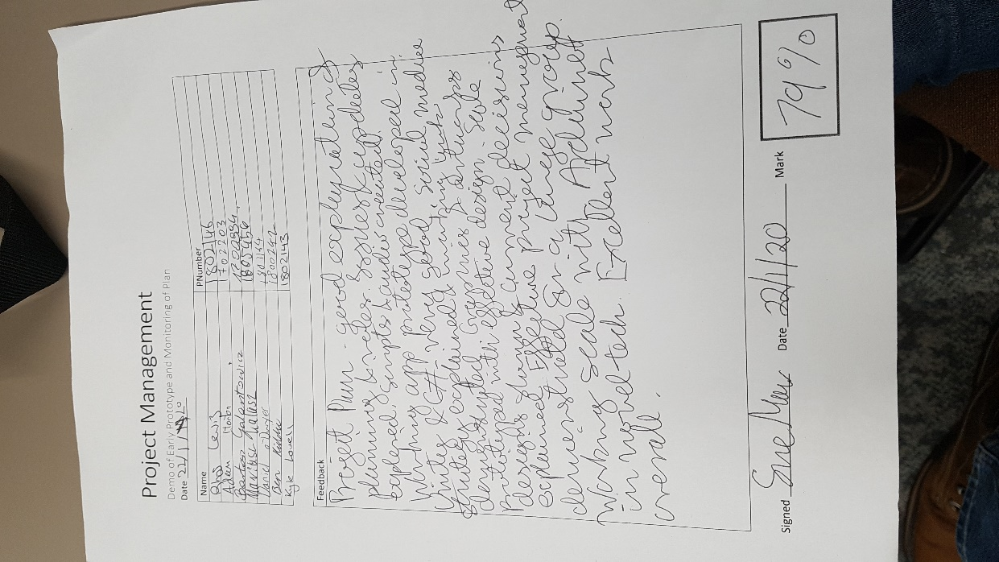
Appendix 3 Results of task 2 project demo

