1.
NAME: Andrea Lester

STUDENT NUMBER: 1912330

MODULE CODE: BMSW 4005

MODULE TITLE: Professional and Career Development

LECTURES NAME: Abdi Rahman

ASSIGNMENT TITLE: Portfolio of Work

2.

CONTENTS PAGE:

1. Title Page

2. Contents Page

3. Summary

4. Introduction

5. Audit Based on My Skills and Competences,

5/6. Skills required for chosen career.

7. Using Analysis Tools. (PDP), weighing pros and cons, Evaluate Skills in Comparison to my Chosen Career

8. Strengths and Weaknesses

10/12 Training Methods for New Employees, due to Start in My Organisation

13/16 Reflection on My Experience before the Start of this Course and After

17 Conclusion

18. References

3.

SUMMARY

In this assignment I will provide information based on my skills and competencies that relate to my chosen career, I will also provide information for new employees who are due to start our company, I will also produce a reflection before and after this course
4.

Portfolio of Work

This assignment I am about to produce will be based on an official inspection of my skills and competencies using the analysis tools known as (PDP) Personal Development Plan, the assignment will also identify the skills that are required for my chosen career in comparison with my own skills I possess, as the Assistant Manager I will provide employees who are due to start with training and learning development methods that will be great help to them before they officially start the organisation, the assignment will also produce a reflection based on my experience before the start of this course and after.
5.

My skills and competencies I possess are as follows:

- Good Communication Skills

- Strong Organisation Skills And Attention to Detail

- Excellent Customer Service Skills

- Team Player With Ability to Work Independently

- I Obtain Excellent IT Skills and an NVQ in Health and Social Care

- I am able to Type Quickly and Effectively

- I have Excellent Phone Manners and am able to Communicate Confidently

- I have Empathy, and put my heart into everything I do

My chosen choice when it comes to my career is a Support Worker, I have been working in the Care Sector from the age of 18, and I am now 33 so I do have a lot of knowledge and experience. The skills that are required when entering the Support Worker Career are highlighted below:

- Communication Skills

- Relationship Management

- Report Writing

6.
- Working as Part of a Team

- Access to a Huge Amount of Job-Relating Training

- Literacy and Numeracy

- Digital and Interpersonal Skills

- Problem Solving Skills

- The Ability to Work on your Own Initiative and Prioritise your Workload

- Good Listening Skills

- Caring Attitude

- Good Customer Service Skills

- Good Writing Skills to Fill in Care Plans

- Follow Policies and Procedures

- The Ability to Work in a Person- Centred way is also Crucial

- Empathy- Empowering People

And many more (Support worker job description | Totaljobs, 2020)

7.
Weighing the pros and cons of skills Scales 0-5
(PDP) SWOT ANALYSIS
Plus + | Minus - | Required Skills For Chosen Career?
Organisation Skills (+5) | Relationship Management(-5) | Required Skills For Chosen Career?
Organisation Skills (+5) | Relationship Management(-5) | Timekeeping(5+)
Attention to Detail (+5) | Problem Solving(-5) | Admistering Medication(-4)
Team Player (+5) | Digital(-4) | Temperature Checks(-3)
Work Independently(+4) | Interpersonal(-5) | Level 5, NVQ(-5)
Type Quickly and Effectively(+4) | Report Writing(-4) | Reviewing Case Loads(-4)
Phone Manners, Communicate Confidently (+4) | Attending Court Hearings(-5) | Making Important Decisions(-4)
Empathy(+5) | Implementing Polices and Proceduers(3-) | Update Care Plans(-3)
Total=32 | Total= -21 | Total=18

8. Strengths and Weaknesses
STRENGTHS  - Organisation Skills  - Attention to Detail  - Team Player  - Work Independently  - Type Quickly  - Effectively  - Phone Manners  - Communicate Confidently  - Empathy | WEAKNESSES  - Relationship Management  - Problem Solving  - Digital  - Interpersonal  - Report Writing  - Attending Court Hearings  - Implementing Policies and Procedures  - Administering Medication  - Level 5, NVQ
9. 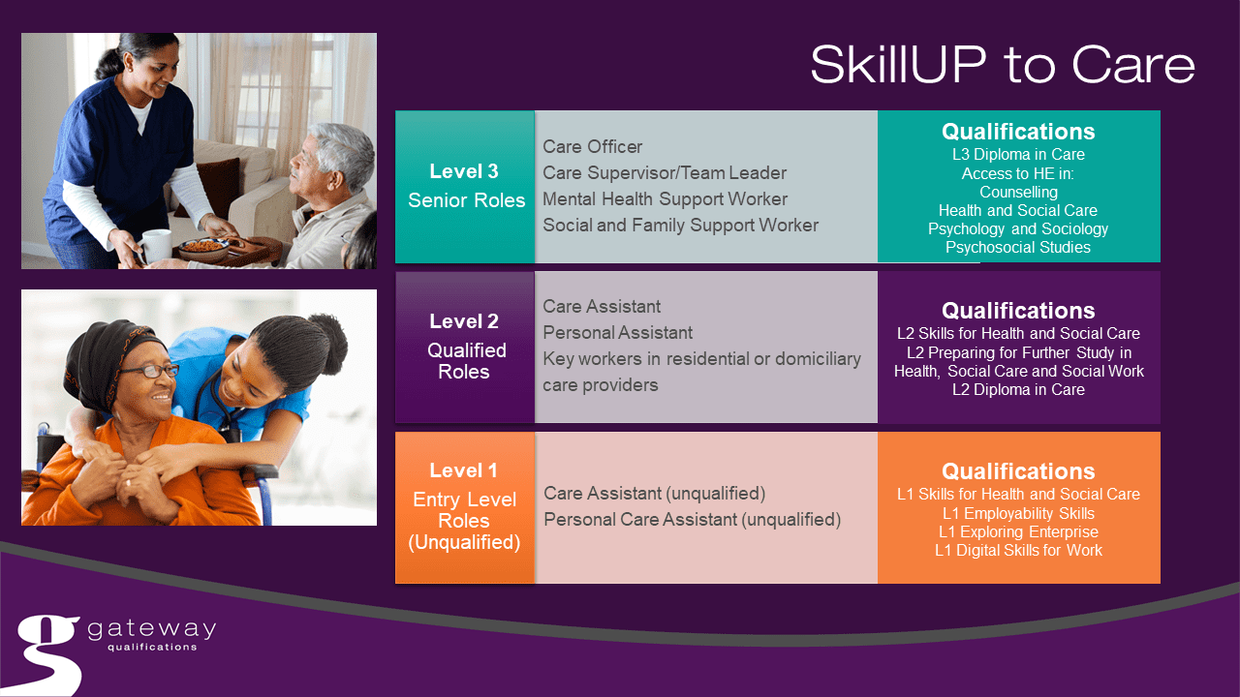(Setting et al., 2020).

10.
Training Methods for New Employees, Due To Start in My Organisation.

Training for new employees is important, for on boarding as well as employee retention, when a new employee joins the team they usually turn up excited and egar to learn more about our company, for existing staff members they still are required to learn and develop new skills, in learning these new skills method is just as important as the material (2020).
The types of training methods new employees are required to learn before starting our company are as follows:
- All individuals who are successful within the interview process and have been accepted as a support worker and ready to start employment must learn the knowledge and skills to provide emotional support to individuals and their families.
- Learn the knowledge to provide practical support for individuals, for example, helping with household tasks, personal care and paperwork.
- Learn the skills and knowledge to support and monitor individuals with their healthcare needs for example, Administering Medication, and Checking their temperature.
- Learn the knowledge and skills to encourage individuals to pursue their hobbies and interests.
- Learn to support and analysis individual’s needs, drawing up a focused support plan (Support worker job description/Totaljobs, 2020).

Once new employees have learned the knowledge and skills required, the process continues, from the outcome and feedback they have received referring to the training methods and materials, new employees must develop a (Personal Development Plan) they should follow these steps in order to address their results they must:

IDENTIFY-once the training process is complete new employees must identify a plan of action the next area or skill for development it is
important that new employees record what skills they have achieved or not achieved and use the feedback given to assess each stage of the process.
11.
to help them develop their skills further, if they have successfully gained a new skill or skills through the training materials and methods they can either learn the knowledge to identify new areas to develop new skills at any time or skills they have not successfully obtained, continue to learn the knowledge to develop these skills further, it would help employees if they brainstormed or set a goal chart about skills they wish to develop now and in the future, they must acknowledge their realistic goals and their strengths and weaknesses.

RECORD-for new employees, recording the skills they have successfully achieved or not achieved will be very helpful for their learning process, they should record how the learning process was beneficial for them the progress they have made so far also to record any areas where skills may need to continue to be developed in, also identifying new skills, new tasks and new ideas, by now employees should be more aware of the skills learned or areas skills need to be work on, they should go over all the training methods and materials take a step back to calculate everything recorded that they have learned or not learned.

PLAN- new employees must develop a plan of action to progress skills further or develop new skills they can do this by a number of ways for example looking on websites relevant to the chosen skill that must be developed, accessing the required resources they need, such as books from the library that are based on training methods and materials, work experience would be appropriate to implement this new skill in practice, it would help if new employees think of time they have available each week and be realistic about it as making time to develop new skills or skills further will be a very smart and sensible thing to do.

ACTION- a plan of action will be great for new employees as this will allow them to see how skills they have achieved will be implemented in society today, and any areas skills need to continue to develop, they should carry out any tasks they set themselves for each goal, and any new skills they pick up along the way, all new skills developed must be updated to CV (personal development plan, process and resources, 2020).

12.

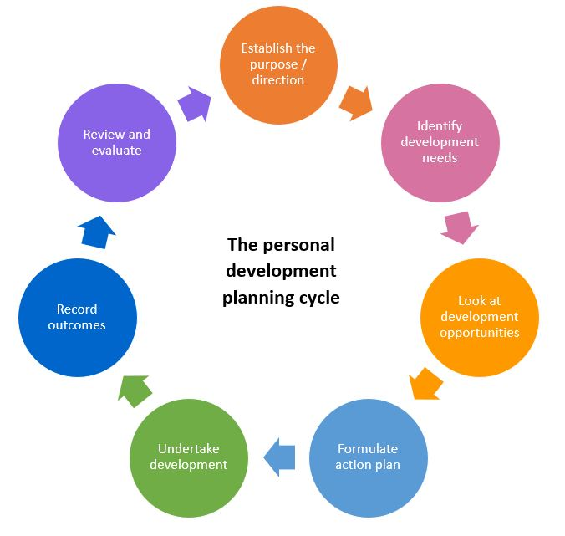
.
(Professional Development Planning Cycle-Eventus-Recruitment, 2020).

13.
Reflection based on my experience before and after this course.

Reflecting back on my experience before the training process of the course, I was unsure as to what training I would receive and concerned as to whether I would be successful in that area of skills I have been required to develop, I was curious to see what it would be like to work with this particular company also how my job performance would benefit the organisation, how the employer would evaluate my job performance (potential work related issues to ask about, 2020).
The Johari Window, Meta Development was produced for individuals who are unsure of their ability to learn the knowledge to gain skills, also the knowledge to identify their strengths and weaknesses highlighting the areas that need more work, the Johari Window was very beneficial in my circumstance, it help me to develop my own personal development plan, looking into the 4 most important areas that allow you to learn more about yourself as an individual for example:

AREA 1- is known as the open area; once the training methods and materials have been complete the feedback we receive will then allow us to learn more about ourselves areas we are successful in also areas that need more work for development, this can also help other employees who have been working in the company for some time to get to know more about us.
AREA 2- is what we call the blind area, this area represents areas in which we may not know about ourselves, but other employees or people we know do, this could be information we have not yet realised.
AREA 3- is stated as the hidden area, this is area is based on stuff we know and learn about ourselves but don’t want nobody else to know.
AREA 4- this area is known as the unknown area, unknown information by ourselves, and everyone else for example this could relate to our attitudes, for managing people, also never been given the opportunity to develop skills.
Employees who have been in the company for a long period of time, will have more knowledge, so they belong in the open area, they are free from, good communication, conflict, mistrust, misunderstanding.
14.
Employees who have just started the company will have little knowledge, so they belong in the unknown area, the new employees must grow the open area they can do this by revelling their ideas, suggestions and concerns once this is done they will then be able to shrink the unknown area.
The blind area should be reduced by allowing increased trust this can be done by giving and receiving feedback, this is a great idea to work on feedback skills to help the new starters learn more about themselves in terms of the job. Values of, self-disclosure, constructive feedback, and accepting constructive criticism, with this knowledge given can help new employees, and old employees to build a relationship to trust each other and work more effectively as a team (the johari windows meta development, 2015).
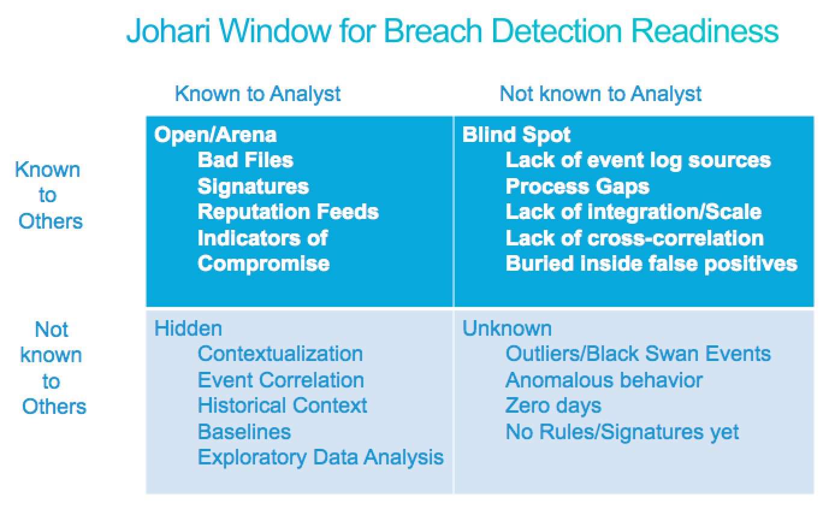
(Dara, 2014)

15.
After the course was over I felt very confident in all areas, I was able to gain the knowledge on how to develop my skills further, what training material and methods were available for me to do this, I am currently attending university to develop my management skills further, the training methods used really help me in terms of taking steps putting everything I learned into action and practice.
Becoming more self-aware of me is the best thing I could have done this allowed me to learn what skills I was good at and any areas I needed more improvement in, also allowed me to identify my likes dislikes strengths and weaknesses, and helped me to acknowledge skills I had that the chosen career job requires. According to Alain Morin self-awareness represents the capacity of becoming the object of one’s own attention. In this state one must identify the process and store of information about the self (morning, 2011). While 95% of individuals think they self-aware the real figure is closer to 10-15 %( t, 2017).
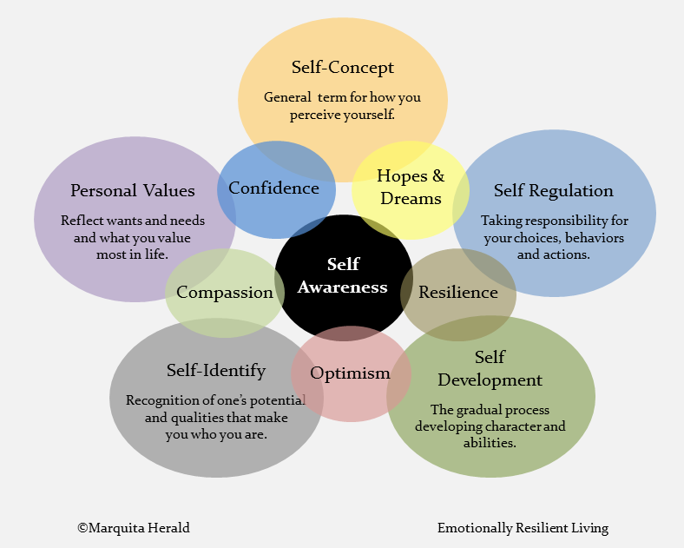(Self-awareness the key to self-mastery-emotionally, resilient living self-awareness, resilience awareness, 2020).
16.
I am very happy with how things went for me throughout the training process I was able to learn a lot of new skills and also I was able to get the help an guidance I needed to apply for university to develop these skills I have learnt further to become a qualified manager, although there is still some areas I need to work on I will do this by observing more, I will also look on more websites and training methods and materials to enhance the skills I am struggling with further. I compared my CV with another employee within my organisation their CV had a lot more information on then mine this is due to them having a lot of experience and knowledge with in their chosen career, they advised me I should do the same every new skill earned or job I’ve undertaken or training I have undergone I must always update this information to my CV as this will beneficial and help my future career when applying for vacancies, or when attending training this gives the employer a better understanding of skills training jobs I have already achieved or areas I’m working on so they will possibly have new skills for me to develop and this process will continue.

17.
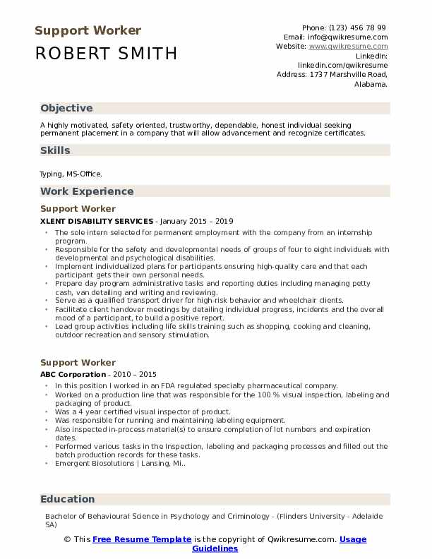

(support workers resume samples/quick resume,2020).

18.

CONCLUSION
In- conclusion I have provided information based on my skills and competencies, I have highlighted the skills that are required for my chosen career, weighing up the pros and cons based on a swot analysis looking at my strengths of the skills I have developed and the weaknesses of skills I have not developed that need to be worked on, I have provide information relating to training methods to help new employees who are ready to start our organisation, I have also provided them with a reflection report based on my experience before and after the training process, new employees ready to start work should learn to develop these skills further as this will be very helpful and beneficial for them and their chosen career .

19.
REFRENCES:
Dara, S., 2014. A Model For Evaluating Breach Detection Readiness - Cisco Blogs. [Online] Cisco Blogs. Available at: <https://blogs.cisco.com/security/a-model-for-evaluating-breach-detection-readiness> [Accessed 30 November 2020].

emotionalressilentliving.com. 2020. Self-Awareness The Key To Self- Mastery -Emotionally, Resilient Living Self-Awareness, Resilience Awareness. [Online] Available at: <http://n.ipinterest.com/pin/> [Accessed 30 November 2020].

Eventus Recruitment. 2020. Professional Development Planning Cycle - Eventus Recruitment. [Online] Available at: <https://www.eventusrecruitmentgroup.com/blog/career-development/professional-development-planning-cycle/> [Accessed 29 November 2020].

Indeed.com. 2020. [Online] Available at: <https://www.indeed.com/career-advice/career-development/best-types-employee-training-methods> [Accessed 28 November 2020].

Morin, a., 2011. What is Self-Awareness.

2020. Potential work related issues to ask about.

Settings, S., Settings, S., Dementia, S., Care, S., Care, S., Care, S., Care, S., Care, S., Care, S., Care, S., Units, E., Units, L. and Units, L., 2020. Skillup To Care | Gateway Qualifications. [Online] Gateway Qualifications. Available at: <https://www.gatewayqualifications.org.uk/qualification-area/skillup/skillup-to-care/> [Accessed 28 November 2020].
T, E., 2017. .

The Open University Help Centre. 2020. Personal Development Plan, Process And Resources. [Online] Available at: <http://help.open.ac.uk/pdp> [Accessed 30 November 2020].

Totaljobs. 2020. Support Worker Job Description | Totaljobs. [Online] Available at: <https://www.totaljobs.com/advice/support-worker-job-description> [Accessed 28 November 2020].

Youtube. 2015. The Johari Windows Meta Development. [Online] Available at: <http://youtube> [Accessed 30 November 2020].

Qwik resume. 2020. Support Workers Resume Samples/ Quick Resume. [Online] Available at: <http://quickresume.com/resume-samples/support-worker/> [Accessed 30 November 2020].

