Skills and qualities that influence critical thinking!
Critical thinking is self-guided, self-disciplined thinking

Creativity
(Elder, 2007)
Open minded

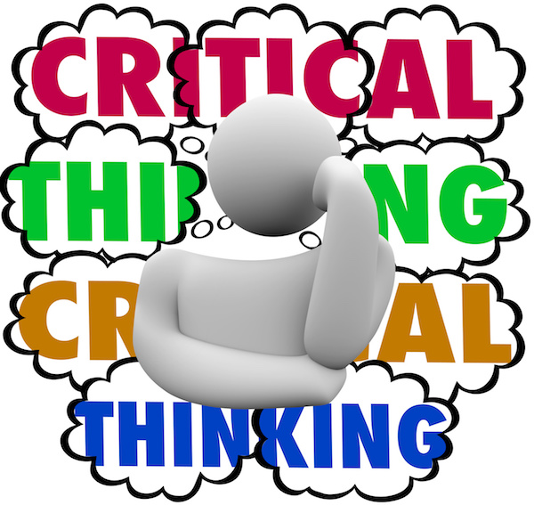
Creativity is intelligence having fun
Without an open mind, you can never be a great success
(Stewart,2010)
(Albert Einstein)
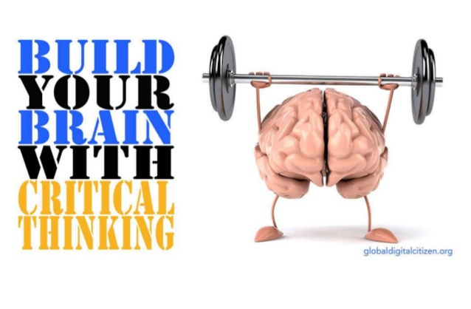

(Eason,2017)
(Obispo,2016)
Reasoning
(Roth,2010)
Reflection
Reasoning

Reasoning is disclosure in which some statements are set forth as supporting, Justifying belief in, or explaining some other statement or statements. (Cogan 1998)

Analyze
The way that we learn
From experience in order to understand
Breaking something down into its constituent parts, usually in order to understand it
( Black,2011)
And practise (Jasper,2003)

(Chartrand,2008)
Reference list

. B.Black. (2011) ‘An A to Z of critical thinking’ A&C Black.

. Chartrand, J (2008) ‘ How good are your critical thinking skills?’;
https://www.copyblogger.com/critical-thinking (Accessed 17th October 2018)

. Cogan,R (1998) ‘Critical thinking step by step’ University press of America.

. Eason, A (2017) ‘critical thinking, its importance and ways to improve it’;
https://www.adam-eason.com/criticalthinking.
(Accessed 17th October 2018)

. Elder, L (2007) ‘The foundation for critical thinking’;
www.criticalthinking.org ( Accessed 5th October)

. Jasper (2003) ‘What is reflection and how to write it’;
www.youtube.co.uk (Accessed 14th October 2018)

. Obispo, J (2016) ‘Thinking critically & creatively for learners’;
https://www.slideshare.net/Janaethobispo/critical-thinking-vs-creativethinking.
(Accessed 17th October 2018)

. Roth,M.S (2010) ‘Beyond critical thinking’;
https://www.chronicle.com/article/beyondcritical.
(Accessed 17th October 2018)

. S.Martha https://courseslememlearning.com (Accessed 14th October)

