Waste Materials in Concrete

Jacob Passmore
1706871

Trinity Saint David University

A thesis submitted for the degree of
Bachelor of Science: Civil Engineering


Abstract

Concrete is the most commonly used construction material in the world, being one of the most flexible, robust and cost-effective building materials in use today. Cement production accounts for the highest cost in the manufacture of concrete.
This work has been focused on the necessity of using partial cement substitute materials to minimise the use of sand and cement inside concrete, the two existing substitutes are ground blast furnace slag and limestone dust.
This paper addresses principles upon which to maximise the use of the waste materials in concrete, there is also talk about concrete properties such as flexibility and compression and can it be engineered better by using these waste materials.

Table of Contents
Introduction 6
Scope 6
Cement 7
Concrete 7
Waste in Concrete 9
Aim and Objectives 9
Aim 9
Objective
10
Experiment 10
Batch 1 10
Batch 2 11
Batch 3 11
Batch 4 11
Batch 5 11
Batch 6 12
Batch 7 12
Batch 8 12
Batch 9 13
Why these percentages? 13
Workability Test 13
Preparing for other tests 13
Compression 14
Flexural strength 14
Measurable? 15
Time 16
Literature review 16
Introduction 16
Waste from Industrial activities in the UK 16
Construction, demolition and excavation Waste 17
What is Concrete? 17
Fresh State 18
Hardened State 20
Waste Materials 21
Fly Ash 21
Fly Ash Case Study 22
Testing 23
Results 23
Blast Furnace Slag 25
Research Paper 25
Regen 26
Iron Blast Furnace Slag Production 26
Hydration Process 26
The Second Severn Bridge 27
Product and volume supplied by Hanson: 28
Limestone Dust 28
Results 29
Influence of Limestone Dust on the Unit Weight 30
Influence of Limestone Dust on Compressive Strength 31
Permeability Tests for Concrete 33
Methodology 34
Mix Designs 34
Mix Procedure 34
Replacement Materials 36
Lime Stone Dust 36
Grounded Granulated Blast Furnace Slag 36
Sand 37
Cement 37
Water 37
Strength Tests 37
Cubes 37
Curing 37
Flexural Test 38
Compressive Strength 39
Results 41
Introduction 41
Errors 41
Mixes 41
Flexural Results after 7 days 44
Flexural Results after 28 days 45
Conclusion on the Flexural Strength 45
Compressive Strength Results after 7 days 45
Compressive Strength Results after 28 days 46
Compressive Strength Conclusion 46
Conclusion of Results 46
Conclusion and recommendations 47
Recommendations for further studies 47
References 49

Introduction

Scope

Concrete is basically made of aggregates that are bonded by a paste of cemented materials that is made from cemented materials and water. Each of these concrete primary constituents has an environmental impact to a different degree and gives rise to various sustainability issues
The current concrete building practise is considered unsustainable because it uses not only large amounts of stone, sand and drinking water, but also two billion tonnes of Portland cement per year, which is not an environmentally friendly material from the point of view of energy use and greenhouse gases releasing, contributing to global warming. Due to global warming emerging to one of the most serious environmental issues and that sustainability is an important issue of economic and political debates, developments in the concrete industry shouldn’t be concrete manufacturing with materials that are expensive but concrete manufacturing with low costs and high durable concrete mixes that contain large amounts of waste materials products that would be suitable for the replacement of cement and sand.

Cement

Cement processing accounts for the highest cost of concrete manufacturing and is the most energy-intensive operation from all of its constituents. Ordinary Portland cement production is environmentally sensitive in two areas: first, the processing of materials and, second, the production.
Cement is the cause of about 8 percent of the world's carbon dioxide (CO2) emissions, says think tank Chatham House. Cement manufacture produces CO2 in two ways: by turning calcium carbonate into calcium oxide within the kilns, and by burning vast amounts of fossil fuels to heat the kilns to the requisite 1450 ° C. As part of the Kyoto Agreement, by the end of 2012, European countries had to agree to reduce greenhouse gas emissions by 8%, these were based on 1990 rates. The cement manufacturing industry is one of which the European union has placed quotas to cap hazardous emissions. Lack of enforcement of the agreements commitments would then result in large fines. Improving those restrictions, however, will bring financial benefits through carbon trading. The industry has already showed results in its ability to boost its efficiency as regards to climate change between 2001 and 2004, a 21.2% consumption in energy usage was decreased.

Concrete

Over the entire life cycle of concrete, the environment is impacted badly, from material extraction, the process, assembly, the transport and construction and maintenance and disposal.
- Cement production is the third ranking producer of anthropogenic (man-made) CO₂ in the world after transport and energy generation.
- 4 - 5% of the worldwide total of CO₂ emissions is caused by cement production.
- Production of one tonne of cement results in 780 kg of CO2
- Of the total CO₂ output, 30% derives from the use of energy and 70% results from decarbonation (Rodgers, 2018)

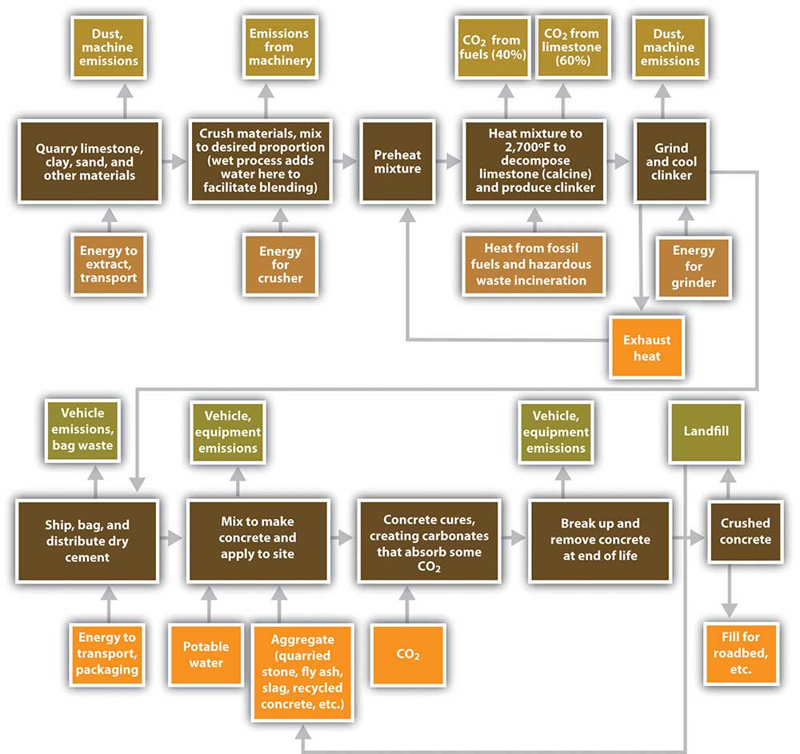

Fig 1
(The Environmental Impacts of Concrete, 2020)

Being one of the most durable, strong and cost-effective materials used in construction in use today concrete is the most commonly used building material in the world, only larger quantities of fresh water are used and this is generally because it is wasted. About 100 million tonnes of concrete are used in the UK annually with concrete sales of £5bn.
Concrete has the obvious environmental impacts reflected in concrete raw material quarrying; the resources used in its processing, and the resulting carbon dioxide emissions. Like with all products, it will eventually reach the end of its useful life, and will therefore require recycling. Many actively participate in initiatives aimed at reducing the environmental impacts of concrete production, some examples are:

- The reduction of polluting and gases emitted during the manufacturing of concrete
- More efficiency of the resources in concrete manufacturing, such as reusing materials and waste materials
- More effective ways of using waste and secondary materials for aggregates and fuel
- Environmental restoration when the industrial activity has finished

Waste in Concrete

Each year millions of tonnes of waste are created in the world and much is not recyclable. In addition, recycling waste is energy consuming and causes pollution. Additionally, waste accumulation in the suburbs and waste disposal is very harmful for the community. The use of waste material in concrete manufacturing is an effective approach to achieve two objectives: eliminating waste and adding positive properties in concrete.
“About 1,300 million tonnes of waste are generated in Europe each year, of which about 40%, or 510 million tonnes, is construction and demolition waste (C&DW). The US produces about 325 million tonnes of C&DW, and Japan about 77 million tonnes. Given that China and India are now producing and using over 50% of the world’s concrete,2 their waste generation will also be significant as development continues.” (Construction and demolition waste - Environment - European Commission, 2019)

Aim and Objectives

Aim
This dissertation will examine how two types of waste material can benefit the construction industry by reducing the amount of cement and sand in concrete and adding these materials, the materials being used are already established and approved in the industry and what the waste materials physical and chemical elements contain for it be suitable for a cement and sand reduction. these waste materials that are going to be used are slag and limestone dust, as the slag will reduce the cement and the limestone dust will reduce the sand.

Objective
- Undergo desk research of articles and reports on this topic to create a database of people’s insight and knowledge and to implement it into this thesis.
- Perform experiments for properties of workability, flexural strength and compression that will provide statistics towards the thesis.
- Identifying factors that impacts concrete with waste material applied to it.
- The data from both desk research and experiments will be analysed to see what the advantages and disadvantages are.

Experiment

To achieve the reduction of cement and sand in concrete the author will conduct experiments that will look for the properties such as workability, flexural strength and compression. Each test will be done more than once so that an average can be calculated and multiple experiments with different percentages of cement and sand with a mixture of slag and limestone dust will be achieved.
Before any of these tests are completed, the concrete batches need to be mixed with the appropriate amount of materials. The first batch will contain the following:

Batch 1
- 1350 grams of sand
- 450 grams of cement
- 247.5 millilitres of water
As you can see there is no waste material in the first batch as the author will compare a normal batch of concrete to a batch with waste material applied to it.

Batch 2
For the second batch of concrete there will be a 0% reduction to the cement but there will be a reduction of sand so 25% of it can be limestone dust.
- 1012.5grams of sand
- 450 grams of cement
- 247.5 millilitres of water
- 337.5 grams of bottom ash

Batch 3
Third batch will have the normal amount of cement but an increase of limestone dust so therefore a 100% reduction to the sand.
- 450 grams of cement
- 247.5 millilitres of water
- 1350 grams of limestone dust

Batch 4
The fourth batch will now have a 30% reduction in cement and slag will be its replacement, the sand remains the normal amount.
- 1350 grams of sand
- 315 grams of cement
- 247.5 millilitres of water
- 135 grams of slag

Batch 5
The fifth batch has the same reduction of cement as the fourth but a 25% reduction to the sand.
- 1012.5 grams of sand
- 315 grams of cement
- 247.5 millilitres of water
- 135 grams of slag
- 337.5 grams of lime stone dust

Batch 6
Sixth batch includes the same as the fifth except an increase of the amount of bottom ash to 100%.
- 315 grams of cement
- 247.5 millilitres of water
- 135 grams of slag
- 1350 grams of limestone dust

Batch 7
Seventh batch has a 50% reduction of cement and the sand remains the normal amount.
- 1350 grams of sand
- 225 grams of cement
- 247.5 millilitres of water
- 225 grams of slag

Batch 8
Eighth batch has a reduction of 50% of cement and a 25% reduction of sand.
- 1012.5grams of sand
- 225 grams of cement
- 247.5 millilitres of water
- 225 grams of slag
- 337.5 grams of lime stone dust

Batch 9
The last batch has a 50% reduction in cement and a 100% increase in limestone dust.
- 225 grams of cement
- 247.5 millilitres of water
- 225 grams of slag
- 1350 grams of limestone dust

Why these percentages?
The reasons for the 30% of slag are due to the fact that most general concrete applications such as foundations, paving and walls use these waste materials if wanted, typically uses between 25% to 50%. For the 50% of each waste material this was down to getting the maximum strength of slag concrete.
When the mixture is complete, testing can be done.

Workability Test
Make sure that the slump mould is on a flat surface and fill the mould half way, after this compact the concrete with a tamping rod, then fill the mould to the top and strike off the top surface with a trowel. Quickly remove the slump mould vertically but make sure you do not cause the concrete slump to deform, start the vibrator and keep it going until the concrete surface becomes horizontal.

Preparing for other tests
When the workability test has been completed place the concrete in concrete block moulds but only fill them half way, when the mould has been filled half way, place the mould on a vibrator to compact the concrete, fill it to the mould surface and compact again, then place the mould in a air tight bag and place in the oven to harden for the allocated time.

Compression
Place the concrete blocks in the machine so that the load will be applied to the opposite side of the blocks cast and align the block central on the base plate, apply the given amount of pressure and note down the maximum load of the concrete block and any strange features in the type of failure.
Concrete mixtures are designed to provide mechanical and durability properties, these have to meet the design requirements for a structure. The most common performance attributes used by engineers when designing structures is compressive strength.
To measure compressive strength, one would need to break a concrete block in a compressive strength testing machine, this is “calculated from the failure load divided by the cross-sectional area resisting the load and reported units” (Testing the Compressive Strength of Concrete — What, why, & how? – Nevada Ready Mix, n.d.)

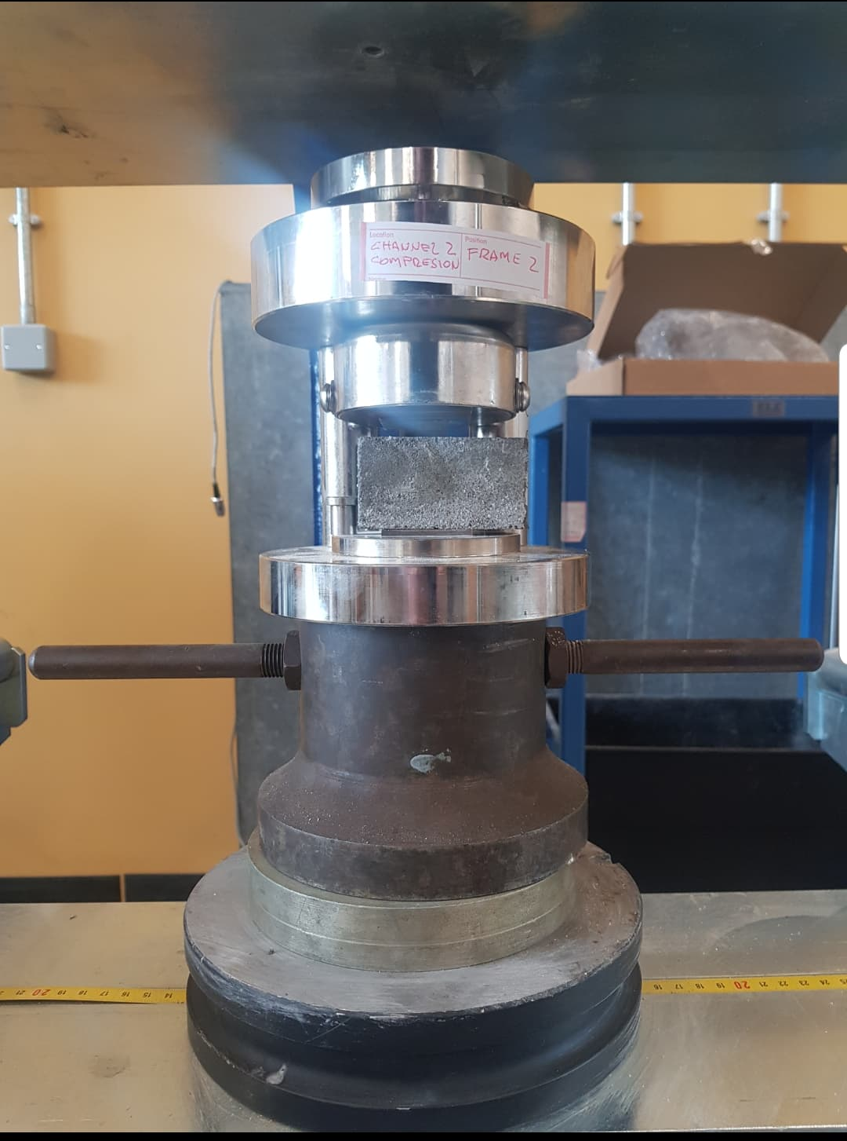
Fig 2 Fig 3

Flexural strength

In general, flexure testing is used to determine the flexural modulus or flexural resistance of a material. A flexure test is more cost effective than a tensile test, with very different test outcomes. The material is distributed horizontally over two contact points (lower support span), and then one or two contact points (upper load span) apply a force to the top of the material before the sample fails. The maximum recorded force is the flexural strength of that particular sample.
A flexure test does not determine fundamental properties of the material relative to a compression or tensile test. When a material is placed under flexural loading all three basic stresses are present: tensile, compressive and shear and thus the flexural properties of a specimen gain from the combined impact of all three stresses as well as (although to a lesser extent) the geometry of the specimen and the rate at which the load is applied
A flexure check is most widely used for calculating flexural tension and flexural modulus. Flexural strength on either the compression or tension side of the specimen is defined as the maximum stress on the outermost fibre. Based on the slope of the stress vs strain deflection curve.
The flexural modulus is calculated. These two values can be used to determine the ability of the sample materials to withstand flexure or bending forces.

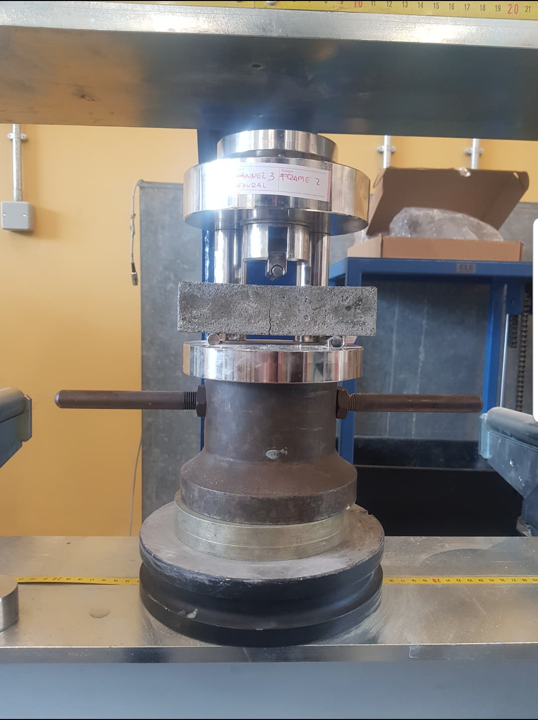
Fig 4 Fig 5

Measurable?
The author will know when and if the aim has been achieved because when the experiments have been completed, it will show statistics on if the concrete with added waste materials can be used and what percentage of what waste material makes the concrete suitable for use in the construction industry.

Time
Time has a big contribution in this thesis as the experiment takes time, the author has made a calendar for the experiment so that they can complete this efficiently and effectively

Literature review

Introduction

In today's industry there is rising demand to reuse and recycle products, rather than send them to landfill. With greater public awareness of the environmental damage caused by industry, both local and global political parties now position CO2 reduction and energy efficiency goals at the top of the policy agenda.
The UK government is working on proposals to slash carbon emissions by 80 percent, amid reactions from critics who cautioned that the climate change bill's 60 percent target was not practical enough to tackle climate change (Fisher, 2020)
The fact that the government is prepared to reconsider its priorities according to the opinions of campaigners, shows the value of this strategy. Given these stresses on the concrete industry, a study of waste and pollution is provided before addressing concrete-related issues.

Waste from Industrial activities in the UK

In 2016, the UK C&I sectors created 41.1 million tonnes of waste, of which 33.1 million tonnes (roughly four fifths) were produced in England. By contrast, the estimates for the 2014 UK C&I waste arisings were 40.0 million tonnes, of which England produced 31.7 million tonnes.
The industrial sector produces over two-thirds of C&I waste, in both the UK and England.
The new figures for England show that that in 2018 waste production was about 37.2 million tonnes, and in 2017 it was 36.1 million tonnes. England's projection for 2017 was a fairly significant improvement from the 2016 33.1 million tonnes. Approximately half of this rise is accounted for by certain care areas where EA has made progress in identifying additional facilities from 2017 that have been excluded in previous years; thus, estimates for 2017 onward are not strictly comparable with previous years. Caution should usually be exercised in evaluating apparent year-on-year shifts in C&I statistics, due to inherent inconsistencies in the statistics and methods underlying them. (Fisher, 2020)

Tonnage figures for the generation and final disposal of all waste were determined in the UK and England in order to report the return for 2016 against the EC Waste Statistics Regulation. In compliance with 10 criteria of the Regulation, total waste generation is divided by material and NACE's economic activity is responsible for producing it. Complete waste generation is divided by material and NACE economic activity is responsible for generating it, in compliance with the requirements of the Legislation. Users should be aware that "absolute waste" encompasses all economically generated waste and is thus much broader than commonly examined subsets such as "municipal waste" or "household waste." Users should also consider the specific natures and impacts of various waste materials included in total waste

Construction, demolition and excavation Waste

Approximately three fifths (62 per cent) of total UK waste produced in 2016. Commercial and industrial (C&I) waste accounted for nearly a fifth (18%) of overall waste generation and the remaining fifth was divided between 'Households' (12%) and 'Other' (8%). In England, CD&E's share was higher at 64 percent of the total, 'Households' was close to UK, and C&I and 'Other' contributions were marginally lower at 17 percent and 6 percent, respectively, than UK contributions.

What is Concrete?

Concrete is the most widely encountered manmade material on earth. It is an essential material of construction that is commonly used in buildings, bridges, highways, and dams. The uses vary from network structures to pavements, kerbs, pipes and drains.
Concrete is a composite mixture of cement, water, and aggregate manufactured from Portland cement. The majority of the volume is aggregates, usually 70-80 percent. Other components, such as admixtures and partial components for replacing cement, can also be applied to the basic constituents (Illston 1994).
Portland cement, binding material in the form of a fine ground powder, usually white, which is formed by burning and grinding a mixture of calcareous and clay, or calcareous and shale. In 1824, England's inventor Joseph Aspdin patented the basic method, naming it for the cement similarity when applied to Portland stone, a limestone stone from Portland Island. The anhydrous calcium silicates and other constituents in the Portland cement, when combined with water, chemically react with the water, reacting with it (hydration) and decomposing in it (hydrolysis), and hardening and developing strength. (Portland cement, 2020)
Concrete is a two-state process with each state having its own property and specifications for application needs and standards

Fresh State

The first state is the "fresh state." While new concrete is only of temporary interest, because its properties are constantly changing, it should be understood that the strength of concrete of the given mixing proportions is very seriously affected by the degree of its compaction. It is therefore important for the consistency of the mix to be such that the concrete can be transported, placed, compacted and finished with great ease and without segregation (Neville 1995).
Consistency is the term used for what was known as 'workability' in BS 5328 in BS EN 206-1 (BS EN 206, 2005) and BS 8500 (BS 8500, 2002). Consistency is the measure that shows the capacity of the concrete to withstand internal friction and to become self-compacting.
Concrete quality is a product of three key characteristics of plastic concrete:
- Mobility - The speed with which concrete flows and which can be recast

- Compactability - The flexibility in which the concrete can be compacted and the air voids within the concrete covered

- Cohesiveness - The ability of the concrete to retain a diverse mass and not to become separated

Although there are several ways to assess consistency, there are four standardised measures in the sequence of BS EN 12350 'Testing fresh concrete.' The Slump test (BS EN 12350-2), the Flow table test (BS EN 12350-5), the Vebe test (BS EN 12350-3) and the BS EN 12350-4 test for compactability.
Such tests have one measurement and are often generally referred to as 'single-point' tests. The Slump test is the most celebrated and the oldest test. Because of its simplicity this approach is commonly used throughout the world in site work. The apparatus was created in the USA around 1910, and it is assumed that it was used for the first time by Chapman although the test apparatus is associated with Abrams in several countries (Bartos 2002).
Though work continues to find a more rigorous measurement for concrete rheology (Li 2007), the measurement simplicity and low cost are among the reasons why the slump test remains the most common method for field fresh concrete quality control assessments (Saak 2004)
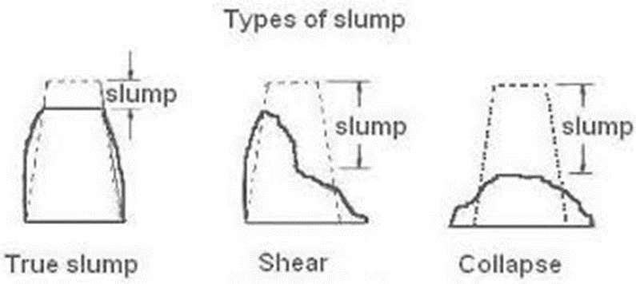
Fig 6
(Concrete slump test, 2019)

Notwithstanding these benefits, the Slump test isn't without its disadvantages. The European standard acknowledges only a true form of recession, no recording of values from the shear or collapsed recession is allowed. The norm also recognises that the test is vulnerable to changes in consistency leading to slumps between 1 0 and 200 mm, and the test is not deemed appropriate beyond those extremes. There are also differences as well as those drawbacks in fact. The test is highly user based, with different types affecting test results. As for the point to be taken from the equation (Domone 2003), the European standards differ from the American standard. The relationship between slump and more abstract theological criteria is not well understood although slump offers a qualitative workability measure. However, despite their inherent shortcomings, single-point operability tests continue to be used in functional specification and quality control (Saak 2004).

Hardened State

Compressive strength test is by far the most common test performed on hardened concrete. This is partly due to the fact that this type of test is simple and fairly inexpensive to perform. The European Standards covering the testing requirements use different geometries of specimens to determine the compressive concrete strength, fc (notation for the concrete cube strength). The most commonly used geometries are slim cylinders (ratio height / diameter) equal to two and cubes (del Viso 2007);
Cylinders (0150 mm > < 300 mm) are used in the United States, South Korea, France, Canada and Australia while 150 mm and 100 mm cubes are the standard specimens used in the United Kingdom, Germany and many other European countries. There are some countries (e.g. Norway), where both cylinders and cubes are evaluated (Yi 2006).
Over several months the strength production of concrete increases under favourable conditions. This improvement of strength depends on the conditions of temperature and humidity during curing. Higher temperatures increase the rate of chemical reaction and hence the rate of production of strength, and the loss of water from concrete must be avoided in order to achieve higher strengths at later ages. For research purposes, as in BS EN 12390-2 (BS EN12390 2000), the concrete test specimens are kept in water at a constant temperature until the date of test. On specimens tested within 28 days (BS EN 206 2000), the compressive strength of concrete is determined. Throughout manufacturing the characteristics of the materials used are inevitably variable.
The total variability in the calculated concrete strength obtained during a project can be assumed to consist of three component sources (BRE 1997):
- variability in the consistency of the material used

- variation in the mixing proportions due to batching

- variation due to sampling and testing.

Waste Materials

Fly Ash
For coal fired power plants, the gas produces spherical particles from burning coal with a diameter of 0.1 to 0.15 mm, the particles are made up of around 85% carbon, aluminium, iron, magnesium and calcium. Investigating the impact of fly ash began in 1999 and it has been found that the degree of creep and shrinkage of fly ash samples can be lower than those of materials that do not use fly ash (Day, 1990). When increasing the curing temperature, the fly ash reaction will increase in the cement paste (Hanehara et al., 2001). This is not limited only to the amount of hydration of cement, but has effects on the form, characteristics, stability and hydration cycle (Rojas & Cabrera, 2002; Ma, 2013). Fly ash has two grades according to ASTM C618, class F and class C, they key difference between the two is on the ash content of calcium, aluminium, silicon and iron. Haque et al (1984) pioneered high volume fly ash concrete work. Studies investigated that the introduction of significant amounts of fly ash into concrete between 1987 and 1989. The approach was for aerated and non-aerated concrete with 55% fly ash weight replaced by cement at three strength levels of 21, 28 and 35 MPa. Results showed that the initial and final setting was not greatly affected by replacing fly ash with cement by 55%. Furthermore, concrete that contained 40 to 60% fly ash at an early curing state showed lower compressive power. It showed however higher compressive strength in 28 days compared to equivalent concrete without fly ash (Naik & Ramme, 1987, 1989). Class F fly ash typically produces good mechanical properties, durability and low chloride permeability with strong pozzolanic activity (Malhotra, 1990). Poor abrasion resistance was created by the use of a superplasticiser compared with concrete without fly ash (Bilodeau & Malhotra, 1992). Reasonable concrete was obtained for the building of reinforced structures by using 50% fly ash in class F (Siddique, 2004). Chung-Ho et al (2013) revealed that fly ash concrete, setting time and air percentage increased with fly ash dose increased. The porosity of concrete is declining due to the fact that a high volume of fly ash and strong pozzolanic activity interacts with cement CH. In addition, the compressive and flexural power of concrete is showing a continuing trend in 91 days and 365 days. Concrete mixes containing fly ash with low ignition loss had higher mechanical properties compared to concrete fly ash and high ignition loss, furthermore, increased fly ash in concrete caused greater shrinkage due to drying at various ages (Chung-Ho et al., 2013).

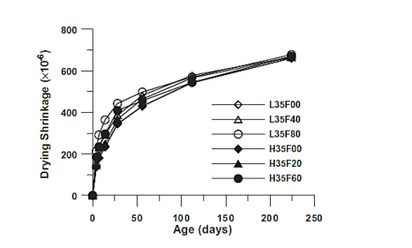
Fig 7
(Chung-Ho et al., 2013)

Figure 6 shows the development of shrinkage at different curing ages

Evidence has also shown that fly ash can increase concretes compressive strength over long healing days, and enhance concrete longevity by reducing permeability and increasing density. Like concrete waste and brick, is ideal for use in reinforced concrete.

Fly Ash Case Study

A case study called “An Experimental Study on Strength and Durability for Utilization of Fly Ash in Concrete Mix” (Karaşin and Doğruyol, 2014). Talks about the possibility of decreasing the amount of cement in concrete building construction. To this end, laboratory experiments were performed to examine concrete's compressive strength and sulphate-resistant ability by using 20 percent fly ash as mineral additives, waste materials, rather than cement. As a case study, TS 12457-4's standard sulphate parameters were compared with the soil samples obtained from Siirt Province areas containing high sulphate levels. Connection of underground water in these regions flowing into hardened concrete substructures poses a risk of concrete degradation. To assess the variation in strength and durability of concrete that is exposed to this hostile environment, the samples were rested for processing in the Na2SO4 solution (150 g / lt), in compliance with ASTM C 1012. As a result of this experimental analysis, it is noted that over time, the use of 20 percent fly ash, substitute content instead of cement, has no noticeable impact on concrete's compressive strength.

Testing

FA and BFS were applied 20 per cent by weight of cement to Portland cement (C42.5). The proprieties of cement are listed in Table 4. Replacement concretes from FA and BFS were contrasted with each other, as well as cement concrete from Portland. First, 15 cm cube specimens were prepared and cured at 7, 28, 90, and 150 days with developed concrete mixture. Fly ash was applied to the mix in the laboratory as a substitution of 20 per cent by Portland cement weight. For the reference mix is selected the 0.56 water / cement ratio and 300 kg / m3 cement dosage. There is also a concrete control sample created that has the same dosage. Mineral additive concrete performance was achieved in both the sulphate and water cures. Three series of concrete samples were produced in this context; a series with constant fly ash ratio was used as additives in two concrete samples, and one series of samples were used without additives. Concrete samples were rested in a solution of Na2SO4 (150 g / L) in compliance with ASTM C 1012 to see the impact of strength and toughness of the concrete at high-rate sulphate. To examine the destructive effect of sulphate on concrete, one group of specimens was continuously held for 5 months in a sodium sulphate solution with a concentration of 150 g / L (in 15 percent sulphate solution). The other community samples were deposited in water during this time period. For each concrete property a total of 3 specimens were tested at the end of each curing cycle. Surface hardness and compressive strength of samples of concrete exposed to the sulphate effect were regularly measured. At the same time, the surface distortions and weight changes of the samples were regularly observed

Results

A pressing machine of the brand ELLE was used for compressive strength values with a pressure ratio of 4.5 KN / mm2/sn. The samples were taken out of curing pool 48 hours earlier before the compression test. Monotonic axial compression of specimens 28-day old. The compressive intensity of the reference mix and the mix of 7-day, 28-day, 90-day, and 150-day-old specimens containing fly ash were determined and shown in figure 7. In 7, the compressive strength values of each category are the mean values of 3 specimens.

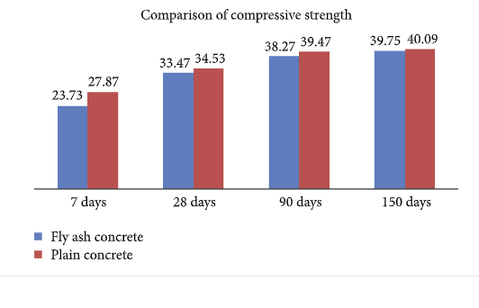
Fig 8
(An Experimental Study on Strength and Durability for Utilization of Fly Ash in Concrete Mix, 2020)

Figure 7 findings indicate that the strength of FA concrete at an early stage is around 18 per cent lower than that of concrete. The disparity means the concrete with fly ash requires longer moulding time. As shown in the figure, as discussed elsewhere, the gap appears to decrease at later stages. In other words, at 5 months later it decreased to less than 1 per cent. Using fly ash as a substitute for ordinary Portland cement causes the early intensity to decrease considerably. In the case of sulphate attacks, specimens of FA concrete accumulate more strength over time than those of plain concrete. Consequently, the final stage finds a small difference in energy.
The case study also states that, in addition, concrete cavities can be better filled by mineral additives because of their fine graininess. They can also increase concrete resistance to harmful influences caused by sulphate by producing a lower permeability on concrete surface after 5 months with a small loss of compression strength (about 1 percent). The use of fly ash in concrete mix design instead of cement often provides economic benefit. However, the use of fly ash in the concrete mix instead of cement also brings major economic benefits.

Blast Furnace Slag

Ground Granulated blast furnace slag is the slag from the iron producing blast furnaces that is rapidly quenched in water and then ground into a powder. It is also similar to Portland cement chemically but less reactive than it. This can hydrate in a similar way to Portland cement when combined with water. Based on the product, it is often used in conjunction with Portland cement, usually 60% of Portland cement and 40% of blast furnace slag to 30% Portland cement and 70% blast furnace slag.
The mixtures can be pre-mixed cements developed in the factory or formed in the mixer by adding Portland cement and blast furnace slag from their own silo. Concretes that contain blast furnace slag and Portland cement are slower reacting than pure Portland concretes, but may have improved durability. ()

Research Paper

A research paper from the University of Wisconsin – Madison, called Effects of Ground Granulated Blast Furnace Slag in Portland Cement Concrete – Expanded Study examined concrete that had properties containing 120 grade slag cement at replaced levels of 0%, 30% and 50%. The primary concrete properties studies were compressive strength, split-tensile strength and resistance to deicer scaling. Content variation include four ordinary Portland cement sources and two types of coarse aggregates. Properties for strength were studied at room temperature and mixing and curing conditions at 40 ° F. Deicer scaling resistance under six curing conditions had been tested for concrete healing. Carbonisation of cured concrete had also been studied under the six conditions. It was determined that the concrete containing 30% and 50% replacements of Portland cement with 120-grade slag cement had an initial compressive decrease and tensile strength compared to Portland cement concrete. Nevertheless, the strength of the 120-grade slag cement concrete equalled or exceeded that of Portland cement concrete by 14 days. Compared with Portland cement concrete, the opening time of 3000 psi was delayed by 1 to 2 days for 30% replacement and by 3 to4 days for 50% replacement. Deicer scaling resistance decreased as the amount of replacing slag cement increased. Curing methods that restricted the carbonation created concrete with the highest degree of resistance to scaling. Air cured concrete had better resistance to the scaling than concrete cured with commercial using compounds. The resistance of all grade 120 slag cement concrete to scaling was within reasonable limits. Variations in the source of Portland cement induced changes in the properties of strength and resistance to scaling. Variation in coarse aggregate affected compressive and tensile strengths but did not affect the resistance of the deicer to scaling.

Regen

Regen is ground granulated blast furnace slag made by a company called Hanson Heidelberg cement Group. This is a by-product of the iron making industry. They have stated that by using one tonne of regen in concrete it lowers the CO2 embodied by about 900kg () compared to using one tonne of Portland cement, and improves its durability as well. Regen is more sustainable than other cements replacements such as fly ash.
In the United Kingdom, GGBS is usually supplied as a separate concrete part and applied to the concrete mixer. It can replace Portland cement by 70 per cent or more. GGBS is referred to as an 'addition' in British Terms, and is entirely counted against concrete cement material. Regen complies with BS EN 15167-1 "Ground Granulated Blast Furnace Slag for use in concrete, mortar and grout" and is available in the UK, supported by a robust package of technical and logistic support. (Hanson)

Iron Blast Furnace Slag Production

Throughout the late 19th century the cementitious properties of blast furnace slag were discovered and have been commonly used in concrete production for over 100 years. Blast furnaces work at temperatures of up to 2000 ° C and are fed with a carefully managed combination of iron ore, coke and calcareous stone. The iron ore is converted into iron which sinks to the furnace's bottom. The remaining materials form a slag which floats above the iron. The molten iron and slag are drawn off from the furnace at regular intervals. As the slag is removed the chemistry is controlled as a test on the furnace's efficiency. This means the chemical composition of the slag is very consistent. The slag is easily quenched in water, after being tapped from the furnace and removed from the iron. This method is called granulation because it creates glassy granules, similar to a coarse sand in appearance.

Hydration Process

GGBS may be used as a replacement for cement, as the hydration process is similar to Portland cement. As cement from Portland reacts with water, the insoluble hydration products form near the cement particle. As isolated crystals, surrounded by large pores, precipitates the more soluble hydration substance (calcium hydroxide. When GGBS particles are also present, both the GGBS and Portland cement hydrate. In addition, the GGBS reacts with the excess calcium hydroxide to form hydrates that help to fill and block the pores. The product is a hardened cement paste, which has much lower calcium hydroxide and a less permeable polished pore structure. Reducing free calcium hydroxide makes concrete chemically more stable, and the finer porous structure limits the ability of hostile chemicals to pass through the concrete. Fly ash from coal-fired electricity-generating power stations is another cement addition. The method of hydration for fly ash is pozzolanic, not cemented. (Hanson)

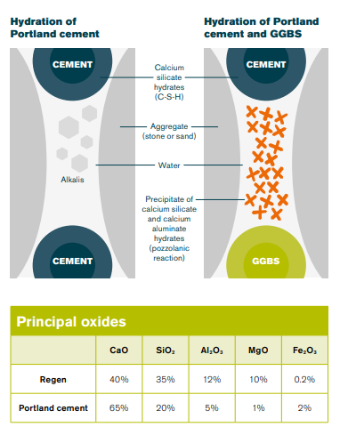
Fig 9
(Hanson)

The Second Severn Bridge

In a hostile setting long-term stability was a vital factor in the construction of the Second Severn Crossing. More than 60,000m3 of Regen was used to meet these requirements, replacing in concrete between 20 per cent and 70 per cent of the cement. The concrete displays no signs of decay, more than 25 years later.

Product and volume supplied by Hanson:
- All aggregate, cement (Ketton), Regen (GGBS/Llanwern) and asphalt/laying
- C70 concrete mixes for piles, foundation and bridge segments (6500 tonne ship at 20 knots)
- CEM I and between 20% and 70% Regen (GGBS) mixes (durability, control of heat of hydration and colour)
- Concrete volume 320,000m³
- Regen volume 60,000m³
(The Second Severn Crossing, n.d.)

Limestone Dust

This paper explores the effect of sand-based limestone filler on concrete properties, including fresh concrete workability (slump test method), compressive and tensile strength, unit weight, and ultrasonic pulse duration. Six concrete mixtures with specific limestone filler ratios (0, 10, 20, 30, 40, 50) percent sand-replacement were used while maintaining a constant water / cement ratio. The findings showed that limestone filler replaces up to 20 per cent of sand without adversely impacting concrete strength
A total of six mixtures of concrete were prepared. The first is a reference concrete mix, the remaining five sand substitute mixtures of limestone one filler each (10, 20, 30, 40, 50) per cent. Throughout the test, the water-to-cement ratio is stable at 0.57. The details of the composition of mixtures are given in Table 1
(Alshahwany, 2011)

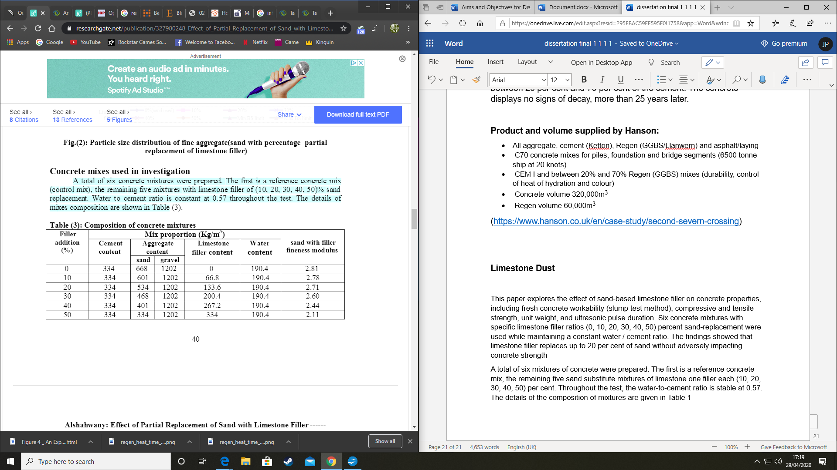
Table 1
(Alshahwany, 2011)

Aggregate, limestone filler and cement were mixed in a vertical rotating concrete flow mixer for one minute, mixing continued for another minute while adding water, slump testing was performed to assess the concrete mixing workability and unit weight testing was performed. For each mixture, twelve cubical specimens of (100×100×100) mm for the compressive strength and three cylindrical specimens of (100 ϕ ×200) mm for the splitting tensile strength were cast in steel moulds, a vibration table was used to consolidate the concrete.
The prepared specimens were processed under cure conditions before the experiment was conducted. The compressive intensity was determined for 3, 7, 14 and 28 days according to (BS1881: Section 116).

Results

The slump test was used as a function of limestone fill content for constant w / c ratio, the impact of limestone filler content on the slump is shown respectively in Table (2). The slump value tends to decrease with a higher percentage of limestone filler material, which is due to the relatively high-water absorption capacity attributed mainly to the broad specific surface of limestone filler


Table 2
(Alshahwany, 2011)

Influence of Limestone Dust on the Unit Weight

It has been observed that by increasing the limestone filler quantity, the unit weight of the mix increases until a certain optimum value of the limestone filler quantity depends on the distribution of the sand particle size representing 20% of the sand replacement with limestone filler, At this quantity of limestone filler the unit weight increased by 3.8% of its reference value, then decreased regularly for a higher filler quantity but still more than the unit weight of the control l mix; this is interpreted as fine particles of limestone filler filled spaces between grains of sand (before reaching full compactness), thereby increasing the mass volume of the mixture. When the voids were filled, fine particles started to take the place of sand grains, which decreased the proportion of sand grains and thus the unit weight of the mix.
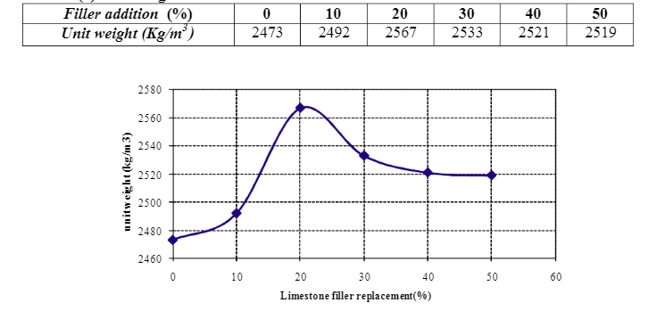
Table 3
(Alshahwany, 2011)

Influence of Limestone Dust on Compressive Strength

Table (4) illustrate the compressive strength results of all concrete mixtures at the age of 3, 7, 14 and 28 days. The intensity values are three sample averages. In various age classes, the strength efficiency of mixtures containing 10% and 20% limestone filler replacement is continuously increased, the compressive strength decreases when concrete (30, 40 and 50) contain limestone filler replacement with sand compared to the control mix.

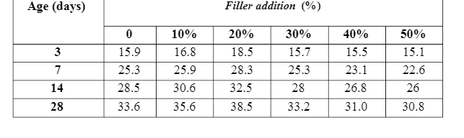
Table 4
(Alshahwany, 2011)

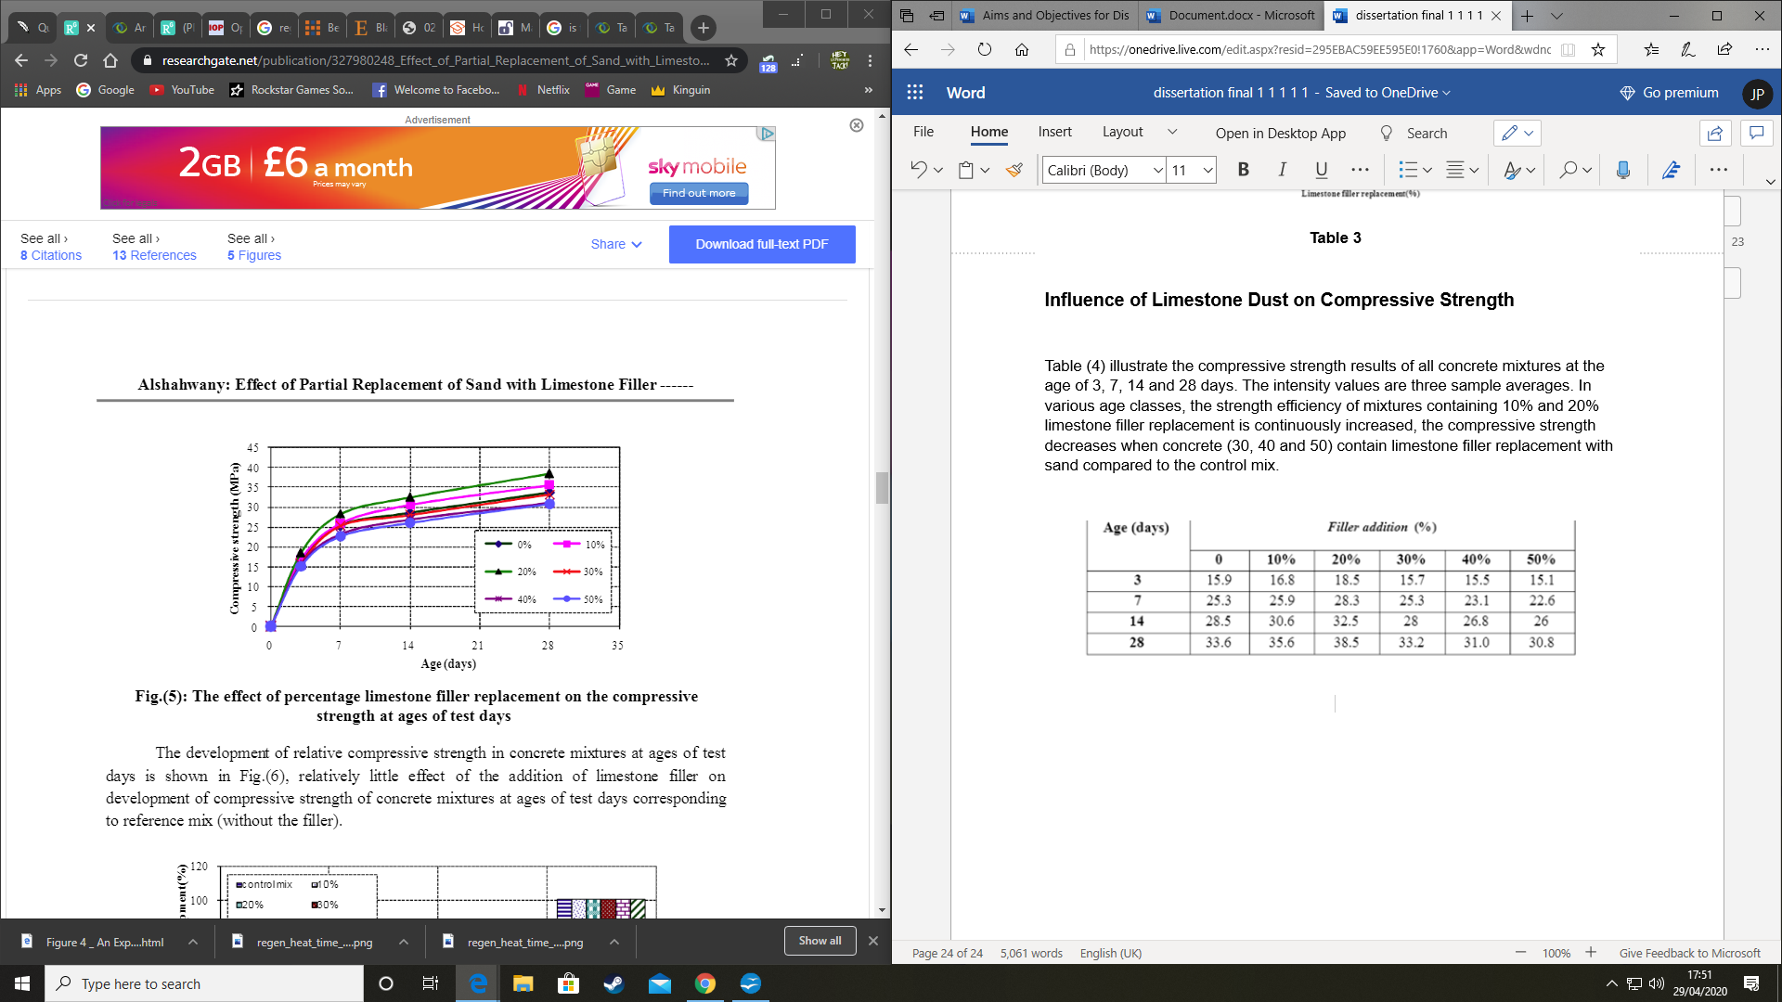
Fig 10

(Alshahwany, 2011)

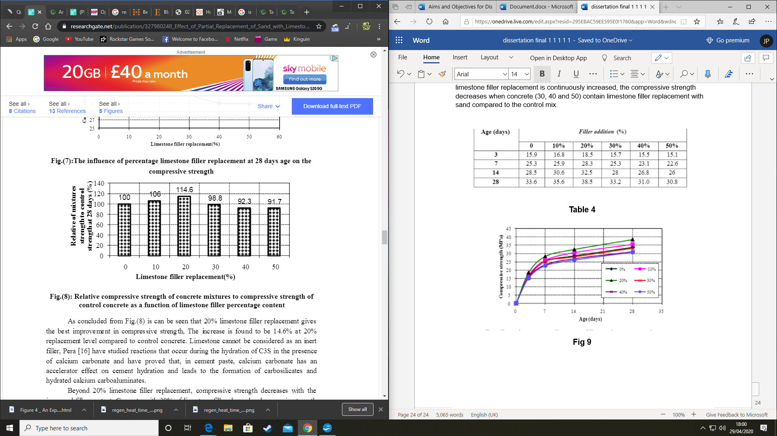
Fig 11
(Alshahwany, 2011)

As can be seen from Fig. (10) that 20 percent limestone filler replacement provides the strongest compressive strength boost, the increase is found to be 14.6 percent at a replacement level of 20 percent compared with concrete control. Limestone cannot be considered an inert filler, the author has studied reactions that occur in the presence of calcium carbonate during the hydration of C3S and has shown that in cement paste, calcium carbonate has an accelerator effect on cement hydration and contributes to the formation of carbosilicates and hydrated calcium carboaluminates. Beyond 20 percent replacement of limestone filler, compressive strength decreases with increased filler material, concrete with 30 percent of limestone filler showed a decrease in strength of about 1.2 percent, the decrease extended to 8.3 percent with a replacement of 50 percent compared to control mix.
The author found that, above the optimal value of the application of crushed stone dust, the number of fines increased to such an extent that the cement paste could not coat both fine and coarse-particles (i.e. both filler and sand). That phenomenon weakens the bond between cement and aggregate This results in a loss of compressive strength for higher filler quantities than the desired value.
(Alshahwany, 2011)

Permeability Tests for Concrete

Permeability testing of concrete cubes can be conducted using 100 mm concrete cubes and exposed to a 10-bar nitrogen gas pressure in pairs and then calculate the time it takes to reduce the gas pressure to 5 bar.
A case study shows that they removed the samples at 28 days from the curing tank, and drilling a 6 mm diameter hole through the centre of the cube at right angles to the casting path, the drilling procedure was done through the middle of one face to half a cube depth, and from the opposite side to the middle of the holes. This technique was used to avoid spilling of concrete as the drill pushes itself through the cube's rim. The sample cubes were then dried on the surface, and set at 105 ° C in an oven. Continuous weight control was maintained until the weight loss was less than 1 per cent of the cube's weight over a 24-hour span. The cubes were removed from the oven at this stage, and put to cool in a desiccator.

Methodology

Mix Designs

This study used an Ordinary Portland Cement, and a ground granulated blast furnace slag, all of which adhere to BS EN 197-1:2000, lime stone dust and sand. Both cement and sand replacement materials were obtained from various sources, the cement and sand were sourced through Trinity Saint David University, the blast furnace slag was obtained from Tarmac – Llanelli Concrete Plant and the limestone dust was supplied from TRJ, T Richard Jones (Betws) Ltd Yard where limestone is crushed.
The measure of performance for the replacement materials for sand and concrete was judged against other case studies found online, the replacement material, lime stone dust was blended in ranges of 25% and 100% while the blast furnace slag had a blended range of 30% and 50%. The only variable that stayed constant was the water, which was 247.5ml.

Mix Procedure

When producing the mixes, all aggregates needed to be dry before use, so the materials were placed in an oven for 24 hours to dry. Each of the batch’s materials were weighed on scales and then placed in an air tight bag ready to be poured into the concrete mixing machine, 247.5ml of water was poured into the machine and then turned on to mix on slow, in the first 30 seconds of the mix the cement or cement and blast furnace slag was placed into the machine, after the first 30 seconds are complete there was a 60 second wait for it to mix in, after that the sand or sand and lime stone dust was then poured in and that had to be done in another 30 seconds. When there had been a total of 120 seconds on a slow mix for an additional 60 seconds it had to go on a fast speed mix, when finished turn off the machine and place the wet concrete half way in the concrete mould and then place on the vibrating machine for 20 seconds to compact the concrete and then fill it to the top compact it again for another 20 seconds on the vibrating machine. When this has been done place the mould in an air tight bag for 24 hours and after 24 hours, demould the concrete blocks and submerge them in water for the allocated times.
This was done to all 9 batches and redone once more.

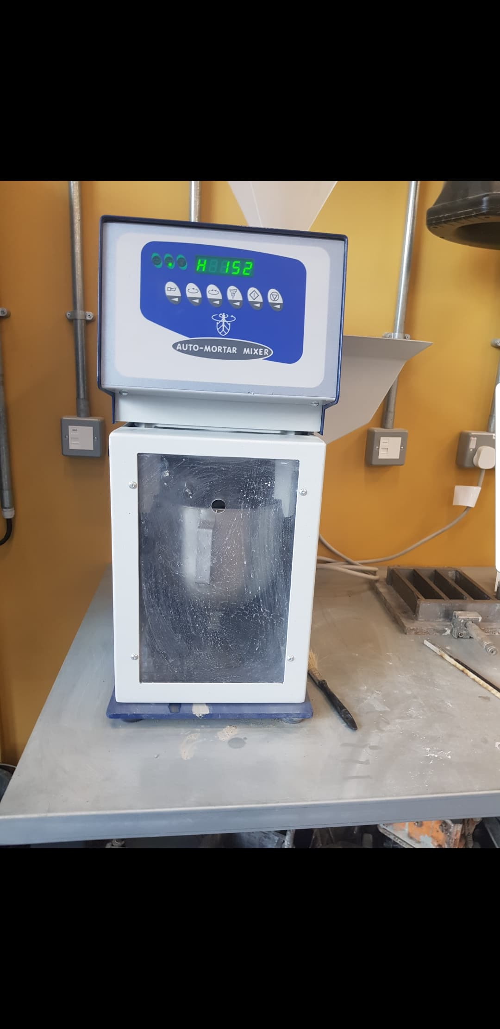
Fig 12

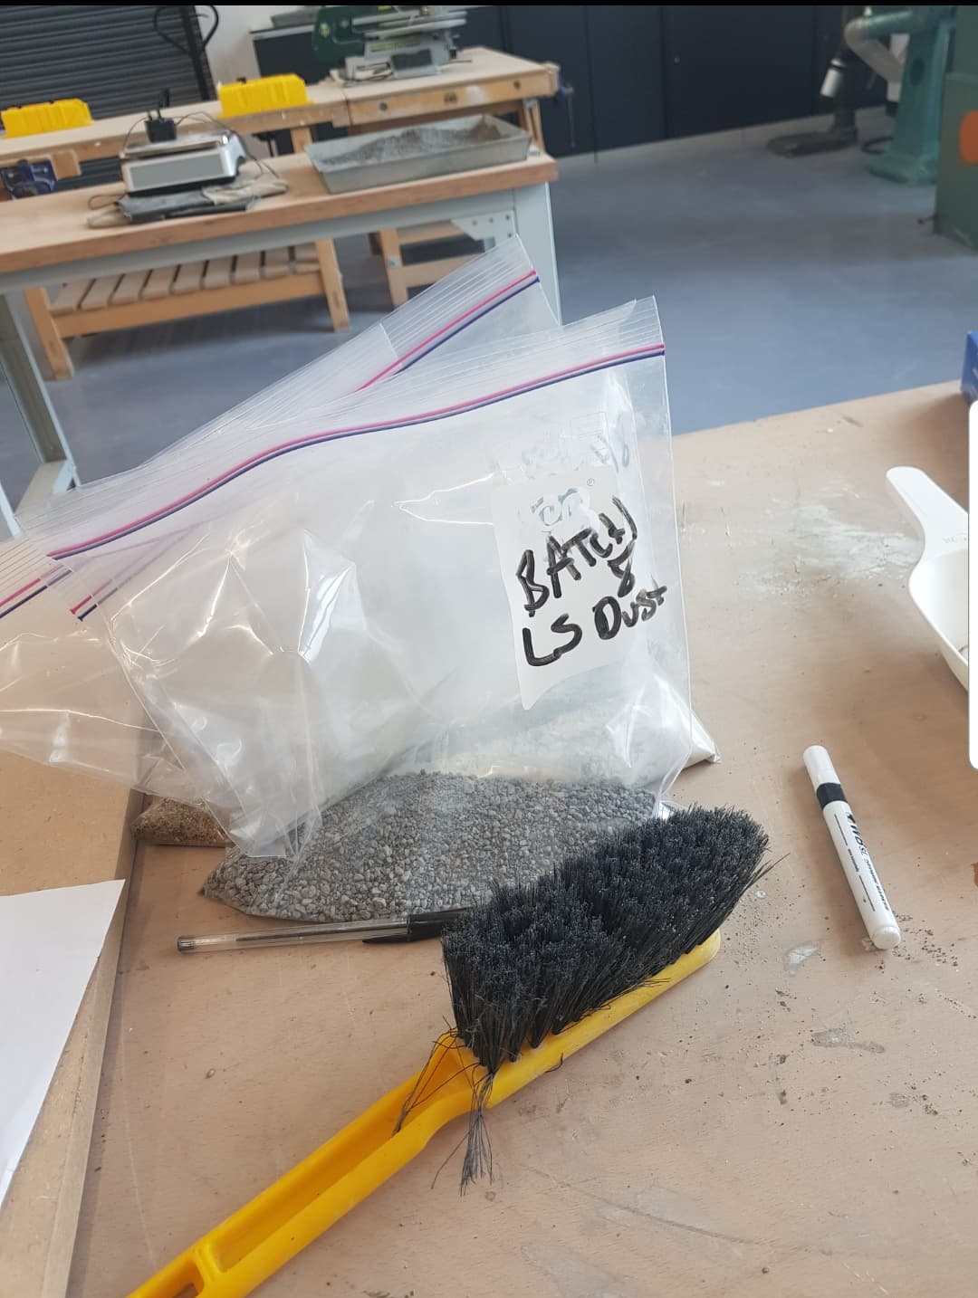
Fig 13

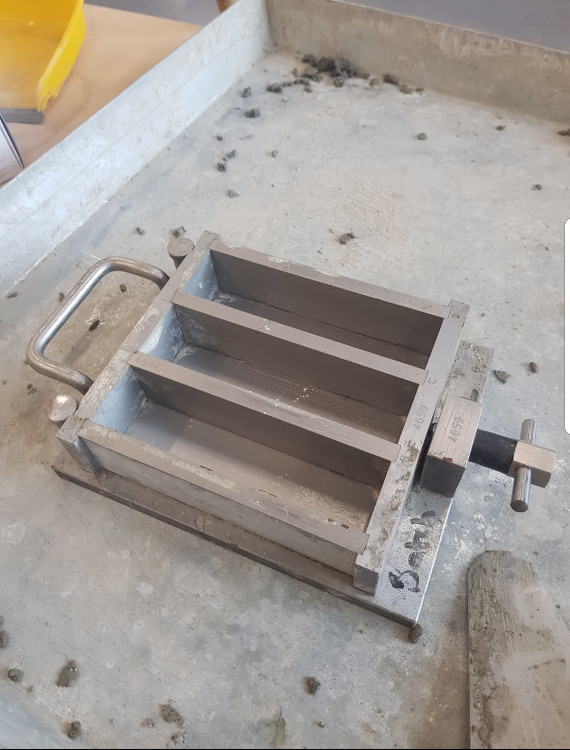
Fig 14

Replacement Materials

Lime Stone Dust

The lime stone dust used in this research was supplied by TRJ, T Richard Jones (Betws) Ltd Yard, the lime stone dust is created in TRJ’s yard where the limestone is crushed.

Grounded Granulated Blast Furnace Slag

The blast furnace slag was obtained from Tarmac – Llanelli Concrete Plant.
GGBS (BS EN 15167-1)

Sand

All sand that was used was provided by the University of Trinity Saint David Swansea

Cement

All the cement that was used was provided by the University of Trinity Saint David Swansea

Water

All water used in this research was drinkable water as supplied from the University of Trinity Saint David Swansea

Strength Tests

Cubes

The cubes that were used in these flexural and compression strength tests were produced using steel cube moulds, compaction of the concrete was carried out using a vibrating machine.

Curing

The cubes were removed from the moulds after twenty-four hours and placed completely submerged in the curing tank. The water in the tank. The pre-test curing period varied based on the standard normal concrete testing period of 7 days, 28 days.

Flexural Test

Flexural measurements are typically used to determine the flexural modulus or flexural strength of an object. A flexure test is more cost effective than a tensile test, with very different test outcomes.
The material is laid horizontally over two contact points (lower support span) and then a force is applied to the top of the material, either through one or two contact points (upper load span) before the sample fails. The maximum force registered for this particular sample is the flexural power.
A flexure test does not assess fundamental material properties, as compared to a compression test or tensile test. When a specimen is put under flexural loading all three fundamental stresses are present: tensile, compressive and shear and hence the flexural properties of a specimen result from the combined impact of all three stresses as well as (although to a lesser extent) the structure of the specimen and the rate at which the load is applied.
A flexure check is most widely used for calculating flexural tension and flexural modulus. Flexural strength on either the compression or tension side of the specimen is defined as the maximum stress on the outermost fibre. Based on the slope of the stress vs. strain deflection curve, the flexural modulus is calculated. These two values can be used for determining the ability of the sample materials to withstand flexure or bending forces.
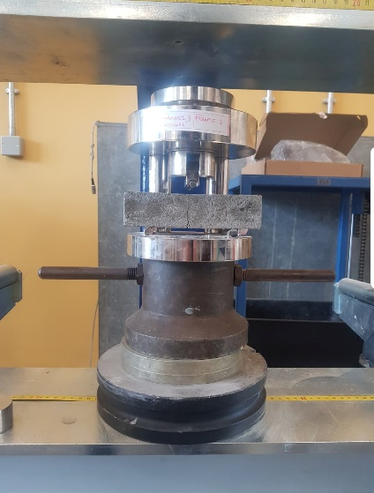

Fig 15

Fig 16

Compressive Strength

Concrete compressive strength is an outstanding measure of concrete quality and is generally the most significant basis for requirements and quality control, as many other properties are directly or indirectly connected to it
The compressive strength test was carried out using a compression testing machine at a pacer rate of 180kN / minute on concrete cubes, to BS EN 12390-3:2002. Although the sample compressive strengths have been identified at different times, the strength of 28 days is the most important to industry (BS EN 206-1:2000). The tests for compression were carried out on cubes removed from the curing tank at 28 days.
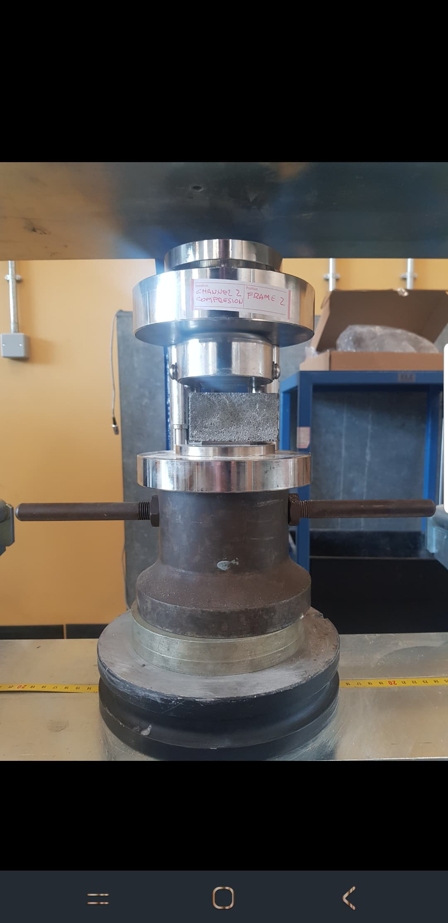
Fig 17
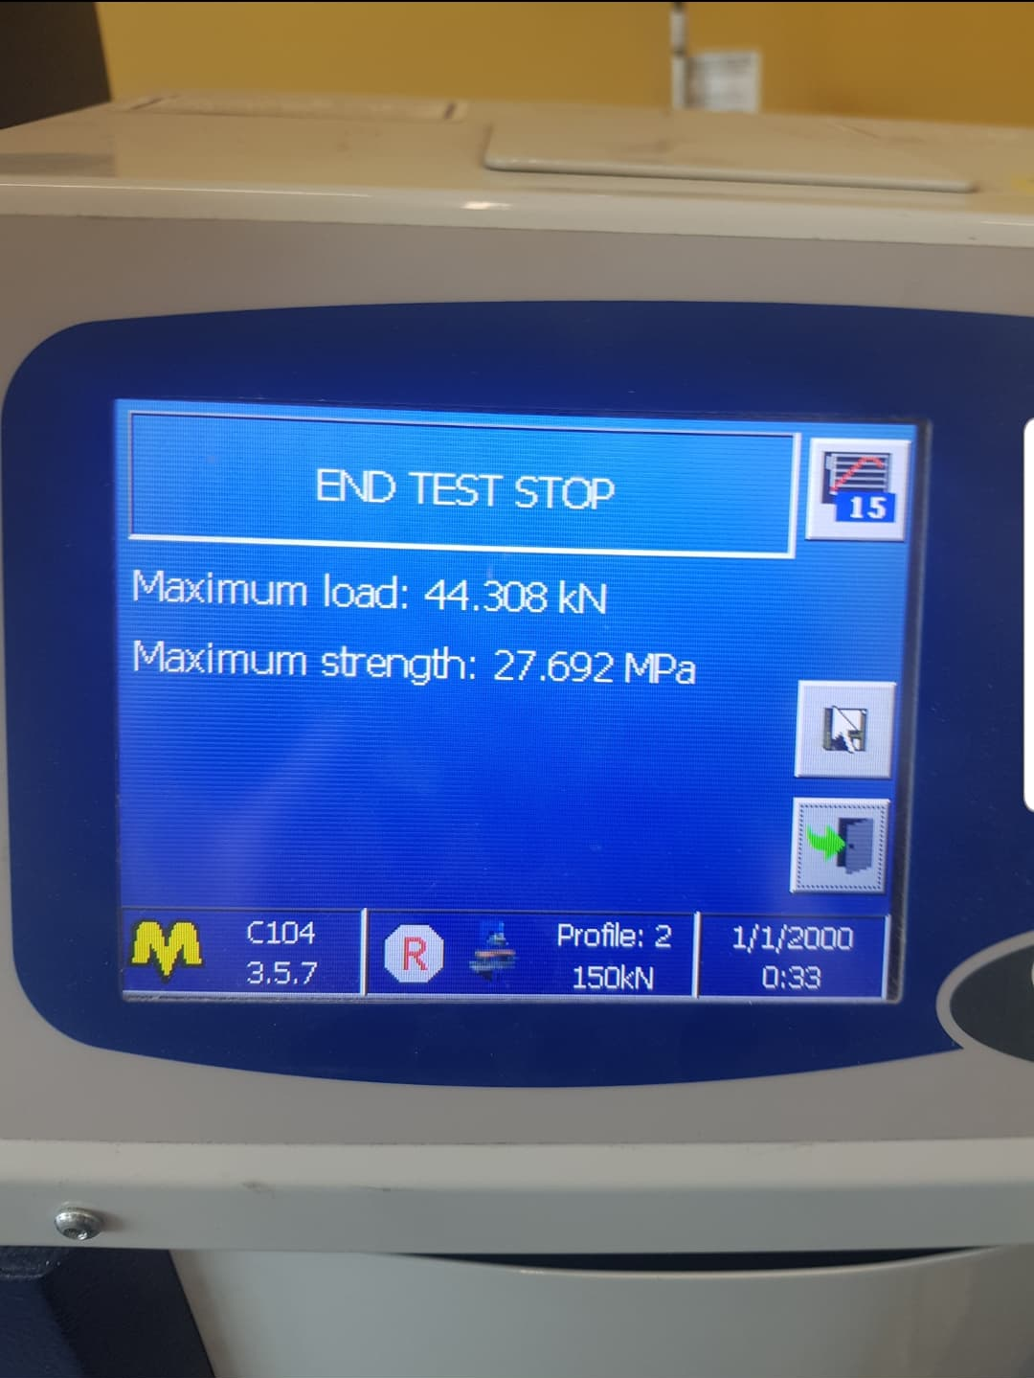
Fig 18

Results

Introduction

This chapter deals with the analysis of the waste materials, blast furnace slag and lime stone dust used in concrete to reduce sand and cement. The chapter starts with a look at the controls used, and offers values that can be used to calculate test materials. The chapter goes on to look at the use of blast furnace slag as a replacement of cement and lime stone dust as a replacement of sand has been created on the concrete. The work studies the performance of the materials and their physical characteristics, and attempts to classify the characteristics that either strengthens the concrete used or impedes the concrete from reaching its full potential

Errors that could have occurred

Because of the high estimate of the necessary samples and the amount of concrete mixes needed to supply such samples, standardisation of the mixing and testing process was determined from the outset. It was expected that keeping a schedule would reduce errors and have a limited spectrum of outcomes; however, potential causes of errors need to be established.
All materials used in the experiment was stored in air tight bags and a locked room, so ensuring that the materials remained useable with no changes to the properties, if changes occurred such as moisture levels increased in the sand then data would be incorrect. The lime stone dust proved to be a problem from the start due to not being able to source the material, but eventually found a source. Drying the sand and limestone dust was a challenge too as it needed to before placed in a oven for 24 hours before use.

Mixes

To establish a measure for the viability of the potential material, control mixes were required, the control mixes were decided from case studies that relate to this experiment, they were:
- 25% and 100% of lime stone dust to reduce the sand
- 30% and 50% of blast furnace slag to reduce the cement

Batch’s | Ingredients (Grams)
1 | - 1350 grams of sand  - 450 grams of cement  - 225 millilitres of water
2 | - 1012.5grams of sand  - 450 grams of cement  - 247.5 millilitres of water  - 337.5 grams of bottom ash
3 | - 450 grams of cement  - 247.5 millilitres of water  - 1350 grams of limestone dust
4 | - 1350 grams of sand  - 315 grams of cement  - 247.5 millilitres of water  - 135 grams of slag
5 | - 1012.5 grams of sand  - 315 grams of cement  - 247.5 millilitres of water  - 135 grams of slag  - 337.5 grams of lime stone dust
6 | - 315 grams of cement  - 247.5 millilitres of water  - 135 grams of slag  - 1350 grams of limestone dust
7 | - 1350 grams of sand  - 225 grams of cement  - 247.5 millilitres of water  - 225 grams of slag
8 | - 1012.5 grams of sand  - 225 grams of cement  - 247.5 millilitres of water  - 225 grams of slag  - 337.5 grams of lime stone dust
9 | - 225 grams of cement  - 247.5 millilitres of water  - 225 grams of slag  - 1350 grams of limestone dust
Table 5

Table to show the first 9 concrete batches flexural and compression in 7 and 28 days

Batch’s | Flexural Testing after 7 days  (KN) | Compressive Strength test after 7 days  (KN) |  | Flexural Testing after 28 days (1)  (KN) | Compressive Strength test after 28 days (1)  (KN |  | Flexural Testing after 28 days (2)  (KN) | Compressive Strength test after 28 days (2)  (KN)
1 | 2.887 | 44.308 | 45.068 | 4.370 | 65.166 | 65.542 | 3.889 | 64.124 | 64.475
2 | 3.073 | 27.984 | 28.670 | 4.241 | 37.052 | 44.348 | 4.280 | 45.175 | 42.041
3 | 4.299 | 42.278 | 50.664 | 5.782 | 80.548 | 82.052 | 4.899 | 75.977 | 78.243
4 | 2.893 | 33.750 | 30.375 | 3.549 | 38.951 | 39.643 | 3.735 | 57.873 | 55.601
5 | 4.630 | 58.594 | 47.110 | 4.788 | 58.646 | 65.321 | 5.105 | 65.321 | 63.249
6 | 4.436 | 55.099 | 46.533 | 5.560 | 58.372 | 57.779 | 4.857 | 66.031 | 66.281
7 | 1.195 | 12.457 | 11.165 | 1.919 | 20.073 | 27.345 | 0.793 | 24.730 | 25.207
8 | 1.482 | 13.476 | 14.190 | 2.825 | 28.221 | 30.325 | 2.378 | 27.119 | 30.440
9 | 1.918 | 18.500 | 19.479 | 3.553 | 39.502 | 23.087 | 3.564 | 29.901 | 30.415
Table 6

Table to show the second batch of 9 concrete batches flexural and compression in 7 and 28 days

Batch’s | Flexural Testing after 7 days  (KN) | Compressive Strength test after 7 days  (KN) |  | Flexural Testing after 28 days (1)  (KN) | Compressive Strength test after 28 days (1)  (KN |  | Flexural Testing after 28 days (2)  (KN) | Compressive Strength test after 28 days (2)  (KN)
1 | 3.002 | 38.461 | 36.536 | 1.414 | 60.061 | 57.161 | 3.844 | 46.982 | 49.178
2 | 2.530 | 36.337 | 39.426 | 2.628 | 34.619 | 38.724 | 4.408 | 45.532 | 42.617
3 | 4.713 | 44.262 | 44.733 | 4.493 | 63.123 | 62.725 | 5.432 | 59.641 | 60.752
4 | 2.357 | 28.980 | 29.843 | 3.374 | 50.090 | 51.142 | 3.655 | 47.348 | 49.794
5 | 2.775 | 27.910 | 29.491 | 3.294 | 54.383 | 52.888 | 3.645 | 51.068 | 52.335
6 | 4.210 | 33.960 | 31.575 | 4.968 | 76.188 | 63.765 | 5.455 | 76.598 | 69.451
7 | 0.995 | 8.301 | 9.908 | 2.809 | 23.581 | 23.952 | 2.302 | 25.132 | 22.754
8 | 1.213 | 11.007 | 11.958 | 2.728 | 27.150 | 27.521 | 2.477 | 17.902 | 17.404
9 | 1.530 | 15.040 | 16.129 | 3.241 | 34.358 | 33.913 | 3.306 | 35.249 | 35.057
Table 7

Flexural Results after 7 days

From these results, batch 3 had the best possible outcome when it comes to flexural strength, the results were 4.299 KN and 4.713 KN, these ingredients were:
- 450 grams of cement
- 225 millilitres of water
- 1350 grams of lime stone dust
Batch 6 had similar results to batch 3 on the first set of batches but when it came to the second batch the flexural results dropped in difference between batch 3 and 6. the weakest results for flexural strength came from batch 7 which a 1.195 KN for the first try and 0.995 KN for the second try. The ingredients are:
- 1350 grams of sand
- 225 grams of cement
- 225 millilitres of water
- 225 grams of slag

Flexural Results after 28 days

From the results, batches 3 and 6 and very similar results from both first and second attempt, but the results show on the first attempt the flexural strength drops on the second 28th day cubes on batch 3 and 6 but on the second attempt the both blocks increase in flexural strength.
The weakest batch for flexural strength was batch 7 with a rating of flexural strength of 1.919 KN and 2.809 KN.

Conclusion on the Flexural Strength

It can be seen that over time the concretes flexural strength does increase on all batches but does show a variation in strength between mixes at different time periods on both attempts.

Compressive Strength Results after 7 days

The strength of ready mixed concrete is influenced by a large number of factors making it a highly variable product. A variance coefficient for concrete compressive strength usually varies from 10 per cent to 20 per cent (Sear L 2003). Since this is a laboratory combination, the higher control available should be expected to achieve a strength variability lower than 10 per cent.
On the first attempt, batch fives compression has the highest with 58.594 KN and 47.110 KN but on the second attempt there is a massive decrease in compression as its 27.910 KN and 29.491 KN. The materials where:
- 315 grams of cement
- 225 millilitres of water
- 135 grams of slag
- 1350 grams of bottom ash
the highest with similar results would be batch 3 with results of 42.278 KN and 50.664 KN for the first attempt and the second attempt with 44.262 KN and 44.733 KN.
The weakest batch for compressive strength after 7 days was batch 7 with a compression of 12.457 KN, 11.165 KN and for the second attempt, 8.301 KN, 9.908 KN.

Compressive Strength Results after 28 days

Batch 3 on the first attempt had the greatest compression with 80.548KN, 82.052 and 75.977 KN, 78.243 KN. But the results for the second attempt varied, to 63.123 KN, 62.725 and 59.641 KN, 60.752 KN
The weakest compression after 28 days came from batch 7 with a compression strength of 20.073 KN, 27.345 KN and 24.730 KN, 25.207 KN and second attempt had similar results, they were 23.581 KN, 23.952 KN and 25.132 KN, 22.754 KN.

Compressive Strength Conclusion

To conclude, each batch and its duplicate had similar results when it came to compressive strength and it also increases in strength to an extent between 7 to 28 days.

Conclusion of Results

From the work that has been carried out in this chapter the main conclusions are:

- Replacing sand with lime stone increases the flexural and compressive strength to a standard concrete mix
- Replacing cement by 50% with blast furnace slag decreased the flexural and compressive strength overall to a standard concrete mix
- Reducing the sand by 25% with lime stone does increase flexural and compressive strength but not by a larger margin than replacing sand completely
- Reducing sand and cement with lime stone by 25% and blast furnace slag by 30% does increase the flexural and compressive strength in comparison to a normal concrete mix

Conclusion and recommendations

The findings of this thesis aimed at advancing the understanding and use of waste materials as concrete substitutes of cement and sand are listed below:

- Reducing the sand and cement in a concrete mix and adding lime stone dust and blast furnace slag provides additional compressive and flexural strength benefits to the concrete.

- Taking out all the sand and replacing it with lime stone dust also increases the flexural and compressive strength.

- Reusing waste materials from industry such as lime stone dust and blast furnace slag can be done so less cement and sand use can be achieved.

- Environmental factors such as less carbon dioxide will be produced if using these waste materials in concrete.

Recommendations for further studies

This research is seen as a first step towards creating a workable specification for the specifications of cement substitution content. Further work needed to further advance this research is discussed below

- Full-scale plant testing should be conducted using different mix designs to evaluate the products being tested in a more practical manner, as it is well known in the cement and concrete industries, laboratory research comes from idealised conditions and usually does not necessarily reflect what happens in industry.

- Using different types of waste materials as there's so many options to use such as fly ash and bottom ash.

- If there was more time for laboratory work, maybe there's possibilities of waiting more days for the concrete to harden.

References

2020. The Environmental Impacts Of Concrete. [online] Available at: <http://www.greenspec.co.uk/building-design/environmental-impacts-of-concrete/>
A.M, N., 1995. Properties of Concrete” Longman Group, U.K. 4Th Edition. [online] Available at: <https://trid.trb.org/view/454875>
Alshahwany, R., 2011. Effect of Partial Replacement of Sand With Limestone Filler On Some Properties Of Normal Concrete. [online] Available at: <https://www.researchgate.net/publication/327980248_Effect_of_Partial_Replacement_of_Sand_with_Limestone_Filler_on_Some_Properties_of_Normal_Concrete>
Bartos, P.J.M. Sonebi, M. 2002. Workability and Rheology of Fresh Concrete: Compendium Of Tests. [online] Available at: <https://www.researchgate.net/publication/259638295_Workability_and_Rheology_of_Fresh_Concrete_Compendium_of_Tests> [
Bilodeau, A., & Malhotra, V. (1992). Concrete incorporating high volumes of ASTM Class F fly ashes: Mechanical properties and resistance to deicing salt scaling and to chloride-ion penetration. Turkey
BRE, 1997. “Design Of Normal Concrete Mixes”, Construction Research Communications LTD. 2Nd Edition. [online] Available at: <https://www.academia.edu/34172199/Design_of_normal_concrete_mixes_BRE>
Chung-Ho, H., Shu-ken, L., Chao-Shun, C., & How-Ji, C. (2013). Mix proportions and mechanical properties of concrete containing very high-volume of class F fly ash. Construction and Building Materials, 46, 71–78.
Day, R., 1990. Optimizing The Use Of Fly Ash In Concrete. [online] Cement.org. Available at: <https://www.cement.org/docs/default-source/fc_concrete_technology/is548-optimizing-the-use-of-fly-ash-concrete.pdf>
Domone, P., 2003. Advanced Concrete Technology Choo. [online] Issuu. Available at: <https://issuu.com/eng.sulaimanalbeak/docs/advanced_concrete_technology-choo>
Ec.europa.eu. 2019. Construction and Demolition Waste - Environment - European Commission. [online] Available at: <https://ec.europa.eu/environment/waste/construction_demolition.htm>
En.wikipedia.org. 2019. Concrete Slump Test. [online] Available at: <https://en.wikipedia.org/wiki/Concrete_slump_test>
Encyclopedia Britannica. 2020. Portland Cement. [online] Available at: <https://www.britannica.com/technology/portland-cement>
Fisher, K., 2020. UK Statistics on Waste. [online] politics.co.uk. Available at: <http://www.politics.co.uk/news/opinion-former-index/environment-and-rural- affairs/brown-calls-world-leading-green-agenda-$481753.htm>
Google.co.uk. 2020. [online] Available at: <https://www.google.co.uk/search?q=true+slump+and+shear+slump&sxsrf=ALeKk02vxJfqasRUKsAs6XMKLkNxgEKS8w:1588262939851&source=lnms&tbm=isch&sa=X&ved=2ahUKEwjGx9vCxJDpAhUQRBUIHYUxAV4Q_AUoAXoECA4QAw&biw=958&bih=923#imgrc=Eb1GC5XLgsFBvM>
Hanehara, S., Tomosawa, F., Kobayakawa, M., & Hwang, K. (2001). Effects Of Water/Powder Ratio, Mixing Ratio Of Fly Ash, And Turing Temperature On Pozzolnaic Reaction Of Fly Ash In Cement Paste. [online] Available at: <https://www.researchgate.net/publication/229223487_Effects_of_waterpowder_ratio_mixing_ratio_of_fly_ash_and_Turing_temperature_on_pozzolnaic_reaction_of_fly_ash_in_cement_paste>
Hanson.co.uk. n.d. [online] Available at: <https://www.hanson.co.uk/en/system/files_force/assets/document/2a/37/hanson-regen.pdf?download=1>
Hanson.co.uk. n.d. The Second Severn Crossing. [online] Available at: <https://www.hanson.co.uk/en/case-study/second-severn-crossing>
Hindawi.com. 2020. Figure 4 | An Experimental Study On Strength And Durability For Utilization Of Fly Ash In Concrete Mix. [online] Available at: https://www.hindawi.com/journals/amse/2014/417514/fig4/
Illston, J., 1994. Construction Materials: Their Nature And Behaviour - PDF Free Download. [online] epdf.pub. Available at: <https://epdf.pub/construction-materials-their-nature-and-behavioure21c7e875d626d696f9787c805fa371d51017.html> [
Karaşin, A. and Doğruyol, M., 2014. An Experimental Study on Strength and Durability for Utilization of Fly Ash in Concrete Mix. Advances in Materials Science and Engineering, 2014, pp.1-6.
Li, Z., 2007. State Of Workability Design Technology For Fresh Concrete In Japan” Cement And Concrete Research 37. [online] Available at: <https://www.researchgate.net/publication/223858686_State_of_workability_design_technology_for_fresh_concrete_in_Japan>
Malhotra, V. (1990). Durability of concrete incorporating high-volume of low calcium (ASTM Class F) fly ash. Cement and Concrete Composites, 12(4), 271–277.
Naik, T., & Ramme, B. (1987). Setting And Hardening Of High Fly Ash Content Concrete. Paper Presented At The American Coal Ash Association’S 8Th International Coal Ash Utilization Symposium.. [online] Available at: <https://pdfs.semanticscholar.org/7c36/15838beb404b464e384bccd844ef46ab5a7d.pdf>
Naik, T., & Ramme, B. (1989). High Strength Concrete Containing Large Quantities Of Fly Ash. ACI Material Journal. [online] Available at: <https://www.sciencedirect.com/science/article/abs/pii/0008884694900566>
Rodgers, L., 2018. The Massive CO2 Emitter You May Not Know About. [online] BBC News. Available at: <https://www.bbc.co.uk/news/science-environment-46455844>
Rojas, F., 2002. The Effect Of Temperature On The Hydration Rate And Stability Of The Hydration Pastes Of MK-Lime-Water Systems. Cement And Concrete Research. [online] Available at: <https://www.researchgate.net/publication/237947404_The_Effect_of_Temperature_on_the_Hydration_Rate_and_Stability_of_the_Hydration_Phases_of_MK-Lime-Water_Systems>
Saak, A., 2004. A Generalised Approach For The Determination Of Yield Stress By Slump And Slump Flow” Cement Mid Concrete. [online] Available at: <https://www.researchgate.net/publication/331271302_Evaluation_on_Protection_Performance_and_On-Site_Applicability_of_Hybrid_Fiber-Reinforced_Concrete>
Siddique, R. (2004). Performance characteristics of high-volume Class F fly ash concrete. Cement Concrete Research, 34(3), 487–493.
Viso, D., 2007. Shape And Size Effects On The Compressive Strength Of High-Strength Concrete. [online] Available at: <https://www.researchgate.net/publication/232361911_Shape_and_size_effects_on_the_compressive_strength_of_high-strength_concrete>
Yi, S., 2006. Effect Of Specimen Sizes, Specimen Shapes, And Placement Directions On Compressive Strength Of Concrete. [online] Available at: <https://www.researchgate.net/publication/245194914_Effect_of_specimen_sizes_specimen_shapes_and_placement_directions_on_compressive_strength_of_concrete>

