
Applied Leadership and Management in the Workplace
Module Assignment Submission
Student Name: | Rebecca Edwards
Student Number: | 2523771
Module No: | BMSK4012
Module Title: | Enterprise and Intrapreneurship

Statement of Confirmation of Authenticity
By the act of making this submission, the student declares that this is the work of the student named above. The work has not, in whole or in part, been knowingly presented elsewhere for assessment, or where assessment has been built on a previous assessment, this has been identified. Where materials have been used from other sources it has been properly acknowledged. If this statement is untrue, the student acknowledges that an assessment offence has been committed.
Attention is drawn to the plagiarism and unfair practice policies of both the University and of ILM.
Contents Page
Content Page No

Executive Summary 3
Introduction 4
Financial Information 5
Market Analysis 7
PESTLE ANALYSIS 8
SWOT ANALYSIS 9
Competitor Analysis 10
Marketing Plan 11
SMART OBJECTIVES 12
THE 7 PS 12
Revenue and Pricing 13
Operations 13
Conclusion 14
References 14

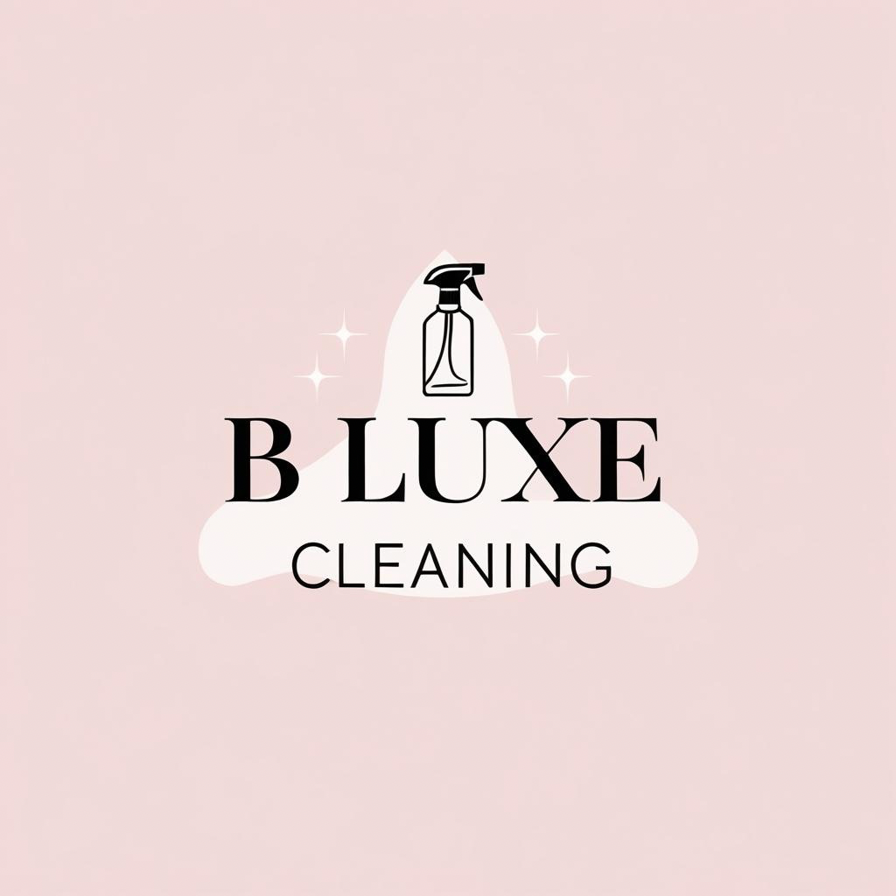

Executive Summary
This business plan outlines the development and future growth of my sole trader cleaning business, B Luxe Cleaning, based in Swansea, Wales. The business provides reliable, professional, high-standard domestic cleaning services while ensuring clients are satisfied with the service provided. Although the business operates as a sole trader the aim is to grow the client base and build B Luxe Cleaning into a trusted and highly recommended local business.
The main goal is to provide affordable and reliable cleaning services for families, elderly residents, landlords and customers who need support maintaining their homes. Alongside regular domestic cleans, the business also offers Airbnb and holiday-let cleaning, end-of-tenancy cleaning and office cleaning. Operating independently allows flexibility with working hours and reduces start-up costs, as the business can be managed from home with direct communication between myself and clients.
This business plan will explore the opportunities for cleaning services in Swansea by analysing the local market and competitors. It will include tools such as SWOT and PESTLE analysis to understand the business environment, alongside marketing strategies, operations, pricing and financial forecasts including cash flow, profit and loss, and break-even analysis. The first-year aim is to gain eight new regular customers through recommendations and retain at least 90% of existing customers by continuing to provide a high-quality service. The business will also increase online visibility by sharing content regularly on social media with customer permission.
B Luxe Cleaning’s target market includes families, busy professionals, elderly residents, landlords, Airbnb and holiday-home hosts, and businesses requiring a reliable cleaning service. Based on the cash flow forecast, the business is expected to generate a monthly income of approximately £3,033, with running costs of around £256. This leaves an estimated monthly surplus of £2,777, showing that the business can cover its expenses and maintain a positive cash flow.
Overall, this business plan demonstrates how B Luxe Cleaning can develop into a successful and professional local business. By maintaining high cleaning standards, building strong customer relationships, and responding to local demand, the business aims to grow and establish a strong reputation within the Swansea area.

Introduction
My business, B Luxe Cleaning, is a sole trader cleaning business based in Swansea, Wales. I provide a range of cleaning services, including regular domestic cleaning, end-of-tenancy cleaning, office cleaning and Airbnb and holiday-let cleaning. The aim of this business is to provide reliable, affordable and high-quality cleaning service to people across Swansea. This business plan explains how I plan to continue growing my business. It includes research into the local cleaning market and my competitors, as well as my marketing strategy, pricing and financial forecasts. It will also look at the strengths, weaknesses, opportunities and challenges that could affect the business. Based on the market research, now is a good time to continue growing the business, as demand for cleaning services is supported by the growth of tourism and accommodation in Swansea (Office for National Statistics, 2024; Swansea Council, 2025).
The purpose of this business plan is to show how I can continue to develop my business, attract more regular clients, and remain financially successful. It also explains my future goals, and how I plan to achieve them while continuing to provide a high standard service. I chose to operate my business as a sole trader because it was straightforward to set up, allows me to be my own boss and gives me the flexibility I need as a parent (HM Revenue & Customs, 2026b). It also means I have full control over the business and keep all the profits. However, there are disadvantages, including managing the workload alone and losing income if unable to work due to illness or taking time off. Despite these challenges, I believe the advantages currently outweigh the disadvantages.
I believe my business stands out because I offer a personalised service that is tailored to each client's needs. As a sole trader, I can be more flexible than larger cleaning companies and can adapt each visit to suit the customer. Whether this involves specific cleaning tasks, ironing or other small household jobs, I always ask the service they need. The personal approach helps build trust and encourages long-term customer relationships.

Financial Information
B Luxe Cleaning has low monthly running costs because I operate the business from home and do not have to pay for business premises. My regular monthly expenses include approximately £45 for cleaning products (this occasionally increases to around £50), £11 for public liability insurance, and around £200 for fuel, giving a total monthly cost of approximately £256.
I charge £20 per hour and currently work around 35 hours per week, generating an estimated weekly turnover of £700. This is equivalent to approximately £3,033 per month or £36,400 per year. Based on these figures, I only need to complete around 13 hours of cleaning each month to cover my business costs, meaning my current workload of 14 regular weekly clients keeps the business well above its break-even point. After deducting monthly expenses, I expect to make an estimated monthly profit of around £2,777 before tax.
These figures show that the business is financially sustainable and has the potential to continue growing. As demand increases, I hope to increase my working hours to around 40-45 per week. If the workload continues to grow, I may consider employing an additional cleaner to support the business while maintaining the high standard of service my customers expect. The cash flow forecast below supports these financial projections.

 | January | February | March | April | May | June | July | August | September | October | November | December
Income
Sales Revenue | £2,000.00 | £3,033.00 | £3,033.00 | £2,700.00 | £3,033.00 | £3,033.00 | £2,800.00 | £3,033.00 | £2,900.00 | £3,100.00 | £3,230.00 | £3,010.00 | £34,905.00
Total Inflows | £2,000.00 | £3,033.00 | £3,033.00 | £2,700.00 | £3,033.00 | £3,033.00 | £2,800.00 | £3,033.00 | £2,900.00 | £3,100.00 | £3,230.00 | £3,010.00 | £34,905.00
Outflows
Cleaning Products | £60.00 | £45.00 | £45.00 | £45.00 | £45.00 | £50.00 | £50.00 | £45.00 | £45.00 | £45.00 | £50.00 | £45.00 | £570.00
Public Liability Insurance | £11.00 | £11.00 | £11.00 | £11.00 | £11.00 | £11.00 | £11.00 | £11.00 | £11.00 | £11.00 | £11.00 | £11.00 | £132.00
Fuel | £200.00 | £200.00 | £200.00 | £200.00 | £200.00 | £200.00 | £200.00 | £200.00 | £200.00 | £200.00 | £200.00 | £200.00 | £2,400.00
Total Outflows | £271.00 | £256.00 | £256.00 | £256.00 | £256.00 | £261.00 | £261.00 | £256.00 | £256.00 | £256.00 | £261.00 | £256.00 | £3,102.00
Opening Balance | £0.00 | £1,729.00 | £4,506.00 | £7,283.00 | £9,727.00 | £12,504.00 | £15,276.00 | £17,815.00 | £20,592.00 | £23,236.00 | £26,080.00 | £29,049.00 | £167,797.00
net cash flow | £1,729.00 | £2,777.00 | £2,777.00 | £2,444.00 | £2,777.00 | £2,772.00 | £2,539.00 | £2,777.00 | £2,644.00 | £2,844.00 | £2,969.00 | £2,754.00 | £31,803.00
Closing Balance | £1,729.00 | £4,506.00 | £7,283.00 | £9,727.00 | £12,504.00 | £15,276.00 | £17,815.00 | £20,592.00 | £23,236.00 | £26,080.00 | £29,049.00 | £31,803.00 | £199,600.00

Market Analysis
B Luxe Cleaning targets customers across Swansea who require reliable and professional cleaning services. The main customers groups include families, Airbnb and holiday home hosts, private landlords and student landlords, along with businesses requiring office cleaning.
Families and busy professionals often have limited time to keep on top of the household cleaning, while some elderly residents may need additional support (Office for National Statistics, 2024). Landlords and Airbnb hosts require properties to be cleaned to a high standard between tenants or guests, and businesses need clean work environments for employees and visitors.
Having a variety of customers helps create a steady income throughout the year, with regular domestic cleans supported by one-off services such as end-of-tenancy, office and holiday-let cleaning.
There is a strong demand for cleaning services in Swansea due to the large number of residential homes, rental accommodation, Airbnb and holiday lets. Areas such as the Gower and Mumbles attract tourists throughout the year, increasing the need for cleaning services between guest stays. According to Swansea Council, the area welcomes 4.62 million visitors in 2024, contributing around £658 million to the local economy. The Office for National Statistics (ONS, 2024) also recognises tourism and accommodation as important contributors to the UK economy, supporting continued demand for services such as professional cleaning. This is important for B Luxe Cleaning because it shows there is a strong and consistent customer base to support the business. It provides opportunities to attract both regular domestic clients and one-off cleaning work, which will help the business maintain a steady income while continuing to grow.
Many customers choose to use an independent cleaner because they receive a more personal and flexible service. Research also shows that reliability, good communication, value for money and consistent standards are important when selecting a cleaning provider. The Competition and Markets Authority (CMA, 2023) advises customers to compare traders carefully rather than solely on reputation. B Luxe Cleaning aims to meet these expectations by offering a personalised service, competitive pricing of £20 per hour, and direct communication with clients.
Overall, the market analysis shows there is strong and consistent demand for cleaning services in Swansea. This provides B Luxe Cleaning with good opportunities to continue growing by maintaining high standards, competitive pricing, and a personalised service.

PESTLE ANALYSIS
FACTOR | IMPACT ON B LUXE CLEANING
POLITICAL | As a sole trader, B Luxe Cleaning must follow government regulations such as complying with health and safety requirements, registering with HMRC, paying tax and National Insurance (HM Revenue & Customs, 2026a, 2026b). Future changes to business legislation could affect how the business operates or grows.
ECONOMIC | The rising cost of living could mean that some customers can reduce spending on the services they see as non-essential. Although, some may still be willing to pay for a cleaner as it helps them to manage with a busy lifestyle and saves them time.  Fuel prices and cleaning products may also have an increase in prices, which will increase the businesses running costs.
SOCIAL | Higher demand for cleaning services due to people having a busy work life and family commitments and not being able to manage it all. Also, elderly people may need help with cleaning if they can’t do it themselves.
TECHNOLOGICAL | Using social media platforms such as Instagram, TikTok and Facebook can be a low-cost way to advertise the business and attract new clients. That way, people can read reviews and recommendations which will encourage new bookings. Online messaging and booking systems can make it easier to communicate and make bookings.
LEGAL | B Luxe Cleaning must have Public Liability Insurance and follow health and safety guidance when using cleaning products (Health and Safety Executive, 2024), also must follow the UK Data Protection laws when handling customer information (Information Commissioner's Office, 2026), this will protect both the business and the customers.
ENVIRONMENTAL | More people are wanting to become more environmentally friendly and using cleaning products that have less harsh chemicals and more ecofriendly products. Using these may attract more customers and improve the reputation of the business.

In summary, the above PESTLE analysis shows that B Luxe Cleaning has good potential for growth due to the increasing demand for cleaning services in Swansea. Although there are challenges, such as rising fuel and cleaning product costs, these can be managed by careful budgeting and reviewing the businesses expenses and making sure that I can put clients in the same areas together to reduce travelling costs. As well as managing costs, B Luxe Cleaning will continue to meet all legal requirements and continue to provide a reliable and high-quality service.

SWOT ANALYSIS
STRENGTHS | WEAKNESSES
B Luxe Cleaning provides a personalised service, helping to build trust and long-term customer relationships. This will allow me to build customer loyalty and encourage recommendations from satisfied customers. | As a sole trader, the number of clients is limited by the owner’s availability. To manage this, I will prioritise regular clients and consider employing additional staff as the business grows.
The business has low running costs as it operates from home and has no business premises to rent. This helps keep prices competitive while remaining profitable. | The business is still developing its reputation and customer base. I will continue to promote the business through social media and encourage customers to leave reviews to increase awareness.
A range of services is offered, including domestic, office, Airbnb, holiday-let and end-of-tenancy cleaning. This helps attract different types of customers and income throughout the year. | If I am unable to work due to illness or holidays, appointments may need to be rearranged, which reduces income. I will communicate with customers as early as possible to rearrange appointments where I can.
Competitive pricing of £20 per hour offers good value for customers. This helps attract new customers while remaining competitive within the local market. | Employing staff in the future would increase business costs and management responsibilities. This would only be considered if customer demand continued to increase and the business could support the additional costs.

OPPORTUNITIES | THREATS
Positive customer reviews and recommendations can attract new clients. I will encourage satisfied customers to leave reviews and recommend my services to others. | During periods of financial uncertainty, customers may reduce spending on cleaning services. I will continue offering flexible services and competitive pricing to retain customers.
The growing number of Airbnb and holiday-let properties in Swansea creates opportunities for regular cleaning work. I will promote my services directly to local landlords and holiday-let hosts. | Rising fuel and cleaning product costs could reduce profit. I will monitor my expenses and review my pricing if costs increase significantly.
Expanding the business and employing staff could increase income and allow more customers to be taken on. This will be considered once there is enough demand to support further growth. | Negative reviews could damage the business’s reputation. I will respond professionally to feedback and resolve any issues quicky to maintain customer satisfaction.
Busy lifestyles continue to increase demand for professional cleaning services. I will continue offering flexible appointment times to meet customer needs. | Competition from other independent cleaners and larger cleaning companies in Swansea remains high. I will compete by providing a reliable, consistent and personalised service rather than simply trying to be the cheapest.

Ultimately, the SWOT analysis shows that B Luxe Cleaning is in a strong position to keep growing. By building on its strengths, taking advantage of new opportunities, and putting strategies in place to manage weaknesses and threats, the business can continue to attract new customers while maintaining a strong reputation within the local community.

Competitor Analysis
B Luxe Cleaning operates in a competitive market, with both independent cleaners and larger cleaning companies providing similar services across Swansea. Although many businesses offer domestic and commercial cleaning, they vary in pricing, availability and the range of services they provide.
COMPETITIOR | STRENGTHS | WEAKNESSES | HOW B LUXE CLEANING CAN COMPETE
Klean with Katie | Personal service and competitive pricing. | Limited availability and fewer services. | Offer flexible appointments, a wider range of services and build long-term customer relationships.
Mrs Bucket Cleaning Services | Larger team, able to take on more work. | Customers may not have the same cleaner each visit. | Provide a consistent service with the same cleaner.
Overall, the competitor analysis shows there is strong competition in Swansea. B Luxe Cleaning can compete by offering a flexible, personalised service, competitive pricing and consistency, helping to build a customer loyalty and encourage repeat business.

Marketing Plan
B Luxe Cleaning will use a range of low-cost marketing methods to promote the business and attract new customers and to build its reputation around Swansea.
Facebook + Instagram will be the main advertising platforms. Consistent posts of before and after pictures (with permission from customers), cleaning tips and product recommendations, showing customer reviews and showing offers. Sharing posts on local groups on Facebook will also help reach more potential customers.
Local Advertising will include business cards displaying the business logo and contact details, placed into local shops, community centres and noticeboards.
Customer recommendations will play an important role in attracting new clients, as reviews can influence potential customers when choosing whether to use a business (Competition and Markets Authority, 2025).
Google Business Profile will make it easier for customers to find B Luxe Cleaning online, view reviews, access contact details, and visit the business’s social media pages before enquiring.
Using a combination of social media, local advertising and customer recommendations will help increase brand awareness while keeping marketing costs low.

SMART OBJECTIVES
OBJECTIVE | SMART TARGET
Increase referrals/recommendations | To gain 8 new regular customers through recommendations within the next 12 months
Keep up with Facebook and Instagram engagement | Aim to take pictures of every clean if possible and consistently post at least every 2 days for the next 12 months.
Keep existing customers | Make sure to retain at least 90% of current regular customers by continuing to provide high-standard service over the next 12 months.

THE 7 PS
7PS | B LUXE CLEANING
PRODUCT | Domestic cleaning, Airbnb and Holiday let cleaning, office cleaning and end-of-tenancy cleaning.
PRICE | £20 per hour with competitive pricing for high-quality cleaning services.
PLACE | Across Swansea and the surrounding areas.
PROMOTION | Facebook, Instagram, Local Advertising, Google Business Profile and Recommendations.
PEOPLE | Customer-owner communication, personal service.
PROCESS | Flexible appointments, easy to book through via email, phone, text/whatsapp or social media messaging.
PHYSICAL EVIDENCE | Before and after pictures, social media pages, business branding, customer reviews, professional appearance.

Revenue and Pricing
B Luxe Cleaning charges £20 per hour for all cleaning services. This price is competitive with other local cleaning businesses in Swansea, while reflecting the reliable, personalised service provided. Customers receive good value for money through flexible appointments, consistent cleaning standards, and the reassurance of having the same trusted cleaner at every visit.
The pricing has been set to remain affordable for customers while covering the business’s running costs and generating a profit. Based on monthly running costs of around £256, the business only needs to complete around 13 hours of cleaning per month, which is equivalent to two regular weekly clients, to cover its costs. This means the business reaches its break-even point quickly and has a strong opportunity to generate profit as the client base continues to grow. As the business continues to grow and demand increases, prices will be reviewed regularly to ensure they remain competitive and reflect any increases in operating costs.

Operations
B Luxe Cleaning operates as a sole trader, providing domestic, office, end-of-tenancy cleans and Airbnb and holiday-let cleaning services across Swansea. The business uses equipment such as a hoover, mop and bucket, cloths and cleaning tools and products which are bought from local supermarkets to ensure that they are the best quality and reasonably priced.
The business holds public liability insurance to protect both the customer and the business. Cleaning products are used safely according to the manufacturer's instructions, and any risks are identified before starting a task (Health and Safety Executive, 2025).
The customer journey starts when a customer makes an enquiry by phone, email, text, WhatsApp, or social media. A quotation is provided, the booking is confirmed, the cleaning is completed, payment is received, and customers are encouraged to leave a review or arrange a repeat booking.
Before each clean, equipment is prepared before travelling to the customers property. A risk assessment is carried out, the cleaning is complete, a final inspection is undertaken, customer feedback is welcomed and the diary is updated with any future bookings.
I believe I am well suited to running this business because I am organised, reliable, and provide good customer service. My flexibility and communication skills help me meet customers’ needs and build long-term relationships.

Conclusion
Overall, this business plan shows that B Luxe Cleaning is a viable business with strong potential for future growth. The market analysis identified clear demand for reliable and professional cleaning services in Swansea, particularly from busy households, landlords, businesses and Airbnb hosts. The financial forecasts show that the business is expected to remain profitable while maintaining low running costs and operating above its break-even point. Going forward, the aim is to continue growing the customer base through recommendations and social media, while maintaining high standard cleaning and building B Luxe Cleaning into a trusted local business.

References
Competition and Markets Authority. (2024). What to consider when using trader recommendation sites. GOV.UK. https://www.gov.uk/government/publications/what-to-consider-when-using-trader-recommendation-sites/what-to-consider-when-using-trader-recommendation-sites
Competition and Markets Authority. (2025). Reviews and social media endorsements: Guidance for businesses and brands. GOV.UK. https://www.gov.uk/government/publications/reviews-and-social-media-endorsements-guidance-for-businesses-and-brands
Health and Safety Executive. (2024). Getting started. https://www.hse.gov.uk/cleaning/getting-started.htm
Health and Safety Executive. (2025). COSHH and cleaners: Key messages. https://www.hse.gov.uk/coshh/industry/cleaning.htm
HM Revenue & Customs. (2024a). Check what taxes may apply to you as a sole trader. GOV.UK. https://www.gov.uk/guidance/check-what-taxes-may-apply-to-you-as-a-sole-trader
HM Revenue & Customs. (2024b). Register as a sole trader. GOV.UK. https://www.gov.uk/become-sole-trader/register-sole-trader
Information Commissioner's Office. (2026). Data protection: Advice on common topics. https://ico.org.uk/for-organisations/advice-for-small-organisations/getting-started-with-gdpr/data-protection-advice-on-common-topics/
Office for National Statistics. (2024). Tourism industry. https://www.ons.gov.uk/businessindustryandtrade/tourismindustry
Swansea Council. (2025). Tourism research and statistics. https://www.swansea.gov.uk/tourismresearch

