
PERSONAL DEVELOPMENT PLAN
Learning in the Digital Era – BMPL4007/BMPS4009

May 5, 2023

Student number: 2224697

Task description:
- Produce a reflection (Gibb’s reflective cycle) ………………………. page 2.
- Produce a Personal Development Plan (PDP) ………………………page 6.

In this essay I will produce a reflection on my transferrable skills developed during studying Law and Legal Practice using a Gibb’s Reflective cycle. Every day experiences contribute to the process of learning and using a reflection will help to identify strengths and weaknesses need to be improved. In 1988 Graham Gibbs was developing a reflective cycle to give structure to learning from experiences. A very important key of his cycle is acknowledgement of the feelings in reflection.

Picture 1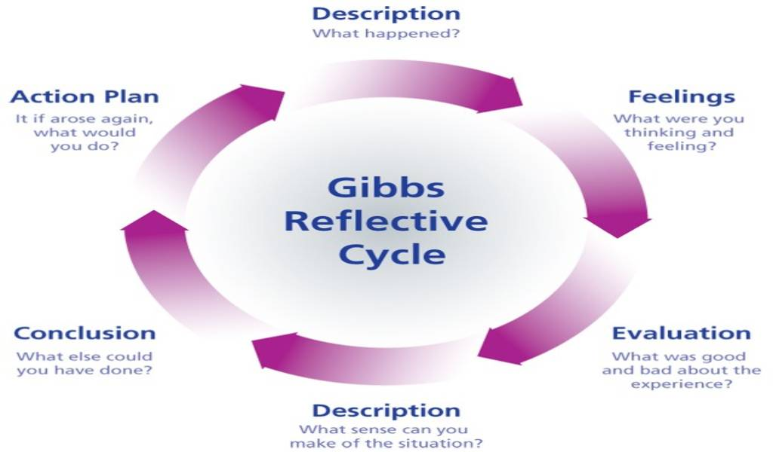
Following the Gibb’s reflective Cycle, I will produce a reflection on how the transferable skills I developed over this course and how they will help me with my future aspirations and improve my weaknesses.

Description:
At the moment, I am working as Dental Nurse within NHS mainly in orthodontic sector and studying CertHE Law and Legal Practice first year. I developed over time with my daily experiences a few important skills which I am using when I am studying. The most important skills are communication, team player, good time management and good habits. Studying and working at the same time is not very easy and sometimes I feel struggled with deadlines for assignments and study for the exams. For my first assignments I worked very hard and many hours in front of books, computer and many other sources of information and tried to understand the academic skills, references and write essays and been very disappointed with the results, all passed but not at the level I was expecting to be. This module really helped me to understand better and gain skills in how to record a video in power point for example, or how to find credible sources for my works and prioritize my time and find a good space for study. I have gaps in my skills, and I am aware about them and the first one is language barrier, English being not my tongue language, is one of 5 language I am speaking. I also developed new skills for writing assignments, improved my English terminology with new terms from laws.

Feelings:
I was very enthusiastic and happy to study, and I’ve worked very hard on my tasks trying to archive best marks. When I’ve got the results for first assignments, I was extremely upset especially when I received very good feedback on drafts and final marking was completely different. This dragged me down to be honest, feeling all my weeks, days and hours of writing was underappreciated and caused me more stress and I started procrastinating my next assignments overloading myself with next assignments to write and studying for exam.
Evaluation:
At the time I was enrolled I was enthusiastic, and I did not realize how hard it would be for me to work, looking after my teenage daughter and grumpy husband, my cats, my koi’s, my garden, and my creative and non-creative hobbies. Now, looking back I realize is not that bad and I managed well, and I feel positive about it because I’ve accumulated new knowledge which strengthens my skills. Accepting a lower marking score than I expected and following the feedback improved my attention towards details and rectify my mistakes.
Description:
Postponing my work due to being upset on my marks causes me more stress near to the deadline, procrastination as a "form of self-regulation failure characterized by the irrational delay of tasks despite potentially negative consequences" (Prem et al. 2018). To study Law and Legal practice always was my dream since I finished college in my country and life got different plans for me at that time and now, I am more and more motivated to excel.
Conclusion:
In retrospect, was way better to not procrastinate, to avoid overload off work before deadlines but, I’ve learned a lesson. I should manage different when I am disappointed and transform it into positive outcome and accept to take criticism and feedback for my work.

Action plan:
In the future I will overcome procrastinating, allocate enough time to study to absorb new knowledges and develop better my skills. I will manage better my time to not feel exhausted after study and writing hours after hours and incorporate small brakes for a craft hobby or a walk to Wilde life wood next to my home. My English will improve once studying and reading books, learning new terminology and been at the current with laws, news, and politics. I need to overcome my language barriers, pass all assignments and exams to complete CertHE Law and Legal Practice first year.

Note: 750 words completed for task 1.
Lacramioara Simona  RADU |  | 2224697 |  | Module  Learning in Digital  Era |  | CODE  BMPL4007  BMPS4009
What goals do I want to achieve? | How will I measure my progress? |  | What resources or support will I need? |  | How is the objective relevant to my personal aspirations? |  | What is the timeframe for the achievement of my goals?
Specific | Measurable |  | Achievable |  | Relevant |  | Timebound
Healthy body/ healthy mind and be fit. | Eating healthy and fresh cooked food, exercise, and walking. |  | Fresh veggie and fruits, sport gadgets and clothing. |  | To be relaxed with healthy body and mind. |  | Set a daily target to achieve and monitor weekly results.  Complete in one to three months.
Time management | Ability to organize daily tasks |  | Having a daily/weekly planner |  | Organised and realistic, having a backup plan |  | Completion of assignments before deadlines.
New challenges and ambition. | Take initiative and focus on myself. |  | Reading books and journals, watching news, engage in subject discussion, take part of activities. |  | Improve and achieve new knowledges. Be informed and smart. |  | As time frame for this goal, I will take a whole first year of studying law and legal practice.
Enjoy life!  “Do not take life too seriously. You will never get out of it alive.” Elbert Hubbard | Having my hobbies and do crafts, having fishing sessions, walking with my husband in the forest. |  | I need time for myself, I need fishing gears, I need plants and flowers to do my terrariums. |  | Peaceful, happy, and feeling loved will help me to excel in every aspect of my life including professional life. |  | As a time bound this are developing in time and last for long if they maintained and managed well.
English language improvement | The best to measure my progress is comparing the feedbacks. |  | Reading, writing assignments and essay. |  | Books  Internet  News paper  Tv |  | I am every day in progress on achieving this goal and I hope in next 5 years.
Volunteering as Magistrate | Monitoring progress over training. |  | I need Support from my employer to attend court 12 days a year. |  | This will improve my knowledges and skills; I will help my local community. |  | Applied and been accepted now I am in progress to complete the enrolment. In 6-12 months will be completed.
Completing my assignments before deadline and get pass marking grades. | I will measure this by weekly checks how much I’ve wrote or in the days I am off, and I can do research and read my law books. |  | As resources I need time, law books, access to the internet, computer. |  | They relevant to complete my CertHE Law and Legal Practice. |  | The course term in between January and August 2023, to complete my first year.
Career changing into law. | Taking my degrees in Law |  | I need to complete my degrees, money for all taxes and family support emotional and physically. |  | Always wanted to be a lawyer, I am a good listening person and always finding solution. |  | Is a long journey to complete it, perhaps in 6 years from now.
Academic skills  ‘’to be skilled is to be able to perform a learned activity well and at will’’ (Cottrell, p.36). | Feedback received for my academic essays; knowledges gained when looking for resources. |  | I need to read law books, access library, internet sources, university library |  | This is relevant for me to pass my first year and progress to further education in law schools |  | This will take medium term to complete. I will take next 3 years from now.
People skills, working with others/ team player. | Progress checks for teamwork |  | Projects and tasks to complete. |  | Communication skills is relevant with all forms or teamwork. |  | Always is room for improvement and this skill is developing with time and experience.
Motivate and enthusiastic | Check and balance motivation. |  | Family support, academy support and tutor’s support. |  | Is relevant to gain degree and new qualification. |  | Medium term to be achieved in next 12 months.

References list:

- Cotrrell, S. (2013) The Study Skills Handbook. 4 Edn. Palgrave Macmillan
- Gibb’s Reflective cycle picture 1 , Available at: gibbs reflective cycle description - Bing images (Accessed 17 April 2023)
- Mathers, C. (2022). 36 Examples of Personal Development Goals for your Career & Life. Available at: https://www.developgoodhabits.com/examples-personal-development-goals/ (Accessed: 1 May 2023)
- Morgan, A. (2021). Personal Development Plan: A Complete Guide with PDP Template. Available at: https://www.oneeducation.org.uk/personal-development-plan/#:~:text=Personal%20development%20plan%20examples%201%201.%20Wake%20up,8.%20Improve%20time%20management%20skills%20...%20More%20items (accessed: 4 May 2023)
- Prem R. et al (2018). Procrastination in daily working life. Available at: https://www.frontiersin.org/articles/10.3389/fpsyg.2018.01087/full (accessed 27 April 2023)
- Wain, A. (2017) Learning through reflection. British Journal of Midwifery. Available at: https://www.researchgate.net/publication/320342913_Learning_through_reflection (Accessed: 24 April 2023)

