COVID-19 challenge affects it had globally

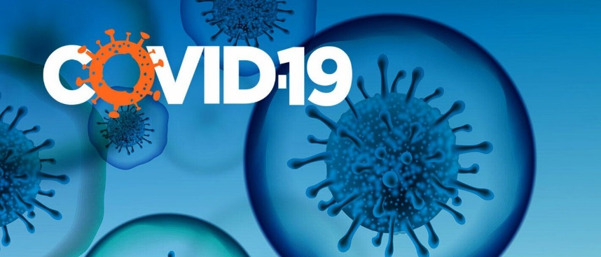

Introduction
COVID-19, short for coronavirus disease 2019, is a highly contagious respiratory illness caused by the SARS-CoV-2 virus. The outbreak originated in late 2019 in Wuhan, China, and has since evolved into a global pandemic. Characterised by symptoms ranging from mild cold- like symptoms to severe respiratory distress, COVID-19 has had profound effects on public health, economies, and daily life around the world.
Background information
COVID-19, caused by the novel coronavirus SARS-CoV-2, developed in the late 2019 and drastically spread around the globe, and it was responsible for the infection and deaths. Vaccination has proven to be an effective tool in shielding the virus’s spread and severity.

Impact of COVID-19 around the world
In the late December 2019, the people in Wuhan, China got infected and unwell with an ongoing unknown pneumonia, it’s the beginning of the disease and it was coronavirus, it was named SARS-CoV-2 by the World Health Organization.
The World Health Organization declared the Coronavirus outbreak a public health emergency of the international concern on January 30th, 2020, and the pandemic on March 11th, 2020. The pandemic has affected the publics mental health by isolation and loneliness due to the lockdown, there was numerous of job losses and financial instability, illness, and death. Coronavirus is the biggest global crisis in generations, and it is a shocking situation through the health systems, economies, and societies all around the world.
From school closures to devastating industries and millions of job losses over the planet due to the infection the social and economic costs of the pandemic are many and varied.

Impact COVID-19 has on the NHS
The pandemic has a major impact of the National Health Service (NHS). The patients under the NHS care are suffering from the COVID-19. Here are the examples of the symptoms of the virus.

- Fever or chills.
- A dry cough and respiratory.
- Feeling tired.
- Muscle or body aches.
- Headache.
- A loss of taste and smell.
- Sore throat.
- Congestion.

As the virus hit the United Kingdom the National Health Service (NHS) has a huge increase in the demand for acute care and care facilities for the unwell patients. There was a redeployment of Existing staff and a drive to bring in recent retired and newly graduated staff to fight the pandemic. The NHS staff was under an immediate threat by the pandemic and for those working on the frontline they were acutely vulnerable to COVID-19 infection. Majority of the medical professionals caught COVID-19 and experienced severe and long -term symptoms. The UK has released its pandemic stockpiles which requires many types of (PPE) to tackle the COVID-19 infection and been a shortage of supplies due to the sick patients at the local hospitals.

COVID-19 Vaccine
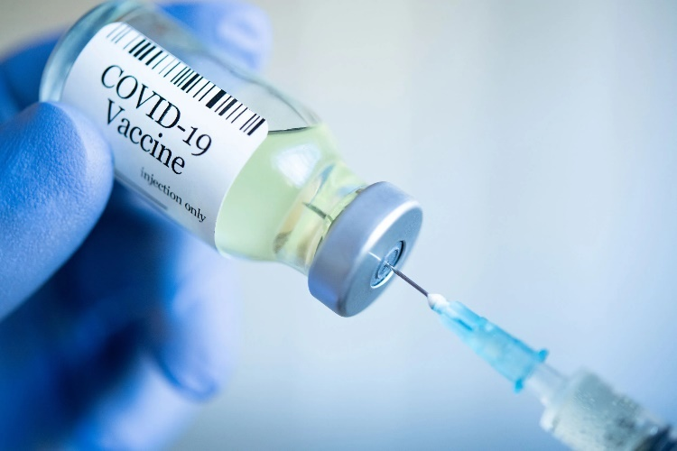
The COVID-19 vaccination programme issued on 8th December 2020. Worldwide tens of millions of adults and children have had the COVID-19 vaccine, and it gives you the best protection against the infection. Like majority of all medicines the COVID-19 vaccine can cause certain side affects and these are the symptoms.

- Sore arm from the injection
- Feeling tired and worn out
- A headache
- Feeling fatigue and achy
- Mild flu like symptoms
- Feeling or being sick

Rare side effects of COVID-19 vaccination
Most people with allergies including (food or penicillin) can be vaccinated against COVID-19. If the person has had a serious allergic reaction including (Anaphylaxis), notify the healthcare staff before you’re vaccinated. They will ask what you are allergic to.
If you’ve has a mild allergic reaction before, like getting a rash, having trouble breathing, or getting hives, it’s okay to receive a regular COVID-19 vaccine. The people giving the vaccine know how to handle allergies and will take care of it right away if it happens.
If you are experiencing an allergic reaction, they may refer you to a specialist clinic for your vaccination or have an alternative COVID-19 vaccine.

Heart inflammation (myocarditis)
There have been numerous rare cases of inflammation of the heart (myocarditis) reported after COVID-19 vaccinations. Most of the people who has the inflammation of the heart recovered following rest and simple treatments.

The first COVID-19 lockdown
On the 23^{rd of} March 2020, the Prime Minister Boris Johnson announced the first national lockdown during an address to the nation. They have already to begun working on building products, services, and content to help users understand the new rules and the help that was available. The lockdowns across the whole UK during the pandemic were not a good choice in public health policy, according to an expert in disease patterns. This is because they were not seen as the last option to control the situation. The problems caused by things like social distancing, especially lockdowns, such as the impact on the economy, education, healthcare access, and overall societal well-being, including mental health, were not considered by SPI-M-O or anyone else as far as I could see,” Woolhouse explained to the inquiry.

the second COVID-19 lockdown
A second national lockdown started in November of 2020, because COVID-19 cases were rising faster that ever in the UK. It was supposed to end on November 26th, 2020, and then they planned to have local restrictions (“tiers”), all over England and Wales. Between 11 am and 3 pm, there was around 18 million errors on the GOV website because a lot of people were checking their COVID results using the postcode checker and it wasn’t working well. They had to quickly fix this problem by improving how data was stored. To make sure the systems could tolerate more users, they also made some machines work better. Even though they tested the systems before it started the number of people using it was much higher than they expected. The experience taught their team an important lesson. It helped them get better at communicating with each other and with other government departments when making important announcements or statements. After the second lockdown Margret Keenan was the first ever person in the world to have the Pfizer COVID-19 vaccine jab, as part of a bigger vaccination programme on the 8th of December 2020.

The third lockdown.
A third lockdown happened on Monday the 4th of January 2021 at 8pm after the Prime Minister” Boris Johnson”, announced the lockdown on live TV. The team worked late by publishing landing pages and the guidance to support the announcement. There has been 3.2 million people who visit between 8pm and 9pm. It estimated the equivalent of 12% of the UK population visited the GOV.UK website on the day it got announced.

Effects COVID-19 had on economy and businesses
COVID-19 had a really bad impact on the UK businesses since the start of the pandemic. During the crisis business sales took a large fall. As the COVID-19 was around there has been employees working from home and effected global economy by disrupting supply chains, depressing consumer demands, and putting million of people out of work. The pandemic has not affected all businesses the same some of them struggle more than others like industries rely on personal interactions or travel, such as airlines or hotels, have been hit the hardest. The pandemic is heavily affecting labour markets, economies, and enterprises. Early news reports of empty grocery shelves have made it clear that the pandemic is crimping some supply chains at the same time. The spread of the virus is causing restaurants, schools, and hotels to temporarily close, leading local farmers and food producers to discard unused food products. Approximately 25% of businesses had temporarily shut down due to the coronavirus lockdown, and most of the remaining operational companies experienced a decline in turnovers, as reported by the office of National Statistics. The survey, which involved 5,300 businesses and is the most extensive assessment to date of the business impact, focused on the initial two weeks following the lockdown implement in March of 2023. Within that timeframe, 0.4 percent of businesses reported that they had discontinued their operations.

Conclusion
In summary, COVID-19 has presented an unprecedented challenge to our global community, affecting individuals, societies, and economies in profound ways. The pandemic has underscored the importance of collaboration, resilience, and adaptability.

References

(2023) covid-19 coronavirus, https://disasterphilanthropy.org/disasters/covid-19-coronavirus/

Propper, C.P, Stoye, G.S, Zaranko, B.Z, (2020) The Wider Impacts of the Coronavirus Pandemic on the NHS, Fiscal Studies, volume 41, issue 2, https://onlinelibrary.wiley.com/doi/10.1111/1475-5890.12227

(2023) COVID-19: The impact of the pandemic on the medical profession, https://www.bma.org.uk/advice-and-support/covid-19/what-the-bma-is-doing/covid-19-the-impact-of-the-pandemic-on-the-medical-profession

(2021) Hospital Outpatient Activity 2020-21, https://digital.nhs.uk/data-and-information/publications/statistical/hospital-outpatient-activity/2020-21/covid-19-impact

(2023) COVID-19 vaccines: everything you need to know https://www.gavi.org/covid19-vaccines?gclid=Cj0KCQiA7OqrBhD9ARIsAK3UXh3hFiFBub56m-HOHKgaYnL1ATzGKkWHiSKJp7HxEwT_M18j8yW9984aAuDJEALw_wcB

Res, J.B.R, (2020) Effects of COVID-19 on business and research, National Library of Medicine, https://www.ncbi.nlm.nih.gov/pmc/articles/PMC7280091/

(2023) COVID-19 vaccines side effects and safety, https://www.nhs.uk/conditions/covid-19/covid-19-vaccination/covid-19-vaccines-side-effects-and-safety/

Sherrington, A.S, (2022) 2 Years of COVID-19, Government Digital Service, https://gds.blog.gov.uk/2022/07/25/2-years-of-covid-19-on-gov-uk/

(2023) UK lockdowns were a policy ‘failure’, health expert tells Covid inquiry, The Guardian, https://www.theguardian.com/uk-news/2023/oct/16/uk-lockdowns-were-a-policy-failure-health-expert-tells-covid-inquiry

Romei, V.R, Thomas, D.T, (2020) Covid-19 shuts down a quarter of UK businesses, financial times, https://www.ft.com/content/f9537538-d7a0-44e3-8e86-5cb9a984aae4

