

Student Name: | Sarah Bowen |  |  | Student Number: | 1504126
Module: | Management Practices |  |  | Module Code: | BMSP7002
Assignment Number: | 1 | Date: | 27th March 2022 | Assignment Title: | Report
Tutor: | Dr Alex Bell |  |  | MBA Sustainability Leadership  University of Wales Trinity Saint David

We are all under pressure to think about our impact on the environment and how commitments by the governments will affect our lifestyles. Companies and organisations have to consider sustainability in order to move towards targets being set around the world.
The National Health Service (NHS) is one such organisation in fact is one of the largest. This assignment discusses the issues of sustainability in one health board, Hywel Dda University Health Board (HDUHB)
The three pillars in sustainability are Economic, Social and Environment, and when balanced will work in connection with each other. Efforts by any organisation to be more environmentally sustainable will benefit the economic sustainability of the organisation, such as recycling valuable resources to reduce the intensity of extraction, which is required to sustain businesses. [1]
Generating social sustainability can include focusing organisations efforts on employee retentions in addition to economic priorities. Investments in well-being of employees, which would be much more likely to generate economic benefits for the organisation by increasing employee motivation and retaining valuable knowledge and skills. [2]
Environmental sustainability focuses on the well-being of the environment, such as water quality, air quality and reduction of environmental stressors for example greenhouse gas emissions. [3]
These all link together benefiting our planet and us. Human health is inextricably linked to the quality of the individual’s environment, closely aligning human health and the state of the environment. As a result, efforts to preserve and restore the environment will benefit the people too. [4], [7] A health outcome of a service are measured against the environmental, social and economic costs and impacts, it will determine its sustainable value. [16]
Climate Change is a major threat to the National Health Service (NHS), staff, patients and communities due to the direct link between the health of our planet and the health of our people. With the NHS reducing the harmful gases it puts into the atmosphere, fewer emissions mean fewer patients with asthma, heart disease and cancer. [17]
In Wales, the NHS produce around 600,000 tons of waste every year, and although much of the waste is recyclable, a significant amount is sent to be incinerated or to the landfill.
The Environment Act (Wales) 2016 puts in place the legislation needed to plan and manage Wales’ natural resources in a more proactive and sustainable way. The Act covers sustainable management of natural resources, climate change, and charges for carrier bags, collection and disposal of waste. The Act introduces new arrangements in relation to waste segregation and collection. Provisions in the act focus at different parts in the waste management chain. Ensuring higher levels of recycling, food waste treatment and energy recovery, helps to boost the economy of Wales whilst at the same time helping to protect the environment and natural resources. Regulating waste and recycling ensures that valuable recycling materials and resources are not burnt. This protects the environment by ensuring that only remaining waste streams are disposed of in landfill or incinerated. [8]
As an example in one single Special Care Baby Unit (SCBU) Hywel Dda University Health Board 2021 (HDUHB) over 100 bins are replaced twice a day, 50% of them being black bags, which are taken to the landfill, and 50% being clinical waste where the clinical waste is incinerated. This is just one small example of the waste problem within hospitals. It must be worth investigating where landfill or incineration is better for our planet. It must also be worthwhile to see how much recycling, such as disposal of plastic formula bottles, is being encouraged within the clinical areas.
In 2019/20 HDUHB spent over £609,089 on waste management.
We are all facing increasing pressure to reduce our impact on climate change.
The NHS contributes to a substantial impact on the environment and are one of the biggest contributors to climate change. With the use of energy, water and consumables, it is vital that healthcare professional are educated on the importance of climate change as a health risk.
Reducing consumption can be an extremely challenging problem, particularly for energy-intensive organisations such as the NHS. Reducing energy consumption is a big part of environmental management. Energy efficiency within hospitals can be challenging and some solutions are easier to achieve than others. In April 2001, the Government introduced The Climate Change Levy (CCL), which is an environmental tax charged on the energy that businesses are using, its purpose is to encourage businesses to be more energy efficient in how they operate, and by acting or investing in energy efficiency, it would reduce both the fuel bill and the tax charge. CCL is charged on ‘taxable commodities’ for heating, lighting and power use. The theory being organisations would rather pay for energy improvement than pay the Levy charge. [18]
In 2019/2020, Hywel Dda University Health Board (HDUHB) spent over £6.6 million on utilities.
Hywel Dda spends an average of £20k per day on energy, by switching lights of and equipment when not needed would save over £70k per year. [15] These are all contributing factors. Most people do not consider these things whilst being fully engaged in performing their jobs to their best ability when at the work place, and most people would be shocked at how much effect these small changes could make overall.
Most hospital sites are energy intensive due to the requirements of healthcare, especially our acute sites. They account for 95% of all electrical energy consumed by the health board and 96% of all non-electrical consumption. Decarbonisation opportunities cannot compromise the delivery of care and to continue to effective operation whilst achieving the scale of reductions vital to support a 2030 net zero target make Hywel Dda the largest decarbonisation challenge. [12]
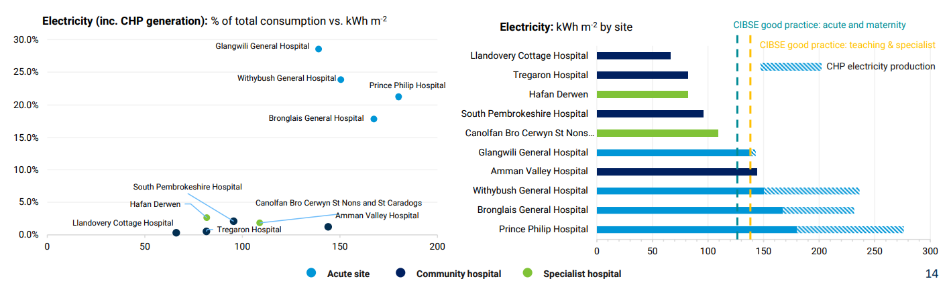
Section 2: Footprint analysis V.02, pg 14 [12]

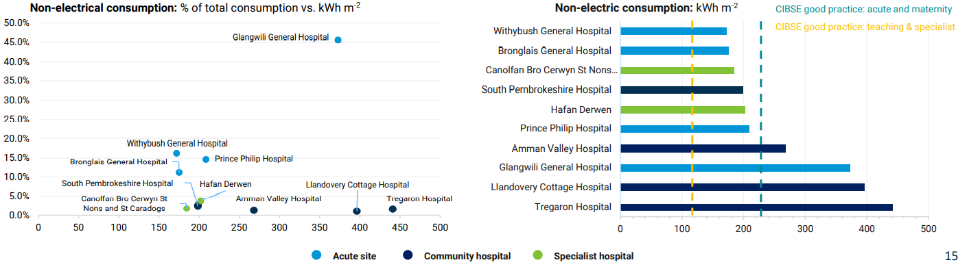
Section 2: Footprint analysis V.02, pg 15 [13]
Within the brand new Special Care Baby Unit (SCBU) based at Glangwilli Hospital the heating is causing continual problems within the nurseries, as they are often kept much hotter than needed, resulting in staff opening windows to let the heat out. There is no local temperature control, which means contacting the engineers to come out so they can be adjusted. This is also an issue with our parent rooms along with staff rooms and other offices around the site. Simple solutions such as localised temperature control switches may help to alleviate this situation saving energy and money. (HDUHB)
Glangwili Hospital is the only acute hospital in wales that runs on an oil heating system as the gas main that services Carmarthen needs significant upgrading to be able to supply the hospital, but due to its estimated £2 million investment it’s not an option. A Biomass boiler has been installed which is a good alternative to oil, reducing the cost spent per Kwh and greatly reducing our C02 emissions. Hywel Dda are able to claim the Renewable Heat Incentive (RHI) for each Kwh generated. The boiler also uses wood chip, which is sourced in Wales. [19]
Hywel Dda energy improvements are now underway focusing on heating control and insulation at ward and department level, linked to the Building Energy Management System (BEMS), which will allow the sites to be remotely monitored and control the heating, ventilation and air conditioning (HVAC) systems. Set temperatures have been agreed for all areas and by using the BEMS, it will ensure that these are maintained. [20] Whether it will solve localisation problems such as the SCBU, which has the need to have different temperatures at different times according to the client base remains to be seen.

Energy Efficiency Challenges

Our Estate
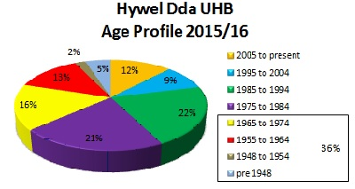

Showing the age of the estate this pie chart displays 21% of buildings constructed within the last 2 decades, insulation and heating controls were not considered priority when the estate was being developed.

In 2016/17 HDUHB consumed an average 489 kWh/m², the highest average consumption of all Health Boards in Wales. Action to address the energy efficiency challenge has been taken by putting longer-term solution in place, starting with the Energy Performance Contract (EPC) from December 2014.

The Health Service is inevitably a high consumer of energy with contributions from:

- 24 hour operation – lighting
- High volumes of administration equipment – computers, printers, photocopiers
- High volumes of domestic type appliances – fridges, microwaves, Televisons, kettles, toasters
- Medical equipment – x-ray machines, electric beds
- Specialist services – catering, laundry, Hospital sterilisation and decontamination unit (HSDU)

Environmental & Transport: Hywel Dda University Health Board | Energy Efficiency Challenges (wales.nhs.uk) [14]
Hywel Dda produced its first energy and carbon strategy in 2009, prompting a long-term solution to the energy management challenges. The decision was to produce an Energy Performance Contract (EPC). This is a contract with an external provider implementing energy efficiency measures and providing a guarantee that savings will be delivered. British gas is the provider for Hywel Dda and has predicted a reduction of C02 emissions by over 4,000 tonnes per annum.
“The Hywel Dda University Health Board is committed to reducing its carbon emissions and energy costs and has entered into a partnership project with British Gas and its partners. Edina’s CHP installations and on-going maintenance obligations is a key part of the project that will support the Health Board in meeting its carbon and energy saving objectives.” (Paul Williams, Head of Property Performance, Hywel Dda UHB) [5]
New combined Heat and Power Plant (CHP) represents an interesting solution to improve the energy efficiency of industrial sites while reducing greenhouse gas emissions. CHP are now on two of our Hywel Dda sites, Prince Philip Hospital and Withybush General Hospital. The CHP units use mains gas to generate electricity on our sites and produce waste heat to supplement the heating system. Edina group supplied two 600kWe natural gas engines that have reduced the rise in energy within the Prince Philip and Withybush.
With the investment in Prince Philip and Withybsush it has provided better equipment and improved energy efficiency measures reducing carbon emissions and increasing the security power. The units use mains gas to generate electricity also producing waste heat to supplement the heating system. By using the CHP it increases gas consumption, but greatly reduces the mains electricity, some may question the savings, however, mains electricity is more expensive compared to gas used to generate electricity and heat on our sites.
The government incentive forms part of Hywel Dda University Health Board strategy to reduce the rise in energy costs within the NHS. Worth up to £9.3million, the funding will future proof Withybush General and Prince Philip Hospitals to reduce its energy consumption, provide long-term security of power and achieve high standards of environmental performance.
There were a number of challenges between the both sites, Prince Philip Hospital had the removal of an existing and defunct CHP plant from an operational boiler house which required isolation from the main system. There was also the issue of the removal and replacement of the glass façade of the building itself. Additional space also had to be factored into the installation of the new equipment making the installation process a particular challenge.
To avoid any power supply issues at the hospital, the installation of the Air Circuit Breaker within the hospital’s existing panel had to be arranged during low operational use of clinics and operating theatres, which resulted in work being completed out of hours. The installation of the CHP plant at Withybush General Hospital presented similar challenges. In order to install the unit the team constructed a new concrete base slab in an existing busy hospital access road that required careful planning and site management. [9]
The renewable Energy Guarantees of Origin (REGO), administered by Ofgem, Britain’s Independent Energy Regulator who provides a scheme that provides transparency to consumers about the proportion of electricity that supplier’s source from renewable generation. Reducing energy consumption whilst having any effect on working practice will all contribute to the energy we save. This includes such things as, where possible turning all equipment not being used off, turning lights off when leaving a room, turning computers off when going to lunch/meetings/end of day. We are all guilty of leaving equipment in standby mode, which continues to use energy. Some may argue that these are small figures but they become quite high when you look at the scale of the organisation. [10], [11]
“Over the years, Hywel Dda has been committed to being a pioneer in implementing energy efficient solutions at our healthcare facilities. But we won’t be resting on our laurels. Over the next few weeks and months, we will be announcing several new initiatives, which will continue to reduce our carbon footprint, as well as save money in terms of energy costs. (Williams, P. western telegraph 15th February 2022) [6]
The Assembly Government and the NHS are determined to reduce the impact on the environment. Both Prince Philip and Withybush General have introduced travel plans to support staff, patients and visitors to travel by public transport, car sharing or walking/cycling to build on the long term environmental strategy of the hospital.

Reference:
[1] Three pillars - Xavier, Lucia Helena, et al. "Sustainability and the Circular Economy: A Theoretical Approach Focused on E-Waste Urban Mining." Resources Policy, 2019., doi:10.1016/j.resourpol.2019.101467

[2] Nunes, Leonel J.R., et al. "Economic and Environmental Benefits of Using Textile Waste for the Production of Thermal Energy." Journal of Cleaner Production, vol. 171, 2018, pp. 1353-1360., doi:10.1016/j.jclepro.2017.10.154

[3] Morais, Dafne O.C. and Bruno S. Silvestre, "Advancing Social Sustainability in Supply Chain Management: Lessons From Multiple Case Studies in an Emerging Economy." Journal of Cleaner Production, vol. 199, 2018, pp. 222-235., doi:10.1016/j.jclepro.2018.07.097

[4] Vandyck, Toon, et al. "Air Quality Co-Benefits for Human Health and Agriculture Counterbalance Costs to Meet Paris Agreement Pledges." Nature Communications, vol. 9, 2018, pp. 4939., doi:10.1038/s41467-018-06885-

Climate change | Sub-topic | GOV.WALES

[5] Paul Williams, Head of Performance Hywel Dda University Health Board – Hywel DDA University Health Board (edina.eu)
EDINA Assignment withybush and pph.pdf
[16] Sustainability in Quality Improvement | Centre for Sustainable Healthcare
[8] Environment (Wales) Act 2016 (legislation.gov.uk)
Renewable Energy Guarantees Origin (REGO) Scheme Explained - Simply Switch
[12] Section 2, pg 14, Footprint analysis V.02 [Final]- Appendix 12 - Scoping and Modelling Assessment for Building & Transport Decarbonisation (1).pdf
[13] Section 2, pg 15, Footprint analysis V.02 [Final]- Appendix 12 - Scoping and Modelling Assessment for Building & Transport Decarbonisation (1).pdf
Energy efficiency in hospitals (activesustainability.com)
[6] Williams, P 15th February 2022 - How Hywel Dda Health Board will reduce carbon emissions | Western Telegraph
[14] Environmental & Transport: Hywel Dda University Health Board | Energy Projects (wales.nhs.uk)
[7]Allen, L. August 7th, 2021 - What Are the Three Pillars of Sustainability? (treehugger.com)
‘Future health – Sustainable places for health and well-being’, CABE 2009 http://webarchive.nationalarchives.gov.uk/20110118095356/http:/www.cabe....
[9] www.theade.co.uk - Hywel Dda UHB NHS Hospitals | Commercial CHP | Case Studies | The Association for Decentralised Energy (theade.co.uk)
[17] Healthier Planet Healthier People - CHP supporting health care for a Greener NHS - Community Health Partnerships
EVIDENCE OF BENEFITS | NHS Forest
[18] Environmental & Transport: Hywel Dda University Health Board | Energy Taxes (wales.nhs.uk)
[19] Environmental & Transport: Hywel Dda University Health Board | Energy Projects (wales.nhs.uk)
[20] Building Energy Management Systems (BEMS) | Climate Technology Centre & Network | Tue, 11/08/2016 (ctc-n.org)
NHS Forest | Centre for Sustainable Healthcare
Sustainability in Quality Improvement | Centre for Sustainable Healthcare
Sustainability in quality improvement: redefining value | RCP Journals
Environmental sustainability in health and social care | The King's Fund (kingsfund.org.uk)
https://phw.nhs.wales/topics/health-and-sustainability/making-space-for-nature-the-public-health-wales-biodiversity-plan/
NHS Wales Decarbonisation Strategic Delivery Plan (gov.wales)
Infographic: Energy security | Ofgem
Energy data publications | Ofgem
[10] Renewable Energy Guarantees of Origin (REGO) | Ofgem
Business energy guides and resources | Gazprom Energy (gazprom-energy.co.uk)
Climate change and net zero public awareness and perceptions summary report (publishing.service.gov.uk)
Hywel Dda UHB NHS Hospitals | Commercial CHP | Case Studies | The Association for Decentralised Energy (theade.co.uk)
Layout 1 (theade.co.uk)
Hywel DDA University Health Board (edina.eu)
Reference: (nhs.wales)
[11] Renewable Energy Guarantees Origin (REGO) Scheme Explained - Simply Switch
Appendix 12 - Scoping and Modelling Assessment for Building & Transport Decarbonisation.pdf
www.sciencedirect.com/topics/engineering/combined-heat-and-power-plant
Combined Heat and Power Plant - an overview | ScienceDirect Topics
Healthier Planet Healthier People - CHP supporting health care for a Greener NHS - Community Health Partnerships
Our commitment to carbon reduction and environmental sustainability - Hywel Dda University Health Board (nhs.wales)
Environmental & Transport: Hywel Dda University Health Board | Environment Team Homepage (wales.nhs.uk)
Environmental & Transport: Hywel Dda University Health Board | Environment Act (Wales) 2016
Factsheet 10 Biodiversity and resilience of ecosystems duty english (wales.nhs.uk)
Environmental & Transport: Hywel Dda University Health Board | Energy Performance Contract (EPC) (wales.nhs.uk)
How NHS Wales is responding to the climate emergency | NHS Confederation
NHS Wales Decarbonisation Strategic Delivery Plan (gov.wales)
[15] Environmental & Transport: Hywel Dda University Health Board | Energy Efficiency in the Workplace (wales.nhs.uk)

