Network Operating Systems and Services Part 2

Task 1
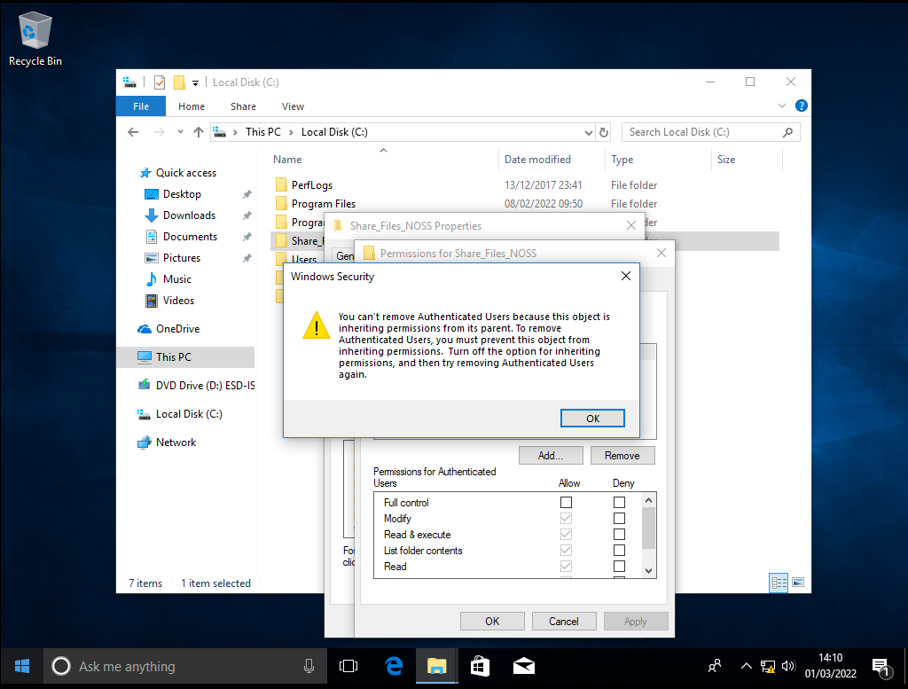
Here the user isn’t able to remove the authenticated users.
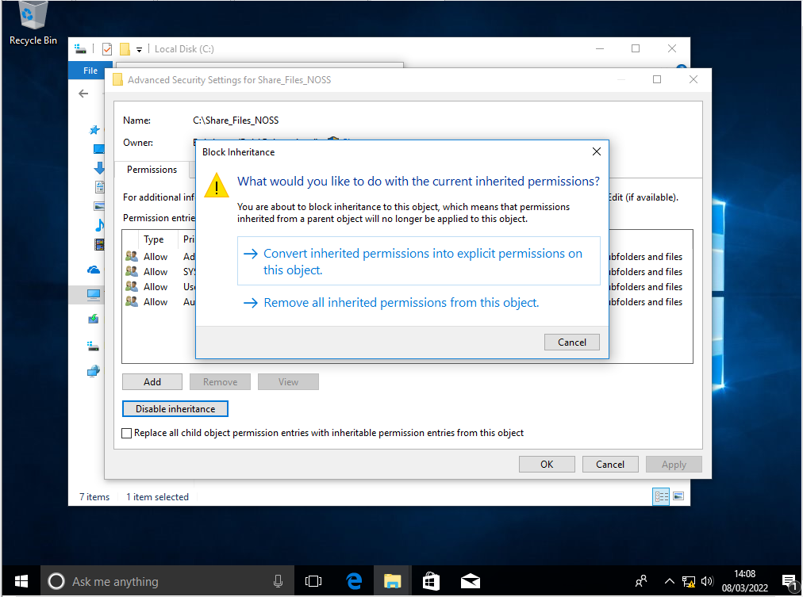
Here you can see that the user has disabled the inheritance this allows them to complete the task they were trying to do before (to remove authorized users)
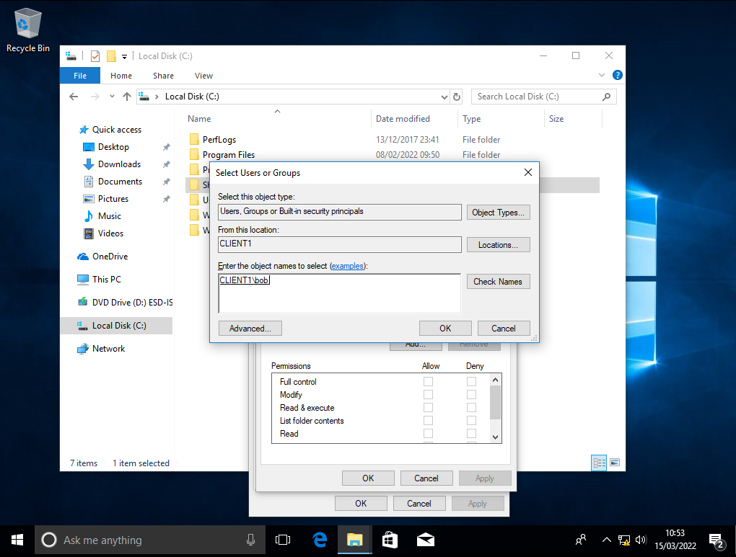
Here you can see that the client is adding a new client to the folder and is called bob this will also allow the user to have full control
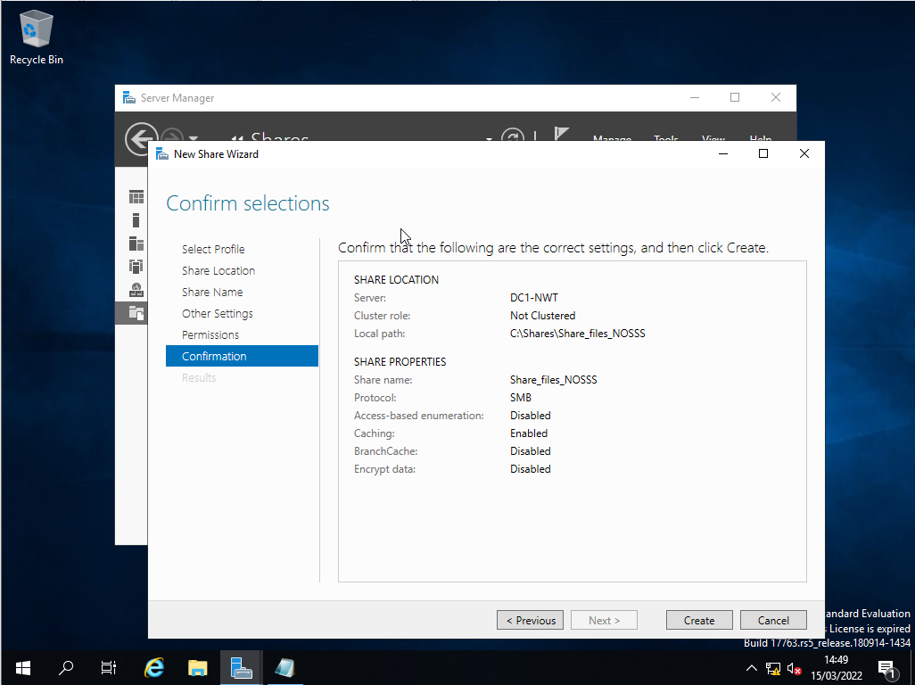
Here we have created a new path on the c drive called Share_File_NOSSS this is accessible by the users
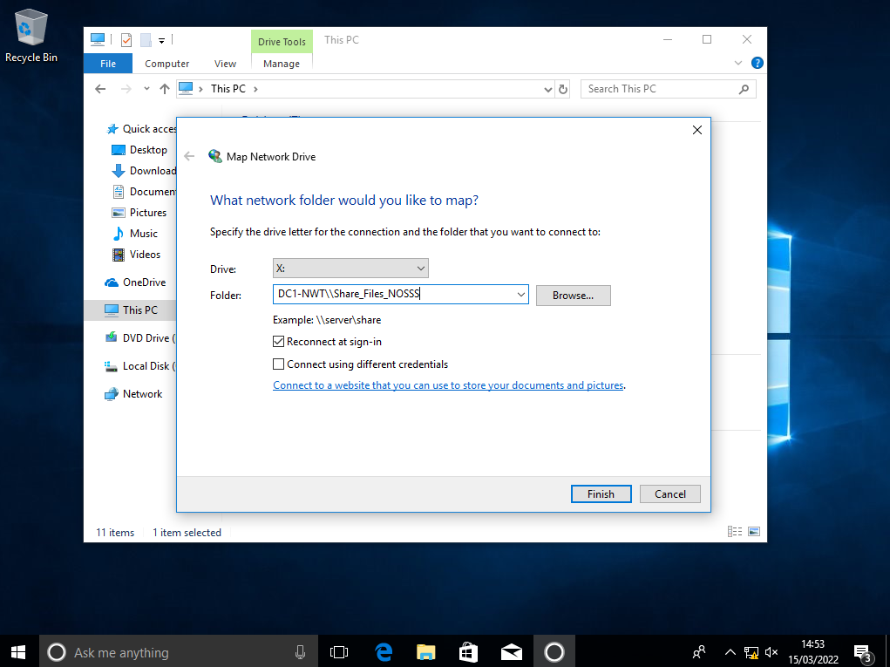
This is showing that we are putting that path on the x drive to allow for it to be a different area
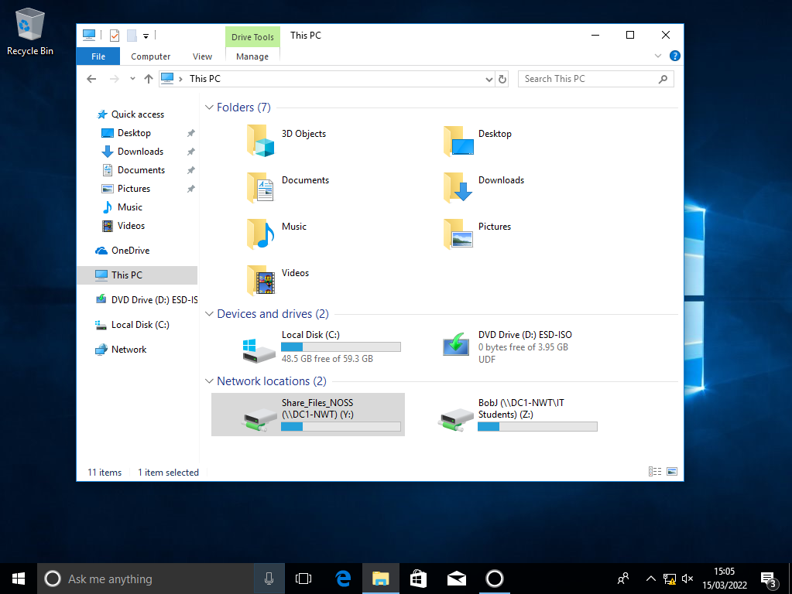
Here is what the folder looks like client side
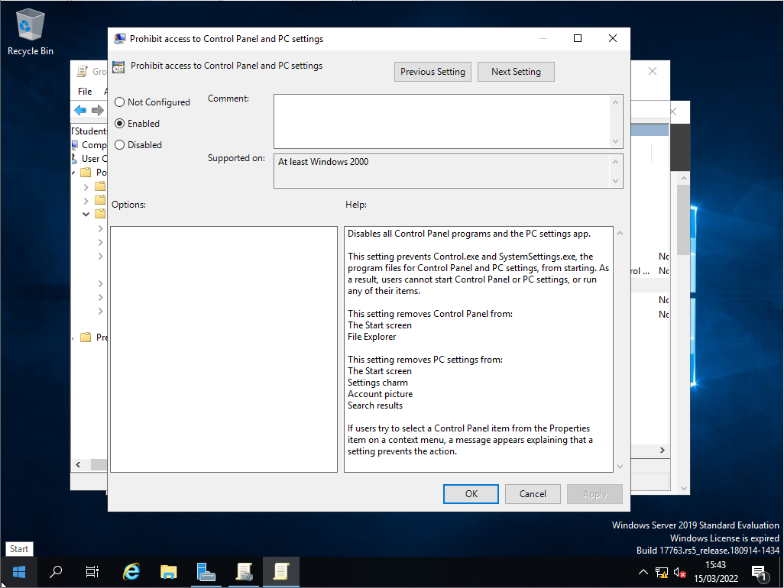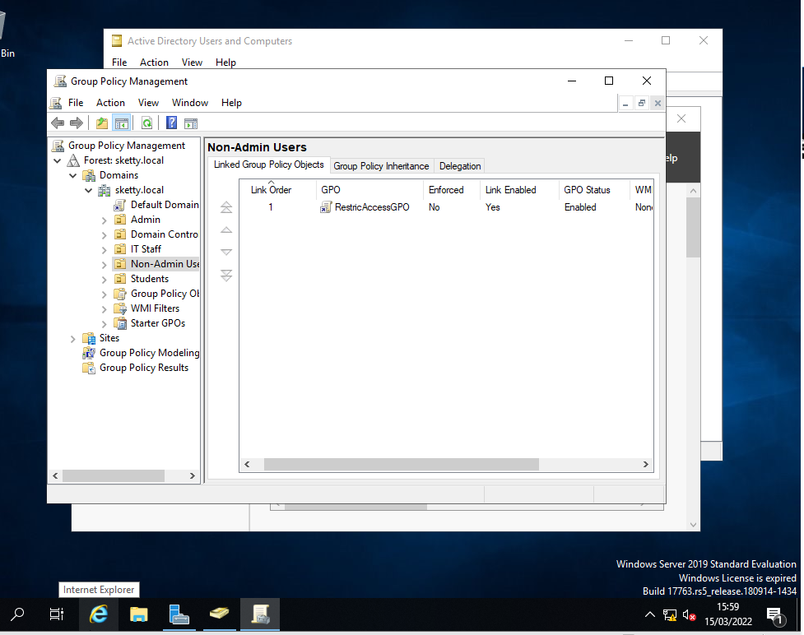
Here we are making a group policy that will restrict the user from access the control panel

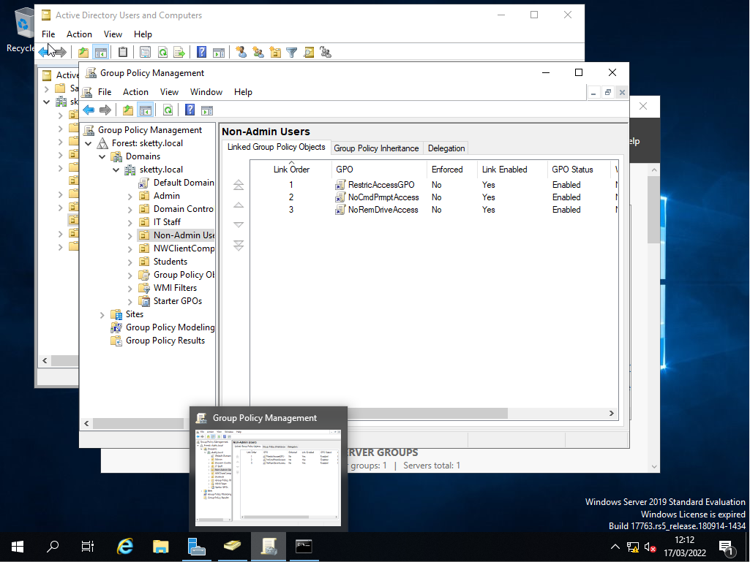
Her we have created 3 more GPO (Group policies) that have their own function
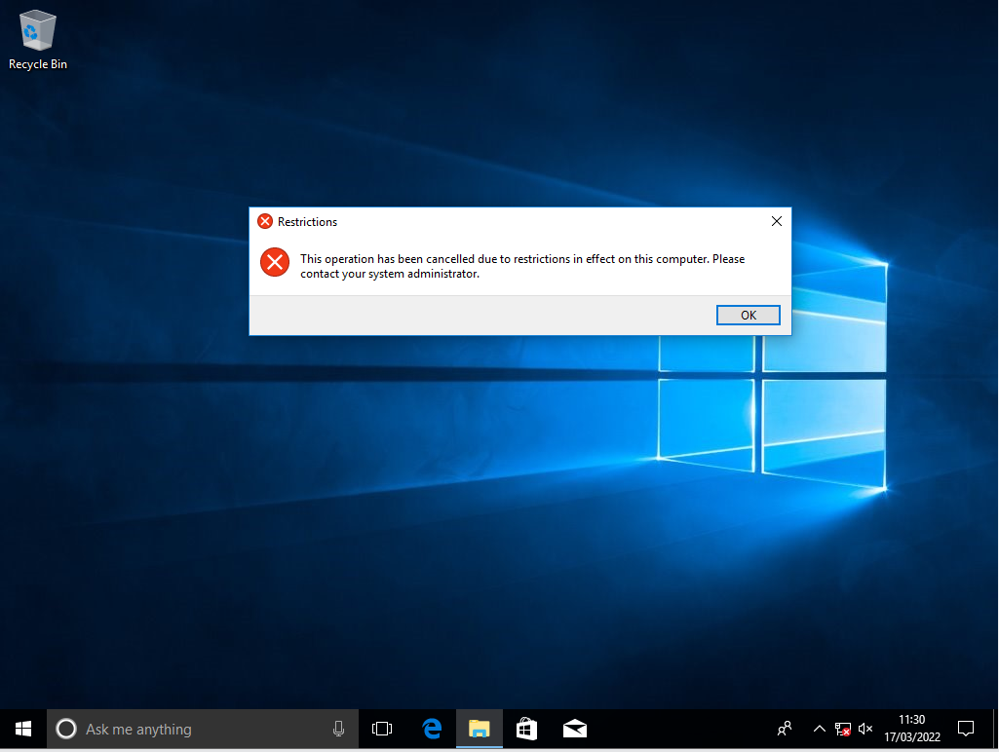
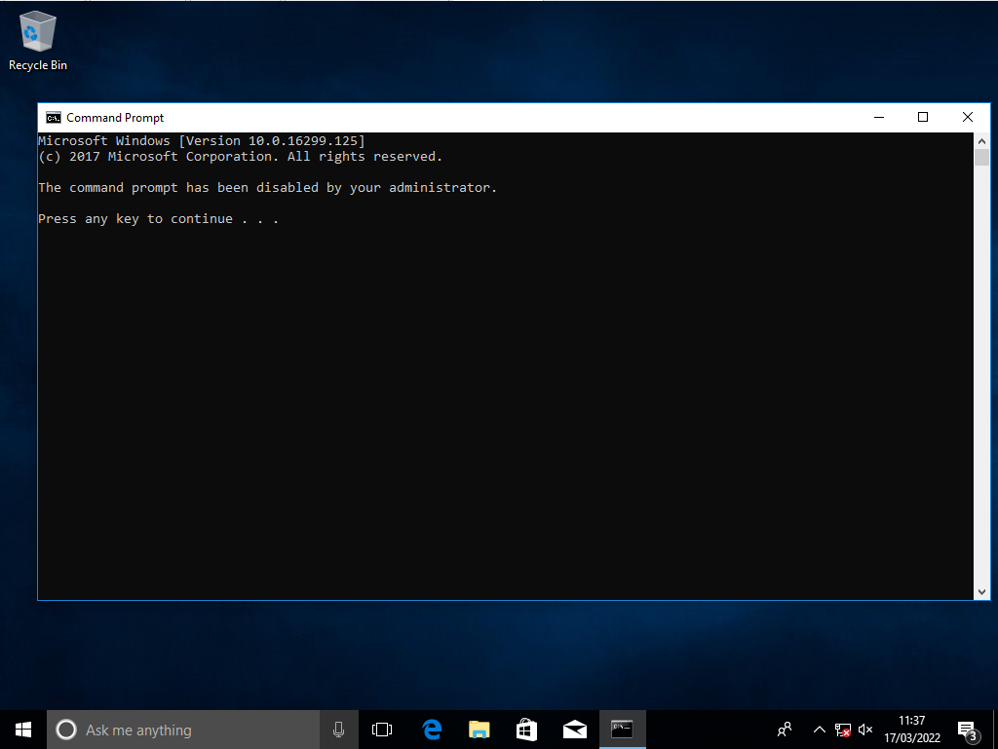

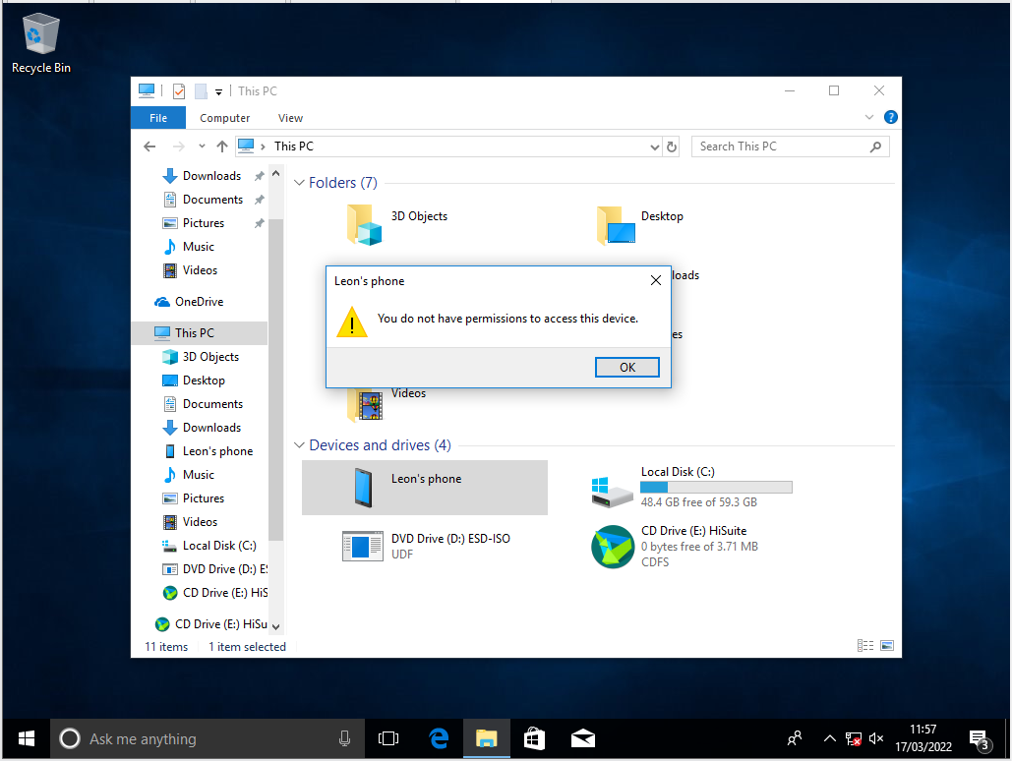
Here are the 3 outcome of the group policies (view from client side), 1 has stopped the user from using the control panel, 2 is stopping the use of the command prompt and 3 is stopping the user from using an external drive
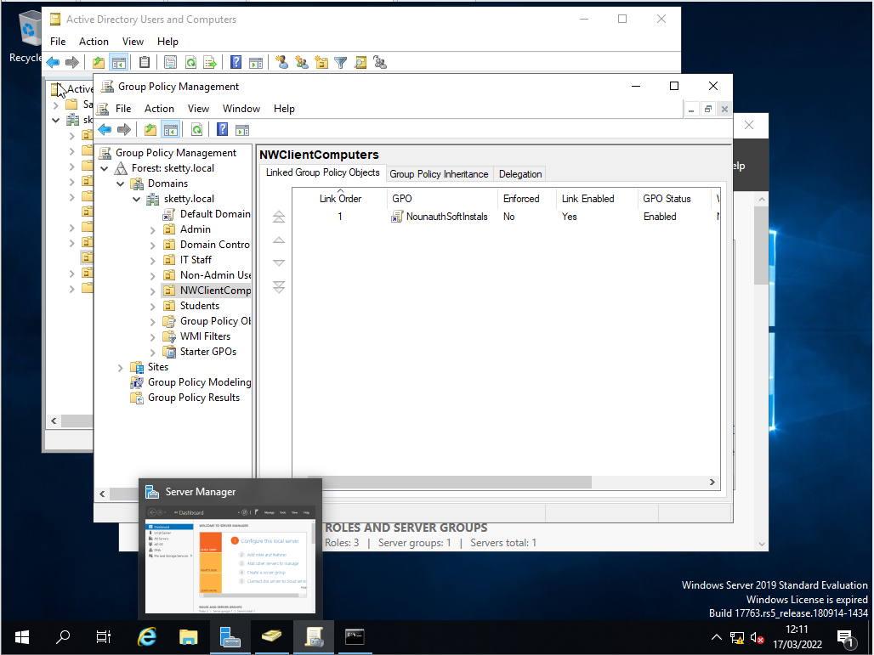
Her eis a new group policy on the new organisational group of NWClientComputers
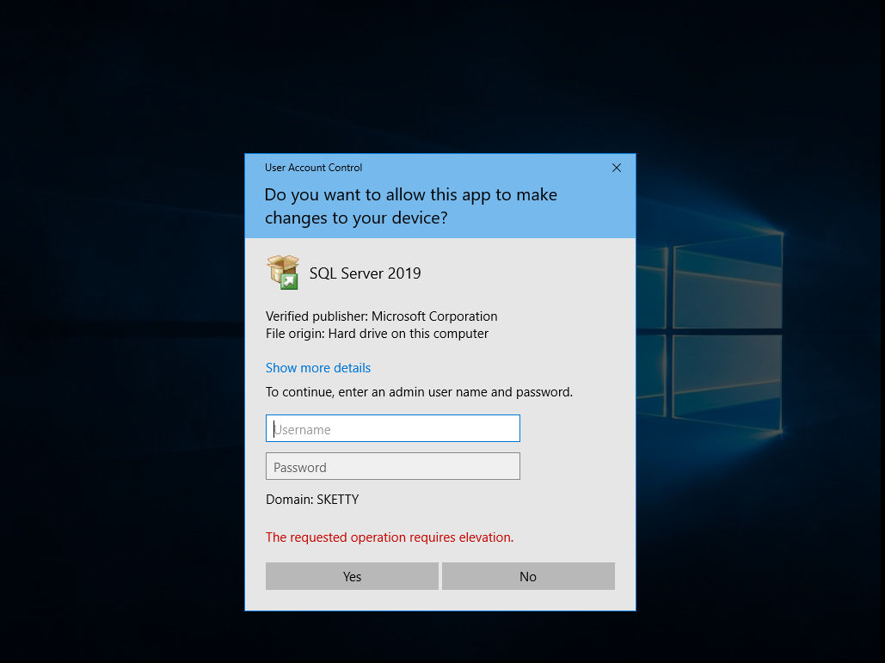
This is stopping the user from downloading anything without admin permission (client side)
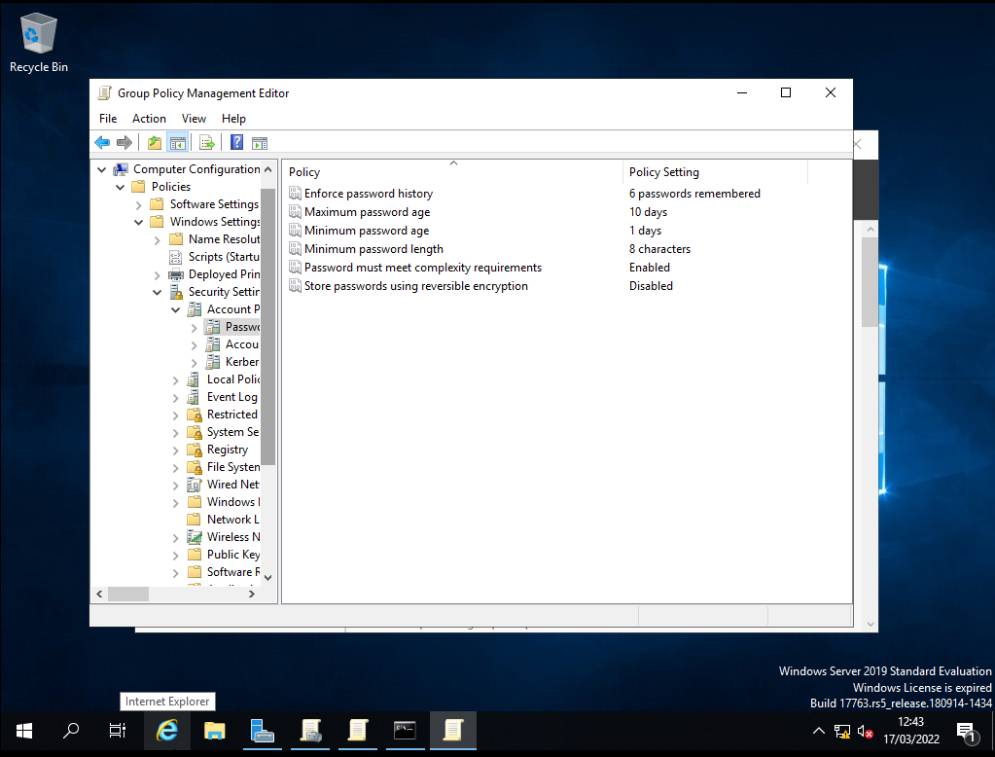
Here are the pass word restrictions that the admin has to follow when making a new user
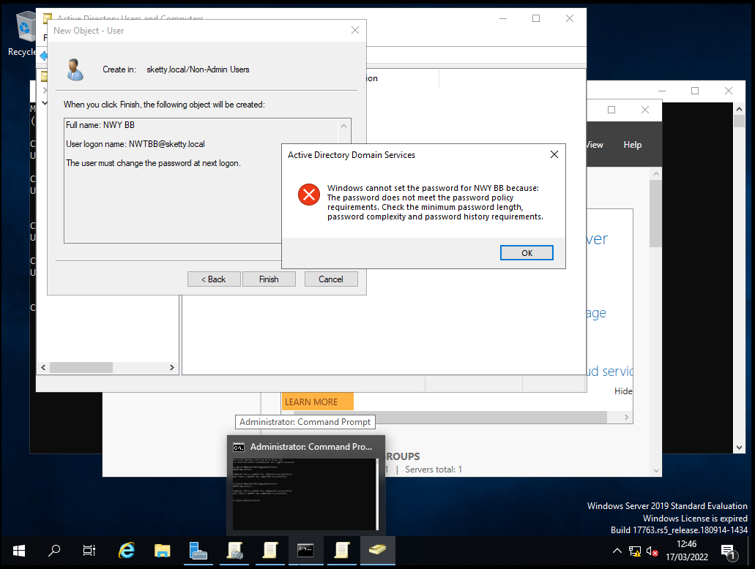
Here is the outcome of not completing all requirements

Observational Task
- “Write on your own words to demonstrate sound ‘password’ principles in modern network environments.”
When it comes to passwords there are many ways that you can make it “strong” many companies have the same policies for example you can have a character minimum I would suggest between 6-10 characters as a minimum, you could also have a capital letter and maybe special character like an exclamation mark or a question mark this also makes it harder for a user to get access to the account.
Failover Clustering for high availability systems/services
A Failover Cluster is a selection of computers that all work together to make more availability and scalability of any clustered roles. It will also have backups of the sever so that any users working on the server can continue working even if the server breaks down.
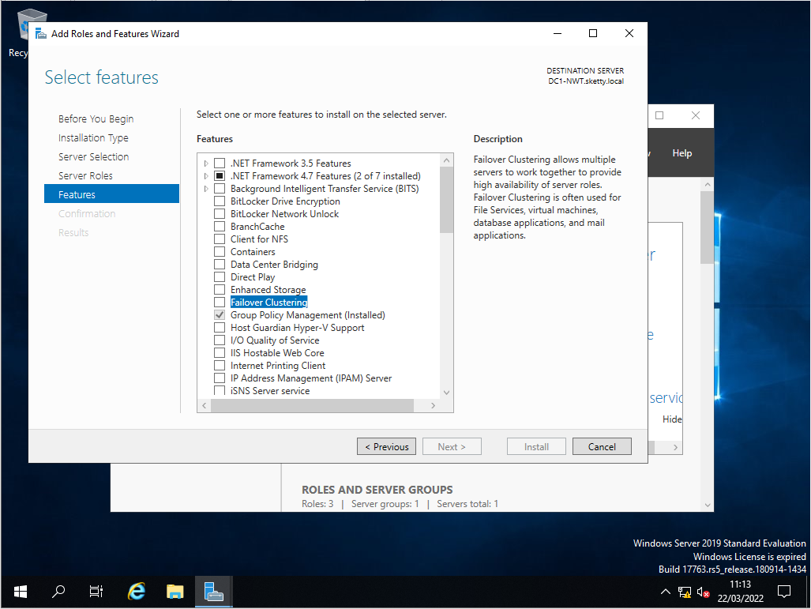
when setting up a failsafe cluster you will have to install the failover clustering in the add roles and features.
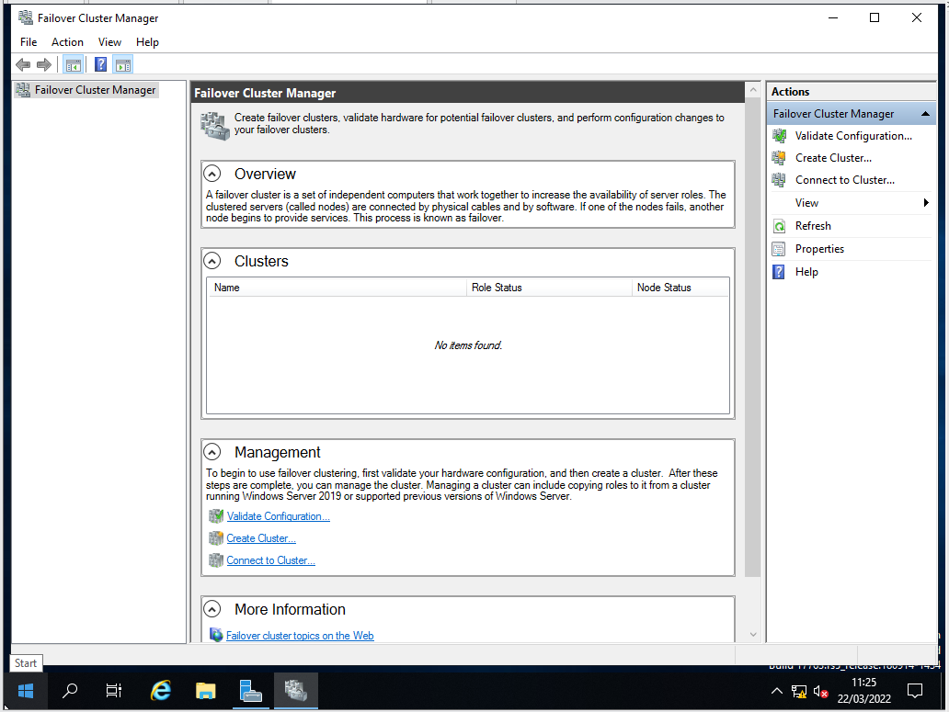
Here is where you will create the failover cluster
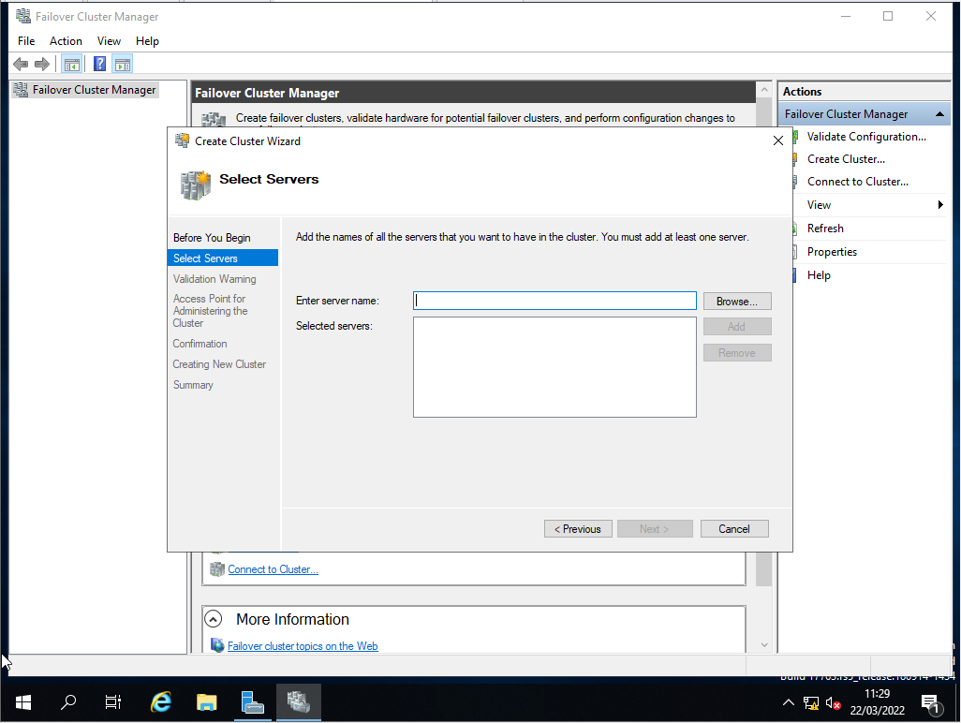
Here is where you will add a server and where you will make the cluster.
Network topology
I have chosen that a mesh topology is the best course for this company as it has very high data transfer speeds and the network has many areas that it can work from so if one node shuts down the network will be ok and it is easy to find any faulty equipment however this will cost a lot to make it requires a lot of set up time and gear and the computers have a limited number of cables.
I have found many risks that may occur with the business that the network will need to keep an eye out for and if necessary to get rid of, they are:
- Data Loss – this risk can be solved by making sure that the network has many backups saved so that it can revert back to the most recent saved file
- Untrained end users – to help prevent this is to make sure that the person you’re working with knows what they are doing and if they don’t explain the potential problems.
- Lack of Awareness – this can be prevented by making sure that your teams are aware of any problems and what things they need to look out for.
- Unmanaged IoT (internet of Things) – The way to prevent this from being a problem is to have a system that will monitor the company’s internet usage while using company resources.
- Personal data Accessibly – The best way to prevent this from being a problem that they have the correct people to work at the correct sections and to make sure they are doing the correct thing with the data
- Insider threats – to prevent this from being a big problem I would suggest having constant team meetings to have a check to see what the teams are coming back with and you can check to see if there are problems.

