AC1.1
Evidence based practice (EBP) is a decision making approach that combines critical thinking with the available evidence from 4 key sources: Scientific research, Organisational data, professional expertise, stakeholder feedback. Using these sources effectively can help organisations achieve improved outcomes. (CIPD, 2025c). At Admiral Group Plc EBP is brought to life with an example being reviewing monthly attrition reports and analyse leave reasons to assess what changes may need to be made in the business to build better retention. To do this we review the figures of those leaving against qualitative feedback we get alongside this to help understand the areas of focus. Relying simply on figures would not give us this oversight. According to (Admiral Group Plc, 2026) monthly attrition report, the highest reason for leaving in April 2026 was to pursue a different career path accounting for approximately 25% of all resignations. Whilst specific data cannot be shared for confidentiality purposes, this suggests that a high proportion of employees may not have been aligned with their current roles or may not have seen future development opportunities within the company

As learners in People Practice this approach can be used to critically assess key information, though it is important to ensure there is confidence in the evidence that is relevant to the decision outcome. EBP is important to ensure decisions are not made on personal bias, this is not a trustworthy source of evidence and hinders decision making. Facts and supporting data should be taken from these sources, ensuring we have solid research, company KPI’s/Metric data, professional judgement and employee feedback. This will enable teams to reach an evidence based outcome (Barends and Rousseau, 2018).

However, not all evidence is perfect, and using critical thinking will be essential. Using the six A’s (appendix A) to gather reliable data, ask challenging questions to ensure assumptions are not made, reviewing the data and consider the views of others. From this a better outcome can be achieved which is clear and unbiased using the best evidence available (CIPD, 2025d). Following this process will benefit professionals in current and new HR practices, which will help produce better outcomes (Waite et al., 2021, p.47).

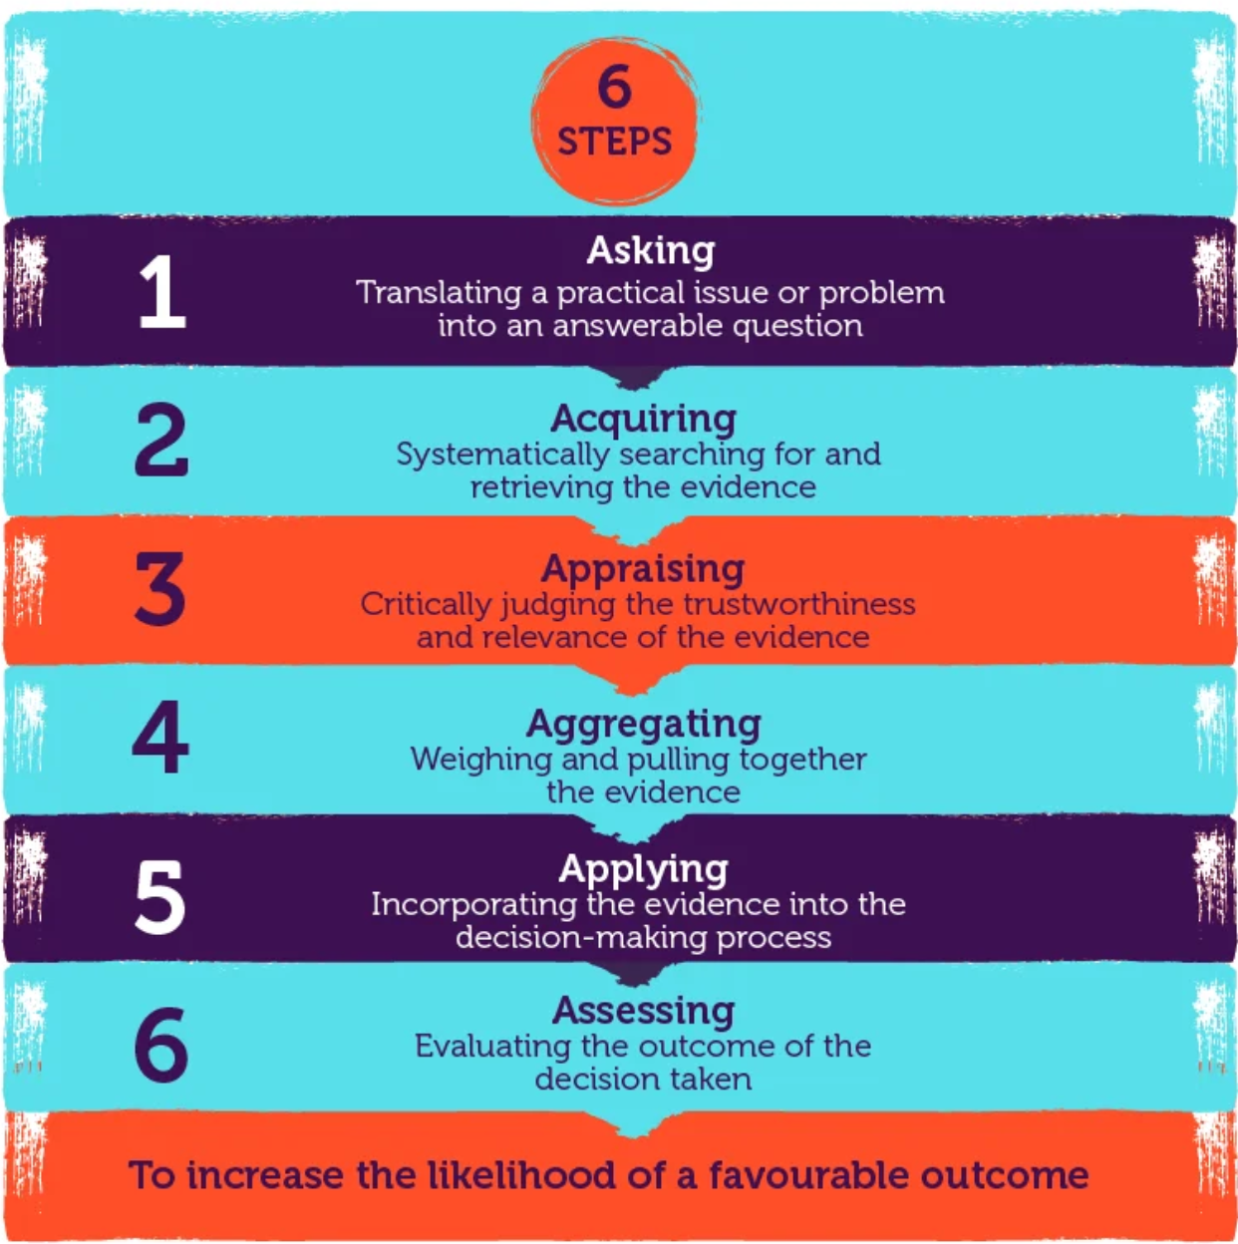
Appendix A taken from CIPD Website (Young, 2023)

Data may be limited and gathering evidence can take time. These challenges should be tested and reviewed via trial programs and pilot studies and learn through continuous experimentation (Adam et al., 2022). Another limitation is the need for strong skills in finding and assessing good quality evidence which can also take time. Absence of these skills could lead into confirmation bias where focus is only on the information that they believe in (CEBMa, 2024).

Applying the rational model in People Practice will help define the problem, giving a systematic, analytical and organised approach. Whilst this is a good option this only works if all information is available (Taylor and Woodhams, 2022a).

There are limitations to the rational model such as time restrictions. In People Practice if a decision needs to be made quickly it would be more desirable to use some evidence than no evidence at all, as there are dangers in relying on heuristics (Mallard, 2018).

Conclusion
EBP is essential in the People Practice Team, using this information creates a balanced and fair approach for better outcomes. EBP is crucial when analysing data such as attrition information for example. It will also play a big part in employee wellbeing using absence data to review sickness reasons, so that we can identify if employees need further support.
Even though there are limitations to EBP overall it provides the guidance needed to ensure that we have reliable evidence to support a fair and consistent outcome.

AC1.2
People Practice organisational issues need to be diagnosed effectively. Applying appropriate analysis tools and methods will help the People team produce unbiased and credible evidence based results. There are several analysis tools that are used in organisations to help carefully evaluate an organisation's internal and external factors with the goal to develop a strong business plan. It gives professionals the ability to detect trends, opportunities, and possible risks (The Strategy Institute, 2025).
SWOT analysis covers internal factors for strengths and weakness and external factors for opportunities and threats. This can provide valuable feedback and give good insight to the organisation where these factors lie. It is an easy tool to use and involves stakeholder’s views.
Limitations for a SWOT analysis include; time taken to organise the process and its reliance from stakeholder participation which in turn could lead to assumptions being made. It requires strategic thinking and it could oversimplify the data used for decision making (CIPD, 2024c).

SWOT sessions in People Practice can identify the following:
Strengths – Incorporates employee feedback and identify where the organisation is performing well
Weakness – Are competitors doing it better, how can we change
Opportunities – New Innovative products
Threats – Technology changes AI

Interviews offer a Qualitative method and provide a direct understanding how employees are feeling, offering a lot of facts and insights where other methods would not. They can be structured with set questions, although this approach may be too rigid. Unstructured interviews have no set questions and can be useful to allow the employee to talk free (Taylor and Woodhams, 2022b). A drawback to using the interview method highlights that the employee may tell us what they think they want us to hear. Also, arranging these would carry time constraints to set up and then review the data. If using the unstructured interviews, the interviewer would need to be skilled in this area at carrying out interviews and being an effective listener and knowing what questions to ask (Armstrong and Taylor, 2020).

A solution would be to plan ahead and ensure interviews are booked in advance and allow time for review of the data to improve consistency in People Practice.

In summary using SWOT and Interviews method combined helps the People Practice Team to support EBP by reviewing the information and identify credible key factors such as wellbeing issues, high turnover and also identify skill gaps in the workplace. By combining employee feedback with organisational analysis and strengthening the integrity of these decisions will provide a better EBP outcome.

At Admiral Group Plc, SWOT analysis meetings are arranged for departments to gain valuable feedback from employees. This can show what is working, where improvements are needed, opportunities for growth and any factors that may cause a potential threat such as new AI technology for example. We need to stay close to this to ask how this will benefit us in the future and does it have any impact on people’s roles being streamlined when introduced. A potential opportunity for efficiency and cost savings with salaries but being mindful of the threat of an increase in Employee Relations cases as a result of this. SWOT analysis is beneficial to all to aid decision making.

AC1.3

Critical thinking supports fair evidence based discussion points. Reasoning is needed to ensure we can make a conclusion from factual evidence, and a well reasoned argument is provided (Armstrong and Taylor, 2023a).

It calls for an open mind, whilst assessing and scrutinising information ensuring it is valid and not based on personal bias and prevent jumping to conclusions. The People Practice Team need to assess if assumptions are being made that these are challenged, then apply a logical approach and critical thinking to identify fallacy and false arguments. Arguments need to have strong endorsed reasons based on quality research and relevant experience to back this up. This will lead to a better factual decision being made and guaranteeing consistent practices in the organisation (Armstrong and Taylor, 2023b).

Secondly, the internet is used by most people as an everyday tool, it is critical that People Practitioners do not believe ‘fake news’ and always rely on credible sources to avoid ambiguity as this can be challenging in an organisation if well reasoned arguments are not backed up (Cottrell, 2023a)

According to Tom Chatfield (Chatfield, 2019), collaboration helps build knowledge, trust and objectively compare viewpoints of others and this creates fair conversations. This reduces bias whether that be conscious or unconscious. Perfection doesn’t exist and we need to rely on critical thinking to support the best available evidence for our decision.

Triangulation can be used to compare evidence and sources. It is essential to check that these are comparable like for like to make for a steady argument. It is easy to make an incorrect decision based on causal assumption if two pieces of evidence occur simultaneously. False correlation could happen and it is imperative that patterns are checked and confirmed that there is an actual link to the evidence (Cottrell, 2023b).

As a People Practice Team it is imperative that we apply critical thinking in our everyday situations, ensuring reliable decisions are based on EBP. CIPD believe it is a significant step for the people profession to use the Profession Map (figure 2) to be principle led, evidence based and outcomes driven (CIPD, 2023b).

This would strengthen the team’s development to trust in their ability to effectively make decisions and promote consistency.
In my role as a Shared Services Manager I need to critically assess workloads daily. If there is absence on the team or annual leave, I need to be able to move workloads around to ensure all priority work is handled and deadlines are met whilst ensuring the team are not overwhelmed with additional work.

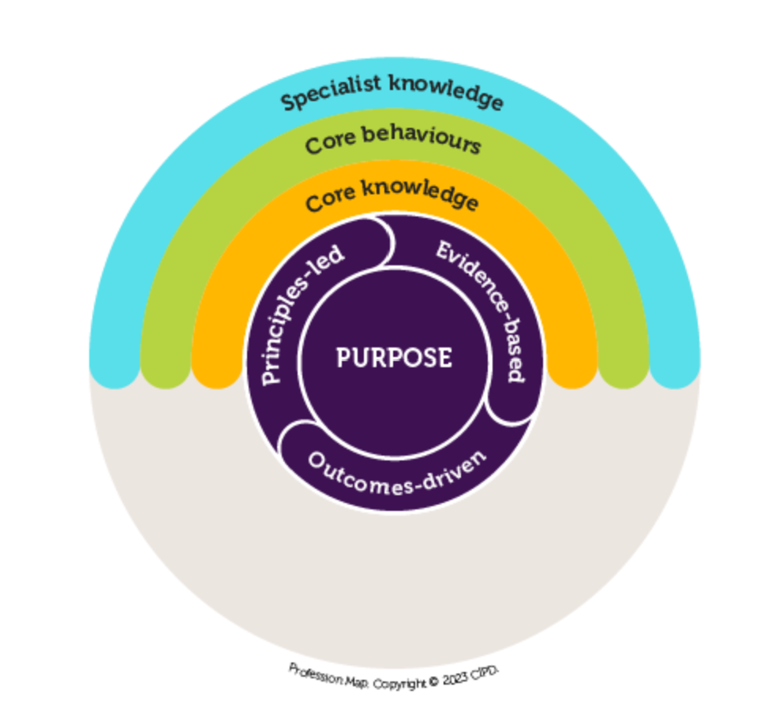
Appendix B taken from CIPD Website (CIPD, 2024)

AC 1.4
Decision making is essential in the People Practice Team especially with a new team who will need to build knowledge and confidence in this area. According to CMI “decision making” and “problem solving” are often together but are not the same. First the problem needs to be identified before decision making skills are applied (CMI, 2020). This can be a challenge for the People Practitioners when under pressure in a fast paced organisation.
John Adair’s depth mind principle (Adair, 2019) is applied by analysing, synthesising and valuing ideas to problem solve. To carry these out in a workplace it requires analysing the problem objectively and assessing any limitations, then reviewing all possible options by gathering available research and data to evidence the outcome. Finally evaluating information to decide on the effective solution, whilst also checking for any risk elements. Once everything has been evaluated, if it passes all criteria you will have your outcome.
Another effective decision making model is De Bono’s six thinking hats (De Bono, 2000), this calls for thinking outside of the box and focus on one thinking method at a time. The six hats demonstrate how each coloured hat is labelled with a purpose i.e black for risk, green hat for creativity. Following this process means we can consider different elements to our decision making. However, it can be a timely process which could impact productivity level’s so considerations are needed.
It is important when using these models that the People Practice Team gather credible research and reliable information to review and assess the problem and come to a fair and consistent outcome whilst also aiming to reduce risk. Listening to employee viewpoints and assessing emotions, helps to build trust and ensures no personal judgements are made (Taylor and Woodhams, 2022c). The People Practice Team can then identify what is going well, where improvements are needed to help manage effective strategy.
This method will be effective in People Practice when reviewing absence rates and sickness reasons, are there issues within the workplace that can then be addressed. Using this qualitative and quantitative data can be essential for any changes needed ensuring we are making a balanced approach when it comes to decision making and providing consistency across the organisation.

AC1.5
According to CIPD, “ethics are at the centre of professionalism”. The People Practice role is required to set clear boundaries, build trust and show honesty when giving advice and ensure there is fair treatment and equality shown to employees across the organisation. The People Practice role is to instil ethics and values within the organisation and should be followed every day (Young, 2024).
Ethical practices are important to a business, if a company has a good reputation for showing care and consideration to employees this could be advantageous against competitors who do not treat their staff well. This would showcase good attrition rates and employee engagement if employees felt valued by their organisation.
Utilitarianism is a belief that we would do whatever makes the most people happy, even if it is wrong and causes harm to others. It has had challenges that this doesn’t support rights of individuals and it only considers the bigger picture (Armstrong and Taylor, 2023c). In Admiral plc for example if there is a company shift pattern change, whereby it benefited 90% of the employees, using this approach would support this change as it is creating greater good for most of the people, even if the 10% are impacted.
Deontology is the right for individuals to make their decisions by following rules regardless of outcome. It focuses on treating everyone fairly and equally regardless of any factors such as race, age. This decision making could ensure fairness and equality even if the outcome is only beneficial for the individual. A criticism for this approach is following the roles even it if means it is not beneficial to all (Rueter, 2023). In Admiral if a group of employees breach the rules, the same outcome would be applicable for all individuals regardless of their position in the company.
For all ethical dilemma cases the People Team should review each case and situation individually and gather evidence and facts to ensure a fair decision is made and not rely on personal bias. Incorporating the 8 lenses such as rights, merit and fairness will guide People Practitioners to achieve better decision outcomes (Clark, 2015).
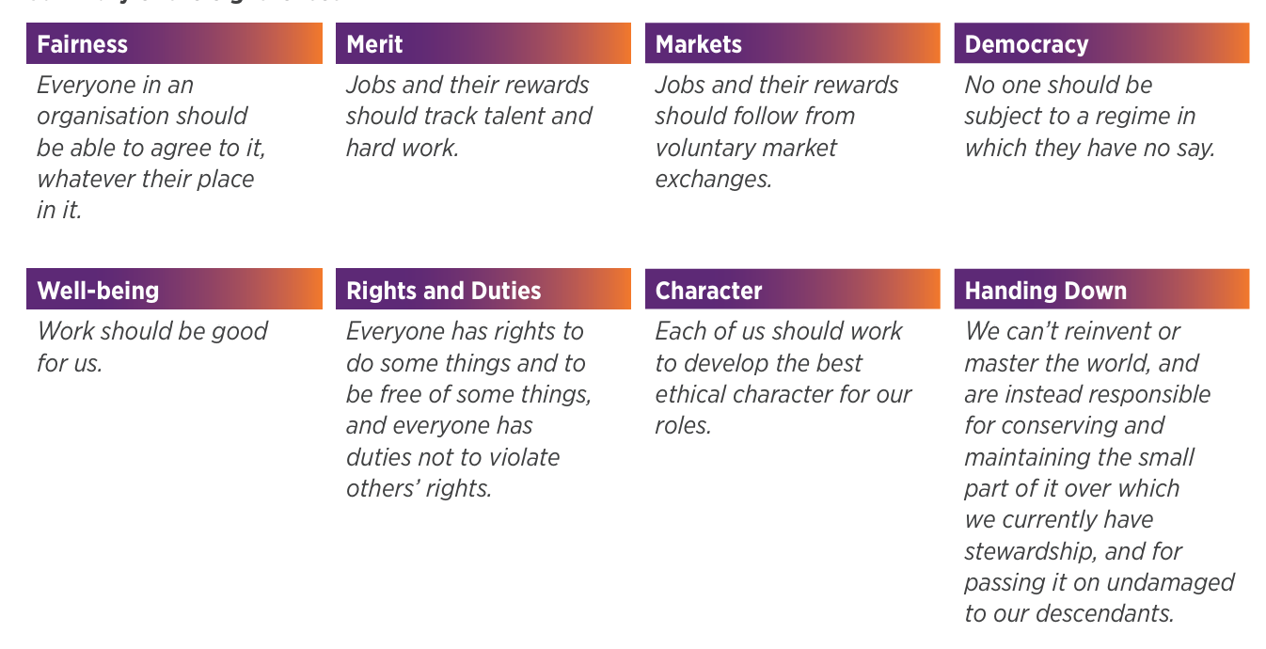
Appendix C -taken from CIPD research report August 2015
It is vital for the People Practice Team to embed ethics into everyday decision making. Using Utilitarian to organisation strategy and wellbeing in the workplace, while Deontology should be used to ensure fairness and equality in organisation. Combining these ethical approaches helps the People Practice Team to act with integrity, trust and foster a culture where employees are treated with respect.

AC 3.1
Measures for financial and non financial performance give an overview using key metrics to show how company performance and profitability alongside Key Performance Indicators (KPI’s) for non financial measures taken from a number of factors such as customer satisfaction surveys, attrition rates and employee engagement surveys. Financial measures on their own are not as strong without critical information from customers and stakeholders (Armstrong, 2022a). Combining financial and non financial data provides valuable information for the company to evaluate if organisational targets have been met.
Financial measure
Gross profit margins give the company an overall view on their performance. If profits are high this indicates the company is achieving their goals, managing revenue and handling claims cost efficiencies. Low profit would show poor management, poor organisational frameworks and high spends (CFI Team, 2023). This is a strong indicator to show profitability overall but needs to take in to account these figures are before tax, claims costs and expenses are deducted and it doesn’t take in to account people related performance. Whilst being in profit is an aim for all companies, if profits were to dip, there would be cause for concern that could lead to staff retention, and additional money would need to be spent on Recruitment using up further profits. Admiral Group Plc uses profit margins to assess overall financial performance and market competitiveness. Profits are up despite an increase in combined ratio. Admiral Group Plc profits grew in the UK and most of their European offices which indicates they are achieving their goals and business strategy. By applying a good pricing and underwriting structure has helped them be competitive and led to an increase in profit and customer base.

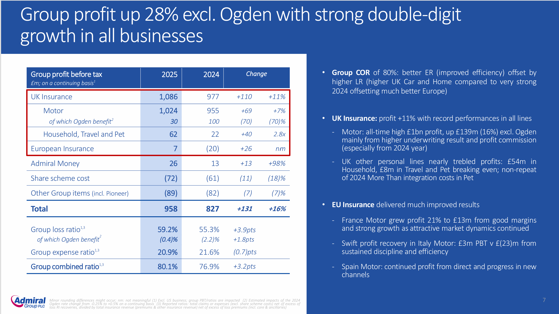
Appendix D – taken from Admiral Group Plc annual report 2025

According to Armstrong, the limitation with using financial measure is seen as past performance information and not in real time reporting (Armstrong, 2022b).
CIPD survey (CIPD, 2023a) found that people matters such as retention contributes to the overall challenges facing organisations. 31% listed employee retention as a significant non financial metric that should not be overlooked. In my role as HR Shared Services Manager in Admiral Group Plc, we review the company’s attrition percentage monthly, using quantitative attrition data, alongside Great Places to Work survey data as a gauge. It is important to balance this with qualitative exit interview feedback to really understand how employees are feeling at work, measuring wellbeing and culture alongside traditional financial measures of a company’s success. Admiral Group Plc have a tag line of ‘those who like what they do, do it better’ which highlights an importance in retaining talent through great culture and avoid expensive recruitment costs replacing attrition.

AC3.2
The People Practice Team look to develop measures of HR success which involves looking beyond simple measurements like cost efficiency to assess the true impact of HR on the business (CIPD, 2025a). If the company is not performing this could have an impact on performance, capability and retention in the future which would lead to overall cost inefficiencies.
People Practice can add significant value to improve business performance and enhance employee experience (Coogan, 2024). People Practice values need to be measured in different ways across the organisation depending on the individual and the situation. This can be done by combining qualitative information such as surveys and quantitative data such as key HR data metrics for example employee turnover. These are metrics that can be used to meet objectives for the People Practice Team to support an effective EBP decision (Taylor and Woodhams, 2022d).
Impact measures where the People Practice have helped influence the business can be highlighted through increased performance in productivity, reduced attrition rates, training and development and wellbeing. Measuring impactful changes can help the organisation show where a People Practice has been effective and can improve decision making and continuous improvement (Burke, 2022).
Cost Benefit Analysis (CBA) is a useful financial measuring evaluation which compares the costs and effects of a decision. The .gov website specifies after using CBA, if the intervention costs are less than the value of the gains in monetary terms, then it clearly provides good value for money and is a good decision outcome which is essential for the business to grow (Office for Health Improvement and Disparities, 2020). Setting clear objectives, using valuable data and analysing the results will allow decisions need to be clear and evidence based and will give the best options with the biggest overall benefit. An advantage of CBA is that it provides a clear financial picture, allowing the business to view financial value in the company (Return on Investment) to give the board an overview on how the company is performing. It will also demonstrate productivity and efficiencies across the organisation. Limitations to CBA, it may not capture the longer term benefits such as improved employee experience or superior data quality.
A second method would be using staff surveys these are non financial measures and provide important data for cultural value. Surveys encourage employee feedback making them feel included and valued in the organisation, this helps to identify strengths and weaknesses in employee engagement and trust in the organisation (Gallup, 2025).
Surveys are a great tool for the People Practice Team to use to gauge job satisfaction and track any patterns or trends to improve any weaknesses. Survey data can be impacted if employees feel their feedback is not taken on board, this will lead to disengagement for any future surveys. Acting on their feedback will prove to employees that they are being listened to and will improve capabilities.
Using both these methods will give the People Practice Team the data to help drive organisational value and productivity whilst gaining a good insight into staff engagement and culture. It is essential for the People Practice Team to understand the Key Performance Indicator metrics used to measure outcomes (CIPD, 2025f) to build knowledge and help gain confidence in these areas to achieve success.

AC2.1
People Practice Area | Regular user | Infrequent user | Effective | Not Effective | High Value | Little Value
HR Policy Guidance | 72.4% | 27.6% | 43.7% | 56.3% | 29.4% | 70.6%
Resourcing | 18.0% | 82.0% | 88.1% | 11.9% | 93.9% | 6.1%
Performance | 66.4% | 33.6% | 46.5% | 53.5% | 41.8% | 58.2%
Employee Development | 62.6% | 37.4% | 94.4% | 5.6% | 98.6% | 1.4%
ER related issues | 26.2% | 73.8% | 74.5% | 25.5% | 70.1% | 29.9%
Pay and Reward | 73.1% | 26.9% | 97.4% | 2.6% | 99.5% | 0.5%
Workforce Planning | 5.6% | 94.4% | 3.7% | 96.3% | 0.9% | 99.1%
General Administration | 97.0% | 3.0% | 83.6% | 16.4% | 77.8% | 22.2%
EDI | 11.0% | 89.0% | 49.8% | 50.2% | 52.1% | 47.9%
Wellbeing advice | 62.9% | 37.1% | 85.7% | 14.3% | 95.6% | 4.4%

AC2.2

The data from the graphs below provide the People Practice Team with quantatitive evidence to identify strengths and weaknesses for each department. By applying an evidence based analysis the following recommendations are made to improve effectiveness in the team which can be aligned to organisation strategy (CIPD, 2025e).

The People Practice function has strengths in some areas such as Wellbeing advice, Employee Development and Pay & Reward which score highly in being effective, high value and trusted by managers, but there are clear gaps between areas such as; Resourcing users are low, but score highly on effectiveness and value. Maybe an increase in awareness for managers would elevate this score. EDI scores low on the usage and around 50% for effective and value. Current processes need to be reviewed to ensure clarity and understanding in EDI for managers and provide further training in this area to improve knowledge and confidence (CIPD, 2024a). Similar scoring for Performance area, but they did show a higher usage, but effective and value scored midway. There could be a lack of understanding and further training is needed to ensure managers and employees are competent and understand what the requirements are within their role . If not addressed this could have financial implications if current performance goals are not being met.
Whilst HR Policy Guidance is critical for the organisation, the data tells us this is low in value and not as effective as it needs to be. It is essential for the People Practice Team to review the policies and guidelines to ensure these are clear and consistent for managers and align to company strategy.
Concerning factors that are currently a risk to the business are Workplace Planning scoring lowest in all areas. This needs urgent review. A SWOT analysis with the employees could identify any current challenges that can be addressed and help put better practices in place where managers and employees would benefit from better strategic processes put into place to help overcome any weaknesses (Taylor and Woodhams, 2022e).

AC2.3

The data below shows there are some strong areas for the People Practice Team such as managers confidence in the ability to support them with advice on employee matters. There is a strong combined score on our support in the development of employees, handling of any legal matters and they have confidence in the team to deliver resourcing and onboarding for employees.
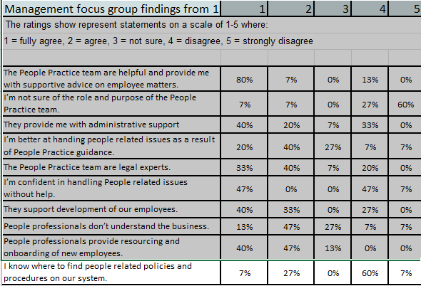
Some mixed results in managers confidence in dealing with people issues, the People Practice Team need to identify if there is training and guidance needed and must ensure managers have the support and knowledge to be able to help employees (CIPD, 2024b).
A concerning outcome from these results is that managers do not know where to find policies and guidelines. It is essential for managers to have access to all policy details to ensure they have all the facts and can review guidelines ad policies and not make a biased decision on a judgement call due to limited information. There is a clear lack of confidence in the area and could be a risk factor if issues are not dealt with consistently. The People Practice Team need to review this as a critical action point to ensure managers have access to information. A recommendation for this would be a central place for all HR information to be kept, such as a HR SharePoint page where the business can access the information when they need it. This would cut down on the number of queries fielded by the People team if information was more accessible. Moderate costs for the implementation of a SharePoint page if the business does not already have one would provide a long term gain in efficiencies for the People team. We introduced this in Admiral Group Plc and this has helped reduce the amount of email traffic that we get through requesting policy and guidelines information now that employees have access to this tool.
Another key concern is managers do not feel that the People Practice Team understand the business. This is a key role that the People Practice Team need to instil trust between them and the manager to show the level of understanding across the organisation (CIPD, 2017). A recommendation for this would be for the People Team to be more visible in the organisations, attending team meetings, or holding informal regular tea parties to be accessible for employees. We currently do this at Admiral Group Plc and it has been a success. Since implementing these informal chats employees have more trust in us as a function and have a clear understanding of what the HR role is.
Conclusion
Whilst there are strengths in the data, there are concerning factors for the People Practice Team who need to review their policies and guidelines to equip managers with the tools to do their job (CIPD, 2025b). This will help build trust and enable managers to become effective leaders and improve performance overall.

Bibliography list
Adair, J.E. (2019). Decision making and problem solving : break through barriers and banish uncertainty at work. London: Kogan Page, pp.56–57 [Accessed 30 April 2026]
Adam, F. et al. (2022) Rational Decisions in Organisations. [edition unavailable]. Auerbach Publications. Available at: https://www.perlego.com/book/3476348 [Accessed: 20 May 2026]
Admiral Group Plc (2026) Monthly Attrition Report. [Confidential Internal Document]
Armstrong, M. (2022a). ARMSTRONG’S HANDBOOK OF PERFORMANCE MANAGEMENT : an evidence-based guide to delivering high... performance. S.L.: Kogan Page [Accessed 30 April 2026]
Armstrong, M. (2022b). ARMSTRONG’S HANDBOOK OF PERFORMANCE MANAGEMENT : an evidence-based guide to delivering high... performance. S.L.: Kogan Page [Accessed 30 April 2026]
Armstrong, M. and Taylor, S. (2020). Armstrong’s Handbook of Human Resource Management Practice. 15th ed. [online] Perlego, Kogan Page, p.314. Available at: https://www.perlego.com/book/1589838 [Accessed 2 May 2026]
Armstrong, M. and Taylor, S. (2023a). Armstrong’s Handbook of Human Resource Management Practice. 16th ed. New York: Kogan Page [Accessed 07 May 2026]
Armstrong, M. and Taylor, S. (2023b). Armstrong’s Handbook of Human Resource Management Practice. 16th ed. New York: Kogan Page, p.172 [Accessed 07 May 2026]
Armstrong, M. and Taylor, S. (2023c). Armstrong’s Handbook of Human Resource Management Practice. 16th ed. New York: Kogan Page [Accessed 07 May 2026]
Barends, E. and Rousseau, D.M. (2018). Evidence-Based Management: How to Use Evidence to Make Better Organizational Decisions. 1st ed. [online] Perlego. Kogan Page. Available at: https://www.perlego.com/book/1589395 [Accessed 30 Apr 2026]

Burke, E. (2022). People and the creation of value. Data Intelligence, [online] 4(4), pp.1033–1054. Available at: https://www.bell-foundation.org.uk/app/uploads/2018/02/Educational-Outcomes-of-Children-with-EAL.pdf?_gl=1 [Accessed 12 May 2026]
CEBMa (2024). What Are the Limitations of Evidence Based practice?» CEBMa. [online] cebma.org. Available at: https://cebma.org/resources/frequently-asked-questions/what-are-the-limitations-of-evidence-based-practice/ [Accessed 30 Apr 2026]
CFI Team (2023). Financial ratios. [online] Corporate Finance Institute. Available at: https://corporatefinanceinstitute.com/resources/accounting/financial-ratios/ [Accessed 10 May 2026]
Chatfield, T. (2019). Think Critically. S.L.: Sage Publications [Accessed 05 May 2026]
CIPD (2017). CIPD | HR and line managers – getting the relationship right. [online] CIPD. Available at: https://www.cipd.org/uk/knowledge/bitesize-research/hr-line-managers-balance/ [Accessed 10 May 2026]
CIPD (2023a). Survey report EFFECTIVE WORKFORCE REPORTING Improving people data for business leaders. [online] Available at: https://www.cipd.org/globalassets/media/knowledge/knowledge-hub/reports/workforce-reporting-1_tcm18-113899.pdf [Accessed 11 May 2026]
CIPD (2023b). The Profession Map / Professional values and purpose. [online] CIPD. Available at: https://www.cipd.org/uk/the-people-profession/the-profession-map/explore-the-profession-map/professional-values-purpose/ [Accessed 6 Jun. 2026].
CIPD (2024a). CIPD | Equality, Diversity and Inclusion in the Workplace | Factsheets. [online] CIPD. Available at: https://www.cipd.org/uk/knowledge/factsheets/diversity-factsheet/ [Accessed 10 May 2026]
CIPD (2024b). CIPD | Management Development | Factsheets. [online] CIPD. Available at: https://www.cipd.org/uk/knowledge/factsheets/management-factsheet/ [Accessed May 18 2026]
CIPD (2024c). CIPD | SWOT Analysis | Factsheets. [online] CIPD. Available at: https://www.cipd.org/uk/knowledge/factsheets/swot-analysis-factsheet/#when-to-use-a-swot-analysis [Accessed 2 May 2026]
CIPD (2025a). CIPD | Analysis | Recognition of the HR function in organisations. [online] CIPD. Available at: https://www.cipd.org/uk/views-and-insights/thought-leadership/insight/hr-function-organisations/ [Accessed 12 May 2026]
CIPD (2025b). CIPD | Effective performance management: Guide for HR professionals. [online] CIPD. Available at: https://www.cipd.org/uk/knowledge/guides/effective-performance-management/ [Accessed 31 May 2026].
CIPD (2025c). CIPD | Evidence-based Practice for Effective decision-making | Factsheets. [online] CIPD. Available at: https://www.cipd.org/uk/knowledge/factsheets/evidence-based-practice-factsheet/ [Accessed 31 May 2026].
CIPD (2025d). CIPD | Evidence-based Practice for Effective decision-making | Factsheets. [online] CIPD. Available at: https://www.cipd.org/uk/knowledge/factsheets/evidence-based-practice-factsheet/ [Accessed 11 May 2026]
CIPD (2025e). Evidence-based HR: Make better decisions and step up your influence. [online] CIPD. Available at: https://www.cipd.org/uk/knowledge/guides/evidence-based-profession/ [Accessed 6 Jun. 2026]
CIPD (2025f). Performance management: an introduction. [online] CIPD. Available at: https://www.cipd.org/uk/knowledge/factsheets/performance-factsheet/ [Accessed May 31 2026]
Clark, S. (2015). Ethical decision-making: Eight Perspectives on Workplace Dilemmas. [online] CIPD. Available at: https://www.cipd.org/globalassets/media/comms/the-people-profession/profession-map-pdfs/ethical-decision-making-2015-eight-perspectives-on-workplace-dilemmas_tcm29-9564.pdf [Accessed 13 May 2026]
CMI (2020). Decision Making. [online] CMI. Available at: https://www.managers.org.uk/knowledge-and-insights/resource/decision-making/ [Accessed 9 May 2026]
Coogan, S. (2024). CIPD | Business Partnering | Factsheets. [online] CIPD. Available at: https://www.cipd.org/uk/knowledge/factsheets/business-partnering-factsheet/ [Accessed 12 May 2026]
Cottrell, S. (2023a). Critical thinking skills : developing effective analysis and argument. 2nd ed. Basingstoke: Palgrave Macmillan [Accessed 05 May 2026]
Cottrell, S. (2023b). Critical thinking skills : developing effective analysis and argument. 2nd ed. Basingstoke: Palgrave Macmillan [Accessed 05 May 2026]
De Bono, E. (2000). Six Thinking Hats. London: Penguin Life [Accessed 09 May 2026]
Gallup, I. (2025). Employee Surveys: Types, Tools and Best Practices. [online] Gallup.com. Available at: https://www.gallup.com/workplace/692474/workplace-employee-surveys.aspx [Accessed 13 May 2026]
Mallard, G. (2015). Bounded Rationality And Behavioural Economics. S.L.: Routledge [Accessed 30 April 2026]
Office for Health Improvement and Disparities (2020). Cost Benefit analysis: Health Economic Studies. [online] GOV.UK. Available at: https://www.gov.uk/guidance/cost-benefit-analysis-health-economic-studies [Accessed 12 May 2026]
Rueter, S. (2023). Deontology: Understanding Ethics and Morality. [online] philosophos.org. Available at: https://www.philosophos.org/ethics-and-morality-deontology [Accessed 9 May 2026]
Taylor, S. and Woodhams, C. (2022a). Studying Human Resource Management a Guide to the Study, Context and Practice of HR. 3rd ed. Kogan Page, p.119 [Accessed 20 May]
Taylor, S. and Woodhams, C. (2022b). Studying Human Resource Management a Guide to the Study, Context and Practice of HR. 3rd ed. Kogan Page, p.115 [Accessed 20 May]
Taylor, S. and Woodhams, C. (2022c). Studying Human Resource Management. 3rd ed. London: Kogan Page, p.129 [Accessed 20 May 2026]
Taylor, S. and Woodhams, C. (2022d). Studying Human Resource Management a Guide to the Study, Context and Practice of HR. 3rd ed. Kogan Page, p.132 [Accessed 20 May 2026]
Taylor, S. and Woodhams, C. (2022e). Studying Human Resource Management a Guide to the Study, Context and Practice of HR. 3rd ed. Kogan Page [Accessed 6 June 2026]
The Strategy Institute (2025). Strategic Analysis: A Deep Dive for Business Leaders. [online] Thestrategyinstitute.org. Available at: https://www.thestrategyinstitute.org/insights/strategic-analysis-a-deep-dive-for-business-leaders [Accessed 2 May 2026]
Waite, K., Beevers, K., Small, N., Tomlinson, K. and Hussain, S. (2021). People Practice : A Complete Guide. 1st ed. London, United Kingdom : Kogan Page, p.47 [Accessed 4 May 2026]
Young, J. (2024). Ethical Practice and the Role of People Professionals. [online] CIPD. Available at: https://www.cipd.org/uk/knowledge/factsheets/ethics-role-hr-factsheet/ [Accessed 14 May 2026]

Appendix
Appendix A
Young, J. (2023). CIPD | Evidence-based practice for effective decision-making | Factsheets. [online] CIPD. Available at: https://www.cipd.org/uk/knowledge/factsheets/evidence-based-practice-factsheet/#what-evidence-should-we-use [Accessed 14 May 2026].
Appendix B
CIPD (2024). How to Use the Profession Map. [online] CIPD. Available at: https://www.cipd.org/uk/the-people-profession/the-profession-map/how-it-works/ [Accessed 14 May 2026].
Appendix C
Clark, S. (2015). Ethical decision-making: Eight Perspectives on Workplace Dilemmas. [online] CIPD. Available at: https://www.cipd.org/globalassets/media/comms/the-people-profession/profession-map-pdfs/ethical-decision-making-2015-eight-perspectives-on-workplace-dilemmas_tcm29-9564.pdf [Accessed 15 May 2026].
Appendix D
Admiral Group Plc Full Year 2025 Results | Admiral Group Plc

