Rachid Aboulachouaq (2237654)
2237654@student.uwtsd
ACCA5023 Course work 2

Table of Contents
ICMP and Firewalls 3
6
Remote Access and Routing 7
DNS and Domain 8
DHCP 13
VPN – Wireguard 15

ICMP and Firewalls

Firstly, ICMP and firewall rules were altered, further fine tuning the Virtual machine from course work 1.
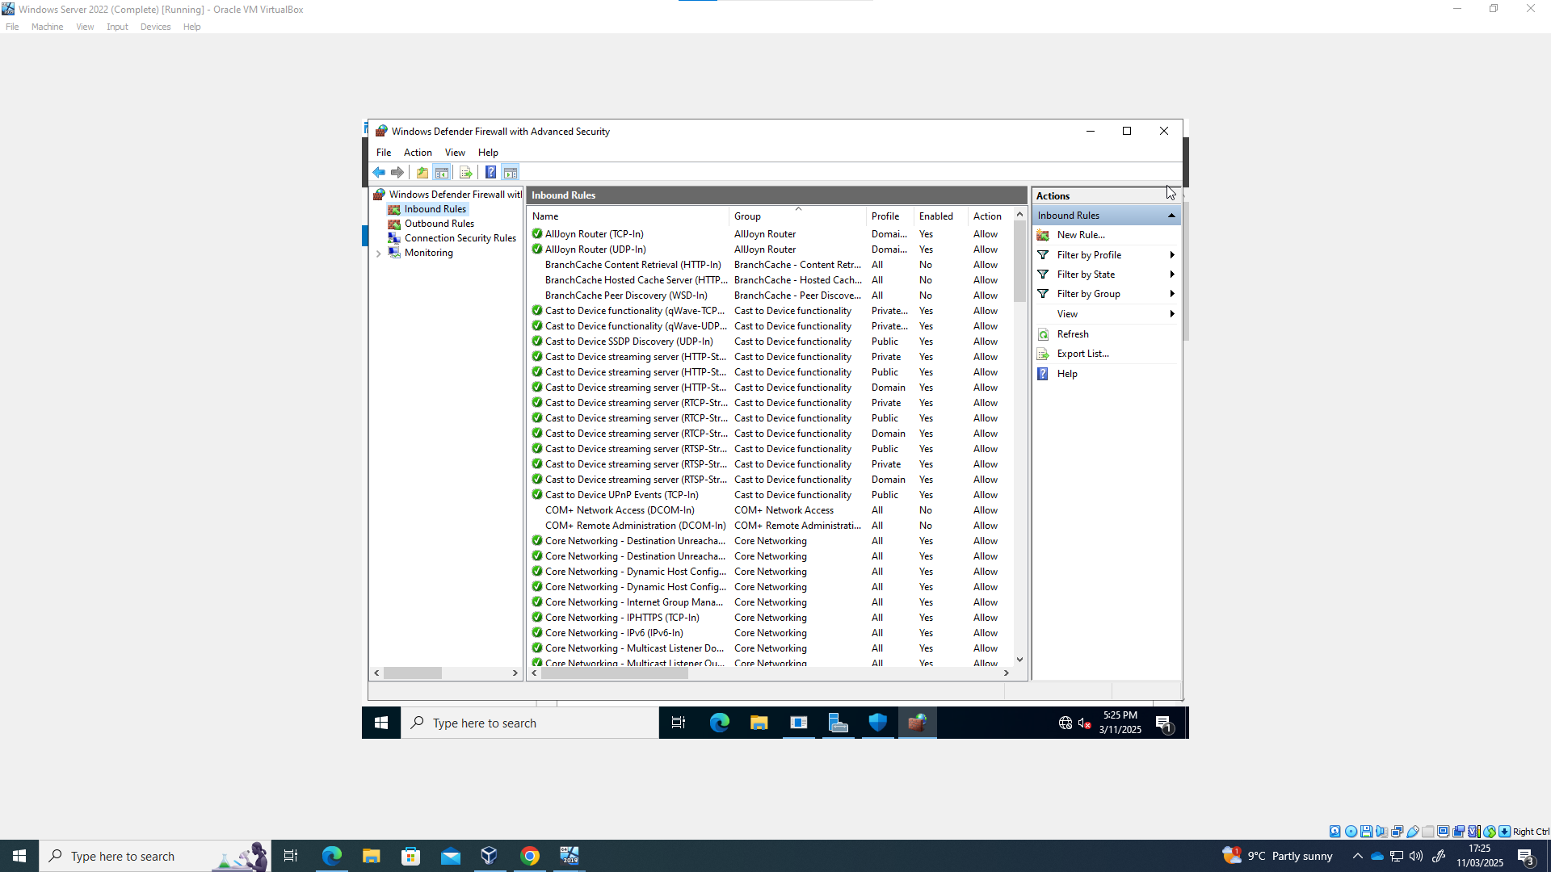
This involve going into fire wall setting, and with the correct networking set up, ICMP echo request were allowed in the fire wall rules of all clients. 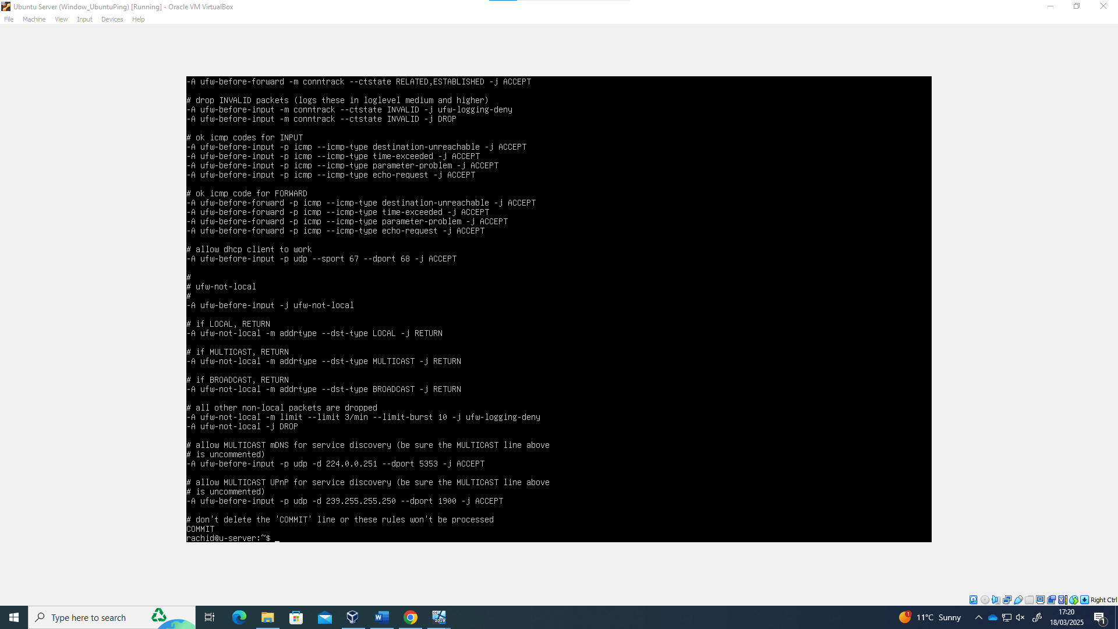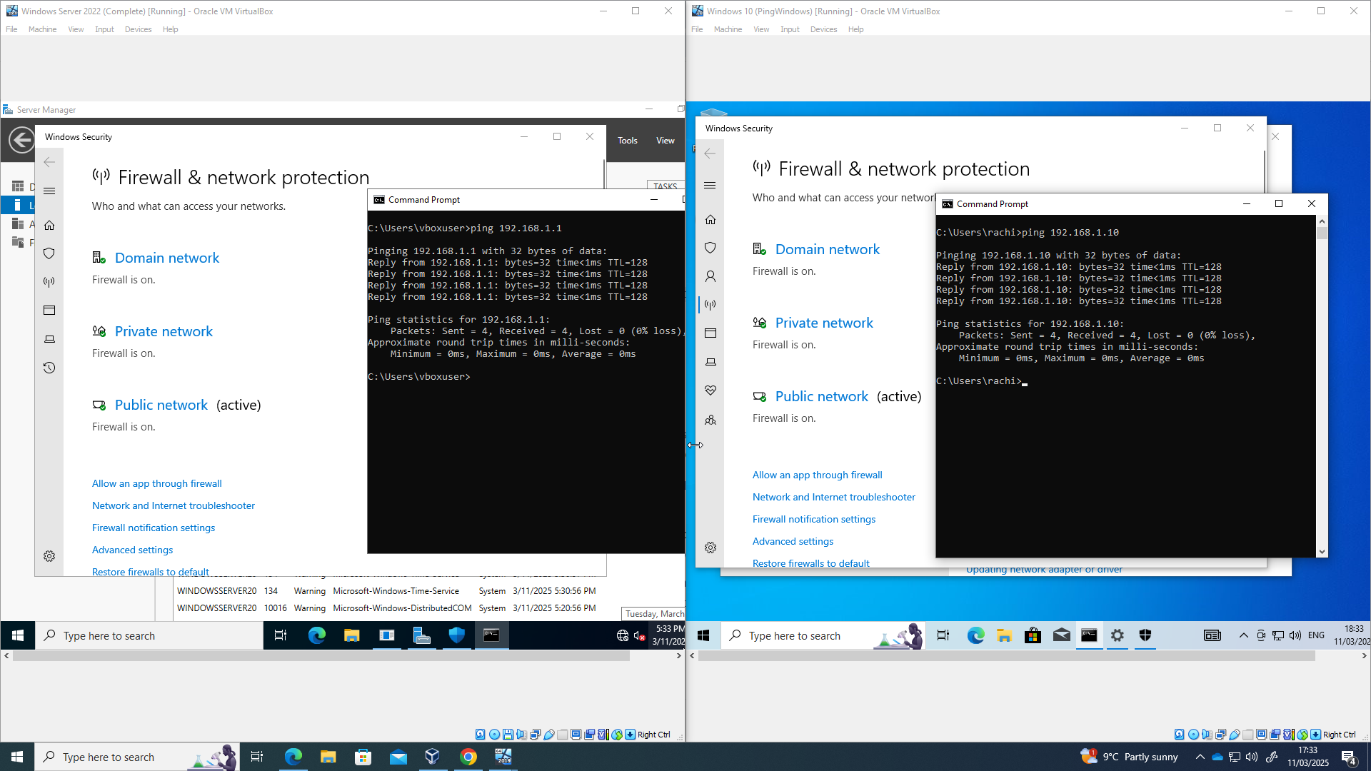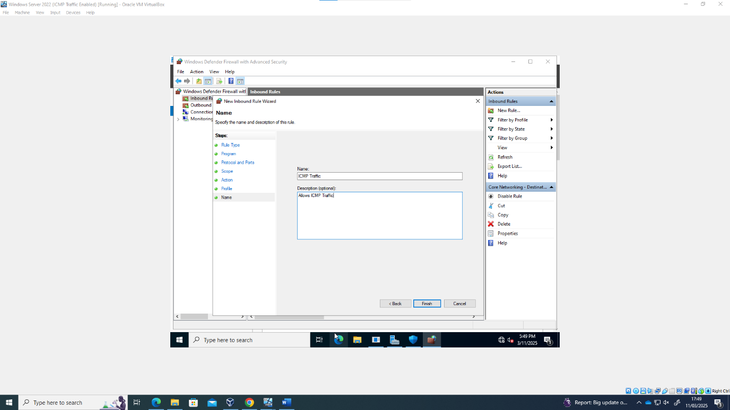
By setting up specific firewall rules to allow certain traffic, the network remains secure against threats while also carrying out efficient communication between devices

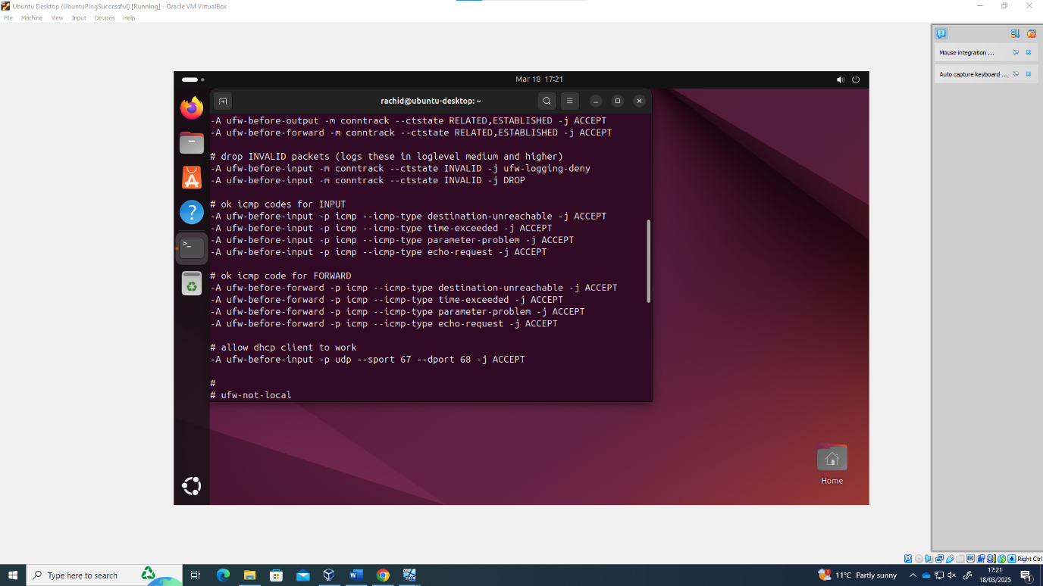

Remote Access and Routing

The next stage was ensuring that the devices were able to communicate effectively between different operating systems and networks. Therefore Remote access and routing services were added.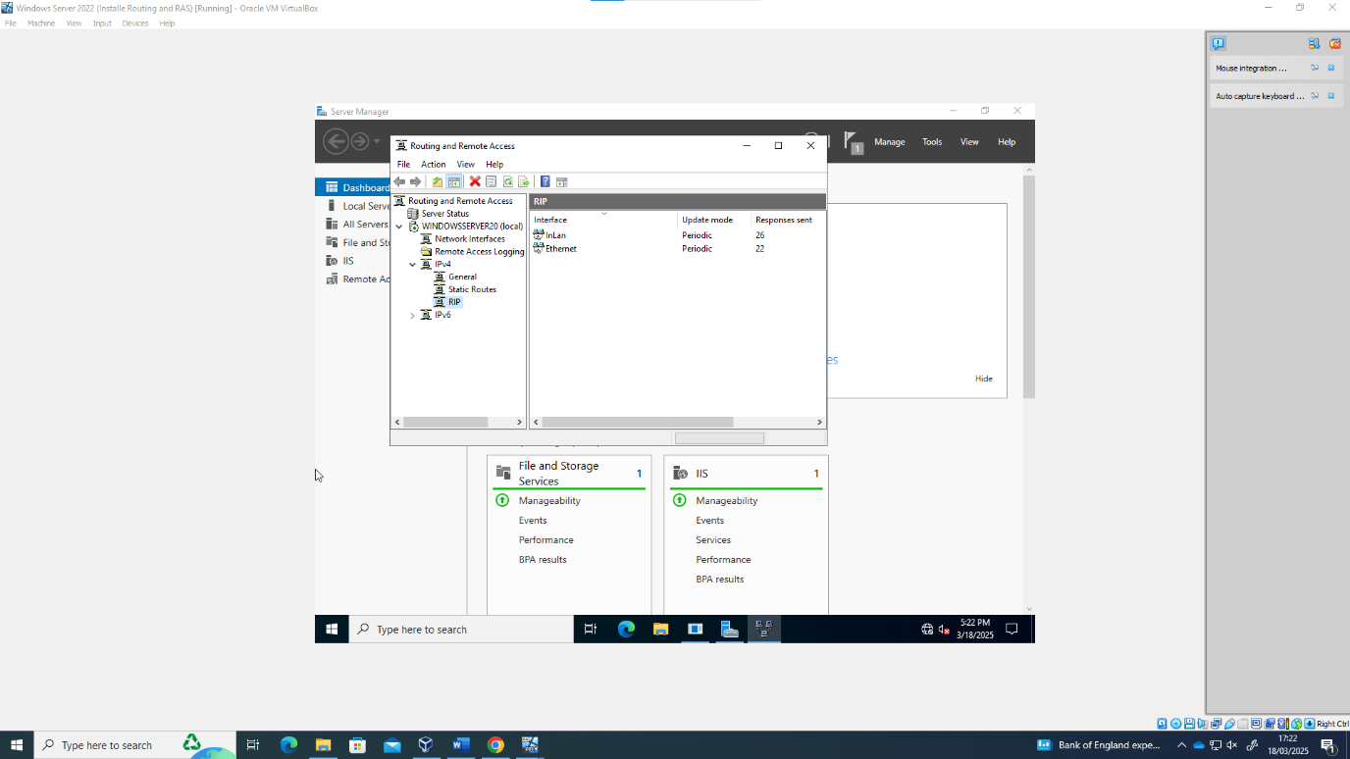

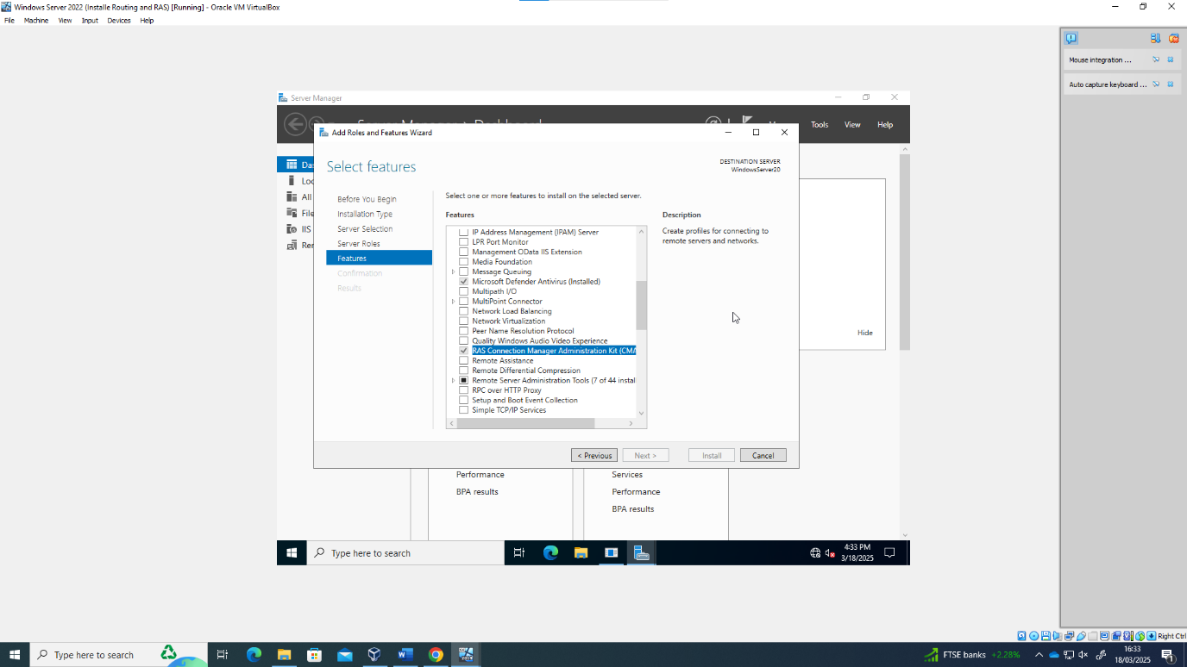

The use of Routing Information protocol allowed for the individual networks to be configured with how the interacted , and the routes that the packets could take to communicate with other devices on different networks.
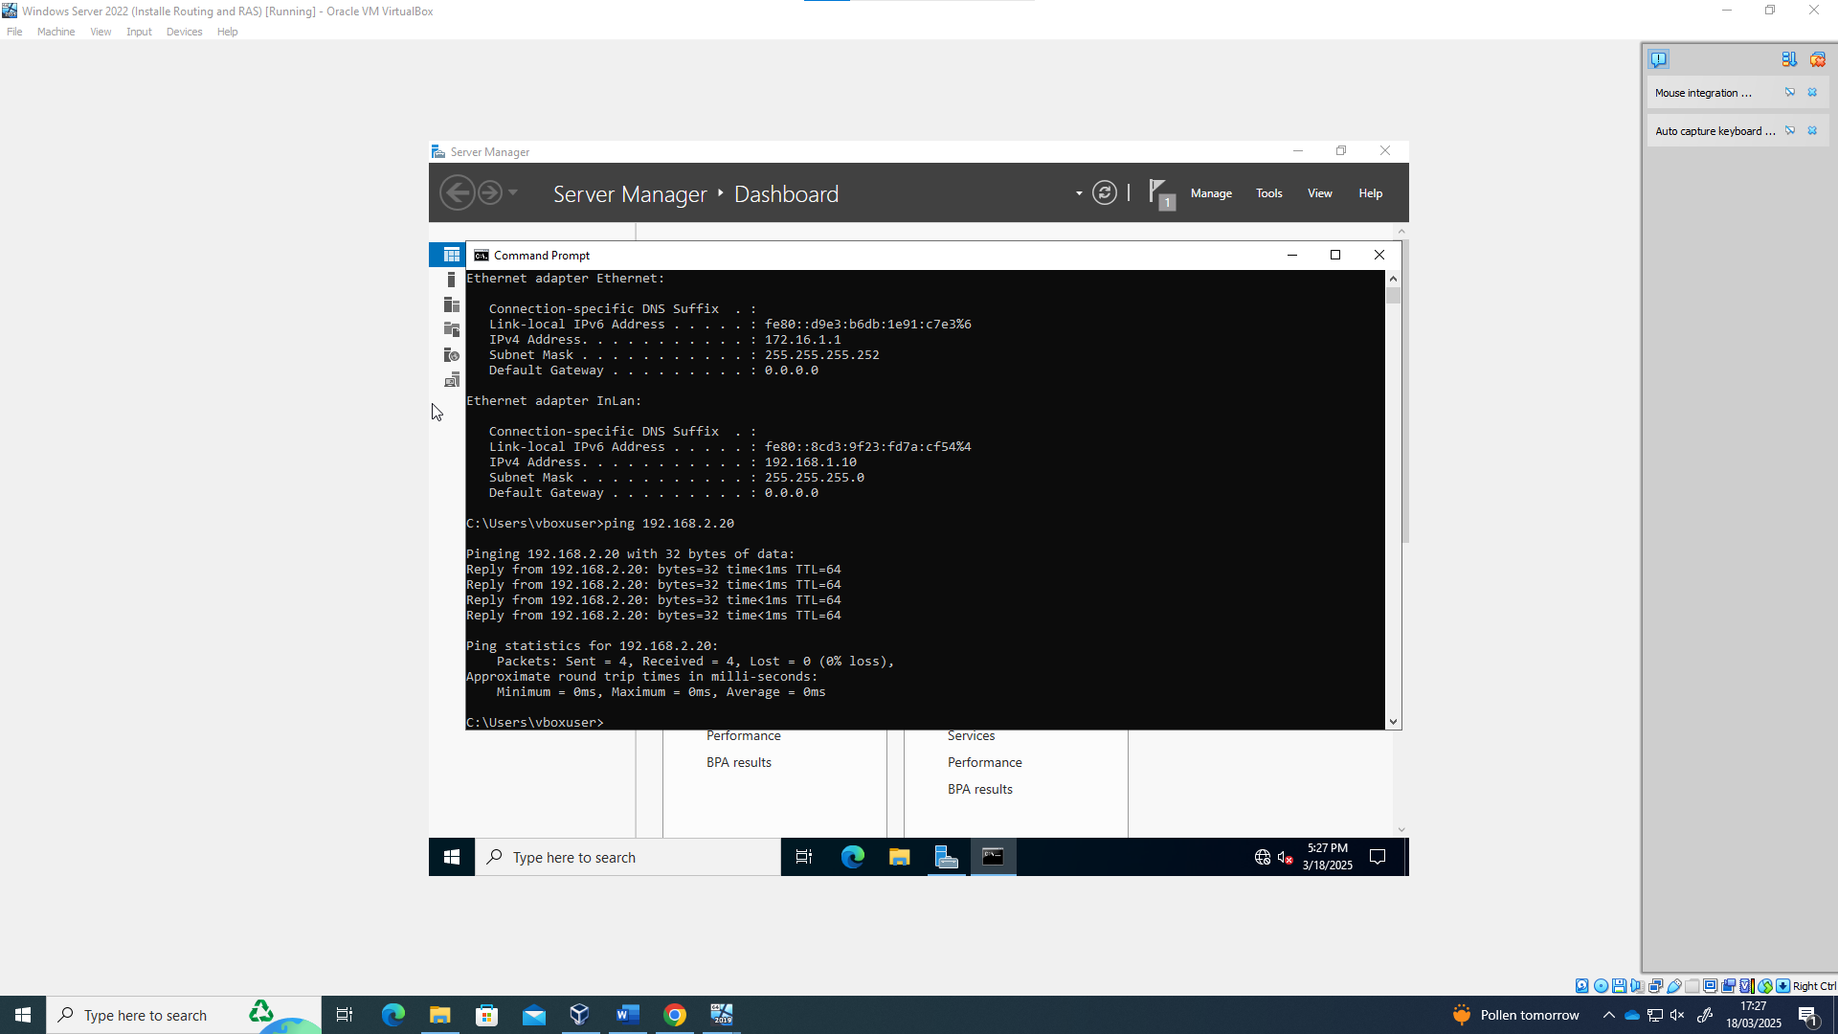

DNS and Domain

The next stage to address in the topology was the creation of the DNS server. 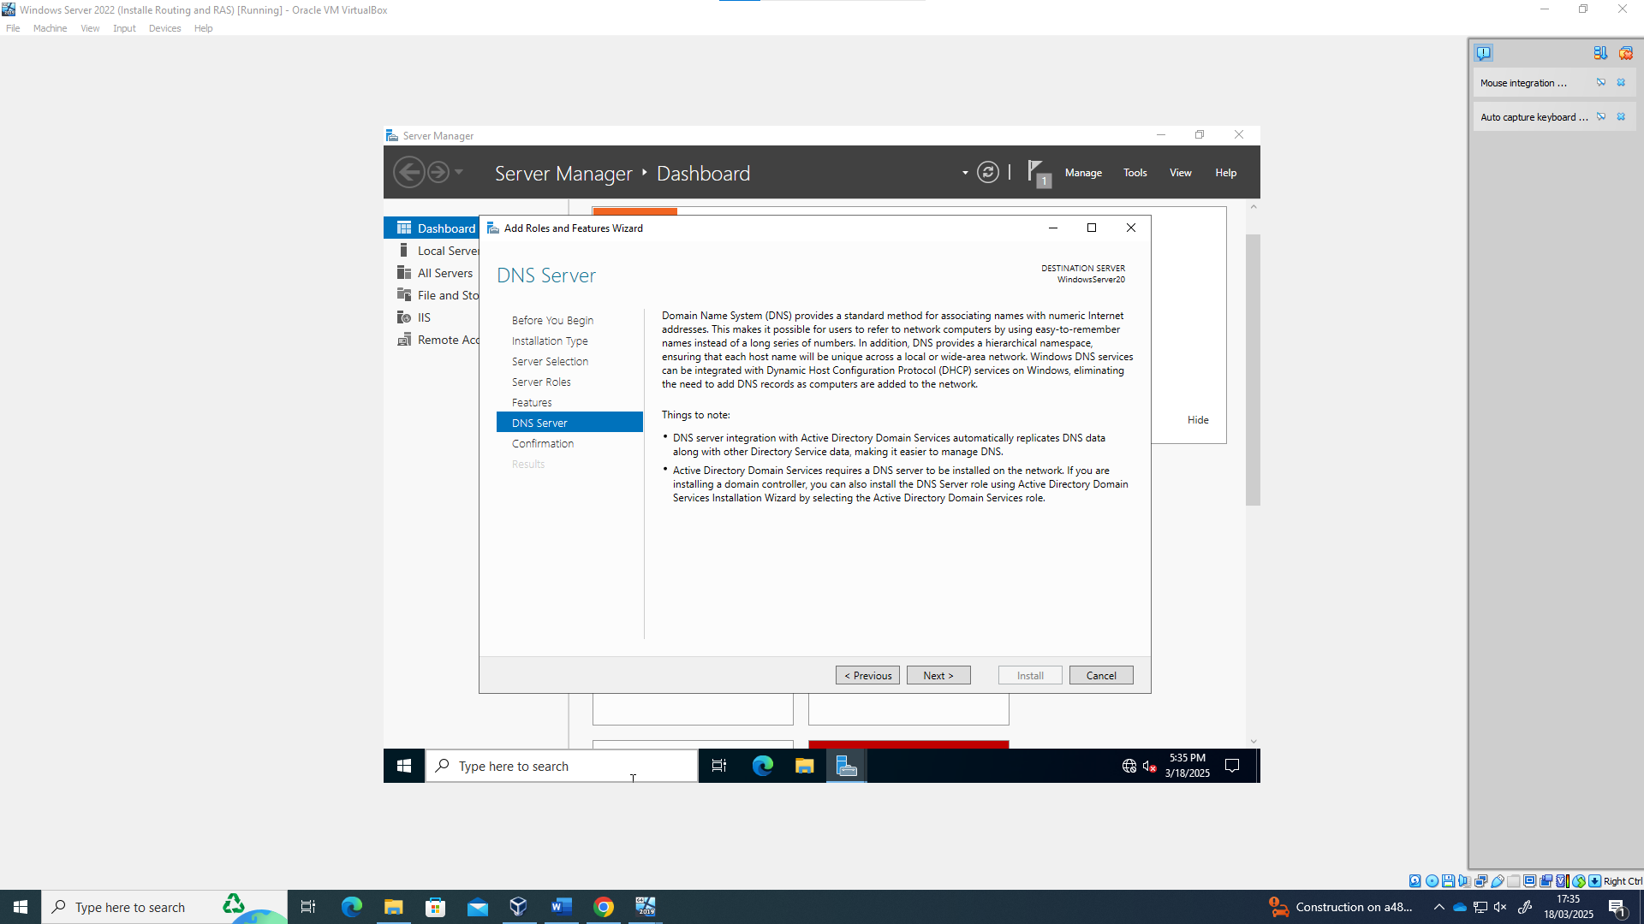

The Domain Name System is required to resolve the ip addresses into user friendly information, such as Googl.com (8.8.8.8).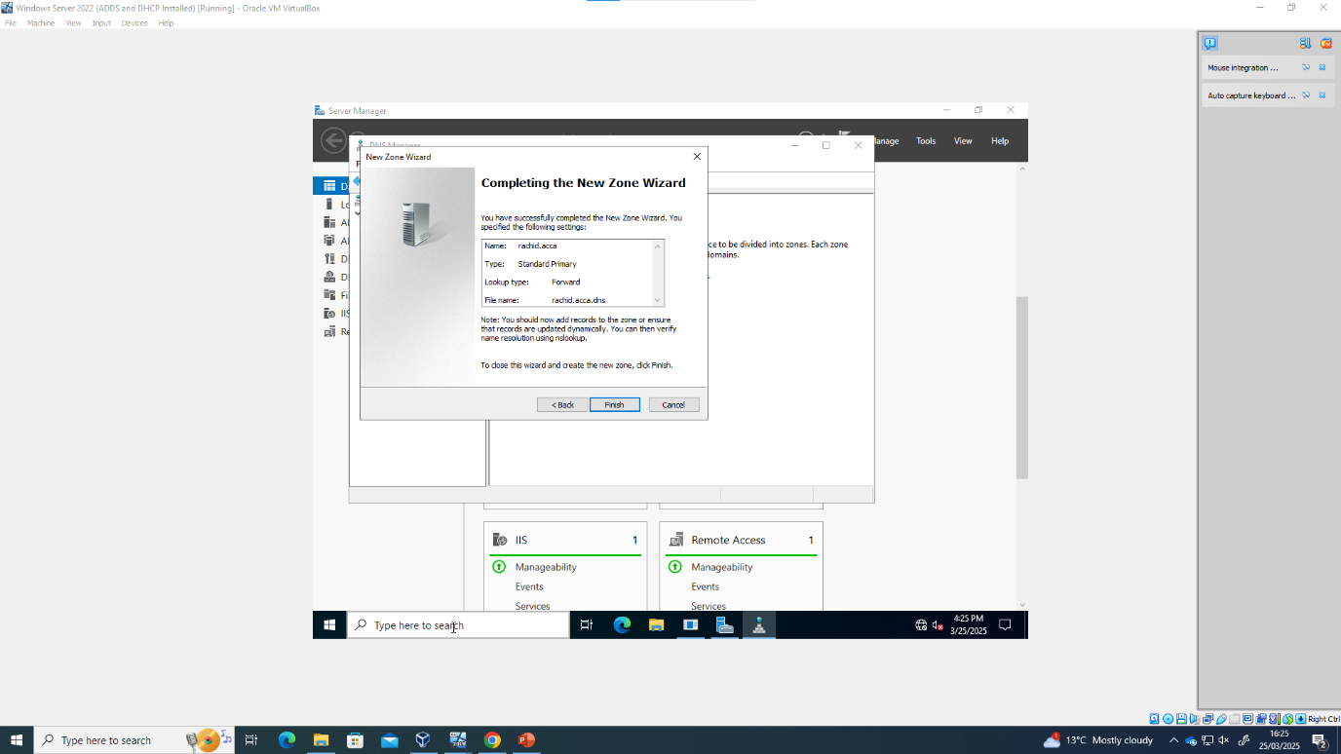

As such, this also required setting up of the domain, rachid.acca. To achieve this it was necessary to create forward look up zone, as well as reverse look up zone. This allows any queries coming to the DNS server to direct to the correct IP address.

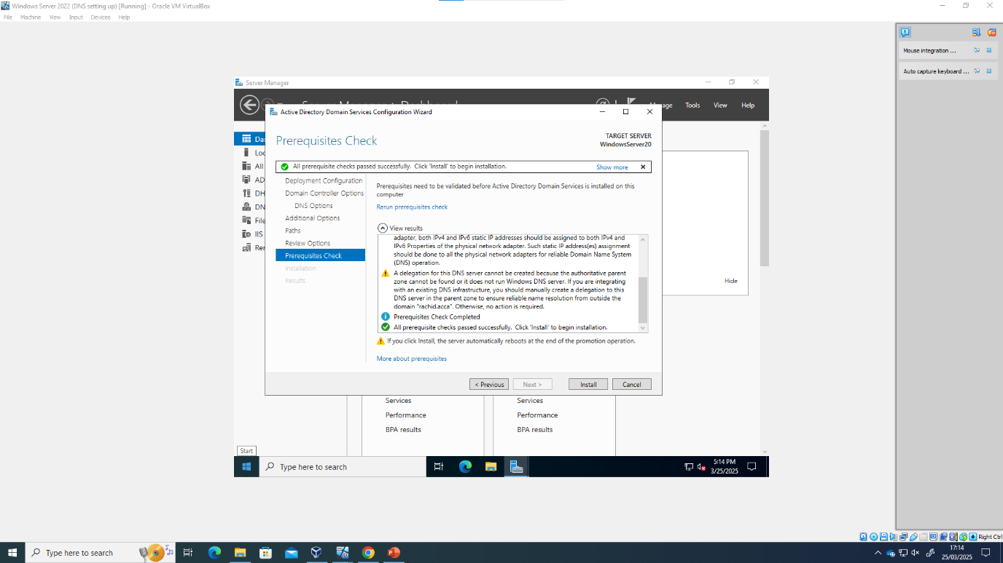
Acca is the root domain and rachid is the domain/forest that it belongs to. This allows users and devices to be managed and grouped together by Active directory domain services to organise and manage permissions and access the groups.

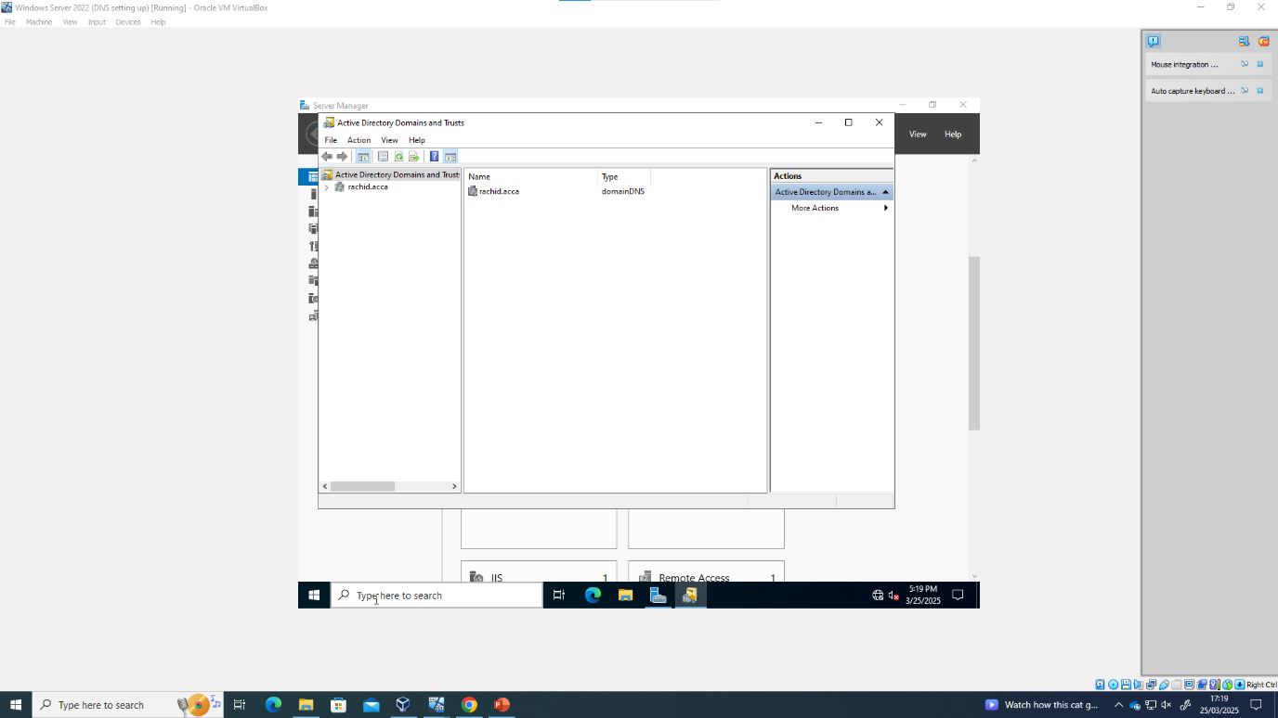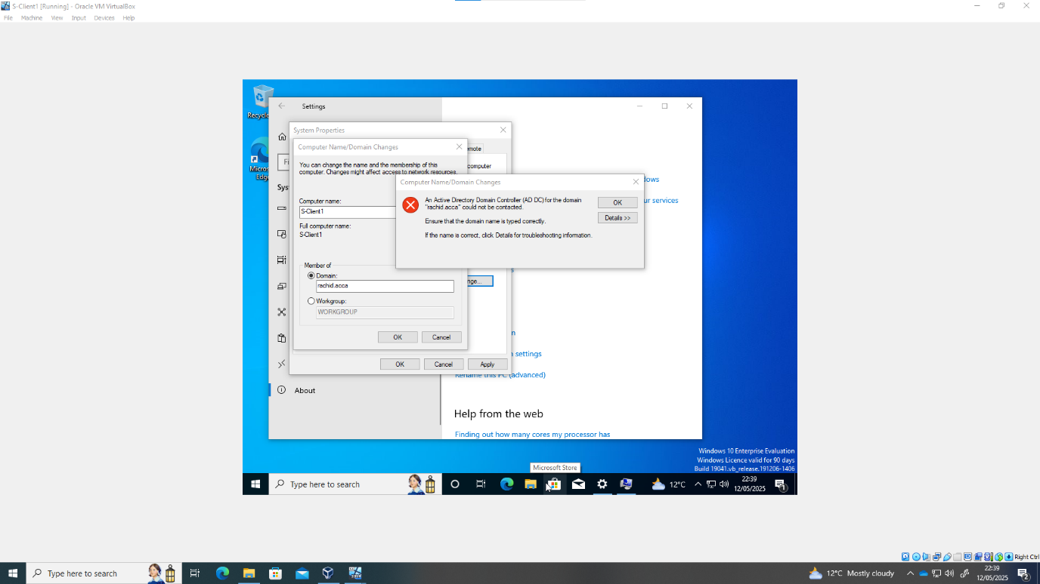
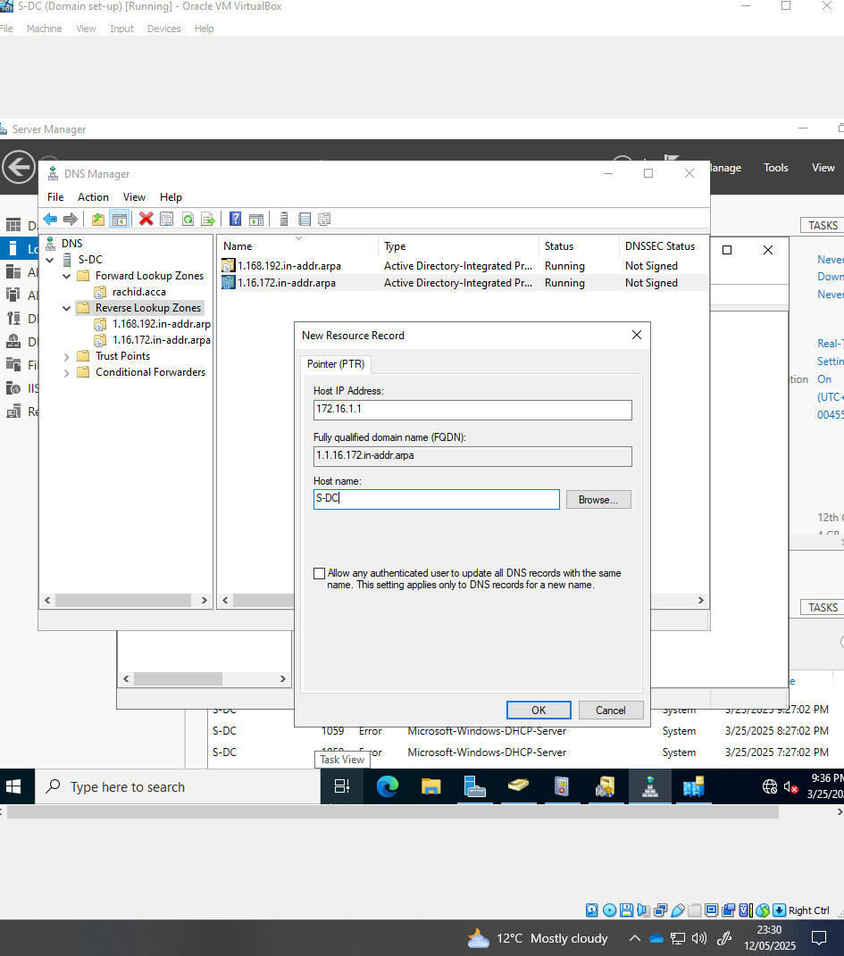
Pointer records are needed for a DNS to be accurately identified by client devices in a domain.
There was a bit of trouble adding the client device to the domain that required additional configuration of the DNS server to resolve.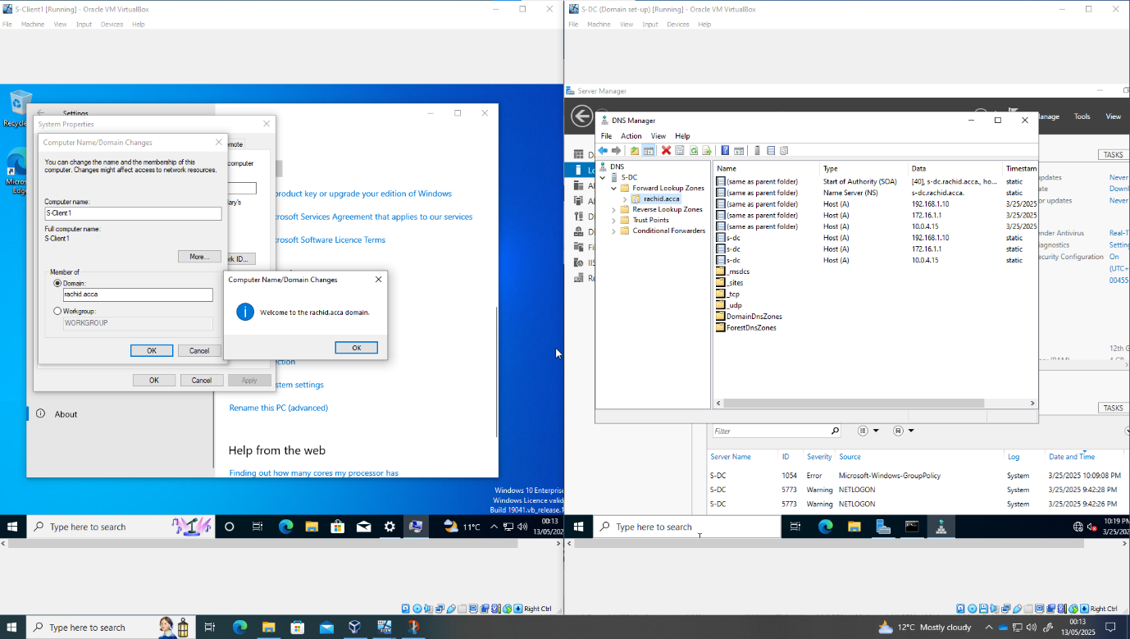
Certain pointer and forward lookup records were not being created by the DNS service, therefore it was necessary to manually reset and register the domain DNS files.
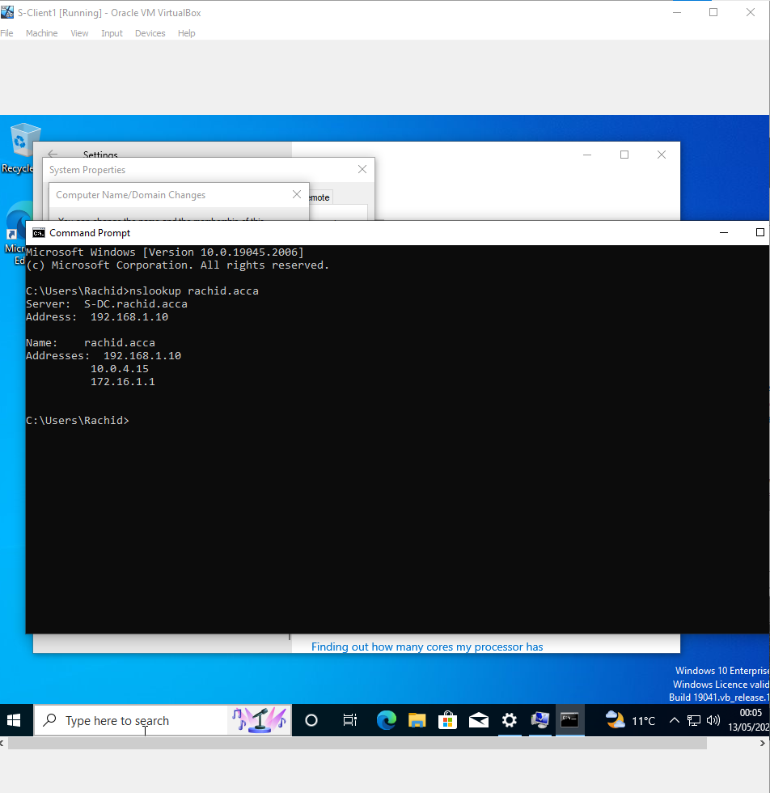

DHCP

As there would be very many devices operating within the domain, it would be needed to automatically assign IP addresses to those devices on t he network.
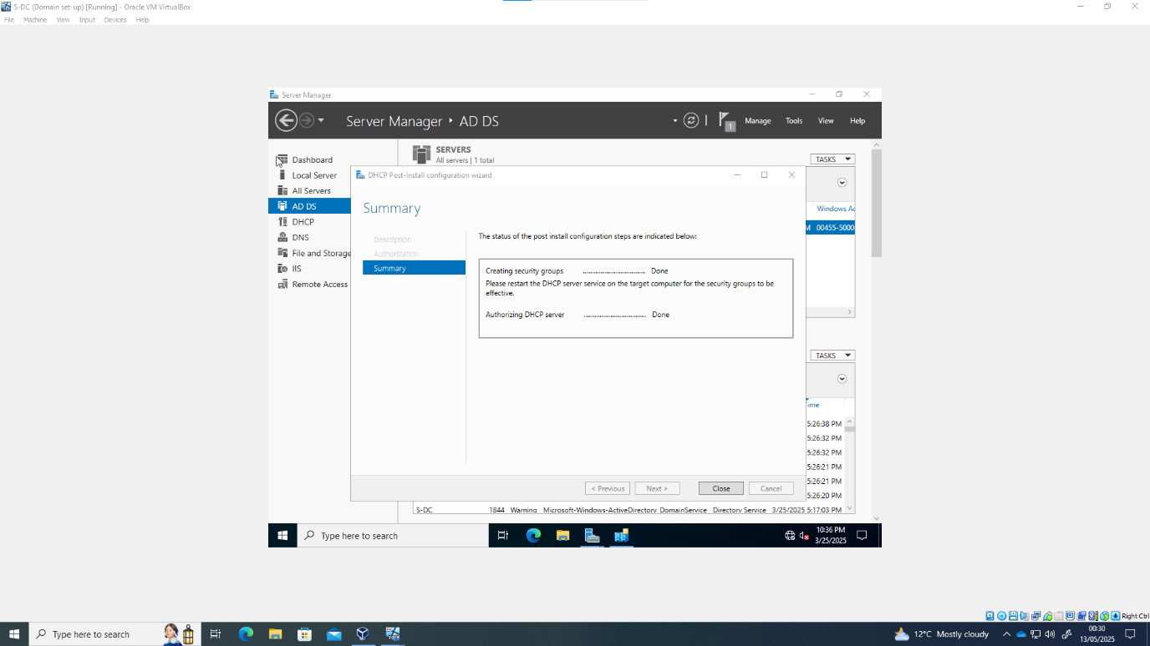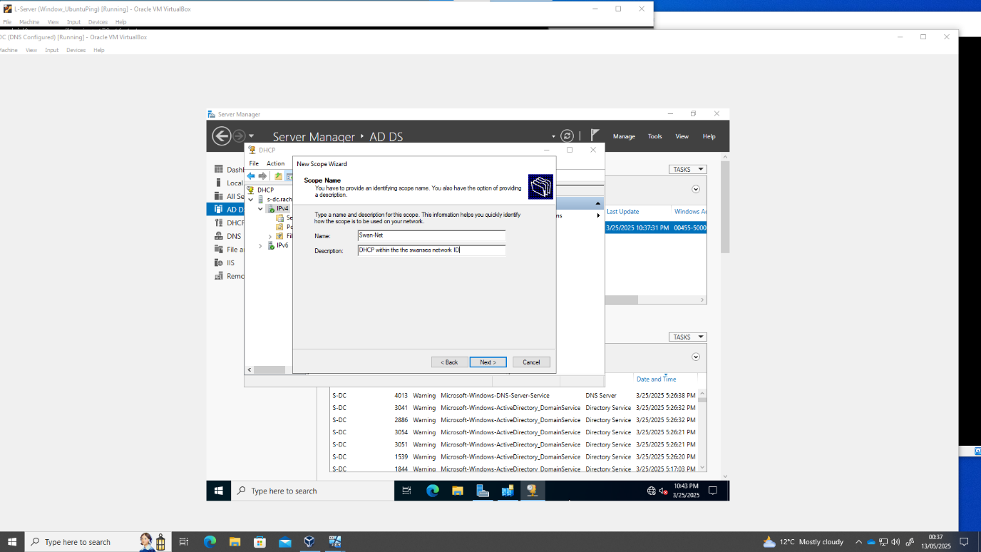

A scope of IPV$ addresses in range for multiple devices was created as a dynamic register for the IP addresses. Devices will be assigned IPv4 addresses automatically. The IP address of the domain controller was exclude so that there are no mistakes in routing.
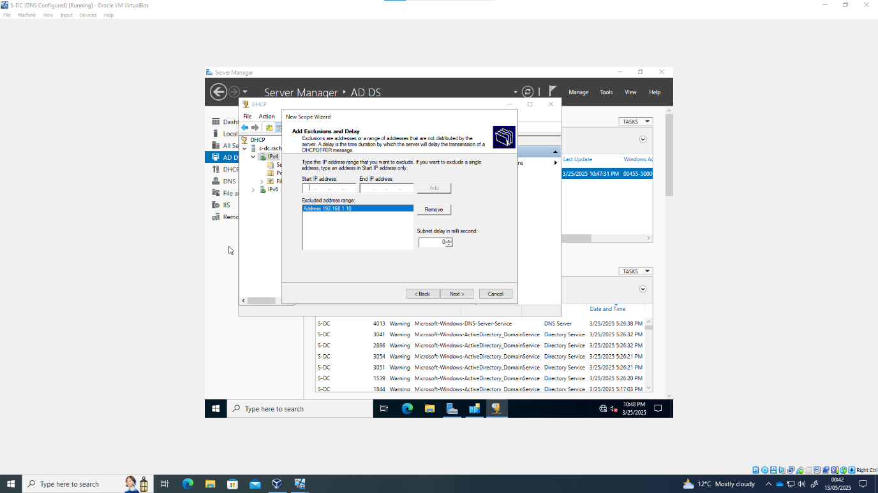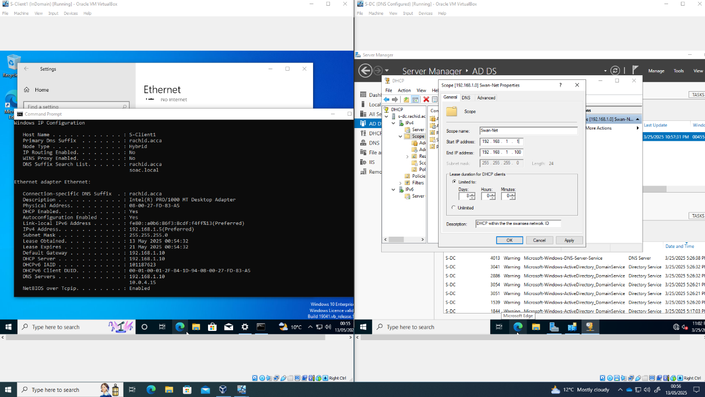

VPN – Wireguard

The decision to use wireguard was taken due to the ease of use and access on both servers.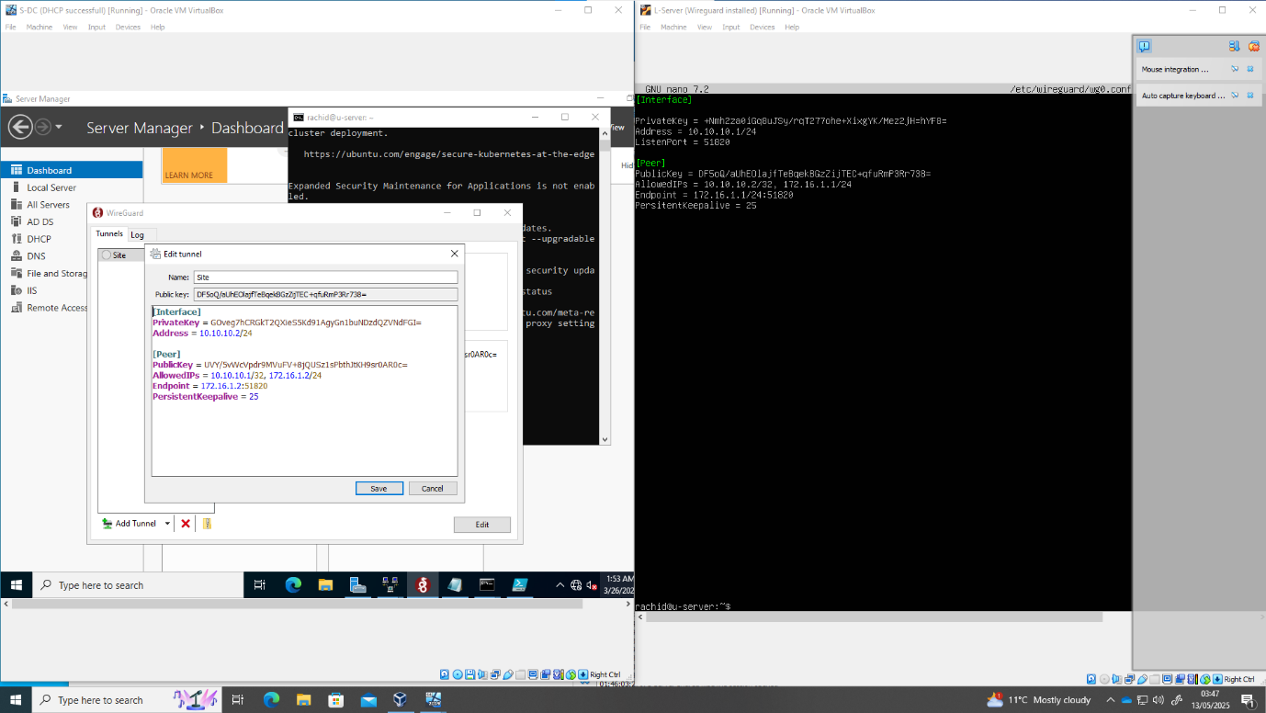

A secure site to site (or point -to point) connection was established between both servers, with a virtual IP address used.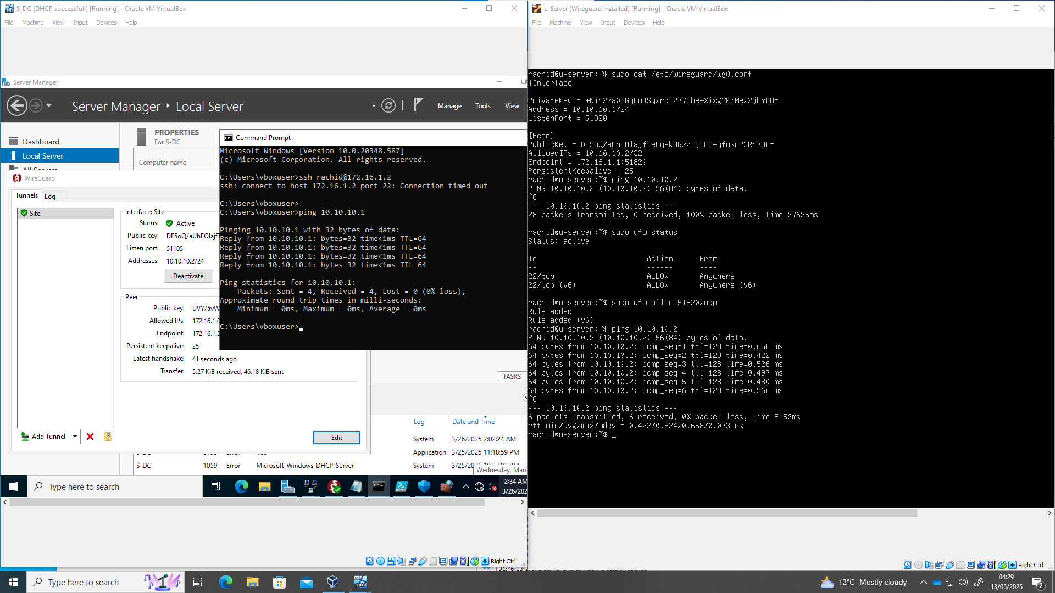

This therefore allowed the two server machines to communicate directly with each other.

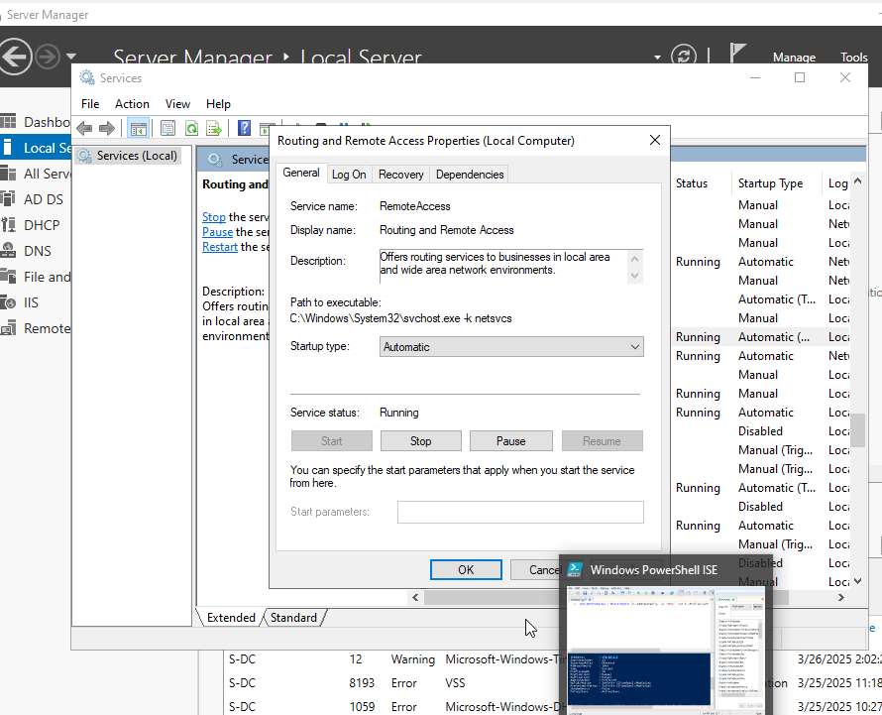

The VPN connection was made persistent altering the start up configuration of the connection in both servers, as well as ensuring that the connection will be re-established if the network goes down for whatever reason.

