Smart Reflective Jacket: Group Project Plan
Ashleigh Elder P141924
27th of April 2018

Contents
- Introduction 2

- Risk Management 2-3

- Sustainability 3-4

- Law and Ethics 4

- Quality Assurance 4

- Conclusion 5

- Bibliography
  - References 5
  - Appendix 6

Introduction
For this assignment a clearly identified individual product for e-bikes was developed as part of a group. Through the group the company “Viking E-Bike Technologies” was created to market these products and make sure they fulfil the requirements of the company focus. The project proposed for this assignment is a “Smart Reflective Jacket” that promotes road safety and cyclist visibility using a non-integrated bicycle accessory. This “Smart Reflective Jacket” is a reflective jacket that detects and responds to traffic and street lights by lighting LED strips on the corresponding reflective sections of the jacket. This light strip remains on for a few seconds after the light source is removed from the product in to make sure the cyclist is visible even when there is no direct light to reflect (an improvement on a typical reflective jacket). In case of emergency for added security there is an SOS setting where each zone lights at the same time that can be enabled using a simple switch.
This assignment aims to demonstrate how this project plans to deal with issues that might arise during the project development life cycle and commercial use. This includes legal and ethical issues and adhering to good quality control practices.
Risk Management
The Project Management Body of Knowledge states that “Risk is an uncertain event or condition that, if it occurs, has an effect on at least one [project] objective”[1]. Risks have varying degrees of severity depending on how negatively they could affect the project goals. Luckily a risk can be identified and analysed to develop strategies to mitigate the effects (and in some instances prevent the risk from developing into an issue). There are four steps to successfully managing risk in a project[2] which include:
- Identification
- Analysis and Evaluation
- Planning
- Treatment and Monitoring
First, the risks to the project need to be identified so that they can be managed successfully and is usually achieved with the use of causal maps and brainstorming sessions.
- lack of knowledge
- requirement changes
- lack of parts
- personal events (i.e. illness, appointments… e.c.t.)
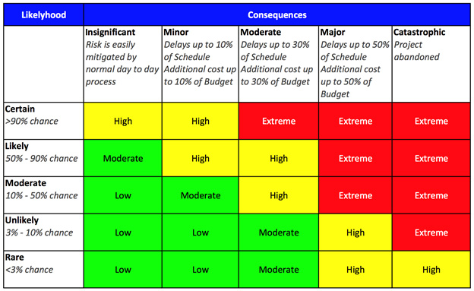
- Unrealistic time and cost estimates
After the risks have been identified the next step is to analyse and evaluate their potential severity and the chance of these risks occurring and developing into problems. Risks are measured by two quantifiers, likelihood and severity, severity being the quantifier that holds the most weight when determining risk (fig1) severity.
This means that each risk can be put onto a checklist ranked from extreme severity to low severity. Having applied this method to the project the potential risks and their severity can be seen below:
- lack of knowledge (Extreme)
- requirement changes (High)
- personal events (i.e. illness, appointments… e.c.t.) (High)
- Unrealistic time and cost estimates (Moderate – High)
- lack of parts (Moderate)
The above checklist shows that lack of knowledge is the greatest risk but this can be rectified by allocating time to research the correct software coding methods and circuits at the beginning of the project. Requirements changes and personal events are the only other issues being high severity are difficult to avoid thus extra time should be allocated in order to accommodate potential issues.
Sustainability
Philippe Vaesken states that, “Sustainability in project management is about balancing or harmonizing social, environmental and economic interests in a project”[3]. Sustainable design in project management should take the project life-cycle into account rather than focusing entirely on its production methods. There are three main categories (or ‘Orders’) that the projects sustainability can be assessed by, these being First, Second and Third Order. First Order is directly caused by the projects existence whilst Second Order is the willingness of the application to reduce other impacts and Third Order is caused by societal changes to the products environment.
First Order – This includes energy use and as the project uses electricity it should run from a renewable energy source like rechargeable batteries as this reduces e-waste as spent batteries don’t need to be discarded. Another way this project directly assists the environment is it’s for use with an electric bicycle and promotes e-bikes and road safety for cyclists and other pedestrians.

Second Order – This project could potentially help reduce levels of greenhouse gasses by promoting electronic bikes and cycling. This product in particular can have other applications to promote safety for pedestrians near the road.
Third Order - The independent states that, “Paris will ban all petrol- and diesel-fuelled cars by 2030, a decade ahead of France’s 2040 target.”[4]. Many countries are attempting to reduce the amount of petrol and diesel fuelled cars on the road as a way to tackle climate change meaning that many people may turn to alternative means of transport such as electric bikes. This project promotes road safety and can add an additional layer of security to cyclists thus promoting e-bikes.
Law and Ethics
Define Law and Ethics
It is vital that Law and Ethics are taken into consideration when planning any project as they can affect many things the project is and is not allowed to do. This project takes this into account by consulting the British Computer Society Code of Conduct[5], and the IEEE Code of Conduct[6][7] as they define the overall standards expected for an electronics and software based project along with the Road Vehicles Lighting Regulations as the project uses lighting and is intended for road use.
Both the British Computer Society and the IEEE Code of Conducts broadly cover several topics but in short, they aim to protect the environment and the rights and wellbeing of the public, maintain professional integrity for the profession.
With regards to safety the smart reflective jacket needs to be weather proof assessing sustainability earlier in the project helps this as the project intends to promote safety. The Road Vehicles Lighting (Amendment) Regulations 2005 state that “it (is) now legal to have a flashing light on a pedal cycle, provided it flashes between 60 and 240 times per minute” [8][9]. As the product needs to avoid dazzling drivers it must stick to a maximum flashing frequency of 240 times per minute to stick within the bounds of the law.
Quality Assurance
According to the module studied there are four main areas the project needs to maintain:
- Effectiveness – ability to achieve user goals with accuracy and completeness
- Productivity – avoids excessive use of resources in achieving user goal
- Safety – within reasonable levels of risk of harm to people, business, software, property, environment etc,
- Satisfaction – happy users!
As there is no working prototype as yet it is difficult to assess quality, the virtual prototype works successfully according to the requirements of the project plan but further testing is needed. This also applies to long term quality of the product and whether it’s susceptible to faults early in its use.

Conclusion
Throughout this report the many issues facing and new project were assessed, and preventative measures were put in place to best deal with them. Risks that were more severe were allocated additional time to overcome in case they became an issue although some big issues couldn’t be prepared for. Decisions for the project have been made by first consulting questions of law and ethics and this has changed a few decisions including the speed of the light flashing and time alight. The project also appropriately maintains a balance between quality and sustainability through many indirect means and a couple of direct ones.
In conclusion time should be set aside for the developer to gain an understanding of the software and hardware use to build the project and more time needs to be put in to testing to ensure a great quality assurance.
Bibliography
References
[1] Project Management Institute, Project Human Resource Management. 2008.
[2] Bright Hub Inc., “What are the 5 Risk Management Process Steps?” 2012.
[3] P. Vaesken, “Project Management and Global Sustainability What Is Sustainability ?,” PMI Global Congress Proceedings – Dallas, Texas. pp. 1–12, 2011.
[4] C. Beale, “European cities announce bans on petrol and diesel cars as green initiative spreads across continent,” The Independent. 2017.
[5] R. Alves, A. Souza et al, “Code of Conduct For Bcs”, Igarss, 2014
[6] IEEE board, “IEEE Code of Conduct,” no. June, pp. 3–4, 2014.
[7] IEEE, “IEEE - IEEE Code of Ethics,” Ieee, no. 0. p. 2015, 2017.
[8] S. Bever, “An updated guide to cycle lighting regulations | Cycling UK,” Cycling UK. 2017.
[9] HMSO, “The Road Vehicles Lighting Regulations.” 1989.

Appendix

(Fig 1) - CBIS, “Project Risk Management - CBIS.” 2013.
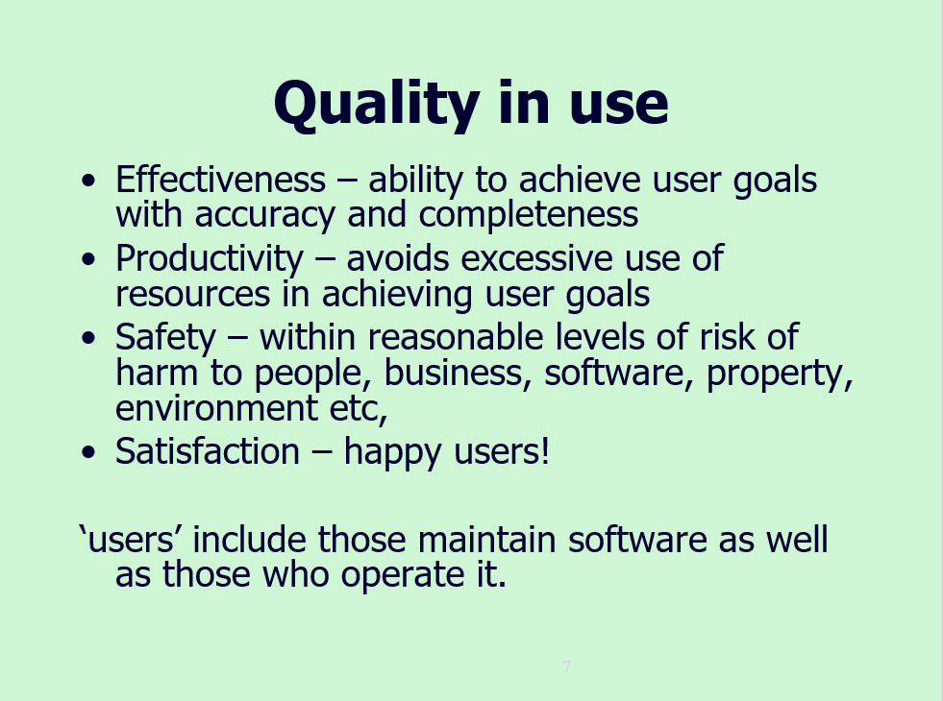
(fig 2) – Quality Control By Sue Maw 2018.

