

Unit Title | Problem Solving Decision Makings
Unit Number | BMSK4004
Unit level | Level 4
Student’s Name | Isac Ndejeya
Student’s ID | 1712481

Executive Summary
Fast food restaurant industry is hyper competitive. One of them is McDonald’s in which I am working. Because of its fierce competition an unpredictable rise or fall of sales level are observed. Recently we realize that the profitability of our restaurant decreases which reduces our profit margin. Obviously this is because of hyper competition which increases our cost of gods sold and decreases our transaction level by attracting our customers.
In order to survive in this competitive era we need to make decision. Every problem is unique and it has unique solutions to. There are many decisions making tool and techniques which we can use to choose the best alternative action and implementing it efficiently. In order to solve our problem it is necessary for us to make a productive decision.

Table of Contents
Introduction 4
Company Overview: McDonald’s 5
Identification of the problem 6
Rationale of the problems 9
SWOT analysis of McDonald’s 10
Probable alternative solutions 11
Tools and techniques for solving problems and making decisions 14
Communicating the plan to the stakeholders 19
Suitable monitoring and review techniques 20
Conclusion 20
References 21

Introduction
Today’s business environment becomes more competitive as the number of competitors increases, which make it possible for consumers to get served from alternative sources. To stay in this competitive era businesses required to earn sufficient amount of profit by providing qualified products and services (Russo and Duci, 2016). We know that when a similar product or service is offered by more number of sellers the business environment becomes more competitive. Survival, sustainable growth and profitability of a company become more difficult in this competitive business environment.
Fast food restaurant industry is more competitive, as number of alternative sources is available for consumers to choose from. For the company the ability to turn the problems or challenges into appropriate opportunities is the great strength, which helps it to stay competitive in the market. Some problems faced by fast food industry includes nutrition and health conscious, assuring product traceability and maintaining it, accepting to strategy and standards, varying consumer demand, congested market, sluggish product innovation etc. As I am working in the McDonald’s fast food restaurant, recently it is perceived that McDonald’s faces a critical problem of lower profit margin behind which various reasons are responsible.

Company Overview: McDonald’s
One of the American fast food companies is McDonald’s, which established in 1940 by Richard and Maurice McDonald and operated as a restaurant in San Bernardino, California, United States. It offers services over 100 countries with more than 35000 restaurants. (Market Realist, 2019). It also creates great employment opportunities, where more than four million people are employed by McDonalds. As it operates over 100 countries, the amount of customers are served is about 70 million per day (Market Realist, 2019), which exceeds the population of France. According to IBIS World, 17% shares in the fast food restaurant industry had been owned by McDonalds in USA which is recognized as major share in fast food restaurant industry in 2014.
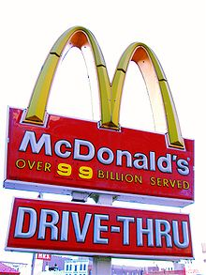
Figure: McDonald’s
A number of fast foods are served by the company, which includes fries, the Big Mac, chicken sandwiches, the quarter pounder with cheese, chicken nuggets, hamburgers, salads, wraps, desserts, soft drinks, and other beverages. In order to make sure that it got engaged to serve international markets locally significant food menus are offered as well. Major sources of income are rent, royalties and fees which are paid by the franchisees and sales in company operated restaurants.

Identification of the problem
Problem is something for example an issue or circumstances which perceived as detrimental or unwelcome to the business and requiring to be dealt with and conquer. One of the world’s best ever growing sectors in food industry is fast food industry. In recent time we faces numerous challenges. Starting a fast food business is perceived as a great achievement for an entrepreneur but managing and completing its task efficiently is more difficult, which is important for a business to achieve its desired goal. (Varshney, 2019)Fast food industry gains eminence across the world because of the growing number of nuclear families, changing lifestyle, changing demands, economic growth, increasing per capita income and globalization. In fast food restaurant major problems faced by consumer are lack of vigorous menu, no new varieties in fast food items, sluggish delivery time. For a fast food restaurant the most essential challenges are employing the right people in the right place, the success of the business mostly depends on our behaviours as it perceived as service sector. Recently we face distinctive problems which reduces our profit margin. The followings are the problems which causes our restaurant’s profit margin to decrease:
Increasing supplier costs: Profit margin is the amount of revenues which left after deducting the costs of providing the products or services to the customers. It is known that the fast food industry is hyper competitive. To survive in this competitive era it requires providing higher quality services in order to attract a large portion of market share. Customers tends to move other fast food restaurants if they do not get their desired services from our company. On the other hand, the suppliers strive to raise their own profit by charging higher rates for raw materials (Yourbusiness.azcentral.com, 2019)Higher costs of raw materials increase the cost of sales, which ultimately causes a reduction in profit margin by deducting large portion of revenues. Thus the bargaining power of suppliers is one of the problems which lead a decrease in our profit margin.
Higher level of competition:Increasing number of competitors in fast food industry is another problem which decreases our profit margin. In order to retain existing consumers and attracting new one we have to offer more attractive services in comparison to our competitors, it is more difficult for us to make customers to pay more for our qualified services than they agree to pay others(Eskandari et al., 2015). When McDonald’s attempts to charge more for providing attractive services, customers will start to move to others. In this situation we have to charge lower rates for the purpose of remaining competitive in the market. On the one hand bargaining power of suppliers increases our cost of goods sold. On the other hand bargaining power of consumers decreases our revenues. Higher COGS and lower revenues than expected ultimately reduces profit margin of our restaurant.
Health consciousness of consumers:people around the world are becoming more health conscious day by day because of numbers of diseases they have faced after having fast food. Fast food is more harmful for physical health; it causes various diseases such as diabetes, obesity, premature cardiac death, cancer, stroke and more. It also hampers mental health and varying brain, fuelling depression and mental illness. We cannot control an increase in consumer’s awareness, which results decreasing trends of consumers as the demands for fast food reduces. In this situation we required to offer fresh vegetable option to our menu and to use pure ingredients for making fast foods. For this we need to invest more in order to ensure physical and mental health of consumers.We concentrate more on foods safety and hygiene.
Higher ancillary COGS: Ancillary costs are the cost of providing additional services along with main products or services(Kaplan and Atkinson, 2014). The purpose of providing ancillary services is to get the customers to purchase more at one time. For this purpose we have to bear ancillary COGS along with higher supplier prices. In order to ensure convenience, friendly service, cleanliness and delicious food we employ our physical and mental effort in our restaurant. Free Wi-Fi, arch card, play places and parties are some of ancillary services offered by us.In this case we either can transfer the cost of providing ancillary services to consumers or obtain a strike on gross profit margin. Thus ancillary costs of providing additional services also contribute to reduction of profit margin of our restaurant.
Higher labour payment: The success of a business organization depends on their management and employees attitude towards the goal of the business(Kaplan and Atkinson, 2014). In order to attract skilled labour we need to pay higher remuneration and offer various incentives. As we are operating a fast food restaurant approximately 60% of our business success depends on employee’s quality of service.
Threats of substitute products:In current situation, the treats of substitutes are more than before in fast food industry. The convenient food storesare offering similar products as the fast food industry offers(Eskandari et al., 2015). Various food items are sold by convenient store/ gas station and quick trips for example hot dogs, eggrolls, pizza stuffs, breadsticks, and immeasurable beverages choice. This creates a treats to our profit margin.
Unproductive pricing policy: Each and every business required to gain sufficient amount of profit in order to stay competitive and survive in the industry (Adair, J., 2013). One of the most important factors for achieving sufficient profit is a productive pricing policy. Price is something which has been charged for providing goods and services. Entrepreneur inspired to take risk in order to gain some profits. Pricing strategy of our restaurant may not be properly designed that’s why it could be unable to attract customers and failed to earn desired profit for our restaurant.

Rationale of the problems
For a fast food company, it is found more difficult to operate efficiently as McDonald’s area of doing business is comparatively large than other organization. We face various difficulties and challenges in our day to day business.We have to make number of decisions in order to solve various problems which make hindrances to the success of our business.
Our fast food restaurant is known as one of the world’s leading fast food organizations, which creates great employment opportunities around the world every year. We required solving various problems which has been faced by our restaurant while operating the business globally. It is more challenging business as it has to serve customers internationally in consistent to their domestic cultures, changing needs, changing lifestyle of the relevant countries customers (Varshney, P., 2019). We always have to stay tune with the customers changing preferences and demands across the world. The main purpose of every business is to serve customers, earn profit and survive in the world market.
It is perceived as more difficult task to maintain the fast food chain restaurant. To complete this task efficiently, it requires proper planning, designing and implementing the plan efficiently.

SWOT analysis of McDonald’s

Strengths | Weakness
- Impartiality of brand internationally  - Strong brand reliability because of products variety, quality and strong presence.  - Leading fast food brand in the market.  - Increasing effective promotional tools.  - Improving effective pricing policy, some of which aimed at price sensitive customers. | - Slower product innovation than competitors.  - Having trouble to satisfy modern generation because of calorie heavy items.  - Turned down reputation and higher staff turnover due to HR issues and legal harasses.  - Dissatisfaction of franchisees.
Opportunities | Threats
- Growing sales in the Asian markets.  - Improving innovative and healthier items.  - Join with other brands in order to increase market share.  - Improving marketing strategy to retain customers. | - Higher level of competition in the fast food industry  - Economic crisis around the world  - Increased health awareness among customers
Figure: SWOT analysis(Pratap, 2019)

Probable alternative solutions
As we are having profit margin crisis, a number of solutions to this problem have been identified. Some of the causes behind the problem have been discussed in the earlier sections. The following solutions can be used to reduce the profit margin crisis.
Product differentiation:
In order to increase our profit margin we can use product differentiation strategy, which means providing or offering products and services with variations so that our items or menu can be easily identified and differentiated from that of our competitors(Armstrong, Kotler and Opresnik, 2016). As a result consumer would be willing to pay more for our unique menu. Profit margin is the amount which left after paying the cost of goods sold which is the difference between the revenue and COGS. Customer’s preference and demand are changing continuously, in order to grab them we need to offer such services which would be relevant to meet their needs. The consequences of using this solution are given:
The amount of sales per day will have been increased as consumers tend to move to our company for consuming our unique goods and services which are not offered by other competitors.As the demands for our services increase we can take the advantages of providing unique menus or items by charging more for it. This will increase the total amount of revenues.As consumers preferred more our restaurant to others competitors, it will help to grab the large portion of market share, help to be competitive, to increase profit and ensure growth.
Improving the quality of the fast food items:
According to a consumer survey report, most of the consumers claim our company offers lowest quality of foods out of all other big fast food restaurant. It is one of the reasons why we are facing the decreasing trend of profit margin. Because consumers are dissatisfied to the quality of our foods and they preferred to move to our competitors (Armstrong, Kotler and Opresnik, 2016). According to RBC capital markets review, a global investment bank, our company was ranked in 12 numbers. In this situation we have lots to work if we want to grab younger consumers. There are several number of fast food items in our menu. In order to increase the quality of our foods we have to use fresh and good ingredients while preparing the food items. It may require extending expenses on serving our customers. Though it will increase cost of goods sold, it increases number of sales. When amount of transactions increases the sales revenue also increases which ultimately contribute to an increase in profit margin.
Bring change in the marketing strategy:
Another solution to this problem is marketing strategy. We can bring change to our existing strategy in order to satisfy our ever-changing customers need. It is a strategy which is planned and designed for reaching people and turning them into customers of our restaurant. Our company has several food chains which have spread over 100 countries. Our success in those segments depends on our capability to identify and take action quickly on changing customer’s demographics, taste and preferences (Armstrong, Kotler and Opresnik, 2016). Lower quality of foods, higher supplier cost, higher bargaining power of customers, hyper competition causes a decrease in profit margin. We have to design our marketing strategy in such a way which can be able to solve those problems. KFC, subway, Dominos are the main competitors of our food chain. The customers of our company are in the group of 15-40. To attract younger customers and compete in the market we can use social media to publish our quality, differentiate foods item, flexibility of getting our products. We have to bring change in the segmentation, targeting and positioning strategy.
Developing effective pricing policy:
Effective pricing policy can also help us to increase our profit margin (Armstrong, Kotler and Opresnik, 2016). One element of product mix strategy is pricing. Pricing is most important for any kind of the business organization to achieve desired goal. Our marketing strategy specifies price ranges of the foods and beverage products. The aspired of the pricing is to increase profit margin and amount of sales.
As we are facing lower profit margin, we need to develop an effective pricing strategy. We can add some other benefits to those strategies. We can offer buy one get two service. For example when a customer purchase a burger and pays for only one burger but get two burgers. This offer must be for a specific time period. The purpose of that offer is attracting customers, increase sales volume and profit margin.

Ensuring innovative and healthier menu to satisfy modern generation:
Modern generation becomes more health conscious as they are facing several diseases after having fast foods (Armstrong, Kotler and Opresnik, 2016). It requires us to develop innovative food items, reduce artificial ingredients, and use fresh vegetables while making foods. People are more attentive towards nutrition and health aspects of the foods; they are not concern about the dieting and cutting calories of the foods.
In order to increase profit margin we need to grab new generation by providing services according to their preferences.

Tools and techniques for solving problems and making decisions
After identifying the problem which we are facing and probable solutions to solve this problem, it’s time to make decision. Decision making is the process of choosing the best alternative solution which can be implemented effectively to solve the problem (Gano, D., 2011). Here the problem we are facing is the lack of profit margin. Mathematical and graphical both techniques can be used to make the best vehicle for making productive decision. I have used two techniques for problem solving. 1. Fishbone diagram, 2.Porter’s five force model.

Fishbone diagram

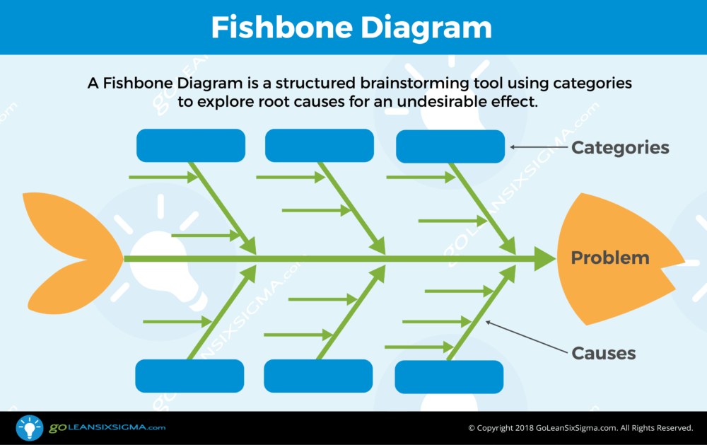
Figure: fishbone diagram
Fishbone diagram theory is a process of identifying causes and effect of a problem that people are trying to solve (Isixsigma.com, 2019).
Our identified problem is low profit margin. Increasing supplier cost, higher labour payment, decreasing amount of sales because of lower quality of products and services, losing market share due to hyper competition and substitute products are the causes of low profit margin. Modern generation are more health conscious, they prefer nutrition and healthier food to fast food, which decreases amount of transaction, ultimately causes a decrease in profit margin. To solve this problem either we have to increase our sales level or we have to decrease our expenses by taking the best alternative solution.

Porter’s five force model
It is natural for a business facing problems while operating in the market. We need to find out possible alternative to solve the problem. Here porter’s five force model is used to make efficient decision for solving our problem (Eskandari et al., 2015). Here we are rating each element of the model ranging from one to five.

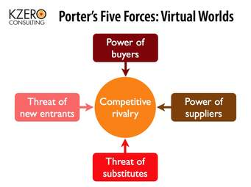
Figure: porter’s 5 force model (CGMA, 2019)
Forces | rating
Bargaining power of supplier | 4
Bargaining power of customers | 2
Competitive rivalry in the industry | 4
Threats of new entrants | 4
Threats of substitute products or services | 3
total | 17
According to this model, the power of supplier, competition, threats of new entrants belongs more scores which means that lower number of both labor and raw materials providers, uniqueness of their products or service, higher switching cost from one to another supplier; the number and capability of competitors is high, they provide similar foods which will reduce market attractiveness; there exists substitutes of our food which will reduce market attractiveness.
From this analysis we get to know that those factors affecting our profitability in the fast food industry. To face this situation we need to develop our competitive strategies by differentiating our products from competitors. This may help us to increase our revenue base and profitability of our business.

Market research:it refers to analysis the taste and preferences of prospective customers, size and condition of the market and competitors, which help us to make an effective decision.
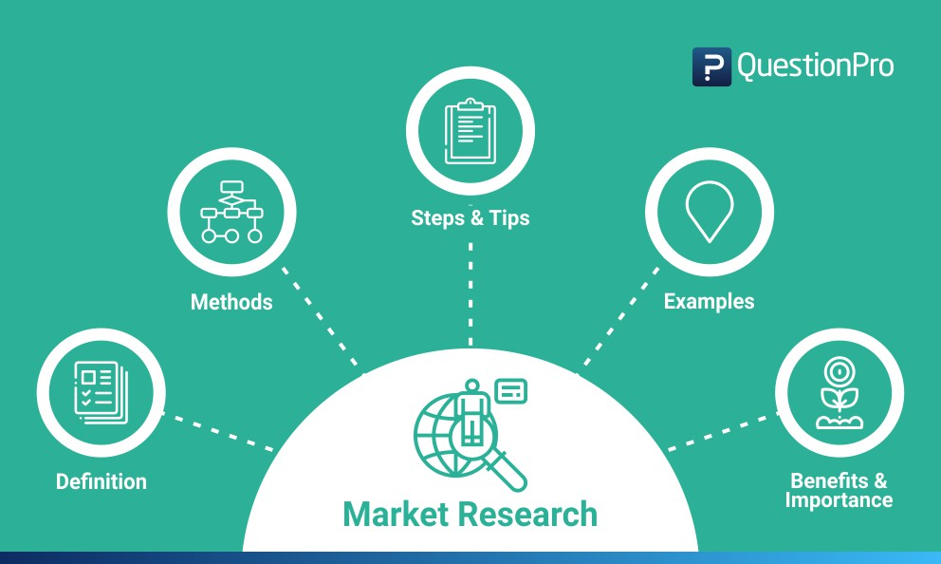
Figure: market research
Decision matrix:It is one of the effective techniques for making decision when many alternatives solutions are available is decision matrix, in which influencing factors are taken into account.
Cost benefit analysis: It is a decision making tool which helps to analysis the benefits of each alternative courses of action and then comparing these with the costs associated with each action(Kaplan and Atkinson, 2014). The alternative which offers more benefit will be chosen.
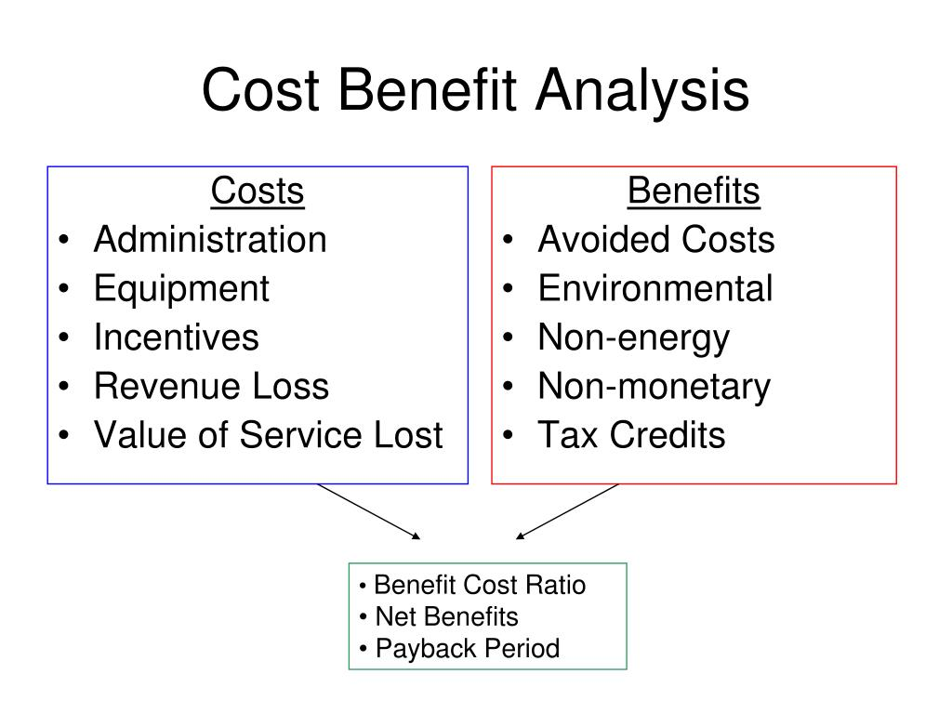
Figure: cost benefit analysis
T-chart: It analyzes the strengths and weakness, pros and cons, advantage and disadvantage of each alternatives. It helps decision maker to take the best alternative solution at the last stage of the decision making process.
Establishing an outline for implementing the plan
It is important for any business organizations success to implement the strategic plans effectively. Though it appears easier, it is tougher to implement efficiently (Smallbusiness.chron.com, 2019). Implementation process represents a number of interrelated activities which are having similar importance.
Identifying the specific problem: At the first stage we have to find out the main cause of declining our profit margin. Higher competition and health consciousness of consumer are the main reasons why the profit margin of our restaurant falls.
Selecting the best alternative course of action: As the main problem is hyper competition, we can choose the product differentiation strategy (Cottrell, S., 2011).By adding unique features and use healthy & nutritious ingredients to produce food, we can differentiate our product from that of our competitors.
Implementing the selected action: The next step in the process is to implement the product differentiation strategy (Mothersbaugh and Hawkins, 2016). While implementing the strategy we must be concern not to let increase the cost of producing the foods items.
Monitoring the performance: It is necessary to monitor the performance of the employees whether they are performing in due manner and time (Maund, A., 2017). Try to find out whether this action improves the profit margin than before.
Establishing benchmark and controlling: For every activity there must be a benchmark in order to compare the actual performance with the expected performance to see whether there is any deviation between them.
Providing feedback to remove the deviation: After comparing the actual performance with the benchmark, if any deviation is found out we need to communicate the deviation with the employees to remove the deviation (Mothersbaugh and Hawkins, 2016).
This process would help us to solve our problems which is reducing our profit margin. Each activity seems easy but while implementing it then finds out how tough it is! Thus we must be attentive about our responsibility while implementing it.

Communicating the plan to the stakeholders
Stakeholders are the persons who are directly or indirectly associated with the business organization. The owner or CEO of our restaurant business must communicate the selected plan or strategy to solve the problem with us.
Since the plan or strategy is to be implemented by the management and employee of the restaurant, they must be known each and every aspect of the selected strategy and the way how activities are to be implemented (Mothersbaugh, D. and Hawkins, D., 2016).
While choosing the best alternative action, we must take into account their perception about these alternatives. Which one they think is better to solve the problem as they are facing the problem while operating the business.

Suitable monitoring and review techniques
While implementing the plan it is necessary for the management to monitor their employee’s performance and use records against plan to see improvement towards meeting the goal (Gano, D., 2011). The use of monitoring and review technique depends on our implication, which one we think better suited to our strategic plan.
Fixing a specific supervision time: In order to supervising the performance of our employee’s to ensure they are performing in due manner and time we must set a time or date on which monitoring will have been completed.
Drafting a suitable monitoring system: We need to choose the one technique which will bring improvement for our restaurant in the long run.
Organizing the implementation plan: We should coordinate all the actions of the implementation plan in order to achieve the strategic goal.
Removing discrepancy (if any): If we find any deviation between the actual and expected performance, we need to remove the deviation to achieve our objective of the plan.

Conclusion
Today’s fast food industry becomes more competitive and the taste & preferences of consumers ever-changing (Market Realist., 2019). To stay competitive and serve customer in accordance with their preferences becomes tough. In this competitive era we are facing declining trend of our profit margin behind which various causes are responsible, among which higher competition and changing lifestyle and health consciousness are contributing more to decline profit margin. for these the production cost of foods and beverage increases as the supplier and labor costs of our restaurant increases, losing large portion of market share, which ultimately causes a decrease in profit margin. In order to solve this problem we have to identify main cause of that problem and then solve it using aforementioned tools and techniques.

References
Russo, D. and Duci, S. (2016). Supporting Decision Making and Requirements Evaluation with Knowledge Search and Problem Solving. Procedia CIRP, 39, pp.132-137.
Market Realist. (2019). Must-know: A company overview of McDonald's - Market Realist. [online] Available at: https://articles.marketrealist.com/2014/07/must-know-company-overview-mcdonalds/
Maund, A. Schriek, M. and Tinkler, P. (2017). Certificate in Higher Education: Skills for the Workplace Student Yearbook. Sage Publications
Varshney, P. (2019). Challenges Faced By Food And Beverage Industries - Discover Food Tech. [online] Discover Food Tech. Available at: https://discoverfoodtech.com/problems-faced-by-food-industry/
Cottrell, S. (2011).Critical thinking skills: Developing effective analysis and argument (Palgrave study skills). 2nd ed. Basingstoke: Palgrave Macmillan.
Yourbusiness.azcentral.com. (2019). What Causes the Decline in Gross Profit Margin?. [online] Available at: https://yourbusiness.azcentral.com/causes-decline-gross-profit-margin-5298.html
Adair, J. (2013).Decision making and problem solving strategies. 2nd edn. London: Kogan Page.
Pratap, A. (2019). A SWOT Analysis of McDonalds (2016) - Cheshnotes. [online] notesmatic. Available at: https://notesmatic.com/mcdonalds-swot-analysis-2016/
Gano, D. (2011). Seven steps to effective problem solving and strategies for personal success. 1st ed. EBook: Reality Charting.
Eskandari, M., Miri, M., Gholami, S. and Nia, H. (2015). Factors Affecting the Competitiveness of the Food Industry By Using Porters Five Forces Model Case Study in Hamadan Province, Iran. Journal of Asian Scientific Research, 5(4), pp.185-197.
CGMA. (2019). Porter’s Five Forces of Competitive Position Analysis. [online] Available at: https://www.cgma.org/resources/tools/essential-tools/porters-five-forces.html
Smallbusiness.chron.com. (2019). The Implementation Process of Strategic Plans. [online] Available at: https://smallbusiness.chron.com/implementation-process-strategic-plans-4514.html
Kaplan, R. and Atkinson, A. (2014). Advanced Management Accounting. 3rd ed. Upper Saddle River, N.J: Prentice Hall.
Isixsigma.com. (2019). The Cause and Effect (a.k.a. Fishbone) Diagram | iSixSigma. [online] Available at: https://www.isixsigma.com/tools-templates/cause-effect/cause-and-effect-aka-fishbone-diagram/
Armstrong, G., Kotler, P. and Opresnik, M. (2016). Marketing. 5th ed. Pearson Education UK.
Mothersbaugh, D. and Hawkins, D. (2016). Consumer behavior. 4th ed. New York, NY: McGraw-Hill Education.

