INTERNATIONAL BUSINESS PLAN
Volkswagen
NAME | AMANDEEP SINGH
STUDENT ID NUMBER | 1712270
MODULE TITLE | LCMB7014
ASSESSMENT TITLE | VOLKSWAGEN
LECTURUR`S NAME | ZE ZOOK

TABLE OF CONTENTS

INTRODUCTION 3
MAIN BODY 3
Product of the company and Company market information 3
Annual Report of Volkswagen. 4
MACKENZIE SEVEN (7S) 500 9
PORTERS FIVE FORCES 10
ANSOFF MATRIX 11
SMART OBJECTIVES 12
STYLE OF ENTRY 13
CONCLUSION 14
REFERENCES 15
APPENDIX 19
INTERNAL SOURCES 19
ECONOMIC SCALE 19
POSITIONING IN COMPARISON TO COMPETITORS 23
FINANCIAL DATA 23

INTRODUCTION
International Business plan is prepared for the company to enter in the international market place. Planning is the important for company to have sustainability in the operations and functions. The main purpose of International business plan is to set the goals and objectives and allocate them effectively so that can gain competitive advantages over the competitors (WYRED Consortium, 2018).
Volkswagen company is being chosen in the assessment. It is a German multinational automotive manufacturing company whose headquarter is located in Wolfsburg, Germany. Company was founded in 1937 by Berlin. There are about 12 brands including Volkswagen, Audi, and Volkswagen commercial vehicles, Skoda, Seat, Lamborghini, Porsche, Ducati, Man, Scania and Bentley.
This assignment will discuss how an international business organisation can successfully and efficiently globalise their operations, processes and marketing to accomplish their goals of business. The Volkswagen has their own factories in a lot of the part of the world, Volkswagen has factories. In many parts of the world, manufacturing or assembling vehicles for local markets. In addition to plants in Germany, Volkswagen has manufacturing or assembly facilities in Mexico, the United States, Slovakia, China, India, Indonesia, Russia, Malaysia, Brazil, Argentina, Portugal, Spain, Poland, the Czech Republic, Bosnia and Herzegovina, Kenya and South Africa. In 2011,
Volkswagen was named in the top 25 largest companies in the world by the forbes Global 2000.It will include the micro and macro analysis about the organisation, strategies applied competitive analysis, smart objectives as well as entry model to enter in the international market or nation. In this present assignment, Volkswagen is going to enter in India with more expansion through their main product, Car. Shaping mobility for generations to come is the strategy of Volkswagen which takes a goal of making mobility sustainable for them and for coming generations. They are focusing on manufacturing electrical vehicle, autonomous driving and digital networking and will make clean, innovative, intelligent and safe automobile. There are four dimensions of this strategy are excited customers, excellent employer, role of safety, integrity and environment, competitive profitability.

MAIN BODY

Product of the company and Company market information
The product chosen for this present assignment is Volkswagen Car as it is the main product of cited organisation. There are wide ranges of organisation involved automotive industry in the development of design, production, selling and marketing of motor cycles. Automotive sector is said to be one of the biggest economic sector in terms of revenue. In 2017, the international sales of passenger car are estimated to cross 78.6 million. Volkswagen partnered with Daimler AG and other companies to market the BlueTec clean diesel technology on cars and trucks from Mercedes-Benz, Volkswagen, and other companies and brands. As concerned According to the United States of America Environmental Protection Agency it is recorded that four of the ten most fuel-efficient vehicles are available for the sale in the United States of America are powered by Volkswagen diesel engines. They were a three-way tie for 8th (TDI Beetle, TDI Golf, TDI Jetta) and ninth, the TDI Jetta Wagon. In addition, all Volkswagen TDI diesel engines produced from 1996 to 2006 can be driven on 100% biodiesel fuel. For the 2007 model year, however, strict U.S. government emissions regulations have forced Volkswagen to drop most diesels from their U.S. engine lineup, but a new lineup of diesel engines (then thought) compatible to U.S. standards returned to the American market starting with Model Year 2009. These post-2009 Clean Diesel engines are limited to running on 5% (B5) biodiesel only to maintain Volkswagen's warranty. Volkswagen long resisted adding a SUV to its lineup, but relented with the introduction of the Touareg, made in partnership with Porsche, while they worked on the Porsche Cayenne and later the Audi Q7. Volkswagen has been offered a number of its vehicles with a TDI (Turbocharged Direct Injection) engine, the result of which lends class-leading fuel economy to several models. Though acclaimed as a fine handling vehicle, the Touareg has been a modest seller at best, and it has been criticized by auto reviewers for its absence of a third-row seat, the relatively poor fuel economy, and the high vehicle mass. Volkswagen set plans to add a compact SUV with styling influences from the "Concept A" concept vehicle introduced at the 2006 Geneva Auto Show, and on 20 July 2006, Volkswagen announced that the new vehicle, called the Tiguan. The success of Volkswagen was started to continued upward trends and it is growing continuously. The sales revenue and customers base is increasing consciously by 5.9 percent to €20.1 billion. Company is growth across the world as well as expanding in Germany itself. Innovation is rising continuously. In August 2018, company has delivered 513300 vehicles which is about 3.7 percent hike. In 2018, Company is growing with high pace b the hike of 26 percent in Europe.

The automobile industry is said to be trending as in 2019 the total revenue is $3tr and the number of businesses operating in the industry currently are 1760. The annual growth recorded between 2014 to 2019 is 4.5 percent and about 2580803 people are employed in this industry (Global Car & Automobile Manufacturing Industry - Market Research Report, 2019).
It can be said from the findings that, the producer of vehicle and suppliers across Europe and India need to be prepared for immense hold-up because of boycott of China products and materials. Volkswagen company is expanding its business in India and they have experienced bouncing and flourishing growth since last years. In 2017-18, the Indian automotive industry have spread out 18.3 percent to reach the US level target which is $51.2 billion (Automobile Industry in India, 2019). The contribution of automotive industry in the Gross Domestic products (GDP) of India for 2.3 percent and it employs 1.5 million of people directly or indirectly. The market size of automobile industry is tends to be amazing. The total value of automotive exports of India stand at 13.5 billion and that is one of outstanding growth. It can be estimated that growth of automotive industry will raise by 8 to 10 percent (Global auto industry faces strong headwinds, 2019). From the statistical facts, it can be said that Volkswagen can easily expand the business more in India because studies have estimated that automobile organisations operating in the market of India are expected to make a leader in the market of four wheeler and two wheeler in the world by 2020.

Annual Report of Volkswagen.
Volkswagen Company is drive their organisation by maintaining sustainability and will continue to shape individual mobility in the coming generation.
Here are the some key figures of Volkswagen Group:
Volume  (units) | 2018 | 2017 | Percentage (%)
Number of Deliveries | 10834 | 10742 | 0.9
Production | 11018 | 10875 | 1.3
Sales of Vehicles | 10900 | 10777 | 1.1
Number of Employees | 664.5 | 642.3 | 3.5
Financial Data  (in millions) | 2018 | 2017 | Percentage (%)
Revenue from sales | 78001 | 76729 | 1.7
Net Income from Fiscal year | 4620 | 4353 | 6.1
Dividends
- Per ordinary Share | 4.8 | 3.9
- Per preferred Share | 4.86 | 3.96

Macro & Micro Analysis about strategic business unit of organization and specific product.
While making any business decisions, it is quite important to conduct environmental analysis where organisation can track the changes and forces that influence the business operation's and functions in both positive and negative way. Volkswagen is also going to conduct the environmental analysis so that they can track those forces and than take decision for further expansion (Makoviy and Khaskovo, 2019). Macro and Micro are said to be the external marketing environment and the forces of these environment are on the far side the control of organisation but the forces still impact the decision made when creating strategic strategies of marketing.
Micro Environmental Factors includes supplies, resellers, customers, competitors, government, general public etc. On other hand, Macro environmental factors includes forces like demographic, economic, physical or natural and factors includes technical, political, social, cultural, environmental, legal etc.
SWOT ANALYSIS
It is said to be one of the best model to track the external and internal forces which influenced the firm. With the SWOT analysis, organisation can determine the strategies that Volkswagen can use or applied to exploit external opportunities, counter threats, and build on as well as protect strength and eliminate the shortcoming of the company.
Strength:
Geographical Coverage: This is said to be one of the biggest strength of Volkswagen as through the operation's all over the world, cited company has about 120 facilities for manufacturing in which 71 manufacturing units are in Europe. By having production across the world, the control regarding cost and delivery add as a identifiable benefits in superior segment (Wang, Li and Cao, 2018). The expansion of Volkswagen is contentiously rising with great motivation and inspiration. For example, in India, Volkswagen is already have there operation's but company is planning for more expansion over India to cover maximum amount of market share. It is a pure ethanol vehicle. It sold pure ethanol powered E100 only vehicle in brazil (1973, oil crisis)
Audi: Audi is also one of the important part of Volkswagen and it is remarkable as the strength of the company. The cash of Volkswagen is mainly contributed by Audi car which is around 27 percent by having sales of 1500 plus. like audi there are so many brands which are the part of Volkswagen. Further, the product portfolio of Volkswagen is very large in which the passenger car have the highest contribution to the sales of cited organisation which is approximately 48 percent. With the large product portfolio, Volkswagen company can easily recover their loss with other products. In the year 1980 , the Volkswagen was competed with the audi developed lltis placed 1st ,2nd ,4^{th,} and 9th overall.
Proshce: This is one another premium brands which have joined in 2013 in the Volkswagen group. This brad is the among the third largest contribution in the sales revenue of Volkswagen.
Skoda: Skoda is said to be one of the most valuable brand in terms product offering and brand equity. The acquisition of Skoda was done in 1993.
Bugatti, Lamborghini, Ducati and Bentley: The abroad brands, which have been methodically acquired one after the other by Piech are amalgamate into bigger units so few financial information are render (Grant, 2016).
Weaknesses:
High Dependency on Europe: The sales and profitability of Volkswagen is highly depending of Europe by which if there is any drop in prices of car due to change in economic climate has lead to direct impact on the earning.
Volkswagen Brand: In western Europe, Brazil and China company is one of the dominant player but in United States, India and Russia, company is lagging behind of its competitors (Kreutzer, 2019).
Image and Reputation is negatively affected by diesel scandal: In 2015, the diesel scandal of Volkswagen has negatively affected the brand image in the market and impact is continued till 2017. Company have to bear million of loss.
Operating Profit is reduced because of rising compliance issue: The operating profit of Volkswagen had badly affected as they have to billion of fines because of tainted and rotten vehicles. For example in US, 25 Billions of penalties were paid by Volkswagen.

Opportunities:
Demands of Passenger cars is rising in Asia Pacific: This is the major opportunity that Volkswagen have in the market of Asia Pacific. In Asia Pacific, India is one of the biggest market which are offering vast offering (Zhang and Wang, 2019).
Sustainable Technology: There are huge numbers of opportunities which are provided by Sustainability. On the other side from sustainable manufacturing of cars and supply chain, sustainable innovation is offering intense opportunities for R&D.
Partnership and Restructuring: This is another opportunity that Volkswagen have as they can make partnership agreement with the companies operating in India like Hyundai, Honda, Maruti Suzuki etc. In addition to this, there are various issues related to the management, so after Diesel scandal, VW can set an aspiring plan to improve the health of the business (Wang, Shen and Zuo, 2019).
Threat:
Heavy Competition: The competition in automotive industry is very high as it is keep growing high. Not only in particular segment but organisations are facing intense competition in premium segment from rival brands.
Economic Fluctuation: The sales and profitability of automotive industry is highly affected by the economic fluctuation. Like in the time of recession, the sales of Volkswagen was greatly affected (Lin, 2016).
Legal Issues: legal issues are also leading company in great trouble especially in automotive sector. Recently, Volkswagen has landed itself into major troubles related to emission.
PESTLE ANALYSIS
Pestle Analysis is one of the best models to track the external factors that impact on the business profitability, earning, sales and its operations. Volkswagen is going to expand there business more, so it is all important to analyse the factors to undertake the critical decisions for the company.
Political Factors:
Political factors include all the government laws, legislation which affects the business in both positive and negative way. The political stability of India is good where Volkswagen can make the strategies on the basis of political system of India. Volkswagen can operate its business more transparently so that possibility of corruption is reduced. Further the regulatory practices are also in a streamlined with international laws that aids nations to improves its ease of doing business which is also a great opportunity for Volkswagen (Monteiro, 2016). Apart from this, there are some challenges which organisation can face like they have to keep regular eye on the changing policies because anything missed can negative effect on the reputation of the company.

.
Economic Factor:
Economic Factors have a direct effect on the business and they do not by affecting demand. Fluctuations in economic condition in automotive industry have badly affected the sales and profitability of automotive industry. The government of India has raised the investment in developing core infrastructure in order to facilitate as well as amend business environment. The rate of exchange also affects the sales of Volkswagen. Volkswagen is concerned as a most popular brand as compare to the other vehicles .Company can raise their performance by 9 top 10 percent due to increasing expenditure of government, rising investment and rising disposal income. Apart from this, at the time of declining economic power of people in India the sales of vehicles are badly affected (Trávníčková, 2018).
Social Factor:
Social Forces are also playing increasingly essential role in the growth of business industry. This includes forces like preference of customers and customer purchasing habits. Like in India, the demands of passenger cars are very high, so it is better for Volkswagen to manufacture passenger cars. Company can raise its customer base and sales by manufacturing car according to the needs and trends of Indians (Kasap and et.al., 2016). As the part of liking of this it is most popular in the social factors.Apart from this, people also highly prefer products which are sustainable cars and electric cars. So, Volkswagen can also raise its customer base and sales.
Technological Factor:
The role played by technology is central part in the automobile industry as the success of brands is depends on how the company is advance in terms of technology. Companies operating in automobile industry is investing huge amount in R&D just to remain ahead of competitors. In German Research Centrer for Artificial Intelligence (DFKI), Volkswagen partnered with Daimler AG and other companies to market the BlueTec clean diesel technology on cars and trucks from Mercedes-Benz, Volkswagen, and other companies and brands. As concerened According to the United States of America Environmental Protection Agency it is recorded that four of the ten most fuel-efficient vehicles are available for the sale in the United States of America are powered by Volkswagen diesel engines. They were a three-way tie for 8th (TDI Beetle, TDI Golf, TDI Jetta) and ninth Volkswagen has taken on a great stake. For getting higher satisfaction of customer, Audi is also focussing on innovation. By taking this as an opportunity, Volkswagen can take an advantage and invest more in manufacturing highly technical budget (SM, 2018). On the other hand, the rapid change in technologies affects the demand and sales of the company negatively as they have to embed with highly technical gazettes that raise the operational cost and decreases the amount of profit.
Environmental Factor:
The role played by environmental factor in automotive industry is all important. The laws and legislations of pollution has raised in India as well as in other countries too. There is high penalties if companies do not follow all the rules and laws embedded by government.It is all important that the vehicle launched by the company should able to meet the green standard. Volkswagen was badly affected by the diesel scandal where they can recall millions of cars because they are not meeting the standard of emission. That leads to billion of loss for the company. So, now Volkswagen is going to manufacture more electrical and hybrid cars so that they can gain the trust of customers (Wen, 2016).

Legal Factors:
Legal factors include the rules, legislations which have acquired huge significance in India and all over the world. There are various laws which Volkswagen have to follow like business laws, data protection act, restricted trade practices, employment laws, health and safety laws etc. It is mandatory for organisation to follow all these laws and if they do not follow it will lead to serious concern for the company (Fitt and et.al., 2018). Volkswagen was the first manufacturer to apply ISO 14000, during its drafting stage and then it was again certified as under the standards in September 2005.The brand was found using illegal devices which was highly unbearable for the company. But after that, Volkswagen has emphasized huge focus on the legal laws and regulations in order to keep the organisation legally bonded.

MACKENZIE SEVEN (7S) 500
Mackiney's 7-S Framework is used by organisation to distinguish the hard and soft activities of the organisation. It helps organisation to determine how they will achieve the targeted objectives and goals, amend the style of the company as well as determine the effect of changes within organisation (). Volkswagen is also using this model in order to implement the strategies or policies to amend the skills as well as competencies of workers-
HARD ELEMENTS:
Strategy: These are the action which are plan by the company to respond the changes as well as impact of external forces. Volkswagen will use merger and acquisition strategies to expand the business in India. Apart from that, in building changes, Volkswagen could use motivational strategies to make the employees satisfied.
Structure: It includes the complete structure of the company either may be centralized, functional, matrix, divisional etc. Volkswagen used hierarchical structure where the span of control is completely defined (Van Alstyne, 2015).
System: System refers to the processes, routines, procedures which states how work can be done in a systematic manner. Volkswagen used that system within organisation that ultimately support strategies of the company.
SOFT ELEMENTS:
Style: It includes the style of behaving with employees within organisation. The style consist of two elements of organisational culture and management styles which are important to make it clear when undertaking any critical decisions for the business. So, the manager of Volkswagen will use motivational styles in order to main the culture of organisation that is able to fulfil the belief and values of employees of India.
Staff: This includes the total number of workers and types of workers required within organisation. Volkswagen will have completely new workforce in new business in India where all the positions are systematically defined and assigned to managers.
Skills: It represent the distinctive abilities of the individual of the company as a whole. In order to monitor the skills of employees and raise the capabilities, they use to provide training to employees that depicts there personal and organisation growth both.
Shared Values: The core values of the company is the part of shared values in this theory. Volkswagen used to believe in providing quality of products to the customers, protecting the environment and abiding all the laws of country (Muñoz,2018).
The 7S models is most valuable instrument or technique for Volkswagen in order to implement change as well as to to given them direction.

PORTERS FIVE FORCES
Volkswagen is one of the most honour automotive brands of the world. They are wishing to expand the business more in India. So, to undertake the critical decisions, company is going to use Porter's five forces in order to analyse the competitive strength and positioning in the market place. There are five forces in this model which are as follows-
Bargaining Power of Suppliers:
This is the pressure or force which is exerted by the suppliers or vendors in the company to increase the prices of raw material. The bargaining power of suppliers is low. The reason is that the suppliers of Volkswagen is spread out of the world (Liu, Zhang and Feng, 2017). So, suppliers could not able to raise the prices of raw material and if they tends to raise company will purchase from other suppliers.
Bargaining Power of Customers:
This is the pressure which is exerted by the customers on the company to lower down the prices of products. There are various factors that have lead to raise the bargaining power of customers. Just because of having several players in the market customers have option to move on others. Thus, in order to reap the benefits of high customer base, Volkswagen used to focus on innovation and commercialisation.
Threat of Substitute:
This is the kind of force which is exerted on the company by having similar range of product in the market. The threat of substitute is high due to having high competition in automotive industry (Grant, 2016). Apart from rivalries, there are various other options available for customers like public travels and taxis. But, financial strength and reputation of company is the things which mitigate the threat of Volkswagen.
Threat of New Entrants:
This is kind of force which is exerted by the new players in automotive industry on the company. In automotive industry, the threat of entrants is low it is due to the fact that opening infrastructure, license fees and human resources, supply chain and other cost are too high to set up a same business in the market (Stocker, Kaiser and Fellmann, 2017). However, the brand image of Volkswagen mitigate the pressure of the force.

Threat of Competition:
This is the type of pressure which is exerted by the competitors on the company. There are various brand sin India which are providing same car with same features and quality that create pressure on the company (Bolos, 2016). So, in order to mitigate the force, Volkswagen used to invest in R&D so that they can provide cars in more better way.

ANSOFF MATRIX
This is the model that is very important for strategic marketing planning that can be applied to look to opportunities to grow revenue for a business. This theory is the key tool for making business strategies. Volkswagen is also using this theory in order to select the best growth strategies. There are four quadrants in Ansoff Matrix which are as follow-
MARKET PENETRATION | PRODUCT DEVELOPMENT
This is the growth strategy where company tends to increase market share or sales of existing products (dos Santos and Fukushima, 2017). It can be accomplished through competitive strategies of pricing, sales promotion, restructuring of company, promotion camping etc. | This is quadrant that means company can growth with new or existing products. Company can develop or create new product to replace existing one. It required huge cost and market research because company come with new product launch.
MARKET DEVELOPMENT | DIVERSIFICATION
This is the type of growth strategy where company try to launch new product in new market as the customers are totally new to the company. There are various approaches of this growth strategies which are new geographical market, fresh dimension of products, different policies of pricing and new distribution channels. | This quadrant is one of the complex and it is said to be very toughest growth strategy. It is the type of strategy where the market is completely new, customers are new and products is also completely new (Andryushchenko and et.al., 2018).

From the above all strategy, the bes growth strategy that Volkswagen can adopt to expand the business in India is Product development Company should target customers with completely new product (Santos, 2017). They can launch new hybrid car because customers are highly attracting towards hybrid cars.

SMART OBJECTIVES
The objectives of Volkswagen is highly smart as it is complete specific, measurable, attainable, and reliable and it will completed in set time.
SPECIFIC | Volkswagen is going to expand its business in India in a metro city by having merger and acquisition with TATA Motors.
MEASURABLE | Volkswagen is going to raise its market share in India by 25 percent through innovative cars.
ATTAINABLE | The objectives of Volkswagen is attainable as the revenue of the company will be increase by 20 percent and operational cost will be reduced by 35 percent.
RELIABLE | The goals of Volkswagen are reliable and realistic as it can be achieved because Volkswagen has a good public image with better financial strength.
TIME-TAKEN | The time taken for achieving the desire goals, Volkswagen will take approximately 8 month to 12 months to have complete process and there establishment.

STYLE OF ENTRY
The best style of entry from which Volkswagen can expand their business in India is through Merger and Acquisition. It is referred to as the consolidation of the companies by several kinds of financial transactions that also includes, acquisition, mergers, consolidations, tender offers, purchases of assets as well as management acquisitions (Greve, and Man Zhang, 2017). The best entry mode for Volkswagen is having merger with TATA motors which is one of top brands in automotive industry of India. It can take place by purchasing of assets, common shares, or through exchanging shard for asserts of TATA motors. Here are some advantages of merger and acquisition with TATA motors that Volkswagen can enjoy-
Diversification of Portfolio: TATA motors used to manufactures Vans, passengers car, truck, tractors and many other types of vehicles, so Volkswagen can also focus on these vehicles and diversify there portfolio of product. It will result in raising of profit and customer base.
Better Access to huge market: TATA motors has covered large market share in India, so by having merger, Volkswagen can also take over he larger market share in the Indian market (Yılmaz, and Tanyeri, 2016).
Reduce Competition: Merger and acquisition also reduces the competition in the market place. Volkswagen can give tough competition to other brands in India as the strength of both brands will be merger which is TATA motors and Volkswagen.

CONCLUSION
From the above study it can be concluded that planning is very important part of the business when it comes to expansion of the business in the country. It aids in setting their goals by efficaciously assigning the resources and ascertain which nation offer the most potential for their products as well as how to reach their clients and how to make competitive offers. Further, it has been summarised that, global presence of the company highly matters in beating the negative public image in the market as well as gaining competitive benefits. However, it is not permanent but it is most valuable. Moreover, the management by objectives style is one of the best way to achieve the desire goals and objectives of the company as it helps in defining the roles and responsibilities clearly. It is better for organisation to conduct micro and macro analysis before undertaking any decision for expansion or any critical decision. Moreover, it has been identified that when organisation is deciding for expansion in that country where it is already existence at that time merger and acquisition is the best strategy for business expansion. Further, it has also been identified that, in automotive industry, it is very important to abide the environmental laws because it directly affect the brand image of the company. At last, it can be said from the evidence of above analysis conducted that, Volkswagen can undertake the business expansion in India by having merger and acquisition with TATA motors.

REFERENCES
Books and Journals:
Andryushchenko, I.Y and et.al., 2018. Technological stratification of the large business enterprises’ development.
Bolos, M.A.G., 2016. Equity research of Volkswagen: valuation amidst of an emissions scandal (Doctoral dissertation, Instituto Superior de Economia e Gestão).
dos Santos, A. and Fukushima, N., 2017. SUSTAINABLE PRODUCT SERVICE SYSTEMS DESIGN: TOOLS FOR STRATEGICS ANALYSIS. MIX Sustentável, 3(4), pp.149-156.
Fitt, H., Frame, B., Fletcher, A., Curl, A., Dionisio, M., Ahuriri-Driscoll, A., Baldwin, N. and
Grant, R.M., 2016. Contemporary strategy analysis: Text and cases edition. John Wiley & Sons.
Grant, R.M., 2016. Contemporary strategy analysis: Text and cases edition. John Wiley & Sons.
Greve, H.R. and Man Zhang, C., 2017. Institutional logics and power sources: Merger and acquisition decisions. Academy of Management Journal, 60(2), pp.671-694.
Hair Jr, J.F and et.al., 2015. Essentials of business research methods. Routledge
Kasap, H and et.al., 2016. Solar-driven reduction of aqueous protons coupled to selective alcohol oxidation with a carbon nitride–molecular Ni catalyst system. Journal of the American Chemical Society, 138(29), pp.9183-9192.
Kreutzer, R.T., 2019. Tools for the Strategic Analysis. In Toolbox for Marketing and Management (pp. 89-142). Springer, Cham.
Lin, X., 2016. Strategy analysis of a boutique and lifestyle hotel: a SWOT analysis (Doctoral dissertation, California State Polytechnic University, Pomona).
Liu, X., Zhang, S. and Feng, X., 2017, January. Comparative Analysis of International Competitiveness of Chinese-American Automobile Industry. In 2016 2nd International Conference on Economics, Management Engineering and Education Technology (ICEMEET 2016). Atlantis Press.
Makoviy, K. and Khitskova, Y., 2019, April. Complex interaction of AHP technique and SWOT–analysis for virtual desktop infrastructure (VDI). In Journal of Physics: Conference Series (Vol. 1202, No. 1, p. 012029). IOP Publishing.
Monteiro, C., 2016. International placement analysis of the German business market for a Nova School of Business and Economics graduate student (Doctoral dissertation).
Muñoz, M., 2018. Characterization of Botrytis cinerea from Commercial Cut Flower Roses and Evaluation of Current Crop Management Practices.
Santos, F., 2017. Volkswagen group (Doctoral dissertation).
SM, A., 2018. PHYSICO-CHEMICAL ANALYSIS OF SELECTED AGRICULTURAL SOIL SAMPLES IN JUNNAR TEHSIL OF PUNE DISTRICT, MAHARASHTRA. International Journal of Forest, Soil & Erosion, 8(3).
Stocker, A., Kaiser, C. and Fellmann, M., 2017. Quantified vehicles. Business & information systems engineering, 59(2), pp.125-130.
Trávníčková, L., 2018. A Competitiveness Analysis of Škoda Karoq.
Van Alstyne, C.J., 2015. The price isn't right: mobility alternatives and their plight (Doctoral dissertation, Massachusetts Institute of Technology).
Villar, J., 2016. Research study for an entrepreneurship practical guide (Doctoral dissertation).
Wang, X., Li, M. and Cao, J., 2018, June. SWOT Analysis of the Old and New Campus of the University and Its Countermeasures. In 2018 2nd International Conference on Education, Economics and Management Research (ICEEMR 2018). Atlantis Press.
Wang, Z.L., Shen, H.C. and Zuo, J., 2019. Risks in Prefabricated Buildings in China: Importance-Performance Analysis Approach. Sustainability, 11(12), p.3450.
David, T., 2016. Volkswagen Connected Vehicles Senior Design Report.
Wen, W., 2016. Automation of electric vehicle and development prospects.
WYRED Consortium, 2018. WYRED Association Business Plan. WP8_D8. 4. Version 2.1. Grupo GRIAL.
Yılmaz, I.S. and Tanyeri, B., 2016. Global merger and acquisition (M&A) activity: 1992–2011. Finance Research Letters, 17, pp.110-117.
Zhang, J. and Wang, R., 2019. Research on the Marketing Strategy of New Energy Vehicles in SL Company. American Journal of Industrial and Business Management, 9(2), pp.306-314.
Online:
Global Car & Automobile Manufacturing Industry - Market Research Report. 2019. [ONLINE]. Available through:<https://www.ibisworld.com/industry-trends/global-industry-reports/manufacturing/car-automobile-manufacturing.html>.
Global auto industry faces strong headwinds. 2019. [ONLINE]. Available through: <https://www.thehindubusinessline.com/specials/auto-focus/global-auto-industry-faces-strong-headwinds-in-2019/article25902313.ece>.
Automobile Industry in India. 2019. [ONLINE]. Available through: <https://www.ibef.org/industry/india-automobiles.aspx>.

APPENDIX

INTERNAL SOURCES
Volkswagen Group is represented by five passenger car brands in India: Audi, Lamborghini, Porsche, ŠKODA and Volkswagen.
(https://www.volkswagenag.com/en/sustainability/reporting/regions/india.html)

ECONOMIC SCALE
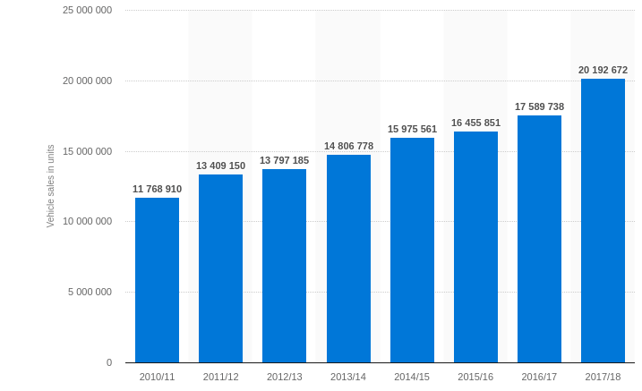Illustration1: Two-wheeler sales in India from 2010/11 to 2017/18 (in units)
(Source: Two-wheeler sales in India from 2010/11 to 2017/18, 2018)
https://www.statista.com/statistics/318023/two-wheeler-sales-in-india/

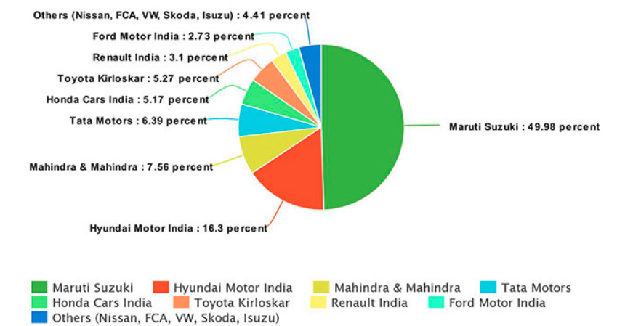Illustration 2: Car Maker's in India
(Source: Car Maker's in India, 2018)
https://www.financialexpress.com/auto/car-news/top-10-carmakers-in-india-and-their-market-share-maruti-suzuki-owns-half-of-the-indian-market/1129193/

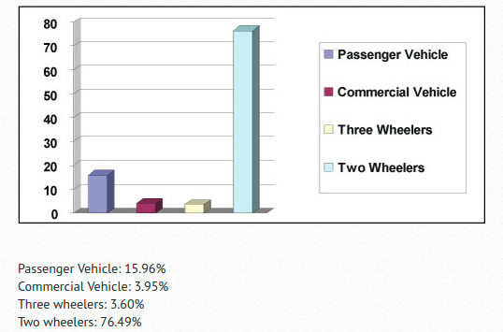Illustration 3: Segmentation of market share of automobile industry in India
(Source: Segmentation of market share of automobile industry in India, 2011)
https://business.mapsofindia.com/automobile/

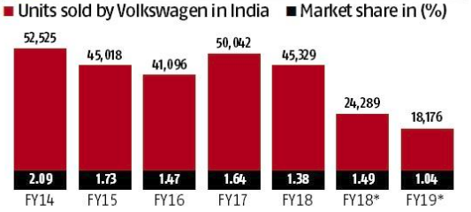Illustration 4: Unit sold by Volkswagen in India
(Source: Unit sold by Volkswagen in India, 2019)
https://www.business-standard.com/article/companies/volkswagen-s-india-share-dips-to-1-firm-seeks-revival-with-2-0-strategy-118101600334_1.html

POSITIONING IN COMPARISON TO COMPETITORS

FINANCIAL DATA
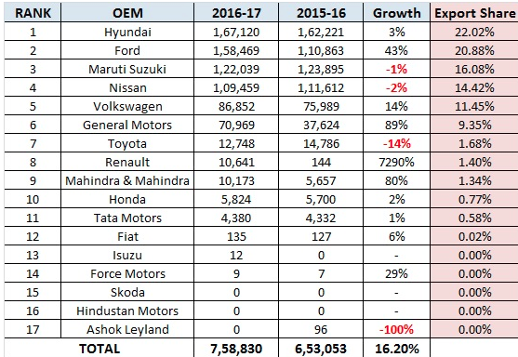Illustration 5: Positioning of Volkswagen in India
(Source: Positioning of Volkswagen in India, 2017)
http://www.autopunditz.com/news/cars/cars-export-statistics-india-fy17/

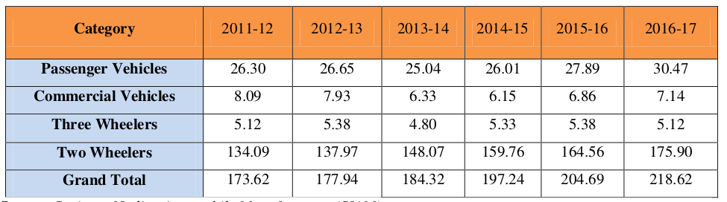Illustration 6: Automobile Domestic Trends
http://ajast.net/data/uploads/2124.pdf

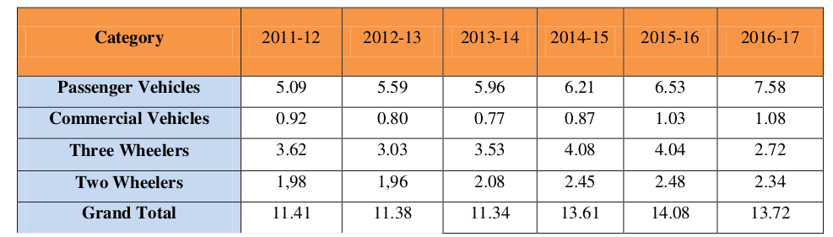Illustration 7: Automobile Exports Trends (In Lacks)
http://ajast.net/data/uploads/2124.pdf

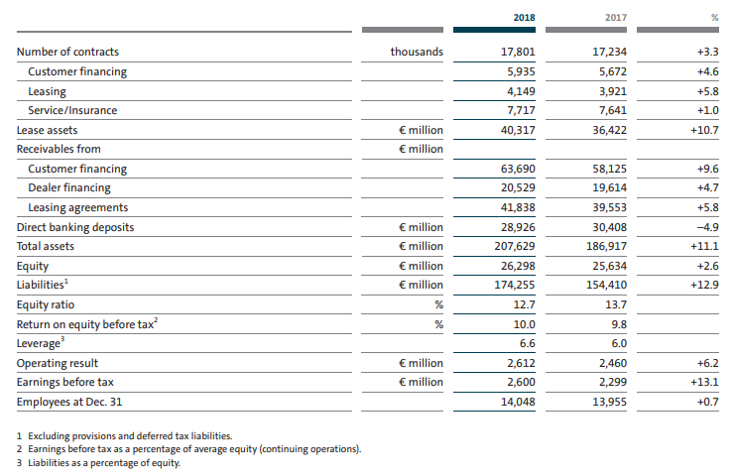Illustration 8: VOLKSWAGEN FINANCIAL SERVICES
(Source: VOLKSWAGEN FINANCIAL SERVICES, 2017)
https://www.volkswagenag.com/presence/investorrelation/publications/annual-reports/2019/volkswagen/en/Y_2018_e.pdf

