University of Wales Trinity Saint David
Course: BA (Hons) Business Management Level 5- Term 2
Name: Diana-Veronica Ciobanu
Student Id: 1913295
Module name: Management economics
Lecturer: John Malagila

Date: 10/05/2022
Assessment 1

Table of Contents
Introduction 3
1. The description of the business 3
The chosen product 3
The reason behind choosing this product 4
2. Demand and Market Equilibrium 4
Price of substitutes 4
Price of complements 6
Consumer income 7
Consumer tastes and preferences 8
Consumer expectations of price 8
Demographics 8
3. Factors that influence the Price Elasticity of Demand 9
Substitution Effects 9
Income effects 10
Pricing policy 11
Conclusion 12
References 12

Introduction
The organisation and the product that has been chosen for this report is Coca Cola. The Coca-Cola Corporation is a global corporation that is better known for its soft drink business. It covers a diverse range of carbonated beverages as well as flavorful soda brands, notably Fanta, Sprite, Coca-Cola as well as other sparkling soft drinks in a variety of flavours and sizes (Allen, 2020). The company offers its products in practically every country on the planet, and it has a considerable market. In this report, the demand and market equilibrium regarding the chosen product will be analyzed. Besides that, the price elasticity of demand will also be discussed in this report.

1. The description of the business

The chosen product
This research will focus on the Coca-Cola Company and its most well-known soft drink, Coca-Cola. Coca-Cola Company is dreaded by the beverage market that regards it as a weapon for capitalist supremacy. Currently, Coca-Cola is one of three or four products in the global markets that have already obtained this position, which is defined as a meta-status (Hirschey, 2021). Also, Coca-Cola has come to signify not just a single soft drink, but also the compounds with several commodities in general (Nsomba, 2021). The Coca-Cola Corporation is the world's most valuable beverage company, and also the world's biggest creator, trader, and supplier of non-alcoholic drink syrups and extracts, and is one of the most renowned and biggest businesses in the United States (Petersen and Lewis, 2019). Also, Coca-Cola is the corporation's most demanding and renowned product, but it now distributes up to 500 various brands in over 220 nations around the globe.

The reason behind choosing this product
Coca-Cola functions on a highly expressive and creative base, finding it challenging for other businesses to maintain its position; this is not a materialistic culture, but instead, a metaphor that can be disputed in light of the materialism of heritage that it reflects. Coca-Cola is indeed dominating the soft drink industry for a quite long time but the market size, as well as the market competition for this product, is huge. Coca-Cola product has a multitude of competing firms across the whole world the most prominent of which has been Cadbury Schweppes PLC, which offers sugary sodas like 7up, Schweppes soda, and also most other types of juices. Shanta, Faygo, Bigshot, and purified water and smoothie beverages are all marketed by National Beverage Corp. Besides, that other rivals in Kenya include Pepsi drinks, soft diet Pepsi along with Hansen Natural Corp. The reason for choosing this product is that, while it currently dominates the market, it also has a plethora of substitute and complementary goods. Furthermore, because it is a well-known product on the global market, demand for it is considerable.

2. Demand and Market Equilibrium

Price of substitutes
In economic and consumer theory, an alternative or substitute product is a product or service that the customer perceives to be essentially the same or similar to other products. In simple words, it can be said that substitute products can be used in place of anything else (Hess, 2021). These substitutes usually play an important role in the market and are considered in the interests of the customer (Mulvey, 2018). They tend to provide consumers more range of opportunities to choose products and allow them to better meet their needs. There are many substitutes for Coca-Cola products but it's worth mentioning that Pepsi drink is the most renowned substitute product of Coca-Cola.
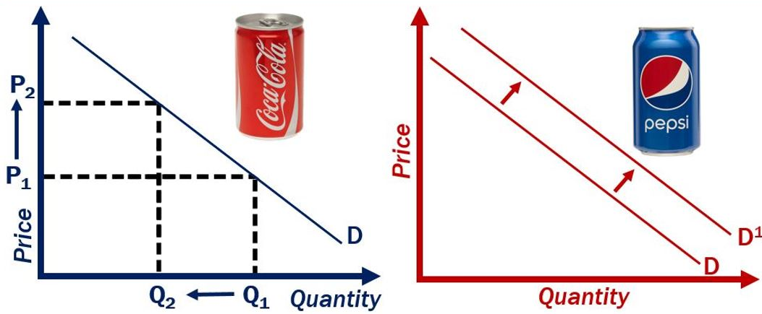
Figure 1: Graphical representation of substitute goods (Allen, 2020)
These days, a developing number of youngsters decide to drink sweets, because of their quick digestion as well as because of the advancement of the healthcare division. All in all, individuals today accept that cutting edge can fix illnesses like diabetes, and Pepsi has a ton of engaging bundling (Hess, 2021). Thus, Pepsi's image reasoning is more following contemporary thoughts that stress youth and essentialness, drawing in more clients and extending the market. Simultaneously, the market upholds this presumption, making Pepsi's stock cost rise.
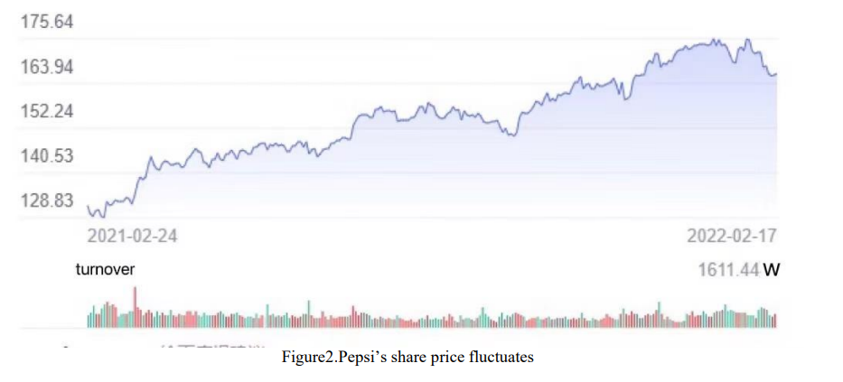
Source: (Hess, 2021)
Pepsi has a much better understanding of future consumer preferences. This means researching and designing beverages and foods that people will enjoy in the future. One of the most important concerns food companies have to deal with is responding to customer preferences. This is Pepsi's great success (Allen, 2020). Due to the popularity of Pepsi, buyers are more likely to buy Pepsi stock and Pepsi's stock price will rise.
As a result, if the price of Pepsi drinks rises, people will be less likely to buy them and would hunt for a cheaper substitute. If the price of Pepsi rises but the price of Coca-Cola falls or stays the same, demand for Coca-Cola will rise.

Price of complements
A complementary product is a good or service that helps to improve the quality or market value of another good or service. To look at it another way, these are two products that the purchaser consumes in tandem (Hess, 2021). Coca-Cola and McDonald's, for example. In some cases, such as with gasoline and an automobile, the complimentary good is required. A complementary product, on the other side, can add extra value to the primary commodity. For instance, both Coca-Cola and Popcorn, as well as Mcdonald's, add value to each other.
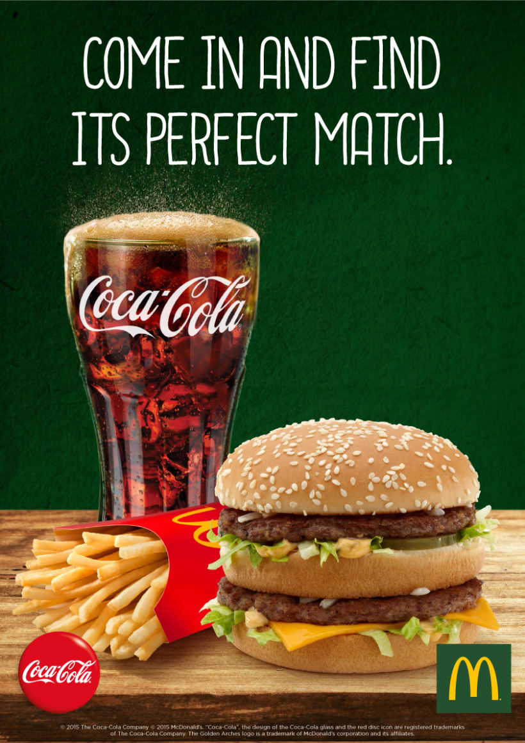
Figure 3: Complementary Goods (Hirschey, 2021)
McDonald's intends to raise the cost of its own customer’s most preferred food items later this year, claiming inflationary pressures as well as other expenditures as factors. Whereas the coronavirus epidemic proceeds and limitations in some markets are reintroduced, the organization has already increased pricing (Hirschey, 2021). Management previously warned that all these challenges have culminated in a feeling of vulnerability, staff shortages, and production problems all around the world (Davies and Lam, 2016). To employ workers, McDonald's has also had to boost the price of the food in line with wage increases, and also cope with increasing costs of key ingredients like beef, chicken and vegetable oil. So, according to the demand hypothesis, if the price of Mcdonald's increases, demand will surely decline, and since people aren't buying food from Mcdonald's, demand for Coca-Cola from Mcdonald's will likewise fall.

Consumer income
Money earned via activity or funding is known as income. The amount of cash someone earns affects how lots they spend.
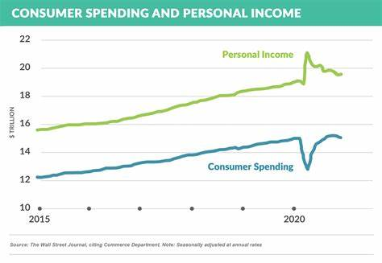
Figure 4: Source (Hess, 2021)
During the Covid-19 scenario, many households experienced job loss, income cuts, and other issues as a result of the organizations' unavoidable troubles. However, the UK government made steps to recover fast and maintain control of the situation. Figure four indicates that the common household income inside the United Kingdom is increasing, on the way to certainly having an impact on their shopping habits. People have extra cash to spend whilst their salaries improve (McGuigan, Moyer and Harris, 2016). As human beings hunt for approaches to spend their extra cash, the call for numerous items and offerings will rise. They may improve matters they presently own, together with a luxury house, brand new car, expensive movie tickets or they could cross on a costly luxury vacation. Businesses will expect to promote greater of those high-give up items and offerings, so they may manufacture greater and probable rent greater human beings (Hastings and Tejeda-Ashton, 2018). However, since Coca-Cola falls under the category of luxury goods, so the income fluctuation of the consumers will impact the demand for goods. So, the rise in income will increase the demand for Coca-Cola and the demand curve will move rightwards.

Consumer tastes and preferences
Customer preference is described as a combination of hypotheses focused on the purchase decision of customers that lead to various consequences such as satisfaction, pleasure, or efficiency. The comprehensive customer preference process contributes to a better option. Consumer preferences allow customers to assess alternative packages of products depending on their usefulness, or overall satisfaction with the service or product. It's necessary to keep in mind that customer preferences are unchanged by disposable incomes or pricing. As a result, a customer's ability to purchase items is unconnected to his or her tastes. In the corporate world, the most unpredictable component is customer tastes and preferences (Allen, 2020). Customers' preferences change over time, and to keep them, businesses create new items based on their preferences. The business world is becoming more competitive, and people are becoming more health-conscious as a result of Covid-19. As a consequence, their food and beverage preferences are shifting toward healthier options. Since Coca Cola drinks contain a huge amount of sugar so the demand may decrease over time due to the changing tastes of the customers.

Consumer expectations of price
If consumers expect that the price of Coca-Cola may increase in the future then they will stock some of them for the future (Davies and Lam, 2016). Since the rate of purchasing is increasing so it is crystal clear that the demand for Coca Cola is rising.

Demographics
Coca-Cola has 2.8 million customers, which includes Gen X, Gen Z, Millenials, and Baby Boomers. When the organization first began, it only targeted Generation X and Millenials. Now, to appeal to a wider audience, they changed the product's taste and quality. In the guise of Coca-Cola, they brought Diet Coke and Low Sugar Coke (Hirschey, 2021). Because the size of the customer base is growing, so is the demand for the sale of the product.
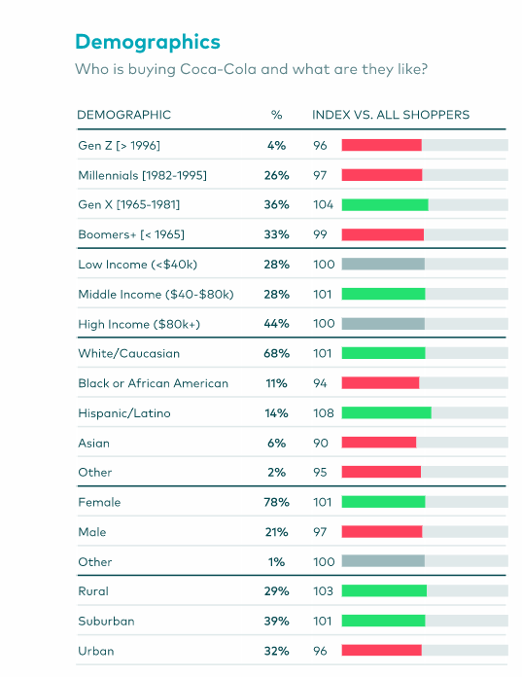
Figure 5: The demographic detail of the customers of Coca-Cola (Nsomba, 2021)

3. Factors that influence the Price Elasticity of Demand

Substitution Effects
The income elasticity of luxury products transcends unity, whilst the income elasticity of products that are necessary or regarded as necessary goods is less than unity but still significant, suggesting that their value runs from 0 to 1 (Jonas, 2022). Luxury items and essentials can also be described using the percentage of a normal consumer's budget based on income elasticity of demand. Coca-Cola supplies their budget-friendly and most popular Coca-Cola drink to more than 200 countries, in addition to the United States and the United Kingdom (McGuigan, Moyer and Harris, 2016). Aside from industrialized countries, Coca-Cola is available to customers in a large number of developing and underdeveloped countries where agriculture is the primary source of revenue. Agriculture is fundamental, while Coca-Cola is a luxury. Coke only provides to its few well-to-do buyers, whilst agriculture utilizes water to benefit the everyday citizen. Though the organization doesn't claim it much, according to the perspective of a huge proportion of customers when drinkable water is a necessary good, then Coca-Cola is a luxury good (Hastings and Tejeda-Ashton, 2018). The versatility of a decent or still up in the air by changes in its cost level. Extravagant things, for instance, have high flexibility of interest because of their aversion to cost changes. Food, for instance, is frequently inelastic since purchasers keep on getting it paying little mind to cost changes. So since Coca-Cola is a luxury good, demand will be more elastic.
But it's worth noting that Coca-Cola is now a generic product. As the disposable income of the consumers rises, the quantity demanded also rises, and conversely. Unless there are diehard Coca-Cola fans who love the flavour as well as the product, consumption will not shift if the cost of Coca-Cola increases.

Income effects
The amount of cash accessible to pay for costs after assessments and allowances is known as discretionary cash flow. Customers' optional pay is the cash left over after they've paid for the "needs" that are expected to keep a fair way of life (Davies and Lam, 2016). By and large, the higher a purchaser's total compensation, the more optional pay they need to spend on 'needs,' or items that aren't completely important to their endurance but instead to their way of life. If the 'centre' client has a restricted financial plan, the things and administrations that are promoted to them ought to be reachable (Petersen and Lewis, 2019). More princely buyers' items, then again, would be made, bundled, and advanced such that mirrored their degree of value and differentiation, and would be estimated in like manner. Coca-Cola is oftentimes bought to meet the social necessities. Coca-Cola is promoted as "a brand-related with tomfoolery, companions, and a great time" in ads. Also, when they look for adoration and connections, clients need to relate to this. The brand fills in for associating two gatherings or two people who wish to encounter an exceptional event. Buyers partner themselves with the brands they purchase (Hirschey and Hirschey, 2020). As far as decision and drive, the brand addresses amicability. Since Coca-Cola offers their products to a wide range of customers making a large customer base, so from the purchasing behaviour of the customer base the consumer's income can be identified. Though it is a luxury good it comes at a very lower price so all range of customers can easily buy it (Jonas, 2022). The response of a client's pay to the interest for a specific decent is estimated by the pay versatility of interest. Contingent upon the item, it very well may be positive, negative, or even non-responsive. A few items are extremely delicate to yield changes, while others are by and large unaffected. Client income can impact buying choices. As their monetary circumstance changes, so do how many items they purchase. Whenever buyer pay vacillates, the pay versatility of interest estimates how much interest varies. The more pay a client has, the more probable they are to purchase the thing. Whenever their pay goes down, they are more averse to getting it (Petersen and Lewis, 2019). The effect of changes in purchaser pay on the interest for an item is called pay flexibility. Understanding the pay versatility of interest upholds the board's independent direction by giving knowledge into the pay responsiveness of an item. Pay flexibility addresses how the sum required changes as a customer's pay vacillate and can be utilized to anticipate which labour and products a singular will purchase pretty much when pay varies.

Pricing policy
Quite possibly the most pivotal business choice that administration take is the value an organization charges for its item or administration. Estimating choices, for instance, impacts incomes as opposed to costs, not at all like different parts of the promoting blend. Valuing can likewise be used as a designated weapon to permit an organization to make the most of publicizing open doors (Jonas, 2022). Valuing, as different components of the advertising blend, should be unsurprising since it influences how purchasers see an item or administration. For its Original Coke, they utilized an expense based assessment way to deal with deciding its cost. They originally made the thing, the main Coke, then, at that point, settled on the expenses, set a cost because of Coke's expense, and afterwards convinced clients of the pop's worth (Davies and Lam, 2016). Coke started utilizing market-section assessment at its expense after that. Coca-Cola things are as of now esteemed at a comparable degree of contention to match the opposition against key parts like Pepsi. Accordingly, their essential way of thinking is Market Price, as they accept expenses ought to not be excessively low or excessively high contrasted with what the opposition is charging. Coca-Cola makes the benefits of the special cost strategy also (Hastings and Tejeda-Ashton, 2018). Coca-Cola has made limited time offers now and again as could be expected. Costs are regularly accidentally esteemed underneath the once-over cost in stores that offer Coca-Cola to develop short-run limits. Coca-Cola brings down its costs during exceptional events, for example, Ramadan, when the cost of a 1.5-litre holder drops to 5 Rupees. It gives the thing a need to get going, and individuals get this is a direct result of the lower cost. The Coca-Cola association gives impetuses to go-betweens or traders as free examples and void jugs, permitting these stores and agents to advance their items into the market. For that reason, Coca-Cola has become more well known as of late. Coca-Cola utilizes a fragmented valuing approach. Coca Cola arrives in an assortment of bundling, each with an unmistakable cost. Since the expenses to make the items are comparative, organizations can upgrade their income by offering their item in numerous sizes and at different costs.

Conclusion
Coca-Cola's benefit is expanded by extra income from different sources. Solid outcomes in different areas can balance market instability. Dissimilar to stores, the organization doesn't have full oversight over its establishment business. To guarantee that the drives and open doors for the development of global organizations were understood, we could depend on the foundation made. Notwithstanding, because of the public authority boundaries that franchisors field-tested strategies present to the executives, associations might require extra opportunity to answer fittingly to worldwide worries.

References
Allen, B., 2020. Managerial economics. 2nd ed. New York: HarperCollins, c, pp.300-310.
Davies, H. and Lam, P., 2016. Managerial economics. 3rd ed. Harlow: Financial Times/Prentice Hall, pp.367-369.
Hastings, J. and Tejeda-Ashton, L., 2018. Financial literacy, information, and demand elasticity. 3rd ed. Cambridge, Mass.: National Bureau of Economic Research.
Hess, E., 2021. The Coca-Cola Company. SSRN Electronic Journal,.
Hirschey, M. and Hirschey, M., 2020. Managerial economics. 3rd ed. Mason, OH: Thomson/South Western, pp.45-48.
Hirschey, M., 2021. Managerial economics. 5th ed. Mason, OH: Thomson/South-Western.
Jonas, I., 2022. MANAGERIAL ECONOMICS. 2nd ed. [S.l.]: ROUTLEDGE, pp.100-110.
McGuigan, J., Moyer, R. and Harris, F., 2016. Managerial Economics. 2nd ed. Mason, OH: Cengage, pp.244-245.
Mulvey, J., 2018. Factors affecting the demand. 2nd ed.
Nsomba, G., 2021. The Coca-Cola Company/Coca-Cola Beverages Africa Merger: Lessons for Robust Regional Competition Enforcement. The Antitrust Bulletin, 66(4), pp.544-555.
Petersen, H. and Lewis, W., 2019. Managerial economics. 2nd ed. Petaling Jaya: Pearson Malaysia, pp.300-310.
Samuelson, W., Marks, S. and Zagorsky, J., 2021. Managerial economics. 1st ed. pp.199-210.
Thomas, C., 2019. Managerial Economics. 3rd ed. Columbus: McGraw-Hill US Higher Ed USE, pp.200-211.

