Arif Khamis Yussuf

EVOLVING YOUR CREATIVE CRAFT
(ACCA5045 – Component 2)
ARIF KHAMIS
2305406
Contents – Assignment Component 2
TASK D – Refined Sketches – 2-8
TASK E – Orthographics and Colour Schemes – 9-12
TASK F – Final Model – 13-14
References – 15

TASK D – REFINED SKETCHES
(Including ‘Element’ Sheets related to TASK C^{[1]})

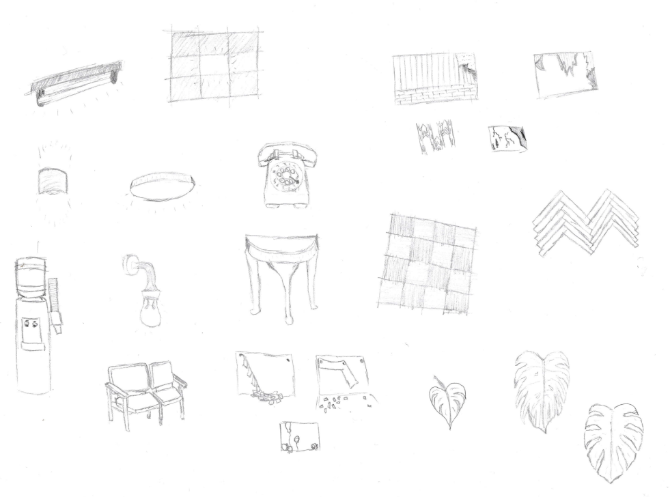

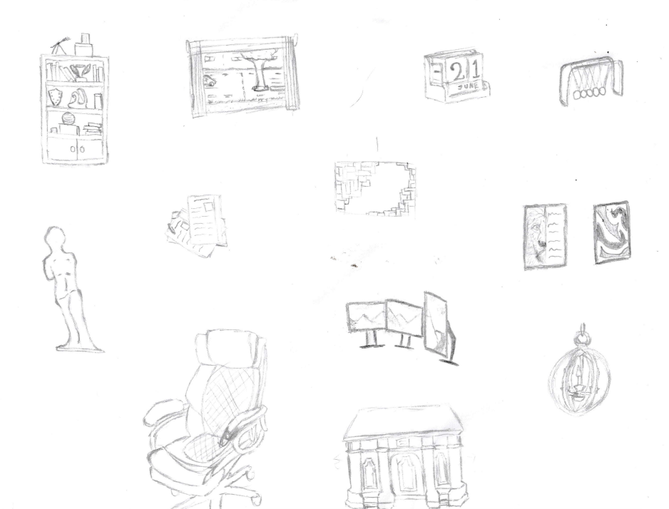

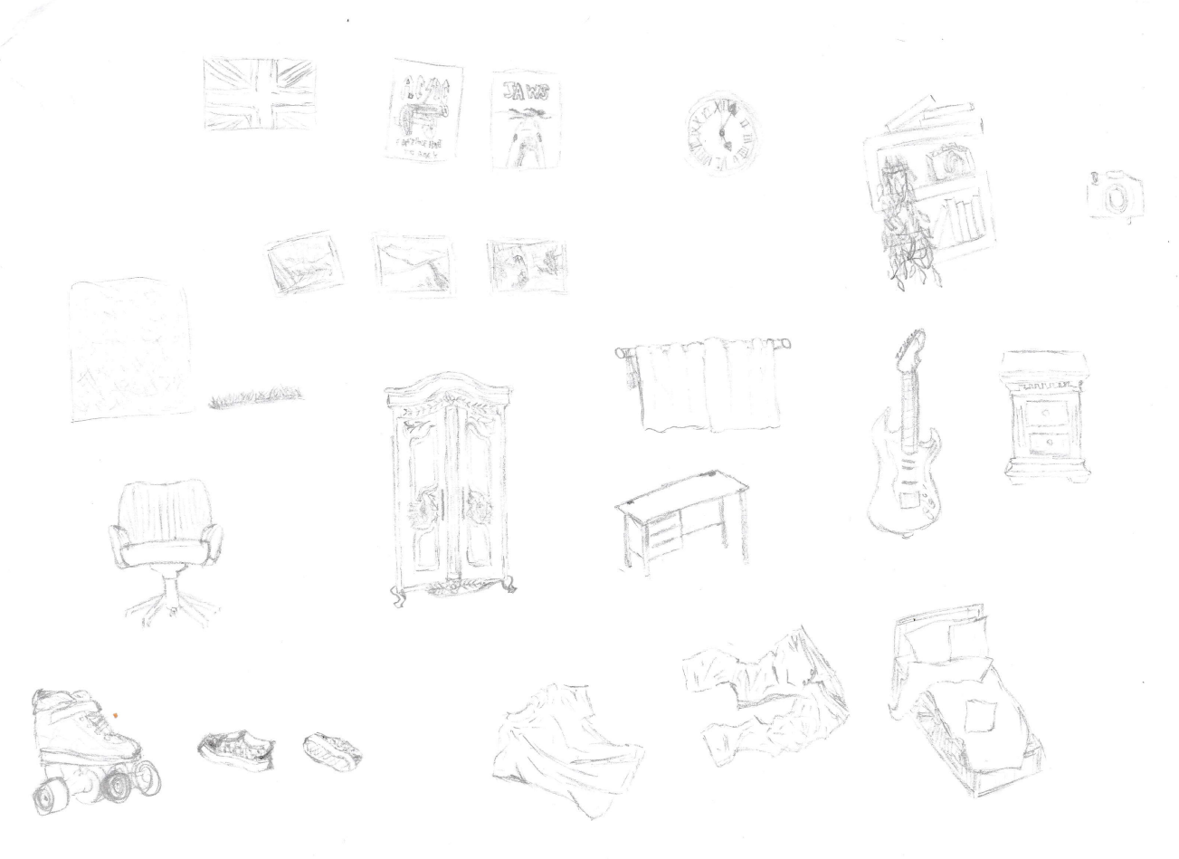

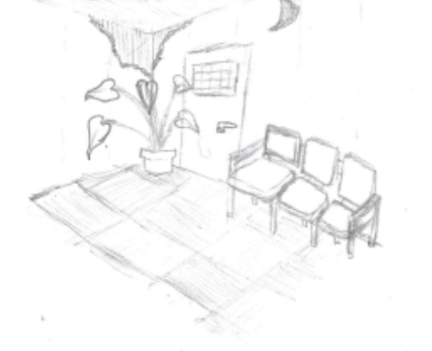
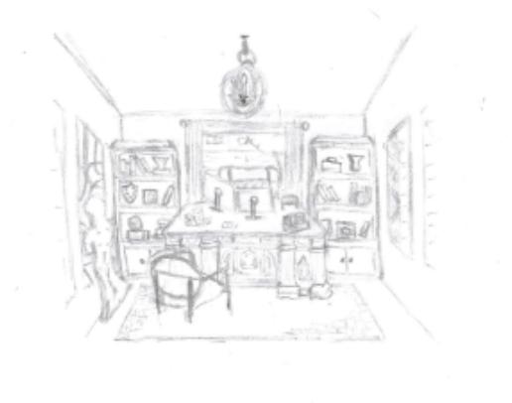
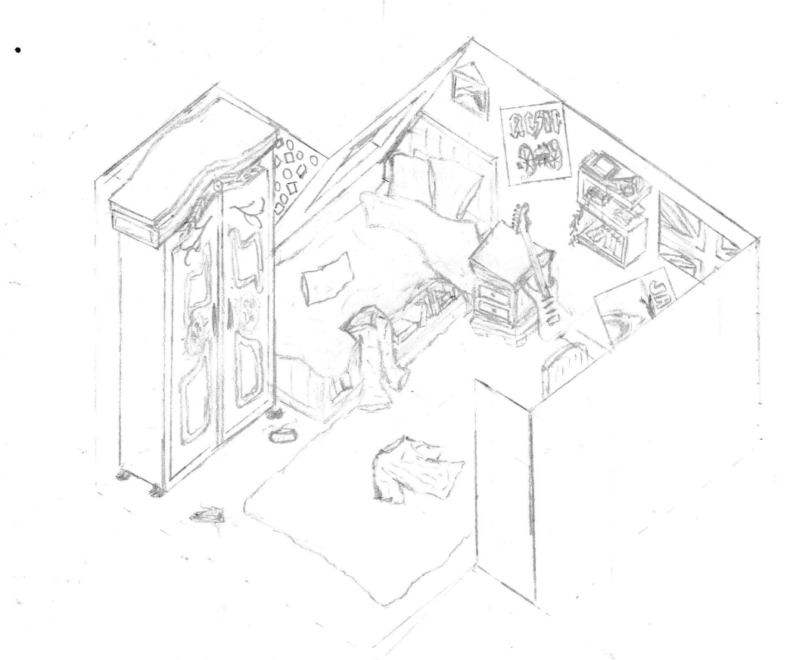

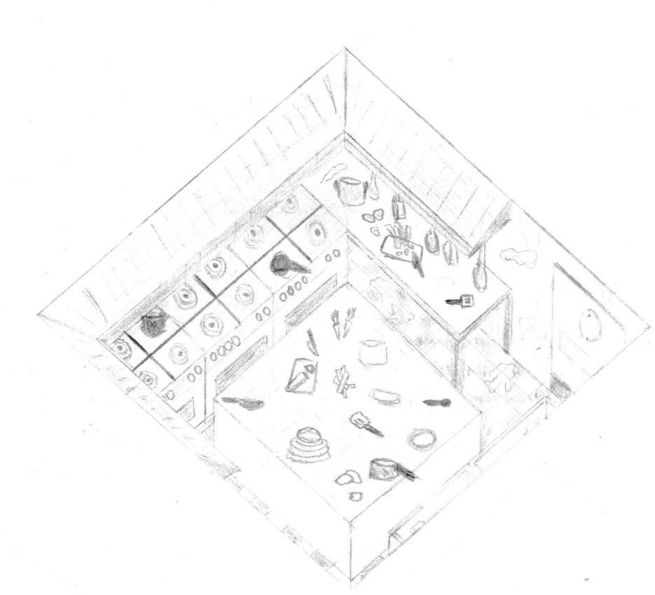

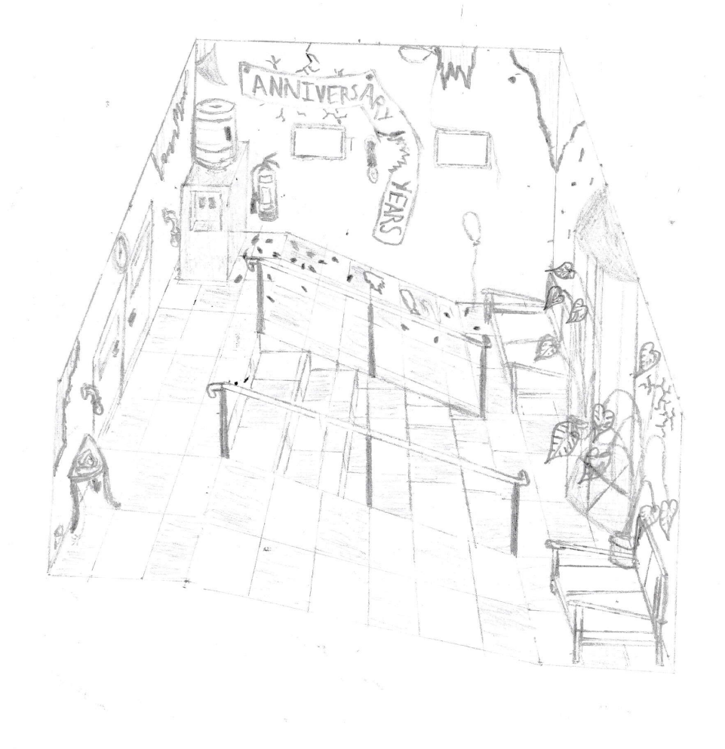

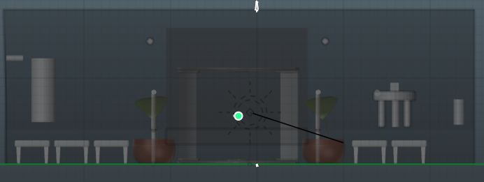
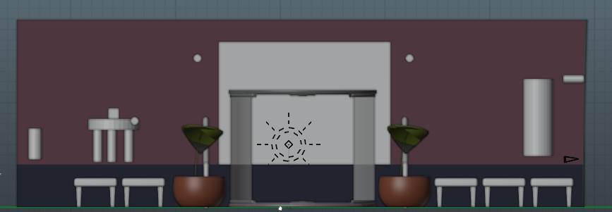
TASK E – Orthographics and Colour Schemes
Waiting Room - Rear
Waiting Room - Front

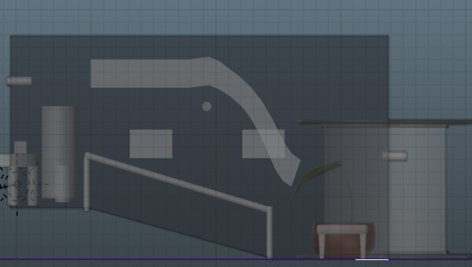
Waiting Room - Side

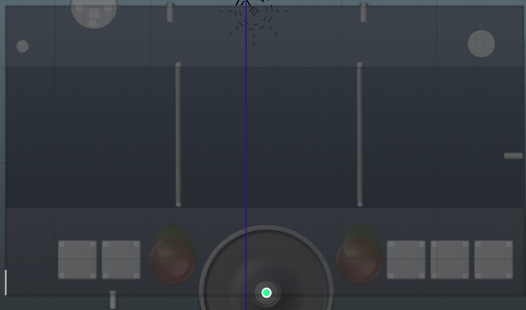
Waiting Room - Top

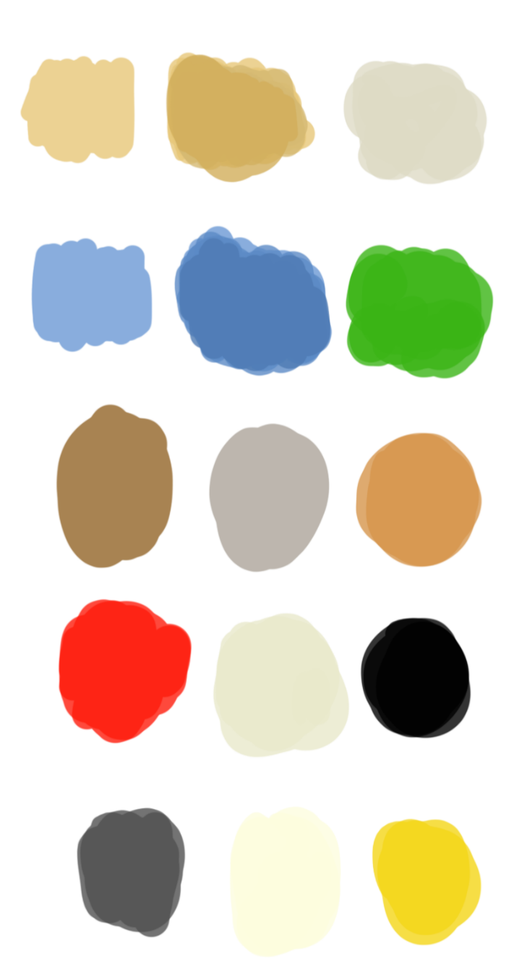

TASK F – FINAL RENDERS

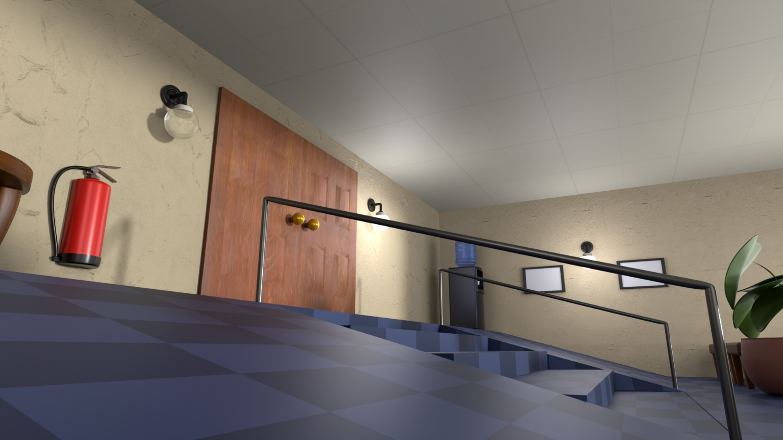

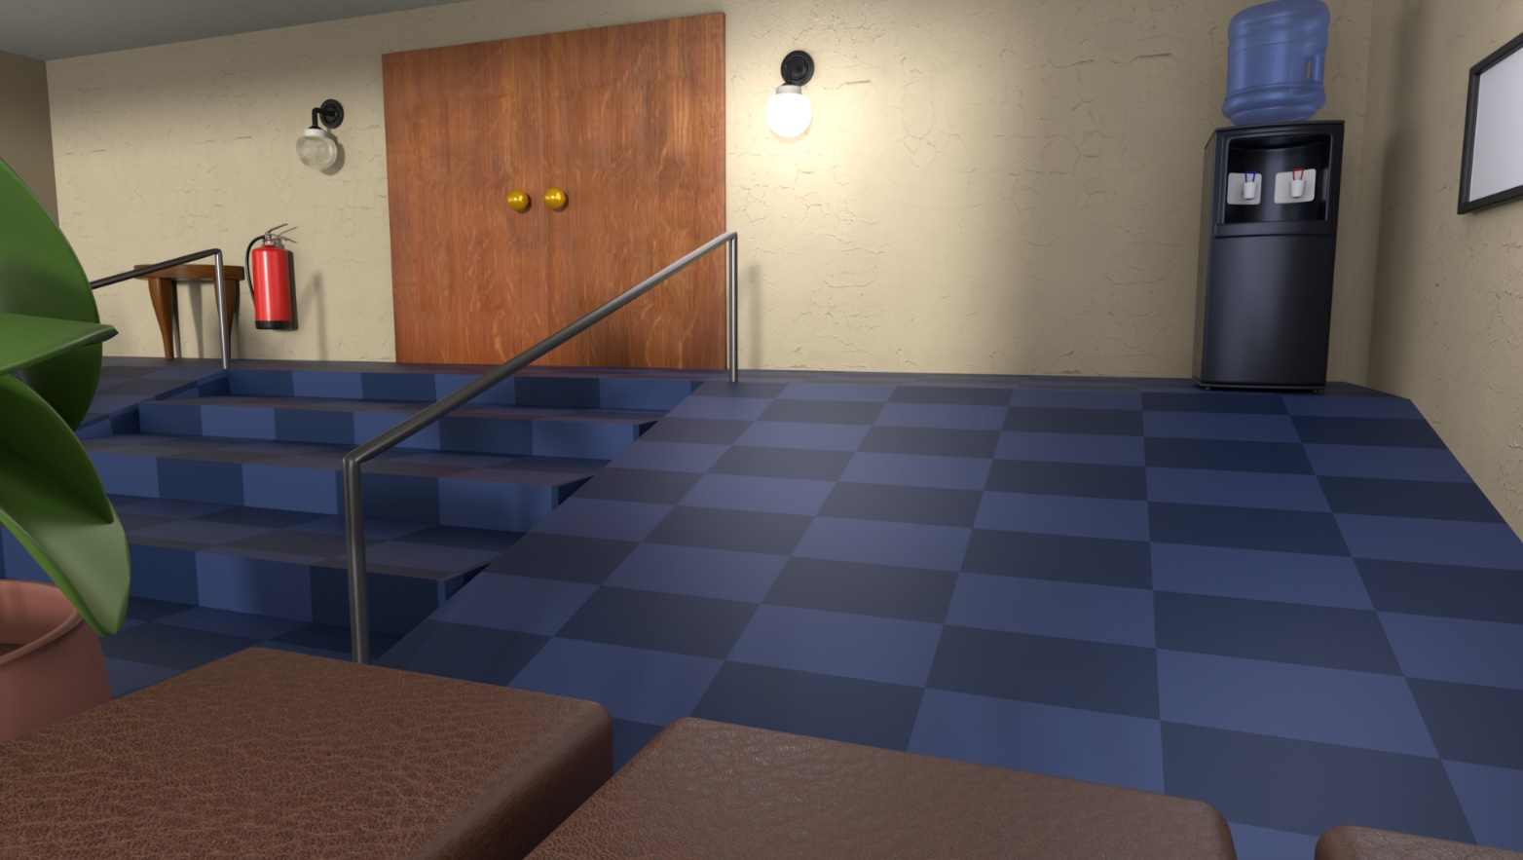

REFERENCES
[1]
“Evolving Your Creative Craft - ECC (ACCA5045 - Component 1) - Arif Khamis (2305406).docx,” Sharepoint.com, 2026. https://uowtsd-my.sharepoint.com/:w:/g/personal/2305406_student_uwtsd_ac_uk/IQDzn5uEKBDsRYO0F275ZVvTAYyv9lZrk6621U_EzxD_I00?e=zrszgH‌

