Project Evaluation

Assignment Title: Written Evaluative Report

Student name: Samuel Riley

Student ID number: 1807467

Programme: BA Computer Games Design

Module: Game Design and Asset Creation 1Module

code: M5X02043

Introduction
(Cyber-line City) is a cyber punk style vehicle racing game with hover, driving, and flying vehicles.

The main goal of the game is to finish the race in as little time as possible.

Later versions of the game will include racing against NPC’s and other players.

Our goals for this project (in semester one), is to get a functioning prototype of the game built.
This includes an art style, ship, character, and environment prototypes/concepts
Gameplay mechanics, and movement mechanics.

My role in the project has been Tech, I have spent most of my time working in unreal engine.
I have been responsible for the movement mechanics, game architecture, and implementing/designing gameplay mechanics.

Research Evaluation

I watched online tutorials and read relevant documentation before starting tasks.
My research has continued throughout the project. I used the unreal forum to find solutions to problems.

My approach to research has mainly worked.

Games Design Theory

How fun is the game?
Lens #3: The Lens of Fun. Fun is desirable in nearly every game, although sometimes fun defies
analysis. To maximize your game’s fun, ask yourself these questions:
● What parts of my game are fun? Why?
● What parts need to be more fun? (Schell, 2008).

flying the hover ship and being able to drift and use the air brake to get around tight corners is fun.

Why Is it fun?
Being close to the ground gives you a sense of speed, and the unpredictability involved in drifting makes racing more exciting.

What is fun about the flying ship is, the ability to move in 6dof and see the Racetrack from a different perspective.

I added collectables for the flying ship to make it better fun, and to keep the player on the intended path.

Adding collectables made the flying a lot more fun.

I think time pickups and a checkpoint system could add More fun to the experience.

Is this game competitive?

Lens #36: The Lens of Competition Determining who is most skilled at something is a basic human urge.
Games of competition can satisfy that urge. Use this lens to be sure your competitive game makes people want to win it. Ask yourself these questions:
● Does my game give a fair measurement of player skill?
● Do people want to win my game? Why?
● Is winning this game something people can be proud of? Why?
● Can novices meaningfully compete at my game?
● Can experts meaningfully compete at my game? (Schell, 2008)

The game has time trails and a leader board.

Players can try to better their own previous lap times and see how their best lap times compare to the lap times of previous player.

This gives players a sense of achievement and a reason to continue playing.

I think getting the fastest time out of anybody who has played the game is something the player can be proud of.

Getting around the track in good time takes skill and practice, if you use the air brakes at the appropriate times you can decrease your lap time significantly.

When the game has more tracks to compete in, gameplay will be more meaningful for experts.

At this point the game lacks depth.

Technical Research

Hover Component: to create the hover component I followed (Ghislanzoni, 2018) tutorial on how to make a hover vehicle using blueprints.
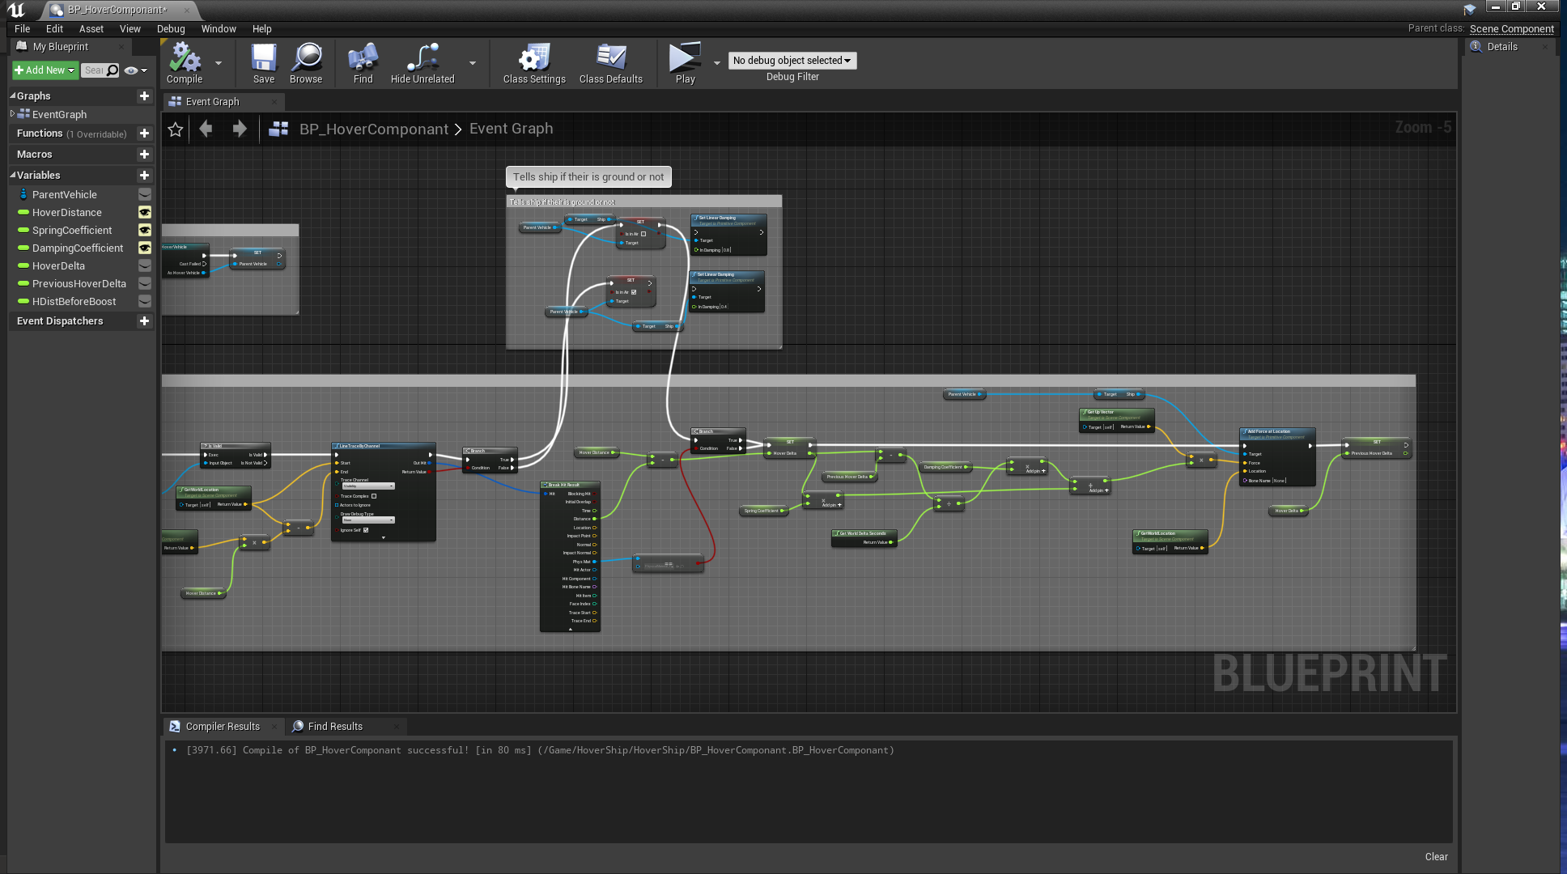
A physical material is used to stop the ship flying on walls or other objects, the ship will only hover on objects that have the hover physical material applied to them.

Timer system: To create the race and lap timer I followed the Unreal engine tutorial
(Unreal Engine, 2015).
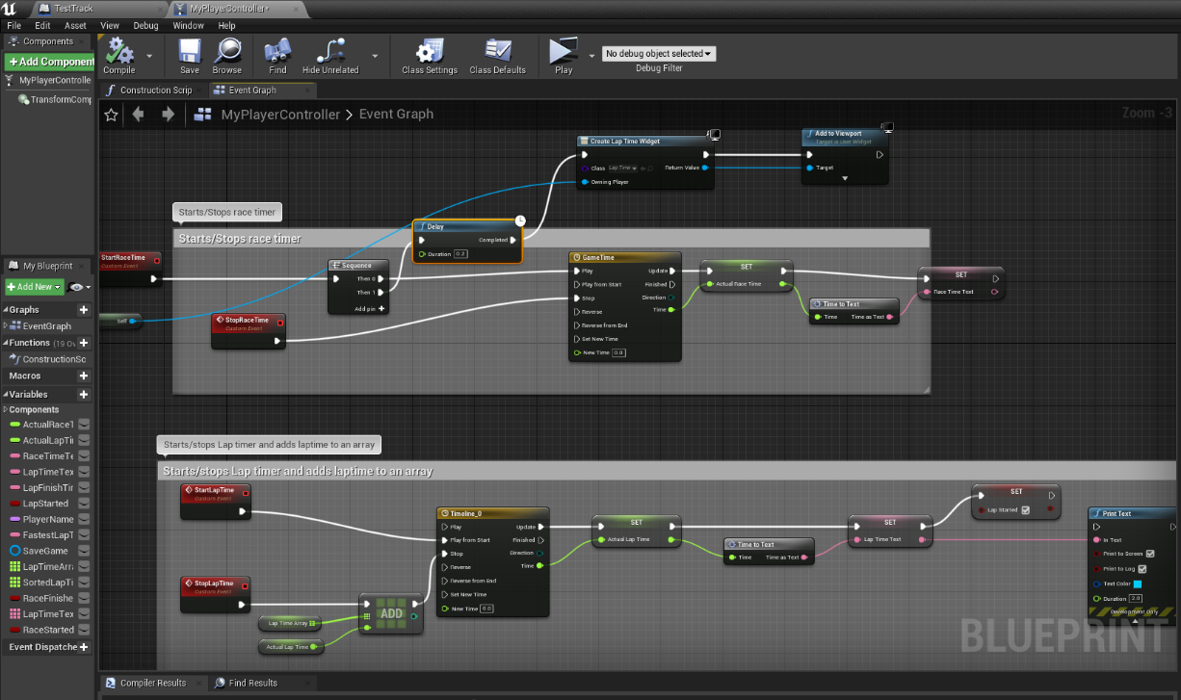
The timeline is used to keep track of time and update the race time. The float value is converted to a readable text format using the macro I made following information from, (Unreal Engine, 2015)

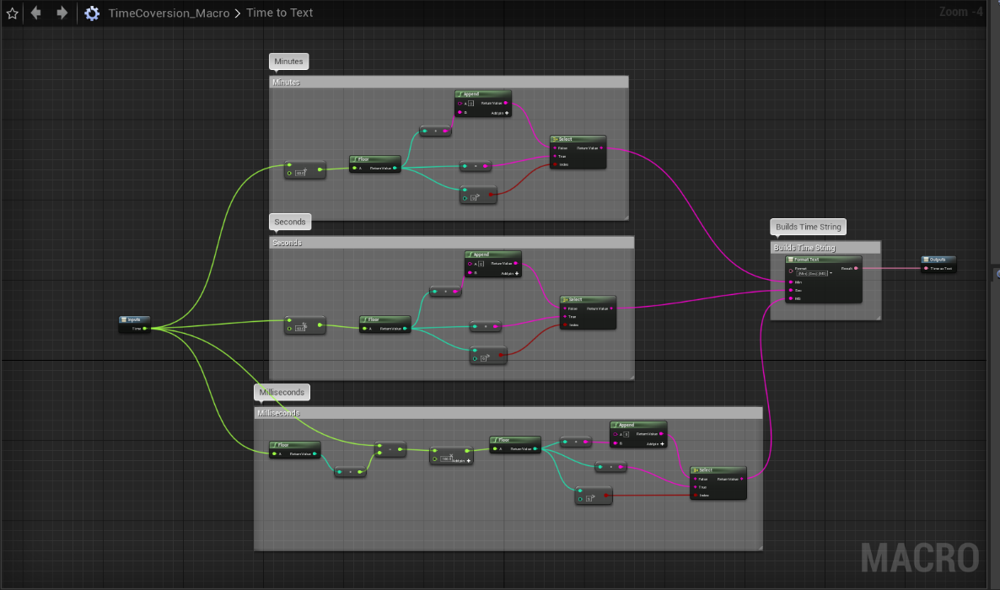
The lap time event works in the same way only when the lap is finished the lap time is added to an array.

Speedometer: I followed Mr z’s tutorial (z, 2018) on Youtube to make the speedometer.

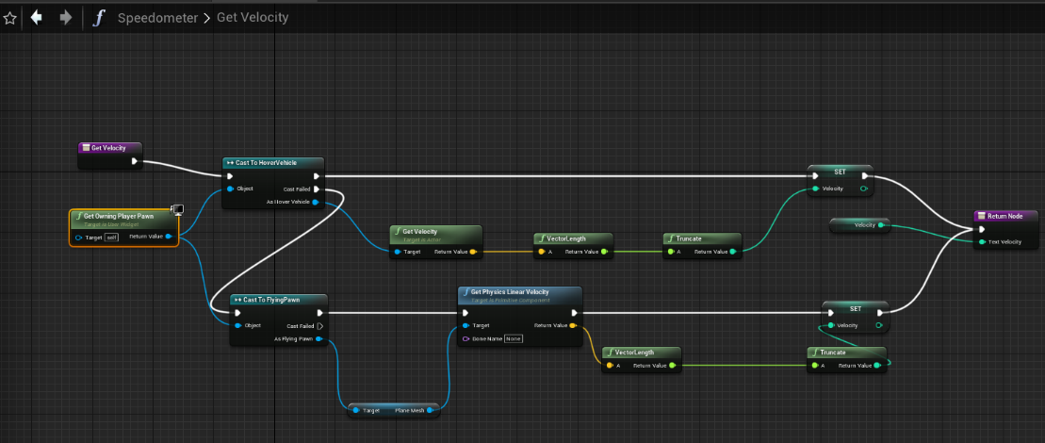
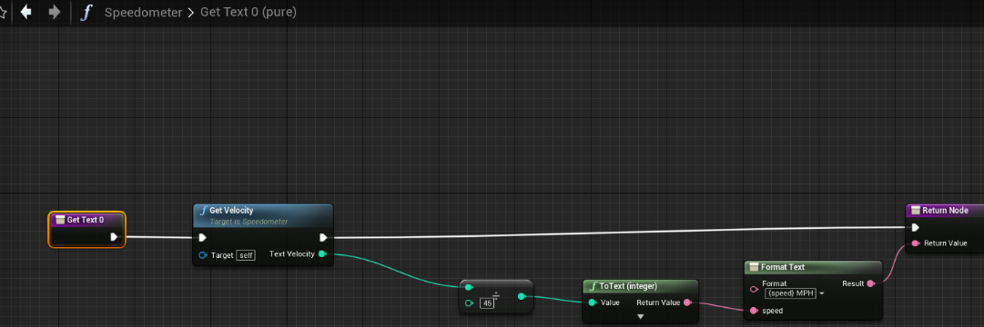
The velocity integer variable is divided by 45 which Gives MPH, according to (z, 2018).
The divided integer is then converted to text and formatted.
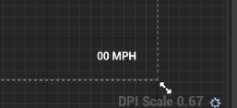
The formatted text is displayed in the widget using an editable text block.
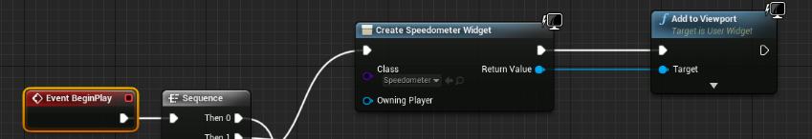
The widget is created inside the ships blueprint and added to the viewport.
Unreal forum:
I found information about sorting arrays by using the unreal forum.
Game dev academy:

Dev Enabled:
I watched tutorials by dev enabled to help me create a shell menu which can be used with a mouse and keyboard or game controller.

Contextual Research
We viewed scenes and pictures from an extensive range of films and games for visual inspiration including
- Fifth element (fifth element, 1997).
- Bladerunner (Bladerunner, 1982).
- Minority report (minority report, 1992).
- Cloudpunk
- Cyberpunk 2077
- Judge dredd (Judge dredd, 1995).

Game Research
Wipeout 2097:
I played wipeout to help me decide how the air brakes should function.

Redout:
I played Redout for reference when I was adjusting the speed of the hover ship.

Cloudpunk:
we mainly used cloud punks for environment art inspiration.

Sonic & All-Stars Racing Transformed:
We came up with the idea of having ships that transform and we decided to try playing sonic racing transformed to give us an idea of how this may look in a game.

Noman’s sky:
I played Noman’s sky for reference when I was adjusting the flying ship controls.

Research Conclusion

For my role, I consider the amount of research I have carried out to be adequate.
Next time I will spend more time researching before I start working as a lot of my research was problem solving.

If I had done better research before starting the project, I may have saved more time.

Technique Evaluation

I mainly used unreal engine blueprints to create game functionality.
I have quite a lot of experience using UE4
In the next phase of game development, I will be more involved with the art side of the project

Identification & Suitability of Production Methods

I have been using UE4 as I think this is the most suitable application for making our game.

Development of Techniques & Skills
My knowledge of Unreal engine has improved.
I have learnt a lot about game architecture and creating shell menus
I have furthered my understanding of multi-player replication.

Overall Quality of Work Produced
I am happy with the work I have done.

Technique Conclusion

I have learnt how to create shell menus which you can interact with using a controller.
I have learnt more about converting arrays and formatting text variables.
I have learnt more about the context in which to use the game instance, and player controller classes.

In the next part of the project I will focus on the AI behaviour tree, and replication/multi-player functionality.

Development Evaluation

My main role was to develop movement mechanics and implement gameplay mechanics.
I solved problems by using the unreal forum and by watching tutorials.

Creativity
The acceleration system and braking system are examples of blueprint functionality which I have designed.
Acceleration:
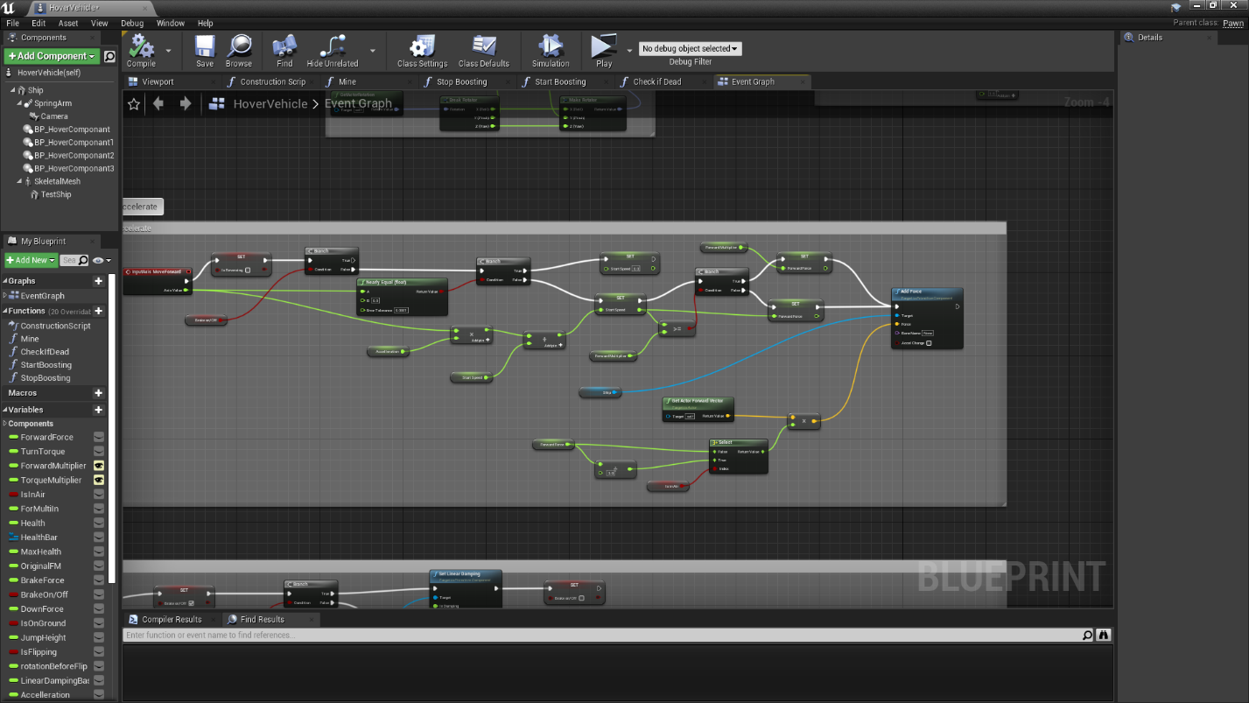
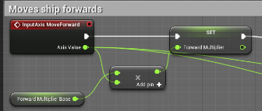
This limits the max speed of the ship in accordance to how far the trigger is held down.

Air Brakes/Strafe:
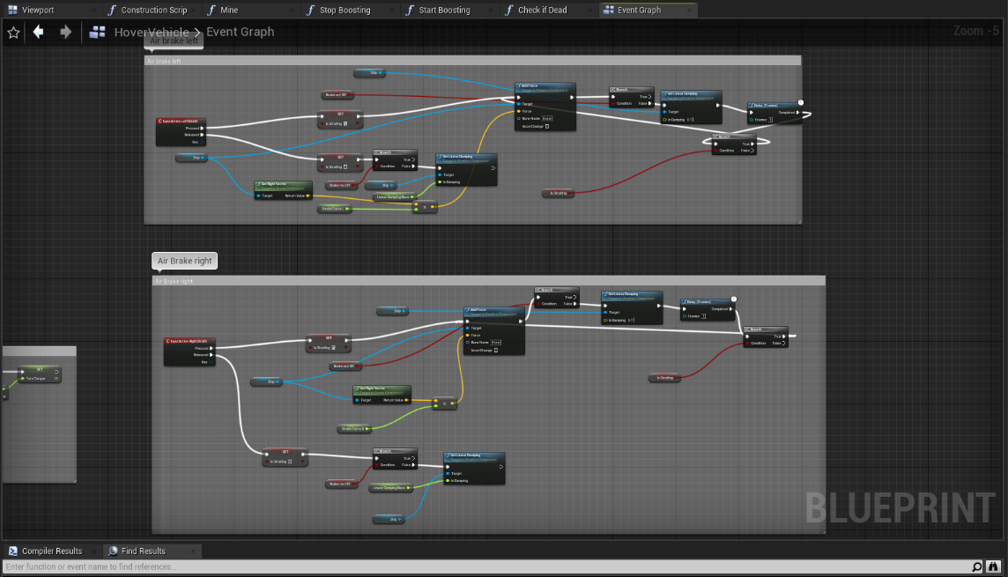
The air brake adds a sideways force and applies some linear damping.

Ship’s Pitch control: (only active if the vehicle has left the ground).

I have also Designed and implemented:
- A self-levelling system for the hover ship
- A system to switch between flying and hovering
- A damage and respawn system
- A Horizontal flip, pickup

Relevance to the brief
I am quite confident we have manged to fulfil the requirement laid out in the brief.

Contribution within a group (group projects)
Discord was very useful in allowing us to share ideas and communicate effectively.
We also use discord for classes and for team meeting to discuss the progression of our game.

The team decided to carry on using google drive instead of setting up a Perforce server.

This was due to some team members not having an internet connection that would allow this to be done.

This has caused issues in the production pipeline.

I suggested using splines to make a track and creating a checkpoint system.

The team decided to not have a spline-based track or checkpoints.

I wanted the game to be a battle game with weapons, I think this would have given the opportunity to apply a wider range of gameplay mechanics.

Not being able to work with co-worker’s face to face has put extra strain on the project.
Communicating ideas has been difficult.

Iterative Design Practice
Our initial sessions focused on idea creation/brainstorming where we came up with the idea of
making a cyber punk style Hover Racing Game.

In later sessions we decided, the hover ship should transform into a flying ship and into a ground vehicle, and possibly a motor/hoverbike?

We also decided our initial prototype should have time trials.

We decided we should add, Multi-player, and AI ships to race against.

We decided to make the hover ship fly upside down and on walls.

We also decided that the game should have boosts and air vent/lifts to elevate the ship to different levels.

Feedback from the team, which I have acted upon:

The Hover vehicle needs air brake:
I implemented a braking system and air brakes/Strafe.

It would be good if the ship were able to hover on walls and ceiling?
I turned off gravity and simulated gravity using a force pushing down on the ship.

Can you make better acceleration control?
I made a system to increase speed over time based on the trigger axis value.

Can you make the ship not fly up walls when you crash into them?
I used a physical material to determine whether the ship should fly on an object.

Needs health system, does not need health anymore:
We decided to get rid of the health system, as running out of health needlessly interrupted the game play.

Can we make the ship respawn on the track after a crash?
The health system has been repurposed and used as the respawn system, I have not placed respawn points yet.

Can we make the ship deflect off walls when colliding?
I repurposed/remade the colliding system from ue4 Flying template.

Can we have a boost system?
I have made a boost pickup, but I have not made a recharge boost system yet.

Can we have the ship flip onto walls?
I made a pickup that flips the ship 90 degrees.

Time Management
Some things ended up taking far longer than planned.

Adjusting the speed and steering and making the transition from hovering to flying ended up taking longer than planned.

I have managed to get nearly everything I had planned finished.

I managed to get a lot of tasks completed.

My work on this project has overspilled into time set aside for other modules.

A more structured approach could have prevented this from happening.

Development Conclusion
Getting source control/SVN set up should have been our priority. as I have done most of the unreal engine work it has affected me more.

Analysis

Contextualising your work within a wider theoretical practice

An in-game reward system and collectables would make the game better fun.
Avatar modifications are planned for in the future version. This will give the player an opportunity to express themselves in the game world.

Critique of the work you have produced
So far play testing has stayed in the closed alpha stage.

See iterative design practice for feedback results.

We will be moving on to closed beta testing towards the end of next semester.

Critique of your own practice (and action taken)

The ability to communicate effectively as a team has been impeded by having no face to face meetings, due to lockdown restrictions.

Using ftrack to keep track of our work would have improved our workflow.

Having source control setup would have improved our workflow.

Bibliography

Bladerunner. 1982. [film] Directed by R. Scott. united states: warner brothers.

Dev Enabled, 2018. GB 0:02 / 19:12 UE4 / Unreal Engine 4 UMG / Widgets - #02 Keyboard/Gamepad Menu. [video] Available at: <https://www.youtube.com/watch?v=gDKIenYaoxw&list=PLPjbBP7GspahAJMI6dBroMUo5hORgYYST&index=28> [Accessed 1 November 2020].

DevSquad, 2020. Creating Smooth Movement- Unreal Engine 4 Dev Question Time. [video] Available at: <https://www.youtube.com/watch?v=o1qxgxxTGYQ&list=PLPjbBP7GspahAJMI6dBroMUo5hORgYYST&index=25&t=789s> [Accessed 10 November 2020].

fifth element. 1997. [film] Directed by L. Besson. France: gaumont.

Ghislanzoni, M., 2018. Hover Vehicle 2018 (Using Blueprints) - Unreal Engine 4 Tutorial. [video] Available at: <8&lihttps://www.youtube.com/watch?v=ko6lDSSNhVst=PLPjbBP7GspahAJMI6dBroMUo5hORgYYST&index=3&t=586s> [Accessed 6 October 2018].

Judge dredd. 1995. [film] Directed by D. Cannon. united states: buena vista pictures.

minority report. 1992. [film] Directed by s. spieberg. united states: 20th century fox.

Rushin, K., 2016. GB 2:43 / 6:51 Unreal Engine Tip #1 Changing Between Pawns And Possession. [video] Available at: <https://www.youtube.com/watch?v=UXFl_yWQjLs&list=PLPjbBP7GspahAJMI6dBroMUo5hORgYYST&index=23&t=161s> [Accessed 15 November 2020].

Schell, J., 2008. The Art Of Game Design. Burlington: Morgan Kaufmann, p.27 p.186.

Unreal Engine, 2015. BP Time Attack Racer: Race & Lap Timers | 08 | V4.8 Tutorial Series | Unreal Engine. [video] Available at: <https://www.youtube.com/watch?v=KS6In6yJerM&list=PLPjbBP7GspahAJMI6dBroMUo5hORgYYST&index=29> [Accessed 1 November 2020].

Unreal Engine, 2015. GB 2:57 / 20:01 BP Time Attack Racer: Race & Lap Timers | 08 | V4.8 Tutorial Series | Unreal Engine. [video] Available at: <https://www.youtube.com/watch?v=KS6In6yJerM&list=PLPjbBP7GspahAJMI6dBroMUo5hORgYYST&index=29&t=176s> [Accessed 15 November 2020].

z, m., 2018. Unreal Engine 4 - Speedometer Tutorial (Part 2). [video] Available at: <https://www.youtube.com/watch?v=7ZfEXf61hiI&list=PLPjbBP7GspahAJMI6dBroMUo5hORgYYST&index=27> [Accessed 25 November 2020].

z, m., 2018. Unreal Engine 4 - Speedometer Tutorial. [Video] Available at: <https://www.youtube.com/watch?v=7ZfEXf61hiI&list=PLPjbBP7GspahAJMI6dBroMUo5hORgYYST&index=27&t=6s> [Accessed 24 November 2020].

