
University of Wales Trinity Saint David
School of Engineering

Group Project
M5X00400

Jonathan Lloyd-Williams
1805620
22/03/2020
Table of Contents
1 Work Content 1
2 Research Carried Out 3
3 Designs & Development Carried Out 4
4 Original Planning & Future Development 8
5 Conclusions 9

Work Content
The aim of this section of the report is to explain in detail the processes involved in building a useable template for a lap time simulation within Microsoft Excel that was capable of being applied easily to a variety of tracks. This simulation was also designed with the intention of it being able to take into account the various inclines found around the various tracks, instead of assuming a flat model. In the course of this project I have created two lap simulations, with the intention of building more in the future. A report has already been produced regarding the method involved with building the first simulation and so the will focus be on how this simulation was then used to produce a template for use with further tracks.
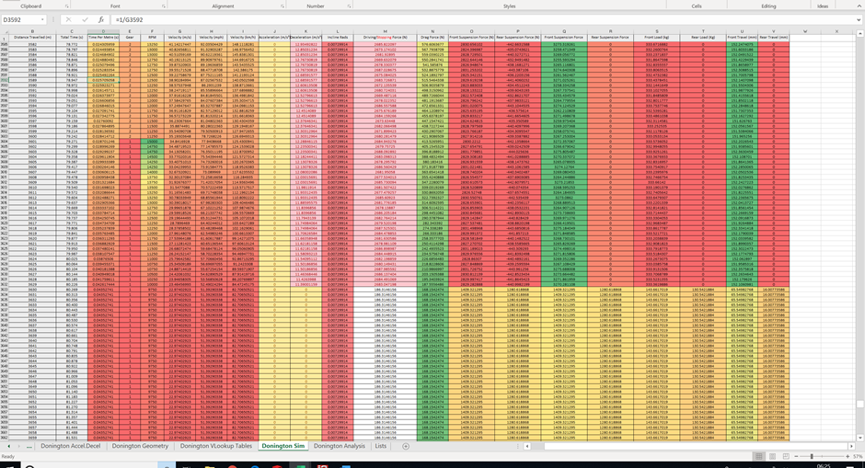
Originally my task for the project was based around building lap simulations for Moto2 tracks. However, working alongside the BikeDevil Racing team during the BSB championship provided an opportunity to acquire data and measurements for use within the simulations, and to provide a useful tool that could be adapted over time for the teams use. As such the focus was then moved to tracks used through the BSB season, for both the championship and testing.
The first Simulation that was built was for the Cartegena Circuit and was able to produce a desired result of 1.32.257 which is 3.62% faster than the lap from the real data, and 2.43% faster than the fastest lap achieved during our 2020 testing session. Building this simulation took to the desired level, took a number of weeks to complete. By developing this simulation into a template and applying it to another track, I was able to complete a second simulation in the space of a few days. The second simulation was produced for Donington, producing a desired result of 1.28.736.
My prediction is that if each time a template is created from the most recently made simulation, that this will continue to become more and more efficient. The other benefit of this method is that it allows for additional error checking. It was only whilst preparing the simulation for use as a template that I discovered several easy-to-miss errors that had been made that I was then able to resolve, and in doing so produce a more accurate lap time.

Research Carried Out
The majority of the research that needed to be carried out in order to complete this project was carried out prior to the building of the first simulation. The equations for which were generally taken from Vittore Cossalter’s ‘Motorcycle Dynamics’, or were taught by Dr Williams during the BENG Motorcycle Engineering lectures and a report detailing these produced
Once the first simulation had been produced, it was a case of modifying the simulations track geometry the various tables involved in order to allow for easy transition between varying track geometry and raw data. This generally involved experimenting with varying formulas to allow for tables and data to be added easily, requiring minimal editing to produce the correct figure for the new track information. To do this some further research was done into Microsoft Excels functions and tools in order to make this process as efficient as possible.

Designs & Development Carried Out
The general layout of the whole sim was reworked in order to make it easy to input new raw data into the Raw data sheet, in that by pasting the new raw data into the appropriate cells, the respective inclines and their effective distances would be calculated, as well as the VLookup tables. However, this was only achievable to an extent, as if the new track geometry is more complex than the previous, involving more inclines, then more V look up tables will need to be produced. For Cartegena there were 68 inclines to be considered, and for Donington 104. 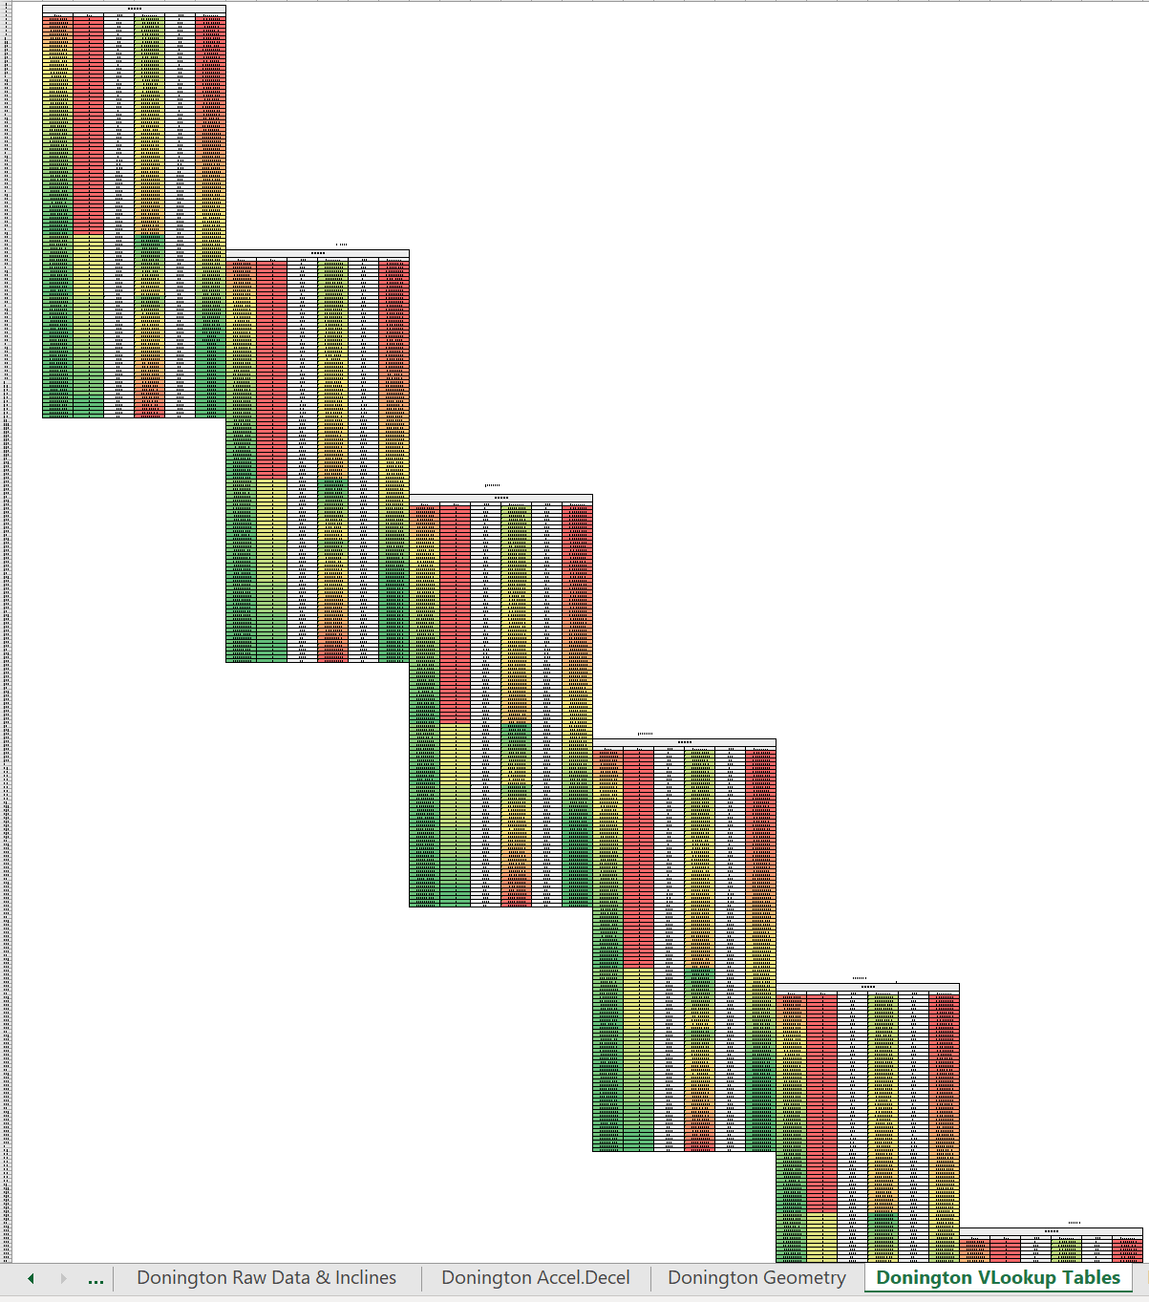
When originally calculating the inclines in the Raw Data sheet some manipulation does need to be done in order to make calculate the new inclines. The GPS Altitude column must be moved in order to for the locator to work. The locators must then be fast copied through their respective columns, and then the same procedure can be followed as was originally followed for the first simulator. This involved copying the 3 locator columns over to the modified columns and using the find and select tool to delete the cells and shift them up. Once this was done, a list was available for each altitude change at each distance, and the incline cells will automatically calculate up the inclines up to the amount for the previous simulation. These cells needed to be fast copied down for the appropriate number of cells in in order to calculate all of the encountered inclines.
A problem was encountered when considering how the acceleration and deceleration tables would be produced. Unfortunately, as the formulas within the tables were different, depending upon whether an incline was positive or negative. The layout of these tables was therefore arranged in the order of the slope’s directions e.g. Negative, Negative, Positive and so on… As each track is going to have variations in not only the number of inclines encountered, but also a variation in the arrangement of positive and negative inclines, this meant that the entire Accel/Decel sheet had to be redone in order to match the number and arrangement of the inclines. These were then created using the same method as that which was used in building the first simulation. Once the original tables for both negative and positive inclines had been modified to allow for easy pasting into the appropriate cells, it was simply a case of adding the tables in the appropriate order, for the number needed for the track. 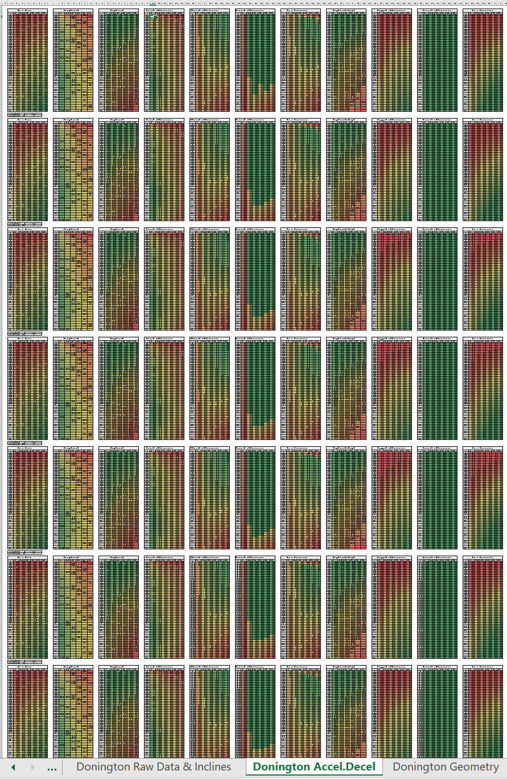 This was made somewhat easier by pasting over the original Cartegena cells where possible as their respective cell that linked the incline to the formulas in the equation was already linked to the cell in which the inclines were calculated and as such had updated automatically for the Donington inclines. However, where new tables had to be made past the 68 that were already there, each cell displaying the respective incline for use within the equation had to be updated manually. One issue with this method is that any errors that were found within the tables after this point required all tables to be fixed, and generally differently depending upon whether they were positive or negative, and correcting some errors took long periods of time due to this.
The track geometry sheet also had to be updated, this was done by using the previously made Solidworks measurements, and the distance checked against existing data and the listed official track length. 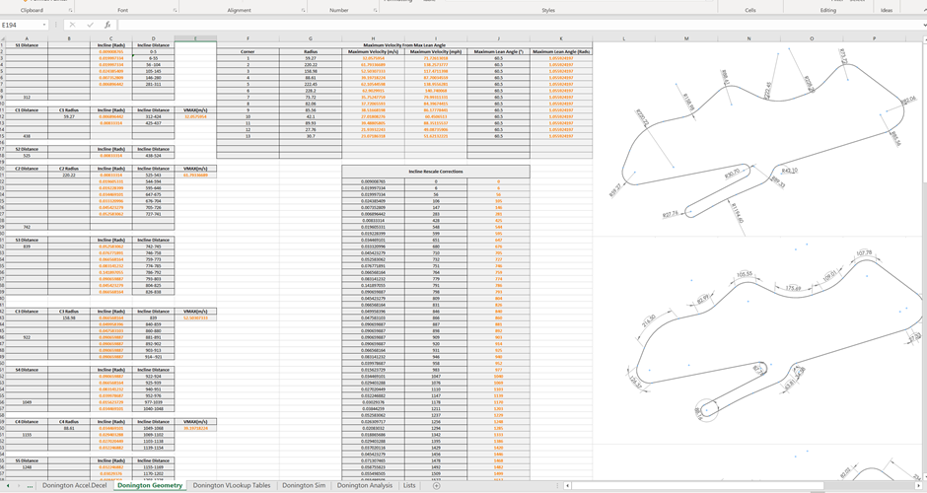Once copies of the measurements had been put into the sheet, it was case of tabling the straight and corner lengths and then rescaling the incline distances to match the chosen race-line around the track. This was done by working out the ratio of the chosen distance over the distance for the raw data and multiplying the original incline distances by this figure. In Donington’s case it was a reduction to approximately 99.34% of the original values. 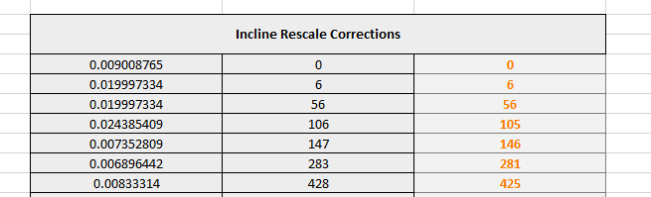They were then mapped out into the separate straight and corner tables to make it easier to plot them in the simulation. 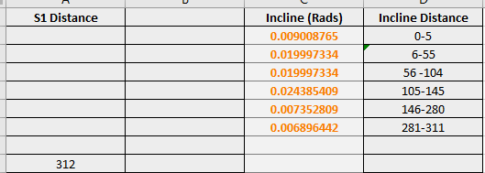
The corner radii were then input into the pre-existing table from the first simulation, and the corner velocities were updated automatically.
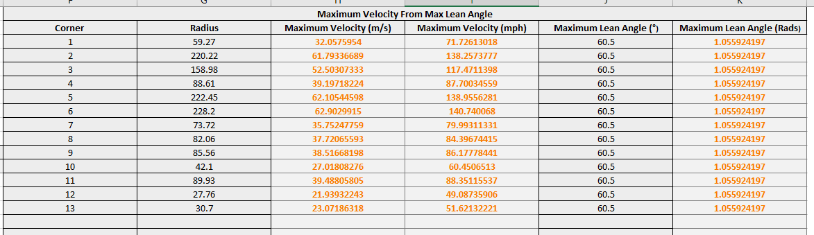
The last thing to update was the simulation itself. The first thing to do was to adjust the distance for each section, and then input the inclines for their respective distances. Once this was done it was necessary to recalculate the starting velocity using the same method as used in the Cartegena simulation. This involved inputting the necessary acceleration equations from the end of the last corner to the end of the final straight to work out what the velocity would be at 1m past the final row. Once this was calculated it was put into the first velocity cell of the simulation. Then finally the acceleration and decelerations were recalculated for the new geometry and a lap time produced.

Original Planning & Future Development
Whilst originally planning for this project, the amount of time it would take to complete the first template and develop further simulations was greatly underestimated. As such the scale of the project was reduced. Originally the intention had been to build a variety of simulations for the Moto2 tracks. Many of these were mapped within Solidworks during the early phases of the project for use once the template was created.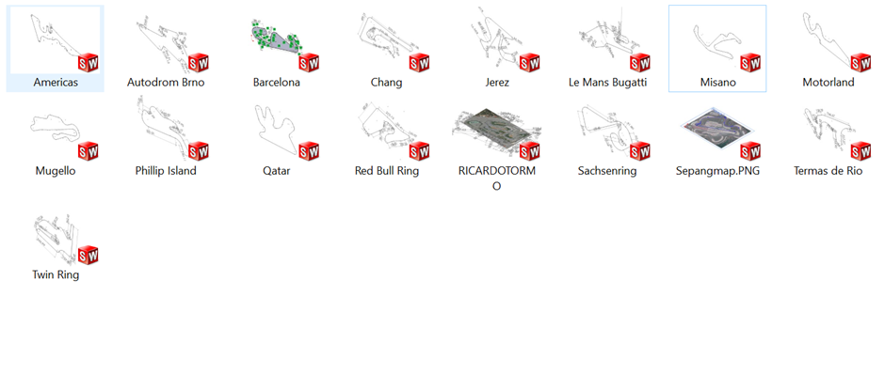 However, as time went on, and individuals within the groups own objectives changed, it became clear that working with bike devil to acquire useable data and produce a useable product for them was an option. This was as members of the group shifted their focus from Moto2 based machines to building a simulator instead, and as such, it became less necessary to focus on the Motot2 tracks. The objective then changed to covering the tracks most used by the Bikedevil Racing Team. Whilst this still remains a long-term objective, due to unforeseen difficulties that were experienced in acquiring certain data and measurements it has only been possible to build 2 simulations to date. However, it is my intention to continue to develop these for the team in future and have begun mapping the tracks for later use.
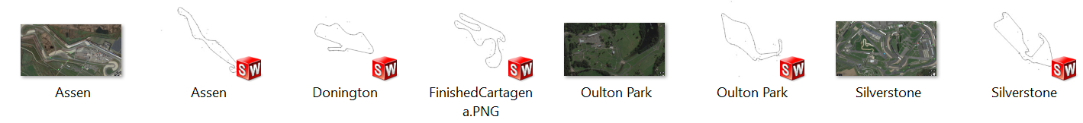

Conclusions
Overall I am pleased with how the template has turned out and look forward to using it to developing more simulations across a wider variety of tracks in the future. I also look forward to working with the Bikedevil team to develop it into a more useful tool that will include a wider variety of variables in the hopes of improving accuracy. The next area I would like to explore would be the dynamics behind acceleration and deceleration whilst cornering.
I would also like to make adjustments to the designs layout and try to experiment with layouts that improve the ease of applying the simulation to new tracks. I feel despite not completing the original objective regarding the number of tracks, I have completed my primary objective of developing a useable template that incorporates inclines. As aforementioned, I predicted that as further developments take place and more simulations produced, the templates design will continue to evolve and improve.

Bibliography
Blevins. (1984). Applied Fluid Dynamics Handbook. New York: Van Nostrand Reinhold.
Bradley, J. (1996). The Racing Motorcycle . Broadland Leisure Publications.
Cossalter, V. (2006). Motorcycle Dynamics. 2nd ed. lulu.com.
Foale, T., 2002. Motorcycle Handling and Chasis Design: The Art and Science. Spain: Tony Foale.
Harrison, A., 2018. Centre of Gravity. Swansea: University of Wales Trinity St David
Harrison, A., 2018. Resistance To Motion. Swansea: University Of Wales Trinity Saint David
Williams, O., 2019. Motorcycle Dynamics Lectures. Swansea: University of Wales Trinity St David

