What do I know already: I know that I am building confidence towards my end goal.
Codie Russell
2315602
500 words
What have I learnt so far: I have learned that I am very ambisious and i am willing to do anything to help children during theyre school life, preparing them for a bright future.
What do I want to develop: To become a teacher?

Objective | Actions | Resources | Target Date for achieving objective. | Success criteria
Completing this degree. | I will complete this by keeping up to date with work not letting myself fall behind in work and putting in all my effort to make sure that I'm doing my best within my work. | Resources that I will need are to complete this degree would be books from the university library and notes/advice from my lectures. | Hopefully, I will be able to complete this degree in 2025. | I will know I have achieved this because I will graduate and have a certificate, I will also have an email result showing that I have passed this degree.
Complete my PGCE. | I will complete this by first completing this degree. Once I finish this degree, I hope to go straight into my PGCE. I will complete this by not giving up and pushing myself to achieve the best I can do. | I will use resources from previous work and work experience to its full ability. This will help me maintain knowledge that I already know and allowed me to develop my education and learning further. I can get support from my lectures, work my colleagues, family and friends, also the resources that are given to help us through the university. | I am hoping to be doing my PGCE in 2025/26, and for it to be completed in 2026/27. | I will know I’ve achieved this because again I will have a certificate to prove and show me that I have passed, also I will know this by me having to graduate.
ALN learning | I will achieve this by firstly learning and experiencing children with ALN this will help me achieve this by observing other professionals doing their job. To help me achieve this I can also use library books and videos to engage and learn more about ALN and the needs that need to be met whilst engaging the children and making the children feel safe and enjoy school. ALN courses is also another way that I can learn more about ALN and the boundaries and standards that should be set. | ALN books and courses will be 2 of my main resources whilst building, my knowledge on ALN learning. These courses will be available at work so will be accessible to me. Also, getting advice and watching my work colleagues that work or have previously worked In an ALN environment will also help me achieve my end goal. By watching people’s ideas and boundaries will help me create my own ideas and allow me to set my own standards think suits the children’s needs. | I am hoping to achieve this goal by 2024/25. | I will know I have achieved this when feel confident enough to handle groups of ALN children with work being done whilst the children are happy and content.

The theory of reflective practise: The further education unit (2020) suggests that using this method to process a situation is a smart idea. This might be an isolated incident or something you encounter regularly, like group discussions that need cooperation. Although Gibbs first recommended using it for recurring events, the phases and concepts also hold true for one-time encounters. If you use an independent experience, the next steps can be broader and include how you might use the findings in the future. Main, P. (2022). Implies that David Kolb's Experiential Learning Theory (ELT), one of the most important structures, was put forward in 1984. It is still regarded as one of the models of learning styles that is utilised the most. The foundation of ELT is the idea that learning occurs via doing or first-hand experience. Although pedagogical techniques change with time, we are now better equipped to select instructional strategies that will most likely have a greater influence on students' learning thanks to the emergence of a new movement known as evidence-informed practise. Improving student development at each stage of school requires a solid pedagogical model that explains how experience is transformed into knowledge.

Why is reflective practise important to EY practise?
Birth to 5 matters (no date) suggests that reflective practise helps professionals develop. This is going to help professionals with developing the methods, techniques, and abilities required to ensure that children make the best possible progress in their learning and development. Additionally, you'll be more prepared, have more confidence as a practitioner, and provide better treatment and education an awareness of their own practise critically.
Brock, A (2014) wrote that, Reflection can be an exciting journey, but there may be tensions that develop when you share your thoughts on reflection with others. These issues can occur because an educational tutor or another assessor is evaluating your work, because you are required to defend adjustments to a line manager who doesn't seem to be persuaded, or because you are simply having trouble expressing your thoughts at this point. Keep in mind that as you practise, it will become simpler since reflection will become automatic. Reflection on practise can therefore refresh or change practise for practitioners looking for greater quality offering since critical reflection can advance knowledge and understanding. The field of early childhood education and care (ECCE) is now informed by so many trustworthy practises study participants who have worked with young children and can reflect on their professional experiences, and it encourages that changes that are constantly taking place in ECCE with the effects of a simplicity our environment influencing on young children and their families. It is important to stay up to date with new advances in information, empirical research, practise, and policy. This is true not only of the UK but also of many other nations, including the USA, South America, Africa, and China, to mention a few. Your method of reflection-on-reflection should resemble a continual learning trip since doing so will not only help you to improve your service but will also help you to. Additionally keep improving your services but will also encourage emotions of professional and personal success and improve job happiness.

What is reflection and reflective practise?

HCPC (2023) say that reflection is a strategy that aids in comprehending any area of your professional activity by examining it. It is possible to maintain best practises and promote advancements for both professionals and the customers they serve by using the information and lessons learned. Since everyone learns differently, while someone may find it helpful to focus on a situation that they found challenging, another individual may find it more helpful to concentrate on a good ending. To get the most out of reflection, it's important to choose a technique that suits you.
Skills you need (2011) suggests that engaging in reflective practise is limited to considering or analysing your actions. It is strongly related to the principle of learning from experience in that it involves evaluating what you did and what transpired, and then determining what you would do better the next time. It is inherently human to think back on the past. Reflective practise, on the other hand, differs from thoughtless "thinking" in that it requires deliberate effort to consider events and draw new conclusions from them. Once you've established a reflective practising regimen, you'll likely find it beneficial at work as well as at home. Learning from experience and applying it to new self- and practice-discoveries is what is meant by reflective practise. All teachers should make use of reflection as an organised assessment process since it enables you to link one lesson to the next and ensure that your pupils advance as much as possible.
A key aspect of teaching and learning is reflection. By 'challenging assumptions of ordinary practise and critically examining practitioners' own responses to practise circumstances,' it seeks to increase your understanding of your individual professional knowledge and actions. Working with others is encouraged by the reflective approach since you may share successful practises and rely on other individuals for support. In the end, reflection ensures that everyone can learn more successfully since learning can be personalised for each student.

Codie Russell
2315602
1500

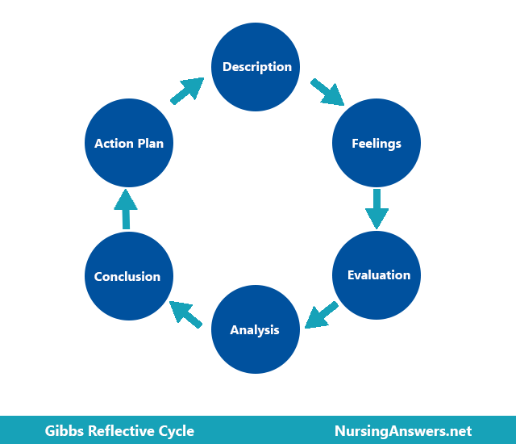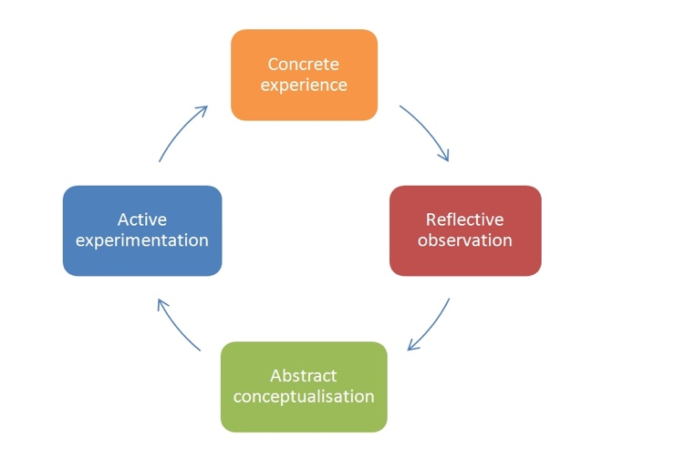
Gibbs Cycle Kolb’s cycle

Analysis of models: Williams, O. (2017) says that David Kolb's four-phase cycle of experience learning. On the other hand, Kolb's model is also known as a learning experience model, which essentially states that learning occurs via experience. Gibbs' approach is frequently called a progressive model, which is really another word for repetition-based learning. Sethmini (2021) claims that the main differences between the Gibbs and Kolb reflective cycles are their varying phases. Kolb's reflective cycle consists of four stages: real experience, observation via examination, mental processes, and involved exploration. Gibbs' reflective cycle consists of six phases: conclusion, action plan, evaluation, analysis, feelings, and description. The Gibbs and Kolb reflective cycles are used in educational contexts. The Gibbs cycle, also known as the iterative model, extends the Kolb's cycle, also known as the experiential learning model. David Kolb created the Kolb reflective cycle to assist educators in assessing their own teaching and pursuing further professional development. Graham Gibbs created the Gibbs reflective cycle to provide a framework for learning from events.. Fiechter, k. (2010) writes that the Kolb Cycle was created to help teachers evaluate how they teach themselves to encourage ongoing improvement. A few years afterwards, the Gibbs Cycle was developed, which is essentially an extended, more thorough versions of the Kolb Cycle. Oxford University professor Graham Gibbs made the following argument, citing the Kolb Cycle: "Just doing or thinking is not sufficient. Simply doing and thinking is also insufficient. Making a connection between doing and thinking is necessary to gain knowledge from experience. One advantage of Gibbs' cycle is its emphasis on the methodical examination of distinct stages in a learning process. Gibbs' headline elements are simple and easy to understand, even if they go beyond the three basic issues of Rolfe's model. This allows for unambiguous reflection that can be meaningful to other people. The descriptive nature of Gibbs' model and its possible lack of analytical rigour make it potentially problematic for understanding the full significance of other people's actions and the thinking processes that underlie them. Gibbs' cycle does not allow for the inclusion of those who are on the opposing side of the event or problem being handled, even though the model is one-sided and only considers the practitioner's perspective. This may provide important information to take into consideration. Study prism (2023) says that Kolb's Experiential Education Reflective cycles are an easy procedure to understand and implement. As such, it may serve as a helpful start to organised introspection. It is adaptable and suitable for a wide range of situations. Not to add that I genuinely assist people in becoming more self-aware. This has enormous worth on its own and is a thing that can be enhanced and used in all facets of life. Critics of the approach, however, would counter that it is oversimplified since it disregards other people's viewpoints and other kinds of input. Furthermore, it ignores other approaches to non-reflective learning or contemplation while acting.

Conclusion: Overall, as a practitioner the Kolb’s reflective cycle is better as it allows students can make sense of what has recently occurred. During the Reflective Observation phase, learners can describe and assess their experiences. The information needed for the following step is provided by this cataloguing: Understanding in abstractions. Students clearly make the connection between their experience, their goals, and the event's result during this second chance for critical reflection. Since students' knowledge is assessed considering their own experiences, the reflection process is the only way for the experience to be transformative. In Kolb, the last Reflection step takes place during the Active Experimentation phase. Students make plans for additional learning opportunities through reflection.
Written Essay: Professional practise in early years, Early years matters (2023) declares that making sure that every child benefits as much as possible from their involvement in the Early Years Foundation Stage is the goal of successful practise. This seemingly straightforward result can only be attained when adults collaborate to get familiar with the kids to encourage play, growth, and learning. All about children (no date) indicates that an early childhood teacher works closely with infants, toddlers, and pre-schoolers, attending to their basic needs such as feeding and changing as well as planning developmentally, academically, and physically appropriate activities. Communication is ensuring that the professional can communicate with other members of staff, children and parents. Being able to communicate helps practitioners plan and more forward in their career which opens more opportunities for further learning, Vicky (2022) said that children actively participate in all conversations, helping to solve the issues and offering their opinions and ideas. Democracy, and dignity, compassion, freedom, listening to others, understanding, and empathy are all addressed. Give the children a voice, make sure that their heard. Early years matters (2023) claims that a strong and independent character traits are instilled in children via excellent connections. Good relationships are kind, helpful, and consistent in establishing boundaries while being warm and caring and fostering a sense of belonging. They also pay attention to the needs, feelings, and interests of the child. Exciting environments for young children based on important human connections. NSPCC (2023) agrees that every encounter between a teacher and a pupil adds significantly to the development of the information and abilities that students will require. Knowing what young people currently know and can do helps practitioners respond to them in a way that maximises the likelihood of high-quality encounters. To guarantee that every child has an equal right to protection from danger, regardless of age, disability, gender reassignment, colour, religion or belief, sex, or sexual orientation, safeguarding policies and procedures should be in place. Children are protected from adults and other youngsters that might be a risk when appropriate safeguarding rules and regulations are put in place and followed. This comprises faith-based organisations, non-profits, businesses, educational institutions, healthcare facilities, and athletic associations. Multi agency is extremely important in early years working together to support the child to be able to achieve the child’s best ability and making sure that the child is supported/ listened to if the is a safeguarding issue. Different professionals working together with different understanding Ables professionals to share new ideas to make sure we get the best to support out children. Whilst multiagency professionals must ask themselves ‘are the children engaged?’ if not change it up, change things around trial and error make sure that the children’s interests are at heart. Observation is to be able to see the level of the child and making sure they’re on track. Ask yourself ‘do they need extra support?’. Valuing them and their work shows the children they have completed the activity correctly if they’re struggling find different ways to support your child. Birth to five matters say that Professional practise includes planning, assessing, and making observations. During the Outcomes Assessment Process cycle and summative assessment, well-informed judgements on the child's growth, learning, and advancement must be made with the greatest degree of objectivity feasible, using the range of available data to determine the "best-fit" course of action. UNCRC has four principles, Unicef (2019) shows that these four guiding concepts help shape societal perceptions of children and their rights. They are predicated on the idea that children are equal to adults. The right to play is affirmed, highlighting the fact that childhood is valuable in and of itself and that these years are only a phase of preparation for adulthood. How can we ensure that children receive the essential protection while still treating them with equal respect? The application of the four basic principles holds the key to the solution. When combined, they create a mindset that is nothing less than positive towards kids. They offer the gathering a moral and ideological component. Children need to be taught how to understand rights of the child; all children should have rights. Planning learning are all linking to UNCRC.

Conclusion: To conclude all the aspects spoken about in this essay are all main factors of being a professional practitioner in early years. Values of a child are very important, children should be taught affirmation, respect, and responsibility from a young age. Communication is key. Communicating helps you learn from other people and better yourself for the children that will be in your present, effective communication is good for getting everyone on the same page, with everyone being on the same page helps each other be able to tam work to have the best professionals around children. Children thrive of good energy and communicating make sure all children are listened to, let them have a voice! Being able to work together gives more chance of the child getting their best ability. Making sure the chid is supported. Through observation, we can determine each child’s unique educational and care needs as well as evaluate the growth of the child. Next phases in the learning and development of the kids can then be planned. We must spend our time wisely and observe children in an environment that is both beneficial to them and helps us learn as much as we can about them. Human rights are in place to ensure that we get decent and equitable treatment as well as the freedom to reach our full potential. In addition to the rights that are universally applicable, there are several that are exclusive to children. Children require additional security that adults do not, hence they should have specific rights.

Reference list

Birthto5matters (no date) Professional reflective practise. Available at https://birthto5matters.org.uk/wp-content/uploads/2021/03/PDF-20-Professional-Reflective-Practice-1-1.pdf
Brock (Ed.). (2015). The early years reflective practice handbook. Routledge. Available at: https://ebookcentral.proquest.com/lib/trinity/detail.action?docID=1744144&pq-origsite=primo
Cambridge Community(no date) Available at: https://www.cambridge-community.org.uk/professional-development/gswrp/index.html
HCPC (2023) What is reflection? Available at: https://www.hcpc-uk.org/standards/meeting-our-standards/reflective-practice/what-is-reflection/
Main, P. (2022)Kolbs learning cycle. Available at: https://www.structural-learning.com/post/kolbs-learning-cycle#:~:text=Kolb%20is%20a%20four%2Dstep,step%20using%20a%20logical%20sequence.
Skills you need (2011) Reflective practise. Available at: https://www.skillsyouneed.com/ps/reflective-practice.html
The further education unit (2010) Gibbs Reflective Cycle. Available at: https://www.ed.ac.uk/reflection/reflectors-toolkit/reflecting-on-experience/gibbs-reflective-cycle
Williams,O. (2017). Kolbs and Gibbs reflective cycle. Available at https://owenwilliams82.wordpress.com/2017/01/08/kolb-and-gibbs-reflective-cycle/
Sethmini(2021) What is the difference between Kolbs and Gibbs Reflective cycle. Available at: https://www.differencebetween.com/what-is-the-difference-between-kolb-and-gibbs-reflective-cycle/
Fietcher. K (2010) Differences between Gibbs and Kolbs cycles. Available at: https://www.ehow.co.uk/info_8582553_kaufmans-five-levels-evaluation.html
NuersingAnswers (2018) Gibbs Reflective cycle. Available at: https://nursinganswers.net/reflective-guides/gibbs-reflective-cycle.php
Studyprism (2023) Kolbs Reflective learning cycle. Available at: https://studyprism.co.uk/reflective-practice/models/kolbs-reflective-learning-cycle/
Earlymatters (2023) Effective Practise. Avaliable at: https://www.earlyyearsmatters.co.uk/our-services/school-and-nursery-improvement-partner/enabling-environments/effective-practice/
Allaboutchildren (No Date) What is an early years practitioner? Available at: https://allaboutchildren.co.uk/news/what-is-an-early-years-practitioner/#:~:text=An%20early%20years%20practitioner%20works,physical%2C%20educational%20and%20emotional%20development.
Hutchin, V (2022) Fundamental British Values in Early years. Available at: https://early-education.org.uk/fundamental-british-values-in-early-years/#:~:text=In%20fact%3A%20democracy%2C%20respect%2C,sharing%20their%20thoughts%20and%20ideas.
OFSTED (2023) A strong foundation in he early years is crucial to children’s success. Available at: https://www.gov.uk/government/news/a-strong-foundation-in-the-early-years-is-crucial-to-childrens-success#:~:text=Every%20interaction%20between%20a%20practitioner,can%20do%20and%20respond%20accordingly
Nspcc (2023) Safeguarding children and child protectiom Available at: https://learning.nspcc.org.uk/safeguarding-child-protection#:~:text=Setting%20up%20and%20following%20good,schools%2C%20hospitals%20and%20sports%20clubs. \
Birthto5matters(No Date) Observation assessment and planning, Available at: https://birthto5matters.org.uk/observation-assessment-and-planning/#:~:text=It%20involves%20observation%20of%20children,adults%20in%20supporting%20and%20extending
Unicef (2019) Four principlesb of convention on the rights of the child. Available at: https://www.unicef.org/armenia/en/stories/four-principles-convention-rights-child

H

