
Library & Learning Resources

- Finding Resources

- To start your search, type UWTSD or http://www.uwtsd.ac.uk/ into your internet explorer. Select Quick Links and then select Swansea Library and Learning Resources. Or you could go straight to the library website: http://www.uwtsd.ac.uk/library/

- To search for books / e-books

- Select Catalogue from the left-hand side of the screen. Scroll down the page and select Search Swansea Campuses. Type in the title of the book you want or the topic you are researching. To find the shelfmark of the book select Check availability.

- To find an ebook (an online book), search on the Catalogue as you would for a book, by typing in the title or topic. Scroll down to Format on the left-hand side and select e-Book. Select the book you want by clicking on Check availability. Then select Click here to view. You will be asked for your user name and password before you can view the ebook.

- Your user name is the P number from your student ID card.
- Your password will be the same as you use to login to Moodle to access your course information, and is usually your date of birth in 6 digits (day, month and the last two digits of the year so e.g. if your birthday was 25th July 1994, you would type in 250794. If you have problems with your password, please contact the IT Helpdesk: Telephone: 0300 500 5055 or email: ITServiceDesk@uwtsd.ac.uk

- Once you have entered your P number and password, you may need to click on an icon which looks like a mini-lectern to access the ebook:


- To search for online journal articles

The Digital Library is a good place to start if you are searching for online peer-reviewed, academic articles. Again, you will need to go to the Swansea Library and Learning Resources page: http://www.uwtsd.ac.uk/library/

- To access the Digital Library, select Online Library from the left-hand side of the screen. Select Swansea Online Library. Then select the Digital Library by clicking on the link: Click here to perform a one-stop search of the Swansea Online Resources via our Digital Library.

*In the search box, type keywords from the topic you are researching, or if you know the title of the article you are searching for, type in the title of the article.
*If you are searching for a topic, you can refine your results on the left hand-side of the screen by selecting full-text articles, limiting to scholarly and peer-reviewed articles and by selecting journals. You can also refine the date.
*You can read a summary by selecting the spyglass and by selecting the folder, email the article to yourself.
*To read the whole article, select Full Text Online. If you are accessing the resources from home, you will be asked to type in your P number and password.

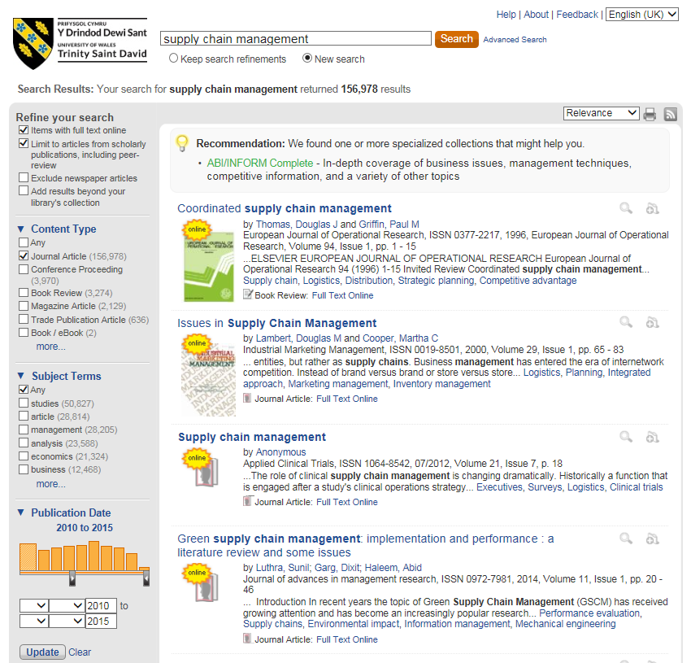

- For more specific journal article searching, try the databases

To find the databases, again go to the Swansea Library and Learning Resources page http://www.uwtsd.ac.uk/library/, select Online Library from the left-hand side of the screen, then select Swansea Online Library. Then under the heading A-Z Listings of Online Resources, click on the box Databases A-Z. If you hover your cursor over each title, you can view descriptions of the databases. Springer Journals, Science Direct and NewsBank are useful databases. Please refer to the help sheets for more information about using these databases.

Search Strategies

- Think about the search terms the author may have used. Look at articles to identify the key words others have used and try those words in your online search.

- If you find a good article, look at the references to see if the articles listed would be useful for your work. If you find a relevant article, copy and paste the title into the Digital Library search box to see if it is available through the library.

- Depending on your assignment, you may have to broaden or narrow your search. Welsh Journals Online has a page to help students which includes Effective searching tips which can be applied to most databases and search engines:

http://welshjournals.llgc.org.uk/content/students

- Refining searches made on the web

- Google can be really useful if you are looking for government, company or association documents. Below are some tips to help refine the amount of results your searches may generate.

- To search for information by an organisation, type org.uk after your search terms e.g. reintroduction of species org.uk

- To search for government related material, type gov.uk after your search terms.

- To search for a pdf, type pdf or pdfx after your search words.
- To search for a Powerpoint, type ppt or pptx after your search words.
- To search for a document, type doc after your search words.

E.g. Typing reintroduction of species org.uk pdf into the search engine will find pdfs organisations have published related to the reintroduction of species.
- To narrow the amount of results your keywords generate even further, you could type the word filetype: as well.

E.g. environment filetype:pdf will find pdfs on the environment.

  - Try putting a phrase in speech marks, e.g. “coastal management”, as it may keep the words together.
  - Use forward looking language e.g. “DEFRA expects” “UNESCO intends”.

(Extracts adapted from Karen Blakeman 2014.)

- Evaluating information found on the web

- There are millions of resources available through internet search engines. However, it is important to remember that anyone can put information on the web and the information you find may not be backed by research, may be biased or inaccurate. To ensure that the resources you find on your internet search engine, e.g. Google, are suitable for your research, please refer to the search tips found in Welsh Journals Online. The link ‘Evaluating web sources’ at the bottom of their search tips page links to the Oxford Brookes University Library web page, http://www.brookes.ac.uk/library/webeval.html , which has a comprehensive list of how to evaluate information placed on the web.

- My contact details

- If you need help finding information for your research, please contact me by coming into the Owen Library and asking for me at the counter, or telephone or email.

Suzanne Taylor
Llyfrgellydd Pwnc / Subject Librarian,
Ffôn/ Phone (01792) 481141
Ebost /Email suzanne.taylor@ uwtsd.ac.uk

