

PROBLEM-SOLVING AND DECISION MAKING

Student: Evelina Gajauskyte (2125731)
Lecturer: Aparna Venkatesan
Module: Problem-solving and decision-making (BMSW4004)
Table of Contents
Introduction 3
The problem 3
Fishbone analysis 3
SWOT analysis 4
Pestle 4
Solution 5
Implementing solution 5
Conclusion 6
References 7

Introduction

We live in a world full of complex problems in the workplace. There are different types of problems, they can be big or small and can be solved in many different ways. To better understand what problem-solving is, Zoe Kaplan (2023) explained that by having problem-solving skills, you will be able to recognize the issue, investigate it and find the best solutions. There are different decision-making techniques to be used, for instance, fishbone, which helps to identify the root cause of the problem, using this method, will allow you to find the main concern and what are the causes. It includes 6 M’s, 4 P’s, and 4 S’s (Lewis, 2020) There is another technique, called SWOT analysis. It helps you to identify your strengths, weaknesses, opportunities, and threats. It allows you to analyze and acknowledge how you can make your weaknesses into strengths and threats into opportunities (CIPD, 2021). The last famous technique is called Pestle. It stands for political, economic, social, technological, legal, and environmental. It studies the external elements that impact organizations (CIPD, 2021). This report aims to get the best result, using the problem-solving techniques given.

The problem

The company called Natural Life, is not making a profit after being open for more than five years. The directors were planning to see higher growth within the first two years, but the numbers are similar as it was after just a year of opening. They kept changing their staff every year because they thought it might increase their earnings and reduce expenses, by not renewing the contract of the existing staff, as they can pay just a minimum wage to new employees, without giving a promotion, and not realizing, that it costs them more. After all, they have to include training as well, and new workers will not be able to work the same way as the ones who have worked for a longer period of time. The suppliers were producing cheaper and not the best quality products, which affected the company in the long run because customers were getting disappointed for paying for bad quality food and did not recommend this company to any of their friends. They tried to save money and did not invest in marketing, in this case, not many people found out about Natural life, and what they sell. This organization's rating is dropping drastically, and the directors have realized that something has to be changed to succeed.

Fishbone analysis

I will be using fishbone analysis first to find the root cause of the problem, once all problems are recognized, then we will try to resolve them. The main problem is that the company is not meeting targets and not getting any profit. Key factors are people, methods, and materials.
People – The company has not realized, that changing staff yearly can cause a loss for the company, because every time they change the staff, they have to provide training, and it takes time to get used to the environment you are working in, which means, that every time they hire someone new, the company is going backward. Second, workers, who have worked a long time for the company, already know the majority of the things there, have made good friendships with the customers, and have made connections and networking, which benefits the company as well. Then, there are disappointed customers, who pay for expensive products, but not getting the quality described. Which goes to the next factor –
Materials – it is a big issue, thinking, that if you will get products cheaper, you will make a bigger profit. In the long run, people will realize, that they pay too much for what it is worth. It has to be a bigger picture, by investing more money in the product, the income will increase drastically, as it will give the trust to the customers, and the word will be spread among the people. Word of mouth is the best marketing, as people know, that someone has tried it and liked it. I will talk a bit more about it in another factor, which is called -
Methods – marketing is one of the most important things in the business, as it allows you to promote yourself, show the world what you do and who you are, and bring more clients to the business. By ignoring this method, the company can lose a big opportunity to get known by a bigger audience, and the business will not go any further. As mentioned earlier, renewing contracts is very important, as it will give your workers stability and motivation to make this business profitable.
By using fishbone analysis, I have found the main causes and what needs to be changed, in order, to be successful.
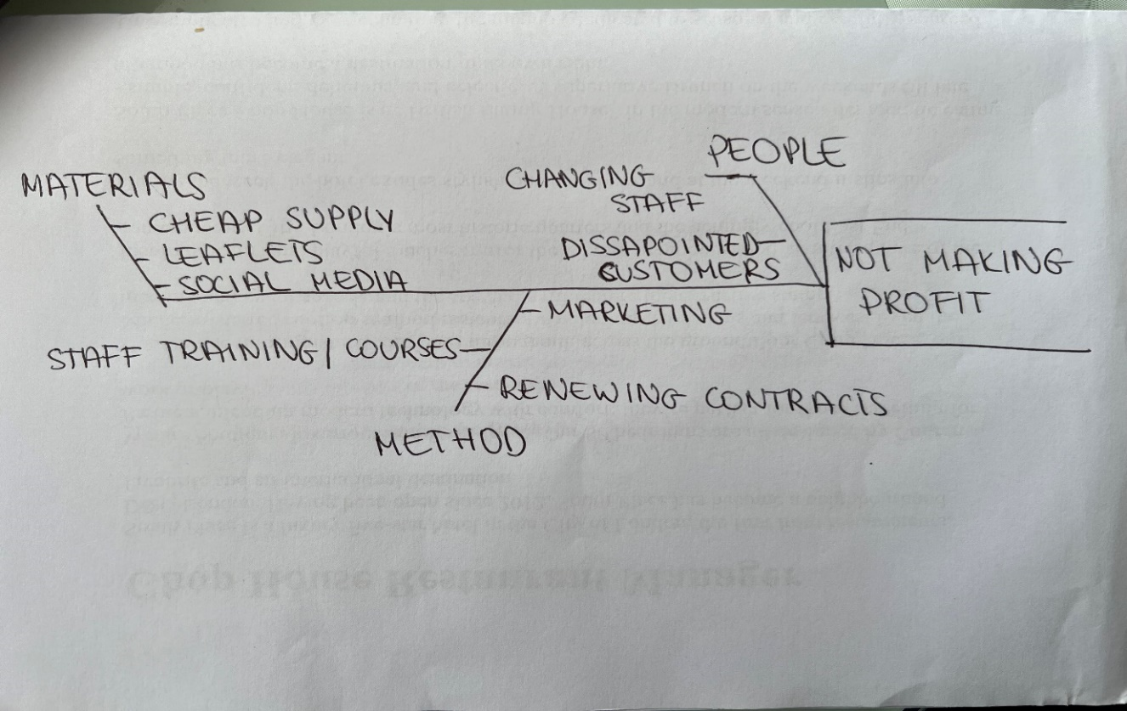

SWOT analysis

Swot analysis helps you understand what your company is doing well and what needs improvement. It helps to establish a company strategy and make good decisions (Bigelow et al., 2023). I have analyzed Swot for Natural Life.
Strengths – it is a good concept, has good connections with other business directors, and has good knowledge of the competitors.
Weaknesses – changing staff way too often, not providing courses needed, cheap produce, not investing in marketing.
Opportunities – getting known by a bigger audience, by promoting the company.
Threats – customer dissatisfaction, bad reputation, no recommendations.

Once SWOT is analyzed, we can see the result and make a plan to adjust it, to make our weaknesses into strengths and threats into opportunities. As it is a well-designed concept, that means, that we just need a couple of improvements to make this business popular and valuable.

Pestle

Pestle analysis is a tool, used for businesses to analyze an external environment and how it can affect the business (Pestleanalysis contributor, 2022). The purpose of Pestle is to see if there are any threats and opportunities for businesses to grow.
P – Political – it can affect any business by increasing the tax and it can give a negative impact on the company.
E – economic – it can be affected by labour costs.
S – social – company has to focus on age groups, race, gender, etc. These are very important factors, as you need to know to what category your product belongs. This will help you focus on the main group of people and know what adjustments to do to make the company profitable.
T – technological – technologies nowadays are very important, in that case, your company can be promoted to a wider audience, there are different applications to use, to make the experience for the customer easier, but we have to be up to date with the modern technologies, as it keeps changing very often.
L – legal – there are many different legal requirements we have to know before opening the business, as every country has its own rules and legislations, if not follow them, the company might be closed down by the government.
E – environmental – many people are trying to look after the environment, to save the planet. They want sustainable and environmental products to be sold (CIPD, 2021).
There are other similar analyses called PESTLIED and STEEPLE – the only difference is that PESTLIED also focuses on international and demographic issues, and STEEPLE emphasizes ethical matters (mindtools, 2022)

Solution

There are a few solutions at this point. First, the company needs to give training to the staff and keep these workers for as long as possible. If the team is hitting targets, they should get bonuses as well, as it will keep them motivated, and they will work even harder. Looking after your staff and noticing when someone needs a promotion. Yearly courses would benefit both parties, so the staff can gain experience and develop the skills needed. Suppliers need to be changed, to get the best quality products. There are many suppliers out there with a good price and still producing decent quality goods. One of the most important steps to make is – to promote the company. Investing in advertising will make the biggest change. It will reach more people and make the business thrive. By making these changes, customer frustration will be removed, and the company will be rated higher. All these steps will make a big change.

Implementing solution

There are many advantages to investing in staff professional development, as it will help them to reach success and meet their targets. By helping employees, the company will succeed as well. Providing yearly courses will keep the team up to date with the skills needed and their knowledge will expand. This will make the staff professionals at work, as they will be confident in what they do. Having occasional meetings with the team also will help to find out what their vision is, and what they think is missing at work.
Changing suppliers might seem to be expensive at first, but the quality will meet the price. To start with the main ingredients needed, and once we see money increase, we can swap the rest ingredients for better ones.
Marketing can be done in many different ways, for example, by handing leaflets to the people outside. It does not cost much, but it is an effective way to get people to the company. Social media is the most popular way of promoting the business. It can be done by the owner, or someone from the member of staff, who is more creative and knows tips and tricks on how to take pictures of the products and post them on social media.
Once these solutions are implemented, Natural Life will face growth and in the next two years, it will probably be one of the fastest-growing corporations.

Conclusion

It is very important to find the main cause of the problem, and it can be done by using any of the techniques given above. All these methods are helpful, the more company examines the root of the cause, the better result it will get. Every company faces different issues, and every staff is treated differently in every company. That is the reason why you have to monitor business, find out what this company is doing good, and what could potentially be changed, to make it work. Staff can be affected positively and also negatively by any changes within the company, so to make sure, that everyone is happy in the environment, it has to be reached out to the staff as well, to get feedback to see their point of view, how they feel, what their thoughts are.

References

Bigelow, S.J., Pratt, M.K. and Tucci, L. (2023) SWOT analysis (strength, weaknesses, opportunities and threats analysis). Available at: https://www.techtarget.com/searchcio/definition/SWOT-analysis-strengths-weaknesses-opportunities-and-threats-analysis (Accessed: 20th April 2023).
Pestleanalysis contributor (2022) The Pestel Framework explained: 6 important factors. Available at: https://pestleanalysis.com/pestel-framework/ (Accessed: April 20, 2023).
Mind tools (2022) Pest analysis. Available at: https://www.mindtools.com/aqa3q37/pest-analysis (Accessed: April 25, 2023).
Kaplan, Z. (2023) What are problem-solving skills? definition and examples. Available at: https://www.theforage.com/blog/skills/problem-solving-skills (Accessed: April 25, 2023).
Lewis, S. (2020) Fishbone diagram (Ishikawa Cause and effect). Available at: https://www.techtarget.com/whatis/definition/fishbone-diagram (Accessed: April 25, 2023).
CIPD (2021) PESTLE analysis. Available at: https://www.cipd.co.uk/knowledge/strategy/organisational-development/pestle-analysis-factsheet#gref (Accessed: April 25, 2023).
CIPD (2021) SWOT analysis. Available at: https://www.cipd.co.uk/knowledge/strategy/organisational-development/swot-analysis-factsheet#gref (Accessed: April 25, 2023).

