Shabilah Hussain 1806501
Task 2 Reflection
David Kolb’s experiential model of learning (Kolb,1984) theory has frequently been used for importance for developing training and development program and has also been used for individuals thinking about their performance and experience. The model represents for a new learning skill we go through, the four activities and stages and self-reflecting on how we can improve.
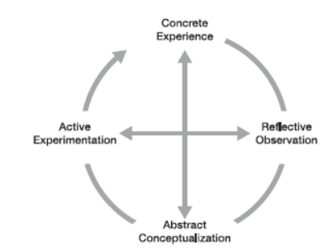

Stage 1 experience, to pass or do well, and I will need to do research, organise my notes and search on the internet and present my poster presentation in a group, Stage 2 reflection, meaning what we do and how we do it and how can I do better and aligning my values, attitude and beliefs with the organisational example used in the poster presentation. We were set a task in groups, and our mission was a presentation, demonstrating the beliefs attitudes and values that contribute to organisational success by applying critical thinking models to regulatory examples, the poster presentation with each group member providing 5 minutes to the presentation with the submission of speaker notes via Turnitin. We submitted the work and had time to reflect on how well we have done after the performance, I had time to discuss my ideas with other students what theories were included and what I thought was relevant and what examples I had given and compared my work to other students, this suggests that I was reflecting on my performance and how well I have done. I found that my strengths were I was very assertive and organised and researched well, and my weakness was that I needed to be more confident in presenting my work in front of group of people and how I could do better next time?, what I could do differently next time is to gather more information and practice presenting more at home and arranged feedback from my lecturer. Stage 3 Theorizing, the model explains when you have given the work and reflected on the job and have analysed the work and what we did,and how we did it, I found that I needed to manage time better when presenting the information and how I should have structured the answers in a better way and could have included more organisational examples. Stage 4 planning, after going through the three stages I need to think now what am I going to do differently next time to be good at presenting information and how to apply my speaker notes to achieve better results, I will need to get regular feedback from lecturer and need to practice more with presentation skill and my writing skills and critically analyses information so that I perform better and to be more motivated. (Barrett, 2019) Model is a useful tool for values and individual motivation for reflection. The model shows seven areas a human’s personal consciousness it provides a framework of understanding the stages in development of individual and group, the model covers our inner journey into self-knowledge and sense of identity, and what we care about in our lives by recognizing our fears and fulfilling our self-esteem and letting go of our own personal and cultural conditioning and achieve our potential and specific values and behaviour characterise each level of consciousness.
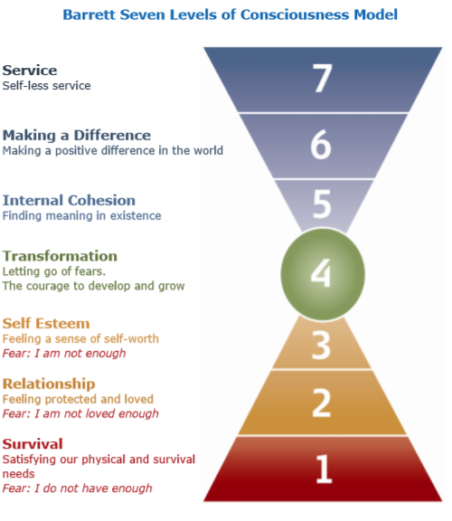
Values and beliefs and attitude are essential to an individual and in an organisation to perform and can impact workplace behaviour, my personal opinion are ideas I hold to be true which is education is important my belief will develop in to a value as the commitment grows and set to be essential to achieve a successful career and to do this I will need support from family, lecture this will affect my attitude and behaviour in class and how I perform this will involve me being professional and how I behave and act to achieve my goal to succeed.
Values come in three stages foundation values, focus values and future values my current foundation value are commitment, loyalty and opinion, my focus values teamwork and relaying good communication skill, and my future values are to respect others feelings and thoughts and work as a team to achieve a common goal.
Conclusion
Learning is a progression to enhance study and work performance and to improve current and future knowledge. To reflect on performance is to align values, develop professionalism and long-term career development and maximising potential, values are a strong influence on behaviours they are a vital part of what motivates people and to be more engaged. The above two models help me think and reflect what you could have done better and how well you have performed and make me more self-aware. As I have come to a realization to make notes on essential reading regularly, meet other students to discuss group work and communicate and comply with my tutor and to organise my notes so that they are easy to read and find ant this will help me be more confident and to develop presentation skills I will need to give myself self-sufficient time to prepare and develop a presentation checklist practice and rehearse it and take feedback and watch how others present, e.g. on tv video of TED and watch lecturers.

References
Kolb, D.A.(1984)Experiential learning: Experience as the source of learning and development.Englewood Cliffs, NJ: Prentice Hall
Barrett. (2019, December 05). https://www.valuescentre.com/barrett-model/. Retrieved from Barrett values centre: https://www.valuescentre.com/barrett-model/
Gallagher, K.(2010) skills development for business and management students.Oxford: Oxford University Press
Maslow,A.H.(1943)'A theory of human motivation',Psychological Review, 50(4),370-96.
Barrett, R., 1998. The Barrett Model.

